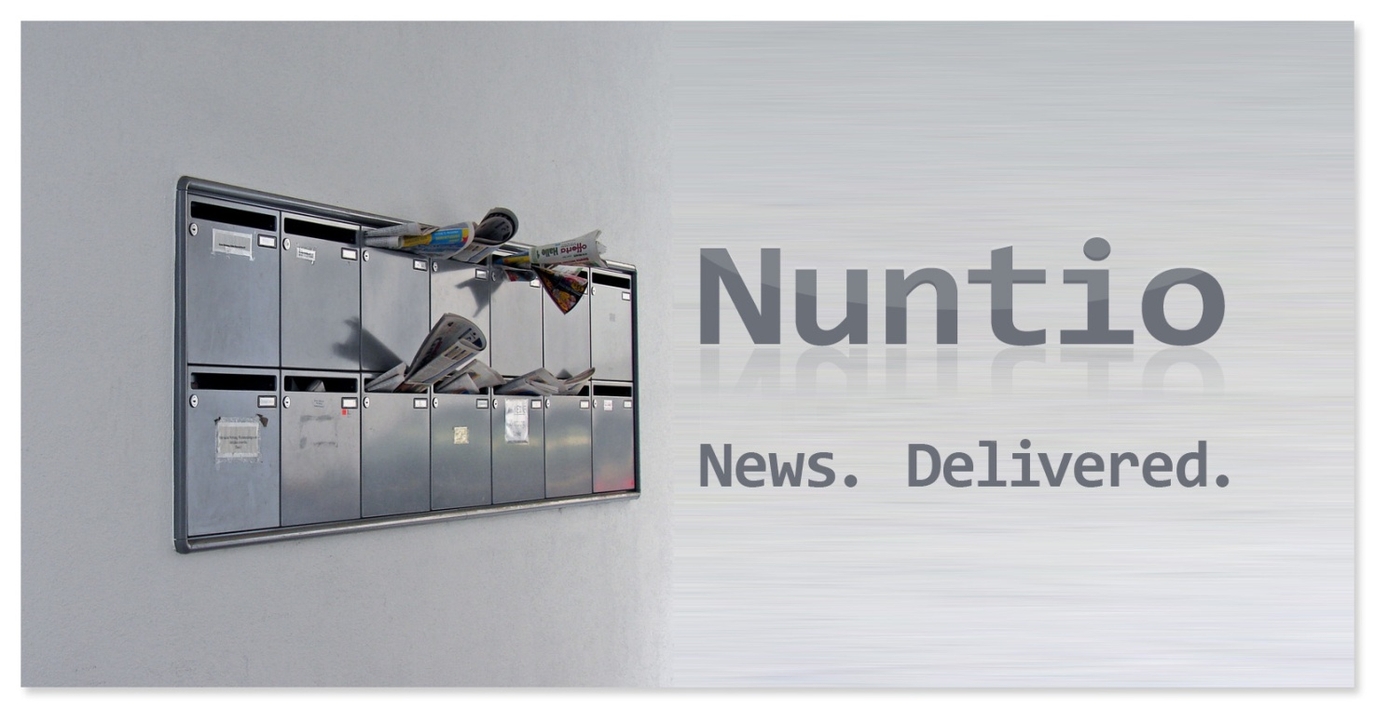

NUNTIO ARTICLES is a news article module for the DotNetNuke platform. The powerful article store enables site visitors of a DotNetNuke portal to browse news articles in multiple languages, filter them by unlimited categories, dig through archive views and receive RSS feeds based on selected categories.
Portal administrators may allow visitors to subscribe to new articles by e-mail, present banners from the DotNetNuke banner store based on categories a given visitor is currently browsing the site and much more.
Due to a simple but powerful moderation concept, no editor permission is needed to publish new articles. Site administrators only need to enable moderation for selected security roles.
The outputted HTML is delivered through a powerful and unique templating engine that enables you to fine-tune the generated output and re-use it theme based in unlimited module instances throughout a DotNetNuke system.

Contents

1 Concepts 3
2 A Nuntio Article 3
3 The article form 4
4 Article Security 11
5 Templating System 11
6 Configure NUNTIO 13
7 Notification Subsystem 18

Copyright 2014 Philipp Becker

Concepts

NUNTIO is an article publishing application that handles news articles in multiple languages. Site visitors can subscribe to new articles and NUNTIO will send e-mail notifications in regular intervals to those subscribers. Each article can be associated with unlimited nested categories.
In order to enable multiple languages in NUNTIO you need to enable at least two languages in your DotNetNuke portal. If you are running your portal only with administrative permissions you may have to ask your host to enable the languages. If you’re running your portal in only one language, NUNTIO will work as standard single locale articles publishing application with no other limitation.
The way NUNTIO handles multiple languages depends on one important main setting where you define what is being presented to the site visitor if no translation is being found in the selected locale of the visitor. The NUNTIO application basically has two work modes; one where a predefined fallback is being used and one where a given article is not being displayed at all if no translation in the selected locale is being found.

A Nuntio Article

Main attributes of a single article:
Title | The title / headline of the article
Summary | The (optional) summary of the article content
Description | The actual content of the article
Publish Date | The date from where on an article will be displayed.  Note that you can set an article listing instance to also/ only show future articles, e.g. articles that have a publish date in the future. The intention of this possibility was to have a list of events where the publish date is then used to make the event date.
Expiry Date | The date until the article is displayed. After that date, articles are no longer visible to public visitors.
Link | An article may be linked to a resource. A resource is either an external url starting with “http://”, a file within the DNN file system, a user account within DNN (then linked to the public profile of the user) or a page within the current portal. For each of those options a convenient selection dialog is provided to easily link to the selected resource.  Once an article is linked to a resource, the templates can be setup to render a link to that resource. See the template section for further details.
Categories | An article can be assigned to unlimited categories; categories are configurable from within the article edit form.
Images | An article can be assigned to unlimited images. Images belonging to an article can be uploaded or assigned from within the article edit form. Each image can have a localized title and / or description. Images are stored in the DNN file system.
Featured Flag | Articles can be marked as featured. An article listing instance can be then be configured to only show featured articles or you may optionally configure a special template to highlight featured articles.
Published Flag | Articles are only visible to the public if they are marked as published. Leave an article not published until you are ready with creating / editing an article.
IsOriginal Flag | This flag is only applicable once you multiple languages enabled in your DNN portal. The flag can then be used to define which locale version of an article is the original text while others are only the translation of that text.  You can setup your templates so that they indicate which locale version is the original article.
Locale | This flag is only applicable once you multiple languages enabled in your DNN portal. Once you edit / add an article you select the locale of the text you are working on. You can later on configure a fallback mode in order to tell the module what to do with articles where a specific language version is not available.
Added to Newsletter | This flag is only applicable for the professional edition. Once notifications are enabled in the module configuration you can mark individual articles to be added to the notification queue. See the newsletter section for further details.

The article form

To add a new article into the database, you need to click on the „Add new article“- link at the bottom of the container, where the module resides in. Note that the link will only appear if you have sufficient permission to add articles (also see chapter 3, Article Security). The article entry form appears and you can fill in all fields as desired. Most of the form field’s values can be rendered by a corresponding token in the template output of the module (also see chapter 4, Templating System)
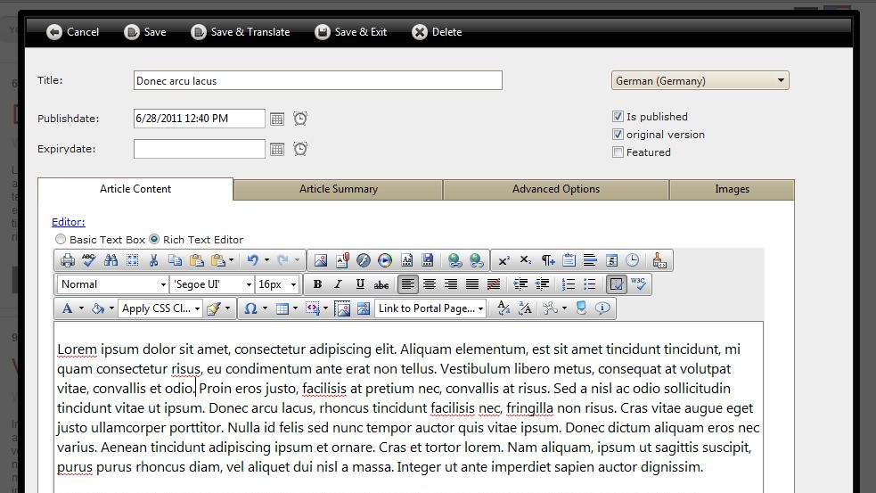

After you have filled in all needed form fields, you have the choice between three actions:
- Save & Exit – this will save or update an article into the database, close the form and reload the article list
- Save & Translate – this will save or update an article without closing the form. If you just added a new article, the save button will cause the form to reload and pre-select the next language in the language dropdown list. You can then add a language version for your new article in the selected locale. If you only edited an article, you can either select another locale to edit or close the form manually by hitting the “Close” button.
- Save – this will save the article and enable image uploading capabilities. You cannot add images to an article as long as it has not been save to the database.
Following is a list of all form fields and their meaning.

Title
This is the title of the article. The template token for this field is [TITLE].
Summary
This is the summary of the article. The field is optional and may be used to display a set of articles somewhere on the website where only a short teaser is desired. The visitor then would click on a “Read More” link to see the whole article (e.g. the summary and the body)
The template token for this field is [SUMMARY].
Body
This is the body / content of the article. This field is mandatory and is used for the content of the article.
The template token for this field is [CONTENT] or [CONTENT:xxx] where xxx may be replaced by an integer value that corresponds to the number of chars to be rendered. Note that using the xxx syntax will strip off any html formatting of your text.
Language
This select-box will only appear if more than one locale is activated in your portal. It is being used to set the language your article is in. The select-box works in two modes:
- if you are entering a new article and have not saved your article, you simply select the language of your article
- if your article is already saved, because you either are editing an existing article or you are adding a new article and clicked on the Save button, selecting another language will cause the form to lookup if there is a localization version in the selected locale in the system already. If so, it will load its content.

The select-box displays an icon next to each locale that indicates, whether an article is already translated into the given language or not.
The article is completely translated
There is no language version for the given language
Only parts of the article are translated, e.g. the body, the summary or the title
When you hover the mouse over the icons, a tooltip will show you the exact meaning of each icon.
Publish Date
The publish date marks the date from where on an article is visible (if also set to published, of course). Use this to automatically have articles visible in the listing on a given date.
Note that you can configure your listing instance to also show articles that are in the future. What this means is that even if the publish date is a date in the future, the article will still be displayed. You can use this feature to make the articles module an event listing module where the publish date is the actual event date for example.
Expiry Date
The expiry date is an optional flag that you can use to automatically have articles displayed no longer once the expiry date is reached.
Is Published
Ticking this checkbox will cause the article to appear in the listing of articles. Do not enable this checkbox as long as you are working on an article draft.
Users that are allowed to publish articles in moderation mode do not see this checkbox. When they save an article it remains unpublished as long as a user with edit permission on the article module publishes the article.
Is Original
This checkbox indicates whether a language version of an article contains the original content. This can be useful if you want to enable your visitors to distinguish between original and translated versions of an article. By using a special token in the templates your visitors can follow a link to see the original version of an article.
Of course only one language can contain the original content of an article. NUNTIO will handle this for you tough on updating an article, e.g. if you check this box, NUNTIO will make sure, that any other language version will no longer have this flag set.
Is Featured
This checkbox marks an article as featured. You can configure any listing instance to include / hide featured articles or show / hide articles that are not featured. Additionally there is a special template for featured articles so that you can highlight those articles the way you like.
Advanced Tab – Article link
On the advanced tab you may associate your article with files, external urls, portal pages or user accounts.
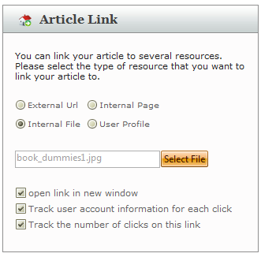
You can link your article either to
- a user account in your portal
This will add a link to the user’s profile
- a page in your portal
This will add a link to the selected page
- a file in your portal
This will add a link to the selected file
- an external website / file
This will add a link to the entered external resource

Depending on what link type you selected, a button will appear that enables you to select the desired resource through either
- a file browser
Simply select the desired file and link it by double-clicking on it
- a page browser
Simply select one of your portal pages by clicking through the tree and click on the desired page
- a user picker
Simply enter a username and click on “Check Account”. If the account is being found, you can click on “Link this account”
- a textbox
Enter your external url in the textbox
You can tell NUNTIO for all link types to track clicks on the selected link. This enables you to track the number of times a link has been clicked on and user account information about a clicked link.
You may also tell NUNTIO to open a link in a new window, if desired.
There are a number of template tokens that you can use to display an article link. See chapter “Templates” for further information.
Advanced Tab – Categories
On the advanced tab you may also associate your article with unlimited categories.
If you have setup categories already, you can check each category that an article should be associated with.
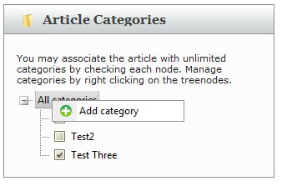
To add a category, you need to right-click on the parent category, e.g. the category your new category should be a child category of. Select “Add category” and enter the names of the category for each locale of your portal.
To edit an existing category, also right-click on a category and either select “Edit” or “Delete”.
You can add a special token in your templates that will list categories that an article belongs to. See chapter “Templates” for further information.

Images Tab
On the images tab you can add images that belong to an article. Images can be selected from the DNN file system or uploaded directly in the file system of DNN. Once you have set the images for your article, you can set a title and a description for each image. If you have multiple images in your article, you can set one of them to be the primary image. There is a token available to render the primary image in your article listing.
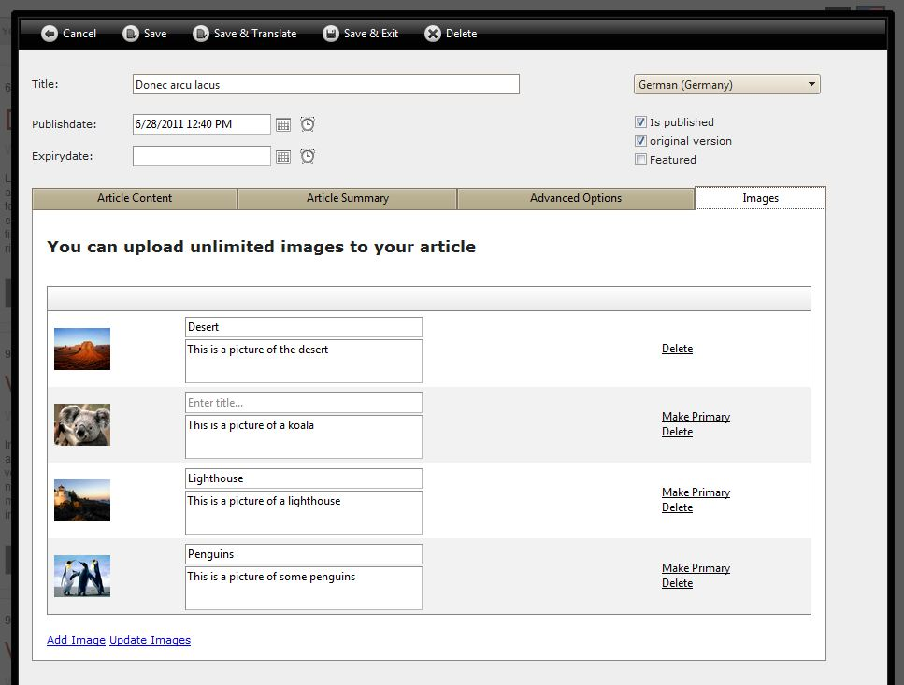
To add images, you click on “Add Image” and select images from within the dialog that appears. In the dialog you can also upload and edit images directly. To edit an image you would select it first and then click on “Image Editor” to do basic image editing like cropping or resizing.
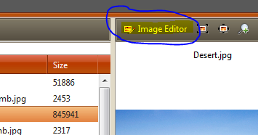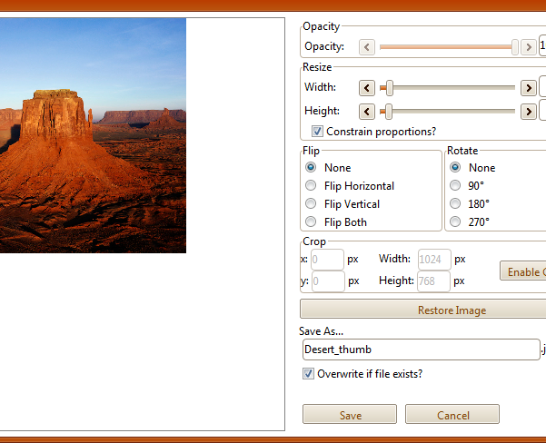

Article Security

Security in NUNTIO can be applied at two levels. First, there is the module based permission grid where you can give a security role or a single user account edit permission on the module. Having edit permission enables a user account to
- manage templates
- add / edit articles
- edit module settings, including those for the articles module
If you need less permission for your article editors, you can enable moderation in NUNTIO. This will enable one or more security roles to add articles into the system. Those articles are moderated though, e.g. a user with edit permission on the module level will have to approve those articles before they are published.
See the “NUNTIO Configuration” chapter for further information about setting up moderation.

Templating System

The templating engine in NUNTIO is the powerful rendering backend for your content. It is gives you full control over the outputted html code that presents your articles to site visitors. A set of template files, where each of them is responsible for a special view in NUNTIO, all together build a so called theme that you can reuse in all module instances throughout a portal and even a whole DotNetNuke installation.
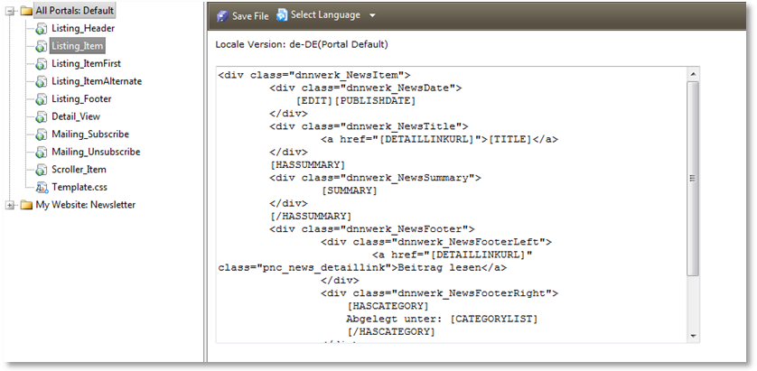
A unique feature of NUNTIO’s templating engine is its localization capabilities. Likewise to articles there is also a dedicated template for each portal locale. In previous version of the module, a lot of localized tokens had to be provided by the backend in order to support different needs. This limitation could be removed completely by adding one template for each locale.
The way it works is as follows. NUNTIO comes with two default themes, the “default” and “blog” theme; the default theme cannot be removed. In order to create a new theme one would typically start by editing an existing theme; NUNTIO takes that typical approach one step further. In order to create a new theme, you must select an existing theme, and copy that into a new one.
Note that NUNTIO also distinguishes between host and portal themes. A host theme may be used by all modules in all portals. A portal theme can only be used in the portal it has been created in. Obviously only host accounts can create host themes.
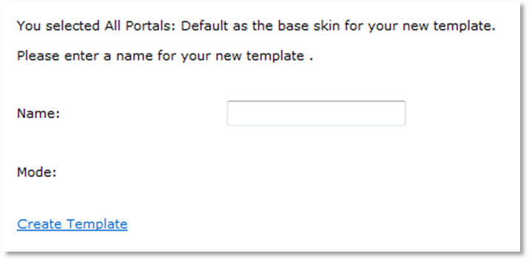
Every template in a theme can be edited from with the template management form by selecting its template name in the themes tree. By default, the template is loaded into the editor in the portal default locale, on selecting another locale the language version of the template is being created if it doesn’t exist yet.
The whole theme system is file system based; e.g. rather than editing it through the module UI you are free to edit files directly in the file system.
Templates and their function
Listing_Header | HTML rendered on top of all articles
Listing_Item | HTML rendered for a single article
Listing_ItemAlternate | HTML rendered for each alternating article
Listing_ItemFirst | HTML rendered for the first article in a list. This template replaces the Item template for the first item.
Listing_ItemFeatured | HTML rendered for each featured article
Detail_View | HTML rendered for a single detail view of an article
Mailing_Subscribe | E-Mail template that is used for the e-mail subscription confirmation mail, e.g. the mail from that a visitor has to confirm a new subscription
Mailing_UnSubscribe | E-Mail Template that is used for the e-mail unsubscribe mail, e.g. the mail that from that a visitor has to confirm his cancelled subscription
Scroller_Item | HTML rendered for a single article if NUNTIO is running in scroller mode
Comment_Item | HTML repeated for each article comment. You can control where the comment list is rendered by adding the [COMMENTLIST] token anywhere in the article detail template.
Comment_Notify | The e-mail template that is used for notifying authors about new comments that are awaiting approval.
Image_Item | HTML repeated for each image that the article is assigned to. You control where the images list is rendered by using the [IMAGEGALLERY] token anywhere in the article detail template.
Template.css | Stylesheets used in a theme. Note that you should work with unique css classes if you are using two different themes on a single page.

The newsletter theme is a special theme that you can neither delete nor copy and duplicate. The reason is very simple; if you look at how the e-mail notification subsystem works (see chapter “E-Mail notifications”) it becomes clear that only one newsletter template per portal can be used.
Mailing_Header | HTML / Text at the beginning of each e-mail
Mailing_Item | HTML / Text for each article
Mailing_Footer | HTML / Text at the end of each e-mail

Configure NUNTIO

If you add a NUNTIO module onto a page, the first question that arises is “What type of view do you want to load?” In order to understand what the module is asking at this stage you must know that we made it easier for administrators to maintain the module dropdown list in the site’s control panel.
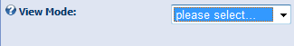
NUNTIO offers several different views into the article database, but rather than having a dedicated module for each view, we followed a very simple approach. There is only one NUNTIO module and before actually using the module on a page, you must tell it what type of view you want to have in each instance.
Let’s explore the several view modes and what they offer:
Article List
The article list view will show a listing of articles based on a number of settings. You can either setup the listing to show articles from its own article store or from another article module from within the current portal.
If set to show articles from its own data store, the module automatically becomes one of your central article stores. You must have at least one article module setup that way in order to show articles anywhere in your portal.
If set to show articles from another module, you must select the module that serves articles to be shown. This view is very handy if you want to show a list of latest articles on the homepage. From there visitors then get linked to the main module where they can read the full story.
Following is the list of settings for the article list view:

Theme: | Set the theme to use to render articles. Themes can be managed and customized using the “Manage Themes” dialog.
Show articles from… | This will set where the articles in the current module come from. Preset is always the option “[current module]” which will effectively make the module a central article store.
Filter by category: | If “Show articles from…” is set to display articles from another module, than you use this category tree to filter the result by each checked category.  Obviously this only applies to module instances that have categories configured in the module.
Max article count | Setup here how many articles to show at maximum.
Enable Paging | If enabled, the listing will page through articles. Each page will contain as many articles as you setup in Max article count
Max Pages | Setup here how many pages to show at maximum when paging is enabled
Show future articles | If enabled, the listing will include articles that have a publish date in the future
Show past articles | If enabled, the listing will include articles that have a publish date in the past
Include Featured Articles | If enabled, the listing will include featured articles
Include Not Featured Articles | If enabled, the listing will include articles that are not featured
Featured Articles sticky | If enabled, the listing will move featured articles at the top of the list and then show all other articles.
Sort order: | If set the asc the oldest article will be the first in the list, if set to desc the most recent article will be the first.
Use Locale Fallback: | Here you tell the module what to do, when a given article has now translation for the language that a visitor is currently browsing the site.  If checked, the module will lookup the original version of the article and show that rather than showing nothing. If unchecked, the article will be hidden as long as the visitor does not switch into the original language of the article.  Let’s take an example for this important setting.  You have two articles. Article A was originally published in English and comes with a German version also. Article B was originally published in German and has no other language version.  If now the visitor browses the site in German, then there is no problem, as we have a german version of both articles. The next visitor browses the site in English though and now we do have problem. We need to tell the module if it should either show Article B in German, as it does when this option is checked, or if it rather should not display Article B at all, as it would do when the option is unchecked.
Search Content: | Here you can enable / disable both search facilities: The core search and / or the module search.  If you have more than one language activated in your portal it is not recommended to use the DNN core search facilities for searching articles. The reason for that is the DotNetNuke search concept’s design. A module like NUNTIO can only hand over the DNN search index all article content. There is no way to tell the search index what language a given article is in. In short words, when you look up a search term in the DotNetNuke search, it will give you all articles containing the term, no matter what language they’re in, no matter what language the visitor is currently browsing the site in.  The module integrated search does only look up article content in the given language of the current visitor. The integrated search form is rendered on top of the article list when using the article list view mode.
Enable Summary: | In the form that you use to publish new articles there are two tabs, each of them containing a richtext editor. One of them is for the article content itself; the other is for the summary of the article.  Depending on your use case, you might not want to use article summaries at all. If that is the case, you might speed up the load times of the publishing form a little bit by disabling the summary here.  Note that the templating engine also allows you to display a given number of chars from an article rather than a specified article summary.
Enable Moderation: | This will effectively allow you to setup security roles whose member then are allowed to publish new articles. Those roles are defined in the Authorized Roles setting (only visible after enabling moderation)  If enabled, the in the Notify Address setting configured e-mail address will be notified about new articles.  Articles published by moderation enabled roles are not being published until they are reviewed and published by someone who has been given EDIT permission on the module.  Note that not everyone who has edit permission will be notified about new articles. Notifications are only being sent to the e-mail address specified in the Notify Address setting (only visible after enabling moderation)!
Enable Twitter Integration | (only visible in the professional edition)  If enabled, editors can opt to have the article posted to their twitterpost account from within the article edit form
Enable e-mail subscriptions | (only visible in the professional edition)  If enabled, you can configure various options that allow visitors to get notified by e-mail about new articles. See the Notification Subsystem chapter for further information
Enable Notification Debugging | Enables a detailed log file that is being written to when the notification task is running. This can come in handy if you run into issues with the mailing feature.
Only registered users can subscribe | If enabled, anonymous visitors are not allowed to subscribe to new articles for the current module instance.
Notify Admin | If enabled the webmaster of the current portal receives notification e-mails about new subscriptions.
Autosubscribed Roles | Check roles to have members of that roles be autosubscribed to new articles. Note that this prevents visitors from unsubscribing. If you want to still allow unsubscriptions you must your own tools to let visitors cancel their respective role membership.
Allow anonymous comments | If enabled, anonymous visitors can comment on articles
Auto approve anonymous comments | If enabled anonymous comments are authorized automatically. Authors can still delete comments.
Auto approve authenticated comments | If enabled authenticated comments are authorized automatically. Authors can still delete comments.
Localized Moduletitle: | You can overwrite the module title for each your portal languages.

Category Browser
The category browser view renders a tree view of all categories from the selected article store. Each category is shown as a link to a view containing articles from the selected category.

RSS Browser
The RSS browser view renders a tree view of all categories from the selected article store. Each category is shown as a link to the RSS feed containing articles in the given category.

Archive Browser
The archive browser renders a tree view of years and months containing articles. Again, each entry in the tree is shown as a link to a view containing articles from the selected year or month.

Banner Viewer

The Banner module is a powerful extension that allows you to show banners from the DNN banner system based on the article category that a visitor is currently browsing. The way it is working is that you need to set up banners in the dnn banner system and add them to categories that must follow the naming conventions of your article categories. That way, if you have an article category called “My Articles” the module will display all banners that are in a category with the name “My Articles” when the visitor is browsing the article category “My Articles”. Refer to the DNN banner help section to learn more about setting banners in DNN.

Following is the list of settings for the banner view:

Select article module: | Here’s where you set the main article module that the banner view is referring to
Hide on main listing: | This will hide the banner view as long as the visitor is not browsing a specific category. If unchecked, it will show randomly show all banners from all categories.
Banner Source: | This will set if banners are taken from the system wide banner store or only those from within the current portal
Banner Type: | This is to select what type of banner to be shown. Banner types come from the dnn core banner system.
Banner Count: | This will randomly pick the given number of banners from the banner store.
Transition Type: | This will set who banners are animated as long as the visitor stays on the same page.

Notification Subsystem

[TODO]

