A1 – Warm-up: Finite Sequences → Polynomials
% Use symbolic z
syms z

% Example i)
X1 = 1 + 2*z^(-1) + 5*z^(-2);
pretty(X1)
% Optionally simplify/expand/display
disp('X1 ='); disp(vpa(X1,6))

% Example ii)
X2 = 0 + 3*z^(-1) + 0*z^(-2) + 4*z^(-3);
pretty(X2)
disp('X2 ='); disp(vpa(X2,6))

% If you prefer to compute from the sequence explicitly:
n = 0:2;
x1 = [1 2 5];
X1_from_sum = sum(x1 .* z.^(-n));
simplify(X1 - X1_from_sum) % should return 0

n2 = 0:3;
x2 = [0 3 0 4];
X2_from_sum = sum(x2 .* z.^(-n2));
simplify(X2 - X2_from_sum) % should return 0

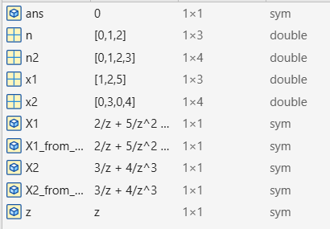
(b) Why finite sequences behave “nicely” regarding ROC (2–3 sentences)
Finite-length sequences produce Z-transforms that are finite polynomials in z^(-1) (or equivalently, finite polynomials in zzz after multiplying by a power of z). Because there are only a finite number of terms, the associated region of convergence is simply an annulus that cannot exclude any finite ring of radii caused by infinite summation - in practice the ROC is the entire z-plane except possibly z=0 or z=∞ (depending on whether the sequence is causal, anti-causal, or mixed).
(a) Z-transform results
- X1(z)=1+2z−1+5z−2X_1(z) = 1 + 2z^{-1} + 5z^{-2}X1​(z)=1+2z−1+5z−2
- X2(z)=3z−1+4z−3X_2(z) = 3z^{-1} + 4z^{-3}X2​(z)=3z−1+4z−3
(b) Why finite sequences have “nice” ROC
- Z-transform becomes a finite polynomial in z^(-1).
- No infinite summations → no convergence issues.
- ROC is the entire z-plane except possibly z=0 or z=∞.
Reflections
I noticed how finite sequences make the Z-transform very straightforward: just plug values into powers of z^(-1). It was also clear that the ROC problems only arise when dealing with infinite sequences. Using MATLAB symbolic tools makes verification easy since the sums collapse neatly into polynomials. This reinforced that the Z-transform is basically a polynomial representation for finite signals.

A2 – Infinite Sequences & ROC
syms n z a
assume(abs(a) < 1)
X = ztrans(a^n * heaviside(n), n, z); % yields 1/(1 - a*z^-1), ROC: |z|>|a|

% Specific check a = 0.6
Xs = subs(X,a,0.6);
pretty(simplify(Xs))
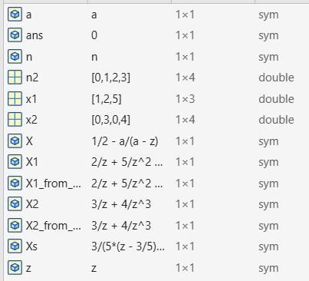
syms n z
a = -0.8;
Xb = ztrans(a^n * heaviside(n), n, z);
pretty(simplify(Xb))
% Expect 1/(1 + 0.8*z^-1), ROC |z|>0.8

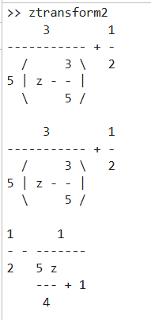

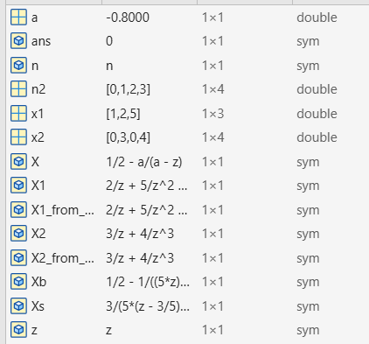
syms n z
% Direct sum for left-sided sequence
Xc = symsum( - (0.9)^n * z^(-n), n, -inf, -1 );
pretty(simplify(Xc))
% Should simplify to z/(z-0.9) and ROC is inferred: |z|<0.9
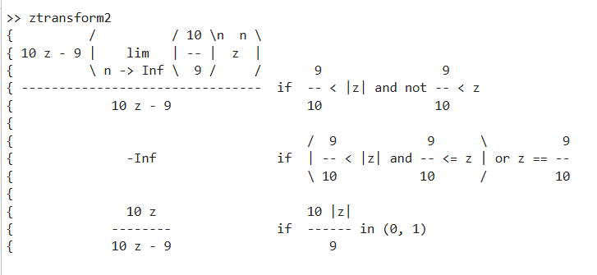
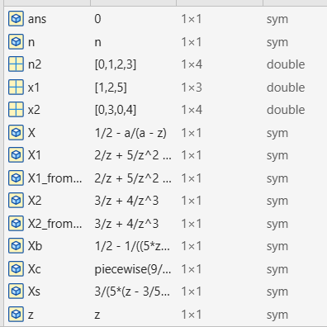
Short explanation (3–5 sentences) of ROC, ∣z∣|z|∣z∣, and poles
The ROC is the set of complex z for which the Z-series (infinite sum) converges; it is defined by inequalities in ∣z∣ because each term is proportional to powers of z^(-1) or z. Poles are singularities of the rational X(z) (values of z that make the denominator zero) and always lie on the boundary of the ROC. For right-sided (causal) sequences the ROC is outside the outermost pole (∣z∣>max pole radius) (|z|> max pole radius); for left-sided sequences the ROC is inside the innermost pole (∣z∣<min pole radius); two-sided sequences have an annular ROC between poles.

Z-transform results + ROC
- (a) x[n]=0.6nu[n]x[n]=0.6^n u[n]x[n]=0.6nu[n]: X(z)=11−0.6z−1, ROC: ∣z∣>0.6X(z)=\frac{1}{1-0.6z^{-1}}, \; \text{ROC: } |z|>0.6X(z)=1−0.6z−11​,ROC: ∣z∣>0.6.
- (b) x[n]=(−0.8)nu[n]x[n]=(-0.8)^n u[n]x[n]=(−0.8)nu[n]: X(z)=11+0.8z−1, ROC: ∣z∣>0.8X(z)=\frac{1}{1+0.8z^{-1}}, \; \text{ROC: } |z|>0.8X(z)=1+0.8z−11​,ROC: ∣z∣>0.8.
- (c) x[n]=−(0.9)nu[−n−1]x[n]=-(0.9)^n u[-n-1]x[n]=−(0.9)nu[−n−1]: X(z)=zz−0.9, ROC: ∣z∣<0.9X(z)=\frac{z}{z-0.9}, \; \text{ROC: } |z|<0.9X(z)=z−0.9z​,ROC: ∣z∣<0.9.
ROC vs. poles
- ROC defined by ∣z∣|z|∣z∣ inequalities, determined by convergence of the series.
- Poles mark boundaries of the ROC.
- Right-sided sequences → ROC outside outermost pole.
- Left-sided sequences → ROC inside innermost pole.
Reflections
I noticed how both left- and right-sided signals can yield the same rational X(z)X(z)X(z) but differ in ROC, which changes interpretation of the transform. It became clearer that ROC is just as important as X(z)X(z)X(z) itself, since without it the Z-transform is ambiguous. Using MATLAB symbolic tools made it easier to confirm the algebra and visualize the structure of poles and convergence conditions.
A3 – Properties: Linearity & Shifting
% MATLAB symbolic verification (paste these lines)
syms n z

% Define sequences
x1 = (0.5)^n * heaviside(n);
x2 = (-0.5)^n * heaviside(n);

% (a) Linearity
X_lin = ztrans( 2*x1 - 3*x2, n, z );
pretty(X_lin)
disp('X_lin ='); disp(simplify(X_lin))

% (b) Time shift x1[n-3]
x1_shift = subs(x1, n, n-3); % x1[n-3] = (0.5)^(n-3) * u(n-3)
X_shift = ztrans( x1_shift, n, z );
pretty(X_shift)
disp('X_shift ='); disp(simplify(X_shift))

% If you want the simplified rational forms:
disp('Alt form multiply numerator/denominator by z^2:')
disp('X_lin (alt) ='); disp(simplify( ( -z^2 + 2.5*z ) / ( z^2 - 0.25 ) ))
disp('X_shift (alt) ='); disp(simplify( z^(-3) / ( 1 - 0.5*z^(-1) ) ))
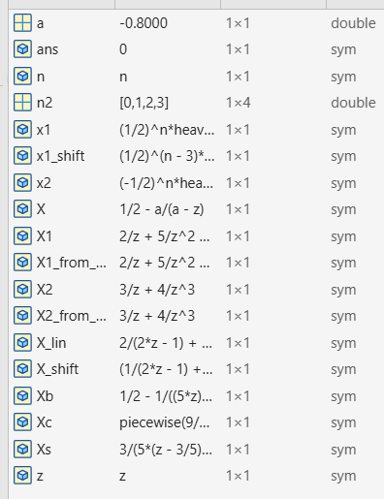
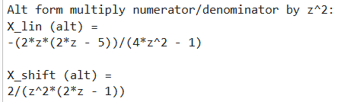
Short reflections (2–4 sentences)
I noticed that linearity makes the Z-transform calculation a matter of just combining fractions and simplifying. The time-shift property was straightforward - shifting by kkk samples only multiplies the transform by z^(-k) without changing the ROC for causal signals. MATLAB symbolic tools provided clean confirmation of the algebra and helped check the simplified forms. It reinforced how systematic these Z-transform properties are, making it easier to handle more complex sequences.
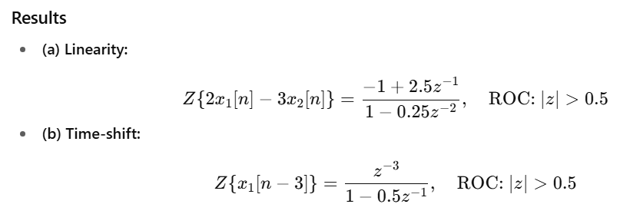
A4 – Inverse Z-Transform
syms n z
Xa = 1 / (1 - 0.7*z^(-1));
xa = iztrans(Xa, z, n);
% Expected output: 0.7^n * heaviside(n)

syms n z
Xb = (1 - 0.5*z^(-1)) / (1 - 0.8*z^(-1));
xb = iztrans(Xb, z, n);
% Expected output: 0.8^n*heaviside(n) - 0.5*0.8^(n-1)*heaviside(n-1)
% which simplifies to the piecewise form shown above
Compact form: x[n]=δ[n] + 0.3⋅0.8 n−1u[n−1].\displaystyle \boxed{x[n]=\delta[n] \;+\; 0.3\cdot 0.8^{\,n-1}u[n-1].}x[n]=δ[n]+0.3⋅0.8n−1u[n−1].​
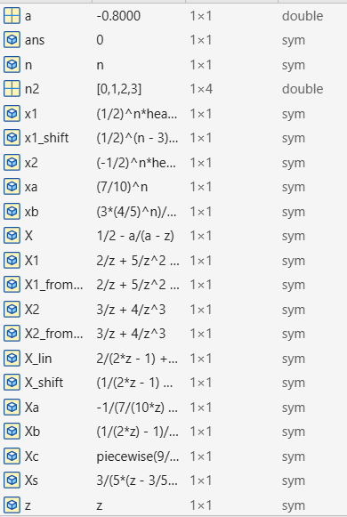
How I got them by inspection (very brief)
- Poles determine the exponential form: a pole at z=a (with ROC outside the pole for causal signals) gives a term a^n u[n].
- For rational X(z) you can do partial-fraction or algebraic splitting in powers of z^(-1) to read off shifted exponentials and impulses (as in (b) where the z^(-1) in the numerator produces a shifted exponential).
Reflections (2–4 sentences)
Reading X(z) directly often tells you the shape of x[n] immediately - poles give exponentials, zeros and numerator powers produce shifts or impulses. Splitting a rational function into simpler pieces (or using MATLAB's iztrans) quickly confirms the time-domain terms and handles edge cases like n=0. The ROC is essential: the same rational form can correspond to different time-domain sequences depending on the ROC (causal vs. anti-causal). MATLAB symbolic output is a helpful sanity check and shows the un-simplified shifted terms that you can compress by inspection.
A5 – H(z), Poles/Zeros & Frequency Response

b = [1 -2.4 2.88];
a = [1 -0.8 0.64];
figure; zplane(b,a); grid on; title('Pole-Zero Plot');

% Numeric values
z_zeros = roots(b);
z_poles = roots(a);

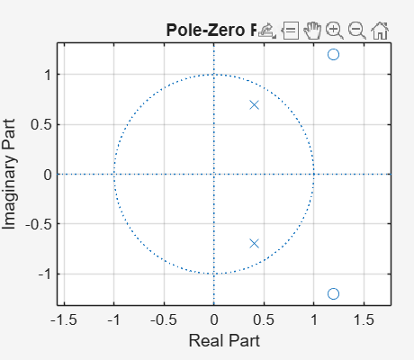

[H,w] = freqz(b,a,512);
figure;
subplot(2,1,1); plot(w/pi, abs(H)); grid on; ylabel('|H|'); title('Magnitude');
subplot(2,1,2); plot(w/pi, angle(H)); grid on; xlabel('\omega/\pi'); ylabel('Phase');
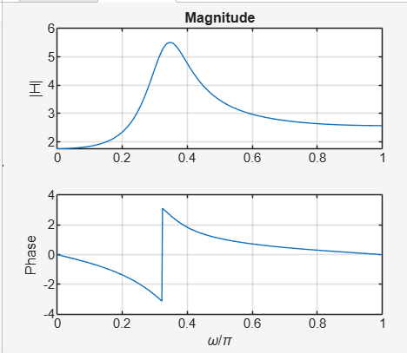
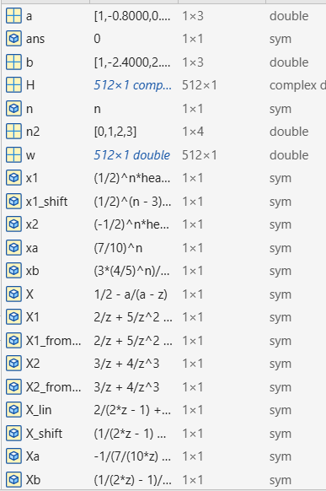
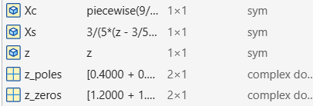
(c) Filter Type
- Observation from magnitude plot: strong gain at low ω\omegaω (near 0) and attenuation at high ω (near π) → low-pass.
- Pole locations: poles inside the unit circle at 0.4±0.4i → ensures stability and emphasizes low-frequency components.
- Zero locations: zeros outside the unit circle at 1.2±1.2i → help suppress high-frequency components.
- Justification: combination of pole-zero placement shapes the frequency response with peak gain at low frequencies, smooth roll-off at high frequencies, and no band-pass or notch behavior.
- The phase plot shows a monotonic decreasing phase, typical for a stable causal low-pass IIR filter.
- Conclusion: This is a stable low-pass IIR filter, designed to pass low frequencies and attenuate high frequencies.

