
Project Report – Bachelor's Degree Programme
Technology, Communication and Transport

YOLO-Based Classroom Analytics

- BANGZHU WEI
- TRANG DINH
- HAMMAD KHALID
- JAWAD NAZAR

AUTHOR/S:
SAVONIA UNIVERSITY OF APPLIED SCIENCES Report
Abstract
Field of Study
Technology, Communication and Transport
Degree Programme
Degree Programme in Incormation Technology, Internet of Things
Author(s)
- BANGZHU WEI
- TRANG DINH
- HAMMAD KHALID
- JAWAD NAZAR

Title of Thesis
YOLO-Based Classroom Analytics
Date | 3rd December 2025 | Pages/Appendices | 17
Client Organisation /Partners
Savonia University of Applied Sciences
Abstract

This project aims to develop a real-time classroom monitoring system that uses computer vision and YOLO-based deep learning to estimate student occupancy and engagement. The system is designed to support classroom analytics without storing or recognizing individual identities, ensuring full privacy.
A camera placed at the back of the classroom captures live video, which is processed using a YOLO object detection model to identify and count students. To approximate engagement, the system applies a simple spatial heuristic that evaluates the position of each detected student within the frame, allowing it to generate an aggregate engagement score. The system also logs time-stamped student counts and engagement metrics for later analysis and runs efficiently on edge hardware such as NVIDIA Jetson devices.
The resulting system is lightweight, real-time, and privacy-preserving. It successfully demonstrates how modern AI vision techniques can support classroom analytics by providing insights into attendance patterns and general student attentiveness without intrusive sensors or facial recognition.

We have 4 members in this project and our contribution is below:
- BANGZHU WEI: test Sanberg camera, download YOLOv11, set up and create python file.
- TRANG DINH: test Sanberg camera, download YOLOv11, set up and create python file.
- HAMMAD KHALID: hardware, make report, slides
- JAWAD NAZAR: hardware, create virtual environment and dependencies.

Keywords
YOLO Object Detection, Computer Vision, Real-Time Monitoring, Student Engagement, Classroom Analytics, Occupancy Detection, Privacy-Preserving AI, Deep Learning, Edge Computing, NVIDIA Jetson, Video Processing, Spatial Heuristics, Attendance Monitoring, Non-Intrusive System, AI-Based Classroom Analysis

CONTENTS
1 introduction
Contents
1 introduction 5
2 OVERVIEW OF COMPONENTS 6
3 TECHNICAL DETAILS 6
3.1 Key features 6
3.2 Project development 6
3.3 Novelty 14
4 applications 15
5 future direction 15
6 conclusion 16
references 17

introduction
Classrooms often need a simple way to monitor how many students are present and how attentive they are during a lesson. Traditional methods rely on manual checking, which can be slow, inaccurate, and distracting. With the growth of artificial intelligence and computer vision, it is now possible to automate these tasks using a regular camera and a lightweight detection model.
This project introduces a real-time classroom monitoring system that uses the YOLO object detection algorithm to identify and count students from a live video feed. A camera placed at the back of the classroom captures the scene, and the system detects students without storing faces or personal information. To estimate engagement, the system uses a basic rule that looks at where students appear in the video frame, giving an idea of how focused the class might be.
The system runs efficiently on an NVIDIA Jetson device and records time-stamped data for later review. Overall, this project shows how computer vision can help monitor classroom activity in a simple, non-intrusive, and privacy-friendly way.

OVERVIEW OF COMPONENTS
- NVIDIA Orin Jetson Nano develop kits with SD card as main storage
- A monitor, keyboard, mouse connected to Jetson
- Sandberg camera plugged in via USB
- Internet connection on Jetson (Ethernet or Wi-Fi)
- Another PC/laptop if needed to flash the SSD (depends on your Jetson model)

TECHNICAL DETAILS

Key features
- Real-Time Student Counting:
The system uses the YOLO object detection model to identify and count students instantly from a live camera feed.
- Engagement Estimation
A simple spatial heuristic analyzes each student’s position in the frame to estimate overall classroom engagement, without requiring facial recognition.
- Continuous Data Logging:
Time-stamped student counts and engagement levels are automatically saved for later review, allowing analysis of attendance patterns.
- Edge Device Compatibility:
The system runs efficiently on lightweight hardware such as NVIDIA Jetson devices, enabling real-time processing without cloud dependence
- Easy Deployment with a Single Camera:
A single camera placed at the back of the classroom provides all necessary visual information, making setup simple and low-cost.

Project development
- Flash OS (JetPack / Ubuntu) to SSD
- On a separate PC (Ubuntu recommended), install NVIDIA SDK Manager.
- In SDK Manager:
- Select your Jetson board model.
- Select the latest JetPack version (this is Ubuntu + CUDA + drivers).
- Flash to your target storage (eMMC, SD card, or SSD/NVMe depending on your board).
- When flashing finishes, connect Jetson to monitor, boot it up, and complete the initial Ubuntu setup (user, password, network).

- Basic system setup and updates
On the Jetson (open Terminal):
sudo apt update
sudo apt upgrade -y
- Connect and test Sandberg camera
Plug the camera into a USB port. Then:
lsusb #See the device on USB
ls /dev/video* # List video devices (It will shows /dev/video0 or similar)
- Install GStreamer helpers (for Jetson + camera)
sudo apt update
sudo apt install -y v4l-utils gstreamer1.0-tools \
gstreamer1.0-plugins-base gstreamer1.0-plugins-good \
gstreamer1.0-plugins-bad gstreamer1.0-plugins-ugly
- See its supported modes:
v4l2-ctl --list-formats-ext -d /dev/video0
- Quick GStreamer test similar to what you already used:
gst-launch-1.0 v4l2src device=/dev/video0 ! \
"image/jpeg,framerate=30/1" ! jpegdec ! \
nvvidconv ! "video/x-raw(memory:NVMM),format=NV12" ! \
nveglglessink
- Install Python virtual environment support
- Install venv
sudo apt install -y python3-pip python3.10-venv python3-pip-whl python3-setuptools-whl

- Create venv and activate it:
python3 -m venv ~/yolo_env
source ~/yolo_env/bin/activate

- Your prompt should show something like:
(yolo_env) iot2@iot2-desktop:~/Documents$
- Install Python dependencies in the venv
Inside (yolo_env):
- Upgrade pip:
pip install --upgrade pip setuptools wheel
- Install NumPy and OpenCV:
pip install "numpy<2.0" opencv-python
- Install PyTorch from the Jetson wheel you used before:
pip install https://github.com/sudoRicheek/jetson-wheels/releases/download/jp6-cu126/torch-2.8.0-cp310-cp310-linux_aarch64.whl
- Install Ultralytics YOLO:
pip install ultralytics
- Verify everything:
python - << 'EOF'
import torch, numpy as np
print("Torch:", torch.__version__)
print("CUDA available:", torch.cuda.is_available())
print("NumPy:", np.__version__)
EOF
- If that prints versions with no error, your environment is healthy
- Download YOLO model weights
In the same (yolo_env) and in ~/Documents folder:
yolo download model=yolo11n.pt
- Create project script
Create a python file in Vscode:
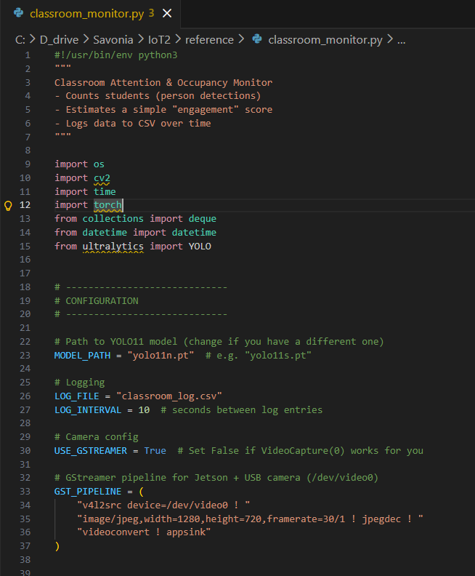
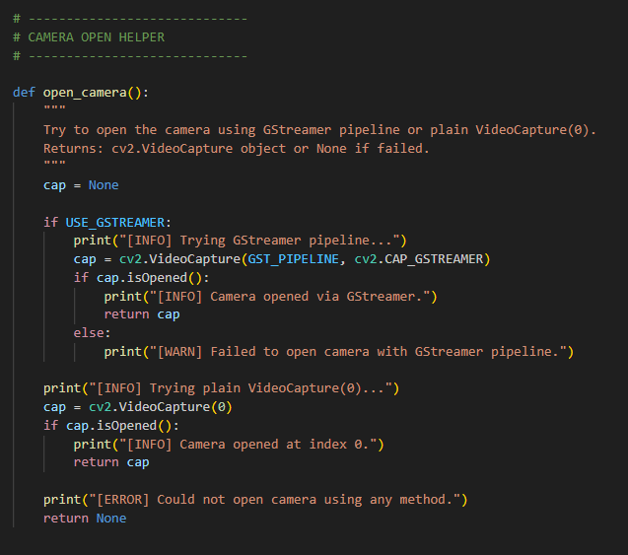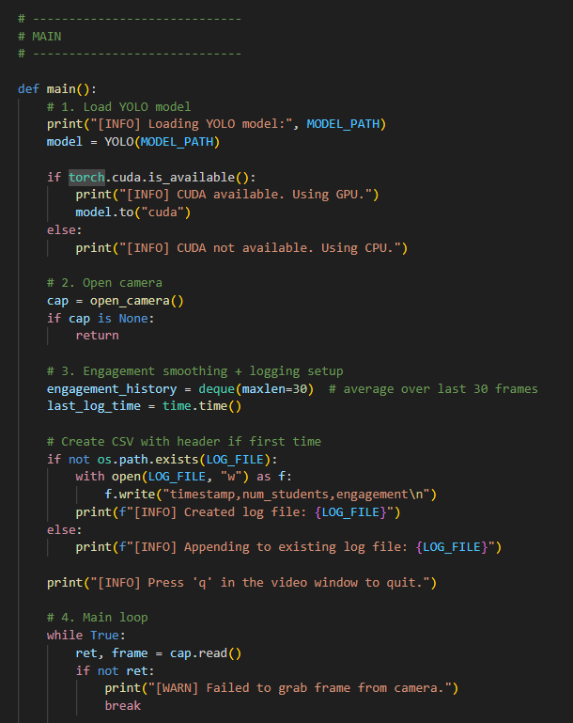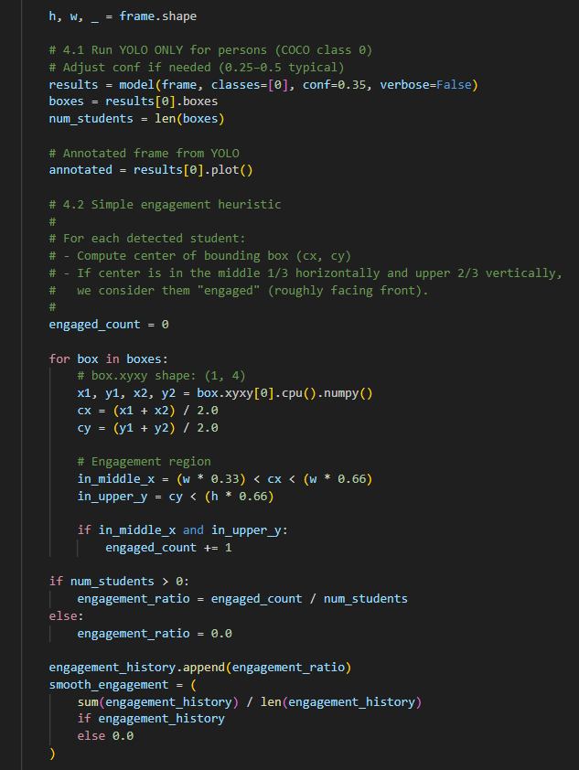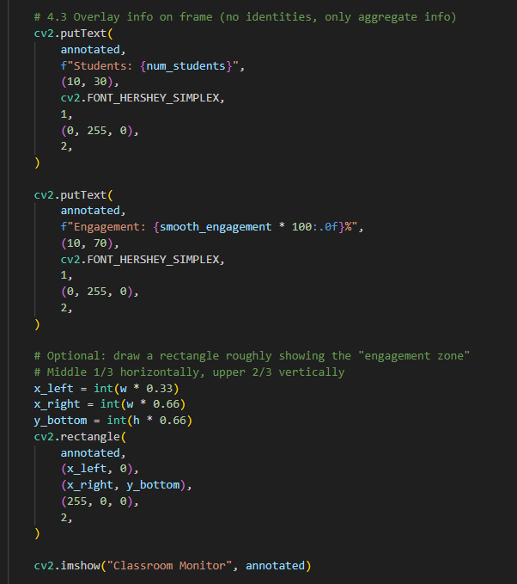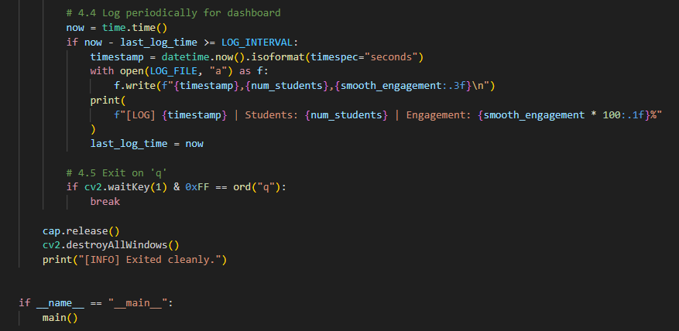
- Next runs
cd ~/Documents
source ~/yolo_env/bin/activate
python classroom_monitor.py
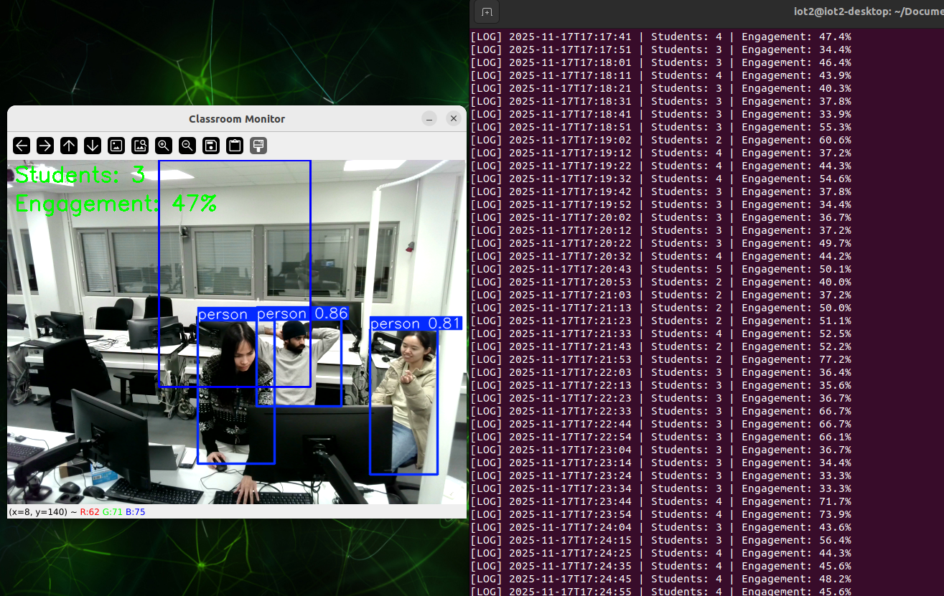

Novelty
Edge device operation: Your system runs locally (e.g., on a NVIDIA Jetson) and does not depend on cloud computing or constant internet connection.
Single-camera, low cost: Rather than many sensors or complex hardware, it uses a single camera placed in the back of the classroom and a lightweight model like YOLO.
Engagement heuristic: In addition to just counting how many students are present, it provides a simple “engagement score” based on spatial zones (middle/front)
Time-series logging for analytics: It logs occupancy and engagement data over time, which supports trend analysis (attendance patterns, engagement drop-off) rather than only live monitoring.

applications
- Classroom Attendance Monitoring
The system automatically detects and counts students in real time.
This reduces manual roll calls and gives teachers a quick overview of who is present.
- Engagement Analysis During Lessons
The system provides an estimated engagement score based on student positions.
Teachers can see:
- When engagement drops
- Which parts of a lesson keep students more attentive
This can help improve teaching methods.
- Lecture Quality Evaluation
By examining logged engagement over time, teachers or administrators can evaluate:
- Which teaching sessions keep students attentive
- Which sessions might need improvement
It acts as an indirect feedback tool.
- Non-Intrusive Monitoring for Large Classrooms
In very large rooms where manual observation is difficult, this system offers:
- Automatic student counting
- General attentiveness estimation
Without disturbing the class.

future direction
Future enhancements for the YOLO-Based Classroom Analytics include:
- Add Head Pose Estimation for More Accurate Engagement: Instead of using only spatial zones, the system can use a lightweight head-pose or keypoint model to determine whether students are looking toward the front of the classroom. This would improve the accuracy of the engagement score.
- Integrate YOLO Pose Model for Body and Hand Keypoints: Using YOLO-Pose or another pose-estimation model would allow detecting hand raising and more detailed activity analysis. This gives a more complete picture of student behavior.
- Develop a Web-Based Dashboard: A simple dashboard could visualize: real-time student count, engagement %, historical graphs, daily/weekly attendance trends. This makes the system more useful for teachers and school administrators.
- Add Seat-Map Detection: By defining desk regions, the system can detect: which seats are occupied, which seats are consistently empty. Useful for attendance and classroom planning.
- Detect Additional Behaviors: With additional training or models, the system could detect: mobile phone usage, sleeping (head down), group activities, movement or restlessness. This enhances its ability to monitor class dynamics.
- Multi-Camera Support for Large Rooms: Future versions could combine multiple camera feeds to cover: larger classrooms, lecture halls, multiple angles. This improves detection in crowded spaces.

conclusion
This project shows that computer vision and YOLO can be used to create a simple system that monitors a classroom in real time. By using a normal camera, the system can detect and count students and give a basic idea of how engaged they are, without storing faces or personal information. This makes the system safe to use and respectful of privacy.
The system runs smoothly on a Jetson device and can record data for later review. Even though the engagement method is basic, it works well and provides a good starting point for future improvements, such as head-direction detection or better behavior analysis. Overall, this project proves that AI can help make classroom monitoring easier, cheaper, and less intrusive.

references
NVIDIA Jetson AI Lab. (2024). Initial setup guide for Jetson Orin Nano developer kit. Retrieved from https://www.jetson-ai-lab.com/initial_setup_jon.html
OpenAI. (2025). ChatGPT – AI Language Model. Information retrieved from ChatGPT on 24 November 2025

