HW 1 Philippe Proctor

A. Information Gathering

- Bugs:
- Not possible to enable signal driven I/O by specifying O_ASYNC when calling open().
- Must check two different error codes EISDIR and ENOENT when determining whether the kernel supports O_TMPFILE functionality.
- When both O_CREAT and O_DIRECTORY are specified in flags and the file specified by pathname does not exist, open() will create a regular file.

- Required files:
- sys/types.h
- sys/stat.h
- fcntl.h

- Related system calls:
- chmod(2)
- chown(2)
- close(2)
- Close()
- No bugs listed.
- Required files: unistd.h

- Searched against kernel 5.0.7

- “usb_device” struct is defined in the linux/usb.h file on line 633.
  - LXR hits on this line in usb.h “struct usb_device {...}”
- The first five members of the structure are int devnum, char devpath[16], u32 route, enum usb_device_state state, and enum usb_device_speed speed.
- The type is declared for the 5th member of the struct in the linux/usb/ch9.h file.

enum usb_device_speed {
USB_SPEED_UNKNOWN = 0, /* enumerating */
USB_SPEED_LOW, USB_SPEED_FULL, /* usb 1.1 */
USB_SPEED_HIGH, /* usb 2.0 */
USB_SPEED_WIRELESS, /* wireless (usb 2.5) */
USB_SPEED_SUPER, /* usb 3.0 */
USB_SPEED_SUPER_PLUS, /* usb 3.1 */
};

3. Source code for temp_conversion.
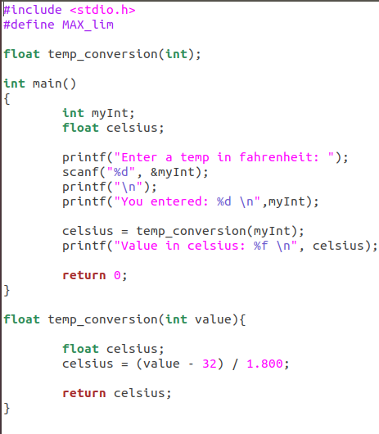

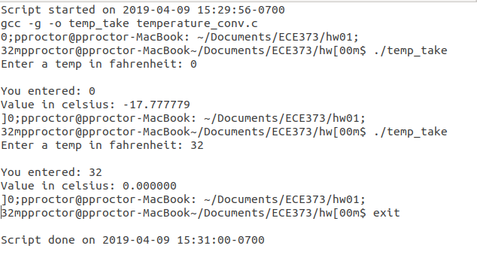
4. Execution of temp. conversion program.

5. Hello.c module code for section D.
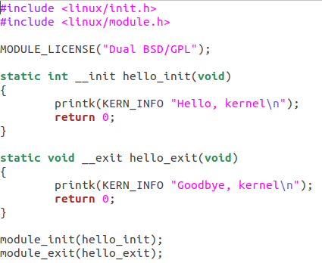

6. Log file printout for section D.
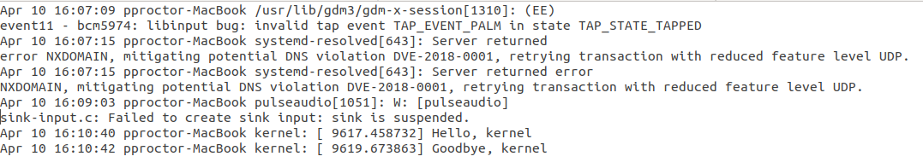

7. Shell Practice Session
