|  |
| --- |
| Fontys Hogescholen |
| Project Plan |
| Software solution for Media Bazaar |

|  |
| --- |
| Group 1, Galieans  Eindhoven |

Document Change Record

|  |  |  |  |
| --- | --- | --- | --- |
| *Date* | *Version* | *Author* | *Comments* |
| [13-05-2020] | 1.0 | Alexandra | Created a new project plan |
|  |  |  |  |

Table of Contents

Definitions, Acronyms and Abbreviations 3

1 Introduction 5

1.1 Document Purpose 5

1.2 Document Overview 5

2 Client and team 6

3 Problem Description 7

3.1 What is the problem that our client has? 7

3.2 What problems we can solve with our solution? 7

4 Project Goal 8

5 Deliverables 8

6 Non-Deliverables 9

7 Constraints 9

8 Phasing 9

# Introduction

## Document Purpose

The purpose of this document is to clarify what we are going to do and how it will look/work. The project plan is intended to define the scope of the project and to plan ahead.

## Document Overview

* Section 2 provides information about the client and the team.
* Section 3 is assessing the current factors that influence our project.
* Section 4 describes the client’s problems and or solution for them.
* Section 5 describes what we want to achieve with this project.
* Section 6 enumerates our deliverables, while section 7 shows what we are not going to deliver.
* Section 8 show the limitations of our project.
* Section 9 shows our process work.

# Client and team

1. CLIENT INFORMATION

Tutor:

* [Bahreini, Kiavash K.](https://fhict.instructure.com/courses/9429/users/18999) (kiavash.bahreini@fontys.nl)

Client:

* “Jupiter” Store company
* [Sivaramakrishnan, Karthika K.](https://fhict.instructure.com/courses/9429/users/15612) (k.sivaramakrishnan@fontys.nl)

1. TEAM INFORMATION

Team members:

* [Ioan, Alexandra A.D. (429690@student.fontys.nl)](mailto:Ioan,%20Alexandra%20A.D.%20(429690@student.fontys.nl))
* [Mihaylov, Konstantin K.D](https://fhict.instructure.com/groups/76530/users/17316). ([431166@student.fontys.nl](mailto:431166@student.fontys.nl))
* [Mihaylov, Petar P.D. (429937@student.fontys.nl)](https://fhict.instructure.com/groups/76530/users/17073)
* [~~Westerweele, Kevin K.L. (391065@student.fontys.nl)~~](https://fhict.instructure.com/groups/76530/users/12381) (as of 21/04/2020)

Roles:

* Designer/ Developer: Alexandra
* Open source Vim Developer: Konstantin
* Open source International interaction Pascal Master/ Developer/Team Leader: Peter
* ~~Team Leader/ Developer: Kevin~~

Repository: [git.fhict.nl/I431166/s-cb-s2-cmk](https://git.fhict.nl/I431166/s-cb-s2-cmk)



# Problem Description

## What is the problem that our client has?

“Media Bazaar” is opening their first shop in Eindhoven. The problem is keeping track of their employees and products. Furthermore, they need a way to assign work shifts to employees and view these work shifts per person but also for the entire store. They also need things such as the addition of departments, in store attendance registration and a dedicated website for employees to view their schedule.

## What problems we can solve with our solution?

We are proposing to build a Management System and a website that keeps track of everything our user requires.

With the Management application we are hoping to solve these problems:

* A way to keep track of employees and their shifts
* A way to update a employee’s details
* A way to assign shifts for a user and have a roll call attendance for the shifts
* A way to keep track of stocks, to create new stocks and reload finished stocks
* A way to keep track of the departments (per user and stocks)
* A way to receive the employees’ cancellations of shifts and to let the user decide if they want to mark them as absent or excused.

With the employees’ website we are hoping to solve these problems:

* A way for the employee to view their schedule shifts
* A way for the employee to cancel a shift
* A way for the employee to view their earnings

# Project Goal

Our project is divided into two parts, which are desktop and web applications so that we can stick to the separation of the concerned concept. The Desktop aims to help the administrators with managing the employee’s accounts and shifts, and the managers with the statistics of the store and employees and the stocks.

The Web application should help employees to see their working schedule, personal information and will help employees to easily view and cancel their shifts. It will present wages per hour, addresses, names, emails of each employee.

# Deliverables

We are going to deliver the following things:

* A desktop application with the following functionalities
  + Manage all employee (add, edit, update, delete, search function)
  + Manage the stock (view, add, delete, reload)
  + Manage the information of an employee (attendance, the wage, working hours, total earnings, personal information, profile picture)
  + Graph, chart of the statistics of the employees and the department
  + Manage the cancellations forms from the employees (see, delete, mark as absent or excused)
  + Manage departments (add, delete, view employees and shifts per department)
  + Convert the user data in CSV/JSON files
* A web application with the following functionalities:
  + View a user’s shift
  + Cancel a shift
  + View earnings and personal details
* A database
* A new logo for Media Bazar

# Non-Deliverables

* online calendar
* excel sheets

# Constraints

Due to the deadlines, in the first weeks we focused more on the employees’ management rather than the management of the store, which is why they have less functionalities. The statistics were also quite simple for the first phase, and they will be developed for the second phase.

We are limited to use the following languages: C# for the desktop application, HTML, CSS, JS AND PHP for the web application.

# Phasing

Phase 1: Analyze

Activities 1:

* + Activity 1.1: Analyze the Project Reader;
  + Description:
  + Estimated time: 30 minutes;
  + Activity 1.2: Brainstorming the problem;
  + Description: interpret and discuss the reader;
  + Estimated time: 2 hours;
  + Activity 1.3: Project plan;
  + Description: document our findings;
  + Estimated time: 1 day;

Milestone 1: the phases and activities;

Deliverable 1: Project plan;

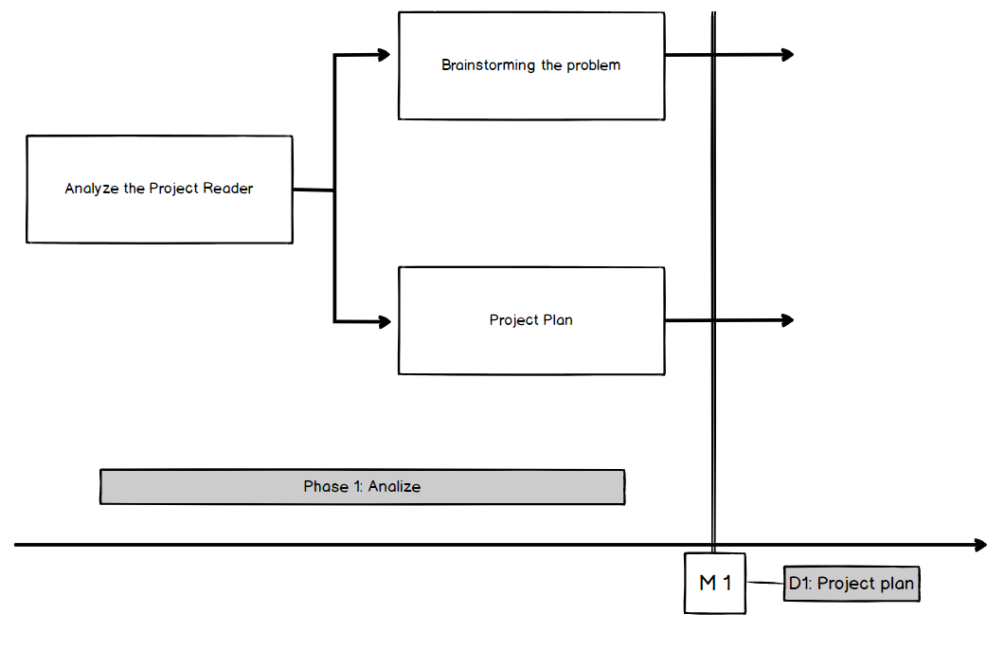

Phase 2: Designing

Activities 2:

* + Activity 2.1: Writing the User requirement structures
  + Description:
  + Estimated time: 4 hours;
  + Activity 2.2: Creating relationships;
  + Description: tables and content;
  + Estimated time: 1 day;
  + Activity 2.3: Prototyping ;
  + Description: Modeling the idea;
  + Estimated time: 4 hours;

Milestone 2: unsettled user requirements;

Deliverable 2: relational tables;

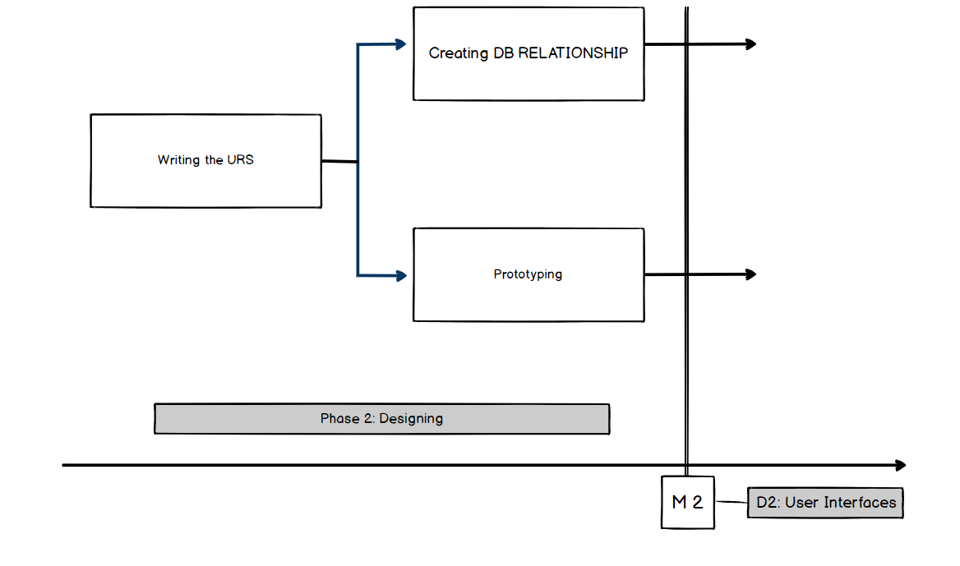

Phase 3: Implementation

Activities 3:

* + Activity 3.1: Split the work;
  + Description: workflow process;
  + Estimated time: 30 minutes;
  + Activity 3.2: Coding Desktop version;
  + Description: Creating the classes, connection, serialization (JSON) with DB;
  + Estimated time: 5 days;
  + Activity 3.3: Web Application;
  + Description: Creating the main pages and roles;
  + Estimated time: 5 days;

* + Activity 3.4: Database Selection;
  + Description: Connection with relational DB;
  + Estimated time: 2 days;

Milestone 3: used technologies and specifications;

Deliverable 3: beta app version / working version;

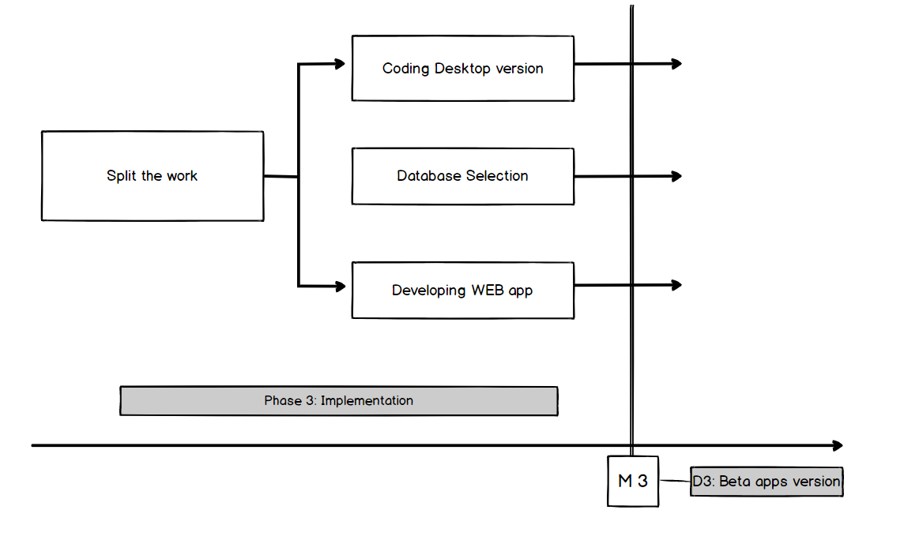

Phase 4: Testing

Activities 4:

* + Activity 4.1: Creating Unit Tests;
  + Description: Test Desktop and Web functionalities;
  + Estimated time: 4 days;
  + Activity 4.2: Monkey testing;
  + Description: Test the UX functionalities;
  + Estimated time: 1 day;
  + Activity 4.3: Fixing bugs;
  + Description: Improve the implementation;
  + Estimated time: 1 day;

Milestone 4: indecent version;

Deliverable 4: fixed version/ appropriate

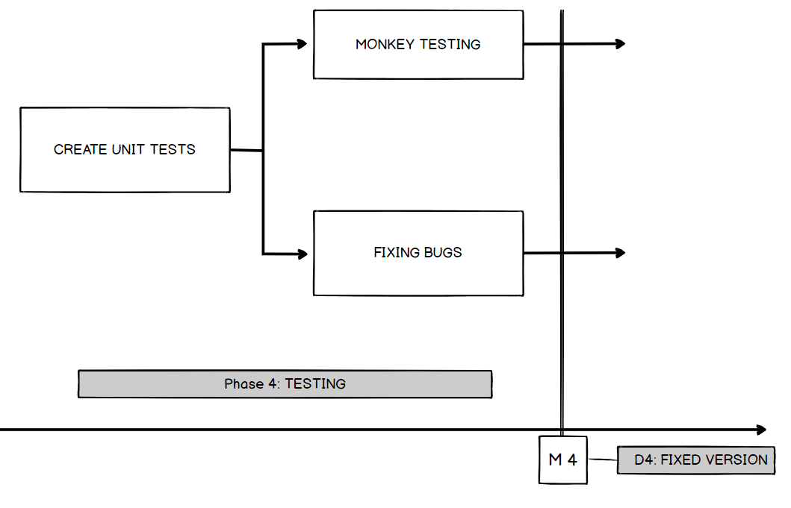

Phase 5: Deployment

Activities 5:

* + Activity 5.1: Deployment of the Web app version;
  + Description: Microsoft Azure services;
  + Estimated time: 1 hour;
  + Activity 5.2: Create an executable file for the Desktop app version;
  + Description: Wizard deployment;
  + Estimated time: 2 hours ~ more;

Milestone 5: incomplete deployment;

Deliverable 5: final version of our applications;

