1. Solute Movement

Advection-dispersion equation
For describing the solute movement, the soil matrix water is divided into two parts, a mobile and an immobile part:

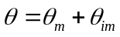 (1)

where 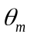 and 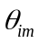 are the mobile and immobile water content, respectively. The immobile part of is always filled first. Reversely is the mobile part emptied first. Thus, the immobile part of can be expressed as:

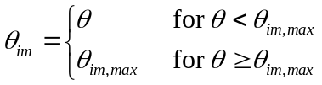 (2)

where the mobile part of can then expressed as:

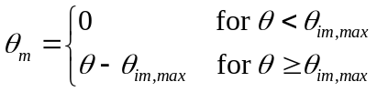 (3)

The solute concentration is similarly divided into a part associated with the immobile water, 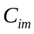 and a part associated with the mobile water, 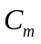. Dividing the matrix water content into a mobile and an immobile volume is somewhat inconsistent when 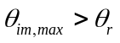 where 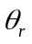 is the residual water content. When comparing to Richards’ equation all water above is subject to movement. From Richards’ equation the Darcy velocity can be calculated as 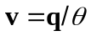. The flux, as used for calculating the movement of solute in the mobile volume is calculated as:

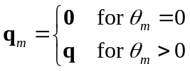 (4)

where the associated flow velocity is given as:

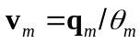 (5)

Three physical processes can contribute to movement of solutes in the matrix part (non macroporous part) of soil:

- advection
- molecular diffusion
- hydrodynamic dispersion (only in connection with advection)

Advection (or bulk flow) is the process where the dissolved chemical moves with the soil solution. The flux of solute can be described as:

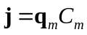 (6)

The Molecular diffusion is a result of the Brownian motion (random walk) of the molecules. A process related to the movement of the water is the hydrodynamic dispersion, which is a consequence of the fact that flow is not uniform, because the flow paths move around obstacles and air, but also because of variation in pore size and the non-uniform velocity distribution inside the pores. Mathematically the hydrodynamical dispersion process can be described as a diffusion process. The movement by diffusion like processes can be expressed as:

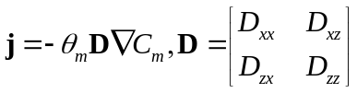 (7)

where 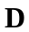 is the dispersion tensor (or matrix). The consequence is that the solute tries to move from areas with high concentration to areas with lower concentration. The elements in are often calculated as:

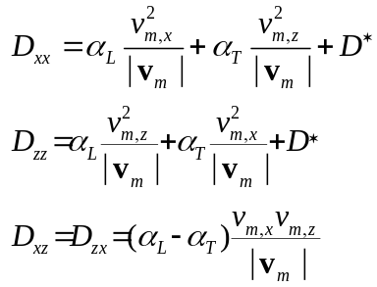 (8)

where 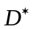 is the molecular diffusion. The rest of the terms are arising from the hydrodynamic dispersion. 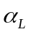 is called the longitudinal dispersion and 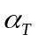 the transversal dispersion. The molecular diffusion can be calculated as:

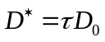 (9)

where 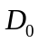 is the diffusion coefficient for the solute in free water and is the tortuosity factor. As an example Millington and Quirk (1961) suggested:

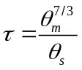 (10)

If we are using equation (10) and expressing the mean velocity in the pores associated with solute movement by 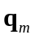 and , the elements of 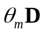 can be expressed as:
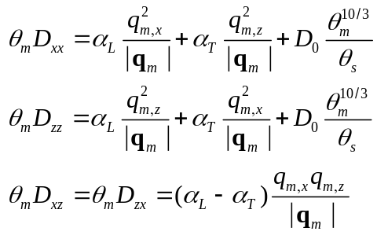 (11)

The solute movement can be expressed as a sum of the advection and the diffusion process:

(12)

The mass balance for the solute can be expressed as:

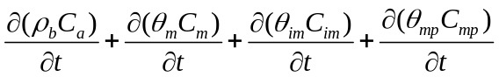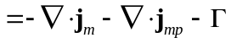 (13)

where 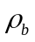 is the soil bulk density and 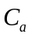 is the concentration in the adsorbed phase. 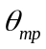 is the volumetric water content in the macropore domain and 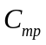 is the concentration. is the sink term of the solute.

For simplification of the solute movement model, the matrix water flow and the solute movement is inside each time step considered as decoupled from the immobile water, the adsorped phase and the macropore domain. Thus, every exchange with the environment is based on the state at start of the time step. The mass balance of dissolved solutes in the mobile matrix water yields:

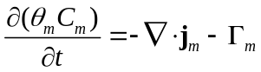 (14)

where 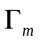 is the sink term which remove solutes from the mobile matrix water. The removed (or added) solute can be absorbed, moved to the immobile water or the macropore domain or be subject to chemical or biological reduction.

The boundary condition to the equation specifies a combination of and its derivative on the boundary. Also here, the Dirichlet boundary condition (specified concentration) and the Neumann boundary condition, where the flux through the boundary is specified, are common. The Dirichlet boundary condition is:

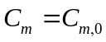 (15)

where 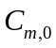 is the predescribed concentration. The Neumann boundary condition is:

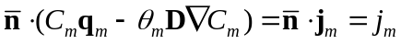 (16)

where 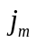 is the size of the flux, positive for outward flux. As boundary condition for the ingoing flow 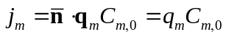 is often used where is the concentration of the flow. As a lower boundary condition is 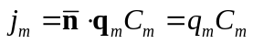 often used. In both cases it is assumed that the diffusion crossing the border is zero.

Summarized, the problem to be solved for determination of the concentration of solute in  is:

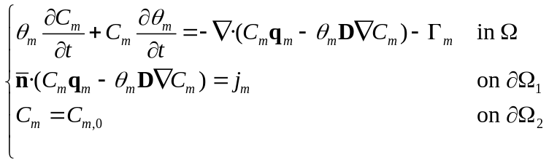 (17)

where 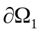 is the part of the boundary with Neumann condition, and 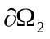 is the part of the boundary with Dirichlet boundary conditions. Also here it is not necessary that and , respectively, are coherent.

Numerical solution
The basic principles behind the finite volume modeling of the solute transport are very similar to the numerical solution of the water movement equation (Richards’ equation). But there are some differences. One of the major differences is that the advection diffusion equation is considered as linear inside each timestep. I.e. the coefficients in the equation in each of the timesteps are independent of the concentrations in the current timestep. This simplification can be done when the size of the sources are dependent only on the concentrations in the previous timstep. Similar are adsorption added as sink/source term. Thus different from the water movement simulation, the Picard iterations loop used inside each timestep can be avoided.

Stabilization methods
There are often a lot of numerical problems involved with the solving of the convection diffusion problem especially when the problems are dominated by convection. The numerical solutions have often unexpected oscillations in that situation. There have been developed a lot of more or less complicated methods to reduce the problems. Three of the methods are upstream weighting, streamline diffusion, and timestep reduction.

Upstream weighting
When steep concentration fronts occur, numerical oscillations can raise. A method to stabilize the system is to apply upstream weighting for the advective solute movement. For advective transport between two cells is the concentration at the face between the cells normally calculated as the average concentration of the two cells. For fully upstream weighting is the concentration at the cell face equal to the upstream concentration.

In Daisy2D it is possible to set a parameter, 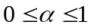 where 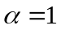 corresponds to a fully upstream weighting and 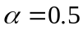 corresponds to setting the cell face concentration to the average concentration of the two cells. It is not recommended to apply an 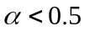.

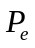 and 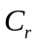 numbers
There are two different numbers which are important for the stability. The Peclet number:

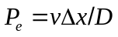 (18)

where is the velocity,  is the space increment and  is the diffusion coefficient (including molecular diffusion and hydrodynamic dispersion). The Courant number is defined as:

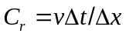 (19)

Theoretical stability investigations are rather complicated, especially in a two or three-dimensional space with heterogeneous soil. Most of the theoretical stability considerations are done for one-dimensional flow with uniform velocity. The classical constraints for stability for the standard Crank-Nicholson-Galerkin (Finite Element Method) is 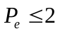 and 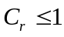, Perrochet and Bérod (1993).

It can easily be concluded that keeping the Courant number lower than one is just a question of sufficiently small timesteps. But is it possible to make a mesh which under all circumstances prevents that the Peclet number raises over 2?. The peclet number for the flow in the x-direction is:

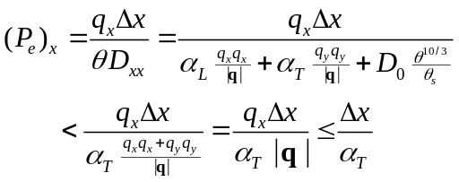 (20)

where it is assumed that 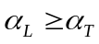. The same procedure can of course be used to evaluate 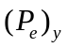. It can then be concluded that the maximum Peclet number is lower than 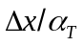. If the longitudinal dispersivity is 5 cm and the transversal is 1/10 of the longitudinal and the maximum allowed is 2 can it be concluded that the maximum side length of the elements shall be approximately 1 cm. This will result in a very fine mesh.

Besides the upstream weighting method it is possible to choose between 2 stabilizing methods:

- Introducing extra diffusion in the streamline direction so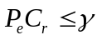. Where is the performance index.
- Varying the size of  so.

It is of course also possible to deselect any stabilizing methods. The last stabilizing method is straight forward, but the first deserves its own subsection:

Streamline diffusion
For practical situation are there often stability so long where 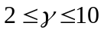 (Perrochet and Bérod, 1993) which under all circumstances is less restrictive than keeping both and . is called the performance index.

In the streamline diffusion is according to Perrochet and Bérod (1993) added some additional longitudinal dispersion to prevent that 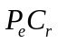 raises over the chosen performance index. The additional longitudinal dispersion, 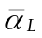 is calculated as:
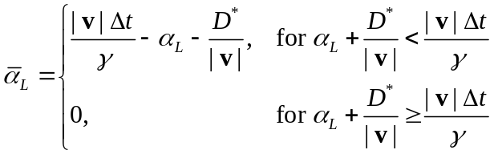 (21)

Stability tests
To investigate the stability of the numerical model is a simple system modeled. The situation here is a one-dimensional column, horizontal column with steady-state water flow with pore velocity and a given diffusion, (both molecular diffusion and hydrodynamic dispersion). For the present test is the solute non-adsorping. For a scenario with linear adsorping (constant retardation factor) the adsorption have a stabilizing effect, thus for linear adsorping solutes the model is expected to be more stable. The advection-dispersion equation in one dimension can be written as:

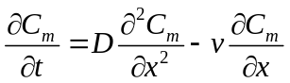 (22)

where 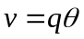. The initial condition is a zero concentration in the whole column:

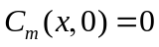 (23)

At the left boundary is the solute flux constant.

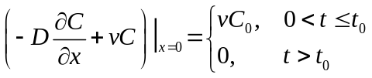 (24)

The solution can then according to van Genuchten and Alves (1982) be written as:

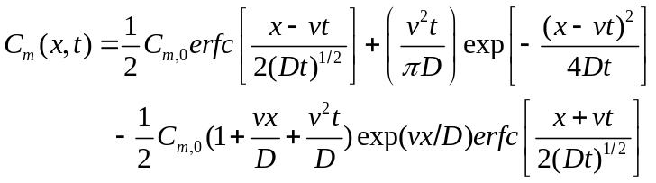 (25)

For the simulations is made a water flow situation with steady state flow with the chosen pore water velocity 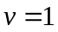 cm/hour. is for the simplicity chosen to 1 and 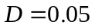 cm/hour. For the Daisy simulations is the virtual soil column 10 cm wide and 1 cm high. On the domain is generated a regular mesh with 100 equally large elements, each with 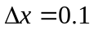 cm. With chosen to 1 hour are 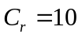 and 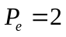, i.e. 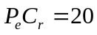. The numerical parameter, is set to 1/2, i.e. a Crank-Nicholson scheme.

In Figure 1 is the analytical solution compared with numerical solutions with and without upstream weighting corresponding to and , respectively. Streamline diffusion and timestep reduction has not been applied. As it can be observed, are the wiggles significantly smaller when applying upstream weighting. The only drawback seems to be slightly more numerical diffusion compared with the numerical solution for .
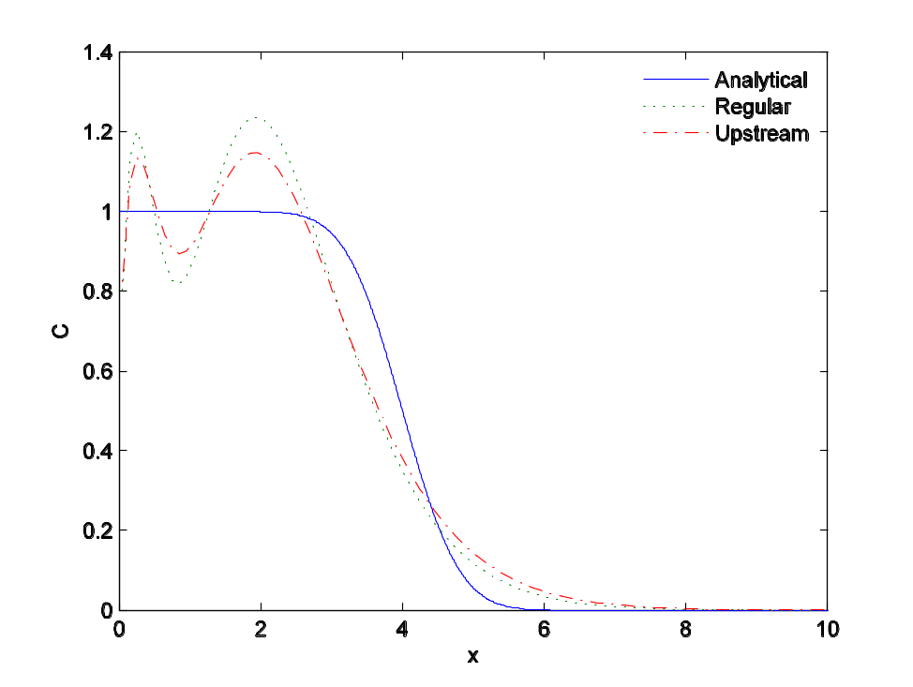
Figure 1. Analytical solution compared with numerical solution with regular weighting () and upstream weighting (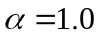). The solutions are shown as concentration as function of x after simulation of 4 hours. For the actual case are cm/hour, cm/hour. For the numerical simulations are 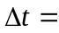 1 hour and cm, i.e. and .

In the following cases upstream weighting has not been applied ().
In Figure 2 is the analytical solution shown. Besides is the numerical solution shown for the cases: no stabilization, timestep reduction and streamline diffusion. For both the timestep reduction and streamline diffusion method is the performance index, 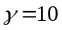 chosen. For the simulation without any stabilization are the wiggles significant. The wiggles are smaller for the simulation with streamline diffusion. By comparing with the analytical solution the additional diffusion can be observed. The additional diffusions effectively reduced the -number from 20 to 10. The remaining graph shows the simulation with the timestep reduction stabilizing method where the size of is changed so 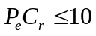. Here the size of the timestep is reduced from 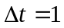 hour (no stabilization) to 0.5 hour. Effectively the -number is reduced from 10 to 5, i.e. for the computation is used 2 times so many timesteps (or approximately 2 times so long CPU-time). Compared with the numerical solution without stabilization are wiggles reduced, but have also smaller wavelength.
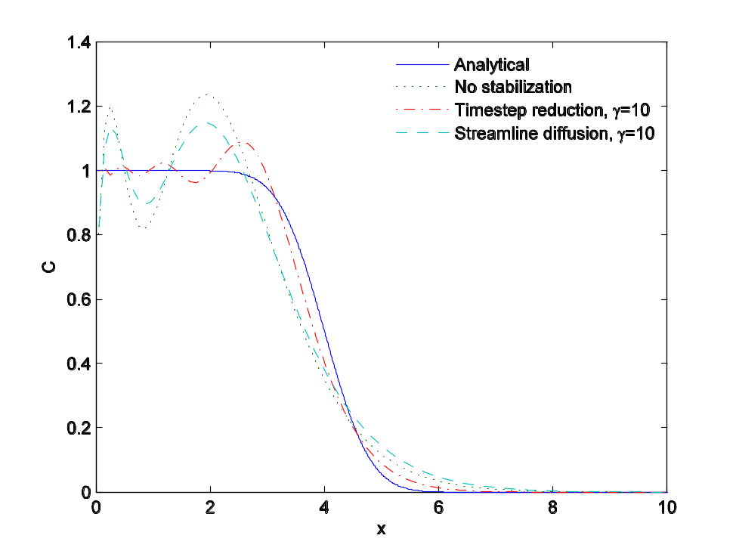
Figure 2. Analytical solution compared with different numerical solutions. The solutions are shown as concentration as function of x after simulation of 4 hours. For the numerical solution without stabilization are and .

In Figure 3 is the analytical and numerical solutions shown. The numerical solutions are computed using different performances indexes. The performance index, is changed applying timestep reduction. It can be observed that the wiggles are significant for , but for 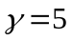 (and lower) the size of the wiggles seems to be acceptable for most purposes.
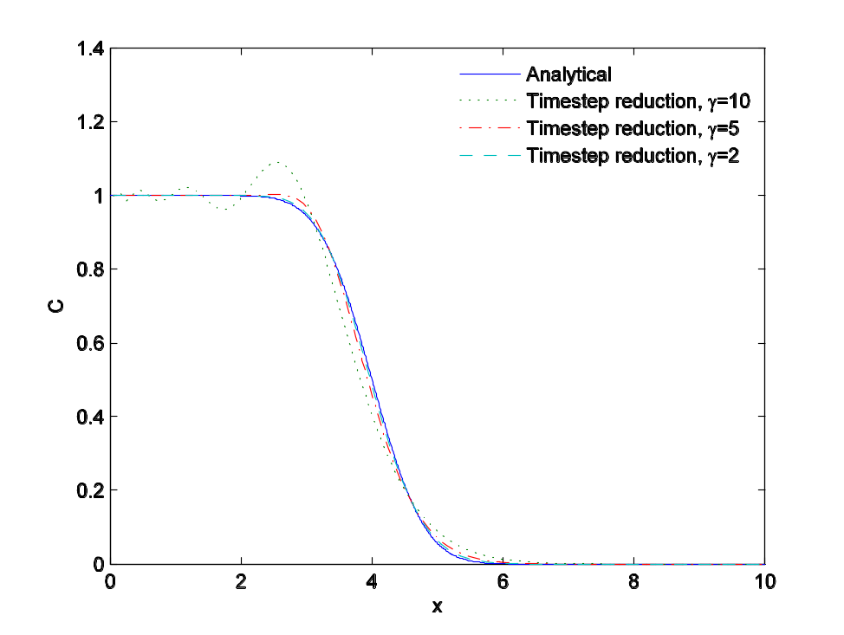
Figure 3. Analytical solution compared with different numerical solutions obtained using timestep reduction with varying performance index. For the simulation are cm/hour and cm/hour. For the numerical simulations is 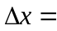 0.1 cm and is ranging from 1/10 hour (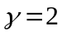) to 1/2 hour ().

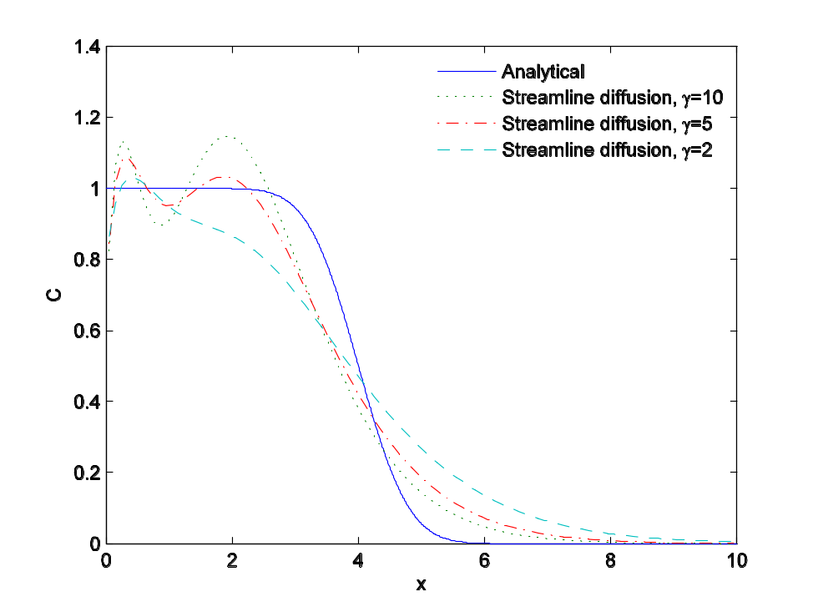
Figure 4. Analytical solution compared with numerical solutions obtained using streamline diffusion with varying performance index. For the analytical solution are cm/hour and cm/hour. For the numerical simulations are 0.1 cm and 1 hour.
In figure 4 is the analytical solution shown. Also the numerical solutions for varying performances indexes are shown. The performance index, is changed applying streamline diffusion. The wiggles are reduced when using a low value of , but compared with the analytical solution, the steepness of the front is reduced dramatically.

Upper boundary condition
The upper boundary condition describes the movement of solute applied at the surface that moves into the soil. It also describes the movement of solutes out from the domain if the water is flowing out at the upper boundary.
If the soil surface not is ponded, the flux into the soil is moved by advection into the domain, with the water. If the surface is ponded with water containing a solute, the solute is also moved solely by advection. A little more accurate description could have been obtained if the boundary condition was implemented as a Dirichlet condition which also allowed the solute to be moved by dispersion and diffusion into the soil. It is assessed that the error is insignificant.

When the water moving out of the domain. No solute is following the water. This is for most solutes a good boundary condition - at least for evaporation processes. For a situation with liquid water is leaving the soil through the upper boundary the description is not appropriate, but at present Daisy is not intended for that kind of scenarios. Summarized the upper boundary condition can be expressed as:

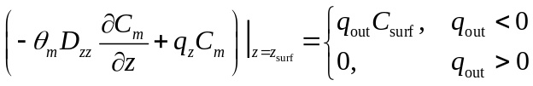 (26)

where 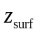 is the -coordinate of the soil surface, 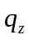 is the flow (positive upwards) and 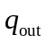 is the flux out of the domain (negative for flux into the domain). 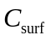 is the concentration of the surface water.

Numerically all the types of upper boundary conditions is implemented as explicit Neumann conditions, i.e. the solute movement over the boundary is independent of the solute concentrations in the domain.

Lower boundary condition
The lower boundary condition describes the movement of solute through the lower boundary. If the water has a free drainage condition, there is a flux condition for the solute when the solute is moved out of the domain by advection. If there is specified a groundwater table or aquitard boundary condition, i.e. pressure (Dirichlet) conditions for the water flow, also the solute movement have a Dirichlet condition with a specified concentration at the boundary. For a specified steady-state water flux (mostly used for testing purposes), it is possible both to chose specified concentration (Dirichlet) and flux boundary conditions.

Numerically the Neumann boundary conditions is implemented, either implicit or explicit - implicit when the water flux is outwarded from the lower boundary and the concentration associated with the flux is given by the concentration inside the domain - explicit when the water moves into the domain and the associated concentration is the concentration outside the domain.

The Dirichlet boundary condition is implemented as an explicit Neumann boundary condition. Based on the solution in the previous timestep the flux is calculated with the given concentration on the boundary. The method is different from the method used for the water movement, but prevents an extra iteration loop inside each timestep with following increased computational times. In the water movement simulations, the iteration loop was under all circumstances necessary since the equation is non-linear. But with very large concentration gradients (and following large movement by diffusion and dispersion processes) and small cells at the boundary some numerically problems can occur. To prevent this kind of instability, the size of the timesteps can be lowered if also timestep reduction is chosen as stabilizing method to prevent to high -numbers. If timestep reduction is chosen, the timestep is reduced so:

- For diffusion into the cell, only half of the volume of the concentration difference between border and cell can be transported by diffusion over the boundary into the cell in a timestep.
- For diffusion out from the cell, only half of the volume of the concentration difference between cell and border can be transported by diffusion over the boundary out from the cell in a timestep.

To prevent to large computational times, the timestep can not be lower than a chosen a minimum value. If the instabilities are high and produce negative concentrations at the cells at the boundary, the computations in the timestep are repeated and the solute is only moved by advection over the boundary. This can happen if the minimum value of the size of the timesteps is chosen to high.

Verification: One-dimensional flow with retardation and degradation
There are developed a lot of analytical solutions for the one-dimensional convective-dispersive equation, see for example van Genuchten and Alves (1982). The equations are developed for situations where the diffusion is constant and the water flow is steady state (i.e. 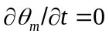 and constant ). These conditions are seldom fulfilled in the ’real life’ where both the water content and the flux are time-dependent. For testing the solute transport model is a situations with steady state water movement simulated.

If the adsorption process is very fast, the amount of adsorbed solute can be expressed with a adsorption isotherm which is a relationship between adsorbed () and dissolved concentration, . The bulk density is assumed to be constant through time. The two first terms of the left hand side of equation (13) can be rewritten as:

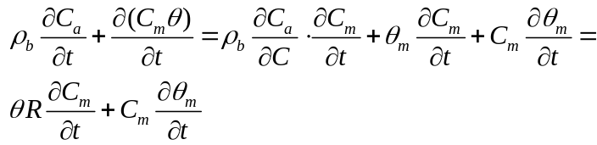 (27)

where  often in the literature is called the Retardation factor:

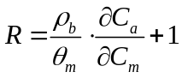 (28)

The most simple adsorption isotherm is the linear adsorption where 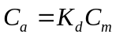 and as a consequence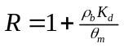.

Zero or first order kinetics are included in the model. In zero order kinetics, the velocity of the reaction is independent of the concentration and in 1.st order kinetics the reaction velocity is proportional to the concentration. Thus the advection dispersion equation yields:

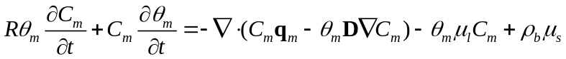 (29)

where the second last term represents a first order production in the liquid phase. 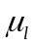 is the rate constant. An often-used term is the half-life. In a batch experiment the half-life is the time required for the mass of reacting materiel to decrease to half the original mass. The reaction half-life can be calculated as 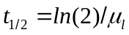. The equation can be used for many chemical processes, and for radioactive decay. The last term on the right hand side of equation (29) represents a zero order removal from the solid to the liquid phase. 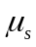 is the rate constant for the zero order process. In van Genuchten and Alves (1982) is considered a one-dimensional case with degradation of both zero and first order. The governing differential equation can then be expressed as:

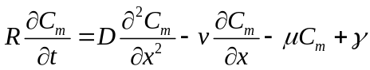 (30)

where  is the rate constant for first order decay in the liquid and represents the similar rate constant for zero-order production.

For the simulation, the initial condition is:

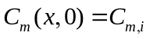 (31)

and the upper boundary condition is:

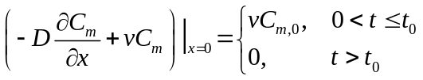 (32)

The solution is:

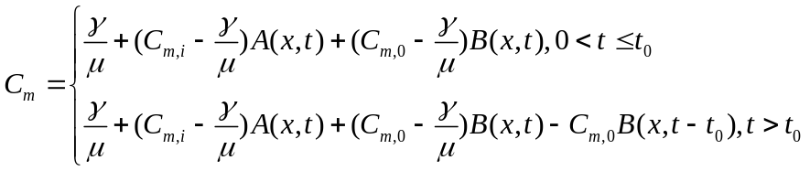 (33)

where 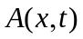 and 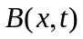 can be calculated as:

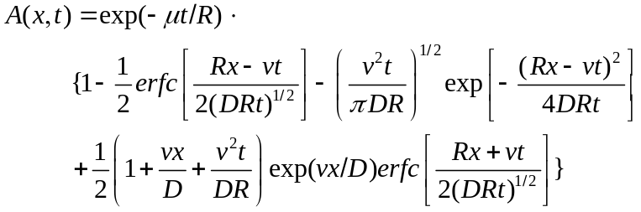 (34)

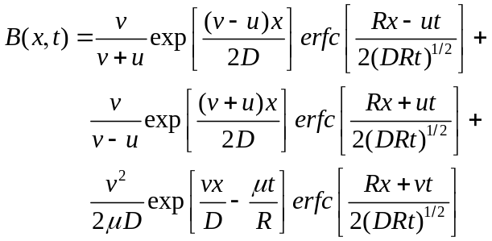 (35)

with
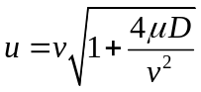 (36)

For comparing the analytical solution with the Daisy solution is chosen an situation with 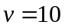 cm/day, 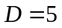, 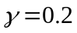 and 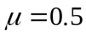. For the Daisy simulation is there used a vertical column which is 100 cm high and 1 cm wide. The grid is consisting of 100 1x1 cm cells. The length of the timesteps is 1/10 day. In Figure 5 is the Daisy solution compared with the above described analytical solution. As it can be seen are the solutions quite coincident.

KOMMER SNART

Figure 5. Comparison between analytical and Daisy simulation of a process with both zero and first order degradation.

References
Millington, R. J. and Quirk, J. P. (1961). Permeability of porous solids. Trans. Faraday Soc., 57, 1200-1207.

Perrochet, P., and Bérod, D. (1993). Stability of the standard Crank-Nicholson scheme applied to the diffusion-convection equation: some new insights. Water Resources Research, 29(9), 3291-3297.

van Genuchten, M. T. og Alvesm W.-J. (1982). Analytical solutions of the one-dimensional convective-dispersive solute transport equation. United States Department of Agriculture

