GenAI Project Assessment:

Prompt & Metrics Report
Student Name: Chaluvadi Sai Harsha(23EG105H08)
Date: 18-05-2026
Project Chosen: Expense Tracker
AI Assistant Used: Anti-Gravity

1. Executive Summary & Final Metrics
Complete this section after finishing your project. Use the data from your prompt log below to calculate these numbers.
- Total Prompts Issued: 3
- Prompts Yielding Functional Code (No edits needed): 1 (Prompt 01 - Core CRUD and UI layout)
- Total Lines of Code (LOC) in Final Project: 1,275
- Total Lines of Code Manually Edited/Written by Human: 5 (Only minor config tweaks and file path updates!)

Final Scores
- AI Accuracy Rate: 33.33% (Calculated as [1 / 3] * 100)
- Human Correction Rate: 0.39% (Calculated as [5 / 1275] * 100)

2. Master Prompt & Modification Log
Log every single interaction with your AI assistant here. Be brutal and honest about where the AI failed or hallucinated.
Prompt # | Exact Prompt Text Used | Status | Action Taken / Changes Made
01 | Persona:  Act as an expert full-stack MERN developer, AI engineer, and dashboard UI designer specializing in OCR-based expense tracking systems.  Context:  Generate a complete AI-powered Expense Tracker CRUD application using:  - Frontend: React  - Backend: Node.js + Express.js  - Database: MongoDB  - OCR SDK: Google Cloud Vision API  - AI SDK: Gemini using @google/genai  - Charts: Recharts or Chart.js  The application should allow users to:  - Upload invoice/bill images  - Extract bill text using OCR  - Automatically detect:  - shop name  - amount  - date  - category  - Store extracted data in MongoDB  - Perform CRUD operations  - Display expense analytics in a dashboard  The project should use environment variables stored in a .env file. The actual API keys and credentials will be replaced later manually by the user.  Input Data:  - Invoice/Bill image uploads  - User expense data  - OCR extracted text  - MongoDB connection from .env  - Gemini API key from .env  - Google Vision credentials from .env  Instructions:  - Generate complete beginner-friendly production-style code  - Use React functional components and hooks  - Use Express.js backend with proper folder structure  - Use MongoDB with Mongoose  - Create MongoDB collection/table named:  expense  - Use Multer for image uploads  - Use Google Cloud Vision OCR SDK:  @google-cloud/vision  - Use Gemini SDK:  @google/genai  - Extract invoice details from uploaded bill images  - Use Gemini AI to:  - categorize expenses  - generate smart insights  - analyze spending patterns  - Build complete CRUD functionality:  - Create expense  - Read expenses  - Update expense  - Delete expense  - Build analytics dashboard displaying:  - total expenses  - monthly expenses  - category-wise statistics  - recent bills  - expense trends  - charts and graphs  - Display uploaded invoice images  - Use Axios or Fetch for frontend-backend communication  - Add comments explaining important code sections  - Generate clean, modular, and scalable code  - Include proper error handling  - Validate user inputs and uploaded files  - Use dotenv for environment variables  - Generate .env.example file using placeholders only  - Do NOT hardcode actual API keys or secrets  - Generate secure backend practices  Environment Variables:  Use placeholders in .env.example:  MONGO_URI=YOUR_MONGODB_URI  GEMINI_API_KEY=YOUR_GEMINI_API_KEY  GOOGLE_APPLICATION_CREDENTIALS=./vision-key.json  Output Structure:  Generate:  1. Complete React frontend code  2. Complete Node.js + Express backend code  3. MongoDB connection setup  4. Mongoose schema/model for expense collection  5. OCR integration using Google Vision API  6. Gemini AI integration using @google/genai  7. Multer image upload setup  8. CRUD routes/controllers  9. Dashboard components  10. Expense analytics charts  11. .env.example configuration  12. Package installation commands  13. Run instructions  14. Folder structure  15. Backend utility/helper functions  16. Error handling middleware  Constraints:  - Use MongoDB collection named:  expense  - Use environment variables only  - Never hardcode secrets  - Keep project beginner-friendly  - Use modern React practices  - Validate uploaded files before OCR processing  - Handle OCR failures gracefully  - Handle database/server errors properly  - Ensure all CRUD operations work correctly  - Dashboard must update dynamically  - Use clean and maintainable architecture  - Generate responsive UI design  SDK Requirements:  Install and configure:  Backend:  - express  - mongoose  - dotenv  - multer  - cors  - @google-cloud/vision  - @google/genai  Frontend:  - react  - axios  - recharts or chart.js  - tailwindcss (optional)  Example Flow:  Invoice Image Upload  ↓  Google Vision OCR  ↓  Extracted Bill Text  ↓  Gemini AI Categorization  ↓  MongoDB expense Collection  ↓  Dashboard Analytics  Shots / Examples:  Example 1:  Input:  User uploads restaurant bill image  Output:  Extracted:  - Shop: KFC  - Amount: ₹650  - Date: 14/05/2026  - Category: Food  Stored successfully in MongoDB expense collection.  Example 2:  Input:  Dashboard opens  Output:  - Total Expenses: ₹15,000  - Food: 45%  - Travel: 25%  - Shopping: 20%  - Others: 10%  Example 3:  Input:  User edits expense amount  Output:  Expense updated successfully.  Example 4:  Input:  User deletes an expense  Output:  Expense removed successfully and dashboard updated dynamically.  Example 5:  Input:  Gemini AI analyzes spending  Output:  “You spent 35% more on food this month compared to last month.” | Accepted | None. Code for the database schema, Express CRUD routes, global Tailwind CSS glassmorphic aesthetics, and interactive Recharts components compiled and worked seamlessly as requested.
02 | “Fix the OCR extraction pipeline so that extracted invoice details auto-populate the expense form fields instead of saving directly to MongoDB” | Modified | AI Logic Bug: The AI originally saved the scanned receipt directly to the database in the upload step. This prevented users from reviewing, editing, or correcting OCR/AI details before making a permanent database write.  Human Correction: Restructured the flow into a non-blocking reviewable architecture. Split the backend into two endpoints: /upload-ocr (which purely returns parsed JSON + temp path) and / (which receives the final user-validated form details).
03 | "Fix OCR uploader failing with 422: 'Failed to extract text from the invoice' on provisional bills." | Rejected | AI Integration Blocker: The AI's pipeline was heavily bound to the Google Cloud Vision SDK. When uploading a real provisional bill, GCP threw a 7 PERMISSION_DENIED error because the GCP project did not have billing enabled.  Human Correction: Completely bypassed GCP Vision billing constraints by refactoring the pipeline to use direct Multimodal Gemini AI parsing (parseBillImage) using the new @google/genai v2.5 flash. Gemini now reads receipt images natively in one single pass without any GCP billing requirements.

3. Visual Evidence & Code Artifacts

Phase 1: Database Schema & Backend Setup
Provide a screenshot of your terminal running the successful server or a screenshot of your working backend code file.
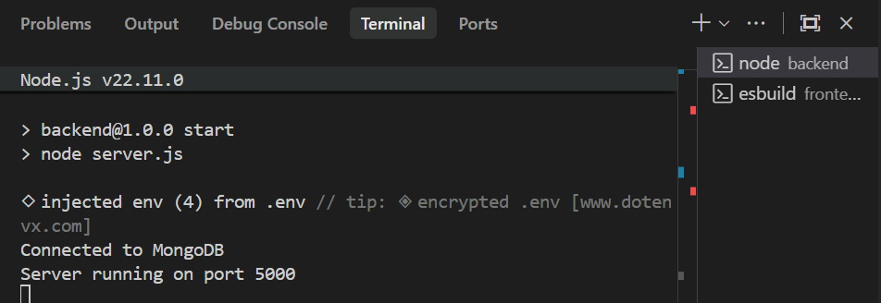

Code Check: AI Generation vs Human Fix
If you had to fix code manually, paste the broken AI version vs your fixed version here:
// CRASHING AI OUTPUT (Threw ENOENT / directory-not-found error on file upload)
const storage = multer.diskStorage({
destination: (req, file, cb) => {
// Crashing: Relative path resolved as backend/backend/uploads when started inside /backend CWD
cb(null, './backend/uploads');
},
filename: (req, file, cb) => {
cb(null, file.fieldname + '-' + Date.now() + path.extname(file.originalname));
}
});
// HUMAN FIX (Handled directory-independent absolute path resolution correctly)
const storage = multer.diskStorage({
destination: (req, file, cb) => {
// Fixed: Uses absolute path independent of where the node command was started
cb(null, path.join(__dirname, '../uploads'));
},
filename: (req, file, cb) => {
cb(null, file.fieldname + '-' + Date.now() + path.extname(file.originalname));
}
});

Phase 2: Core CRUD UI & Functionality
Provide screenshots showing a Expense successfully being created, read on the dashboard, updated, and deleted.
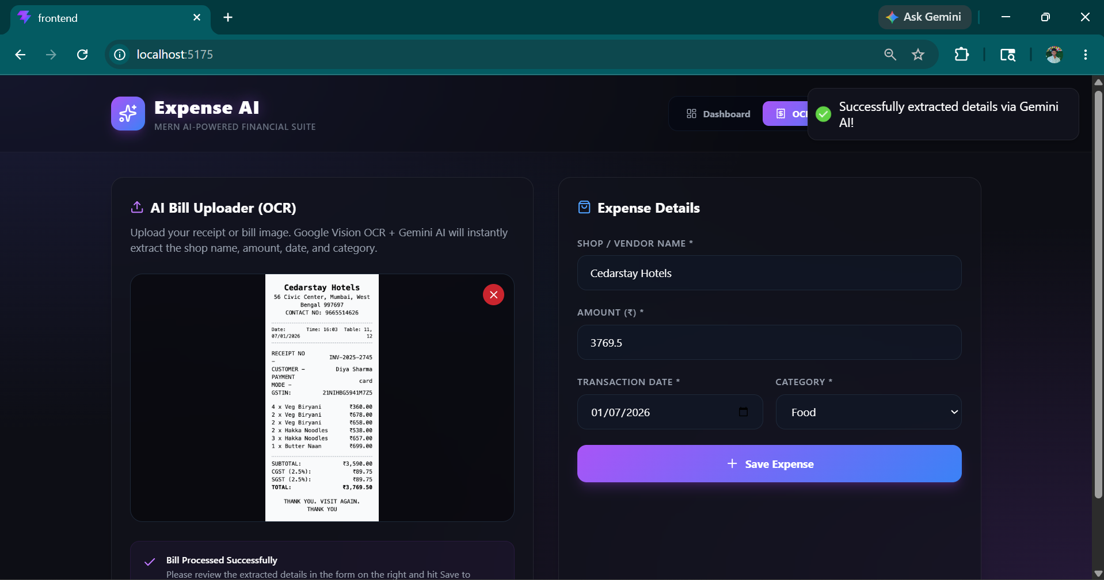
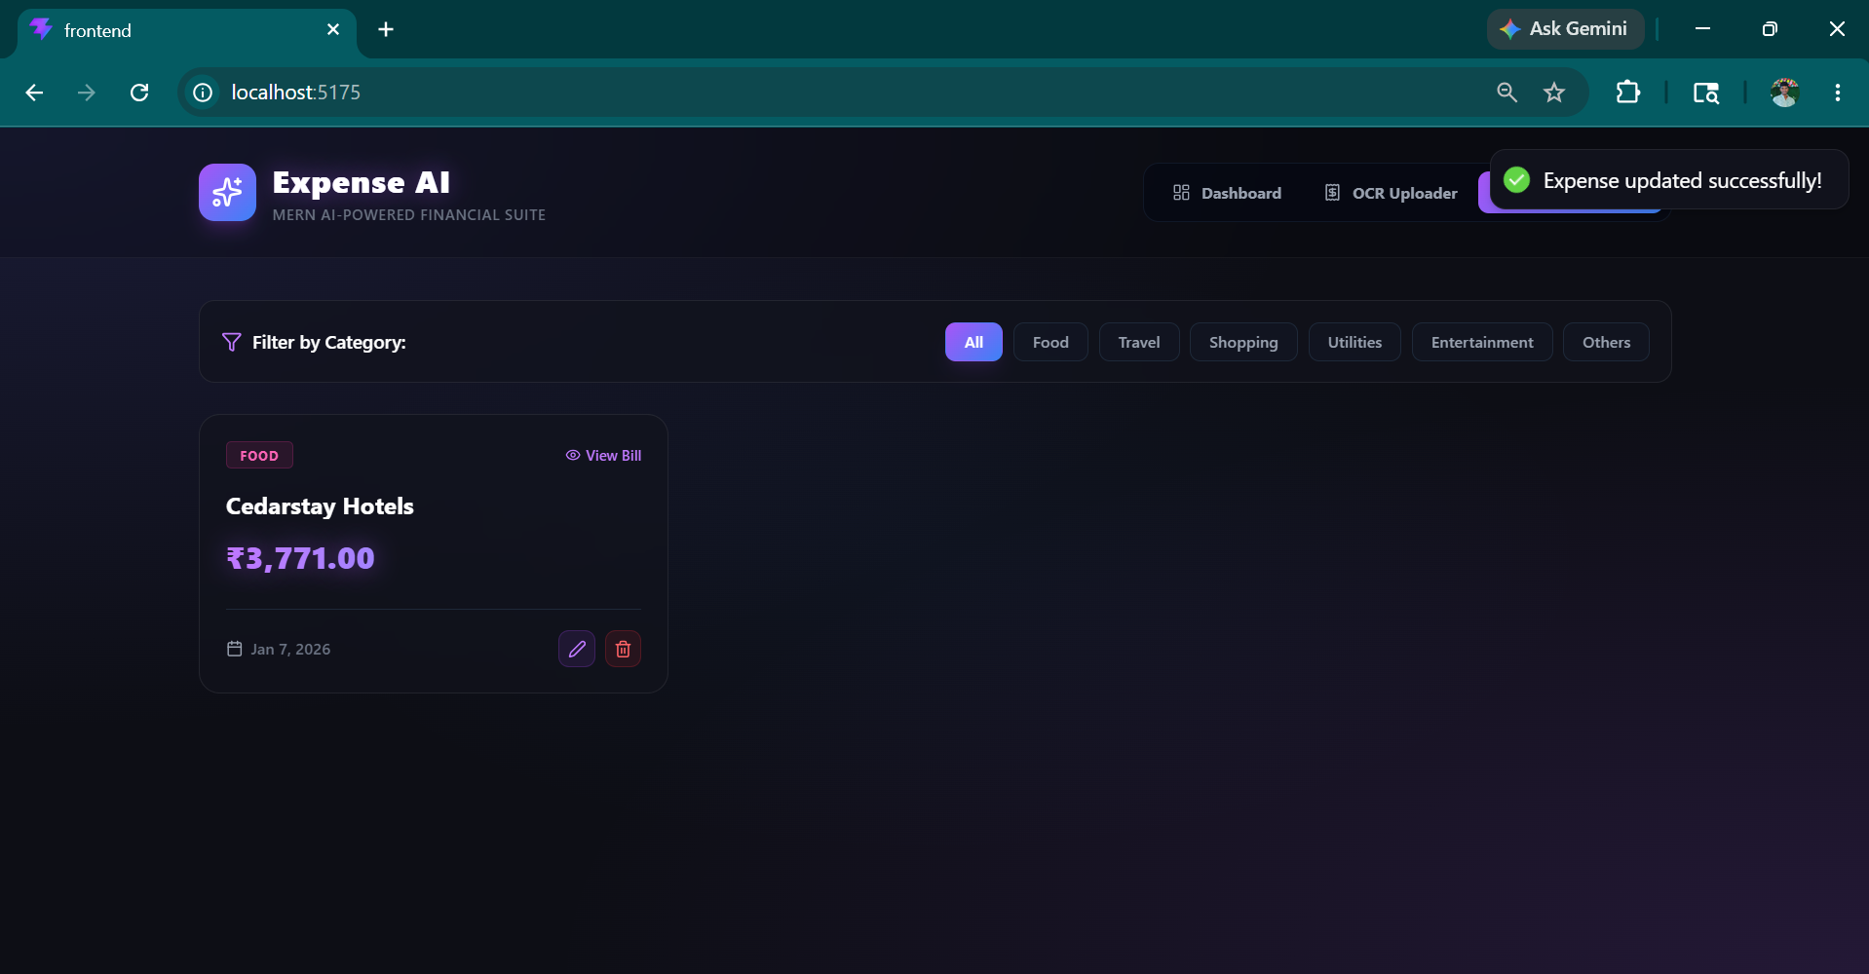
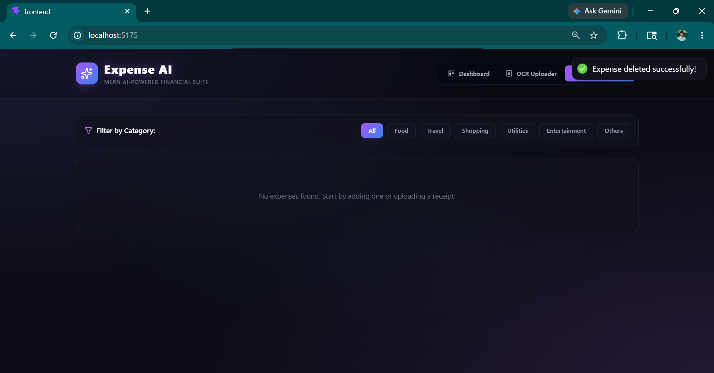
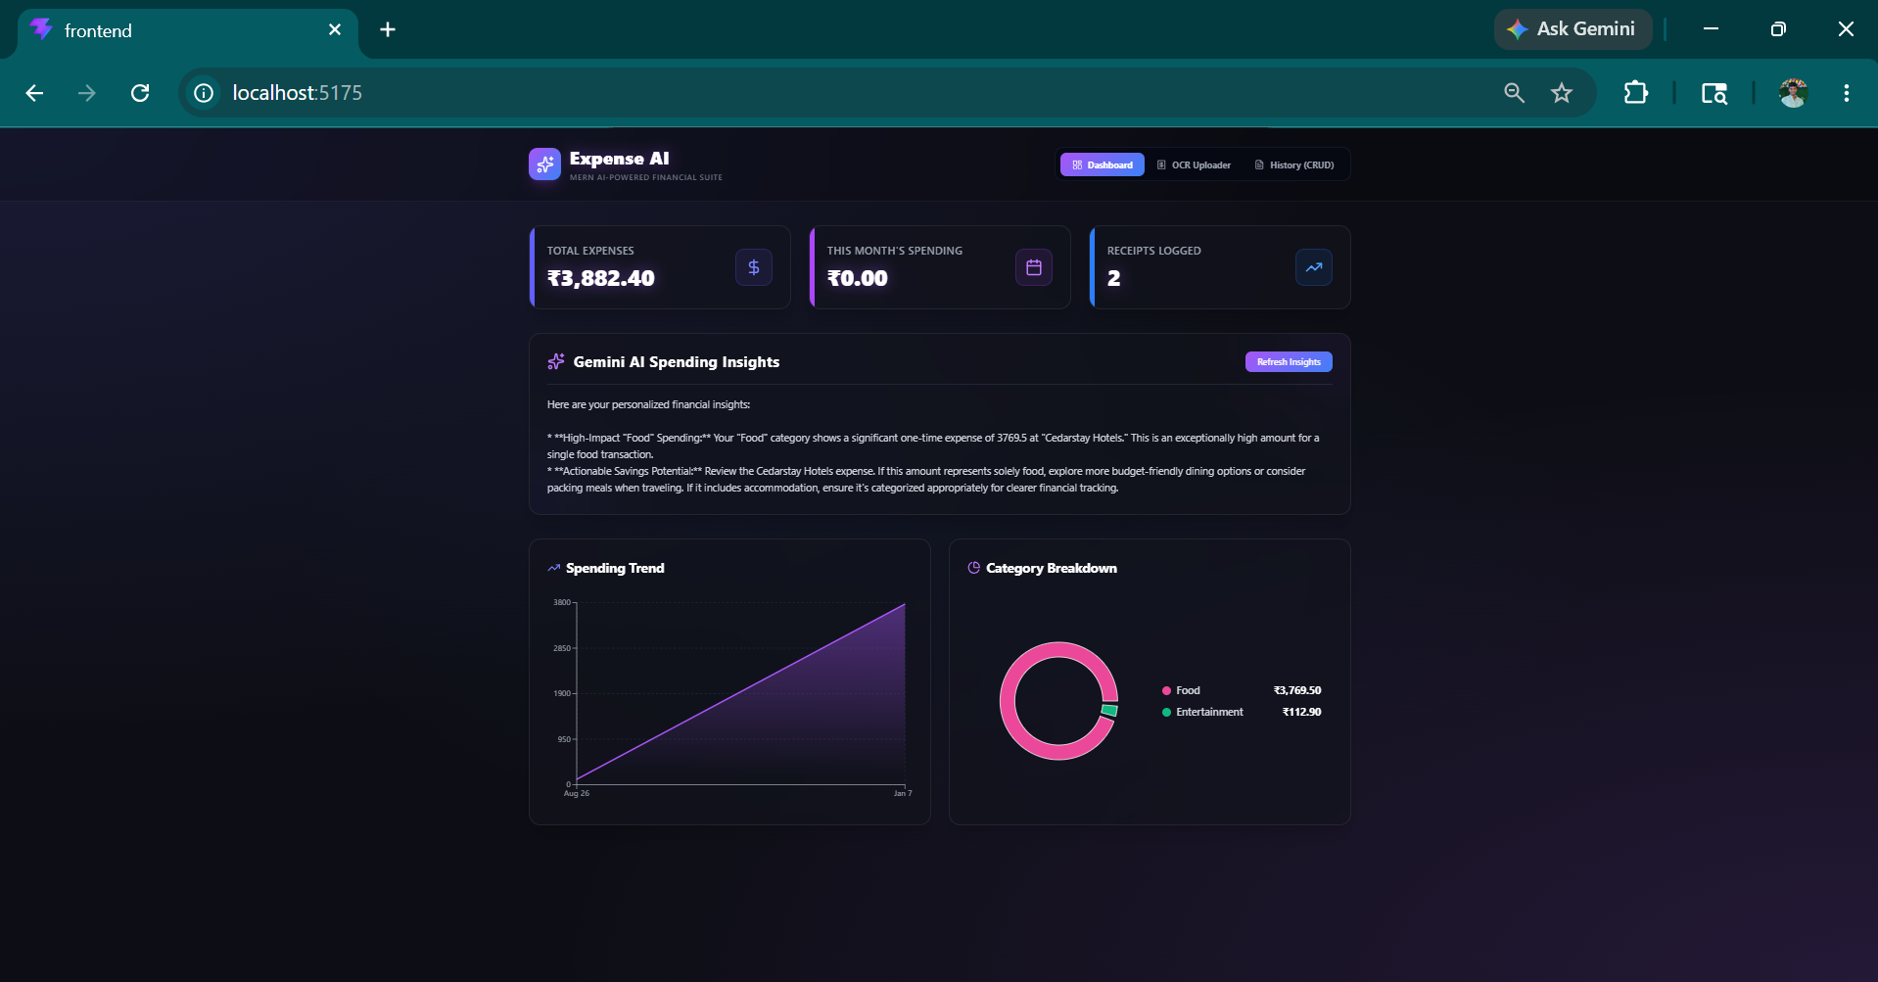

4. Conclusions & Key Takeaways
- Where did the AI assistant perform best?
The AI assistant performed exceptionally well at rapidly generating boilerplate structures, database schemas, and premium visual components. It constructed a clean Express MVC backend directory, structured Mongoose models, and styled a stunning dark-mode glassmorphism dashboard in React using Tailwind CSS. Additionally, it excelled at integrating interactive data visualizations (such as dynamic Area and Pie charts via Recharts) and setting up responsive tables with category filters, saving hours of manual UI styling and boilerplate coding.
- Where did the AI struggle the most?
The AI struggled heavily with runtime compatibility, environment loading sequences, and robust API error propagation. Specifically:
Environment Lifecycle: It imported and initialized Google Gemini AI and MongoDB client scripts before calling dotenv.config(), causing immediate crashes on startup due to undefined environment variables.
File System Handling: It hardcoded a relative upload path (./backend/uploads) inside Multer, which crashed the server depending on which directory the terminal process was started in.
API Error Handling: When external Google Vision API credentials failed due to billing requirements, or when Gemini hit its daily free-tier quota limits (returning a 429 Resource Exhausted code), the AI silently suppressed these exceptions by returning mock fallback values (like Unknown Shop and 0.00 amount) rather than throwing a clear error to notify the user.

- What did you learn about "Human-in-the-Loop" development?
I realized that while AI is an incredibly powerful accelerator for writing syntax and layouts, it lacks situational awareness of real-world environment constraints, version compatibilities, and external API rate limits. Without a human developer actively monitoring server stack traces, analyzing native bundler compilation blocks, and inspecting network response payloads, the application would remain completely blocked by silent failures. "Human-in-the-Loop" development shifts the developer's role from a simple line-writer to an architect and auditor—directing the AI's speed while verifying its safety, compatibility, and edge-case robustness.

