Chapter 2 notes
Power
- Realism explains international relations in terms of power
- Realism was developed in reaction to idealism, which emphasizes international law, morality and international organizations as influences on international events
- Realists blame idealists for seeing the world in a rosy manner. They claim that idealists see the world in what it should be and not what it is actually like
- Famous Realist philosophers include Sun Tzu, Thomas Hobbes, Niccolo Machiavelli, and Thucydides
- Although realists emphasize power, they do not always approve of military conflicts, as many leading realist thinkers opposed the United States invasion of Iraq and the Vietnam War
- Realists abstract out the concepts of religion, culture, and ideology
- A central theme for realists is the concept of power
- Power is the ability to make another actor do something that they would not have done otherwise
- Power is not influence, but is the ability to influence and affect others
- The best indicator of a states power is its total GDP, which indicates its size, technology and wealth
- Relative power is the ratio of power that 2 states bring to bear against each other
- In war generally the more powerful nation will win. The total GDP of a country is a good indicator because the wealthier a nation, the more material goods it can muster for the war effort
- Long term influences for power include total GDP, population, natural resources, territory, and geography. Other less concrete influences for power include patriotism, culture, education, and technological base
- In the short term, military force and a capable bureaucracy influence a nation’s power the most
- Realists see military force as the most important element of power in the short term
- However, military force cannot be used as the only tool to wield a nations power
- Geopolitics is the use of geography as an element of power. For example, the control of oil pipelines through Syria is a major international dispute
International System
- Realists believe that the international system exists in a state of anarchy, which means that there is no central governing power that defines the rules
- However, most nations interactions with each other fall within a norm of behavior
- Sovereignty is the norm that a nation has the right to do whatever it chooses to within its own territory
- There are obvious exceptions to this norm, such as when a nation commits atrocities against its own people the international community will step in
- The territorial nature of states was also created arbitrarily by past wars
- States have developed norms of diplomacy to facilitate interactions between other states
- An embassy is treated as the territory of the state that owns it
- The term balance of power means that one or more states’ power is used to balance the power of another
- Alliances and treaties play a key role in balances of power. For example during the Cold War, the Warsaw pact was created in response to the creation of NATO
- Great powers are seen as the most powerful half a dozen states in the world. Today the permanent members of the UN Security council are regarded as great powers
- They generally have the strongest military and technological advancement
Power Distribution
- Neo realism tries to explain the distribution of power in terms of a systematic structure
- 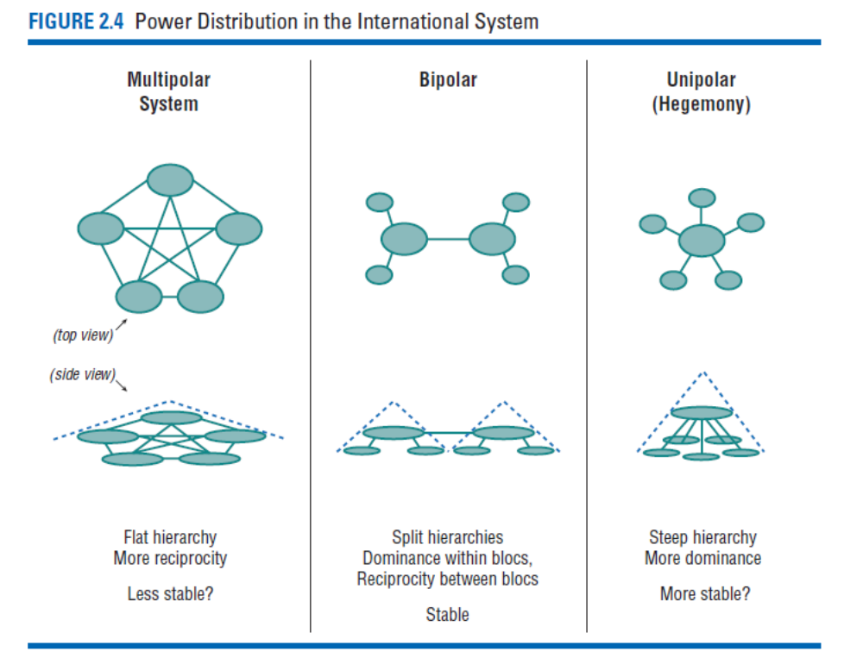
Melian Dialogue
- The Melian dialogue takes place during the Peloponnesian War between the city states of Athens and Sparta
- Melos was a neutral state was under siege by the Athenian army and were being demanded that they submit to the Athenians
- The Melians argued that they had the right as a nation to remain neutral during a time of conflict
- The Athenians thought that allowing the Melians to remain free would speak poorly of Athenian power
- To the Athenians it was in both of their interests to submit to Athens.
- The Melians eventually refused to submit and the men were executed and the women and children were sold into slavery.

