There are three changes in Rel_55.0.0

1.Remove Reflection from Desktop installation package

From Release R55.0.0, Reflection will no longer be included with the iFast/Desktop releases. As a result of this change, the screen for Reflection selection has been removed from the Desktop installation process. So that the client will not be able to install Reflection at the same time of installing Desktop. Reflections for clients who use it will be a separate download. Following are the process of the Reflection installation:

Step1: Down load Reflection from iFast.ca

Step2: Unzip it

Setp3: Open folder Disk1

Step4: run SETUP.EXE

Step5: Follow the instruction in <Instruction of Reflection installation.doc> that is in the same folder of unzips Reflection files located to finish the Reflection installation

2.Support IP Address and DNS name

Existing Desktop installation does not support input of DNS name. From Rel_55.0.0, this limitation does not exist any more. From Rel_55.0.0, Desktop can be installed properly using either IP Address or DNS name. There is no changes in the installation process except the instruction of the input screen for IP address has now been changed to indicate user can either enter IP address or DNS name.

3. Different Log in screen of “Reflection for Unix and Digital”

The first screen is like below.

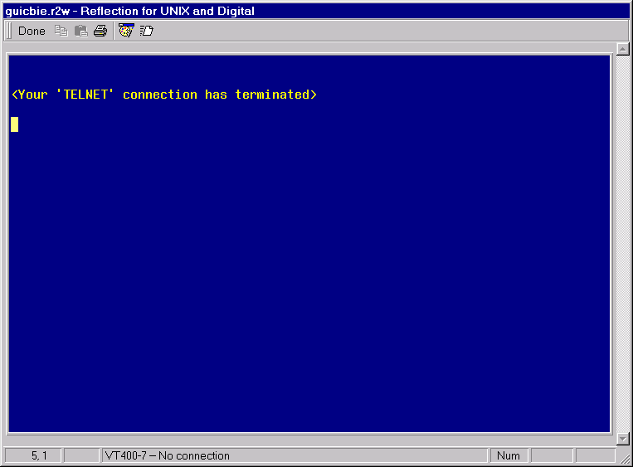
You should press <Enter> first, then the login screen will show up like below:

