Fields

The application allows creating new fields and modifying or deleting existing fields. To start working with fields the following steps must be completed.

1. Run the application
2. Press the “Browse” button and select a “ifastdataimpl” folder from the version of the IFastDesktop that you will be working with.
3. Press the “Load Data” button and application will parse the source files in specified “ifastdataimpl” folder and load data into the “Data Set Explorer”. See image below.
4. Open a “Fields Editor” by clicking on the provided toolbar button or menu item.

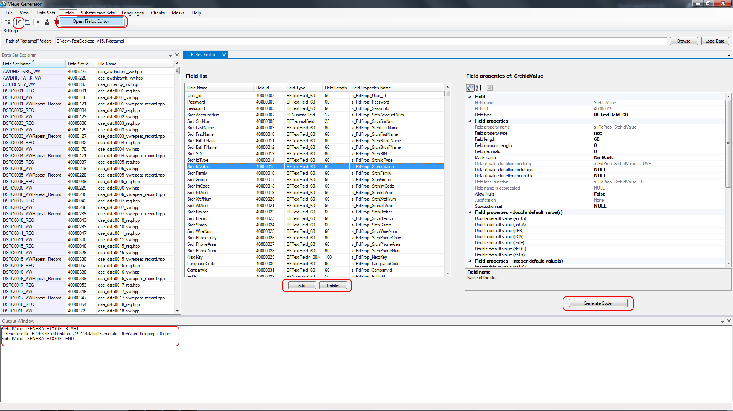

The Fields Editor has again a fields list view; it shows a list of all available fields (the same as in a Data Set Editor). To edit the field’s properties select a field in the “Field list” list view and all field properties will be displayed in the property grid control shown on the right.

The editor also enables creation of new fields and deletion of existing fields, see button below “Fields list” list view control.

Only one field can be selected and edited at a time.

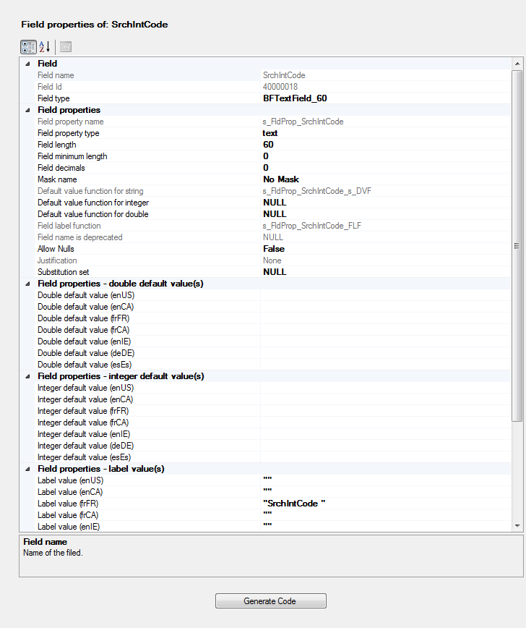

In the field properties grid select and define all properties applicable to selected filed. Make sure that properties are consistent, for example if filed type is ”BFTextField_60” make sure that field property type is “text” and filed length is 60.

For default value functions, if they are included in the field make sure that values for appropriate languages are defined.

Once everything is configured as required press the “Generate Code” button to generate source code for the filed.

As described before, to review the generated files double click on the line containing a file name to open it in default editor on your computer.