Languages

To configure languages that can be used in the application, open the “Languages Editor” and define the required languages. To open the editor you can use a provided toolbar button or menu item.

Before opening the editor ensure the following:

1. Make sure that path to a “ifastdataimpl” folder is specified.
2. Make sure that “languages.xml” file is present in the specified “ifastdataimpl” folder. Initial version of the “languages.xml” file is provided in the “ViewsGenerator.zip” file.

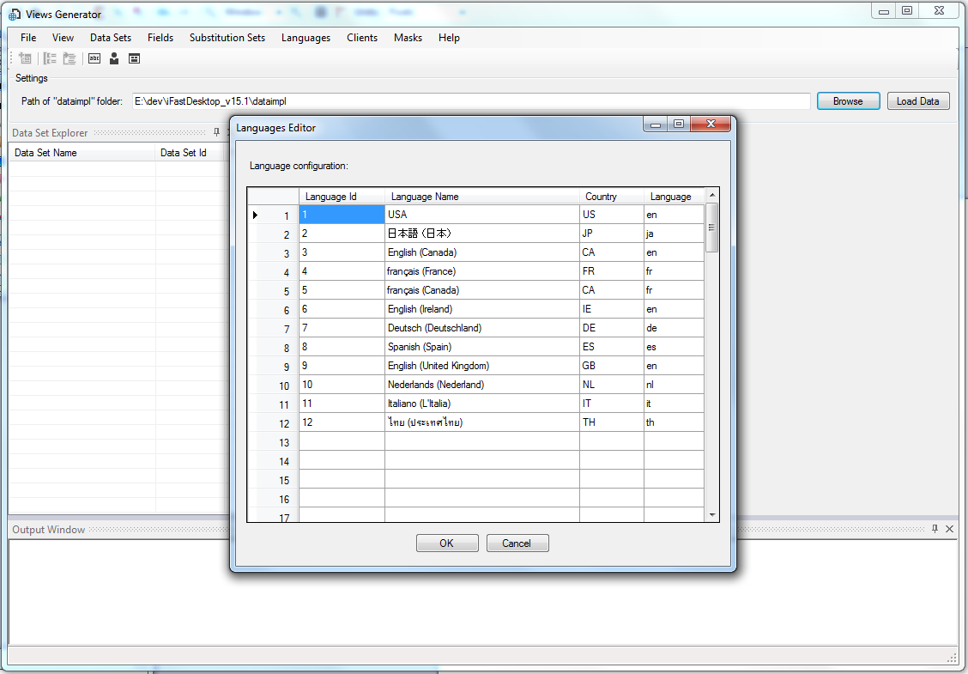

Once editor is opened, double click on any cell to edit the text.

To delete a row, select the row by clicking on the row header and press “delete” button.

To add new row just type the data in the next available row; make sure that language Id is set to the next available Id.

To abort any changes made press the “Cancel” button.

To save the changes press the “OK” button and xml file will be updated.

The editor can also be used when model is loaded.