Introduction

This is a short introduction for how to start using the application.

The application will parse already generated files located in the “ifastdataimpl” folder of IFastDesktop source code tree. Already existing files are the model which will be used instead of MS Access database previously used. By using this tool you will be able to add new, delete or modify existing code and then generate only the changed files. In the future files from a “ifastdataimpl” folder will be put in standard dll library and will not be generated. Only files that need to be changed or modified will be generated. Source code will be checked in SVN like all other source code.

Below is the first screen you will be presented with when you run the application.

STEPS

Loading Desktop side data:

1. When you start the application you must first press the “Browse” button ( **1** ) and select the “ifastdataimpl” folder of the IFastDesktop version that you will be working with ( **2** ).
2. Next press the “Load Data” button ( **3** ) and application will parse the files from “ifastdataimpl” folder and load all required data into memory and populate “Data Set Explorer”.

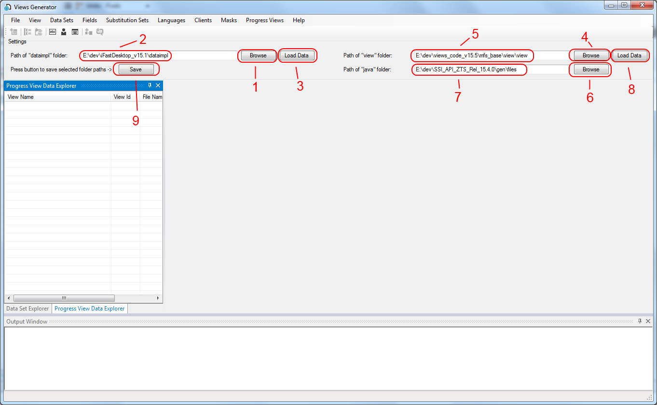

The following screenshot shows how it should look like.

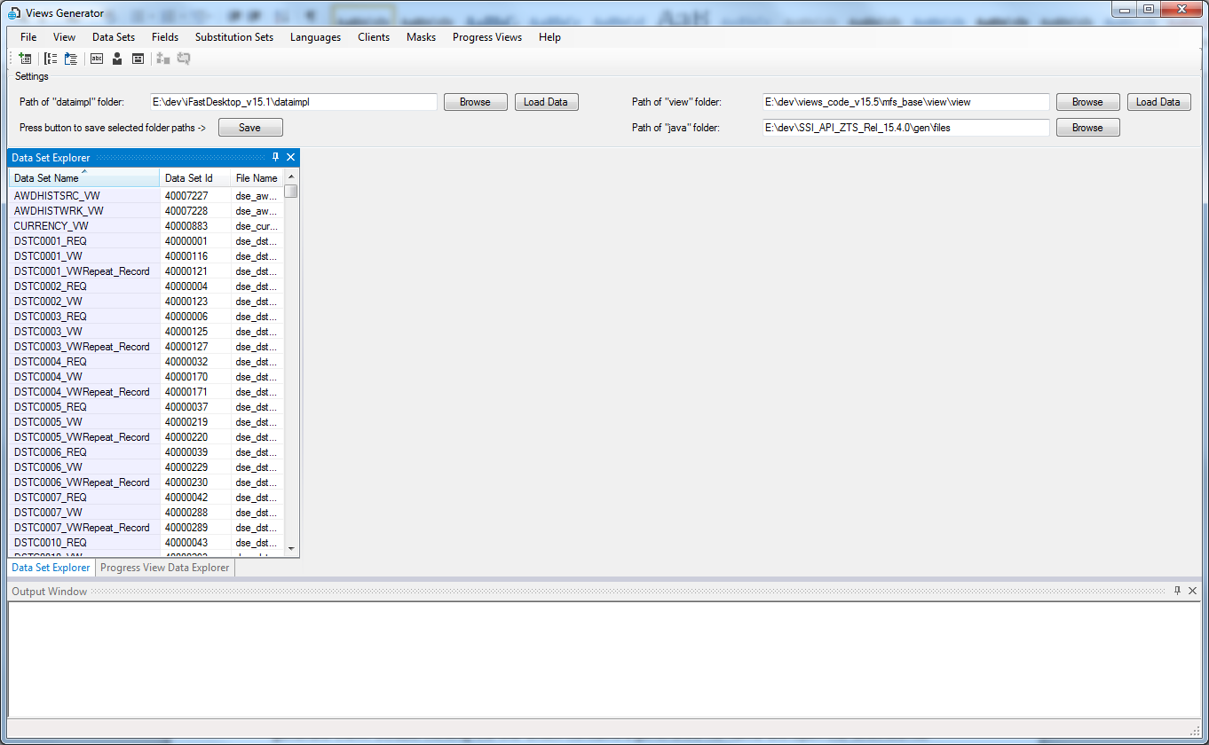

Loading Server side data:

1. Press the Browse button ( **4** ) to select the “view” folder where Progress files are located ( **5** ). Example path: “E:\dev\views_code_v15.5\mfs_base\view\view”, so path in general has format **version\mfs_base\view\view**.
2. Press the Browse button ( **6** ) to select the “Java” folder where generated files for Java and related documentation are located ( **7** ). Example path: E:\dev\SSI_API_ZTS_Rel_15.4.0\gen\files, so path in general has format: **version \gen\files**.
3. Next press the “Load Data” button ( **8** ) and application will parse the files from “view” and “java” folders and load all required data into memory and populate “Data Set Explorer”.

Finally press the “Save” button ( **9** ) and all three selected path will be saved in the xml config file “viewsgenerator_config.xml” which is located in the same folder where executable is. Next time the application is started paths will be automatically loaded from the configuration file.

The following screenshot shows how it should look like.

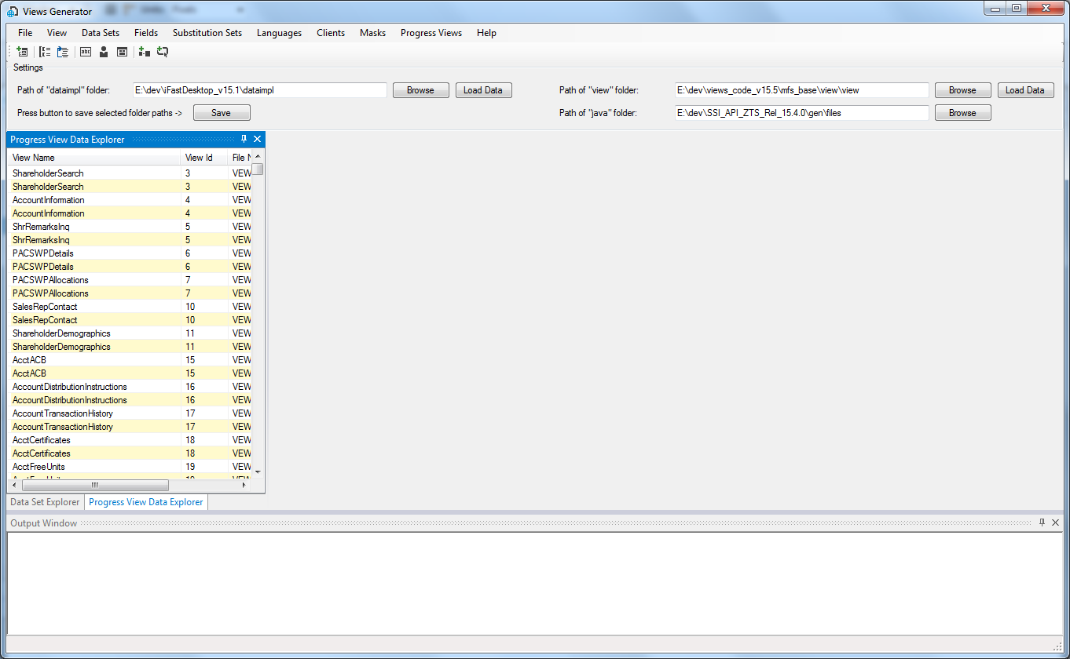

The “Output Window” at the bottom is a log window and it will show a list of generated files as you generate them. Double clicking the line which contains a generated file name will open the selected file in a default editor for that type of file on your computer.

All generated files will be placed in the “generated_files” folder which will be automatically created once you set the path to the “ifastdataimpl” folder, so the path will be “..\ifastdataimpl\generated_files”.

Once files are generated you may open a “file diff” tool and compare the original file from the “ifastdataimpl” folder with the newly created file placed in the “generated_files” folder. If file is correctly generated then it can be copied manually to the “ifastdataimpl” folder.

## Layout

The application provides a modern layout resembling the Visual Studio. You can dock or float windows or display them in a tabbed interface.

Layout is not persisted between application sessions.

The following screenshot shows some of the layout capabilities.

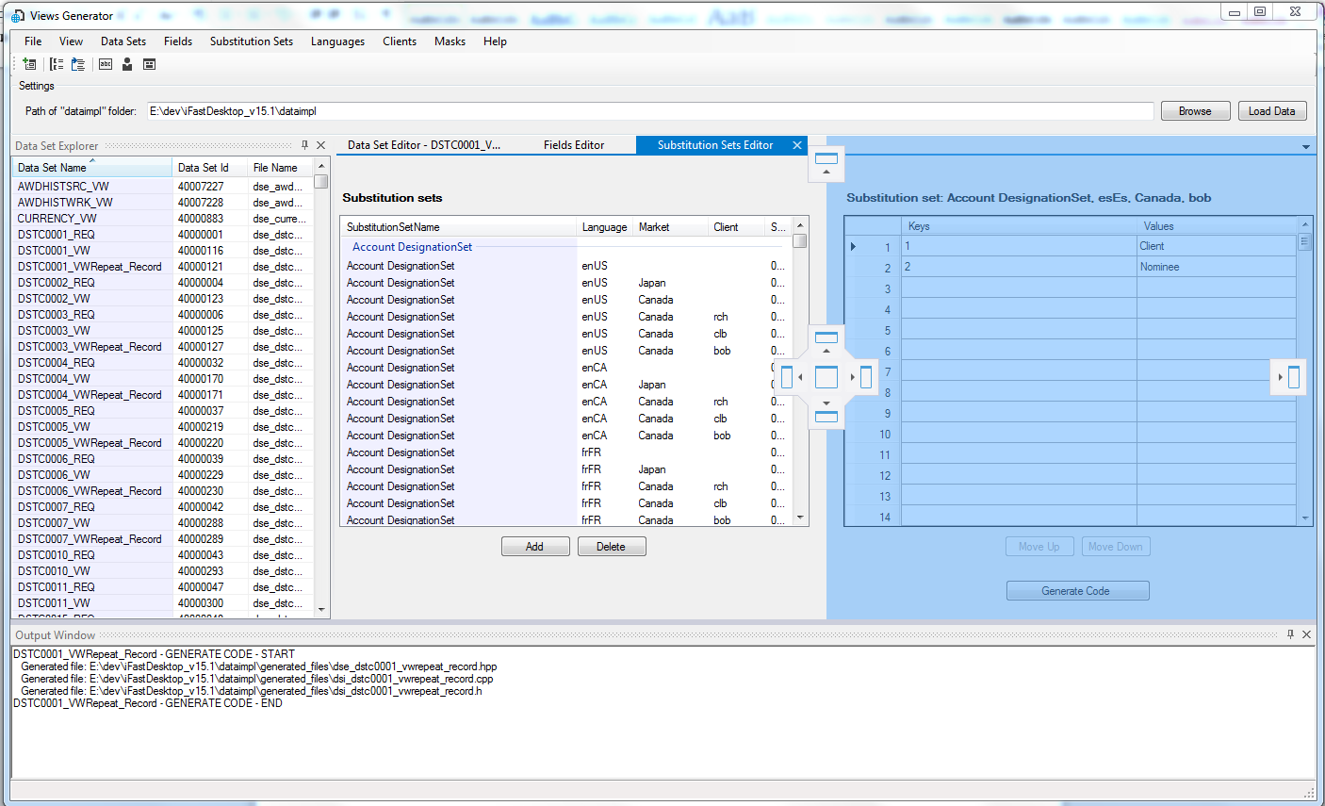

Any windows arrangement is possible, the best way to see all capabilities is to experiment and see what it can do.