Masks

To configure masks that can be used in the application, open the “Masks Editor” and define the required masks for required languages. To open the editor you can use a provided toolbar button or menu item.

Before opening the editor ensure the following:

1. Make sure that path to a “ifastdataimpl” folder is specified.
2. Make sure that “masks.xml” file is present in the specified “ifastdataimpl” folder. Initial version of the “masks.xml” file is provided in the “ViewsGenerator.zip” file.

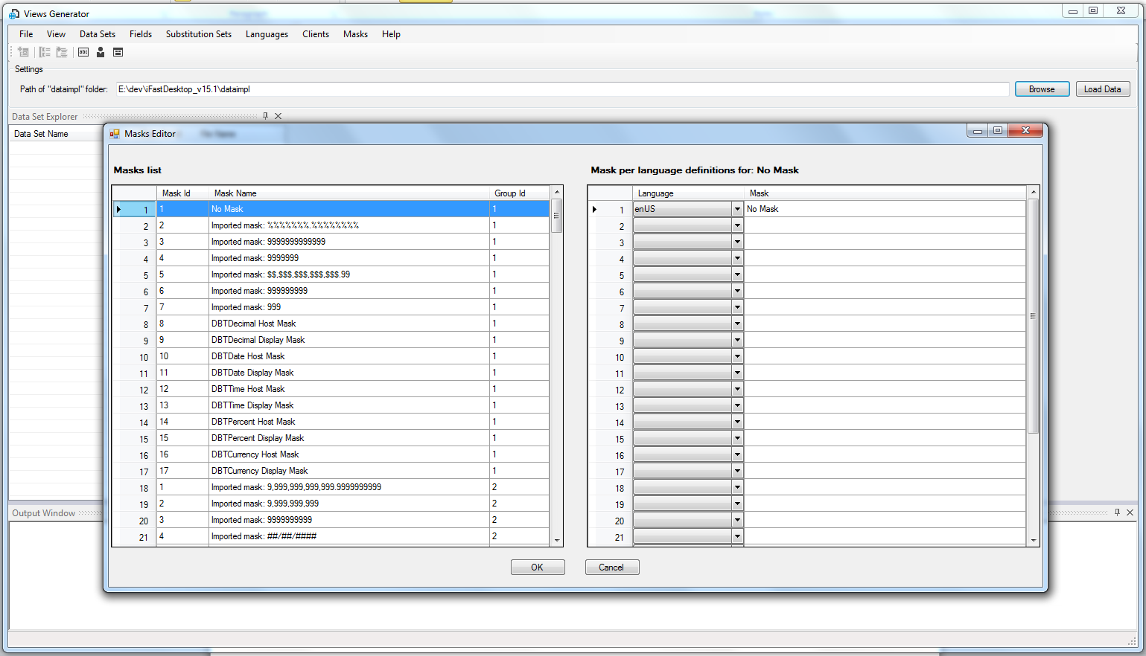

There are two grid controls displayed in the editor. The left grid displays general mask information and the right grid displays masks defined for different languages for the selected mask in the left grid.

Once the editor is opened, double click on any text cell to edit the text or change the selected item in the combo box in the right grid.

To delete a row in the left main grid, select the row by clicking on the row header and press “delete” button. To delete a row in the right grid delete the value in the mask cell and change the selected item to empty string item.

To add a new row in the left main grid just type the data in the next available row; make sure that Ids for market and group are set correctly. Based on Ids entered for group Id and Market Id items will be sorted and saved appropriately. In the right grid to add a new row, first select language in the combo box column and then and the appropriate mask in the mask column.

To abort any changes made press the “Cancel” button.

To save the changes press the “OK” button and xml file will be updated and also new files will be generated for “ifast_masks.cpp” and “ifast_masks.h”.

The editor can also be used when model is loaded.