## Create Chatbots with Intents, Entities, Utterances, and Flows

In this lab, you’ll define and create a financial chatbot.

First you’ll import intent definitions with utterances. Next, you’ll create an entity and associate it with your intent. You will define the flow using BotML. With these pieces in place, you’ll then train the chatbot and test it.

## What Do You Need?

For this lab, you’ll need the following files from the labfiles/code directory

* MasterBot-Intents.csv

Step 1: Access your Intelligent Bots environment

1. Go to the homepage of your Oracle Mobile Cloud Enterprise environment. The url and username/password will be provided during the workshop.
2. Press the “hamburger” menu icon in the top left of the interface

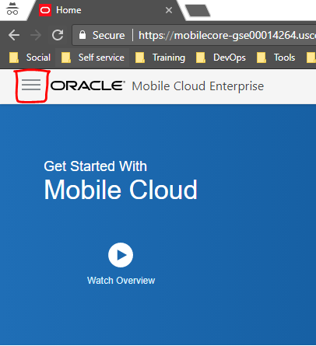

You now have access to all capabilities of Oracle Mobile Cloud Enterprise, such as Mobile Core, Customer Experience Analytics, MAX (Mobile Application Accelerator) and Intelligent Bots.

1. Press Bots in the navigation tab.

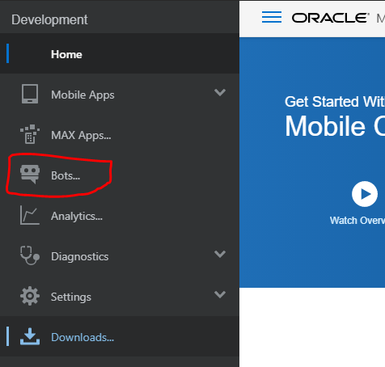

Step 2: Create a New Chatbot and Populate It with Intents and Entities

In this section, you will create a new chatbot, import some intents, and then create some entities. Next, you'll associate the entities with the intents. Don’t worry about the BotML code in this section—you’ll add it to the chatbot in a later lab.

1. Click the **New Bot** button. Name the chatbot *MasterBot_firstNameLastName*, where *firstNameLastName* are your first name and last name. Next add a description and then click **Create**.

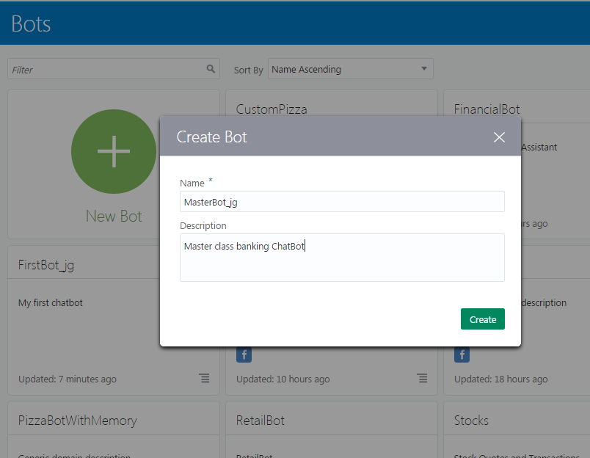

1. Let’s first take a couple of minutes to explore the user interface. In the left navbar, you can see a list of icons that you use to navigate to your intents, entities, dialog flow, components, and settings.

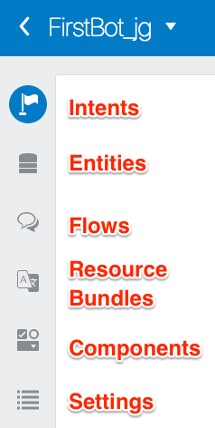

1. By default, the Intents page is open, but as of this moment, you don’t have any intents.

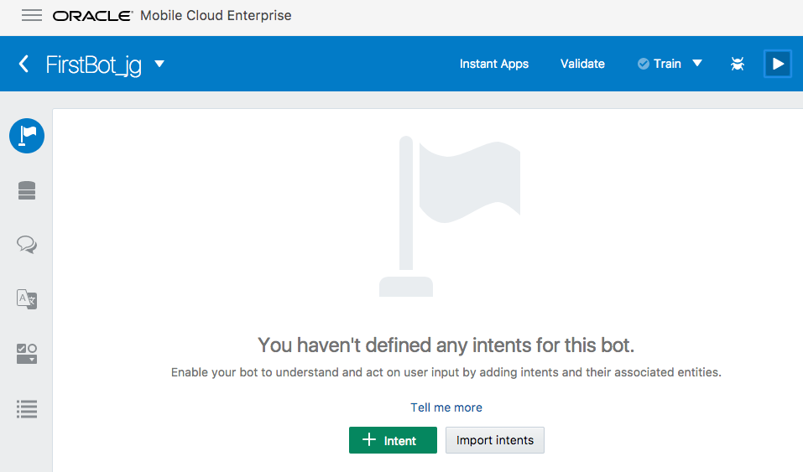

1. Click Entities (the second icon down) and notice that it’s pre-populated system entities. These are standard entities that you can use in your chatbot without having to explicitly define them.

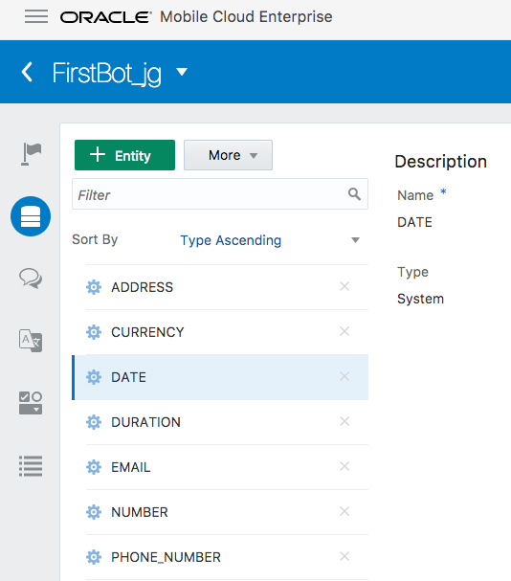

1. Next, click the Flow icon. Notice that it’s pre-populated with code that enables the chatbot to output a “hello” message. Don't worry about the code for the flow right now--you'll make modifications to it later.

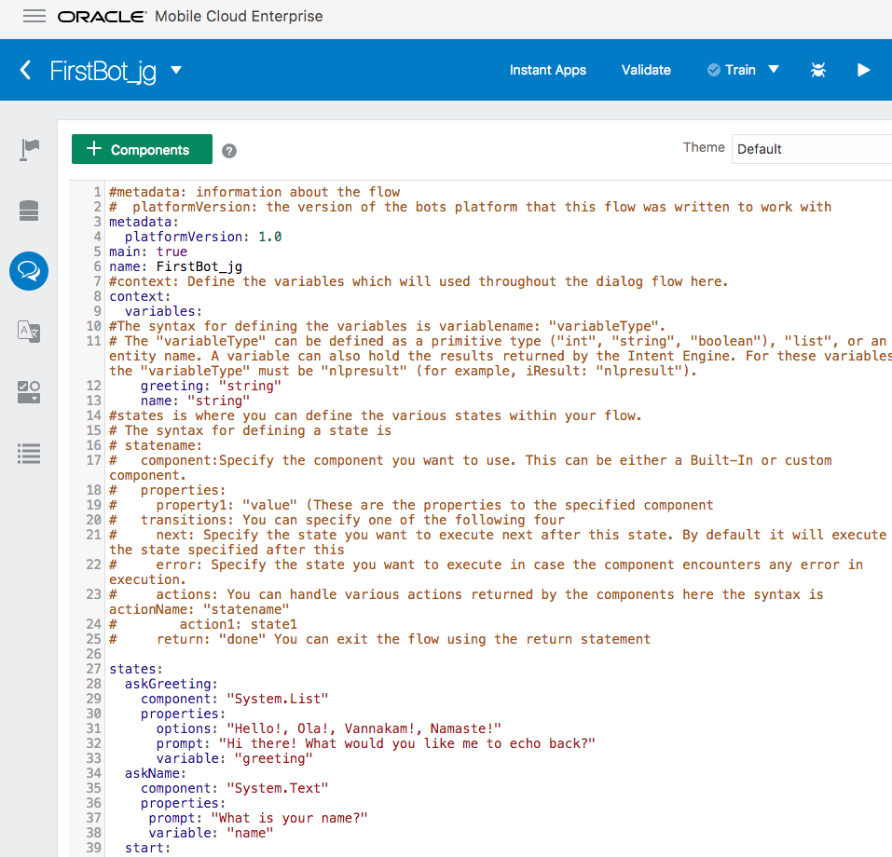

1. Now, click the Components icon. Later on, you’ll see your custom components that provide your chatbot with various functions and data. But since you've just started, there are no predefined services that obtain the custom components.

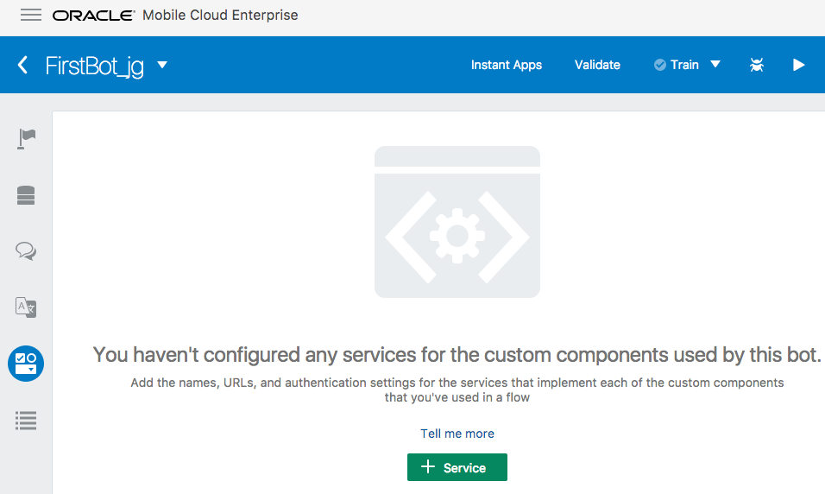

1. Finally, click the Settings icon. Notice its tabs: General and Channels.
2. The General tab contains general details about the chatbot and some properties that influence how the chatbot is trained. You’ll find out more about that later.
3. The Channels tab is where you'll publicize your bot by hooking it up to Facebook Messenger. That too is something that you’ll do in another lab.

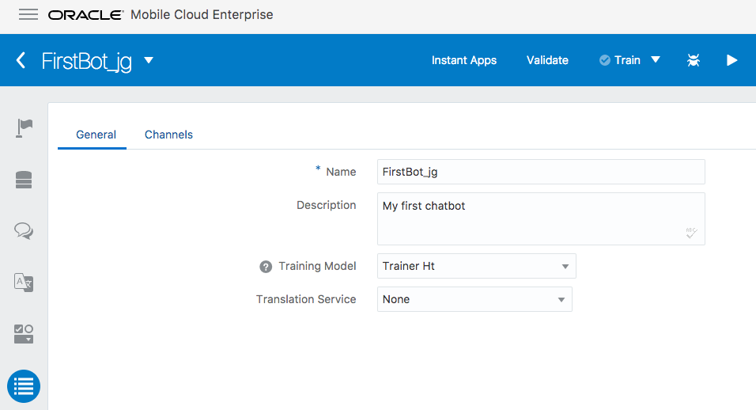

In the next section, you add artifacts to make the chatbot work.

1. First we will create intents for our bot. We could manually add the intents, but you can also add intents quickly by importing them from a CSV file.

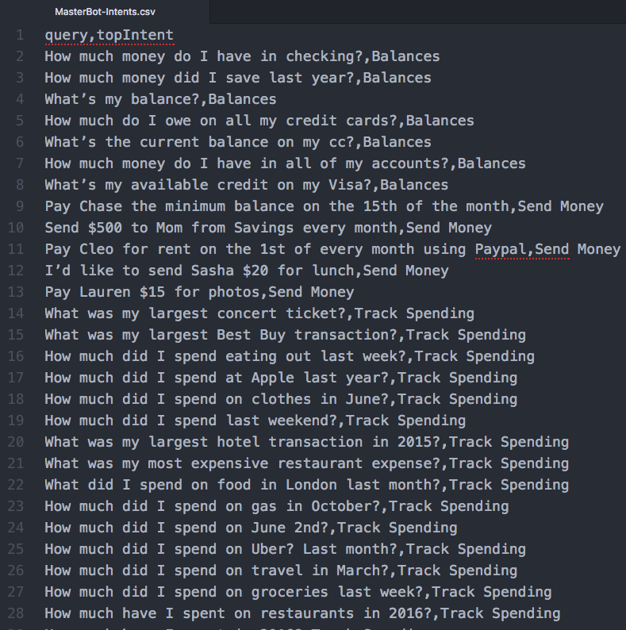

1. Click the Intents icon in the left navbar. In the middle of the Intents page, click the **Import Intents** button and select the MasterBot-Intents.csv file found in the /labfiles/code/ directory.
2. Next, click **Open**.
3. Three intents should be imported: Balances, Send Money, and Track Spending. Each intent has its own set of utterances.
4. To get a better idea of the how the language used in these utterances differentiates each of the intents, click each intent and take a look at their respective example phrases.

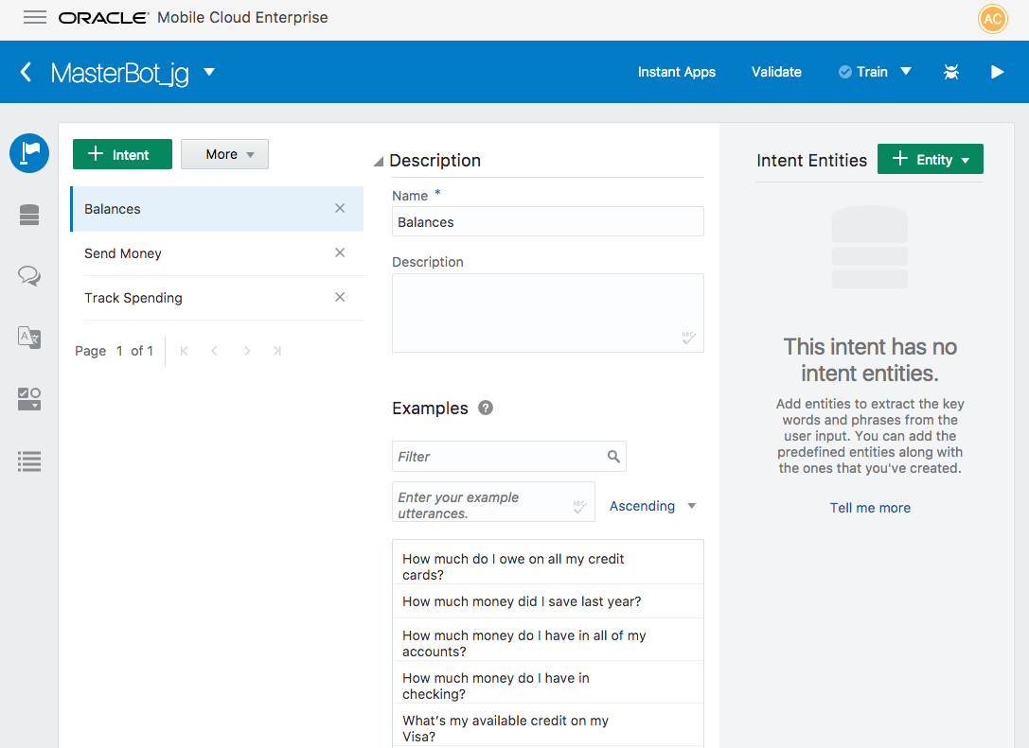

1. Now you’re going to add some custom entities. First, click the Entities icon in the left navbar and then add the AccountType entity as a value list entity. Press the green Entity button and change the name to AccountType.
2. Press the green Value button to add a value and synonym. Add these values and synonyms to the AccountType value list entity:

|  |  |  |
| --- | --- | --- |
| **Entity Name** | **Values** | **Synonyms** |
| AccountType | checking  savings  credit card | (no synonym)  save  Visa, Amex, card |

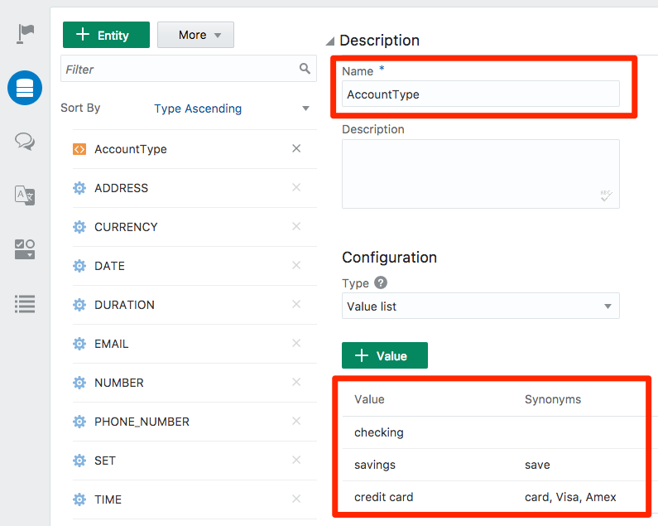

1. Now, using the tables below, add a couple more custom Value list entities (again press the green Entity button).
   1. The first one, ToAccount, is for the recipients of money transfers.

|  |  |  |
| --- | --- | --- |
| **Entity Name** | **Values** | **Synonyms** |
| ToAccount | Lauren  Shea  Mom  Chase Preferred  the baby sitter | sister  daughter  mother  Chase  babysitter |

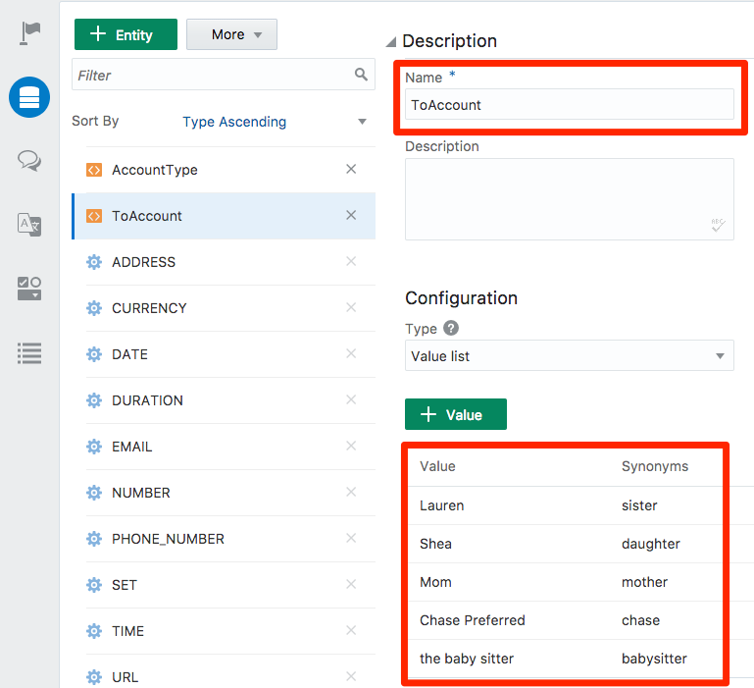

* 1. The second custom entity, TrackSpendingCategory, defines the categories used to track spending. This entity has no synonyms.

|  |  |
| --- | --- |
| **Entity Name** | **Values** |
| TrackSpendingCategory | gas  retail  travel  uber  restaurants  coffee  grocery |

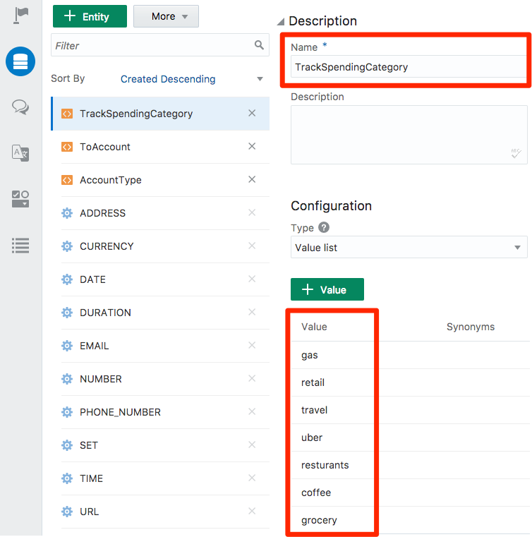

1. Now that you have intents and entities, go back to Intents page and assign the following associations:
   1. Use the green Add Entity button to select the entity.

|  |  |
| --- | --- |
| **Intent** | **Entity** |
| Balances | AccountType |

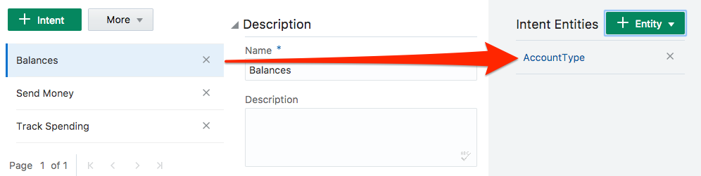

* 1. Now associate the Send Money intent with its entities.

|  |  |
| --- | --- |
| **Intent** | **Entities** |
| Send Money | AccountType  CURRENCY (system entity)  ToAccount |

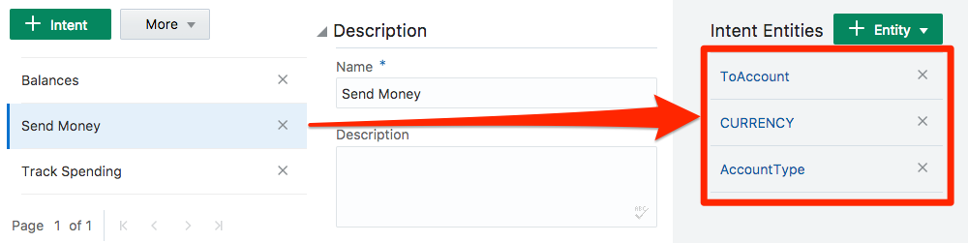

* 1. Finally, associate the Track Spending intent with its entities.

|  |  |
| --- | --- |
| **Intent** | **Entities** |
| TrackSpending | DATE (system entity)  DURATION (system entity)  TrackSpendingCategory |

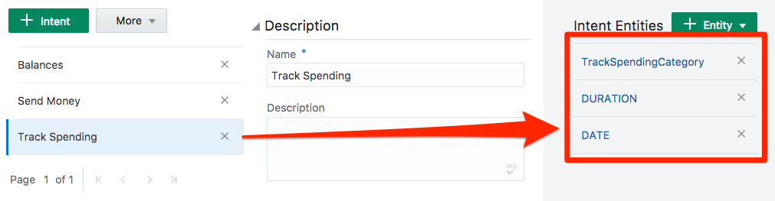

In the next section, you will train the chatbot and then test the intents.

### Step 2: Test the Results

In this section, you will test the intents that you’ve just created.

1. In the upper-right side of the page, click the **Train** button to test the chatbot. Since you’ve added a few intents, the training process could take a couple of seconds. When the training is complete, the **Train** button will gray out a display a check mark.

Sample chart

1. Even though we’ve set up the Send Money and Track Spending intents, we are going to explore the Neural Net and Natural Language Processing (NLP) pipelines through the lens of the Balances intent instead.

Click the **Play** icon to open the Tester.

Sample chart

1. To examine how the training worked, click Intent tab in the Tester.
2. Then in the Message area, enter *What’s the balance in my checking account?* and then click **Send**.

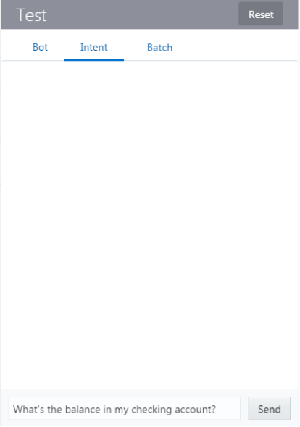

The Tester displays a list of all of the intents that you’ve added, each with a confidence percentage.

1. Notice how the Balances intent is first in the list of intents because the message that you just sent is specifically about balances. Don’t worry if your Balances is ranked at 100% instead of below picture.

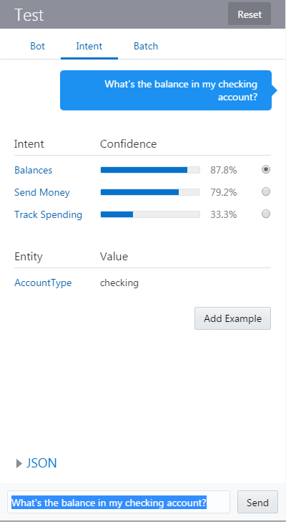

1. Now, click **JSON** (located above the message area) to see what has been returned by the algorithms. Using the slider bar to scroll down, you can see the account type and intent matches.

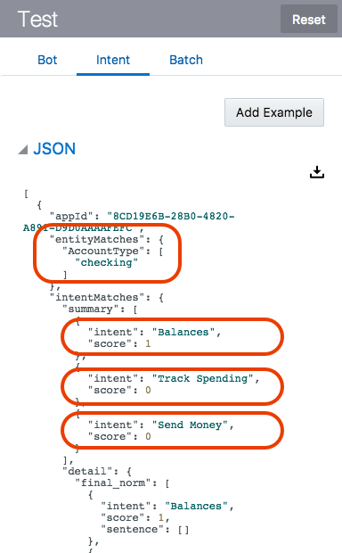

1. Click the **Reset** button.
2. Now let's try a different message: *What’s on the credit card*.
3. Now at this point, you may actually encounter an issue where the A.I. engine identifies an intent that you didn’t expect as the more likely candidate to resolve the input. For example, in the following image, you can see that the Balances intent is rated higher than the Track Spending intent for the input, *What’s on the credit card*.

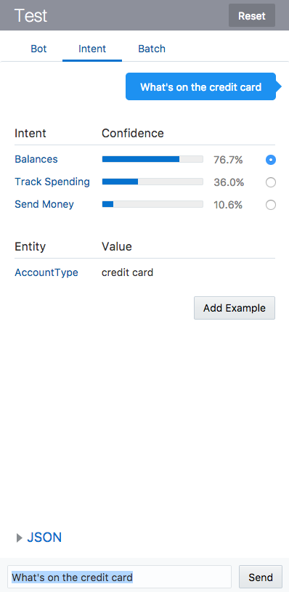

1. When this happens, you can increase the confidence level and the intent accuracy by first selecting the radio button by the correct intent and then by clicking the **Add Example** button. Doing this adds the text from the Message area as an utterance for the selected intent.

Be sure that the radio button by the **Track Spending** intent is selected and then click the **Add Example** button.

1. Next, train your chatbot again with this new example phrase. **Press the Train button again.**

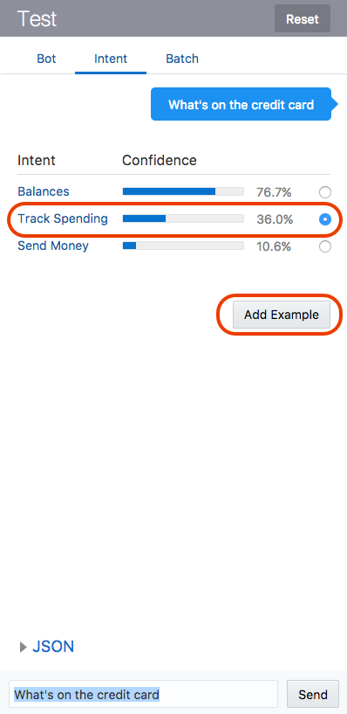

1. Click **Reset** and then enter the same statement (*What’s on the credit card*) again. Click **Send**.

The Track Spending intent should now be at the top of list because you added the new utterance and retrained the chatbot. By testing it with additional values, you can increase the pool of example utterances that your intent uses, making it more accurate.

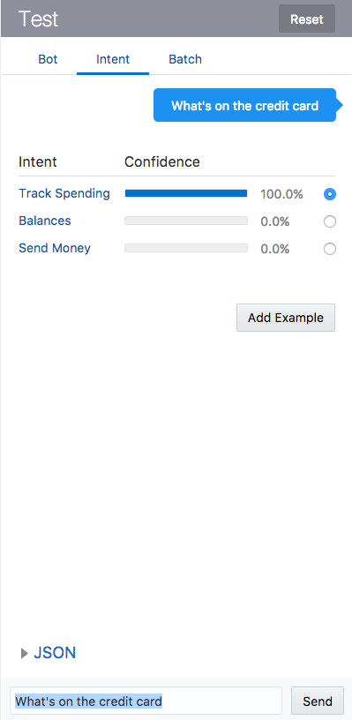

You’re done with your first lab! Good job!