Forecasting Dengue Fever in Thailand Using Cross-Country Case Correlation and Weather Features

Peerawut Eiamin
Burapha University
Chonburi, Thailand
https://orcid.org/0009-0008-6775-7290
line 1: 2nd Given Name Surname
line 2: dept. name of organization
(of Affiliation)
line 3: name of organization
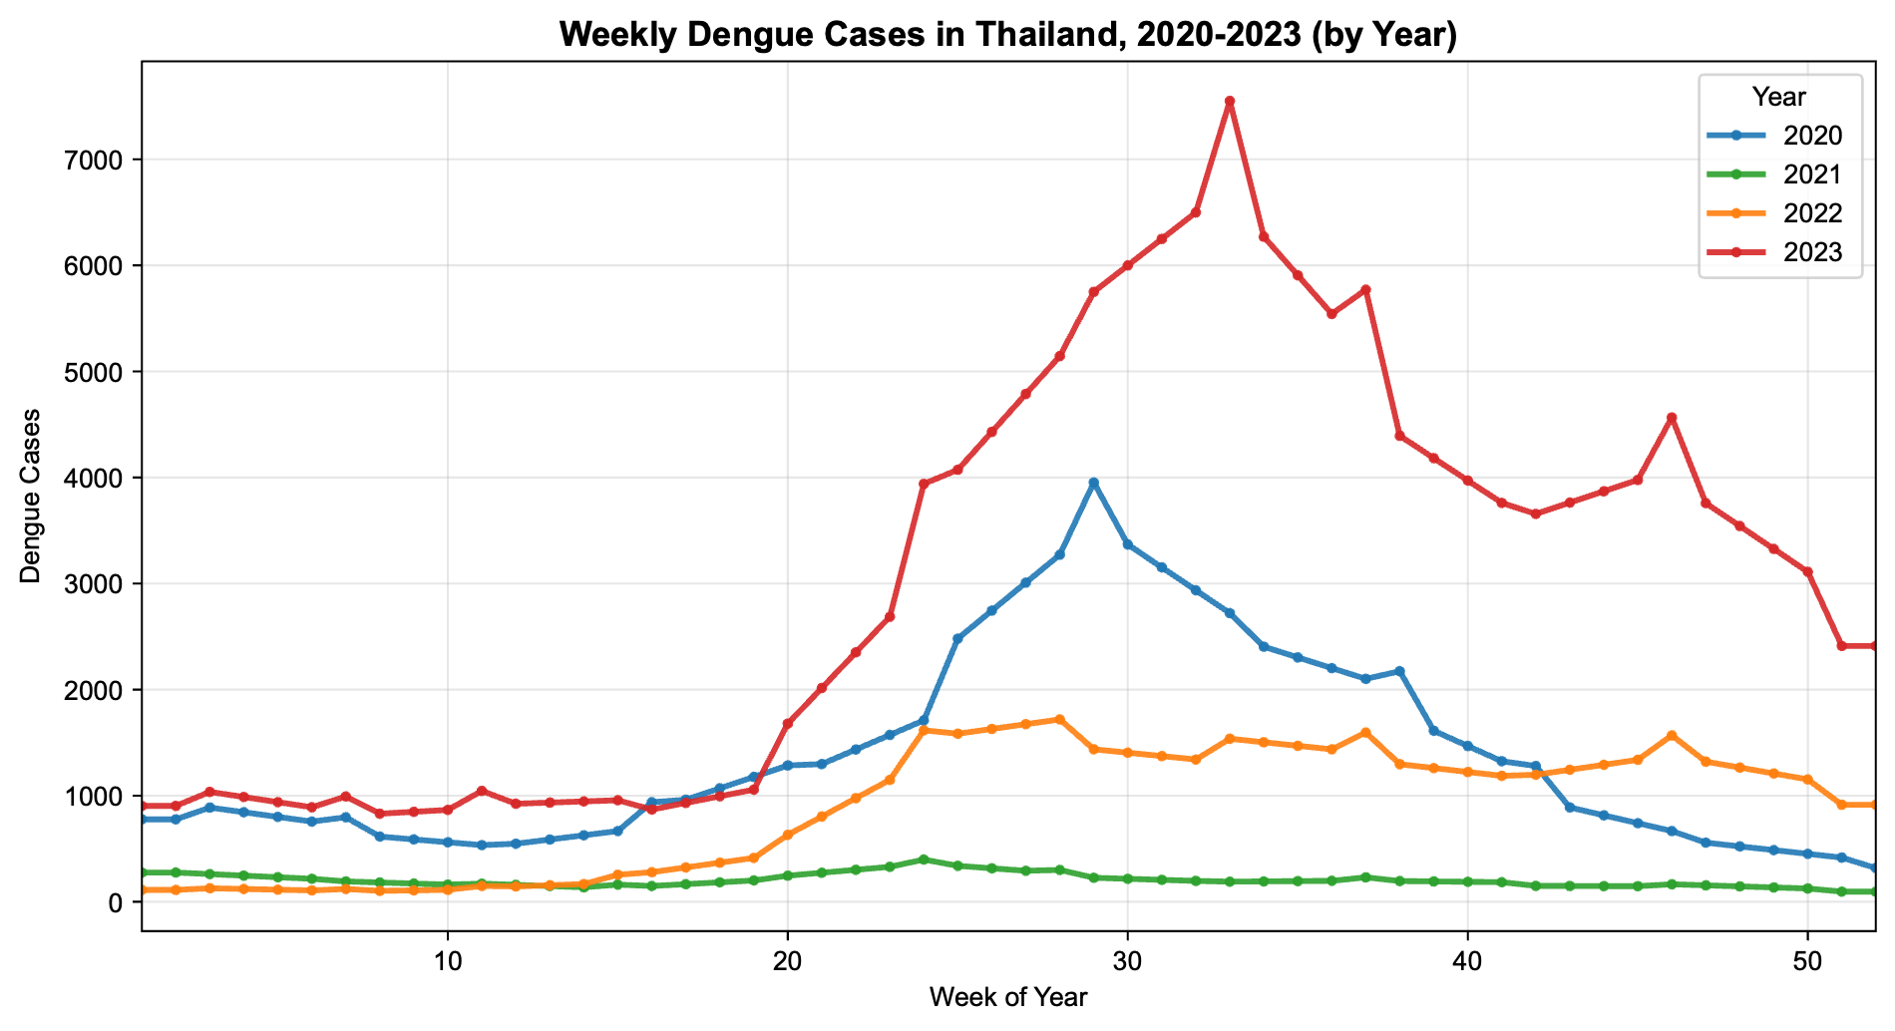
Thanin Methiyothin*
Burapha University
Chonburi, Thailand
https://orcid.org/0000-0002-8868-8035

Abstract— Dengue remains a major public health concern in Thailand, where seasonal outbreaks are interrupted by irregular jump years [1], [2]. This paper compares four XGBoost configurations against a SARIMA baseline for one-year-ahead weekly dengue forecasting. Besides a Thailand Self-lag configuration, we evaluate three country-plus-feature XGBoost configurations selected after correlation screening and backward pruning: Lao PDR (cases and average temperature), South Korea (cases and precipitation), and Guatemala (cases and maximum temperature). Parameters were chosen by walk-forward validation (train 2021–2022, validate 2023) and applied to production training on 2022–2023 to forecast 2024. Using RMSE and MAE, the Korea (precipitation) configuration and the Lao PDR (weather) configuration achieved the lowest absolute errors and clearly outperformed both SARIMA and the Thailand Self-lag configuration.
Keywords—dengue forecasting, time-series analysis, SARIMA, XGBoost, cross-country correlation, weather variables, epidemic surveillance, walk-forward validation.

Introduction
Dengue fever is transmitted mainly by Aedes mosquitoes and remains among WHO's priority global health threats [1], [2]. In Thailand, cases rise in the rainy season, with abnormal jump years every few years [3]. Weekly case counts from 2020–2023 show this clearly: 2023 was by far the largest outbreak year in this window, well beyond what the usual seasonal cycle would suggest (Fig. 1).
This 2023 spike was not confined to Thailand. Similar jumps appear in South Korea and Guatemala over the same period (Figs. 2 and 3), consistent with broader regional synchrony in dengue activity [3], [4]. We therefore test whether lagged dengue counts, and selected weather variables known to influence mosquito-borne transmission [5], from a correlated country can improve Thailand forecasts beyond domestic self-lags.
This study aims to test whether dengue surveillance data from a single well-correlated country can improve one-year-ahead forecasting for Thailand beyond what Thailand's own case history provides. We compare a SARIMA baseline against four XGBoost configurations: one built solely from Thailand's own case history, and three built from a single correlated country's case data plus one weather variable, Lao PDR (weather), South Korea (precipitation), and Guatemala (weather), selected through correlation screening and refined through backward pruning. All XGBoost configurations use temporally ordered tuning and a 2024 production test year.

Fig. 1. Weekly dengue case counts in Thailand, 2020–2023

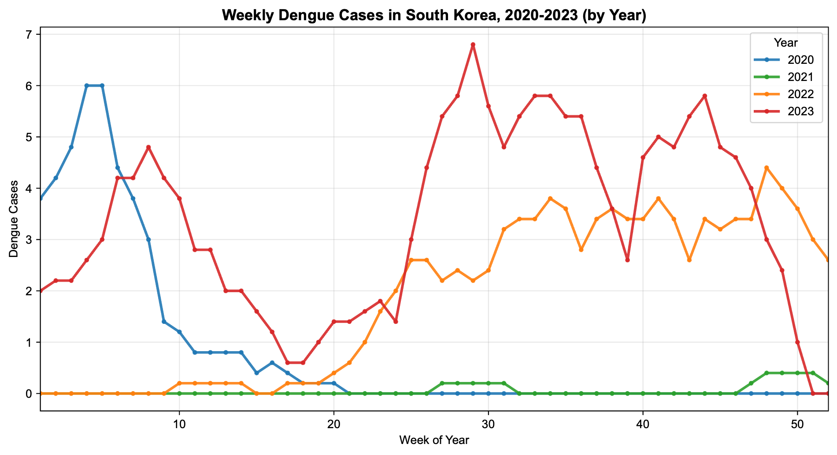
Fig. 2. Weekly dengue case counts in South Korea, 2020–2023.

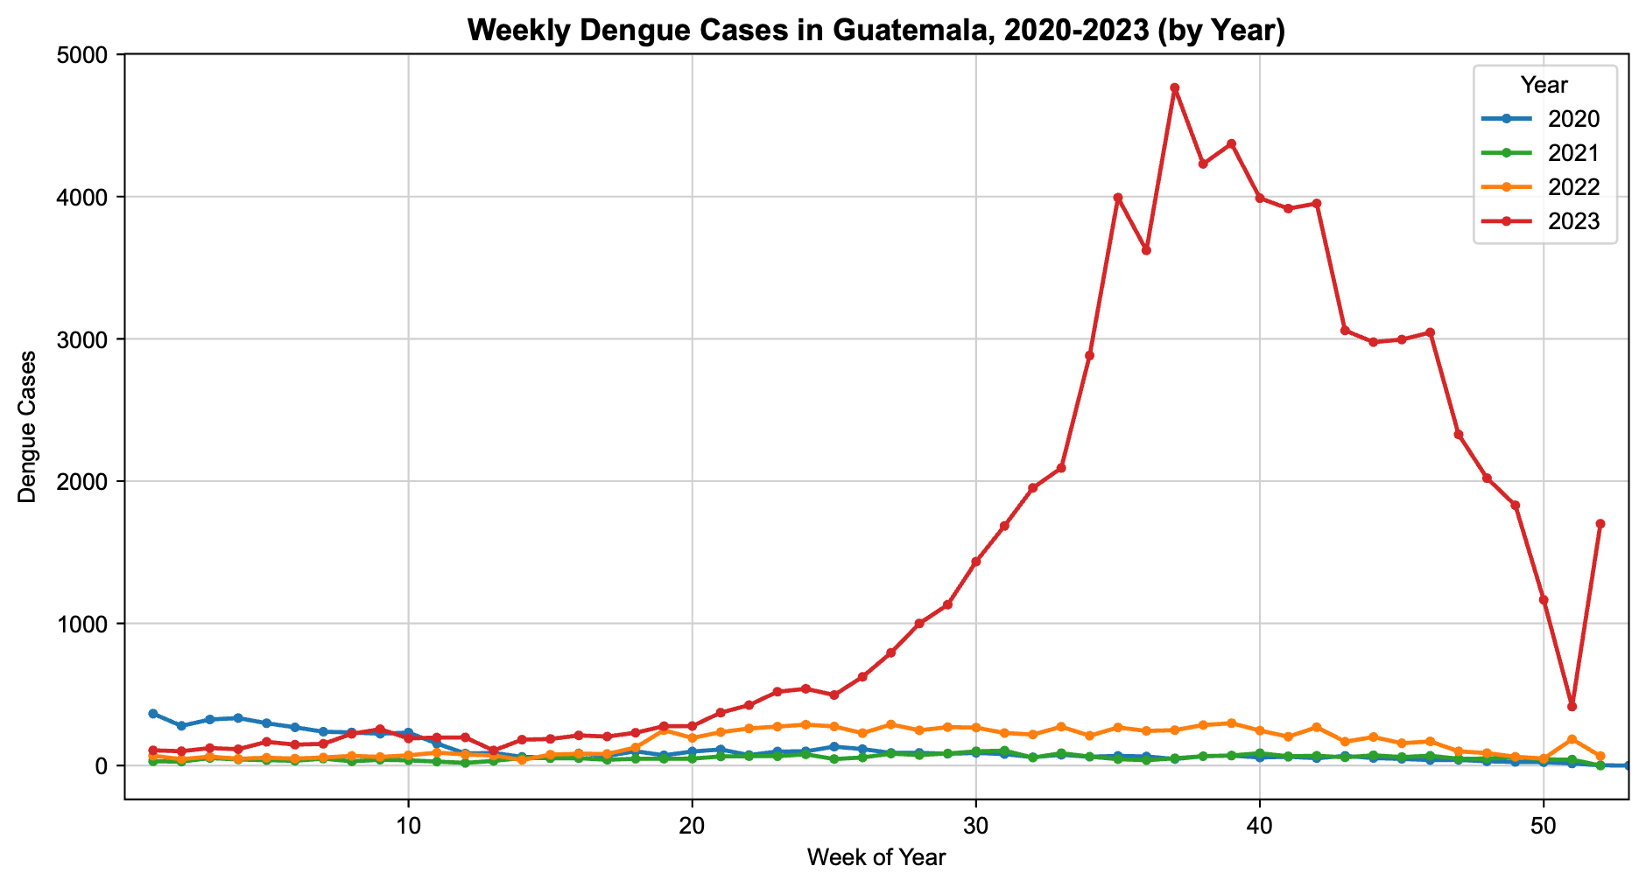
Fig. 3. Weekly dengue case counts in Guatemala, 2020–2023.

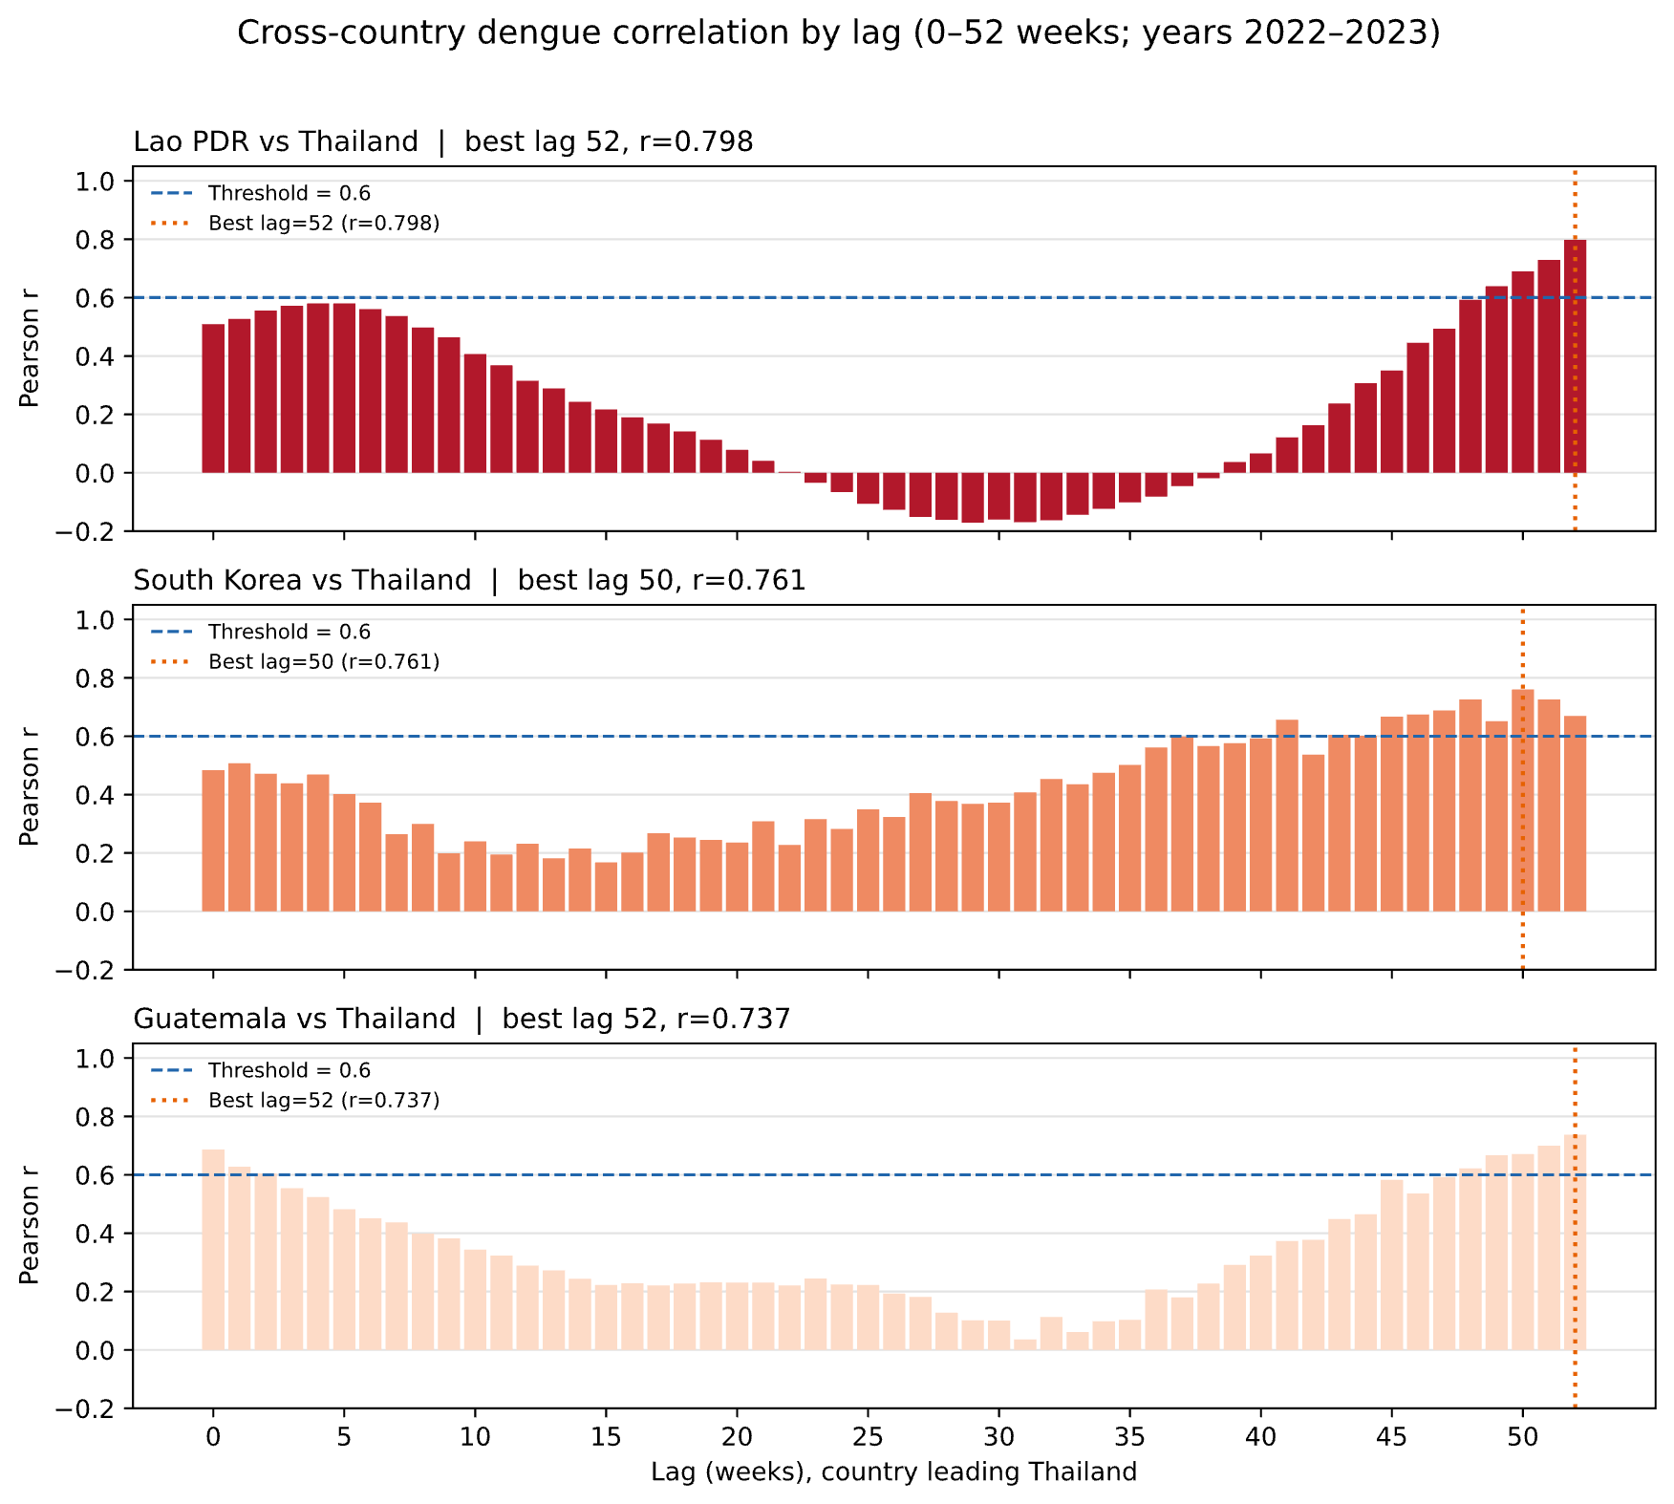
Methods

Data Collection and Lag Construction
Thailand weekly cases came from the ASEAN-South Korea Collaborative Platform for GFID Project [6]; other countries from OpenDengue [7]; weather (TMAX, TMIN, TAVG, PRCP) from NOAA [8]. Thai monthly totals were disaggregated to weekly values. Country-count lags used weeks 2–52; weather lags used 0–52.

Feature Selection via Cross-Correlation Analysis
Pearson correlations were computed on 2022–2023 only. For each country we kept the best lag, defined as the lag with the largest absolute correlation, requiring a lag of at least 2 weeks and an absolute correlation of at least 0.6. Weather variables used the same absolute-correlation gate. From this screen we focus on three country settings that remain informative after pruning: Lao PDR, South Korea, and Guatemala. Thailand Self-lag starts from Thai lags with self-correlation of at least 0.6 and is then pruned.

Feature Refinement via Backward Pruning
After screening, each XGBoost feature set was refined by backward pruning: train the model, rank features by gain-based importance, drop the weakest weather feature (or weakest self-lag), retrain, and keep the best absolute-error subset. Lao PDR dropped TMAX lag 13 and retained cases lag 52 with TAVG lag 10. South Korea retained cases lag 50 with PRCP lag 51. Guatemala retained cases lag 52 with TMAX lag 9 after dropping weaker temperature lags. Thailand Self-lag was reduced to 14 lags.

Prediction Configurations and Walk-Forward Parameter Selection
We used SARIMA [9] and XGBoost [10]. SARIMA is the traditional statistical time-series baseline most widely used for dengue and other infectious-disease forecasting [11].
φ(B)Φ(Bˢ)(1−B)ᵈ(1−Bˢ)ᴰ yₜ = θ(B)Θ(Bˢ) εₜ 
XGBoost minimizes a regularized objective:
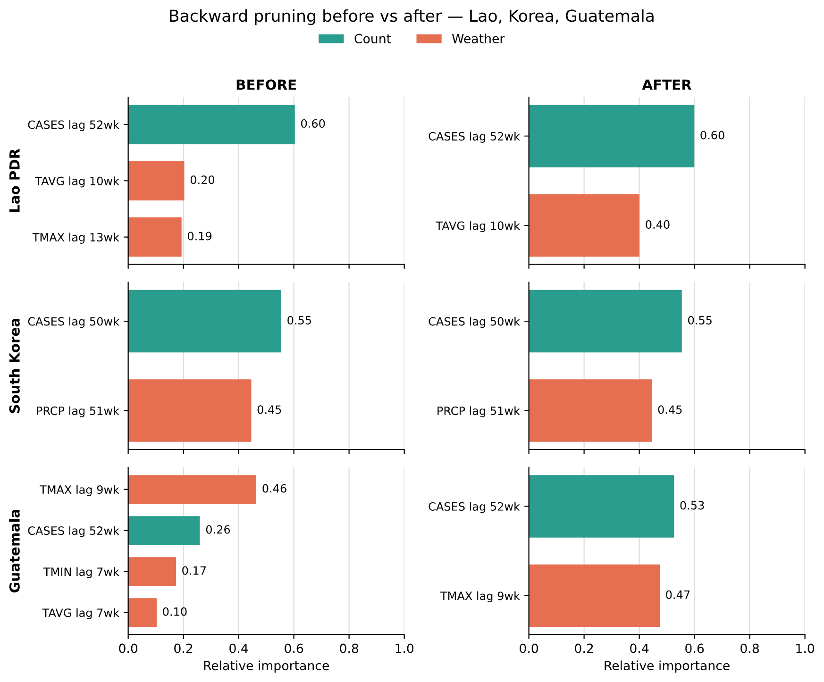
Objₜ = Σᵢ l(yᵢ, ŷᵢ⁽ᵗ⁻¹⁾ + fₜ(xᵢ)) + Ω(fₜ) 2
After features were fixed, hyperparameters were selected by walk-forward validation: train 2021–2022, validate 2023 (lowest validation RMSE). Production configurations were then retrained on 2022–2023 with those parameters and used to forecast 2024. Primary metrics are RMSE and MAE.

Results

Cross-Correlation Screening Results
After correlation screening, we focus on three country settings that support weather-augmented configurations after pruning: Lao PDR (r = 0.798, lag 52), South Korea (r = 0.761, lag 50), and Guatemala (r = 0.737, lag 52). Fig. 4 shows Pearson correlation with Thailand across all lags 0–52 weeks for these countries.

Fig. 4. Pearson correlation of Lao PDR, South Korea, and Guatemala dengue counts with Thailand across lags 0–52 weeks (2022–2023).

Feature Refinement via Backward Pruning
Fig. 5 shows feature importance before and after pruning for Lao PDR, South Korea, and Guatemala; Table I reports every pruning step. Backward pruning trains the model, removes the weakest-contributing feature, and retrains, repeating until only the case count lag remains; the step with the lowest error is kept as the final configuration. For Lao PDR and Guatemala, dropping the weakest temperature feature lowered the error, so their final configurations pair the case count lag with one temperature variable. For South Korea, removing precipitation raised the error, so both features were kept. Thailand Self-lag has no weather feature to remove, so its fourteen self-correlated lags were kept without further pruning. Across all three country configurations, the case count lag remains the dominant feature, while a weather feature is kept only when removing it lowers the error.
Fig. 5. Feature importance before (left) and after (right) backward pruning for Lao PDR, South Korea, and Guatemala.

- Backward Pruning Steps
Configuration | Step | Features Used | RMSE | MAE
Lao PDR | 1 | count52, TMAX13, TAVG10 | 2229 | 1803
Lao PDR | 2 | count52, TAVG10 | 1974 | 1526
Lao PDR | 3 | count52 only | 2103 | 1571
South Korea | 1 | count50, PRCP51 | 2020 | 1567
South Korea | 2 | count50 only | 2609 | 2200
Guatemala | 1 | count52, TMAX9, TMIN7, TAVG7 | 2455 | 1897
Guatemala | 2 | count52, TMAX9, TMIN7 | 2469 | 1911
Guatemala | 3 | count52, TMAX9 | 2379 | 2065
Guatemala | 4 | count52 only | 3991 | 3422

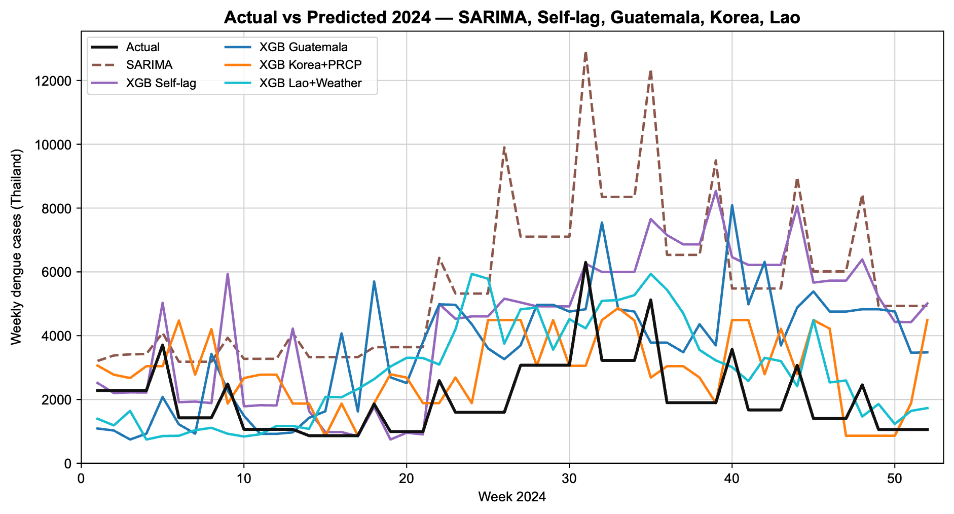
A configuration marked Yes in the Selected column is the feature subset used in the final model for that country. All steps above use the same starting XGBoost settings, four hundred trees, maximum tree depth of three, and a learning rate of point zero five, trained on 2022 and 2023 and tested on 2024. The tuned settings used in the final production forecasts appear in Table III.

Parameter Selection Results
- Reports the parameters selected on validation year 2023
Configuration | Best Parameters (Tuning Step) | Val. RMSE (2023)
SARIMA | (1,1,1)(0,1,1)[52] | 2,105
XGBoost Thailand Self-lag | n=200, depth=2, lr=0.1 | 2,334
XGBoost Guatemala | n=600, depth=3, lr=0.1 | 3,501
XGBoost Lao PDR | n=200, depth=3, lr=0.02 | 3,509
XGBoost Korea | n=200, depth=2, lr=0.02 | 3,572

The three country configurations settled on a lower learning rate (0.02) than the Thailand Self-lag configuration (0.1), suggesting the cross-country signal needed smaller, more conservative updates to avoid overfitting the two-year training window. Guatemala also required three times as many trees (600) as the other XGBoost configurations (200) to reach its best validation score. On this 2023 validation year, SARIMA and Thailand Self-lag had the lowest RMSE (2,105 and 2,334) while the three country configurations scored highest (3,501–3,572); Section III-D shows this ordering reverses once the same tuned parameters are retrained and evaluated on the milder 2024 production year, where the country configurations pull ahead.

Production Forecasting Results
Table III summarizes 2024 production performance. SARIMA is the sole Thailand-only baseline; Thailand Self-lag and the three country configurations are all XGBoost configurations compared against it, with the three country configurations additionally using pruned count/weather features with parameters from Table II.
- Production Forecasting Results for 2024
Configuration | RMSE | MAE
SARIMA | 3,965 | 3,565
XGBoost Thailand Self-lag | 2,968 | 2,344
XGBoost Guatemala | 2,331 | 1,996
XGBoost Lao PDR | 1,730 | 1,407
XGBoost Korea | 1,622 | 1,293

The Korea (precipitation) model achieved the lowest RMSE (1,622), followed by the Lao PDR (weather) model (1,730). The Guatemala (weather) model (2,331) also beat both the SARIMA baseline (3,965) and the Thailand Self-lag configuration (2,968). Fig. 6 compares actual and predicted weekly counts for all five configurations.
Fig. 6. Actual versus predicted weekly dengue case counts for Thailand in 2024 (SARIMA, Self-lag, Guatemala, Korea, Lao).

Discussion
The clearest result here is that South Korea gave the best forecasts of all five configurations. The XGBoost Korea (precipitation) configuration had the lowest RMSE and MAE overall, narrowly ahead of Lao PDR (weather) and more clearly ahead of Guatemala (weather), SARIMA, and the XGBoost Thailand Self-lag configuration. What makes this notable is that South Korea's dengue cases are driven mainly by travel-associated importation rather than local transmission, unlike Lao PDR, an endemic neighboring country that still came a close second. That an import-driven setting outperformed an endemic one suggests the underlying signal is not just about geographic or epidemiological similarity to Thailand, but about how cleanly a country's case timing lines up with Thailand's, which is exactly what the correlation-based screening step was designed to capture. All three cross-country configurations beat both the SARIMA baseline and the Thailand Self-lag configuration: the feature importance results back this up, since across all three configurations the case count lag from the correlated country does most of the work, with the accompanying weather variable adding only a modest contribution on top, kept only when it actually lowers error during pruning. This is a meaningful result in its own right: it shows that a full year-ahead forecast of Thailand's dengue case counts is achievable using case data from a single correlated country plus one weather variable, without waiting on any of Thailand's own recent numbers, and that South Korea's data in particular is worth prioritizing if only one external source can be maintained. SARIMA, the sole baseline, came out with the highest RMSE of all five configurations, mostly because it over-predicted case counts by a wide margin throughout 2024, a year in which the actual outbreak was much milder than the 2022–2023 training period. The XGBoost Thailand Self-lag configuration, while still built purely from Thailand's own case history like SARIMA, benefited from XGBoost's more flexible tree-based structure and came out clearly ahead of SARIMA, though it never closed the gap with any of the three cross-country configurations, and fell furthest behind Korea specifically.

Conclusion
This study compared five configurations, one SARIMA baseline and four XGBoost configurations (Thailand Self-lag, Lao PDR, South Korea, and Guatemala), for one-year-ahead forecasting of weekly dengue case counts in Thailand, with parameters chosen through a temporally ordered train/validation/test split and evaluated on 2024. South Korea gave the best-performing configuration by a clear margin, with XGBoost combined with South Korea's case data and precipitation achieving the lowest RMSE and MAE of all five, ahead of the next-best Lao PDR case-and-temperature configuration. This shows that a full year-ahead forecast is within reach using a single correlated country's surveillance data, which is exactly the kind of lead time that matters for outbreak preparedness. That the top result came from South Korea, an import-driven setting, rather than Lao PDR, an endemic neighboring country, suggests the strength of a source country's correlation with Thailand matters more than whether its outbreaks are locally transmitted or travel-associated.
From a public health standpoint, these results suggest that surveillance data from a well-correlated country, endemic or import-driven, could serve as a practical early-warning signal, giving health authorities real lead time to prepare resources before a seasonal peak arrives.
A few limitations are worth noting. Thailand's underlying case data were originally reported monthly and had to be disaggregated into weekly values, which introduces a step-function artifact into the input series. The 2024 test year also happened to be an unusually mild outbreak year compared to the 2022–2023 training period, a distribution shift that none of the configurations were really built to anticipate. And only two years of data (2022–2023) were available for production training, both of which were fairly severe outbreak years, so the configurations may not generalize as well to milder years like 2024. Future work should look at using more years of training data and finding additional features that can help anticipate abnormal, low-incidence years.

Acknowledgment
The authors gratefully acknowledge support from the Faculty of Informatics, Burapha University, Chonburi, Thailand.

References
- A. Wilder-Smith and E. Schwartz, “Dengue in travelers,” N. Engl. J. Med., vol. 353, no. 9, pp. 924–932, Sep. 2005.
- World Health Organization, “Ten threats to global health in 2019,” Who, Jan. 2019.[Online]. Available: https://www.who.int/news-room/spotlight/ten-threats-to-global-health-in-2019
- B. García-Carreras et al., “Periodic synchronisation of dengue epidemics in Thailand over the last 5 decades driven by temperature and immunity,” PLOS Biol., vol. 20, no. 3, e3001160, Mar. 2022.
- W. G. van Panhuis et al., “Region-wide synchrony and traveling waves of dengue across eight countries in Southeast Asia,” Proc. Natl. Acad. Sci. U.S.A., vol. 112, no. 42, pp. 13069–13074, Oct. 2015.R. Nicole, “Title of paper with only first word capitalized,” J. Name Stand. Abbrev., in press.
- E. A. Mordecai et al., “Detecting the impact of temperature on transmission of Zika, dengue, and chikungunya using mechanistic models,” PLOS Negl. Trop. Dis., vol. 11, no. 4, e0005568, Apr. 2017.
- ASEAN-South Korea Collaborative Platform for GFID Project, Burapha University. [Online]. Available: https://aida.informatics.buu.ac.th/
- J. Clarke, A. Lim, P. Gupte, D. M. Pigott, W. G. van Panhuis, and O. J. Brady, “A global dataset of publicly available dengue case count data,” Sci. Data, vol. 11, art. 296, Mar. 2024.
- M. J. Menne, I. Durre, B. Korzeniewski, S. McNeill, K. Thomas, X. Yin, S. Anthony, R. Ray, R. S. Vose, B. E. Gleason, and T. G. Houston, “Global Historical Climatology Network - Daily (GHCN-Daily), Version 3,” NOAA National Climatic Data Center, 2012, doi: 10.7289/V5D21VHZ.
- G. E. P. Box, G. M. Jenkins, G. C. Reinsel, and G. M. Ljung, Time Series Analysis: Forecasting and Control, 5th ed. Hoboken, NJ, USA: Wiley, 2015.
- T. Chen and C. Guestrin, “XGBoost: A scalable tree boosting system,” in Proc. 22nd ACM SIGKDD Int. Conf. Knowledge Discovery and Data Mining (KDD), San Francisco, CA, USA, Aug. 2016, pp. 785–794.
- M. A. Johansson, N. G. Reich, A. Hota, J. S. Brownstein, and M. Santillana, “Evaluating the performance of infectious disease forecasts: A comparison of climate-driven and seasonal dengue forecasts for Mexico,” Sci. Rep., vol. 6, art. 33707, Sep. 2016.

