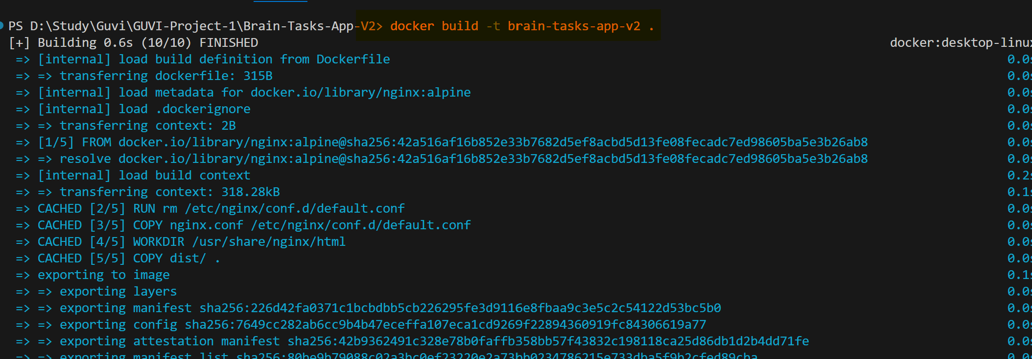

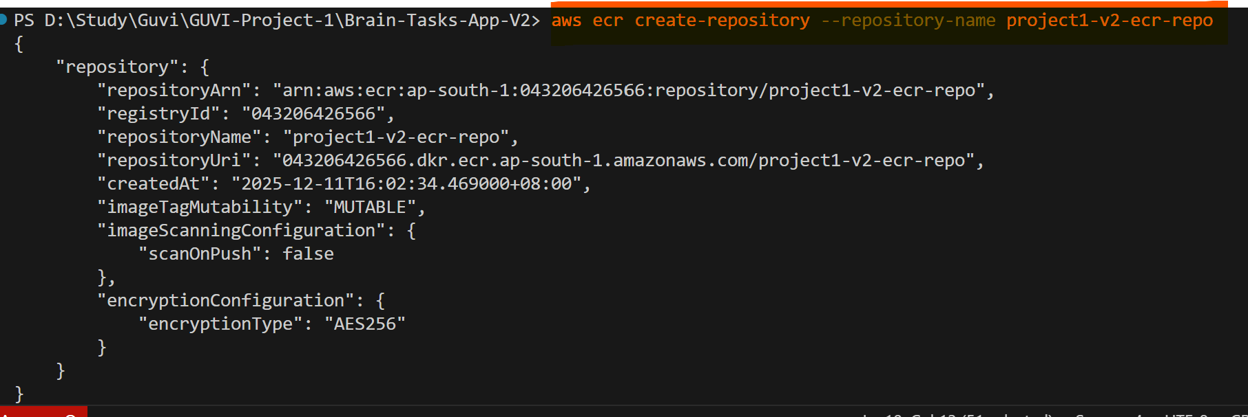

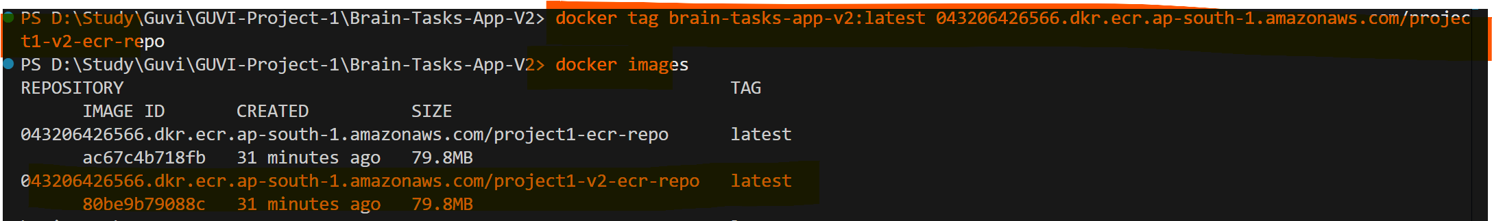

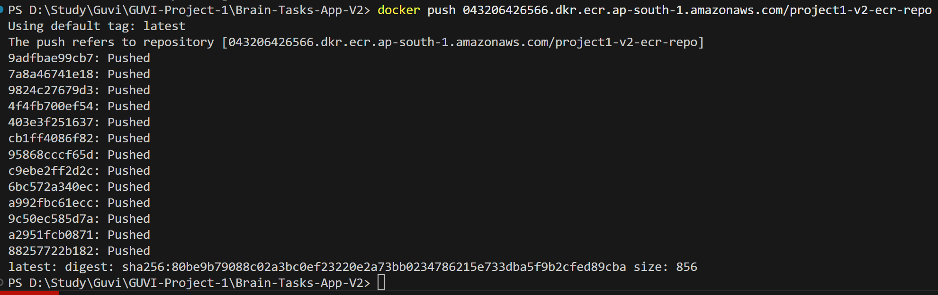

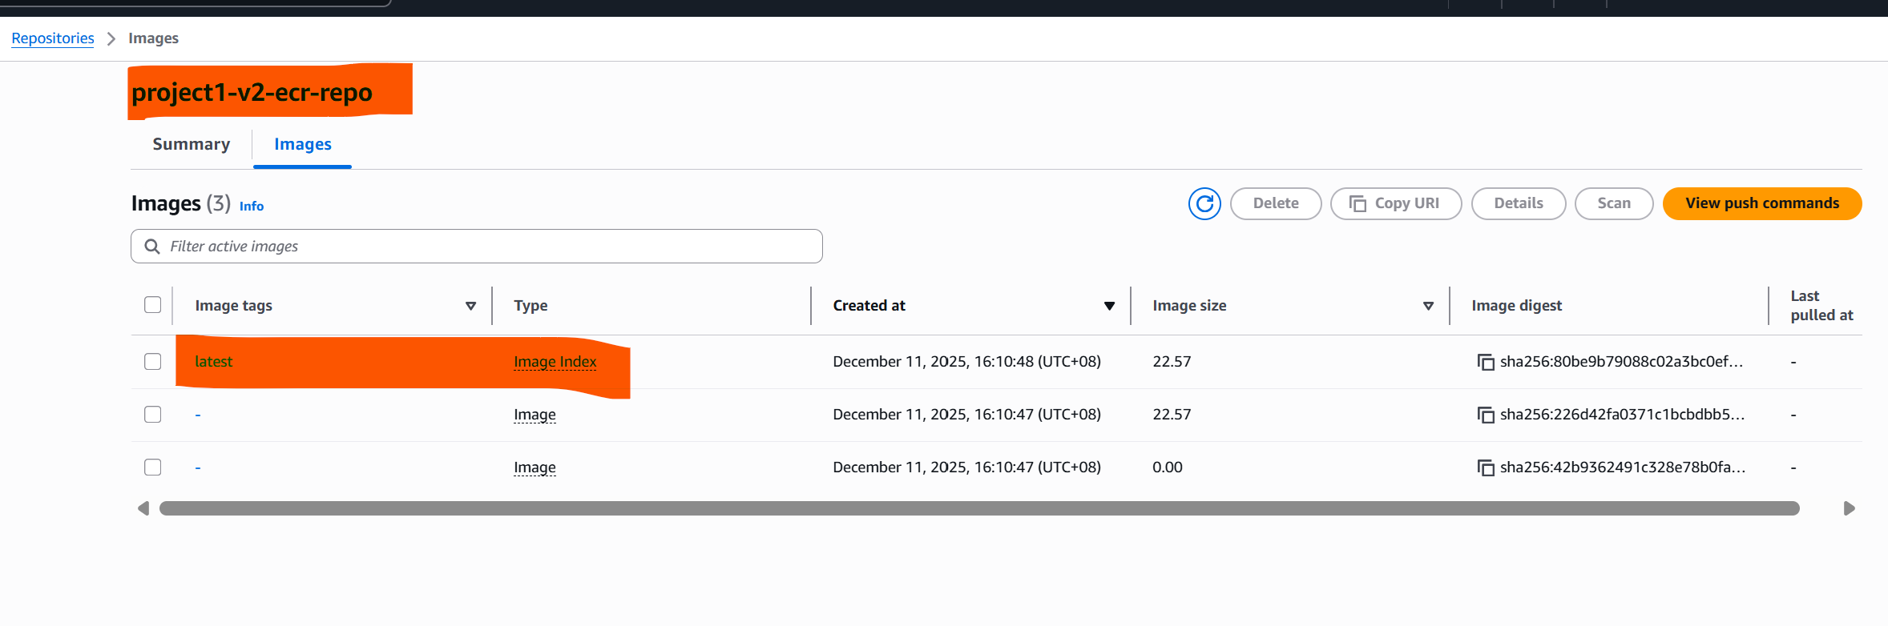

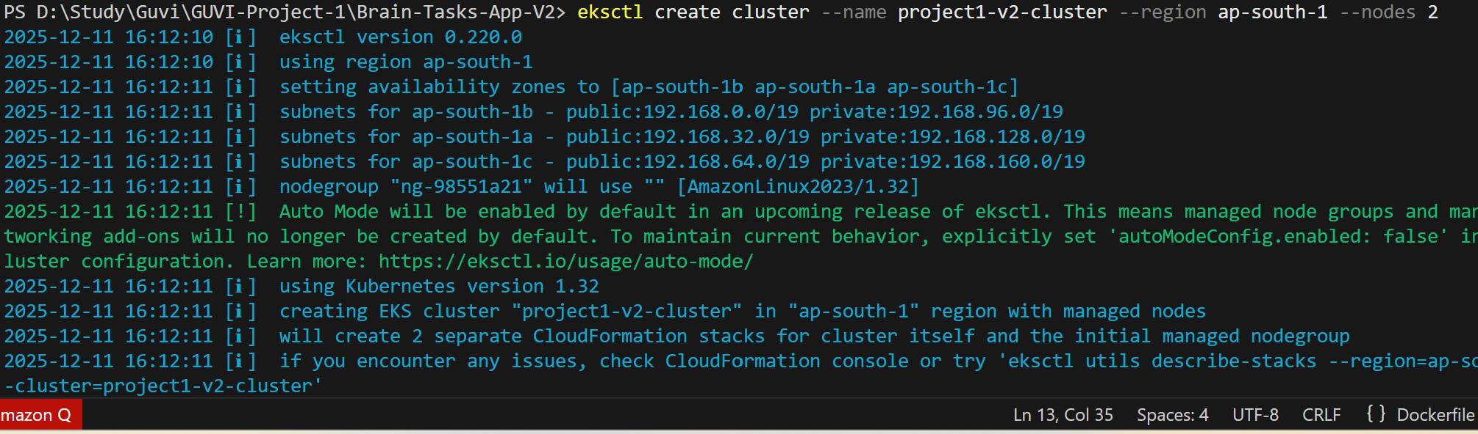

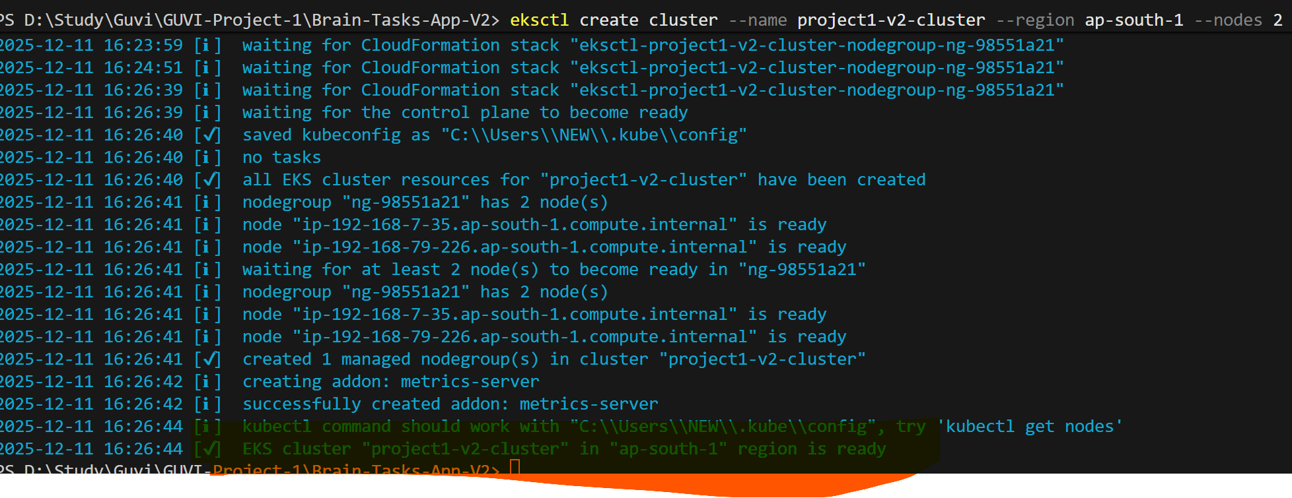

Created below IAM Access entry in EKS
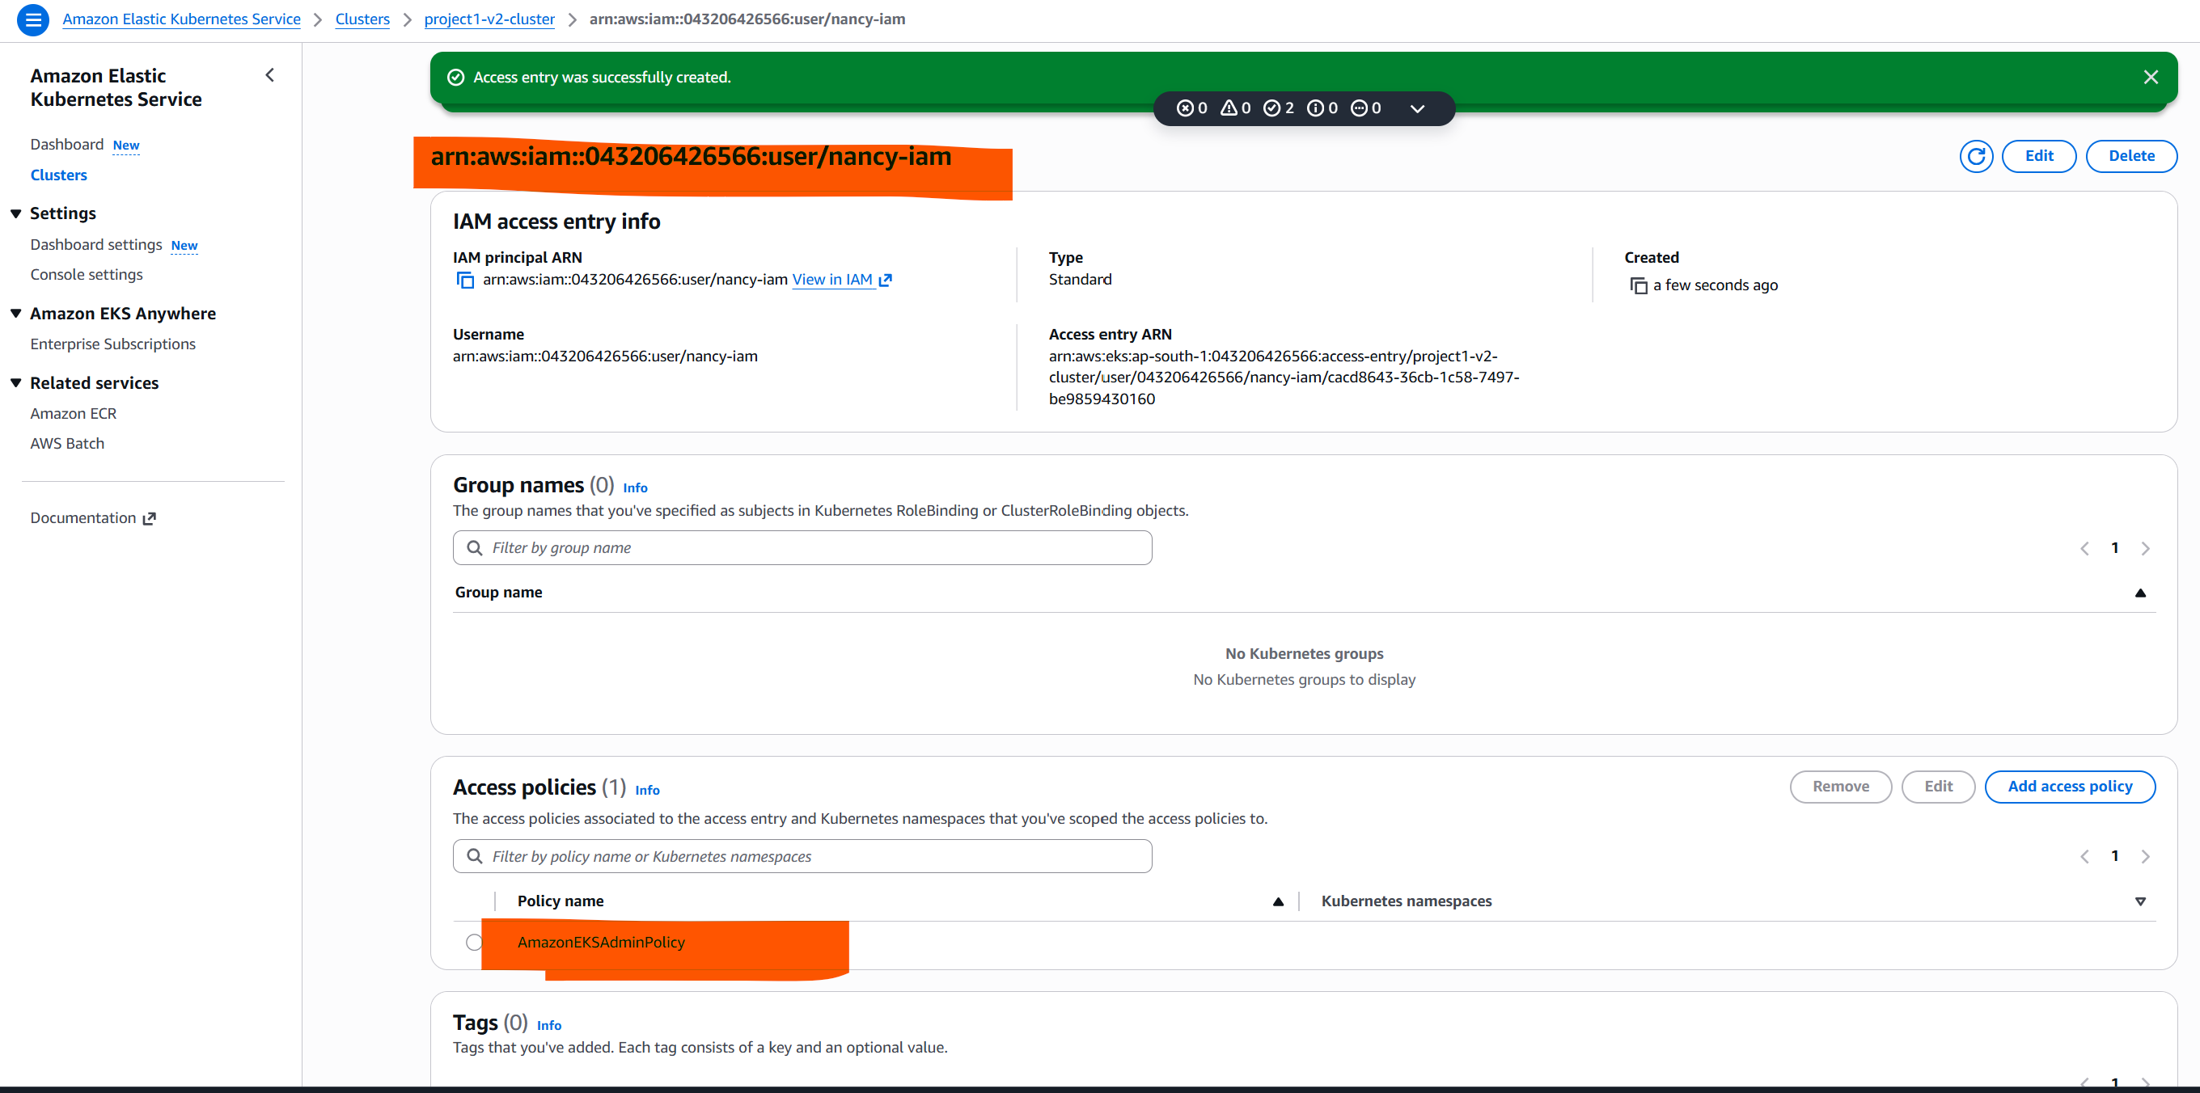

Step 5: Kubernetes Deployment & Service

Latest action execution message
Build terminated with state: FAILED. Phase: PRE_BUILD, Code: COMMAND_EXECUTION_ERROR, Message: Error while executing command: aws ecr get-login-password --region ap-south-1 | docker login --username AWS --password-stdin 043206426566.dkr.ecr.ap-south-1.amazonaws.com. Reason: exit status 1

IAM fix by adding policy in build pipeline service role
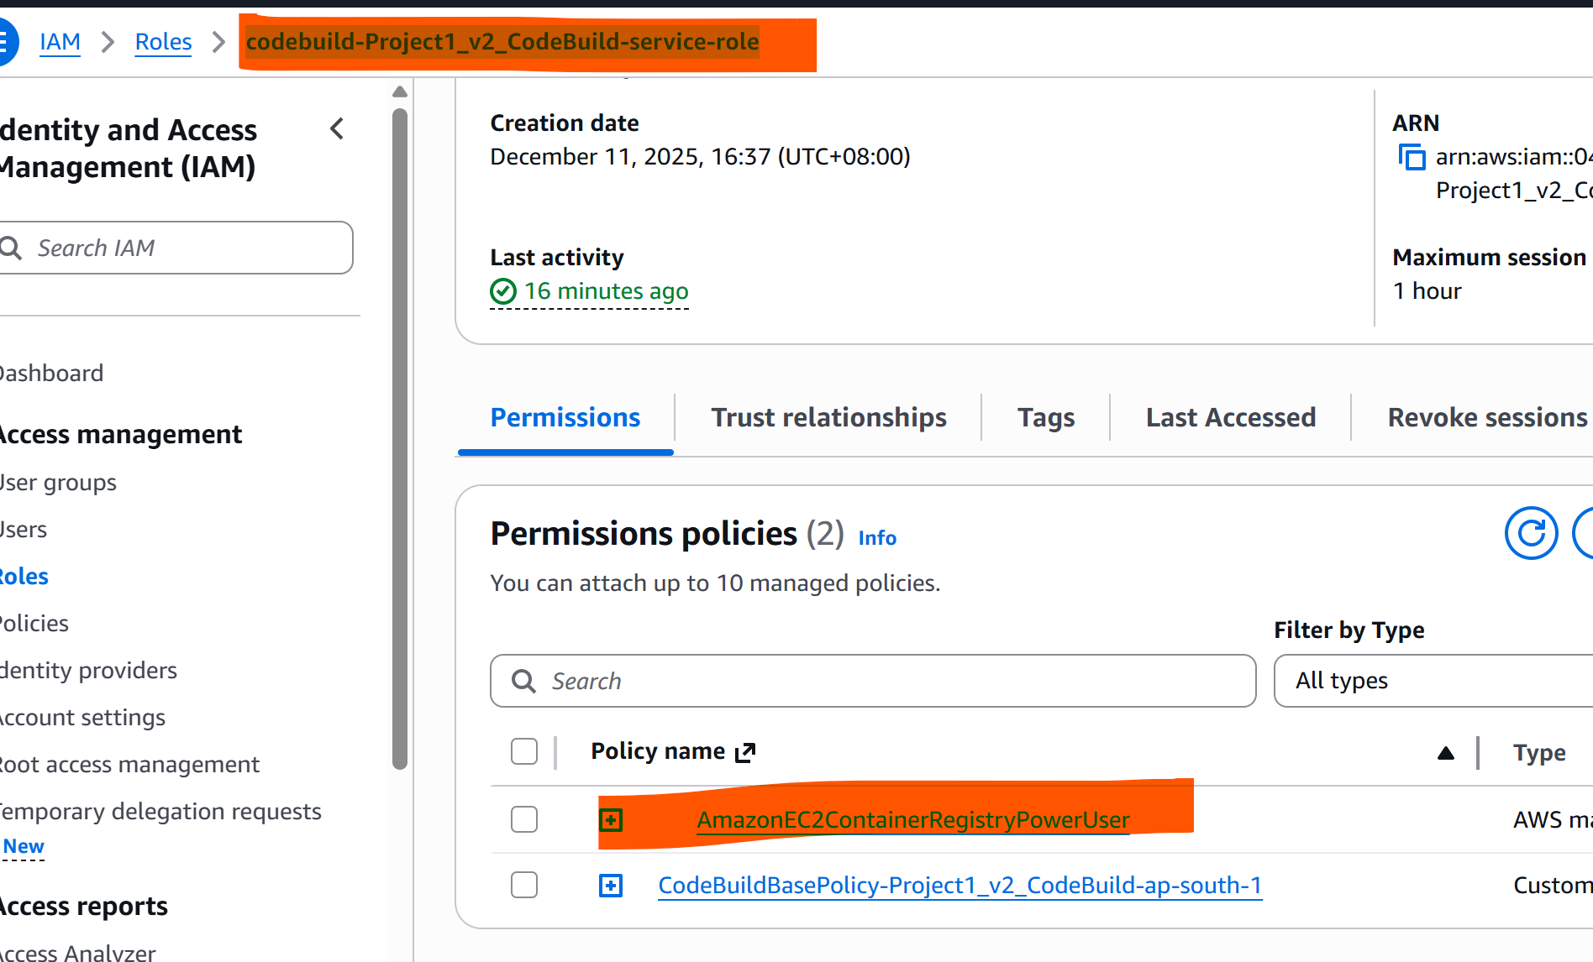

To fix tis

Latest action execution message
Error running command kubectl apply -f deployment.yaml -f service.yaml Command failed: kubectl apply -f deployment.yaml -f service.yaml error validating "deployment.yaml": error validating data: failed to download openapi: the server has asked for the client to provide credentials; if you choose to ignore these errors, turn validation off with --validate=false error validating "service.yaml": error validating data: failed to download openapi: the server has asked for the client to provide credentials; if you choose to ignore these errors, turn validation off with --validate=false Please add your action's role as an access entry in your eks cluster.

You need to add this IAM role as an access entry in your EKS cluster so it can run kubectl commands.
Option 1: Using AWS Console
- Go to Amazon EKS → Clusters → project1-cluster → Access → Access entries.
- Click Create access entry.