**Task:1**

#[2,3,4,6,7,8,9,10,11]

#split odd numbers list / even numbers list

#the even numbers are [2,4,6,8,10] and its totally 5

#the odd numbers are [3,7,9,11] and its totally 4

usr_list=[2,3,4,6,7,8,9,10,11]

even_list=[]

odd_list=[]

for i in usr_list:

if int(i)%2==0:

even_list.append(i)

else:

odd_list.append(i)

print("Even list elements are {} and its total {}".format(even_list,len(even_list)))

print("Odd list elements are {} and its total {}".format(odd_list,len(odd_list)))

**Output:**

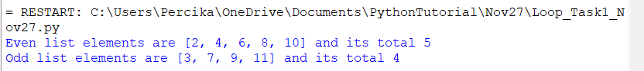

---------------

**Task:2**

#[-2,-3,4,5,6,8,9,0,0,1,2,3,5,-5,-6]

#Number of positive elemtns 9

#number of neg elements 4

#number of zeroes 2

usr_list=[-2,-3,4,5,6,8,9,0,0,1,2,3,5,-5,-6]

positive_cnt=0

negative_cnt=0

zeroes=0

for i in usr_list:

if i>0:

positive_cnt=positive_cnt+1

elif i<0:

negative_cnt +=1

else:

zeroes +=1

print("Number of positive elements in the list is",positive_cnt)

print("Number of negative elements in the list is",negative_cnt)

print("Number of zeroes in the list is",zeroes)

Output:

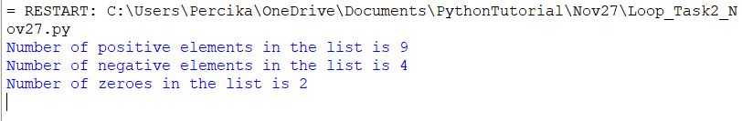

-------------

Task:3

##["mom", "dad", "king", "python", "malayalam", "123321", "123"]

##Number of palindrome strs: 4

##Number of non palindromes : 3

list1=["mom", "dad", "king", "python", "malayalam", "123321", "123"]

x,y=0,0

for i in list1:

if i==i[::-1]:

x +=1

else:

y +=1

print("Number of Palindromes is {} ".format(x))

print("Number of Non Palindromes is {} ".format(y))

Output:

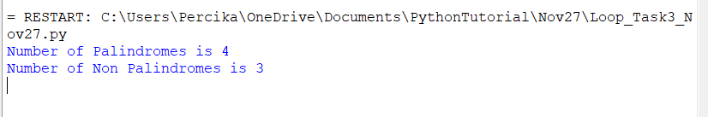

--------------

Task:5

#Get list of strings from user (collect number of elements)

#separate it in to two lists with vowles and non vowels

#["hi","ggg","hello","ravi","bbbb","zzz","yyyy"]

#No of elements with vowel: 4

#No of elements without vowel: 3

#usr_list3=list(map(int,input("Enter the numbers : ").strip().split(',')))

#print(usr_list3)

list1=["hi","ggg","hello","ravi","bbbb","zzz","yyyy"]

vowel_list=[]

non_vowel_list=[]

cnt=0

for i in list1:

if "a" in i or "e" in i or "i" in i or "o" in i or "u" in i :

vowel_list.append(i)

else:

non_vowel_list.append(i)

print(vowel_list)

print("Number of elements with vowel",len(vowel_list))

print(non_vowel_list)

print("Number of elements with vowel",len(non_vowel_list))

**Output:**

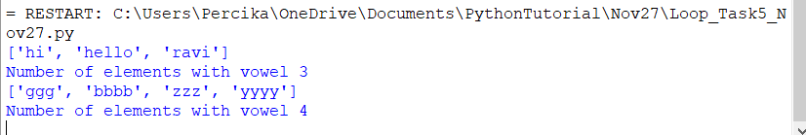

------------

**Task :6**

#Get list of strings from user

#separate it two list (with same first letter and last letter and othr)

#["garg", "kohli", "rohitr", "ishan", "dhoni","dad"]

#No of elements with same first letter and last letter: 3

#Other List: 3

n=int(input("Enter the number of elements:"))

List1=[]

for i in range(0,n):

temp=input("Enter the list elements:")

List1.append(temp)

print(List1)

same_letter=[]

diff_letter=[]

for i in List1:

if i[0]==i[-1]:

same_letter.append(i)

#print(List1[::-1])

else:

diff_letter.append(i)

print("No of elements with same first letter and last letter:",len(same_letter))

print("No of elements with diff first letter and last letter:",len(diff_letter))

Output:

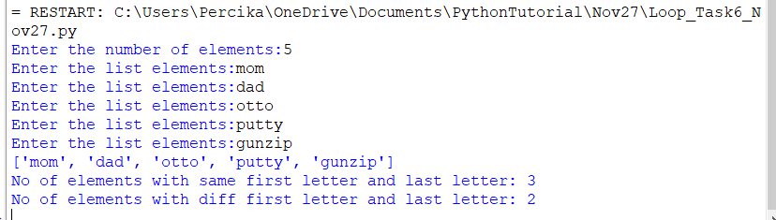

-------------------

Task:7

#fibonacci series

#0,1,1,2,3,5,8,13,21,34,55,89,144

#get one input from user: 5

#[0,1,1,2,3]

usr_int=int(input("Enter the number of elements:"))

a=2

first_ele=0

second_ele=1

nxt_ele=0

list1=[0,1]

while a<=usr_int-1:

nxt_ele=first_ele+second_ele

first_ele=second_ele

second_ele=nxt_ele

print(nxt_ele)

list1.append(nxt_ele)

a=a+1

print(list1)

**Output:**

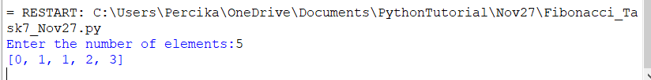

**Task:8**

**#No range function**

**#Multiples of 10 between 12 to 100 using while loop**

**#Multiples of 8 between 120 to 20 using while loop**

**#Multiples of 5 between 9 to 40 using while loop**

**#Multiples of 8 between 300 to 200 using while loop**

**usr_int=int(input("Enter the number:"))**

**usr_int=12**

**while usr_int<=100:**

**if usr_int%10 ==0:**

**print(usr_int)**

**usr_int +=1**

**print("Multiples of 8 between 120 to 20 using while loop")**

**usr_int=int(input("Enter the number greater than 20:"))**

**while usr_int>=20:**

**if usr_int%8 ==0:**

**print(usr_int)**

**usr_int -=1**

**usr_int=int(input("Enter the number:"))**

**print("Multiples of 5 between 9 to 40 using while loop")**

**while usr_int<=40:**

**if usr_int%5 ==0:**

**print(usr_int)**

**usr_int +=1**

**print("Multiples of 8 between 300 to 200 using while loop")**

**usr_int=int(input("Enter the number greater than 200:"))**

**while usr_int>=200:**

**if usr_int%8 ==0:**

**print(usr_int)**

**usr_int -=1**

**Output:**

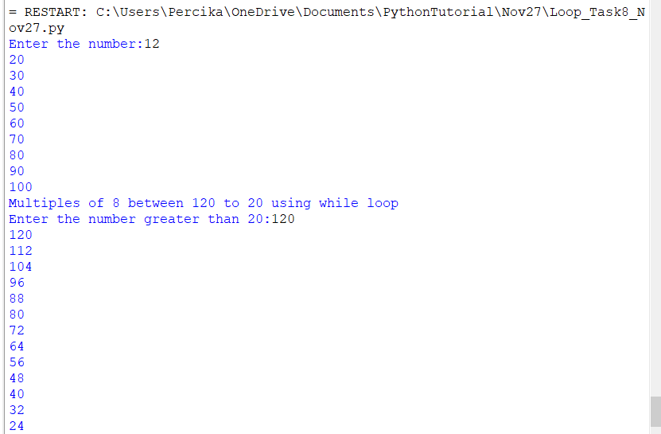

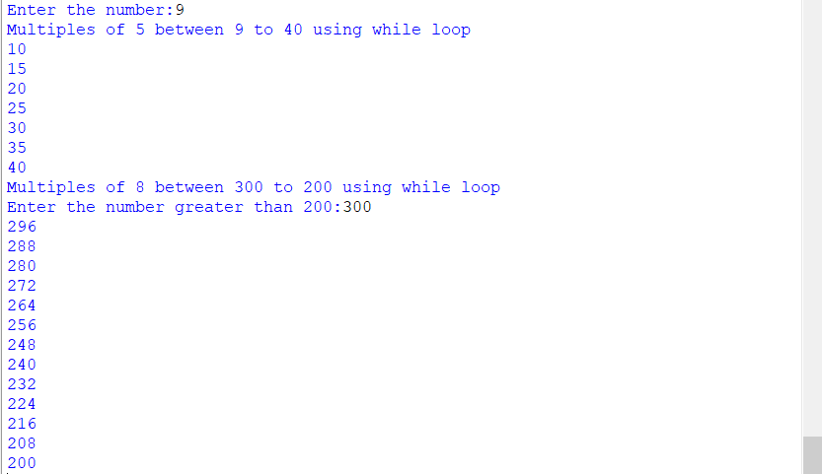

**Task:9**

**#print all elements in the list using while loop**

**#example for loop**

**#for i in Li1:**

**#print(i)**

**#1. calculate len**

**#2. decrement one by one in while**

**Li1=[10,20,30,40]**

**a=len(Li1)**

**while 0 < a:**

**print(Li1[a-1])**

**a=a-1**

**Output:**

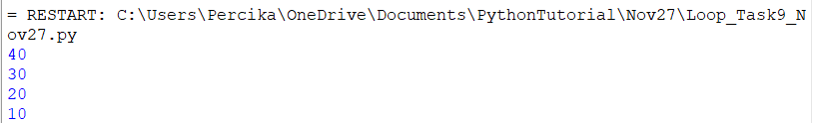

**---------------**

**Task:10**

#check whether a number is armstrong or no

#Dont convert number to string

User_input=int(input("Enter the number: "))

a=0

"""for i in str(User_input):

print(i)

a=a+int(i)**3

print(a)"""

temp = User_input

while temp > 0:

digit = temp % 10

a += digit ** 3

temp =temp//10

if User_input == a:

print(User_input,"is an Armstrong number")

else:

print(User_input,"is not an Armstrong number")

**Output:**

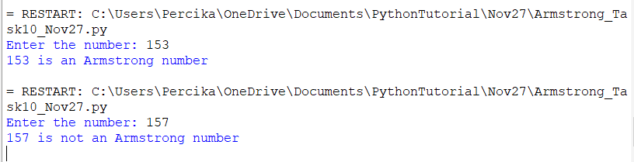

**--------**

**Task:11**

**#Get one dynamic list from user**

**#10 [0,6,5,-3,4,5,3,-2,4,0]**

**#count ==> no of zeros, no of positive values, no of negative values, no of odd numbers, number of even numbers**

**#print the elements**

**n=int(input("Enter the no.of elements in the list:"))**

**Li1=[]**

**for i in range(1,n+1):**

**temp=input("Enter the list elements:")**

**Li1.append(temp)**

**print(Li1)**

**odd_count=0**

**even_count=0**

**positive_count=0**

**negative_count=0**

**zero_count=0**

**positive_list=[]**

**negative_list=[]**

**odd_list=[]**

**even_list=[]**

**zero_list=[]**

**for i in Li1:**

**if int(i)%2==0:**

**even_count+=1**

**even_list.append(i)**

**else:**

**odd_count+=1**

**odd_list.append(i)**

**if int(i)>0:**

**positive_count+=1**

**positive_list.append(i)**

**elif int(i)<0:**

**negative_count+=1**

**negative_list.append(i)**

**else:**

**zero_count+=1**

**zero_list.append(i)**

**print("No. of odd numbers are {} and the elements are {}".format(odd_count,odd_list))**

**print("No. of even numbers are {} and the elements are {}".format(even_count,even_list))**

**print("No. of positive numbers are {} and the elements are {}".format(positive_count,positive_list))**

**print("No. of negative numbers are {} and the elements are {}".format(negative_count,negative_list))**

**print("No. of zeros are {} and the elements are {}".format(zero_count,zero_list))**

**Output:**

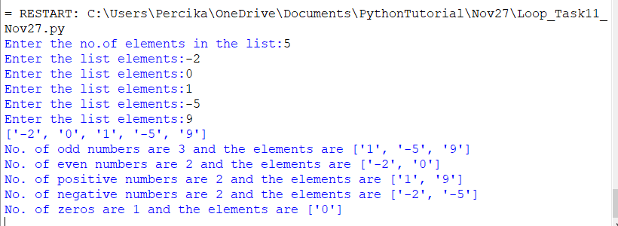

**-----------**

**Task:12**

**#two numbers from user 2 25**

**#2**

**#3 fizz**

**#4**

**#15**

**#16**

**#25**

**#multiple of 3 ==> fizz**

**#multiple of 5 ==> buzz**

**#multiple of 15 ==> fizzbuzz**

**#Others ===> No fizz and buzz**

**#Including last number**

**usr_int1=int(input("Enter the first number:"))**

**usr_int2=int(input("Enter the second number:"))**

**for i in range(usr_int1,usr_int2+1):**

**if i %3 ==0 and i %5==0:**

**print("Number {} is fizzbuzz".format(i))**

**elif i%3==0:**

**print("Number {} is buzz".format(i))**

**elif i%5==0:**

**print("Number {} is fizz".format(i))**

**else:**

**print("Number {} is No fizz buzz".format(i))**

**Output:**

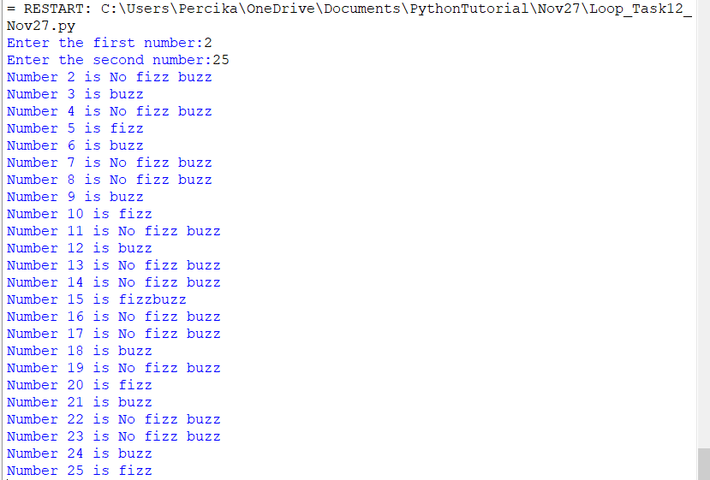

**-------------**

**Task:13**

**#Factorial number**

**#5 ==> 5 * 4 * 3* 2 * 1**

**#120**

**usr_num=int(input("Enter the number:"))**

**factorial=1**

**for i in range(1,usr_num+1):**

**factorial=factorial*i**

**print("The factorial of number {} is {}".format(usr_num,factorial))**

**##tried module**

**import math as m**

**print(m.factorial(usr_num))**

**Output:**

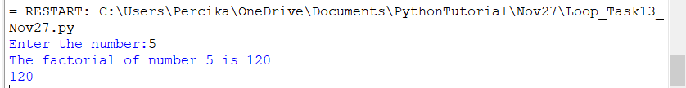

**Task:14**

**#Get one number from user**

**#Sum of digits**

**#325 ==> 10**

**usr_num=input("Enter the number:")**

**sum=0**

**for i in usr_num:**

**#print(i)**

**sum=sum+int(i)**

**print(sum)**

**Output:**

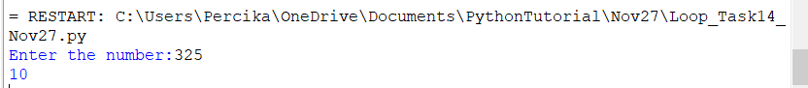

**-----------**

**Task:15**

**#Product of digits**

**#no need to convert to string**

**#927 ==> 9* 2* 7 ==> 126**

**usr_num=input("Enter the number:")**

**"""prod=1**

**for i in usr_num:**

**#print(i)**

**prod=prod*int(i)**

**print(prod)"""**

**num=int(usr_num)**

**prod=1**

**while num!=0:**

**rem=num%10**

**#print(rem)**

**prod=prod*rem**

**#print(prod)**

**quo=num//10**

**#print(quo)**

**num=quo**

**print("Product of the digits {} is {}".format(usr_num,prod))**

**Output:**

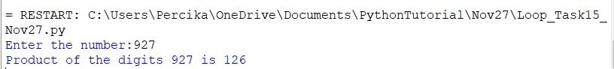

**----------------**

**Task:16**

**#multiples of a number**

**#Get one integer from the user**

**#9 ==> 1,3,9**

**#11 ==> 1,11**

**#25 ==> 1,5,25**

**#16 ===> 1,2,4,8,16**

**usr_num=int(input("Enter the number:"))**

**result=0**

**for i in range(1,usr_num+1):**

**#print(i)**

**if (usr_num/i).is_integer():**

**print(i)**

**Output:**

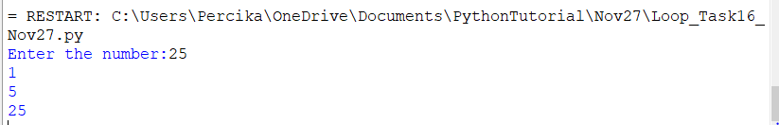

**--------------------------------**

**Task:17**

**#Task17:**

**#Anagram ===> check whether given string is anagram or no**

**#Two input strings**

**#pota**

**#toap**

**#top**

**#pto**

**str1=input("Enter the first string:")**

**str2=input("Enter the second string:")**

**Li1=[]**

**for i in str1:**

**Li1.append(i)**

**print(Li1)**

**Li2=[]**

**for i in str2:**

**Li2.append(i)**

**print(Li2)**

**if sorted(Li1)==sorted(Li2):**

**print("Both strings {} and {} are Anagram".format(str1,str2))**

**else:**

**print("Both strings {} and {} are NOT Anagram".format(str1,str2))**

**Output:**

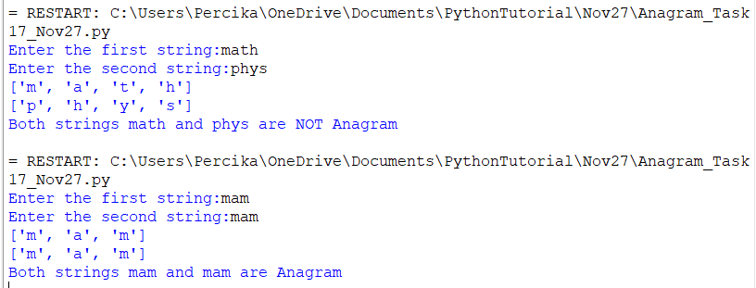

**--------------**

**Task:18**

**#Program to check a number is prime or no**

**#prime number ===> divisble only by 1 and itself**

**#2 is the first prime number**

**#9 ==> 1,3,9**

**#5 ==> 1,5**

**#23 ==> 1,23**

**#25 ==> 1,5,25**

**num=int(input("Enter the number:"))**

**if (num%2) == 0 or (num%3) == 0 or (num%5) == 0 :**

**print("Number {} is not prime".format(num))**

**else:**

**print("Number {} is prime".format(num))**

**Output:**



**Task:19**

**#collect one dictionary from user**

**#number of elemetns**

**#key and value for number of elements**

**n1=int(input("Enter no.of elements for Key:"))**

**n2=int(input("Enter no.of elements for value:"))**

**Li1=[]**

**Li2=list()**

**for i in range(1,n1+1):**

**temp=input("Enter the keys:")**

**Li1.append(temp)**

**print(Li1)**

**for i in range(1,n2+1):**

**temp=input("Enter the values:")**

**Li2.append(temp)**

**print(Li2)**

**dict1=dict(zip(Li1,Li2))**

**print(dict1)**

**print(len(dict1))**

**print(dict1.keys())**

**print(dict1.values())**

**Output:**

