**Multivariate Testing with Percussion CM System and Google Optimizer**

Website multivariate testing is increasingly common as organizations wishing to test content and optimize website performance. This testing effectively allows for “trial and error” experiments whereby variations can be tested for the best option. Comparative reports are generated to illustrate which combinations of content gets the best results according to a specific objective. Variations can be revoked or made permanent depending on their impact on the site dictated by actual site visitors.

Although this is a very effective tool for content editors and marketers, multivariate testing with Content Management Systems (CMS) has been very challenging. Percussion CM System together with Google Optimizer makes it possible to retain a relatively transparent experience for CMS content authors while facilitating flexible and robust Multivariate and AB testing.

This document contains a walkthrough (step-by-step) guide for creating Multivariate and AB tests with Google Optimizer and Percussion CM System. The information will walk users (or editors) through the detailed steps of construct these test. There are some additional notes at the end of the document specifically for developers. Although at first it may appear as many steps, these instructions are very simple and repeatable, so you can create many more test as you prefer.

**Google Website Optimizer**

From Wikipedia, the free encyclopedia

**Google Website Optimizer** is a free website optimization tool that helps online marketers and webmasters increase visitor conversion rates and overall visitor satisfaction by continually testing different combinations of website content.[[1]](http://en.wikipedia.org/wiki/Google_Website_Optimizer#cite_note-gwo-0) Google Website Optimizer can test any element that exists as [HTML](http://en.wikipedia.org/wiki/HTML) code on a page including calls to action, fonts, headlines, point of action assurances, product copy, product images, product reviews, and forms. It can be used at multiple stage in the [conversion funnel](http://en.wikipedia.org/wiki/Conversion_funnel).

**Google Website Optimizer** allows webmasters to test entire pages, known as [A/B testing](http://en.wikipedia.org/wiki/A/B_testing) or page elements, known as [Multivariate testing](http://en.wikipedia.org/wiki/Multivariate_testing) such as Headings, images or body copy. This tool is part of [Google Analytics](http://en.wikipedia.org/wiki/Google_Analytics), though accessed through a different user interface. As it is part of Google Analytics, it uses the Google analytics scripts.

Before jumping into the steps below, there are a few best practices to consider. There is online documentation that will help you understand in great detail how Optimizer works and how you should plan out your experiments. [Click here for a Google Optimizer Tutorial](http://adwords.google.com/support/aw/bin/static.py?hl=en&guide=23825&page=guide.cs).

Meanwhile, please review this checklist;

* Decide which page on your site to test
* Decide what to test on that page
* Identify your conversion page
* Design the test page(s) (in Percussion CM System)
* Launch and monitor experiments

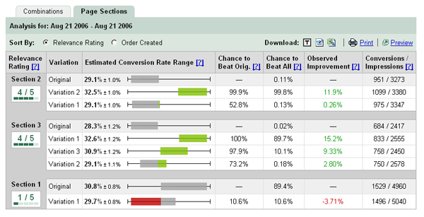

**AB Testing**

AB Testing is very similar to setting up a Multivariate test. The follow steps will guide you to create your first AB Test and you can follow a similar process to set up future tests.

**Steps:**

1. **Surf your website for the pages where you wish to make an AB test. You will need to note the two AB pages (each known as a "Test Page" - the Original and the Variant) as well as the "Conversion Page" (or the page where visitors successfully navigates to). Note the URLs for the next step.**

**NOTE: If you do not have a Variant Test Page (or "B" Page), you can create the page using the Percussion CM System editing tools and publish it to the site.**

1. **Switch to Google Optimizer and create a new experiment. You will need to provide an experiment name and the URLs from the first step.** 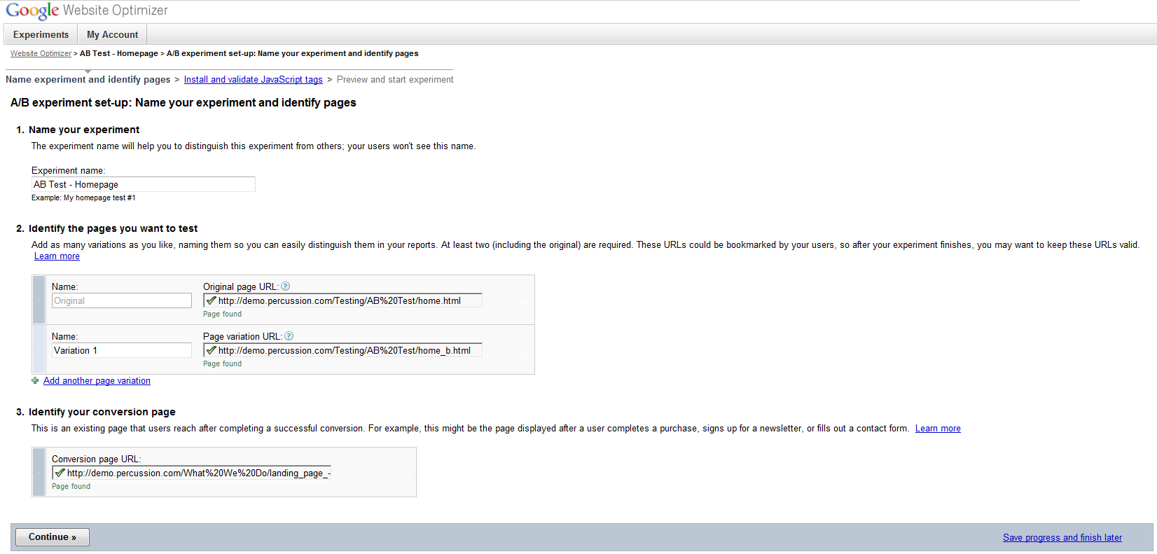
2. **The Google Optimizer wizard will prompt for installing JavaScript tags. You can choose "You will install and validate the JavaScript tags" option and click "Continue >>".**

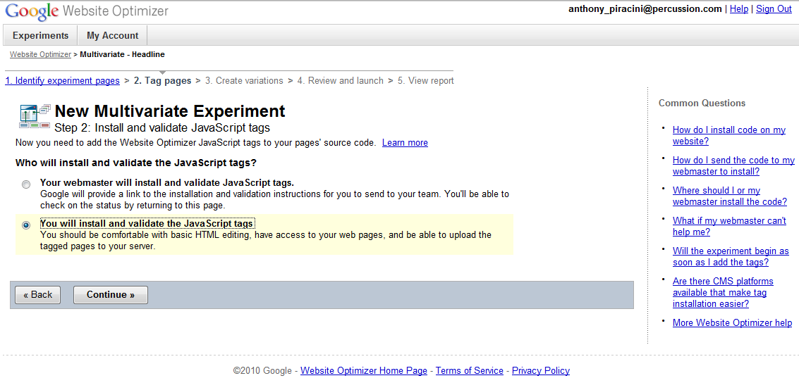

1. **Next, you will need the Experiment Number (copy it to the clipboard). See screenshot below to see where the Experiment Number will be displayed by Google.**

**NOTE: Keep this page open. You will be returning to this wizard to finish the process.**

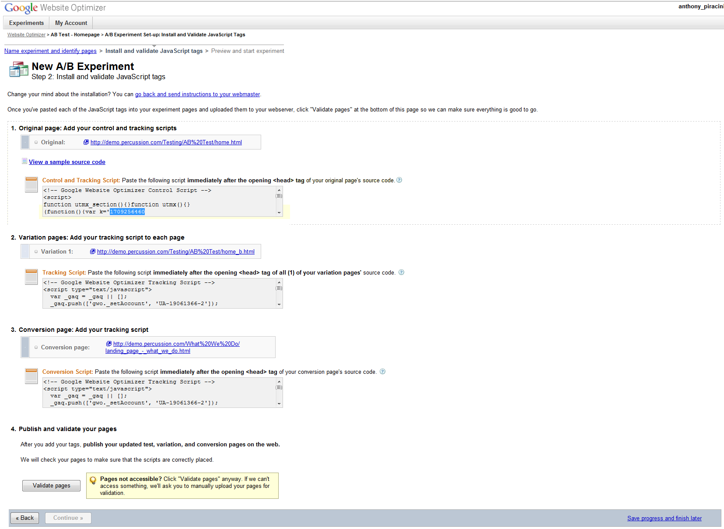

1. **Locate your content item for the Test Pages (Original and Variant). Choose the "AB Test" radio button, paste the Experiment Number into the content item form ("Experiment Number:"), and set the page for a "Test Page".**

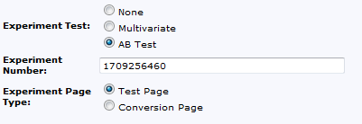

1. **For the Conversion Page content item, you can also choose the "AB Test" and paste the Experiment Number in the Conversion Page content item as seen here. The only difference is that this page needs to be identified as a "Conversion Page" by selecting the radio button as seen here.**

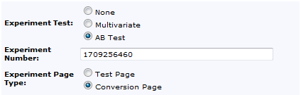

1. **Save the content item changes and republish the pages. You can use the "Publish Now" feature if it is set up in your system. The publishing step will recreate your pages including required scripts.**
2. **Return to the Google Optimizer wizard to validate the pages are created appropriately. Near the bottom of the page, there is a "Validate pages" button () that checks if the pages have all the required scripts according to Google Optimizer. If everything goes correctly, you should have a popup window that shows the pages as all validated. Press "OK" and "Continue" to move on to the next step in the wizard.**

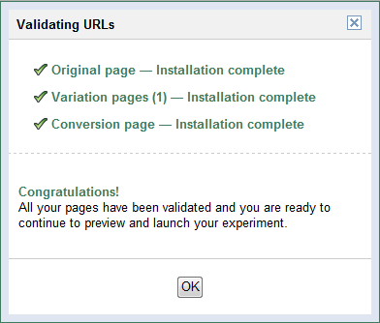

1. **The last step in the wizard will allow you to launch the experiment (click "Start Experiment >>").**

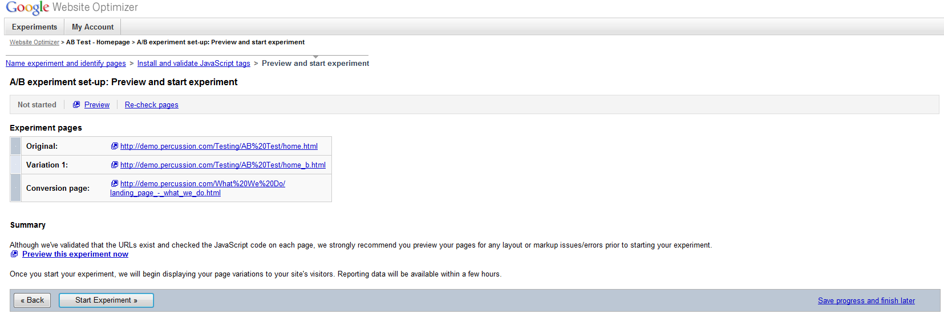

**NOTE: If you want to test or preview your combinations, you can choose to "Preview". The Test Pages can be previewed to determine if the displays are as you would like them. Some users will do this before launching the experiment.**

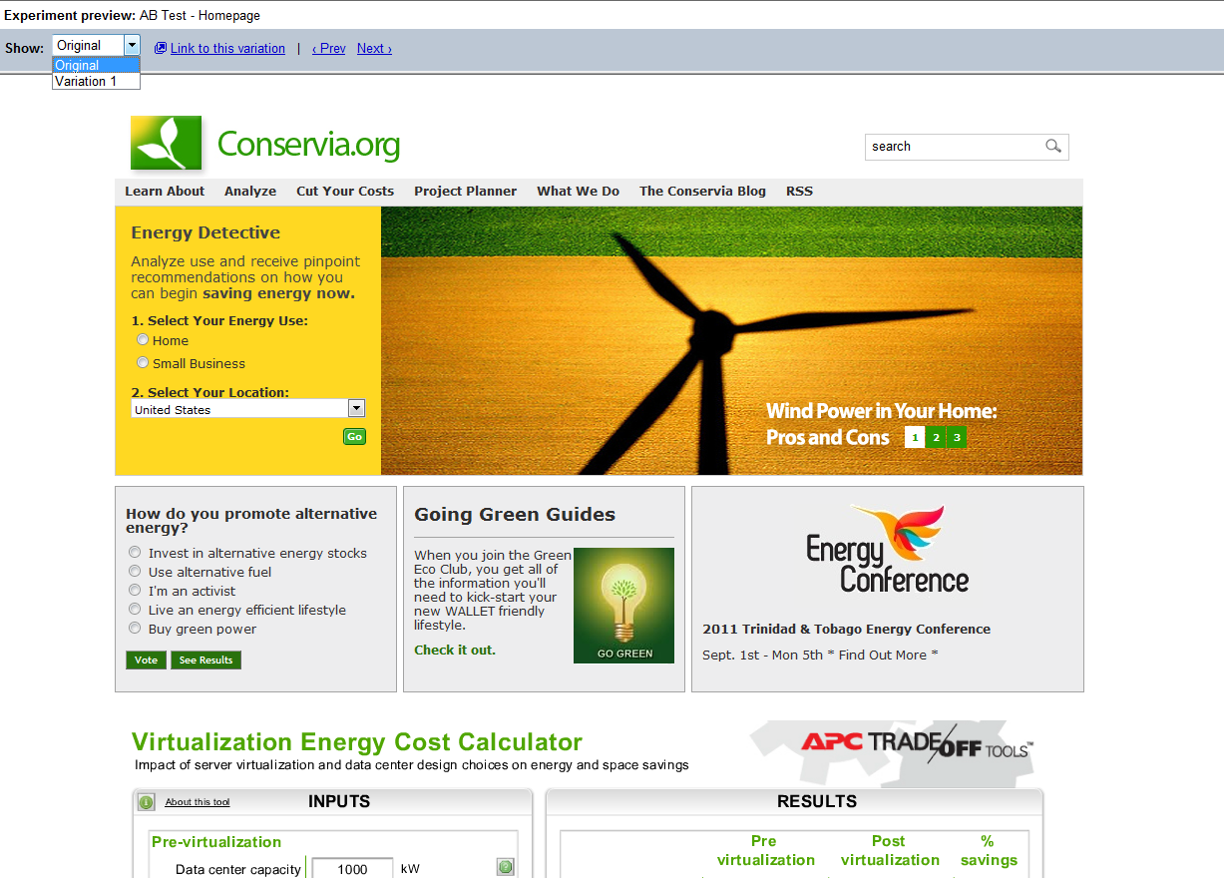

**Multivariate Testing**

Percussion CM System automates and simplifies the inclusion of the scripts required for Google Optimizer to work without requiring custom coding by a developer. In return, the editor will need to follow these simple steps. The steps are made to be less error-prone and repetitive to make a process that is very repeatable and not require developers to be a process focal point or bottle neck.

**Steps:**

1. **Surf your website for the page where you wish to make an experiment. You will need to note this page (known as the "Test Page") as well as the "Conversion Page" (or the page where link to for a successful experiment). Note both URLs for a later step.**
2. **In Percussion CM System, navigate to the page containing the content you wish to test. Locate the Google Optimizer fields in the Percussion Content form for editing.**

**NOTE 1: The input control will show additional fields depending on the input values. For example, "Experiment Number" field will be shown once you choose a Test type.**

**NOTE 2: Experiment is provided by Google and is unknown at this point. The number will be entered at a later step.**

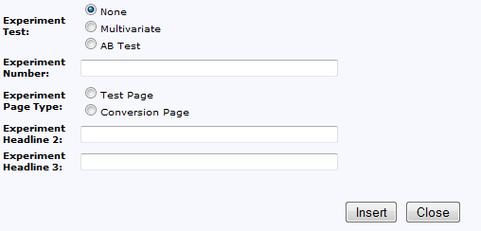

1. **By choosing the option "Multivariate" for the "Experiment Test" type, you will be allowed you to create optional headlines and media for your experiment.**
2. **You can use the WYSIWYG editor to create experimental content in context. Now that the Experiment Test is set, you will have additional headline fields to add more alternative headlines. Also, media in the right column (or slot) will allow you to have optional media. These two experimental areas (headlines and media) will generate combinations to determine the best content to drive the results you are seeking.**

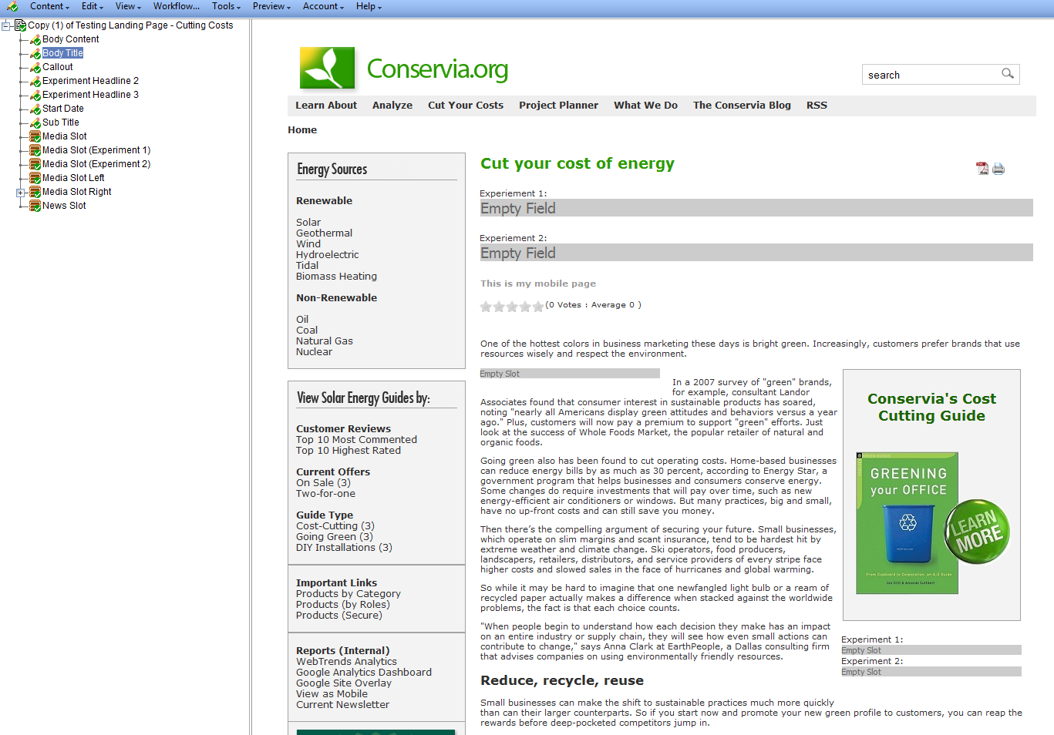

1. **Create experimental versions of the headlines by editing the "Empty Fields" fields. You can also add experimental media items in the experimental "Empty Slot". See below for examples of content edits you could make on the page.**

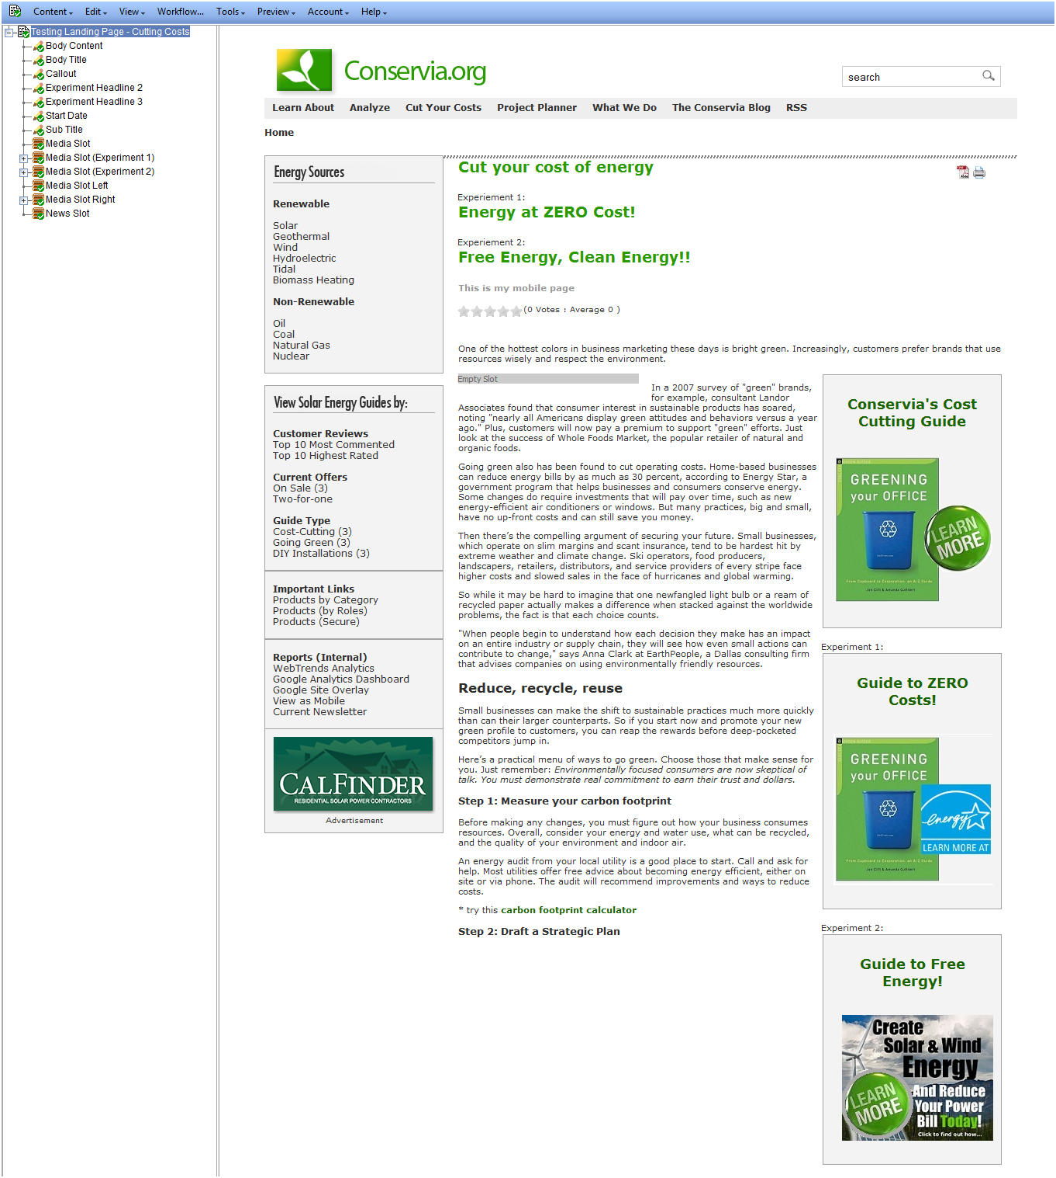

1. **You can also set the Conversion Page values for the Optimizer. Choose the Multivariate option and "Conversion Page" for the Experimental Page Type.**
2. **NOTE: The Conversion Page is a different page than the Test Page. The Conversion Page is the page the visitor will end up on after they successfully click through the multivariate experiment.**

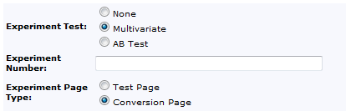

1. **Once you have the content edited the way you want them, switch to Google Optimizer and create a new experiment. You will need to provide an experiment name and the URLs from the first step.** 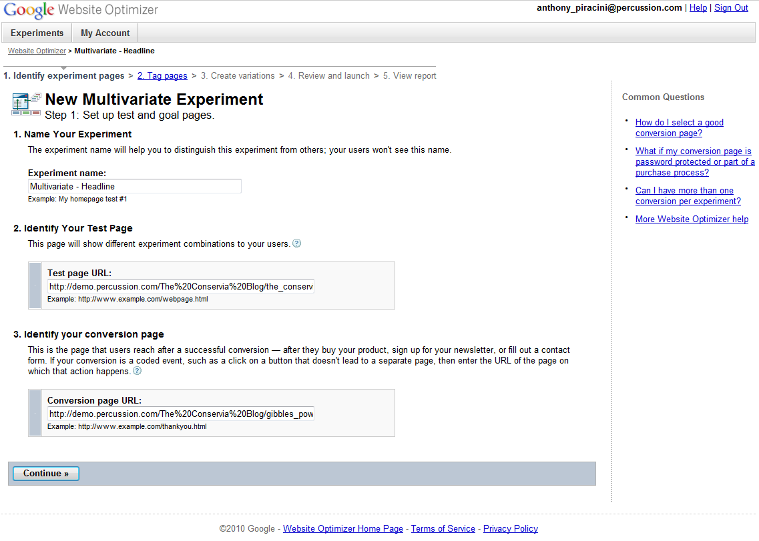
2. **The Google Optimizer wizard will prompt for installing JavaScript tags. You can choose "You will install and validate the JavaScript tags" option and click "Continue >>".**



1. **The next step will be slightly different from a typical Optimizer experiment. Here you can simply copy the Experiment Number (to the clipboard). See screenshot below to see where the Experiment Number will be displayed by Google.**
2. **NOTE: Keep this page open. A later step, you will be returning to this wizard to finish the process.**

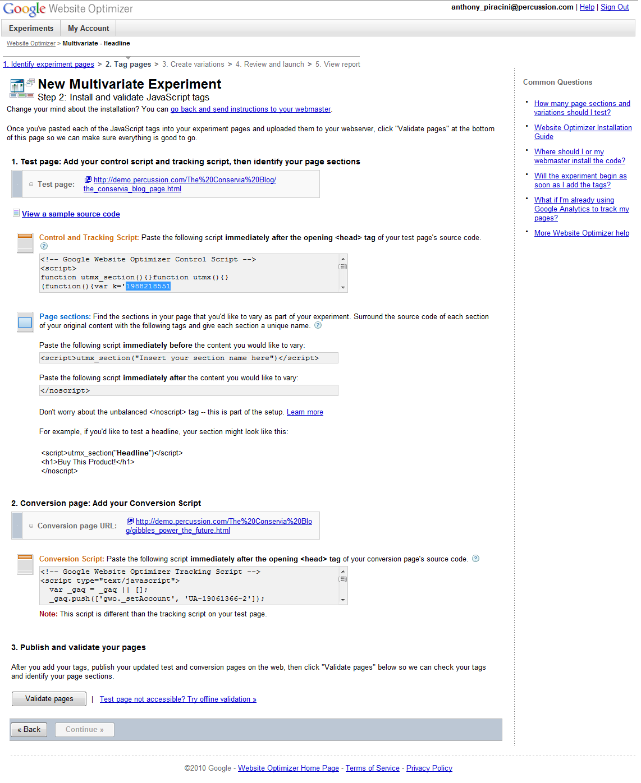

1. **Paste the Experiment Number into the content item form ("Experiment Number:").**

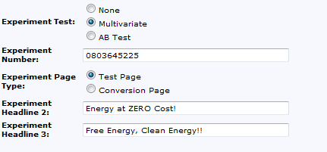

1. **You can also paste the Experiment Number in the Conversion Page content item as seen here.**

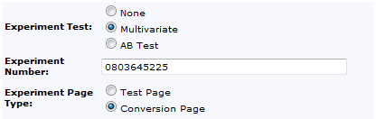

1. **Save the content item changes and republish the pages. You can use the "Publish Now" feature if it is set up in your system. The publishing step will recreate your pages including scripts and experimental content.**
2. **Return to the Google Optimizer wizard to validate the pages are created appropriately. Near the bottom of the page, there is a "Validate pages" button () that checks if the pages have all the required scripts according to Google Optimizer. If everything goes correctly, you should have a popup window that shows the tags as all validated. Press "Continue".**

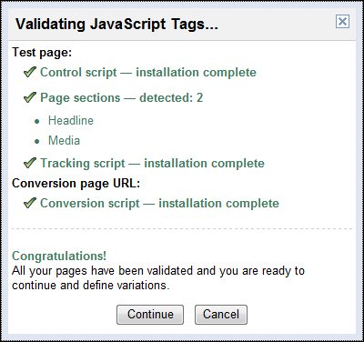

1. **You will now be able to "Continue" to the next step in the Google Optimizer wizard. Creating variations is where you can define the alternative "Headlines" and "Media" areas on the page to the Google Optimizer. You should be at a page that looks like this image below.**

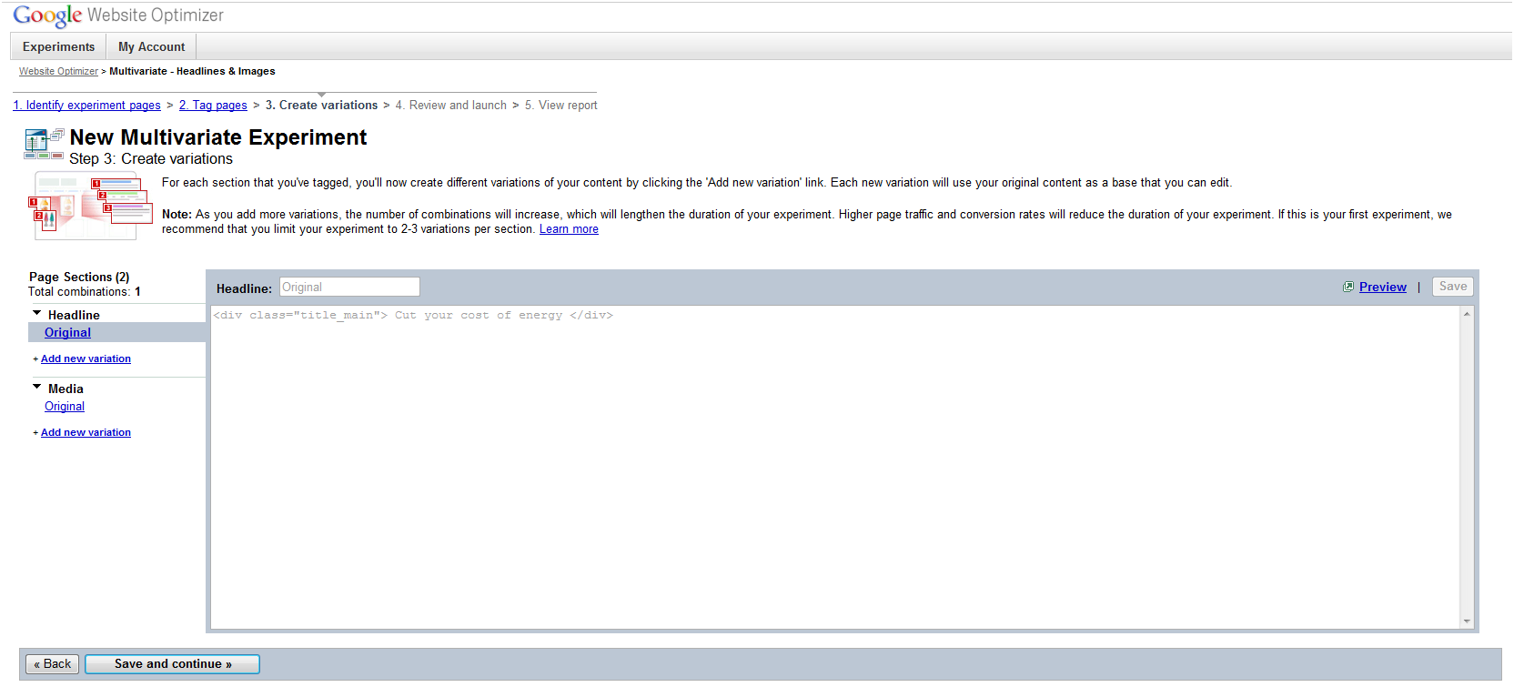

1. **Use the "Add new variation" to create new entries for the experimental entries (ex. "Headline 2", "Headline 3", "Guide Image 2", and "Guide Image 3"). Each variation will need a script pasted and saved in the pop up. Below are 4 scripts you can copy and paste into the Google input pop up.**

|  |  |
| --- | --- |
| Headline 2 | <div class="title_main" id="headline_original"></div><script>document.getElementById("headline_original").innerHTML = document.getElementById("experimentheadline_2").innerHTML;</script> |
| Headline 3 | <div class="title_main" id="headline_original"></div><script>document.getElementById("headline_original").innerHTML = document.getElementById("experimentheadline_3").innerHTML;</script> |
| Guide Image 2 | <div class="content_image_right" id="optMediaSlotAlt_original"></div><script>document.getElementById("optMediaSlotAlt_original").innerHTML = document.getElementById("optMediaSlotAlt2").innerHTML;</script> |
| Guide Image 3 | <div class="content_image_right" id="optMediaSlotAlt_original"></div><script>document.getElementById("optMediaSlotAlt_original").innerHTML = document.getElementById("optMediaSlotAlt3").innerHTML;</script> |

**NOTE: When you are complete with this step, the screen should look like this image below. Click "Save and continue >>" to continue to the next step.**

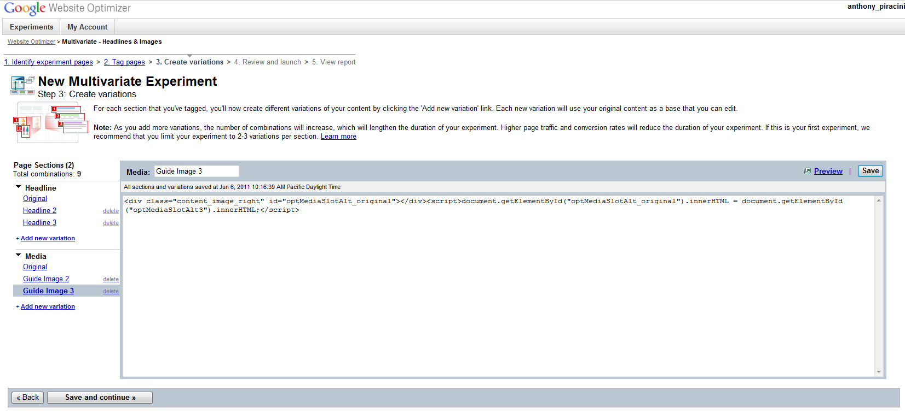

1. **The last step in the wizard will allow you to launch the experiment (click "Launch now >>").**

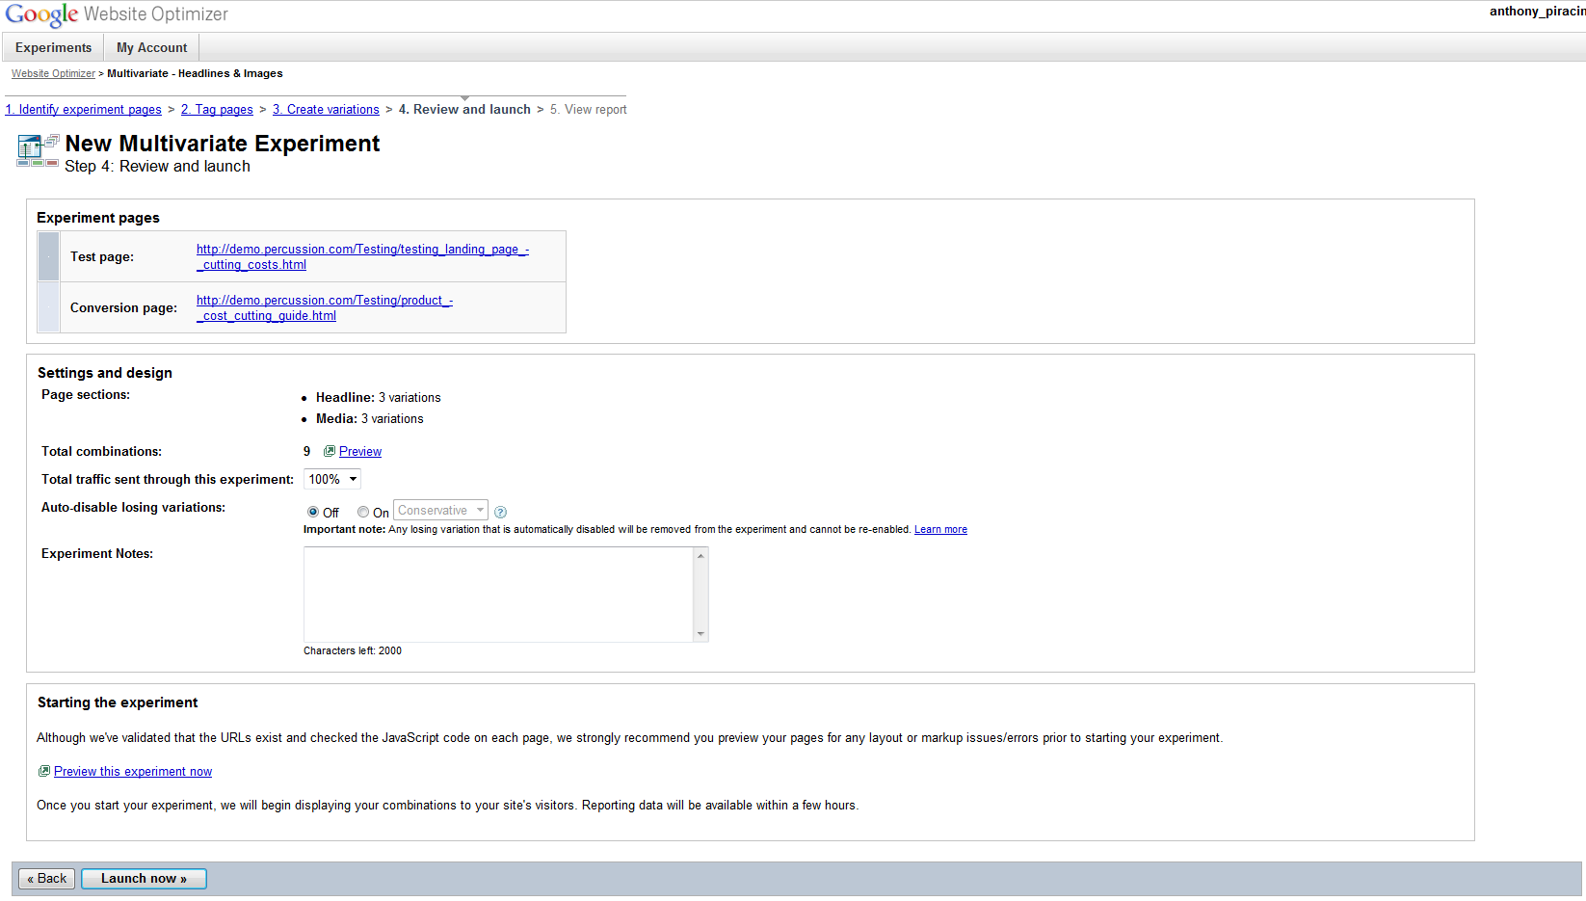

**NOTE: If you want to test or preview your combinations, you can choose to "Preview". All the combinations that will be presented to the visitors can be previewed to determine if the displays are as you would like them. Some users will do this before launching the experiment.**

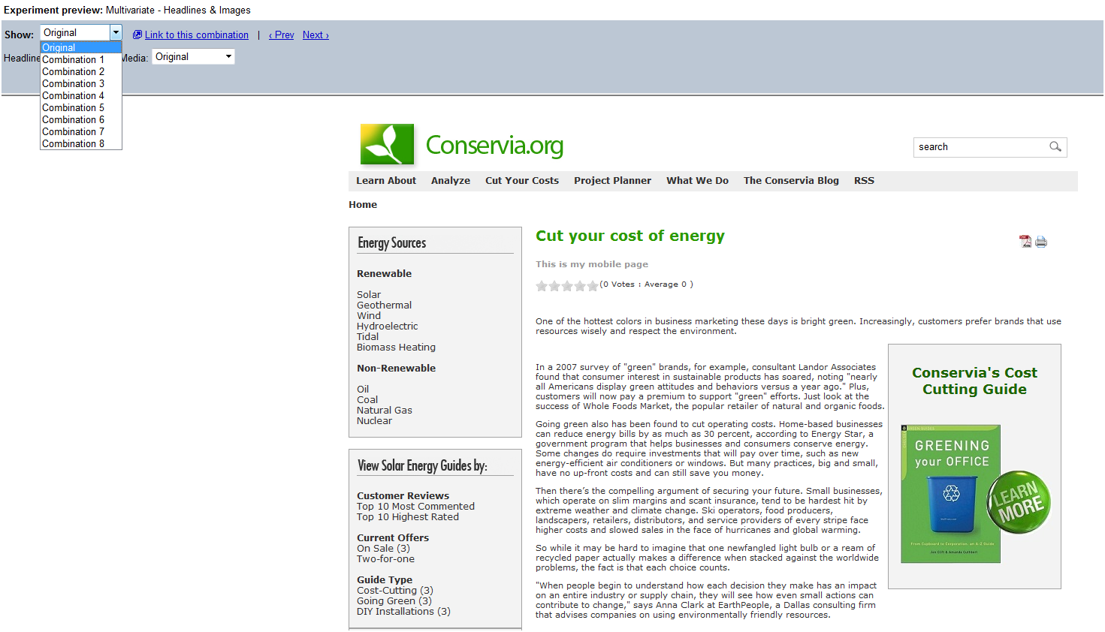

**Developers**

It should be noted that Google has recently deprecated the Optimizer API. This solution does not make use of the API for that reason.

After installing the package, you will need to;

* Set your Google account number as a site context variable
* Add Optimizer (shared) fields to the appropriate content types
* Add calls to the Optimizer macros

The macros retrieve your Google account number from the site context variables. Add the account number you want to use like the screen shot below to your site prior to allowing users to create test.



The content form fields for the Optimizer are shared fields found in the Workbench that can be added to Content Types as seen here. Arrange the order of the fields using the up and down arrow. The field names and values (for the radio buttons) need to remain as they are configured. There is dependencies with the javascript and velocity code that allows this to function properly.

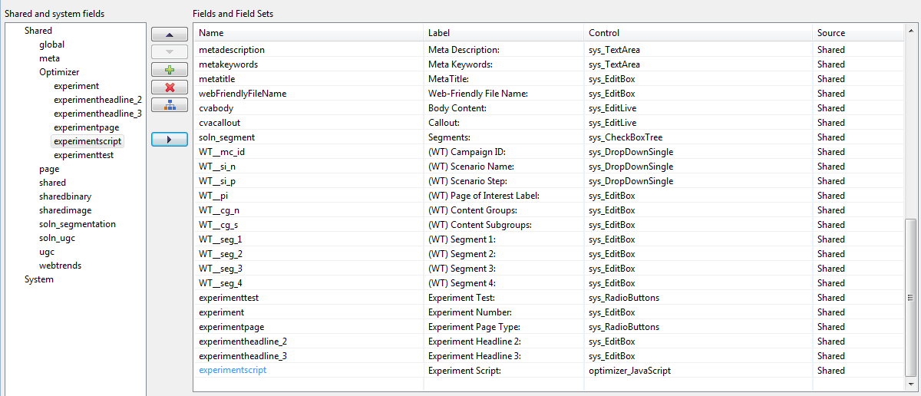

In the templates where you want to apply Multivariate test, you should replace the existing title field macro (#field) with the Optimizer macro (#optimizer_google_altheadlines).

<div class="title_main">#field("cvadisplaytitle")</div>

#optimizer_google_altheadlines("cvadisplaytitle" '<div class="title_main">' '</div>' "experimentheadline_2" "experimentheadline_3")

For Multivariate test with slots, change the standard slot macro (#slot_simple or #slot) with the optimizer slot (#optimizer_google_altslots).

#slot_simple("cvaMediaSlotRight")

#optimizer_google_altslots("cvaMediaSlotRight" "optMediaSlotAlt2" "optMediaSlotAlt3" "" "" "" "" "")

The macros add the following items to the page being published;

* Google Optimizer <head> scripts that include your Google account, the Optimizer experiment number, and content for your tests (multivariate and AB)
* (For Multivariate only) Variant content blocks are hidden (display:none) and embedded in the page and get shown by Google per the code snippets - see below for an example content block.

<div id="optMediaSlotAlt2" style="display:none;"><div class="content_sidebar_box margin"><div class="sidebar_box_info"><p style=" text-align: center;"><a href="/Cut Your Costs/product_-_cost_cutting_guide.html"><span style=" font-size: large;">Guide to ZERO Costs!</span></a></p><p style=" text-align: right;"><a href="/Cut Your Costs/product_-_cost_cutting_guide.html"><span style=" font-size: large;"><br /><img alt="" src="/MediaFiles/Images/Guide-with-EnergySavings.jpg" /></span></a></p></div></div><br /></div>

<div id="optMediaSlotAlt3" style="display:none;"><div class="content_sidebar_box margin"><div class="sidebar_box_info"><p style=" text-align: center;"><a href="/Cut Your Costs/product_-_cost_cutting_guide.html"><span style=" font-size: large;">Guide to FREE Energy!</span></a></p><p style=" text-align: right;"><a href="/Cut Your Costs/product_-_cost_cutting_guide.html"><span style=" font-size: large;"><br /><img alt="" src="/MediaFiles/Images/Learn More - Solar Wind.jpg" /></span></a></p></div></div><br /></div>

<script>utmx_section("Media")</script>

<div class='content_image_right' id='optMediaSlotAlt_original'><div class="content_sidebar_box margin"><div class="sidebar_box_info"><p style=" text-align: center;"><a href="/Cut Your Costs/product_-_cost_cutting_guide.html"><span style=" font-size: large;">Conservia's Cost Cutting Guide</span></a></p><p style=" text-align: right;"><a href="/Cut Your Costs/product_-_cost_cutting_guide.html"><span style=" font-size: large;"><br /></span></a><span style=" font-size: large;"><a href="/Testing/product_-_cost_cutting_guide.html"><img alt="" src="/MediaFiles/Images/Cost Cutting/LEARN MORE.jpg" /></a></span></p></div></div><br /></div>

</noscript>