Smart Preview
Smart Preview is a drop in replacement for the standard Fast Forward Preview and Active Assembly actions. It automatically senses the proper sites and folders and does not rely on the community settings.

Overview
Smart Preview is a preview action that determines which sites and folders a particular item is associated with, and sets the site id and folder id parameters for the preview accordingly.
If an item exists on a single site, the item will be previewed directly (just as happens with the Fast Forward preview). If, on the other hand, the item exists on multiple sites (or in multiple folders on the same site), the preview action will send the user to a selection page.
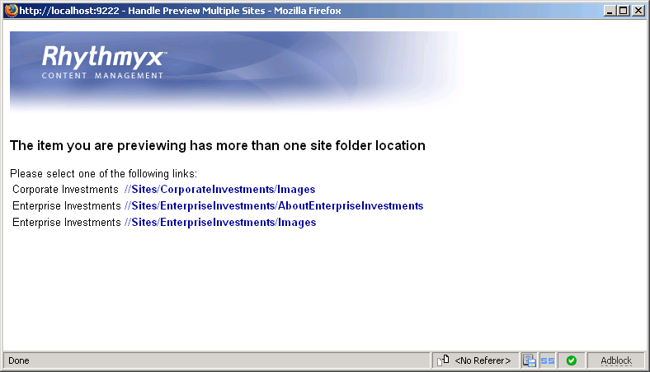
The user may then click on one of the selections, and the selected template will open in preview mode.
In addition to content id and revision parameters, the smart preview action looks at the site id and folder id parameters. If these are present, the selection of potential site folder locations is limited to that site and/or folder.
In normal practice this means that the user will not see the selection screen when browsing through the content explorer folders, because the folder id will limit the item to a single folder and site. However, if the same content item is opened from a Search or one of the Views (e.g. inbox, outbox, recent, etc), the selection screen will be displayed.
There is one important difference between this action and the Fast Forward preview actions. This action returns a list of templates for the item which are visible on the site (or sites) where the item resides. Fast Forward returns a list of all templates defined for the content type and community. These lists not be the same if the templates are configured inconsistently.

Deployment Guide
Smart preview is a Spring servlet application that is deployed into the Rhythmyx/user/apps directory.

Pre-requisites
Smart preview requires Rhythmyx 6.5 or later and the PSO Toolkit. Since it installs using the same mechanism as the PSOToolkit, you will also need Apache Ant and Java 1.5 installed correctly on the machine.

Installation
After installing the pre-requisites, unzip the distribution file into a new folder (e.g. c:\deploy\preview), set the RHYTHMYX_HOME environment variable and run the command:
ant –f deploy.xml

This will install the Spring application into the server directory. Restart the Rhythmyx server.

Creating the Preview Action
In the Workbench, you will need to create a new preview action. Start by copying and pasting the Enterprise Preview action, and giving it a new name. Remember that the name must end in "_preview" if your want to use the Action on the Action Panel.
In the Command tab, change the action URL to "../user/addins/psosmartpreview/default.html", and remove the sys_siteid parameter:
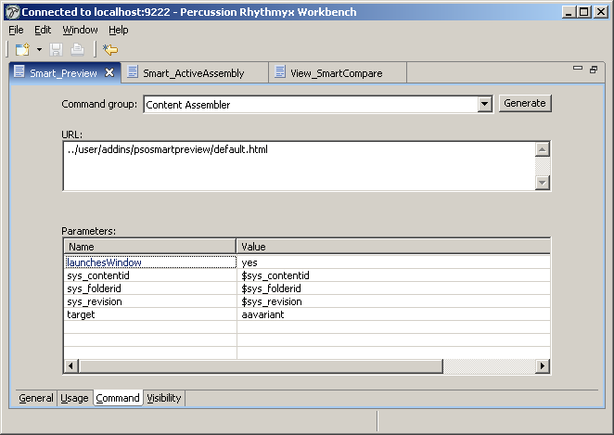
Save your new Action.
It should appear on the menu, and work properly.

Active Assembly Action
Similarly, you can create a Smart Active Assembly action. Copy the Enterprise Investments Active Assembly action. Change the URL to:
../user/addins/psosmartpreview/activeassembly.html

Remove the sys_siteid parameter.

Slot Item Preview Action
The slot item preview action is used in Active Assembly for Documents. Unlike the Preview and Active Assembly actions, this action is not a cascading menu item.
Under the Menu Entries / User, find the Slot_Item_Enterprise_Preview action. Copy and paste it, and then rename it to Slot_Item_Smart_Preview. Change the display title and description to reflect this is "Smart Preview".
The URL field to
../user/addins/psosmartpreview/slotpreview.html

and remove the sys_siteid parameter.
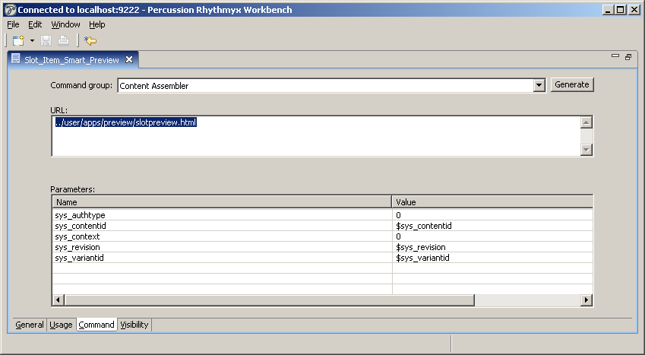
In Active Assembly for Documents, you will now see Smart Preview when hovering over an item in a slot. If you select this menu entry, and the slot item exists on more than one site, you will see the selection window.
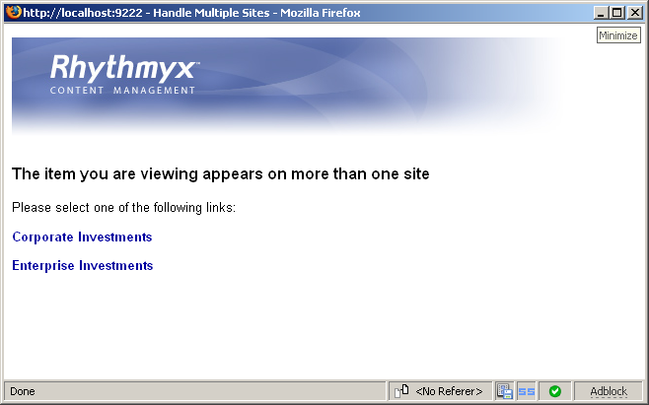
Note that Active Assembly for Documents has no folder id, so this page will be displayed each time you preview a slot item that is in more than one site. If the item is on only one site, you will go directly to the snippet template preview.

Compare
The compare action is available in the View menu. This item is also a menu entry, and is found in the same place as the Slot Item preview.
Copy and paste the View_EICompare menu entry and rename it as "Smart Compare".
Set the URL field to
../user/addins/psosmartpreview/compare.html

and remove the sys_siteid parameter.
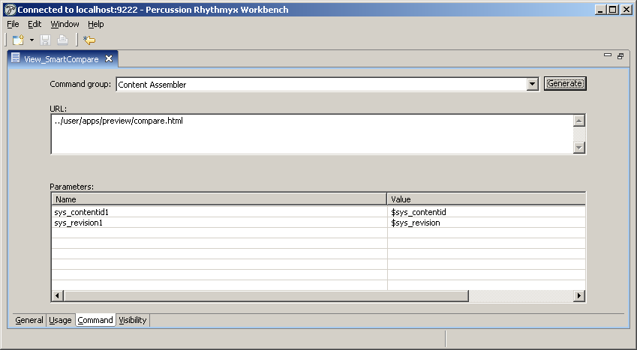
This works exactly as Slot Item preview does: if the item is on more than one site, you will see the site selection screen. If the item is only on one site, the compare window opens directly.

How it works
The preview application is a set of “server addin” consisting of a Spring dispatcher servlet and a set of controller beans. There are 3 main types of beans and 2 beans of each type (one for Preview and one for Active Assembly).
The Action controllers handle the initial call from the Content Explorer. These controllers return an XML document that describes the server action.
The MultiSiteResolutionControllers create the JSP page that allows the user to select a site folder location.
The UrlBuilders build the appropriate URL (for either Preview or Active Assembly).
Generally, the Active Assembly beans have more complex processing, and they "extend" the preview beans.
Both the Slot Item Preview and Compare actions work off the ActionSiteForwardingController. This controller is designed to redirect the user to the original action URL, adding the sys_siteid parameter as necessary. The selection screen is slightly different, in that the MultiSiteResolutionController is not used. This step is not necessary because there is no cascading dropdown for these actions.
In addition to these beans, there is a single SiteFolderFinder. Its purpose is to finds the site and folder location combinations for a given item. Since this function is called from both the Action controller and the MultiSiteResolution controller, it's implemented as a single bean.
The new servlet must be defined in web.xml. This is handled by the installation script. The servlet Spring context is configured from the PSOSmartPreview-servlet.xml file.
There should be no user configuration required to install and run the package. The only required configuration is creating the Action menus in the Workbench.
However, there are a few optional flags which can be turned on in certain cases.
The "testCommunityVisibility" flag, which is present in the action controllers and the site folder finder, determines whether the system filters sites and templates by their visibility in the user's current community. If this flag is false, all eligible sites and templates will be displayed. In most cases, this flag is not necessary, and should be left "false". However if you have system where site folders overlap and community visibility is used for templates, you may wish to turn this flag on.
The other configuration involves the "siteLoader" bean. Since loading the list of Sites is one of the more expensive operations that the preview system performs, the siteLoader caches the list of Sites.
If the scope of the siteLoader is defined as "singleton", the sites are loaded once for all users. In this case, you should also set a "site reload delay", which controls how often the site definitions are reloaded. This number is in seconds.
If the scope of the siteLoader is defined as "session", the sites are loaded separately for each user. The list of sites is loaded when the user first requests the preview menu, and the same list is used until the user logs out or closes the browser window. The site reload delay should be set to 0 in this case.
The default setting is "session", and this will be right for most systems. If you have a very large number of sites, you may wish to experiment with the "singleton" setting.

Configuring Allowed Sites
If you have system where there are many sites, and you only want to use Smart Preview on some of these sites, there is an alternate “siteLoader” bean available for this purpose. This bean extends the standard site loader to add a list of allowed site names.
The sample configuration is as shown below:
<bean id="configuredSiteLoader" class="com.percussion.pso.preview.ConfigurableSiteLoaderImpl" scope="session" >
<property name="allowedSites">
<list>
<value>site1</value>
<value>site2</value>
</list>
</property>
<property name="siteReloadDelay" value="0" />
<aop:scoped-proxy/>
</bean>

Change the list of allowed sites to include the names of those sites where you want Smart Preview to work. Then replace the reference in the site folder finder:

<bean id="siteFolderFinder" class="com.percussion.pso.preview.SiteFolderFinderImpl">
<!-- set testCommunityVisibility to true to filter sites by community visibility -->
<property name="testCommunityVisibility" value="false" />
<property name="siteLoader" ref="configuredSiteLoader" />
</bean>

