|  |
| --- |
| Rhythmyx Revision Removal Utility |

Contents

1. System Requirements 2
2. Revision Removal Overview 2
3. How to configure and use Revision Removal Utility? 3

# System Requirements:

The revision removal utility is available only from Rhythmyx version 7.2 or above. It is required that the system is above 7.2 version and with latest patch for using this tool.

# Revision Removal Overview:

The Revision removal utility facilitates users in Admin role to delete specified revisions of content items. This is accomplished by creating a scheduled task using the sys_PurgeRevisions extension. This feature allows purging of older than current public revisions of content items of all content types. Note that currently this feature does not support the ability to choose revisions of a specific content type or content item for removal.

# Revision Removal Extension - sys_PurgeRevisions

The extension sys_PurgeRevisions in a scheduled task should be used to purge content items of all content types. The revision that needs to be purged can be filtered based on four **required** configuration parameters associated with this extension. Note that the scheduled task will not run without these parameters configured appropriately. Listed below are configuration parameters associated with this extension:

|  |  |  |  |
| --- | --- | --- | --- |
| **Parameter Name** | **Description** | **Value Conditions** | **Required/Optional** |
| *alwaysKeepMinNumberOfRevs* | The minimum number of revisions to keep in the CMS from the last public revision. | alwaysKeepMinNumberOfRevs  < (less than)  deleteRevsAboveCount | Required |
| *alwaysKeepRevsYoungerThanDays* | The revisions that need to be retained in the CMS which are younger than these many days from the last public revision | alwaysKeepRevsYoungerThanDays  < (less than)  deleteRevsOlderThanDays | Required |
| *deleteRevsAboveCount* | Total number of older revisions that need to be deleted from the last public revision. Note that the total number does not include the last public revision. | deleteRevsAboveCount  > (greater than)  alwaysKeepMinNumberOfRevs | Required |
| *deleteRevsOlderThanDays* | The revisions that need to be deleted from the CMS which are younger than these many days from the last public revision | deleteRevsOlderThanDays  > (greater than)  alwaysKeepRevsYoungerThanDays | Required |

Note:

* **Parameters are required**
  + All four parameters are required and the scheduled task will not execute without any of them.
* **Conditional execution of scheduled task** 
  + The scheduled task will execute only when the conditions shown in the above table are met.
* **Alwayskeep overrides deleteRevision**
  + Revisions that fall within parameters *alwaysKeepMinNumberOfRevs* and *alwaysKeepRevsYoungerThanDays* will always be kept in the CMS.
* **Parameters value range**
  + The value of any parameters can be greater than Zero is a valid value for all the parameters which ensures that the current latest revision is kept.
* **Last public revision**
  + The parameter values are applied above last public revision of any content item to determine the revisions to remove or keep.
* **Revision Removal Log file**
  + *The* ***revisionPurge.log*** is a dedicated log file that contains detailed listing of all debug/error information encountered during the revision removal process. On successful completion of revision removal, this file also includes information about number of revisions removed in total and number of revisions removed for each content type.
* **Max revision count takes precedence over max number of days** 
  + Even when the modified date is less than max number of days configured (deleteRevsOlderThanDays) the revision will be purged only when number of revisions is greater than max revision count (deleteRevsAboveCount). For example, if the purge revision is configured to delete all revisions older than 365 days, but asked to delete all revisions above 5 revsions. Even though, the revision older than 365 days, but the number of revisions for that item is less than 4, the revision will not be deleted. This is to honor the deleteRevsAboveCount value.

# How to configure and use Revision Removal utility?

1. **This feature is only available from 7.2 version of Rhythmyx.**
2. **Enable the Revision Removal utility in server.properties**

Add ***allowPurgeRevisionsScheduledTask=true*** property to<Rhythmyx root>/rxconfig/Server/server.properties file to able the Revision removal tool***.*** This property should be set to **true** to enable and to **false** to disable this utility. Please note that a server restart is necessary for this property update to take effect.

1. **Configure a Revision Removal task**
2. Log into the Content Explorer in an Admin role.
3. Follow below steps to create Revision Removal Scheduled task:

* In Admin tab, click *Scheduled Tasks* in the left navigation menu.
* *Action > Create Task*
* Enter a name with no spaces for the Scheduled tasks. For example, *Revision_removal_test*
* In the dropdown for *Extension,* select *sys_purgeRevisions.* Refer to fig. 1.0
* Once *sys_PurgeRevisions* extension is selected, four parameters, *alwaysKeepMinNumberOfRevs, alwaysKeepRevsYoungerThanDays, deleteRevsAboveCount, and deleteRevsOlderThanDays* will appear. See fig. 1.1
* Enter in numerical values (0 or above) into these parameters and ensure that *alwaysKeepMinNumberOfRevs < deleteRevsAboveCount* and *alwaysKeepRevsYoungerThanDays < deleteRevsOlderThanDays.* If the above conditions are not met, the scheduled task will not execute. The server log will show that there were invalid values entered and that the scheduled task did not execute.
* Enter the *Cron Specification* for the task. Rhythmyx uses the Quartz Enterprise Job Scheduler (<http://www.opensymphony.com/quartz/>). Eg. 0 30 15 0 0 0 *. This will run the scheduled job every day at 3:30pm.
* Set up any notifications if required. We can configure either ***Always****,* to get notified whenever the revision removal scripts run or ***On Failure****,* to get notified only when the revision removal process fails to execute.Select the desired Notification Template, preferably *Task_Template.*
* Save the newly created Schedule Task

The scheduled will start at scheduled time or the task can be run immediately by choosing ***Action>Run Now*** in the scheduled task window.

To verify the status of Revision_removal_test task, click on ***Task Log*** from the Admin tab >> left nav menu.

We can check Rhythmyx\AppServer\server\rx\log\revisionPurge.log *revisionPurge.log* for detailed logging of the revision removal task.

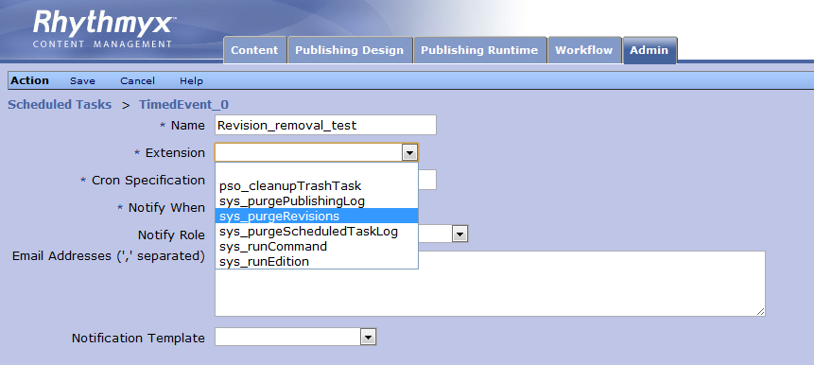**Fig. 1.0**

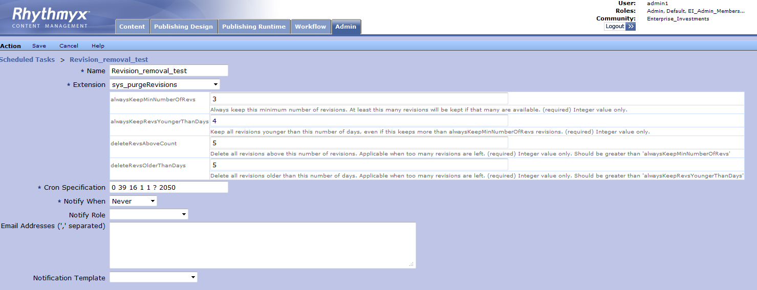

**Fig. 1.1**