Getting Started with
Percussion CM System

Version 7.3

Printed on 12 June 2013

Contents

Introducing Percussion CM System 7
About FastForward 8
Installing CM System in a Development Environment 11
Preparing the Development Environment for CM System Installation 12
Installing CM System 13
Starting the CM System Server 14
Introduction to Content Explorer 15
Logging in to Content Explorer 16
The Content Explorer Banner 18
Content Tab 19
The Navigation Pane 20
The Display Pane 21
The Menu Bar 22
Publishing Runtime Tab 23
Workflow Tab 24
Admin Tab 25
Publishing Design Tab 26
Publishing A Default Edition 27
A Brief Tutorial 31
Creating Content Items 32
Creating a Generic Content Item 33
Creating a Generic Word Content Item 37
Creating an Image Content Item 39

Working with Site Folders 42
Creating the Education Folder 43
Moving Content into the Education Folder 45
Adding Additional Content to the Education Folder 47
Active Assembly 48
Adding Links to Other Generic Pages in the Sidebar Slot 49
Adding an Image to a Generic Page 57
Previewing the Content Item 61
Workflow 62
Check In and Check Out 63
About Roles 64
About the Standard Workflow 65
Transitioning Content Items to a New State 67
Moving Content Items to Public 68
Maintaining Managed Navigation for the Education Folder 69
Creating a Landing Page for the Education Folder 70
Making the Education Navon Content Item Public 72
Publishing the Web Site with the Education Section 73
Troubleshooting 77
Installation 78
Installer Cannot Connect to the Repository 78
Startup 79
Server Shuts Down During Initialization 79
CM System License Period Expired 79

Out-of-Memory Condition Displayed on CM System Startup 79
Index 81

C H A P T E R 1

Introducing Percussion CM System

The Percussion CM System manages content through the automation of content creation, maintenance, and delivery, enhanced with features such as content reuse, delivery to multiple sites, intelligent relationships between content, and simple content assembly for business users.

One of Percussion CM System's key features is content reuse, which it achieves by separating content and formatting, enabling users to create a variety of outputs using the same data. Business users can assemble the same Content Items multiple times using different formats and include the Content Items in the output formats of other content. This enables CM System to output pages to contain many Content Items assembled together.

Another key feature of CM System is its ability to publish content to multiple sites. CM System allows any number of applications to be used to present published content to consumers since the content delivery mechanism (a portal, Web server, or other application) is not connected to CM System. This offers you flexibility in choosing delivery applications and simplifies the process of delivering content to multiple media.

This document will help implementers get started with CM System by installing it with its FastForward sample components and Content Items, starting the Percussion CM Server, and publishing sample content. For more details about content creation, reuse, and delivery, and conceptual information about content assembly and intelligent relationships, see the CM System Concepts Guide.

Note: "Percussion CM System" now replaces the name "CM System". Updated topics in this document refer to "Percussion CM System" or "CM System", while unchanged topics refer to "CM System". In this document, the names are interchangeable and refer to the same CMS system that Percussion Software provides to you.

About FastForward

FastForward is a reference implementation available with Percussion CM System. FastForward includes a set of pre-built components and applications that allow a company to quickly bring their Web site under management. These pre-built components include definitions for the types of content and outputs most commonly implemented by customers and elements for setting up typical publishing and authentication scenarios. This document includes instructions for installing and reviewing these components.

Implementing FastForward

Install, configure, and implement FastForward in a development environment and then test your features in a test environment. After development and testing is complete, migrate your Percussion CM System components to the production environment where your end users perform their work. This process ensures that end users only have access to completed, tested components and features.

Before reading this document, read the CM System Concepts Guide for a basic understanding of the concepts and operation of CM System. Then use this to guide you through the process of installing CM System with FastForward and testing that the installation was successful and that it is publishing content as expected. This document also includes a "guided tour" of CM System's functionality.

After reading this document, use the following documents to guide you through the process of designing and implementing your CM System.

▪ Modeling and Design of a CM System Content Management System
This document outlines the process of modeling your content and designing a CMS
implementation to meet your needs.

▪ CM System Implementation Guide
This document explains the common tasks of implementing a Percussion CM System by illustrating the implementation of selected elements of FastForward.

▪ Setting up the CM System Production Environment
This document explains how to set up the production environment and deploy your implementation from your development environment to that production environment.

C H A P T E R 2

Installing CM System in a

Development Environment

In the recommended CM System environment, implementers create new CM System elements and features on a development server, perform user testing on a testing server, and install tested, new functionality to a production server. In technical terms, this is called a multi-tiered environment, and each Server level represents a tier.

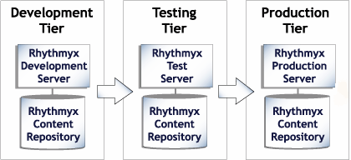

Figure 1: A multi-tiered environment includes development, testing and production tiers.

It is important to implement FastForward on a separate development tier and integrate and test completed development work on a testing tier. On the development tier, configure Site structures and develop CM System applications and elements. On the testing tier, integrate all development work and determine if it functions as expected. Since features in development and testing states tend to be incomplete and unstable, they should never be accessible on the production tier, where users are creating and publishing actual content. Once testing is complete, move new components to the production tier.

A Web Server must be installed on each tier to test or perform publishing. Implementers should successfully publish the sample content on the development tier before configuration is deployed to an integrated testing tier and then a production tier.

Preparing the Development Environment for

CM System Installation

Be certain that you are following CM System's system requirements before installing it. For the latest system requirements, see system requirements page at (http://help.percussion.com/cmsystem/tiki- index.php?page=System+Requirements+and+Installation+Prerequisites&structure=Installation).

Installing CM System

CM System provides Installers for Windows and Unix. You must install your database prior to installation.

To set up your system to use the defaults:

▪ In your repository, define a new schema or database named RXMASTER. During installation, you will specify RXMASTER as CM System’s backend database.
▪ If you are currently using port 9992 free it. Port 9992 is the default CM System Server port. You must enter your license number and installation code to install CM System. They are located on the back of your CD jacket.

For instructions on installing CM System see Installation Examples at http://help.percussion.com/cmsystem/tiki-index.php?page=Installation+Examples&structure=Installation).

Starting the CM System Server

To start the CM System Server in Windows, in your CM System root directory, double-click on the file RhythmyxServer.exe. A terminal window should open and list the progress of the Server initialization. When the terminal window displays the message “Started in...”, the CM System Server is up and running:

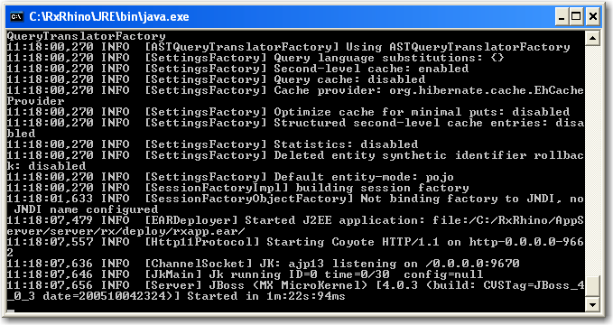

Figure 2: CM System Server Console

If you have problems starting the CM System Server, see Startup (on page 79) in the Troubleshooting section of this document.

C H A P T E R 3

Introduction to Content Explorer

Content Explorer is the default home page Percussion CM System displays when any user logs in to the CMS. Content Explorer gives business users access to Content Item administration functions such as create, approve, and copy, and gives implementers and administrators access to Publishing and Workflow setup screens.
Content Explorer uses a Java Applet. The current stable java 7 update from Oracle should be installed on the client machine to make sure the desktop is kept up to date with security updates from oracle. You may want to wait for a few days and check the forums to make sure that any new update does not cause issues with the product.

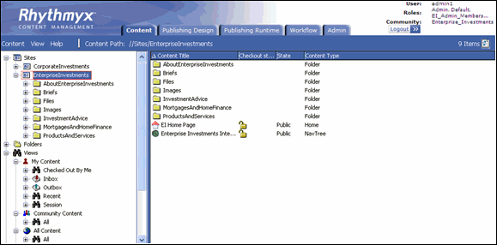

Figure 3: Content Explorer

The following sections explain how to log in to Content Explorer and summarize the functions of each of its tabs.

Logging in to Content Explorer

To log into Content Explorer:

1 Open one of the supported Web browsers and navigate to http://servername:port/Rhythmyx where servername:port describes the location of the CM System server. For example, if your CM System Server is named contentmanager and you are using the default port 9992, enter http://contentmanager:9992/Rhythmyx.

CM System prompts you to log in.
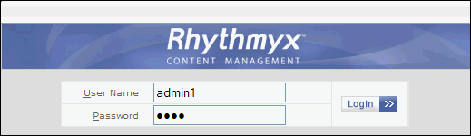

Figure 4: Login Dialog

2 Enter the User name admin1 and the Password demo, and click [Login].

Content Explorer uses a Java applet. When installing the applet, your browser displays a security dialog. If you see this dialog, click the [Yes] button to allow the applet to install on your browser.

When the applet finishes loading, CM System opens Content Explorer. The Content tab is selected, and the interface displays all five tabs.

Figure 5: Content Explorer

The Content Explorer banner (see "The Content Explorer Banner" on page 18) at the top of the page remains the same regardless of which tab is selected.

The tabs available to an administrator with full access are:

▪ Content (see "Content Tab" on page 19)
▪ Publishing Design (see "Publishing Design Tab" on page 26)
▪ Publishing Runtime (see "Publishing Runtime Tab" on page 23)
▪ Workflow (see "Workflow Tab" on page 24)
▪ Admin (see "Admin Tab" on page 25)

The Content Explorer Banner

The banner consists of the Rhythmyx logo, the Logout button, and the login information at the far right. Tabs for the different Content Explorer screens are also visible. The banner remains the same regardless of which tab is clicked.

Figure 6: Rhythmyx Banner

The login information consists of three or four pieces of data:

▪ User: The name of the user logged in to the system, in this case, admin1
▪ Roles: The Roles into which the logged in user has been authenticated. If you hover your mouse over the value of the Roles field, the system displays a popup listing all of the Roles into which the user has been authenticated. The value of the Roles field is also a link. You can click on this link to display a popup window with the user's list of Roles as well. The graphics below illustrate both options:
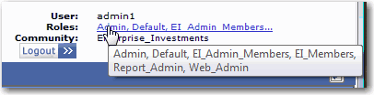

Figure 7: List of user's Roles

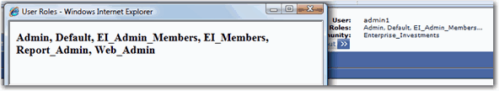

Figure 8: Popup with Roles

▪ Community: The CM System Community into which the user is currently logged. The admin1 user is initially logged in to the Enterprise Investments Community, as illustrated in the screenshot above.
▪ Locale - If the user has a Locale other than US English, the login information displays the
Locale underneath the Community.

Content Tab

In the Content Tab, business users create and modify Content Items and transition them into Workflow States. This tab also allows users to actively assemble Content Items as pages or portions of pages and preview the results.

The Content tab appears and functions similarly to the Windows Explorer interface: the left pane displays a Navigation Tree and the right pane is a Display pane that lists the contents of the node selected in the Navigation Tree.

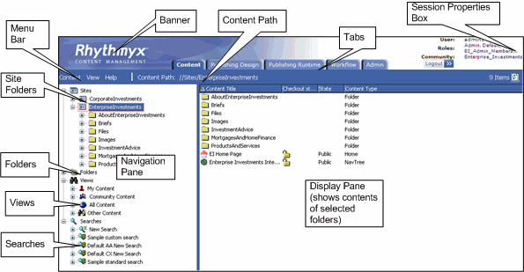

Figure 9: Diagram of Content Explorer

Only the tabs for pages that the user may access are visible. If the user only has access to the Content tab, no tabs are visible.

The Navigation pane (see "The Navigation Pane" on page 20) includes four main nodes that represent different ways of navigating Content Items.

When a user selects a node in the Navigation Tree, the Display Pane (see "The Display Pane" on page 21)
displays it contents.

The Content tab also includes a Menu Bar (see "The Menu Bar" on page 22) with drop menus that include the various actions available to users in the Content tab.

The Navigation Pane

The Navigation Pane provides you with options for locating and organizing Content Items.

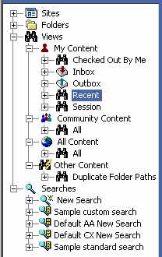

Figure 10: The Content Explorer Navigation Pane as displayed when first accessed

The Navigation Pane consists of four main Nodes:

▪ The Sites node is used to define Site structures and to assign Content Items to those Sites.
When you publish content, the CMS creates a directory structure on the target Web server identical to the structure you define under this node. Published pages are output to the
directory parallel to the Content Explorer Site Folder to which they have been assigned.
▪ The Folders node consists of Folders used strictly to organize Content Items. The folder structures created under this node are not used in Publishing but for personalized organization.
▪ The Views node consists of a set of pre-defined queries that return lists of content. View fall into four categories.
▪ My Content Views

This category is the richest set of default Views. Views in this category list Content Items checked out to the logged user, Content Items assigned to the logged user, Content Items the user has worked on recently, and Content Items created by the user.

▪ Community Content Views

This category consists of Views that list Content Items only in the current Community of the user.

▪ All Content Views

This category consists of Views that can list all Content Items in the system, regardless of their Community or current Workflow State.

▪ Other Content Views

This generic category consists of Views that do not fit in any of the other categories.

▪ The Searches node consists of the New Search query and several pre-defined search queries.
Searches are somewhat simpler than Views. Views can query based on system data not available to searches.
For more details about any of these nodes, see the Content Explorer Help, which you can access by choosing Help > Content Explorer from the Menu Bar.

The Display Pane

The larger area to the right on the Content Explorer is the Display Pane.

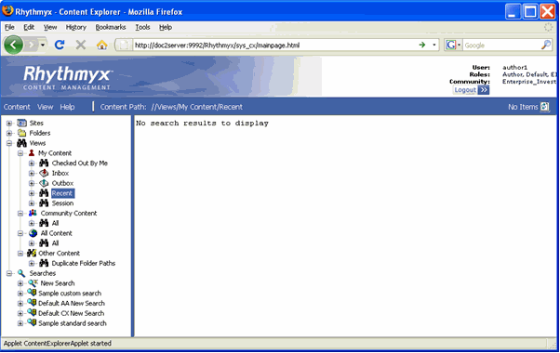

Figure 11: Content Explorer

When you initially log in to Content Explorer, the default navigation selection is always the Recent View. Since you have not logged in before and have not worked with any Content Items to this point, this View has no results, as illustrated in the graphic above, which shows the text "No search results to display".

Expand the Sites node, and select the Enterprise Investments Folder. Now the Display Pane lists the contents of this Folder. This Folder includes a number of Subfolders (such as About Enterprise Investments, Investment Advice, and Products and Services) and a couple of Content Items (EI Home Page and Enterprise Investments Internet Root).

The Menu Bar

The Menu bar separates the banner from the Navigation and Content Panes.

The Menu bar consists of three menu options and the Content Path. The Content Path lists the Navigation path to the object currently selected in the Navigation Pane.

The following Menu options are available:

▪ Content
The Content Menu consists of options for managing Content. This menu includes three options:

▪ New

The New Menu consists of two submenus: New Item and Folder. The Folder option is only available if you are in either the Site or the Folder node, or a Subfolder of one of these nodes. The Folder option allows you to create a new Folder. The New Item option lists all Content Types for which the current user has access to create a new Content Item.

▪ Search

This option launches a new Search.

▪ <selected Navigation Pane node>

This name of the selected node in the Navigation pane. Submenu options available from this choice include the right-click options for the node.
▪ View
The View Menu includes two choices. The Refresh option refreshes Content Explorer. The Options choice activates the Display Options dialog, where you can modify the display settings for Content Explorer.
▪ Help
The Help Menu includes two options. The Content Explorer option activates the Content
Explorer Help. The About option activates the About Content Explorer dialog.

Publishing Runtime Tab

The Publishing Runtime tab provides the capability of initiating Publishing of an Edition and of reviewing the results of all Publishing jobs (whether initiated manually or automatically).

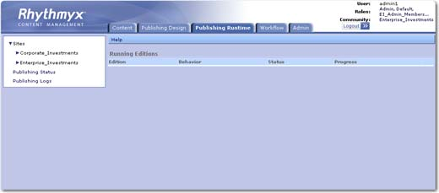

Figure 12: Publishing Runtime Tab

For details about publishing Editions and reviewing publishing results, see the CM System Administration
Manual.

Workflow Tab

A Percussion CM System Workflow is a set of States that a Content Item progresses through during its lifetime. In general, Content Items are published after they pass through one or more approval States and reach a publish State.

The following graphic shows how the default Workflow tab appears when FastForward is installed. Your
Workflow tab should also display the Simple and Standard Workflows.

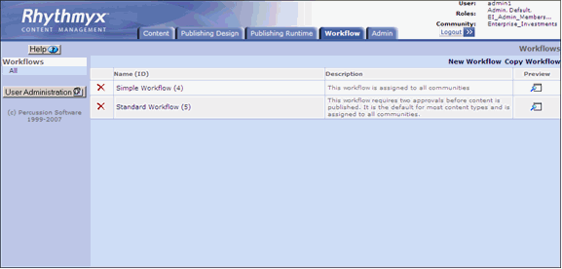

Figure 13: Workflow Tab

For more information about Workflows and the Workflow tab, see the section on Workflows (see "Workflow" on page 62), below, and the Workflow Online Help or the document CM System Implementation Guide.

Admin Tab

The Admin tab includes links to pages used to administer and maintain the Percussion CM System, including:

▪ Console
This page is used to issue commands to the Percussion CM server.

▪ Variant to Template Migration Tool
This page is used on systems upgraded from CM System Version 5.7 or earlier to CM System
Version 6.0 or later to migrate XSLT Variants to Velocity Templates.

▪ Run RxFix
This tool should only be used under the direction and guidance of a Percussion Software
Technical Support Representative.

▪ Run Repository Consistency Checker
This tool should only be used under the direction and guidance of a Percussion Software
Technical Support Representative.

▪ Scheduled Tasks, Task Notifications, and Task Logs
For details about maintaining Scheduled Tasks and Task Notifications, and reviewing
Scheduled Task logs, see the CM System Administration Manual.

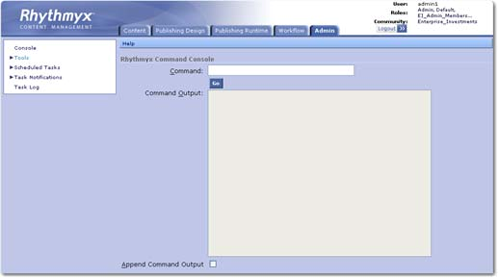

Figure 14: Admin Tab

Publishing Design Tab

The Publishing Design table includes links to pages for configuring publishing infrastructure, including:

▪ Sites, and the Content Lists and Editions associated withe each Site
▪ Contexts
▪ Delivery Types
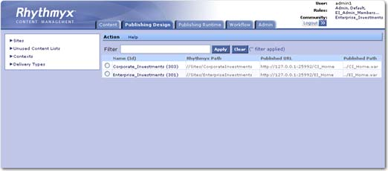

Figure 15: Publishing Design Tab

For more information about the options on this tab, see the Help for the tab, or the following documentation:

▪ Sites: "Setting Up the Publishing Site and Basic Navigation" in the CM System Implementation
Guide.
▪ Content Lists, Editions, and Context: "Configuring Publishing" in the CM System
Implementation Guide.
▪ Delivery Types: "Configuring a Delivery Type" in the CM System Technical Reference
Manual.

Publishing A Default Edition

Before you have made any modifications to your CM System system, it is good practice to publish some content to validate that the publishing system has installed correctly.

Compare your current publishing results to those you receive later, during the tutorial part of this document, when you add content items and a folder to the site.

Now you will publish the preconfigured Enterprise Investments Full Edition, which includes the entire
Enterprise Investments website.

To publish the Enterprise Investments Full Edition:

1 In Content Explorer, click on the Publishing Runtime tab.

2 Expand the Sites node; under the Sites node, expand the Enterprise Investments node. Expand the Editions node.

3 Click on EI_Full.

The edit and view pane displays the Runtime Edition page.

4 In the menu, choose Start.

The edit and view pane displays Edition progress data, including the following:

▪ Progress bar

▪ Start Time

▪ Elapsed time since the Edition was initiated.

▪ Current State of the Edition

▪ Number of Content Items Queued

▪ Number of Content Items Delivered

▪ Number of Content Items for which publishing Failed
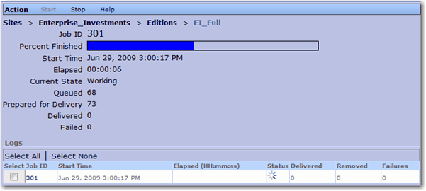

Figure 16: Edition progress data

When the publishing job has completed, the results will be displayed in the Logs. The result should resemble the following screenshot:
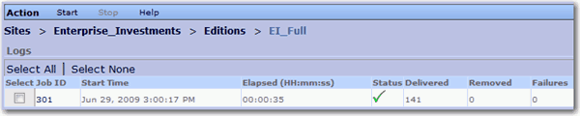

Figure 17: Log listing for completed Edition

Click the log's Job ID to see the results of the publishing job:
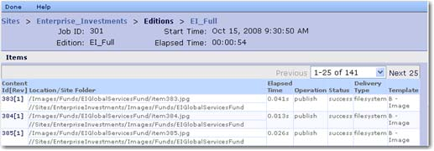

Figure 18: Log for the EI_Full Edition publishing run

Click on an individual Content id to see its results in the job. This tool is particularly useful to determine why a Content Item failed. (the following is an example of the error message for an item that failed to publish. It is unlikely that your publication will have any failures.)

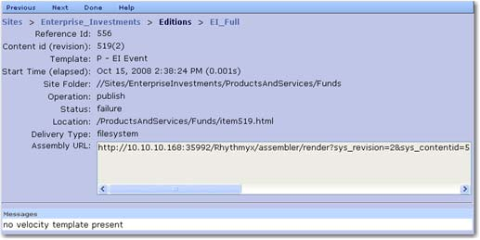
In this example, the Template that was being published did not include any Velocity code.

C H A P T E R 4

A Brief Tutorial

The next section of this document will walk you through the basics of creating content items, assembling them into pages, moving them through approval processes, and publishing them to your website. The purpose of this tutorial is to help you implement your Percussion CM system by giving you an understanding of how your system's business users will use your implementation.

Creating Content Items

Content Items are the basic units of content in Percussion CM System. A Content Item is usually a portion of a page, such as a block of text, an image, or a banner, header, or footer. In some cases, such as home pages, a Content Item may be a complete page, but more commonly, a Content Item is a portion of a page.

By defining content in such a granular manner, CM System provides users greater control over the content. You can use the same Content Item in multiple ways on different pages. Further, if editing is necessary, you only need to change the Content Item that needs to be modified, and do not disturb other parts of the page.

Creating a Generic Content Item

Let us begin by creating a simple Generic Content Item.

You should always create new Content Items in a Folder so you can find them easily. Percussion CM System does not require you to be in a Folder when you create a Content Item, but if you do not create the Content Item in a Folder, you will need to search for it or use a View to find it. We will create our
Content Item in a Site Folder.

In the Navigation pane, expand the Sites node, and select the Enterprise Investments Site Folder. Notice that when you select this Folder, the contents of the Folder are displayed in the Content Pane. Double- click on the "About Enterprise Investments" Folder. We will create our new Content Item in this Folder for now.

Percussion Software provides the content for this new Content Item, and several others we recommend that you create in the course of this walk-through. The content is provided in a set of .txt files in the
<Rhythmyxroot>/Samples/ffsamples directory. If your Percussion CM server is on a remote machine, you may want to copy the contents of this directory to your local machine. We are going to use the tuition.txt file to provide the content for our example Content Item. Open this text file in a simple text editor such as Notepad.

To create your new Generic Content Item:

1 In the Menu bar, choose Content > New > New Item > Generic.

The CMS pops up a blank Generic Content Editor:
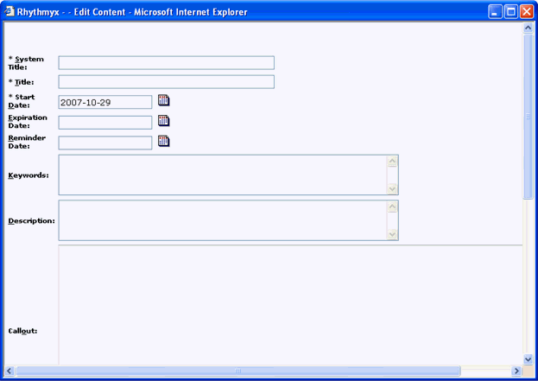

Figure 19: Generic Content Editor

2 Change to the Tuition.txt file, and copy the first line. Change back to Content Editor and paste this text in the System Title field. Paste it again into the Title field.

3 Note that the Start Date defaults to the current date. Do not change the value in this field.

4 Change to the Tuition.txt file and copy the second line. Change back to the Content Editor and paste this text into the Description field.

5 Click the design tab at the bottom of the Callout field to enable it. Change to the Tuition.txt file and copy the third line.
Change back to the Content Editor and paste this text into the Callout field.

6 Click the design tab at the bottom of the Body field to enable it. Change to the Tuition.txt file and copy the text from the beginning of the third line to the end of the file. Change back to the Content Editor and paste this text into the Body field.

7 Click the [Insert] button. You will be briefly redirected to a page asking you to wait a moment while your Content Item is uploaded to the repository, then redirected again the Content Editor.

You have just added a new Content Item to the CM System's Repository.

8 Click the [Close] button to close the Content Editor. Note that the new Content Item, "Tuition Tax Credits and Deductions Offer Free Money from the IRS" has been added to the Enterprise Investments Folder.

9 Right-click on "Tuition Tax Credits and Deductions Offer Free Money from the IRS" in Content Explorer. A menu of options opens. Move your cursor to Enterprise Active Assembly. This option includes a set of links you can use to preview different formatted outputs of the Content Item. For example, if you click the P - EI Generic link, CM System displays a window similar to this:
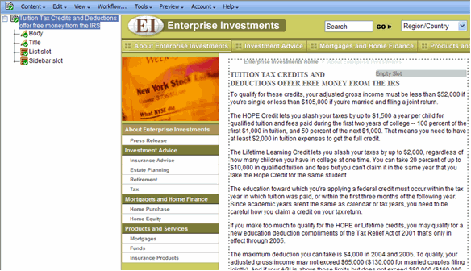

Figure 20: P - EI Generic Format

This page illustrates how the Content Item would look as a published Web page. If you click the S - Title Callout Link, you see a window similar to this:

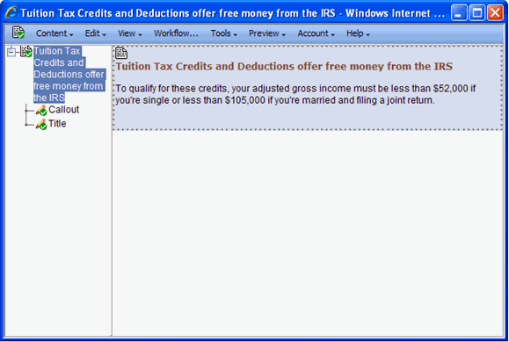

Figure 21: S - Title Callout Link Format

Both links launch the item in Active Assembly. Active Assembly consists of a two-panel interface that lets you edit content items directly on the page. The left panel is referred to as Outline view, and the right
panel is referred to as Page view. Later in this document, we will complete various tasks in the Active Assembly interface. For complete information on Active Assembly, see the Active Assembly Interface Help.

Creating a Generic Word Content Item

Percussion CM System has been designed with enough flexibility that you can connect to third-party tools as Content Editors. One of the most common tools used for creating content is Microsoft Word word processor. The Generic Word Content Type provides the option of entering and maintaining Content Items using Microsoft Word. We will enter Content from the sample Content File SavingForCollege.txt. You should still be in the Enterprise Investments/About Enterprise Investments Folder to create this Content Item

Note that before you can launch Word from CM System, you must update your security options. In
Internet Explorer choose Tools > Internet Options and click the Security tab:

▪ Make your Percussion CM server a trusted site (Click the [Sites....] button then the [Advanced] button. In the Add this web site to the zone... dialog, enter http://localhost (or the name or IP address of the remote machine where your Percussion CM server resides) and
click [Add]. Click [OK] twice to return to the Security tab.
▪ Click the [Custom level...] button and on the Security Settings dialog, find the Download signed ActiveX controls entry. Select either Enable or Prompt for this option.
▪ Click [OK] twice to close the Tools window.
▪ Refresh the Content Explorer screen. To create a Generic Word Content Item:

1 In the Menu bar, choose Content > New > New Item > Generic Word.

The Generic Word Content Editor uses an ActiveX control to launch Microsoft Word. Percussion Software has signed that this ActiveX control is safe, so click the [Yes] button if asked whether you want to run the control. After you click [Yes], the CMS pops up a blank Generic Word Content Editor.

2 Change to the SavingForCollege.txt file, and copy the first line. Return to the Content Editor and paste the first line into the System Title field.

3 Click the Callout field to activate it. Change to the SavingForCollege.txt file and copy the second line. Return to the Content Editor and paste this text into the Callout field.

4 Click the Launch Word link.

CM System launches Microsoft Word. Content editing using Microsoft Word requires the use of Word Styles to mimic fields in CM System. These styles are stored in the GenericWord template. The template includes Word macros that convert the styles into CM System fields during the upload process. You can implement your own Word-based Content Editors. For details see the document Implementing Word in CM System.

5 Change to the SavingForCollege.txt file, and copy the first line again. Switch to the instance of Word and paste it. Notice that the Style for this paragraph is PageDisplayTitle. The content of this paragraph will be entered into that field in the Repository.

6 Hit the <Enter> key on your keyboard. The new paragraph has the Style PageAuthor. In the
Style drop list in Word, choose the style PageBody

7 Change to the SavingForCollege.txt file and copy from the beginning of the second line through the end. Paste this text into the Word document.

8 In the Word button bar, click the Save to CMS button .

9 Word displays a File Name dialog. Enter the text SavingForCollege.

10 Click [OK].

11 Word displays a confirmation dialog:
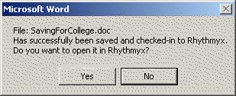

Figure 22: Confirmation dialog displayed when you have successfully uploaded your Content Item into
Word

12 Click the [Yes] button. You will return to the CMS with the Saving For College Content Item displayed in the Display Pane. The Content Item is located as the result of a background search; if you do not see it, click the Search Results node in the left pane.

13 Right-click on the Saving For College Content Item and choose Edit from the popup menu.

CM System displays the Saving For College Content Editor.

14 At the bottom of the Content Editor, you will find links for viewing this Content Item in Active Assembly in different formats. Click on these links to view the formats available for the Content Item.

15 When you have finished, click the [Close] button.

Creating an Image Content Item

Image Content Items are used to manage graphics used as content on Web pages.

Note that some graphics are used within the page layout itself. Examples include company logos and spacers used to define page layout. These graphics, which are referred to as static images, are not managed by the CMS but reside on the Web server so they can be included in the Published pages.

Content images, however, are managed as Content Items of the Image Content Type. Once an Image
Content Item exists in the system, you can use it in any Slot that allows Image Content Types.

An example graphic (moneyroll.jpg) is included in the FastForward sample directory. If you are connecting to your Percussion CM server from a remote machine, you might want to copy this file to your local machine.

To create the Image Content Item:

1 In the Navigation Pane, expand the Enterprise Investments Site Folder, then expand the
Images Site Folder. Double-click on the People Folder.

2 In the Menu bar, choose Content > New > New Item > Image.

CM System displays the Image Content Editor.
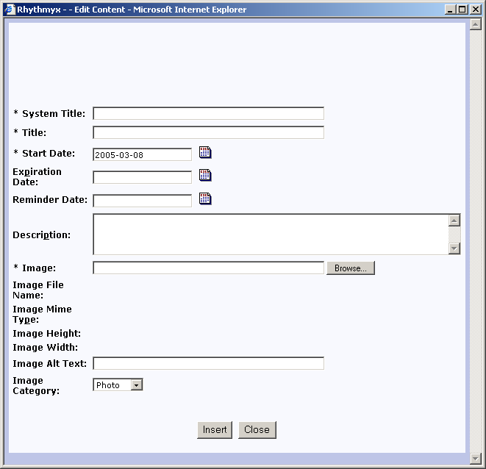

Figure 23: Image Content Editor

3 In the System Title and Title fields, enter Money Roll.

4 Click the [Browse] button next to the Image field.

CM System displays a browse dialog.

5 Browse to the <Rhythmyxroot>/Samples/ffsamples directory, select the file moneyroll.jpg.and click the [Open] button.

CM System adds the path and filename you specified (for example, C:\Rhythmyx\Samples\ffsamples\moneyroll.jpg).

6 On the Content Editor window, click the [Insert] button.

7 CM System uploads the file and refreshes the Content Editor window. Once the window has refreshed, the read-only fields Image File Name, Image Mime Type, Height, and Width include data.

8 Click the [Close] button to close the Content Editor

9 The new Money Roll Image Content Item has been added to the Folder. Two additional sample image files are included in the FastForward Samples directory,
Girllookingatcamera.jpg and taxandglasses.jpg. Add these as Image Content Items to the same Folder.

Working with Site Folders

As discussed earlier, Folders are the fundamental mechanism the system provides for users to organize and navigate content. Folders in Percussion CM System are similar to Folders in Microsoft Windows. The major difference is that the folders in Windows are physical directories on the file system. Files in a folder in Windows are physically located in that Folder.

In CM System, Folders define virtual locations you can use to organize and navigate content. The Content always exists in the Repository, not in the Folders. The Folders merely contain pointers to the physical Content Items stored in the Repository.

The Navigation Pane includes two roots that contain Folders. The Sites Root is used to define Site structures. When you publish a Site, CM System creates a directory structure on the target server parallel to the Site Folder structure you have defined under this node. Note that you can create a several Sites under this node, each of which can be published separately. The Folders Root contains Folders that are used more generically for organization. The Folders under this root are not published.

Otherwise, Folders function identically regardless of the root to which they belong.

Creating the Education Folder

We want to create a new subsection (Education) for the Investment Advice section of our Web site. This section will require a new directory to store the Web pages for the new section. We create the new section, and the new directory, by creating a new Folder.

To create the new Education Folder:

1 In the Navigation Pane, expand the Enterprise Investments node, and select the Investment
Advice node.

2 In the Menu bar, choose Content > New > Folder.

The CMS displays the Create Folder dialog.
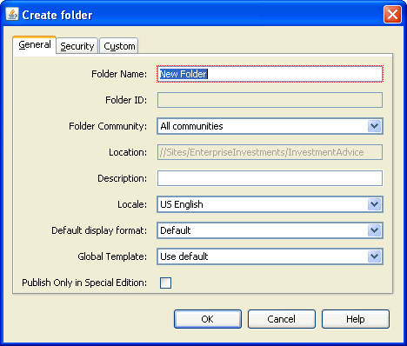

Figure 24: Create Folder dialog

3 In the Folder Name field, enter Education. You can enter a free-form Description if you wish, but that is not necessary. Leave the defaults in all other fields.

4 Click the [OK] button.

The CMS adds the new Folder under Investment Advice.
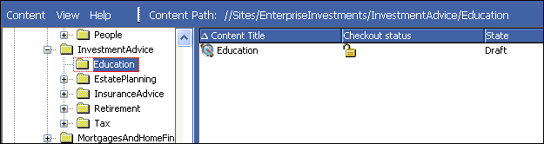

Figure 25: Education folder

Double-click on the Education Folder. The display pane shows the contents of the Folder. Notice that this Folder already has a Content Item, Education, of the Navon Content Type. This Content Item is created automatically by the Managed Navigation functionality. It is used to generate navigation for the Web site automatically when it is published. For more about Managed Navigation see Maintaining Managed Navigation for the Education Folder (on page 69).

Moving Content into the Education Folder

Since Web pages are published to the directory corresponding to the Site Folder in which they are located, we want to move the Content Items we previously created into the new Folder.

Let us move the Tuition Content Item first. To move the Tuition Content Item:

1 Select the EnterpriseInvestments Folder.

2 In the Navigation Pane, select the About Enterprise Investments Folder so you can see its contents in the Content Pane.

3 In the Content Pane select the Tuition Content Item, and drag it to the InvestmentAdvice/Education Folder (as you drag the Content Item, you will notice a small dotted square below the mouse pointer; this square indicates that you are dragging the Content Item.

4 Place the mouse pointer over the Education Folder and release.

A dialog pops up with the following options:

▪ Move

▪ As Link

▪ As New Copy
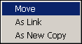
5 Select the Move option.

The Tuition Content Item is removed from the Content Pane.

6 Select the Education Folder. The Tuition Content Item has been moved to the new location.
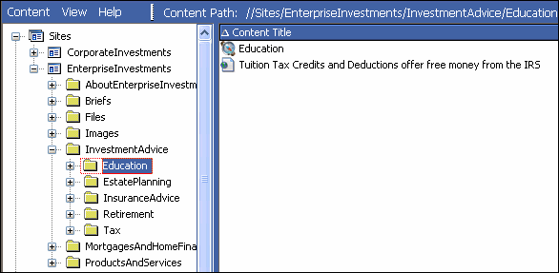

Figure 26: Education Folder with moved item

7 Use the same procedure to move the Saving for College Generic Word Content Item into the
Education folder.

8 Now go into the EnterpriseInvestments/Images/People folder and move the Money Roll, Girl
Looking at Camera, and Tax and Glasses Content Items into the Education Folder.

Adding Additional Content to the Education

Folder

Two additional sample txt files, TenThingstoknow.txt and Section529Plans.txt are included in the Samples directory. Use these to create two more Generic Content Items, "Important Things to Know About Saving for College" and "Section 529" Plans in the Education Folder.

When you have created these Content Items, the Education Folder should resemble the following screenshot:

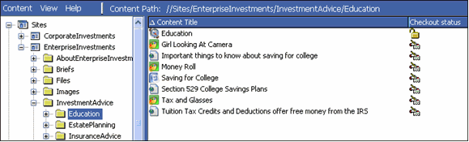

Figure 27: Education Folder

Active Assembly

Now that we have some Content Items, we want to create links between them. In Percussion CM System, the process of creating these links is called Active Assembly. When you use Active Assembly to link one Content Item to another, you are creating an Active Assembly Relationship between the two Content Items.

Active Assembly Relationships are one category of associations between Content Items. CM System provides the ability to create a variety of associations between Content Items. Collectively, these associations are known as Relationships. For more details about Relationships in general, see Implementing the Relationship Engine.

An Active Assembly Relationship defines how one Content Item (referred to as the Dependent) will be included in another Content Item (which is called the Owner because it owns the Relationship) when the content is published. Active Assembly is used for one of two reasons:

▪ to embed one Content Item into another (typically used for graphics, but occasionally also used to embed text from one Content Item into another);
▪ to create a link from one Content Item to another (such as a hypertext link between two pages, or call to a binary file to be displayed to the user).
We will perform both types of Active Assembly, adding links between the pages we created and adding images to the pages.

Adding Links to Other Generic Pages in the

Sidebar Slot

On the P - EI Generic Template, the Sidebar Slot is used to create links to other Content Items that contain content related to the topic on the current page. Let's create a link from the Tuition Content Item to the other new Education Content Items we created.

To create related content in the Sidebar Slot:

1 In the Navigation Pane, select the Education Folder.

2 Right-click on the Tuition Content Item and choose Enterprise Active Assembly > P -EI Generic from the popup menu.

CM System displays the P - EI Generic format of the Tuition Content Item in the Active
Assembly Interface.
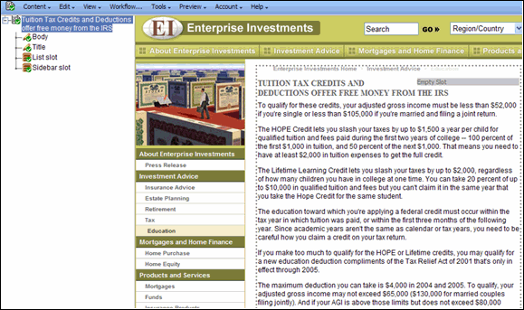

Figure 28: Tuition item in P - EI Generic format

In Active Assembly, you can modify the Snippets in the Slots on this Template.

3 In Outline View, find Sidebar slot, and right-click the icon, and choose Insert Snippet
from the drop menu.

CM System displays the Content Browser.
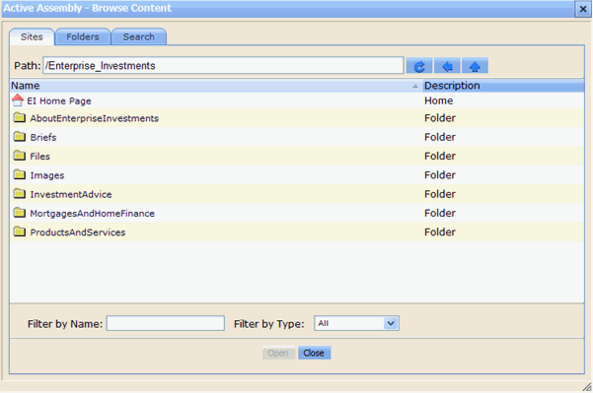

4 Click the Search tab.

Figure 29: Content Browser

Two versions of this tab are available. If you are using the full-text search engine, you will see:
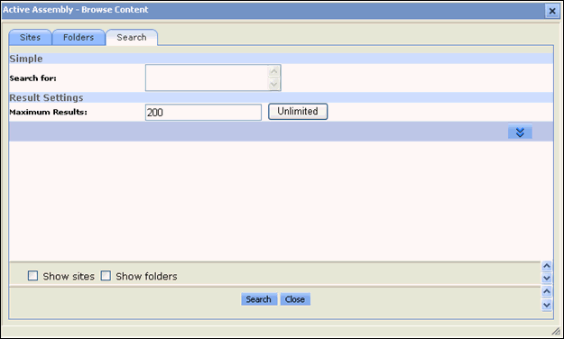

Figure 30: Content Browser, Search Tab

If your system is using the database search engine, you will see:

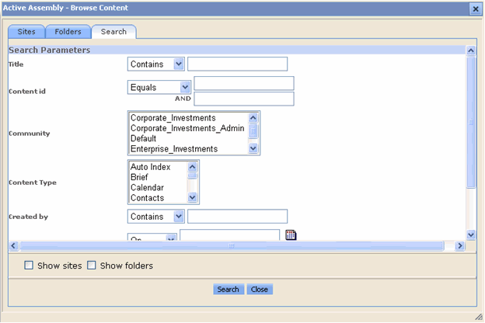

Figure 31: Content Browser, Search tab

5 If you are using the Full-text Search engine, enter college into the Search for field. If you are using the database search engine, enter college into the Title field. Click the [Search] button.

6 CM System returns the Search results:
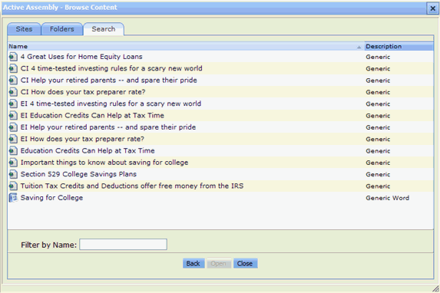

Figure 32: Search results

7 We want to insert the Section 529 College Savings Plans content item, so we click it.

A page that lets us choose the Template or format for the content item opens. It lists five
Templates with which we can format the item:

▪ S - Callout

▪ S - Image Link

▪ S - Title Callout and More Link

▪ S - Title Callout Link

▪ S - Title Link
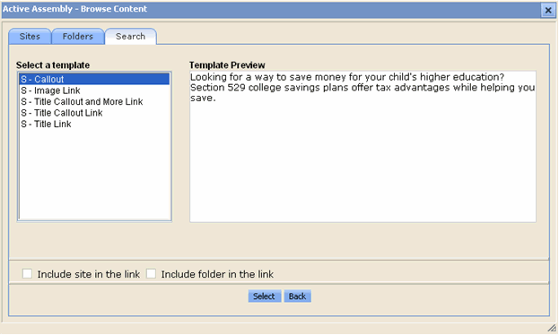

Figure 33: Template selection page

8 Click each option under Select a template to see in Template Preview how it formats the content item.

We want to create a link to the specified page using the Title and Callout of the target Content
Item, so we will use the S - Title Callout Link Template.

9 Select S - Title Callout Link and click [Select].

The Content Browser returns to the page of search results so you can add another item to the Slot. If you move the Content Browser over so you can see the Sidebar Slot where it appears in Page view, you will see that the Section 529 College Savings Plans content item has been added to the Slot.
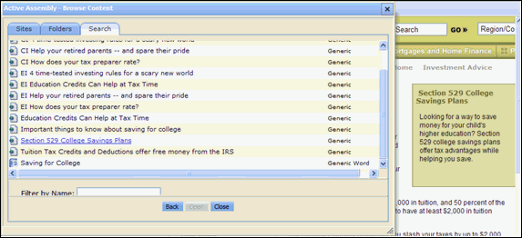

Figure 34: Snippet added to Slot

10 Repeat Steps 7 - 10, adding the Important things to know about saving for college content item in the format of the S - Title Callout Link template.

11 When you return to the Search results, click [Back] to return to the search screen. Since you do not want to enter another search, click [Close].

The Content Browser closes and the page for the Tuition Content Item now resembles:
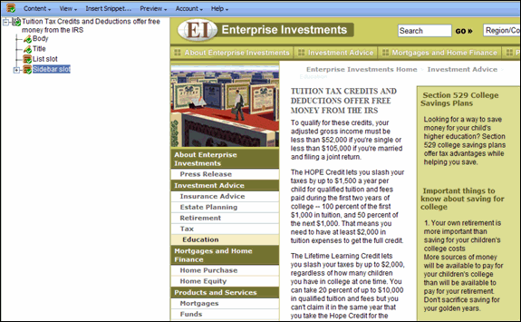

Figure 35: Sidebar Slot with two Snippets added

When you begin with an empty Slot, each new Snippet that you add to the Slot with the Content Browser is inserted at the bottom of the Slot, so the Important things to know about saving for college Snippet appears below the Section 529 College Savings Plans.

Each of the titles in the Snippets that you have added is a link to the Web page for that item. To see this press ALT and click on one of the Snippet titles.

The CMS opens the page that the title links to.

12 When you have finished, close the Active Assembly window for the Tuition Content Item.

Adding an Image to a Generic Page

Now let us add an image to one of our Education Content Items. In this case, let us add an image to the rich-text Body field of the Content Item.

1 In the Navigation Pane, select the Education Folder.

2 In the Content Pane, right-click on the Tuition Content Item and choose Edit from the popup menu.

The CMS displays the Tuition Content Editor.

3 Scroll down to the Body field, and place the cursor before the first character in the field.

4 Click the Insert CMS Image button .

CM System displays the Content Browser.

5 Click the Search tab.

Two versions of this tab are available. If you are using the full-text search engine, you will see:

Figure 36: Content Browser, Search Tab

If your system is using the database search engine, you will see:

Figure 37: Content Browser, Search tab

6 If you are using the Full-text Search engine, enter glasses in the Search for field. If you are using the database search engine, enter glasses in the Title field. Click the [Search] button.

CM System returns the search results.

7 We want to insert the Tax and Glasses content item, so we click it.

A page that lets us choose the Template or format for the content item opens. In this case, there is only one Template available for the item:

▪ B - Image

8 Select B - Image and click [Select].

The image is added to the Body text. The Content Browser closes.

9 Now let us format the graphic so it merges more smoothly with the text. Click the graphic.

A black border appears around it.

10 Right-click on the graphic and choose Image Properties from the popup menu.

CM System displays the Image Properties window.

11 In the Alignment drop list, choose Left.

12 Click the [OK] button.

13 The text will now flow around the graphic, similar to the following screenshot:
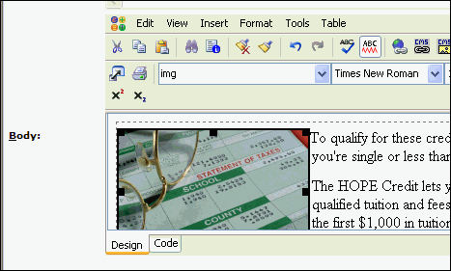

Figure 38: Graphic with text flowing around it

14 Click the [Update] button to upload the changes to the Repository.

When the changes have been uploaded, the Content Editor will refresh.

15 Click [Close].
Now, add the Money Roll Image to the 529 Content Item and add the Girl Looking at Camera Image to the Important Things... Content Item. You may want to try alternative formatting for these images (for example, aligning right instead of left).

Previewing the Content Item

Now that we have added Snippets to the Slots in our Content Items, let us preview them to see how they will look when published.

To preview the Tuition Content Item:

1 In the Navigation Pane of Content Explorer, open the Education folder.

2 Right-click on the Tuition Content Item and on the popup menu choose Enterprise Preview >
P - EI Generic.

3 A preview of the Tuition Content Item opens.
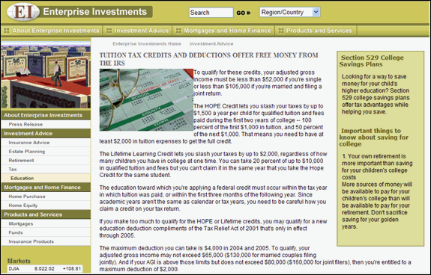

Figure 39: Preview of Tuition content item

Note that the page includes the graphic and the content items in the Sidebar Slot that we added.

Click on the Important Things or Section 529 content item. A preview of the selected page opens. These previews give you an idea of how the pages will look when published. Note, however, that when content is published, the Snippets in the Slots will only be included if they are Public. The following section, which describes Workflow, explains how to make these new content items Public.

Workflow

A Workflow is a business process that defines the life cycle of a Content Item. In Percussion CM System, every Content Item must exist within a Workflow. The Workflow defines:

▪ the steps or stages in the processing of the Content Item;
▪ which users can access the Content Item at a particular point in its life cycle; and
▪ what different users can do to the Content Item at each point.
CM System defines a Workflow as a series of stages, or States, which define the life of the Content Item. In each State, users in specific Roles have access to the Content Item. Users in some Roles can modify the Content Item, while users in other Roles can only see and read the Content Item. Users with the correct access can also Transition Content Items, moving them between States in a Workflow.

Check In and Check Out

The check in and check out functionality allows multiple users to have access to all Content Items, but prevents more than one user at a time from modifying a Content Item. When a user checks out a Content Item, only that user can edit the Item; it is unavailable to all other users.

Check in and check out are special types of Transitions. Check in and check out do not move a Content Item from one State to another, as do normal Transitions. Instead, check in sets a lock flag that indicates a user has the Content Item checked out. Check in removes this flag.

In many cases, CM System checks Content Items in and out automatically. In a few cases (notably when initially creating a Content Item or after modifying the Content Item), you must check the Item in manually.

About Roles

A Role is a collection of users with the same access in Percussion CM System. In Workflows, Roles determine which users can access content in each State and which Transitions they can apply.

Organizing users into Roles helps administrators manage users that have the same permissions. Instead of managing the permissions for each user, they define a Role its permissions, then assign users to it. Users inherit their access rights from the Roles to which they are currently assigned.

About the Standard Workflow

The Generic Page Content Type uses the Standard Workflow, one of two basic Workflows included with FastForward. The Standard Workflow is a common structure that requires one approval before going to Public.

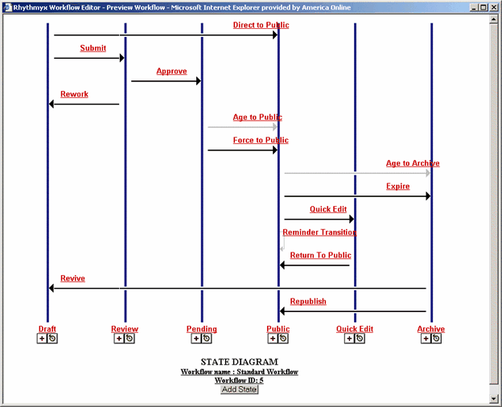

Figure 40: Preview of Standard Workflow

Note that the Standard Workflow includes a Pending State between the Review and Public States. This State is included to support internationalized systems. In some cases, internationalized systems require that Translations of Content Items be Published at the same time as the original. The Pending State provides a holding area" for original Content Items while waiting for the Translations to be completed.

The Public State is the State in which the Content Item is eligible to be Published. When a Content Item reaches this State, it will be published the next time the Publisher runs.

The Quick Edit State is provided to allow quick touch-ups to Content Items without forcing them through the complete Workflow again. For example, if you find a misspelling or minor grammatical error on the Content Item, there is usually no need for it to go back through the complete approval process. Instead, you can move it to Quick Edit, make your change, and return the Content Item to Public immediately. Note that your changes will not be reflected in the published output until the Content Item is re-published.

Finally, the Archive State provides a terminal State for Content Items after they have expired. The Content Items continue to exist in the system, and if necessary can be revived. (In the Standard Workflow, revised Content Items are returned to the Draft State and must go through the complete Workflow before they can return to Public.)

Transitioning Content Items to a New State

Now that we have finished creating our Content Items and adding related content, we want to make them
Public so we can publish them. We will need to perform Transitions on the Content Items. To Transition the Tuition Content Item:
1 In the Navigation Pane, go to the Education Folder.

2 Right-click on the Tuition Content Item and on the popup menu, choose Workflow > Submit.

3 A Workflow Comment window opens. You can enter a free-form comment in this window.
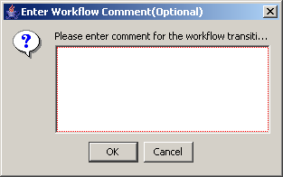

Figure 41: Workflow Comments Popup

4 Click the [OK] button to continue making the Transition.

5 A Message Box informs you that the system is processing the Tuition Content Item.

6 When the message box disappears, the Transition is complete, and the Content Item is now in the Review State.
Repeat the process above for the remaining new Content Items (Important Things to Know, Section 529
Plans, Money Roll, Tax and Glasses, Girl Looking at Camera, Saving for College).

Moving Content Items to Public

We are going to assume for our purposes that these Content Items are all ready to go Public. Rather than
Transition them individually, we can Transition them all at once. To Transition multiple Content Items:
1 Select the Content Items you want to Transition. In this case, we want to Transition all the Generic Page Content Items, the Generic Word Content Item, and the Image Content Items. The Content Explorer applet supports multi-select. You can hold down the <CTRL> key while selecting Content Items, or if multiple Content Items are adjacent, select the first Content Item, then hold down the <Shift> key while selecting the last Content Item you want to select. All Content Items in between will be selected as well.

2 Right-click and from the popup menu, choose Workflow > Approve.

When you multi-select, Content Explorer displays only the Transitions that all selected Content Items have in common. In this case, the Content Items should have the following Transitions in common:

▪ Check-out

▪ Approve

▪ Rework

If the selected Content Items have no Transitions in common, when you select Workflow from the popup menu, the submenu option will be No Entries.

3 The Workflow Comment window opens. If you enter a comment in this window, it will be added to the record for all selected Content Items. You cannot enter different comments for different Content Items in the selection. If you want to enter different comments for different Content Items, you must Transition them individually.

4 Click the [OK] button.

A message window shows the Content Items it is Transitioning. When the message window disappears, all selected Content Items have been Transitioned.
The selected Content Items are now in the Pending State. Ordinarily, when using the Standard Workflow, The Aging functionality moves the Content Items to Public automatically. In the Standard Workflow, an Aging Transition has been added from the Pending State to the Public State. This Transition will automatically move the Content Items to Public based on the System Field Start Date. Recall that we preserved the default Start Date, which is the current date, when we created our Content Items. When the aging process (known as the Aging Agent) runs, it will find our Content Items, and note that their Start Date is the current date (or the past date when you created them). Thus, it will move the Content Items to Public automatically. The Aging Agent runs every ten minutes, so you may have to wait a few minutes
for your Content Items to Transition automatically.

If you don't want to wait, another Transition, Force to Public, is also available from the Pending State. Note: The Force to Public State is only available to users in the Admin role.

Maintaining Managed Navigation

for the Education Folder

Recall that when we created the Education Folder, Percussion CM System automatically created a Navon Content Item of the same name in the Folder. Navons are Content Items, and act like other Content Items in the system. They include Slots and have related Content Items assigned to them. Navons also exist in a Workflow and can be Transitioned. During assembly, however, Navons are treated somewhat differently. CM System uses them to create a background XML document that it uses to apply navigation to published pages.

To ensure that our Education Folder and its content are published correctly, we will need to assign a Content Item to the Landing Page Slot of the Education Navon, and we will have to make the Navon Public.

Note that although the user admin1 can see the Education Navon in the EI Community, this Content Item actually exists in the Enterprise Investments Admin Community.

You must change the Community admin1 is logged in to from Enterprise Investments to Enterprise
Investments Admin.

To change the Community:

1 In the banner at the top of the page, next to the Community label, click Enterprise
Investments.

The Select a Community dialog opens.

2 Choose Enterprise Investments Admin in the drop list and click [Go].

Content Explorer opens again.

3 Confirm that the Community next to the Community label is Enterprise Investments Admin.

Creating a Landing Page for the Education

Folder

A landing page is the page you are directed to when you click on a link in the Navigation part of a CM System page.

You must specify the landing page.

To add a Landing Page to the Education Navon:

1 In the Navigation Pane, go to the Education Folder.

Navons generally act like normal Content Items in the system, so they include Slots. However, during assembly, Navons are used to create a background XML document that is used to add navigation to published pages. They are never assembled into Snippets or Pages. Therefore, you cannot use the Active Assembly Preview to maintain the Slots on a Navon. You must use the Active Assembly Table Editor to add related content to the Slots on a Navon.

2 Right-click on the Education Content Item and on the popup menu, choose Active Assembly
Table Editor.

3 CM System displays the Active Assembly Table Editor.
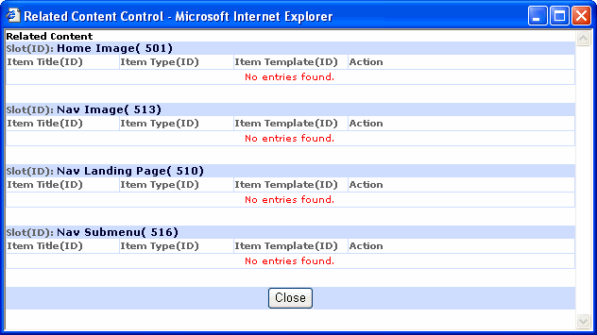

Figure 42: Navon Table Editor

4 Click the nav_landing_page link.

5 CM System displays the Content Browser.

6 Click on the Search tab.

7 Search on the term "tuition".

8 Click the Tuition content item.

The Select a Template window opens. The only option is the S - Title Link Snippet.

9 Click [Select].

10 The Tuition Content Item is added to the Nav Landing Page Slot on the Table Editor.
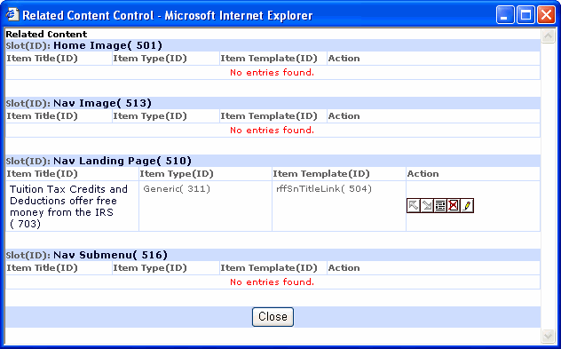

11 Close the table editor.

Figure 43: Landing Page Added

To see how the landing page works, Preview the Enterprise Investments Home Page, which is located in the Enterprise Investments top folder.

To see the landing page:

1 In the Navigation pane, click the Enterprise Investments folder.

2 Right-click EI Home Page and choose Enterprise Preview > P - EI Home.

The home page opens.

3 In the left navigation panel, under Investment Advice, click the Education link.

The Tuition Tax Credits page opens. It includes links to the Education Content Items we added.

Making the Education Navon Content Item

Public

Before our new Education section can be published correctly, we need to make the Education Navon
Public.

Use the same procedure that you used to Transition the other Content Items. Notice that when you choose
Workflow from the popup menu, the submenu includes the option Direct to Public. We will not be making any additional changes to the Education Navon, so use this Transition.

When you are finished, all of the Content Items in the Education Folder, including the Education Navon, will be Public. Now you are ready to publish this Site with the new Section.

Publishing the Web Site with the

Education Section

Now that we have added our new section, we are ready to publish the Web Site to include it. The FastForward publishing configuration is set up to publish the content to the JBoss application server installed with the system.

Once again, you will publish the Enterprise Investments Full Edition. Notice the new components that are published since you have added a folder, content items, and additional navigation to your system.

To publish the Site:

1 In Content Explorer, click on the Publishing Runtime tab.

2 Expand the Sites node; under the Sites node, expand the Enterprise Investments node. Expand the Editions node.

3 Click on EI_Full.

The edit and view pane displays the Runtime Edition page.

4 In the menu, choose Start.

When the publishing job has completed, the results will be displayed in the Logs. The result should resemble the following screenshot:

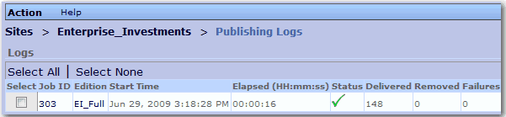

Figure 44: Publish Log

Click the log's Job ID to see the results of the publishing job, and click on an individual Content id to see its results.

If the new content was published successfully, when you go the Publishing target location (by default:
<Rhythmyx root> \AppServer\server\rx\deploy\EI_Home.war\) you will see the new
Education subdirectory in the Investment Advice directory.

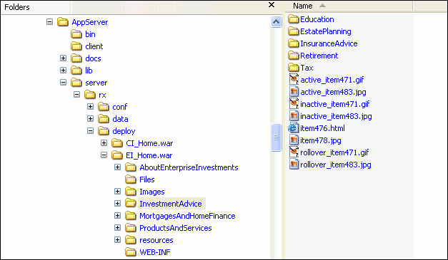

Figure 45: Published Education Folder

If you do not see this directory, none of the Content Items in the Site Folder were published. If you do not see a specific Content Item, it was not published. Review the log for these Content Items to determine
why they were not published. The most common reason for Content Items not to be published is that they are not in a Public State. Go back to the Content tab of Content Explorer and Transition all of the Content Items in the Education Folder to Public.

Another reason that the Education directory might not be created is that it does not contain any Content Items. Go back to the Content tab of Content Explorer and move the Education Content Items to the Education Folder.

If you open the Education directory, you will see four new HTML pages. The names of these files will be itemNNN.html. The value of NNN will be the Content IDs of the Generic Page and Generic Word Content Items you created during this walk-through. You will also see three new JPG pages. These are
the image Content Items that you created. The values should resemble those in the graphic below:

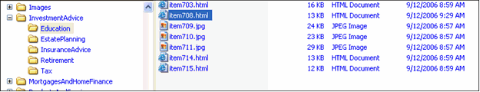

Figure 46: Contents of Education Folder

If any of the Content Items you created are missing, either they are not Public or they are not in the
Education Folder.

If you access the home page in a browser by entering http://localhost:9992/EI_Home/index.html, and then click the Education link in the right navigation pane, your Tuition page will resemble the following:

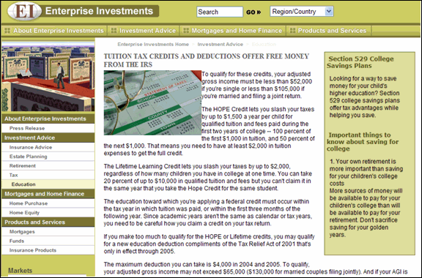

Figure 47: Published Tuition content item

C H A P T E R 5

Troubleshooting

Installation

Installer Cannot Connect to the Repository This indicates improper entry of the Server’s IP, User ID, or Password. Solution:
For SQL Server, follow the next few steps to establish a connection:

▪ Confirm the existence of the sa account through Microsoft’s Enterprise Manager Utility.
▪ Confirm, and if necessary, change, the sa password.
▪ Re-attempt connection to the Server. If it still fails, confirm the port on which SQL Server is listening in Enterprise Manager:
a) Select Tools > SQL Server Configuration Properties.

The SQL Server Properties dialog opens to the General tab. b) Press the [Network Configuration] button.
The SQL Server Network Utility dialog opens to the General tab. c) Highlight the TCP/IP protocol and press the [Properties] button.
The Network Protocol Default Value Setup dialog opens.
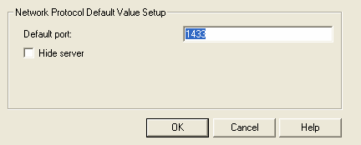

Figure 48: Network Protocol Default Value Setup dialog

d) If the port number listed is not 1433, change it and press [OK]. e) Exit Enterprise Manager and restart SQL Server.

Startup

Server Shuts Down During Initialization

Server encounters an error and shuts down during initialization

Solution:

Go to <Rhythmyx root>\AppServer\server\rx\log. First open boot.log and look for error messages giving you details about the server shut down. If you still need more information, go to server.log and read through any error messages.

CM System License Period Expired

On startup, the CM System Server displays the message, “The evaluation period for this license has expired.”

Solution:
This error indicates that your license for CM System has expired, and you need a new license. Contact
Percussion Technical Support for a new license and for instructions about updating your installation.

Out-of-Memory Condition Displayed on CM System Startup
The CM System Server console displays an out of memory condition when you attempt to start CM System. Solution:
Change the server configuration to allow for at least 1024 megabytes of RAM. 2048 megabytes is recommended.

Edit the RhythmyxServer.bin.lax or RhythmyxServer.lax file. Edit the line .ax.nl.java.option.additional to set the -Xmx

lax.nl.java.option.additional=-Dprogram.name=RhythmyxServer.exe -Xms128m –Xmx1024
m -Djava.endorsed.dirs="AppServer/lib/endorsed" -Djava.library.path=./bin -serve
r -XX:MaxPermSize=128m

Index
Moving Content into the Education Folder • 45
Moving Content Items to Public • 68

O

Out-of-Memory Condition Displayed on
CM System Startup • 79

A

A Brief Tutorial • 31
About FastForward • 8
About Roles • 64
About the Standard Workflow • 65
Active Assembly • 48
Adding Additional Content to the Education
Folder • 47
Adding an Image to a Generic Page • 57
Adding Links to Other Generic Pages in the
Sidebar Slot • 49
Admin Tab • 17, 25

C

Check In and Check Out • 63
Content Tab • 17, 19
Creating a Generic Content Item • 33
Creating a Generic Word Content Item • 37
Creating a Landing Page for the Education
Folder • 70
Creating an Image Content Item • 39
Creating Content Items • 32
Creating the Education Folder • 43

I

Implementing FastForward • 9
Installation • 78
Installer Cannot Connect to the Repository • 78
Installing CM System • 13
Installing CM System in a Development
Environment • 11
Introducing Percussion CM System • 7
Introduction to Content Explorer • 15

L

Logging in to Content Explorer • 16

M

Maintaining Managed Navigation for the
Education Folder • 44, 69
Making the Education Navon Content Item
Public. • 72

P

Preparing the Development Environment for
CM System Installation • 12
Previewing the Content Item • 61
Publishing A Default Edition • 27
Publishing Design Tab • 17, 26
Publishing Runtime Tab • 17, 23
Publishing the Web Site with the Education
Section • 73

R

CM System License Period Expired • 79

S

Server Shuts Down During Initialization • 79
Starting the CM System Server • 14
Startup • 14, 79

T

The Content Explorer Banner • 17, 18
The Display Pane • 19, 21
The Menu Bar • 19, 22
The Navigation Pane • 19, 20
Transitioning Content Items to a New State • 67
Troubleshooting • 77

W

Workflow • 24, 62
Workflow Tab • 17, 24
Working with Site Folders • 42

