CM System

Installing CM System

Version 7.3

Printed on 12 June 2013
Copyright and Licensing Statement
All intellectual property rights in the SOFTWARE and associated user documentation, implementation documentation, and reference documentation are owned by Percussion Software or its suppliers and are protected by United States and Canadian copyright laws, other applicable copyright laws, and international treaty provisions. Percussion Software retains all rights, title, and interest not expressly grated. You may either (a) make one (1) copy of the SOFTWARE solely for backup or archival purposes or (b) transfer the SOFTWARE to a single hard disk provided you keep the original solely for backup or
archival purposes. You must reproduce and include the copyright notice on any copy made. You may not copy the user documentation accompanying the SOFTWARE.

The information in CM System documentation is subject to change without notice and does not represent a commitment on the part of Percussion Software, Inc. This document describes proprietary trade secrets of Percussion Software, Inc. Licensees of this document must acknowledge the proprietary claims of Percussion Software, Inc., in advance of receiving this document or any software to which it refers, and must agree to hold the trade secrets in confidence for the sole use of Percussion Software, Inc.

The software contains proprietary information of Percussion Software; it is provided under a license agreement containing restrictions on use and disclosure and is also protected by copyright law. Reverse engineering of the software is prohibited.

Due to continued product development this information may change without notice. The information and intellectual property contained herein is confidential between Percussion Software and the client and remains the exclusive property of Percussion Software. If you find any problems in the documentation, please report them to us in writing. Percussion Software does not warrant that this document is error-free.

No part of this publication may be reproduced, stored in a retrieval system, or transmitted in any form or by any means, electronic, mechanical, photocopying, recording or otherwise without the prior written permission of Percussion Software.

Copyright © 1999-2013 Percussion Software. All rights reserved

Licenses and Source Code
CM System uses Mozilla's JavaScript C API. See http://www.mozilla.org/source.html for the source code. In addition, see the Mozilla Public License (http://www.mozilla.org/source.html).

Netscape Public License Apache Software License IBM Public License
Lesser GNU Public License

Other Copyrights
The CM System installation application was developed using InstallShield, which is a licensed and copyrighted by InstallShield Software Corporation.

The Sprinta JDBC driver is licensed and copyrighted by I-NET Software Corporation.

The Sentry Spellingchecker Engine Software Development Kit is licensed and copyrighted by Wintertree
Software.

The Java™ 2 Runtime Environment is licensed and copyrighted by Sun Microsystems, Inc. The Oracle JDBC driver is licensed and copyrighted by Oracle Corporation.
The Sybase JDBC driver is licensed and copyrighted by Sybase, Inc.

The AS/400 driver is licensed and copyrighted by International Business Machines Corporation. The Ephox EditLive! for Java DHTML editor is licensed and copyrighted by Ephox, Inc.
This product includes software developed by CDS Networks, Inc.

The software contains proprietary information of Percussion Software; it is provided under a license agreement containing restrictions on use and disclosure and is also protected by copyright law. Reverse engineering of the software is prohibited.

Due to continued product development this information may change without notice. The information and intellectual property contained herein is confidential between Percussion Software and the client and remains the exclusive property of Percussion Software. If you find any problems in the documentation, please report them to us in writing. Percussion Software does not warrant that this document is error-free.

No part of this publication may be reproduced, stored in a retrieval system, or transmitted in any form or by any means, electronic, mechanical, photocopying, recording or otherwise without the prior written permission of Percussion Software.

Microsoft Word, Microsoft Office, Windows®, Window 95™, Window 98™, Windows NT® and MS- DOS™ are trademarks of the Microsoft Corporation.

Schema documentation was created using XMLSpy™.

Percussion Software
600 Unicorn Park Drive
Woburn, MA 01801 U.S.A.
781.438.9900
Internet E-Mail: technical_support@percussion.com
Website: http://www.percussion.com

Contents

System Requirements and Installation Prerequisites 7
System Requirements 8
Server System Requirements 8
Developer Tools System Requirements 9
Desktop Client Components 9
Repository Database Requirements 10
Installation Prerequisites 11
Prerequisites for Installation to Unix and Linux 11
Environments 11
Prerequisites For Upgrade from CM System Version 5.7 and Earlier 11
Installation 13
Installation Flow Charts 14
New Installation 15
Upgrade Installation 16
Starting Installations 17
Installing Remote Client Components 17
Installation Sequence 18
Welcome and Product Licensing 19
Installation Configuration 22
Product Selection 26
Upgrade Configuration 31
Repository Configuration 36
Server Properties 42
Installation Summary 47
Completing the Installation 49
Additional Installation Issues 57
Important Security Measures 58
Assigning New Passwords to Default Users 58
Replacing the Default Users with New Users 59
CM System Workbench Options 60
Technical Support 61

C H A P T E R 1

System Requirements and

Installation Prerequisites

CM System includes the following components:

▪ Repository Database
▪ Microsoft SQL Server

▪ Oracle

▪ MySQL

▪ Server, including Publishing System
▪ The following remote components:
▪ Developer Tools

▪ Multi-server Manager

▪ Optional target database for database publishing
▪ Microsoft SQL Server

▪ Oracle

▪ MySQL

In a Windows environment all components can be installed. In a UNIX environment you can only install the Repository Database and the Server (and optional database publishing target).

System Requirements

The following topics list the system requirements to install and operate CM System. These numbers should be used as a guideline. The actual resources required depend on many factors, such as the number of contributors, how frequently content is published, and how frequently it is updated.

Server System Requirements

The CM System server can be installed in the following environments:

Sun Solaris 11

 | Development Server | Production Server
Processor | UltraSPARC IV (dual core) - 2  GHz | UltraSPARC T1 1.0 GHz
RAM | 2 GB | 4 GB
Disk Space | 1.2 GB + 1.2 GB for installation and application data | 1.2 GB + 1.2 GB for installation (and, depending on the amount of application data, 2 - 20 GB more on the server and 2 - 20 GB more on the database machine)

Microsoft Windows
Windows 2003 (Server and Advanced Server), Windows XP, Windows Server 2008, Windows Server 2012 R2 (see prerequisites for server 2012).

 | Development Server | Production Server
Processor | 2 GHz dual core | 3 GHz dual core
RAM | 1 GB + 1 GB for the database | 3-4 GB (assuming that the database is on a different system)
Disk Space | 1.2 GB + 1.2 GB for installation and application data | 1.2 GB + 1.2 GB for installation (and, depending on the amount of application data, 2 - 20 GB more on the server and 2 - 20 GB more on the database machine)

Linux
Certified on Red Hat Linux AS 4.0, Red Hat Linux 5.0, and SUSE Linux Version 11, Ubuntu 12

 | Development Server | Production Server
Processor | 2 GHz (dual core) | 3 GHz (dual core)
RAM | 1 GB + 1 GB for the database | 3-4 GB (assuming that the database is on a different system)

 | Development Server | Production Server
Disk Space | 1.2 GB + 1.2 GB for installation and application data | 1.2 GB + 1.2 GB for installation (and, depending on the amount of application data, 2 - 20 GB more on the server and 2 - 20 GB more on the database machine)

Developer Tools System Requirements

The Developer Tools are certified only in a Windows environment, including:

Windows XP Professional 2003 (NOTE: Not currently certified on Windows XP Service Pack 2) Windows 2003 Server platform
Windows Vista, Windows 7

Windows Server 2008, Note: Windows R2 is supported in 64 bit mode.

Windows Server 2012 R2

Hardware Requirements
Processor Pentium IV or faster 2 GHz

RAM 1 GB or greater recommended

Disk Space 400 MB to run installed product (800 MB during installation)

Desktop Client Components

Client JRE support: JRE8u45

The Rhythmyx 7.3 with patch 730_20150405 is tested against the following browsers and operating system platforms. Due to frequent release versions of these browsers we are committed to support any current release versions of these browsers:
 | Internet Explorer 11(In Compatibility mode only) | Firefox 35.0.1 | Safari 8.0.3
Windows 7 | yes | yes | -
Linux – Centos 7 | yes | yes | -
Mac (OS X Yosemite 10.10.2) | - | - | yes

- Internet Explorer 11, 10 and 9 is supported in Compatibility mode only.
- Internet Explorer 9 is supported for using the JAWS screen reader
- Starting Google Chrome version 42, the default support for NPAPI was removed. For this reason we no longer support Google chrome browser. Though we removed our support, until September 2015 you may continue to use chrome by enabling the NPAPI manually by following instructions provided below.

Enabling NPAPI in Chrome Version 42 and later
As of Chrome Version 42, an additional configuration step is required to continue using NPAPI plugins.
- In your URL bar, enter:
chrome://flags/#enable-npapi
- Click the Enable link for the Enable NPAPI configuration option.
- Click the Relaunch button that now appears at the bottom of the configuration page.
Reference for Java support in chrome:
https://java.com/en/download/faq/chrome.xml#npapichrome
JavaScript must not be disabled within the browser to use the interface.

The Rhythmyx 7.3 with patch 730_20150405 is tested against JRE8u45. We are committed to test our patch releases against latest JRE prior to its release. If in case would want to try latest JRE before we support, we suggest to test the latest JRE on a small number of users before distributing to a large set. Should you experience any issues with latest JRE, please contact technical support or post your experience/issues to percussion forum at forum.percussion.com.

Repository Database Requirements

Before installing any CM System components, be sure you have a relational database management system installed. CM System currently supports:

RDBMS | Supported Versions
Oracle | 10g, 11g  NOTE: When installing the Repository to Oracle 10g or 11g, the installation user must have CONNECT and RESOURCE privileges, and must also have Create View permission. This permission is implicitly granted with the CONNECT Role in Oracle 10g, but must be explicitly granted in Oracle 11g.
MS SQL Server | MS SQL Server 2005, 2008, 2012,2016 and 2017  NOTE: Do not use the "-" (dash) character, special characters, or embedded spaces or the installation will fail.
MySQL | MySQL 5.5.x  NOTE: You must have a jdbc driver installed. If you have not already downloaded the driver go to http://dev.mysql.com/downloads/connector/j and download 5.1.17 or higher.

Note that CM System does not perform any escaping or character conversion when inserting characters into the database. Therefore, the character encoding of the underlying database character set should match the encoding of the characters you want to store in the Repository. If the encoding of the database does not match the encoding used in CM System, some functionality may be lost. For example, if you use Microsoft Word as a Content Editor and Oracle as your database, Word SmartQuotes might not work if your database uses a character set other than UTF-8.

Percussion Software makes the following recommendations:

▪ Use UTF-8 if the majority of the characters you use match the ASCII character set. This is the recommended option for Western languages.
▪ Use UTF-16 or UCS2 if the majority of the characters you use fall outside of the ASCII character set.
This is the recommended option for most Asian languages. Non-Unicode character sets are not recommended for CM System.

Installation Prerequisites

Before beginning installation, be sure to implement the following prerequisites.

Prerequisites for Installation to Unix and Linux

Environments

Before installing to a Unix environment, you will need to create a user to install and run CM System. If you run multiple instances of the CM System server, you must create a user for each instance.

You must install CM System from the root of the user’s directory.

Prerequisites for Installation to Windows Server 2012

- Grant read/write permissions to the drive for any users that will install or start/stop the Rhythmyx server.
- Open the following ports in Windows firewall:
  - 9992
  - 9443 (If using ssl)

Prerequisites For Upgrade from CM System Version 5.7 and Earlier

When upgrading from CM System Version 5.7 and earlier, you must modify any applications that have backend credentials defined locally. CM System now runs in a web application server container rather than acting as a Web server itself, and all security is provided by the container. Thus, local backend credentials are no longer valid and must be removed. If you attempt to install without removing local backend credentials, the installer will terminate with a warning message

An application includes local backend credentials if the Backend Data Access tab of the Application
Security Settings dialog includes any entry in addition to or instead of CM System Repository.

C H A P T E R 2

Installation

For upgrades and reinstallations:

▪ If you are upgrading or reinstalling the CM System Server or the CM System Repository
Database, shut down the CM System Server and any running applications first.
▪ If you are upgrading or reinstalling a client component, shut down that component locally.
You do not need to shut down the CM System Server. Install the components in the following order:

1 Install the Repository Database from the CD-ROM. (Note: You cannot install the Server until you have installed the Repository Database, as the Server’s programs and files depend on the tables in the Repository Database).

2 Install the Server from the downloaded installation package.

3 Install the client components by browsing to the Server’s web pages and downloading their installers.

Note: If you are evaluating CM System and want to install all CM System components onto the same machine in one installer use the Suite Installer from the CD-ROM.

Installation Flow Charts

The following flow charts illustrate the installation sequence for CM System.

New Installation
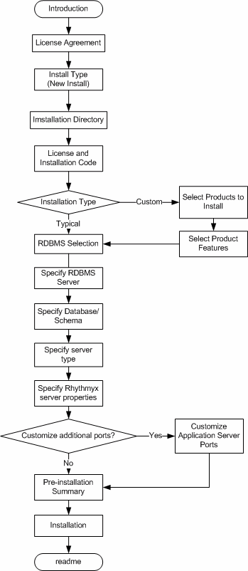

Figure 1: Installation Sequence

Upgrade Installation

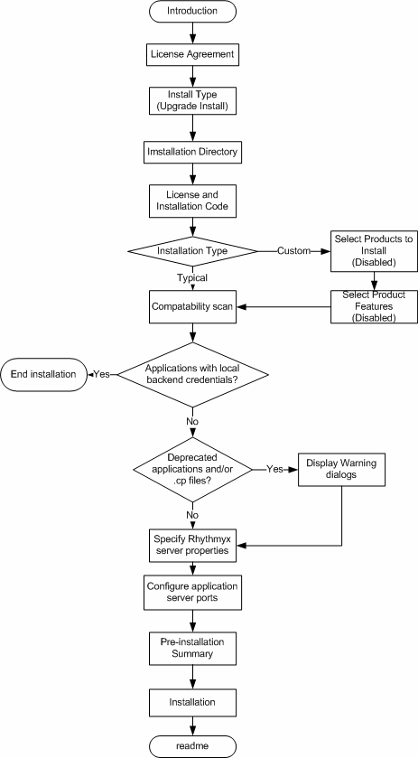

Figure 2: Upgrade installation sequence

Starting Installations

The installation application and process you use depends on the components of the CM System system you are installing and the environment into which you are installing CM System.

When installing into Solaris or Linux, copy the extracted installation package to a directory on the machine where you want to run the installation. (NOTE: The /resource directory MUST be included when copying files from the disk to the machine. If you do not include this directory, the installation will fail.)

When installing to Solaris or Linux, the user performing the installation must be the owner of all files copied from the installation package, must have read permissions on all installer files, and must have execute permissions on the setup script (setupui.sh or setupconsole.sh) that you want to run.

The directory for each operating system contains the setup installer, which installs the CM System server and repository.

You can launch the installer in either command line (terminal window) mode or using a graphic user interface. The command line installer provides more options for tracking and logging the installation process.

To launch the installer as a GUI in a Windows environment, browse to the Windows directory on extracted installation package and double-click on the installation application. When installing in Windows Server 2012 R2, Error dialog appears, Title: "Installer UI Mode Error", Text: "Installer User Interface Mode Not Supported". Workaround for this is:
- right-click on the setup.exe and select "Properties" from the context menu.
- Click on the "Compatibility" tab
- In the "Compatibility mode" section, check-off "Run this program in compatibility mode for:"
- Select "Windows 7" from the drop-list
- Click OK
- Re-run setup.exe by double-clicking it.

To launch the installer in Windows using command-line mode, open a Command Prompt window, change to the directory where the installation application is located, and enter setup.exe.

To launch the installer in Linux or Solaris, change to the directory where the installer files reside, and run the shell script for the mode you wish to use. To run in command line mode use SetupConsole.sh. To run the installer as a graphic user interface use SetupUI.sh.

Installing Remote Client Components

You can install the Developer Tools as a remote client on Microsoft Windows operating systems. (Installing as a remote client on other operating systems is not certified.) To install the Developer Tools as a remote client, start a Web browser and enter:

server:port/Rhythmyx/Administration/DeveloperTools/install.htm
Where:

▪ server is the name or IP address of the CM System server machine;

▪ port is the port the CM System server listens on; For example:
FastForward:9992/Rhythmyx/Administration/DeveloperTools/install.htm

Installation Sequence

All CM System components follow a similar installation sequence, whether installed from the CD-ROM, Suite Installer or browser.

Welcome and Product Licensing

The first phase of the installation wizard is welcoming and product licensing. When you start the installation wizard, it displays welcoming information:

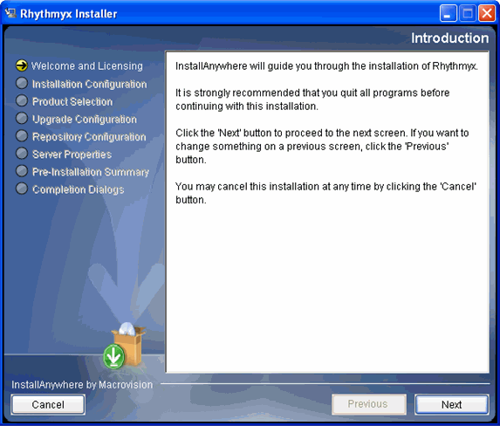

Figure 3: Installation window

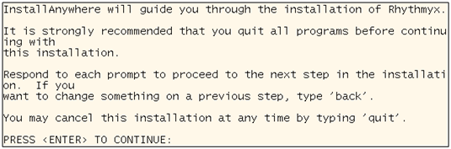

Figure 4: Commannd-line welcome text

To proceed,

▪ in the graphic installation wizard, click the [Next] button;
▪ in the command-line installation wizard, press the <Enter> key.
Also note two additional options in the command-line wizard:

▪ To go back to the previous step in the wizard, enter "back". Note that this string can include any mix of upper- and lower-case characters.

▪ To end the installation wizard at any time, enter "quit". Note that this string can include any mix of upper- and lower-case characters.

▪ Where a list of options is available, the default options is indicated by an arrow (->).
Pressing the <Enter> key without entering an option accepts the default option.
The installation wizard now displays the License Agreement.

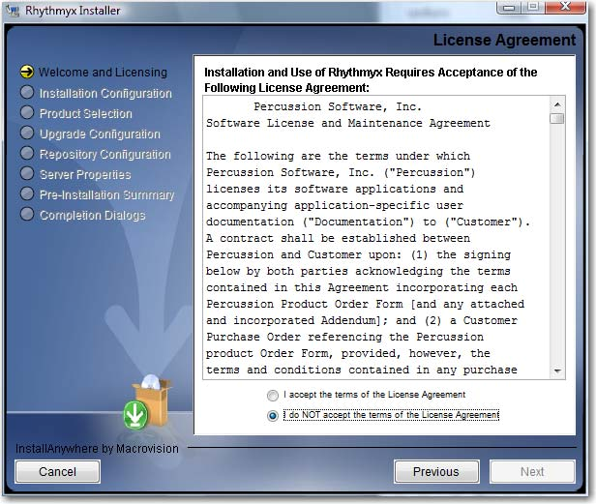

Figure 5: License Agreement

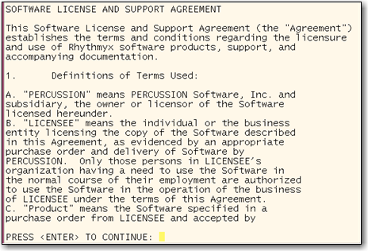

Read the license agreement.

Figure 6: Command-line license agreement

▪ In the graphic installation wizard, scroll through the agreement.
▪ In the command-line wizard, press the <Enter> key when you finish reading each screen. To accept the license agreement:

▪ in the graphic installer, select the I accept the terms of the license agreement radio button and click the Next button;
▪ in the command line installer, enter "Y" (upper- or lower-case) and press the <Enter> key to accept the license agreement and continue with the installation.

Installation Configuration

The second phase of the installation wizard is installation configuration. During this phase you specify whether you are performing a new installation or an upgrade, and define the installation location.

After you accept the license agreement, the wizard proceeds to installation type configuration. Options are new installation and upgrade installation.

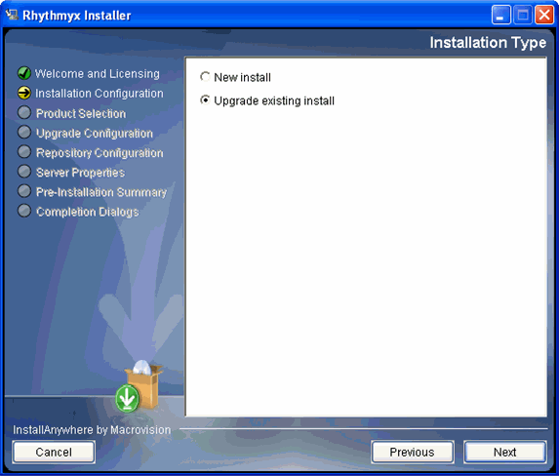

Figure 7: Installation type

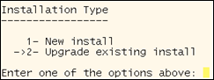

Figure 8: Command-line installation type

To specify the type of installation:

▪ in the graphic installation wizard, select the radio button for the type of installation you are performing, then click the [Next] button to continue with the wizard.

▪ in the command-line installation wizard enter
▪ 1 to perform a new installation;

▪ 2 to perform an upgrade installation (default option). Press the <Enter> key to continue with the wizard.
The next step in the wizard is to configure the installation directory.

▪ When performing a new installation, the default location for the installation is:

▪ C:\Rhythmyx in Windows
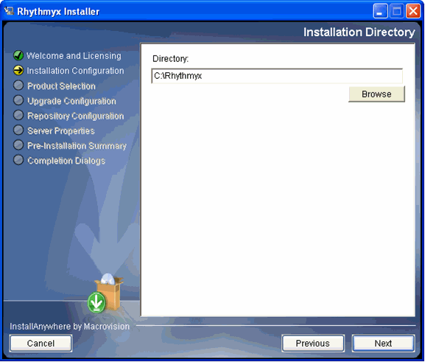

Figure 9: Installation directory

▪ /Rhythmyx. (in Unix and Linux).
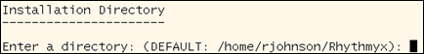

Figure 10: Default location for Unix and Linux in command-line mode

In a new Installation, to change the installation location:

▪ in the graphic installation wizard, enter the path in the Location field, or use the
[Browse] button to browse to the new location;

▪ in the command-line wizard, enter the new path. In a new Installation, to accept the location
▪ in the graphic installation wizard, click the [Next] button;

▪ in the command-line installation wizard, press the <Enter> key.

If you have specified a location that does not already exist, the installation wizard confirms that you want to create a new directory for the installation.
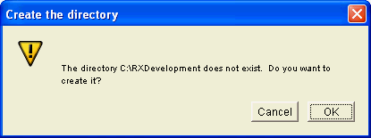

Figure 11: Creation confirmation dialog

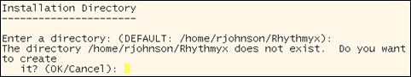

Figure 12: Create directory in command line wizard

To create the new directory:

▪ in the graphic installation wizard, click the [OK] button;

▪ in the command-line wizard, press the <Return> key.

If the specified location already contains a CM System installation, the wizard informs you that it will perform an upgrade.
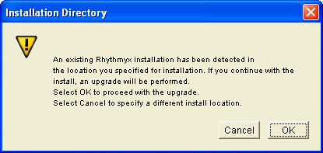

Figure 13: Installation upgrade confirmation

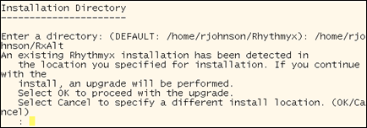

Figure 14: Installation message in command-line wizard

If you do not want to upgrade the installation:

▪ in the graphic installation wizard, click the [Cancel] button and specify a different directory;

▪ in the command-line wizard, enter "cancel" (any combination of upper- and lower- case characters) and press the <Enter> key; the installation wizard returns to installation directory configuration.

▪ When performing an upgrade, click the drop arrow in the Directory field and choose the installation you want to upgrade.
If you are performing a new installation, the next phase of the installation wizard is Product Selection (see page 26). If you are performing an upgrade, the next phase of the installation wizard is Upgrade Configuration (see page 31).

Product Selection

The third phase of the installation wizard is product selection. During this phase you enter your license number and installation codes and specify the CM System elements you want to install.

After you specify the installation location, the wizard requests your license number and installation code. These codes are printed on the jacket of the CM System installation disk.

▪ The graphic installation wizard displays a dialog where you can enter these codes. Enter the codes in the appropriate fields, and click the [Next] button to continue.
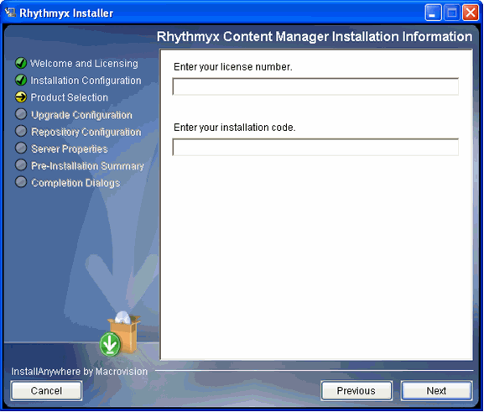

Figure 15: Installation information

If either code is invalid the wizard displays an error dialog detailing the error. Correct the error to continue.
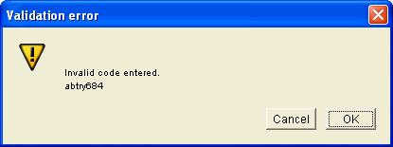

Figure 16: Invalid code dialog

▪ The command line wizard requests each code individually. Enter the requested code.
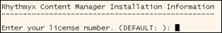

Figure 17: Entering the CM System license code in the command-line wizard.

If either of the codes you enter is invalid, the wizard returns an error message. Enter a valid code to continue with the installation.
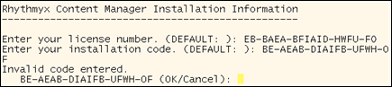

Figure 18: License code error in command-line wizard

Next, specify the installation type. Options include:

▪ Typical
All elements will be installed.

▪ Custom
Only specified installation elements will be installed.

The graphic installation wizard displays the Installation Type dialog.

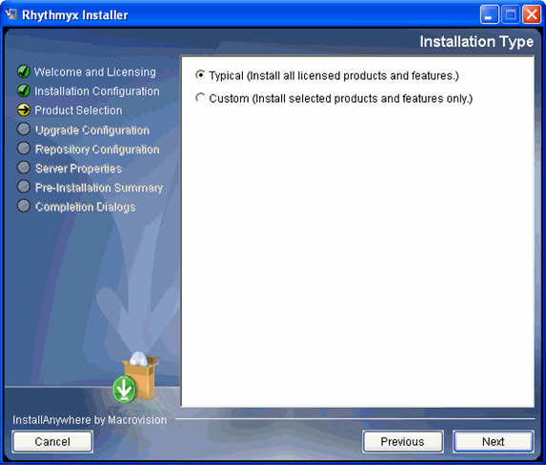

Figure 19: Installation type

▪ To install all CM System elements, select the Typical radio button and click the [Next] button to continue the installation.
▪ To select the CM System elements you want to install, select the Custom radio button. When you click the [Next] button, the wizard displays a series of dialogs listing CM System elements you can install. To install a CM System element, check the box next to the element. In the example below, all elements are checked.

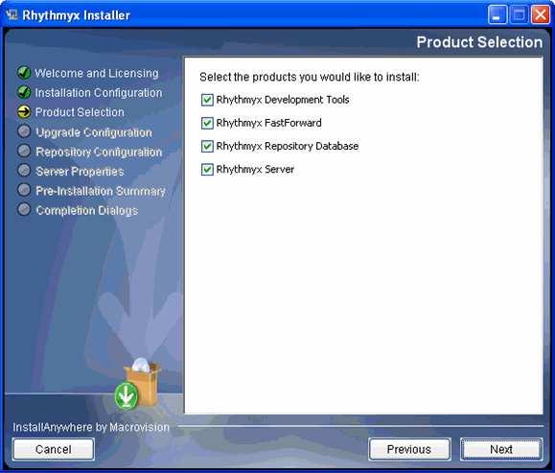

Figure 20: Custom installation

NOTE: On an upgrade installation, the options you currently have installed are disabled on the custom configuration dialogs are disabled. These options will be upgraded by default.

Click the [Next] button on the dialog to accept the options you selected. Continue through all of the pages of options. Some options have pre-requisites. If you attempt to install an option without a required prerequisite, the wizard displays an error message.

The command line wizard asks you to specify the installation type.

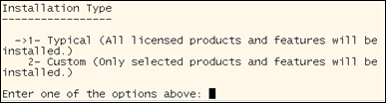

Figure 21: Specify installation type in command-line wizard

▪ To install all CM System elements, accept the default option (1).

▪ To select the CM System elements you want to install, enter 2 and press the <Enter> key. The installation wizard displays a series of configuration options:
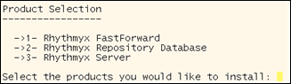

Figure 22: Example installation configuration options

Arrows indicate selected options. To change selected options, enter the numeric values in a comma-separated list. For example, to install only the Repository and server but not FastForward in the illustration above, enter 2,3. Press the <Enter> key to accept your configuration.
A new installation continues with Repository Configuration (see page 36).

Upgrade Configuration

Upgrade configuration occurs only during upgrade installations, and follows Product Selection. During this phase, the installation wizard scans your system for the following:

▪ CM System applications with local backend credentials (only occurs on systems upgraded from
CM System Version 5.7)
▪ deprecated system applications
▪ .cp files (only occurs on systems upgraded from CM System Version 5.7)
The installation wizard also allows you to configure purging of records from the PUBDOC table.

If the installation wizard detects CM System applications with local backend credentials, it displays the following message:

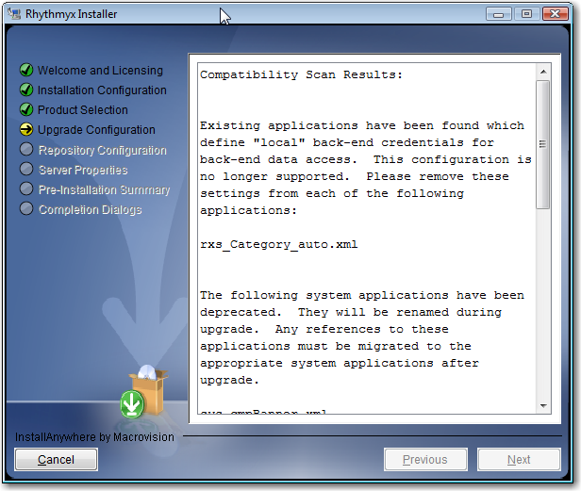

Figure 23: Installation wizard message when local backend credentials are detected

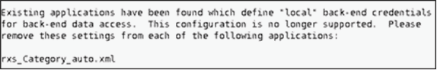

Figure 24: Installation wizard message when local backend credentials are defined, in command line mode

If the installation wizard displays this message, you cannot proceed. You must cancel the installation and remove any locally-defined backend credentials in your implementation. Note that the dialog specifies which applications include locally-defined backend credentials.

If the installation wizard detects deprecated system applications, it displays the following message:

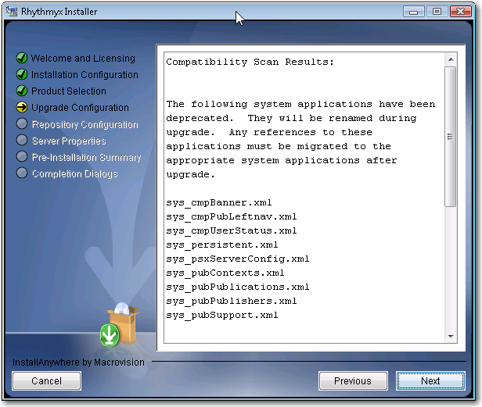

Figure 25: Command-line installation wizard message when deprecated system applications are detected

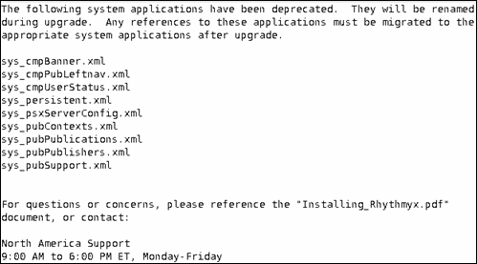

Figure 26: Command-line installation wizard message when deprecated system applications are detected

These applications are renamed during upgrade processing. You must update any code references to these applications.

During the upgrade, the RXPUBDOCS table, stores metadata describing the published output of Content Items, is modified. Processing this table can take a long time, so the installation wizard provides the option of purging records prior to a specified date. Any records prior to the date you specify will be purged from the system and permanently removed from the Repository, so you will not be able to access details of Publication logs (although the logs themselves will still be available). Enter the latest date for which you want to preserve the data in RXPUBDOCS.

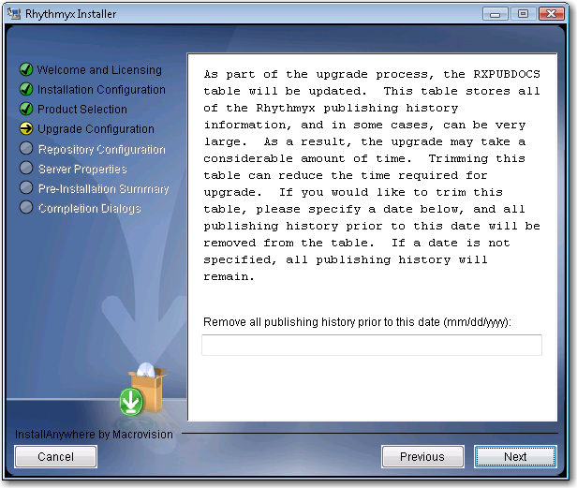

Figure 27: Purge RXPUBDOCS dialog

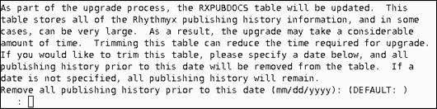

Figure 28: Purge RXPUBDOCS dialog in command-line mode

If the installation wizard detects any .cp files, it displays the following message:

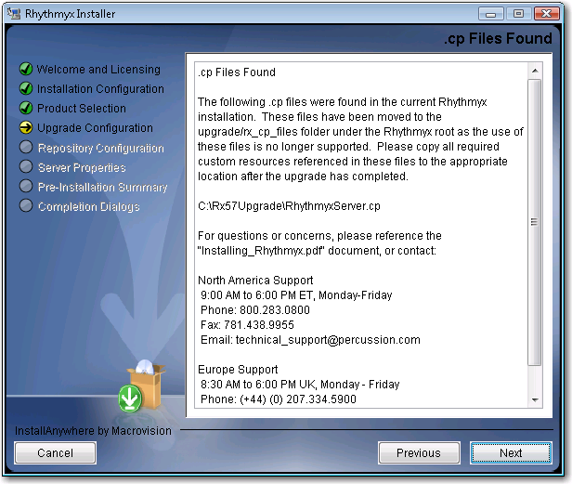

Figure 29: Installation wizard message when .cp files are detected

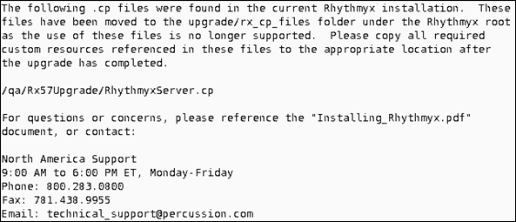

Figure 30: Command-line installation wizard message when .cp files are detected

Repository Configuration

The next phase of the installation wizard is repository configuration. This phase follows production select for a new installation and upgrade configuration for an upgrade installation. During this phase of the installation wizard, you specify the database to use for the CM System Repository.

The first step in Repository configuration is to specify the JDBC driver for the Repository RDBMS. Options include

▪ jtds: SQL Server ((Microsoft SQL Server)
▪ Oracle:thin

To specify the JDBC driver

▪ in the graphic installation wizard, choose the JDBC driver from the drop list, and click the
[Next] button to accept your choice;
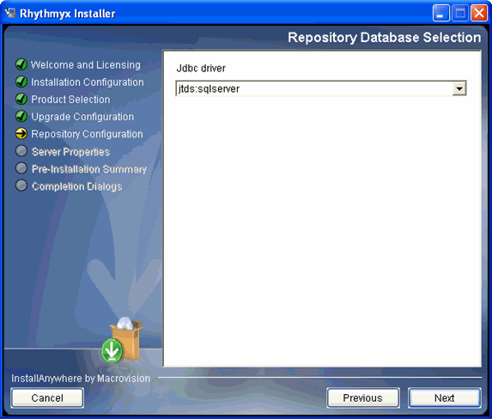

Figure 31: Repository database selection dialog

▪ in the command-line wizard, enter the ID that corresponds with the JDBC driver used to connect to your RDBMS:

ID | Driver | RDBMS
1 | jtds:sqlserver | Microsoft SQL Server
2 | oracle:thin | Oracle

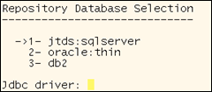

Figure 32: Specifying the JDBC driver in the command-line wizard

Note that you can only enter one ID. If you enter multiple IDs, the system does not accept your response and displays the request again.
The next step is to specify the connection data for the database. Connection data includes the connect string, and the user ID and password that the CM System server will use to connect to that server. The following table illustrates the syntax of the connect string for each RDBMS.

Driver | Syntax | Sample
Oracle | @<server>:<port>:<SID> | @255.255.255.36:1521:ORCL
jtds | <//server>:<port>(;instance= instanceName) | //dbserver:  //dbserver:50000;instance=Rhythmyx

To specify the connection data:

▪ in the graphic installation wizard, enter the connect string in the Database server field, and enter the User ID and Password that CM System will use to connect to the database server, then click the [Next] button to continue;
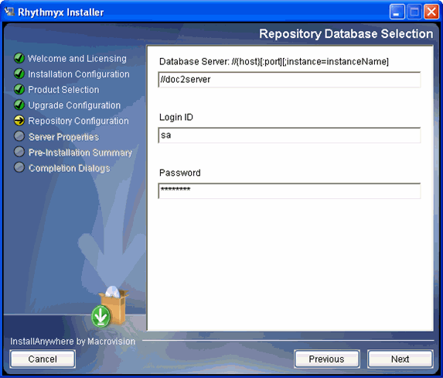

Figure 33: Repository database selection

▪ in the command-line wizard
▪ enter the connect string and press the <Enter> key;

▪ enter the login user that CM System will use to connect to the database server and press the <Enter> key;

▪ enter the password for the user you specified.
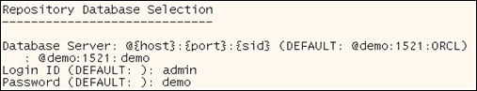

Figure 34: Specifying the RDBMS connetion in the command-line wizard

Press the return key when you have defined all required connection data.

If any of the data is incorrect, the installation wizard returns an error message:
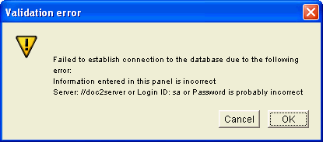

Figure 35: Validation error message

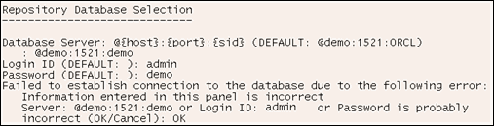

Figure 36: Database specification error in command-line wizard

The final step in Repository configuration is to specify the database or schema used for the CM System
Repository and name the datasource.

▪ In the graphic installation wizard
▪ when installing the Repository to Oracle, select the Schema for the
Repository (options include all schemas defined in the instance);

▪ when installing the Repository to SQL Server, select the Owner for the Repository (options include all database owners defined on the server) and the Database to which the Repository will be installed (options include all databases defined in the instance);

▪ in all cases, specify the name of the Datasource the server will use to connect to the database; the default name of the datasource is Rhythmyx Data, but you can change it to any other name.
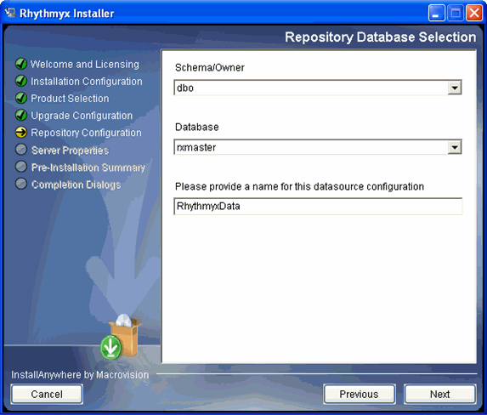

Figure 37: Schema and database definition

▪ in the command-line installation wizard:

▪ When installing the Repository to Oracle, enter the ID of the schema for the repository. Options include all schemas defined in the instance; the default option is the first schema. Press the <Enter> key when you have specified the schema you want to use.
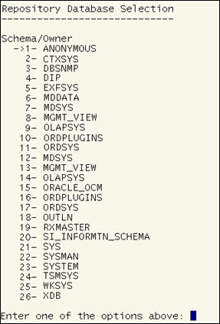

Figure 38: Selecting the schema for a Repository installation to Oracle in the command-line wizard

▪ When installing the Repository to Microsoft SQL Server, specify the database owner; enter the ID of the database owner from the list provided. Options include all database owners defined in the instance; the default is the first option. Press the
<Enter> key to accept your selection.
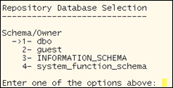

Figure 39: Specifying the database owner for a SQL Server installation in the command-line wizard

Next, specify the database you want to use. Enter the ID of the database you want to use from the list provided. Options include all databases defined in the instance; the default isthe first option. Press the <Enter> key to accept your selection.
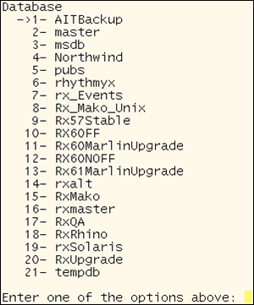

Figure 40: Specifying the SQL Server database for the Repository in the command-line wizard.

After you specify the schema or database for the Repository, the installation wizard asks you to specify the name of the datasource CM System will user to connect to the database or schema you specified. The name defaults to RhythmyxData, but you can change it to any other name you prefer.

Figure 41: Configuring the name of the CM System datasource in the command-line wizard

Press the <Enter> key to accept the name and continue with the installation.

Server Properties

The final phase in the installation wizard is to define CM System server properties. In this phase, you define the type of server you are installing, the ports the CM System server will listen on, and, in a Windows environment, the name of the CM System service.

When you complete Repository configuration, the installation wizard asks you to define the CM System server type. Options include:

▪ System master

A system master is a CM System server that supports both content maintenance and publishing. Every installation requires at least one system master.

▪ Publishing hub

A publishing hub is a CM System server used solely for publishing. Content maintenance is not allowed on a publishing hub. Publishing hubs are optional and are generally used in environments with a high volume of publishing activity.
To specify the server type:

▪ in the graphic installation wizard, select the server type you want to install;
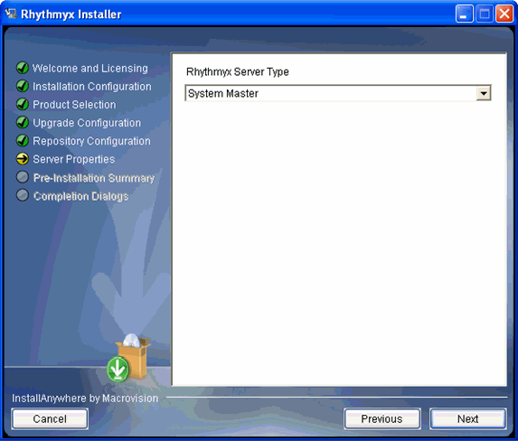

Figure 42: Server Type

▪ in the command-line installation wizard, enter the ID of the server type you want to install.
Options include:
▪ 1 System master

▪ 2 Publishing Hub
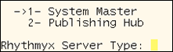

Figure 43: Configuring the server type in the command-line wizard

Next, the Installation wizard asks you to define the CM System server properties.

▪ In a Windows environment, you must define the name and description of the CM System service, as well as the CM System port.
▪ In the graphic installation wizard, enter the Rhythmyx service name (defaults to Rhythmyx Server) and Rhythmyx Service description ( defaults to Percussion Rhythmyx Server). You can accept the default name and description or enter a new one. Enter the CM System port. This value defaults to 9992, but you can change it to any other valid port. Click the [Next] button when you are done.

In addition to the specified port, CM System uses the next six ports for internal purposes. You should confirm that other applications are not using these ports. If you need to change one of these ports, check the Customize additional ports box. When you click the [Next] button, the wizard displays the Application Server Settings dialog. You can change any of these ports to another valid port.
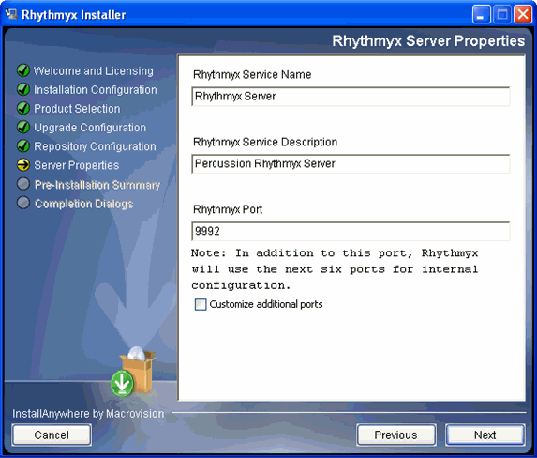

Figure 44: Server properties

▪ In a Solaris or Linux environment, specify the CM System port, and optionally, the additional ports used by the Rhythmyx container.
▪ The command-line wizard asks you to specify the Rhythmyx port. The default port is
9992.
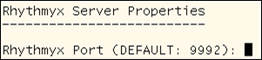

Figure 45: Specifying the Rhythmyx port in the command-line wizard on Solairs or Linux

In addition to the specified port, CM System uses the next six ports for internal purposes. You should confirm that other applications are not using these ports. The wizard then asks if you want to configure the additional ports used by the CM System container. Regardless of your answer, the wizard displays a warning that each port configured for CM System must be unique. If you choose to configure the ports, the wizard displays each
of the additional ports being used with the currently specified port value. You can change any of these values.
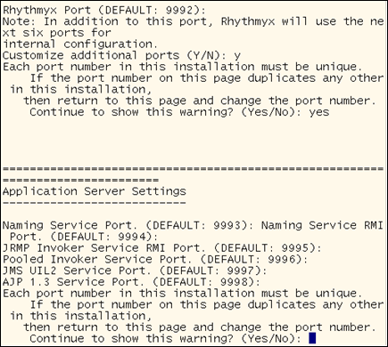

Figure 46: Configuring CM System container ports in the command-line wizard on Solaris and Linux

Installation Summary

Once you have configured all the installation data, CM System displays an installation summary.

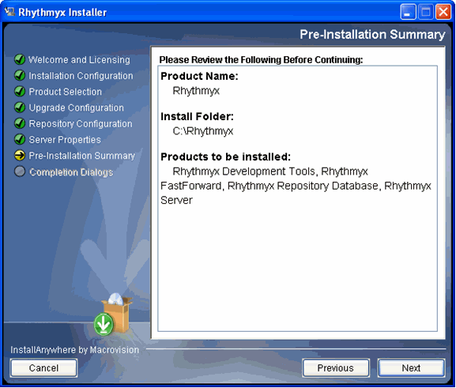

Figure 47: Pre-installation summary

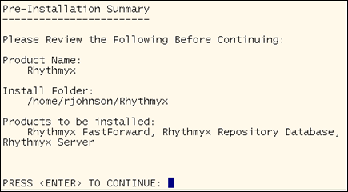

Figure 48: Installation summary in command-line wizard

Review the installation details as configured.

If you need to change any installation configurations:

▪ In the graphic installation wizard, click the [Previous] button until you reach the dialog listing the data you need to change. Modify the data and proceed through the installation wizard again.
▪ In the command-line installation wizard enter Back (any combination of upper- and lower- case letters); repeat until you reach the portion of the wizard you need to modify..
To launch the installation:

▪ in the graphic installation wizard, click the [Next] button;
▪ in the command-line installation wizard, press the <Enter> key.

Completing the Installation

During installation, the installation wizard displays the progress of the installation:

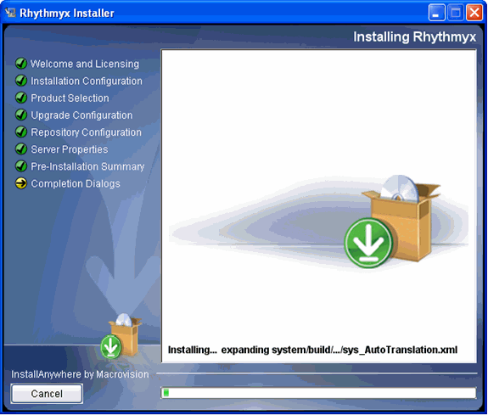

Figure 49: Installation progress messages

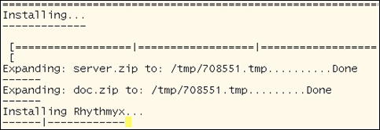

Figure 50: Installation progress in the command-line wizard

When installation is complete, the installation wizard displays the readme:

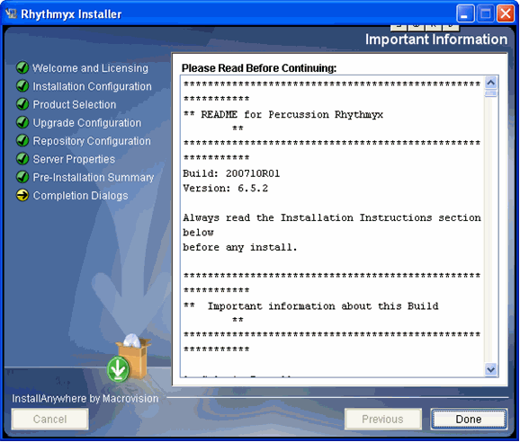

Figure 51: Readme window

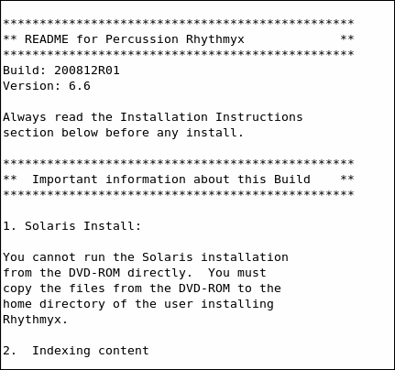

Figure 52: Readme on console

To complete the installation:

▪ in the graphic installation wizard, click the [Done] button;
▪ in the command-line installation press the <Enter> key.
If an error occurs during installation, the installation wizard displays messages informing you of the error and the location of detailed log files:

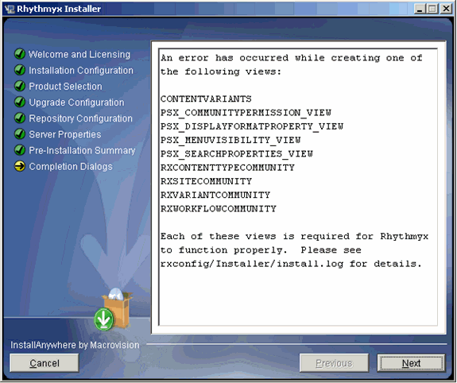

Figure 53: Install screen with error messages

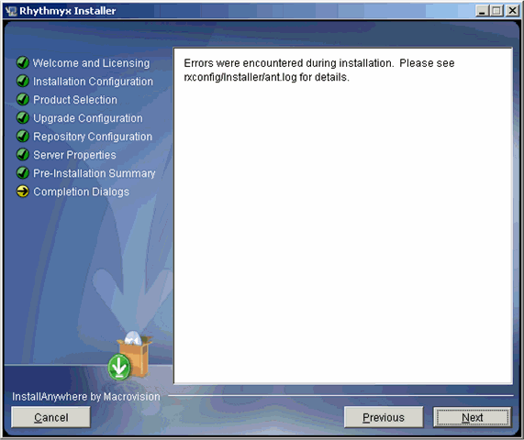

Figure 54: Log location message

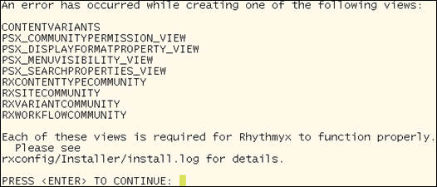

Figure 55: Initial error report in command-line wizard

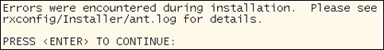

Figure 56: Final error message in command-line wizard

When upgrading from Version 6.5.2 or earlier, re-index your content after completing the installation.

NOTE: If you are installing to Solaris or Linux, you must run /Rhythmyx/InstallDaemon.sh to complete the installation:

C H A P T E R 3

Additional Installation Issues

This chapter addresses miscellaneous issues related to installation of CM System.

Important Security Measures

Important: Every new CM System installation includes a backend Database Security Provider. The backend
Database Security Provider includes the following default users for each Role:

Role | DEFAULT USERS
Admin | admin1  admin2
Author | author1  author1
QA | qa1  qa2
Editor | editor1  editor2
Designer | designer1  designer2
Artist | artist1  artist2
You can use every default user and the password "demo" to access the Rhythmyx Server Administrator.

NOTE: The Admin Role also contains the Member rxserver. This Member is used internally in Rhythmyx as part of the Aging process. DO NOT REMOVE THIS MEMBER UNDER ANY CIRCUMSTANCES.

To prevent unintended access to your system choose one of the following options:

▪ assign new passwords to the default users, or
▪ replace the default users with new users.

Assigning New Passwords to Default Users

To assign new passwords to the default users using SQL:

1 Open the USERLOGIN table in the database.

2 In the Password column, change the password for each default user.

Each new password becomes effective as soon as you enter it.
To assign new passwords to the default users using an Oracle SQL*Plus application:

1 At the prompt change the pass work for the admin1 role by entering the following script:
update userlogin set password='somethingnotdemo' where userid='admin1';
2 Repeat for each default user, changing userid accordingly.

Each new password becomes effective as soon as you change it.

Replacing the Default Users with New Users

NOTE: In addition to the default users admin1 and admin2, the Admin Role also contains the Member rxserver. This Member is used internally in CM System as part of the Aging process. DO NOT REMOVE THIS MEMBER UNDER ANY CIRCUMSTANCES. If you remove this Member, Workflow authentication will fail.

To replace the default users with new users:

1 Open the USERLOGIN table in the database.

2 Add a new user to each role with the same permissions as the default users, but give the new users different names (such as ‘anthonyadmin’ and ‘dianedesigner’) and passwords.

3 After creating a new user for each role, delete the default users from your database.

Rhythmyx Workbench Options

The Rhythmyx Workbench runs on the Eclipse platform. When the Workbench is installed (whether as part of a complete suite installation or with the other Developer Tools), it runs as a stand-alone executable application. (Note: Like all Developer Tools, the Workbench can only be installed to Microsoft Windows. Installation of the Workbench to Solaris or Linux is not supported.)

The Rhythmyx Workbench can also be added as a plugin to an existing Eclipse installation. Your Eclipse installation must meet the following criteria:

▪ Only Eclipse Version 3.0 and 3.1 are supported.
▪ You must have the Web Standard Tools (WST) plugin installed. Download the Web Standard Tools plugin from http://download.eclipse.org/webtools/downloads/ (http://download.eclipse.org/webtools/downloads/). Use the version of WST appropriate to your version of Eclipse.
▪ The minimum supported JDK Version for CM System is version 1.5.
To add the Rhythmyx Workbench to Eclipse, unzip the following files to your Eclipse installation.

▪ RhythmyxWorkbench.zip
▪ RhythmyxWorkbenchHelp.zip
To access CM System, in Eclipse, open the Rhythmyx perspective. The Rhythmyx perspective will prompt you to log in to the CM System server.

NOTE: If you see an error similar to the following:

java.lang.UnsupportedClassVersionError: com/percussion/workbench/ui/PSWorkbenchPlugin (Unsupported major.minor version 49.0)
your Eclipse installation is using JRE Version 1.4. Upgrade the JRE to Version 1.5.

When you upgrade CM System, update your CM System plugin by unzipping the upgraded versions of
RhyhthmyxWorkbench.zip and RhythmyxWorkbenchHelp.zip to your Eclipse installation.

Technical Support

Contact Percussion Technical Support by phone or e-mail.

Boston
600 Unicorn Park Drive

Woburn, MA 01801 U.S.A.

8:30 AM to 6 PM EST, Monday - Friday

Phone: 781.438.9900

Toll Free: 800.283.0800

Fax: 781.438.9955

Email: technical_support@percussion.com

