CM System

Multi-Server
Manager

Printed on 12 June 2013
Copyright and Licensing Statement
All intellectual property rights in the SOFTWARE and associated user documentation, implementation documentation, and reference documentation are owned by Percussion Software or its suppliers and are protected by United States and Canadian copyright laws, other applicable copyright laws, and international treaty provisions. Percussion Software retains all rights, title, and interest not expressly grated. You may either (a) make one (1) copy of the SOFTWARE solely for backup or archival purposes or (b) transfer the SOFTWARE to a single hard disk provided you keep the original solely for backup or
archival purposes. You must reproduce and include the copyright notice on any copy made. You may not copy the user documentation accompanying the SOFTWARE.

The information in CM System documentation is subject to change without notice and does not represent a commitment on the part of Percussion Software, Inc. This document describes proprietary trade secrets of Percussion Software, Inc. Licensees of this document must acknowledge the proprietary claims of Percussion Software, Inc., in advance of receiving this document or any software to which it refers, and must agree to hold the trade secrets in confidence for the sole use of Percussion Software, Inc.

The software contains proprietary information of Percussion Software; it is provided under a license agreement containing restrictions on use and disclosure and is also protected by copyright law. Reverse engineering of the software is prohibited.

Due to continued product development this information may change without notice. The information and intellectual property contained herein is confidential between Percussion Software and the client and remains the exclusive property of Percussion Software. If you find any problems in the documentation, please report them to us in writing. Percussion Software does not warrant that this document is error-free.

No part of this publication may be reproduced, stored in a retrieval system, or transmitted in any form or by any means, electronic, mechanical, photocopying, recording or otherwise without the prior written permission of Percussion Software.

Copyright © 1999-2013 Percussion Software. All rights reserved

Licenses and Source Code
Rhythmyx uses Mozilla's JavaScript C API. See http://www.mozilla.org/source.html (http://www.mozilla.org/source.html) for the source code. In addition, see the Mozilla Public License (http://www.mozilla.org/source.html).

Netscape Public License Apache Software License IBM Public License
Lesser GNU Public License

Other Copyrights
The CM System installation application was developed using InstallShield, which is a licensed and copyrighted by InstallShield Software Corporation.

The Sprinta JDBC driver is licensed and copyrighted by I-NET Software Corporation.

The Sentry Spellingchecker Engine Software Development Kit is licensed and copyrighted by Wintertree
Software.

The Java™ 2 Runtime Environment is licensed and copyrighted by Sun Microsystems, Inc.
The Oracle JDBC driver is licensed and copyrighted by Oracle Corporation. The Sybase JDBC driver is licensed and copyrighted by Sybase, Inc.
The AS/400 driver is licensed and copyrighted by International Business Machines Corporation. The Ephox EditLive! for Java DHTML editor is licensed and copyrighted by Ephox, Inc.
This product includes software developed by CDS Networks, Inc.

The software contains proprietary information of Percussion Software; it is provided under a license agreement containing restrictions on use and disclosure and is also protected by copyright law. Reverse engineering of the software is prohibited.

Due to continued product development this information may change without notice. The information and intellectual property contained herein is confidential between Percussion Software and the client and remains the exclusive property of Percussion Software. If you find any problems in the documentation, please report them to us in writing. Percussion Software does not warrant that this document is error-free.

No part of this publication may be reproduced, stored in a retrieval system, or transmitted in any form or by any means, electronic, mechanical, photocopying, recording or otherwise without the prior written permission of Percussion Software.

AuthorIT™ is a trademark of Optical Systems Corporation Ltd.

Microsoft Word, Microsoft Office, Windows®, Window 95™, Window 98™, Windows NT®and MS- DOS™ are trademarks of the Microsoft Corporation.

This document was created using AuthorIT™, Total Document Creation (see AuthorIT Home - http://www.author-it.com).

Schema documentation was created using XMLSpy™.

Percussion Software
600 Unicorn Park Drive
Woburn, MA 01801 U.S.A.
781.438.9900
Internet E-Mail: technical_support@percussion.com
Website: http://www.percussion.com

Contents

About Multi-Server 11
Manager and Archive Installation 11
How Multi-Server Manager Installation 12
Works 12
Package Types and their Dependencies 14
Content Items to Deploy with Multi-Server 18
Manager 18
Using the Multi-Server Manager 19
Interface 19
Descriptors View 23
Packages View 26
Installation Check List 27
Maintaining CM System Server 29
Registrations 29
Edit/New Rhythmyx Server Registration 30
Repository Alias 31
Repository Change 32
Connect to Server 33
Server Registration Maintenance Procedures 34
Editing a Server Registration 34
Connecting to a Server 35
Maintaining Server Policy Settings 36
About Mapping Elements and Datasources and Identifying ID Types 39
When to Map Elements and Datasources and 41
Identify ID Types 41
Mapping Source and Target Rhythmyx 42
Elements 42
Mapping Source and Target Datasources 43
Identifying Types of Elements 44
Identify ID Types Dialog 45
Reading Descriptions in the Identify ID Types Dialog 46
Specifying ID Types 47
Using the Identify ID Types Dialog 48
Define Transforms for <Server:Port> 49
Define Transforms for <Server:Port> Datasource Map Tab 50
Edit/Add Datasource 51
Define Transforms for <Server:Port> Element Maps Tab 52
Edit/Add Mapping 54
Source to Target Transform Procedures 56
Mapping Datasources 56
Adding Datasource Mappings 56
Editing a Datasource Mapping 57
Deleting a Datasource Mapping 57
Mapping Elements 57
Adding an Element Name Mapping 58
Editing an Element Name Mapping 58
Deleting an Element Name Mapping 59
Creating and Editing Archives and Generating Deployment Descriptors 61
Choose a Server and/or Descriptor 63
Choose Create Mode 64
Add Elements to the Archive 65
Identify ID Types 69
Include Element Dependencies or Ancestors 71
Choosing User Dependencies 78
Create Archive or Descriptor 79
Installing an Archive 81
Preparing a Target Server for Deployment 82
Publishing Lock During Installation 83
Using the Install Archive Wizard 84
Select an Archive and Server Dialog 86
Choose Installation Mode Dialog 87
Add Packages to Install 88
Transforms 91
Specify Actions for Warnings 97
Summary 100
Reviewing Archives 103
Reviewing Installed Packages 105
Package Log Main Tab 106
Package Log Transforms Tab 107
Package Log Informed Warnings Tab 108
Package Log Transaction Log Tab 109
Archiving an Entire CM System System 110
Multi-Server Manager 113
Best Practices 113
The Development Environment 115
Selecting an Archive Structure 116
Simple Example: Adding a New 117
Field to a Content Editor 117
Simple Example: Setting Up the Source and 122
Target Servers 122
Simple Example: Creating an Archive 127
Simple Example: Installing the Archive 133
Simple Example: Reviewing the Installation 139
Troubleshooting 145

C H A P T E R 1

About Multi-Server

Manager and Archive Installation

The Multi-Server Manager helps you install a CM System CMS or portions of a CM System CMS from a source server to a target server. The Multi-Server Manager guides you through each step of the installation process including selecting elements to install, packaging the elements in an archive, and installing the archive’s contents on the target server.

You can use the Multi-Server Manager to migrate CM System elements from a development server to a QA, test, or production server, or from a production server to a development or test server. Some of the scenarios in which you could use it include:

- initially installing CM System from a development server to a production server;

- migrating changes in applications from a development server to a production server;

- migrating content from a production server to a development server so that you can perform testing on live data;

- sending applications and required files to CM System Technical Support or
Professional Services for problem resolution or application of new functionality.
The Multi-Server Manager is a stand-alone tool that functions as a client and interacts with the target and source servers. The CM System installer loads it with other client tools into the CM System root directory.

How Multi-Server Manager Installation

Works

When you create an archive, the Multi-Server Manager copies it to the client (Multi-Server Manager machine), so you can create an archive on a server and install it at a later time on a different server, as long as the target server has the same version and build as the archive.

To install CM System elements with the Multi-Server Manager, you do not have to run the source and
target servers at the same time. You can specify what to install on the source server, save the data in a file on the Multi-Server Manager, and install it on the target server at a later time.

Prior to using the Multi-Server Manager:

- Install and configure CM System on your source and target servers.
- Make sure that the builds and versions of CM System on both servers are the same. The Multi- Server Manager will not perform an installation otherwise.
Limitations

  - The Multi-Server Manager cannot install some elements of a source server, including:
  - Loadable handlers. The Multi-Server Manager warns you and does not allow installation if any loadable handlers that exist on the source server are missing on the target server.

  - Exit classes in the server classpath that are installed at the system level. The Multi- Server Manager warns you and does not allow installation if any exit classes that exist on the source server are missing on the target server.

  - Roles and Role members. The Multi-Server Manager only installs source server Roles that do not already exist on the target server. It does not install Members of Roles.

  - Security providers for user or group entries in ACL lists for applications, and the users contained within the security providers. The security providers should exist on the target server with the same name, and should be able to authenticate the same users or groups as it can on the source server. The Multi-Server Manager does not check for security providers on the target server.

  - Extension configuration files that are not stored in the resources directory of the extension. NOTE: You may create a User Dependency package that includes one of these files.

  - Backend credentials.

  - System applications.

  - Because of the Multi-Server Manager’s installation limitations, it is not intended to be used
  - for backing up CM System; however, you can back up any installable elements using the Multi- Server Manager. To fully back up CM System, use standard backup techniques (see "The
  - Development Environment" on page 113).
  - Because of the Multi-Server Manager’s installation limitations, it is not intended to be used for CM System source control.
  - Tables are the only database objects that the Multi-Server Manager installs. The Multi-Server Manager discovers views, but lists them as (non-installable) server dependencies and labels them as Table Schemas.
  - CM System does not lock your server while you are creating or installing an archive. To avoid errors, users should not access your server while you are running the Create Archive/Descriptor Wizard or the Archive Installation Wizard.
  - Installation using the Multi-Server Manager is not equivalent to Publishing with CM System. Do not attempt to use the Multi-Server Manager to publish public content to a Web site or other destination.
  - You cannot roll back after installation. Once you install an archive on your sever, you cannot uninstall it.
  - The Multi-Server Manager does not recognize or duplicate specific blocks of IDs that you give to elements on a source server. When the Multi-Server Manager adds new CM System elements to a target server (without mappings to target elements), it assigns them new IDs sequentially.
  - If your installation modifies a target server workflow to have fewer states, target server content items in the states that you remove are orphaned. See Troubleshooting (on page 143) for a procedure for moving the orphaned content into an existing state.

Package Types and their Dependencies

During installation, you select which parts of CM System, or Package Types, on your source server you want to install on your target server.

A Package consists of the specific elements that you "package" for installation. For example, a Package for a Content Type would have the Package Type of Content Type and would include the elements: the specific content type and the specific content editor application.

Dependencies refers to the elements that make up a Package. Dependencies can be elements (such as exits and applications) that other elements require to function properly. For example, a Content Type Package has as its required dependencies the content type registration, the content editor application, and may optionally include the applications and exits that the content editor application uses.

Ancestors are elements, such as files or exits, that are not part of a Package but are affected by its dependencies. For example, if a content type is associated with a community, the community is an ancestor of that Content Type's Package because it is not part of the Package but is affected by changes to its elements.

The Multi-Server Manager includes the required dependencies of a Package Type in a Package. You indicate which optional dependencies and ancestors to include. For more about dependencies and ancestors, see Include Element Dependencies or Ancestors (on page 69).

The order in which a Package lists Package Types is important, because dependencies of elements must be installed before the elements that use them. See Add Elements to the Archive (on page 63) for the recommended order of Package Types in a Package.

The following table lists all of the Package Types and their dependencies.

Package Type | CM System Elements automatically included in the Package (Dependencies) | Notes
Action Menu |  the Action Menu definition;   any Action Menus that include the specified Action Menu as a child.
Community Definition |  the Community registration but not any of the CMS elements associated with the Community.
Component |  the component definition;   the component's slot definitions.
Content |  In the Add Elements to the Archive dialog, you choose the Types of Content Items to include. When you choose dependencies, you check which Content Items of these Types to include. | Review the Content Package Type's limitations (see "Add Elements to the Archive" on page 63) before installing it.

Package Type | CM System Elements automatically included in the Package (Dependencies) | Notes
Content Assembler  (legacy package type) |  the content assembler application;   variant registrations of the variants that reference the content assembler application.
Content List |  the content list definition.
Content Type |  the content type definition.
Content View |  the content view definition.
Context |  the Context definition
Custom | Any of the following:   applications;   extensions;   shared groups;   system definitions;   system definition overrides;   table schemas;   table data;   user dependencies – files from the CM System root that the Multi-Server Manager does not list as dependencies. | For experienced users only. If the user requires more control than the Multi-Server Manager offers for one of the Package types or a  dependency is not included in the dependency map, a user may create a custom  Package and select any of  the custom CM System elements.
Display Format |  the Display Format definition.   the ACL definition.
Entire Community |  the Community definition;   all of the Roles associated with the  Community.
Filter |  the assembly item filter definition

Package Type | CM System Elements automatically included in the Package (Dependencies) | Notes
Folder | In the Add Elements to the Archive dialog, you choose the Sites and/or Folders main node. When you choose dependencies, you check which folders within the main node to include. For the Folders that you check, the Multi-Server Manager includes:   the Folder definition;   the Display Format definition for the  Folder;   all Translation Relationships in the  Folder;   optionally, the Content Items in the  Folder.
Folder Tree |  the main Folder;   all of the selected Folder's sub-folders;   all Folder and sub-folder Display  Format definitions;   all Translation Relationships in the  Folders and sub-folders.
Keyword |  the Keyword definition
Locale |  the Locale definition;   the GlobalErrorMessages.js file for the  Locale;   the images for the Locale;   the template.css file for the Locale.
Relationship Definition |  the Relationship definition.
Search |  the Search definition   the definition of the ACL for the search
Site |  the Site definition.   ACL definition for the Site.
Slot |  the Slot definition.
Template |  the Template definition   ACL definition for the Template

Package Type | CM System Elements automatically included in the Package (Dependencies) | Notes
Workflow |  the Workflow definition;   all dependencies of the Workflow definition. | If you are deploying a new Workflow, you must separately package all of the Content Types that you have associated with the Workflow, or the associations will be lost on the target server.
You cannot create a Location Scheme Package. To include a Location Scheme in an archive, create a
package for an associated Site and include the Location Scheme as a shared dependency (see "Include
Element Dependencies or Ancestors" on page 69).

You can also include Roles as shared dependencies (see "Include Element Dependencies or Ancestors" on page 69) of other components. If the Role already exists on the target server, the Multi-Server Manager does not install it. If the Role does not exist on the target server, the Multi-Server Manager installs it, but does not include the users (Members) associated with the Role, since users on the target server most likely differ from those on the source server.

Content Items to Deploy with Multi-Server

Manager

Multi-Server Manager allows you to deploy Content Items from one server to another, but you should only use this function for deploying implementation Content Items (such as Navigation Content Types) from development or staging servers to production servers.

Never develop regular Content Items on a development or staging server and then deploy them to a production server using the Multi-Server Manager. Multi-Server Manager does not resolve inline links or inline Templates within the text of these Content Items and the links will be broken on the target server.

C H A P T E R 2

Using the Multi-Server Manager

Interface

The Multi-Server Manager window consists of a Server Groups Tree, a Status Bar, a Details
Pane, and a Menu Bar.

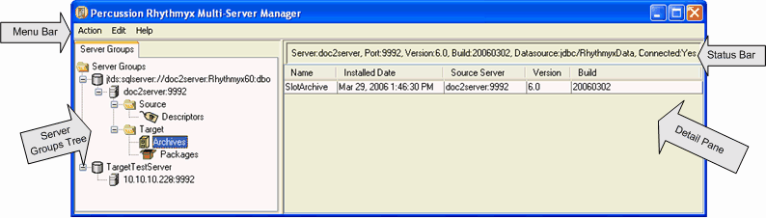

Server Groups Tree

Figure 1: Main MSM Window

The Server Groups Tree displays all of the servers registered with your Multi-Server Manager. The top nodes are the servers’ CM System repositories. Below each repository node is a server name node, and below that are nodes for Source and/or Target elements on the server if they exist. A Source node with a Descriptors node under it is present if you have saved any descriptor files on the server. A Target node with an Archives node and a Packages node under it is present if you have installed any archives on the server.

If you save your login credentials (see "Connect to Server" on page 31), when you click an unconnected server node, the Multi-Server Manager automatically connects you to it. Right-click on the server name node to open a Server Action menu.

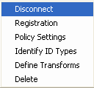

Figure 2: Server Action Menu

The Server Action menu includes the following options

  - Disconnect/Connect

- Disconnect - Disconnects the server from the client (Multi-Server Manager).
- Connect - Connect client (Multi-Server Manager) to the server or open the Connect to Server dialog.
  - Registration - edit the registration of the server.
  - Policy Settings - Set CM System application policy settings. The selected server will give these settings to all applications installed on it.
  - Identify ID Types - Specify ID Types for all server objects on the selected server.
  - Define Transforms - Map elements and datasources for the selected server.
  - Delete - Delete the server registration and remove the node and its contents from the table.
Status Bar

When you select a repository node, the Status Bar displays repository information:

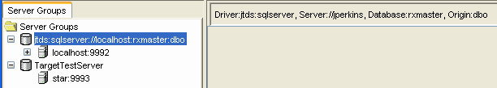

Figure 3: Status Bar displaying repository information

When you select a server node or any node below the server node, the Status Bar displays server information:

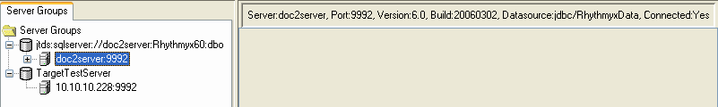

Figure 4: Server Status

Menu Bar

The Menu Bar displays links to three drop-down menus:

  - Action menu
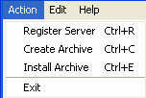

Figure 5: Action Menu

The Action menu includes the following options:

  - Register Server - Register a server with the Multi-Server Manager.
  - Create Archive - Open the Create Archive/Descriptor Wizard (see "Creating and Editing Archives and Generating Deployment Descriptors" on page 59). Disabled (gray) if no servers are registered.
  - Install Archive - Open the Install Archive Wizard. Disabled (gray) if no servers are registered.
  - Exit - Close the Multi-Server Manager

  - Edit menu
You must select a server node to enable options in the Edit Menu.
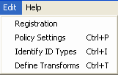

Figure 6: Edit Menu

The Edit menu includes the following options:

  - Registration - Edit the registration of the server.

    - Policy Settings - Set CM System application policy settings on the selected server. These settings will apply to all applications installed on the server. Enabled only if the server is connected.

  - Identify ID Types - Specify ID Types for all hard-coded IDs in server objects on the selected server. Enabled only if the server is connected.

  - Define Transforms - Map elements and datasources for the selected server and the target server. Enabled only if the server is connected.

  - Help Menu
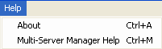

Figure 7: Help Menu

The Help menu lets you display the CM System build and release and opens the online CM System
Multi-Server Manager Help.
- About - Display the CM System build and release.
- Multi-Server Manager Help - Open Multi-Server Manager online help.

Details Pane

The Details Pane displays information about the node selected in the Server Groups Tree. Click on a
Descriptors, Archives or Packages node to see details about it in the Details Pane. The possible views in the Details Pane are
- Descriptors View (on page 22)
- Archives View (on page 24)
- Packages View (on page 25)

Descriptors View

Descriptors are files that store information for creating archives. When you select a Descriptors node in the Server Groups Tree, the Multi-Server Manager displays Descriptors view in the Details Pane. Descriptors view displays the name, description, and last modified date for each descriptor on that server. You can sort on any of the column headings by clicking it. Clicking the column repeatedly toggles the sort between ascending and descending order.

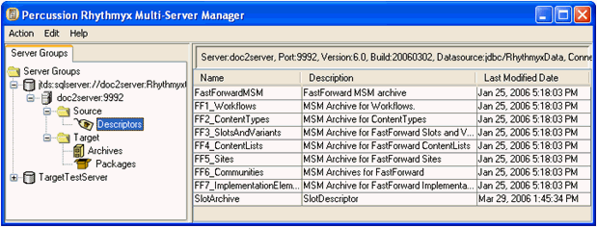

Figure 8: Descriptors View

Right-click on a descriptor row to view a Descriptor Action menu:

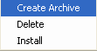

Menu options:

Figure 9: Descriptor Action Menu

 Create Archive - Opens the Create Archive/Descriptor Wizard to the Choose Create Mode Dialog (see "Choose Create Mode" on page 62). Skips the Choose a Server and/or Descriptor Dialog (see "Choose a Server and/or Descriptor" on page 61) because it uses the server and descriptor that you selected in the Multi-Server Manager Window.
 Delete - Deletes the descriptor from the server and removes the row from Details view.
 Install - Opens the Install Archive Wizard with the name of the last archive created using this descriptor. If the Multi-Server Manager cannot find the archive, it displays a warning and lets you proceed to the Wizard to choose an archive.

Archives View

Archives are the files that carry Packages from the source server to the target server. When you click an Archives node in the Server Groups Tree, the Multi-Server Manager displays the Archives view in the Details Pane. For each archive installed on the server, Archives view displays:

- archive name
- installation date
- source server
- CM System version
- CM System build
If you re-install an archive, rows appear for each of its installations in the view. If you overwrite an archive by using its name when creating a new archive, the former archive's listing is deleted from this view.

You can sort on any of the column headings by clicking it. Clicking the column repeatedly toggles the sort between ascending and descending order.

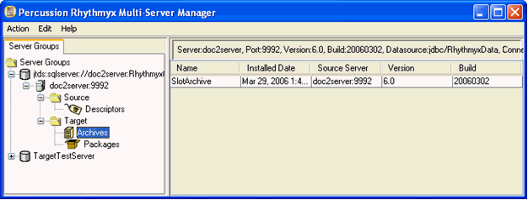

Figure 10: Archives View
Double-click an archive row to view its Archive Summary (see "Reviewing Archives" on page 101). Right-click an archive row to view an Archive Action menu:
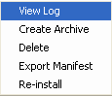

Menu options:

Figure 11: Archive Action Menu

- View Log - Opens the Archive Summary (see "Reviewing Archives" on page 101).

- Create Archive - Lets you repackage elements previously installed from the selected archive without having to redefine the archive contents. Opens the Create Archive/Descriptor Wizard (see "Create Archive or Descriptor" on page 77).
- Delete - Deletes the archive and its packages from the server. Removes all rows representing the archive in Archives view and all packages installed from the archive in Packages View.
- Export Manifest - A manifest is a file that describes the contents of an archive. This option opens a File Browser window so that you can save the manifest to a file.
- Re-install - Opens the Install Archive Wizard to the Choose Installation Mode (see "Select an Archive and Server Dialog" on page 84) dialog so that you can re-install the archive on the target server as previously.

Packages View

Packages are the elements and their dependents that you list together in an archive and install on a target server. When you click a Packages node in the Server Groups Tree, the Multi-Server Manager displays the Packages View in the Details pane. For each package installed on the server, Packages View displays:

- package name
- package type
- description
- archive name
- installation date
- source server
- CM System version
- CM System build.
If you re-install a package, rows appear for each of its installations in the Packages view. If you overwrite an archive by using its name when creating a new archive, the overwritten archive's package listings are deleted from this view.

You can sort on any of the column headings by clicking it. Clicking the column repeatedly toggles the sort between ascending and descending order.

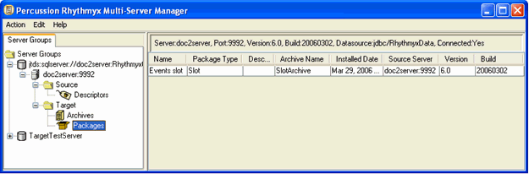

Figure 12: Packages View

Double-click a package row to view its package log.

Right-click a package row to view a Packages Action menu:

Menu options:

Figure 13: Packages Action Menu

- Export - Opens a File Browser window so that you can save the package log to a file.

C H A P T E R 3

Installation Check List

The Multi-Server Manager provides all the necessary dialogs and Wizards for installing a CMS or portions of a CMS from a source to target CM System server. The following table lists the steps necessary for initial set up and installation in the first column, and the Multi-Server Manager dialog or Wizard for completing the step in the second column. Click on a dialog or Wizard to see a topic describing how to use it.

To install CM System elements using the Multi-Server Manager:

Step | Multi-Server Manager Dialog or Wizard
1. Register the source and target servers. | Edit/New CM System Server Registration (on page  28)
2. Identify CM System elements referenced by  CM System server objects. | Identify ID Types dialog (on page 43)
3.Map CM System elements and non-repository datasources on the source server to corresponding elements and datasources on the target server. | Define Transforms dialog (see "Define Transforms for <Server:Port>" on page 47)
4. Specify the elements of the source CM System system to include in your archive and create the descriptor and/or archive. | Create Archive/Descriptor Wizard (see "Creating and Editing Archives and Generating Deployment Descriptors" on page 59)
5. Specify which Packages in your archive to install on the target server and complete installation. | Install Archive Wizard (see "Installing an Archive" on page 79)

C H A P T E R 4

Maintaining CM System Server

Registrations

Before you can create or install an archive, you must register the servers you want to maintain. Registration lets the Multi-Server Manager connect to the source and target servers and identify their configurations.

Edit/New Rhythmyx Server Registration

Use the Edit/New CM System Server Registration dialog to register a server or edit one that you have already registered. Access this dialog by selecting Action > Register Server in the Multi-Server Manager Window.

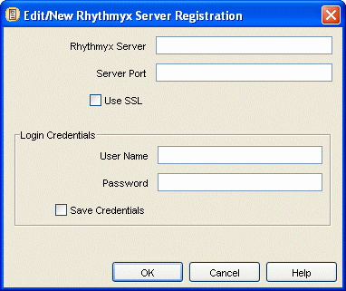

Figure 14: Edit/New CM System Server Registration Dialog

Edit/New Rhythmyx Server Registration dialog fields:

Rhythmyx Server - the name of the Rhythmyx server to register with the client system Multi-Server
Manager).

Server Port - the port number on which the CM System server is listening.

Use SSL - when this checkbox is checked, the client runs over an SSL connection. NOTE: If you check this checkbox, the Server Port must support SSL or you cannot connect.

User Name - your username for logging in to the CM System server.

Password - your password for logging in to the CM System server.

Save Credentials - when this checkbox is checked, the Multi-Server Manager saves the credentials entered in User Name and Password so that you will not have to enter them from the Multi-Server Manager when connecting to the specified server.

Repository Alias

When you enter a new server registration in the Edit/New Rhythmyx Server Registration dialog (see "Edit/New Rhythmyx Server Registration" on page 28) and when you change the server repository through the Repository Change dialog, the Multi-Server Manager displays the Repository Alias dialog, which prompts you to enter an alias name. The alias name is the identifier for the repository that the Multi-Server Manager uses in the Server Groups Tree.

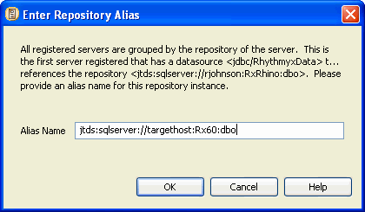

Repository Alias dialog fields

Figure 15: Enter Repository Alias Dialog

Alias Name - the repository alias name.

Repository Change

If you attempt to connect to a server or edit its registration, but its repository has changed since you last connected to it or entered or edited its registration information, the Multi-Server Manager displays a confirmation dialog for changing the repository associated with the server.

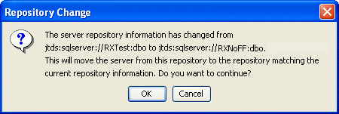

Figure 16: Repository Change Dialog

After you click [OK], the Multi-Server Manager displays the Repository Alias dialog.

Connect to Server

The Multi-Server Manager attempts to connect you to a registered server when:

 you right-click the server in the Server Groups Tree and choose Connect;

 you select the server in the Server Groups Tree and choose an action, such as Identify
ID Types, that requires that the server be registered;

 you are performing an action through a dialog that requires choosing a server, and the server you choose is not connected.
If you have not already saved your username and password, the Connection to Server dialog prompts you to enter your username and password for logging in to the server.

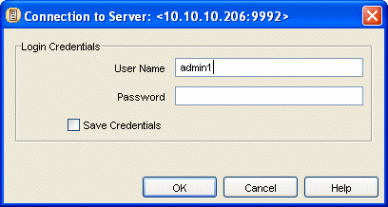

Figure 17: Connection to Server Dialog

Connection to Server dialog fields:

User Name - your username for logging in to the CMS server;

Password - your password for logging in to the CMS server;

Save Credentials - when this checkbox is checked, CM System saves the credentials entered in User Name and Password so that you will not have to enter them again when connecting to the selected server through the Multi-Server Manager.

Server Registration Maintenance Procedures

Registering a Server

To register a server:

1 In the Multi-Server Manager Window, select Action > Register Server.

The Multi-Server Manager opens the Edit/New Rhythmyx Server Registration (on page 28)
dialog.

2 In CM System Server, enter the server name.

3 In Server Port, enter the port on which the server is listening.

4 If you are using an SSL connection, check Use SSL.

5 Optionally, in User Name, enter your username for logging in to the server.

6 Optionally, in Password, enter your password for logging in to the server.

7 If you want the Multi-Server Manager to save your username and password so you do not have to reenter them each time you connect to this server, check Save credentials.

If you save your credentials, the Multi-Server Manager automatically connects you to the server when you click on its node in the Server Groups Tree.

8 Click [OK].

The Multi-Server Manager displays the Enter Repository Alias dialog.

9 Enter a repository alias and click [OK].

The Multi-Server Manager registers the server.

Editing a Server Registration

To edit a server registration:

1 In the Server Groups Tree, select a server node and:

- In the Menu Bar, select Edit > Registration.

OR

- Right-click the server node and select Registration.

2 The Multi-Server Manager displays the current registration information in the Edit/New
Rhythmyx Server Registration dialog (see "Edit/New Rhythmyx Server Registration" on page
28).

3 Optionally, change the Server Port, Use SSL, User Name, or Password. You cannot change the
Rhythmyx Server.

4 If you want the Multi-Server Manager to save your username and password so you do not have to reenter them each time you connect to this server, check Save credentials.

5 Click [OK].

If the repository associated with the server has not changed, the Multi-Server Manager saves the edited registration.

If the repository associated with the server has changed since you added or edited the server or connected to it, the Multi-Server Manager displays the Repository Change dialog.

If the Multi-Server Manager displays the Repository Change dialog:

6 Click [OK] to continue or [Cancel] to return to the previous dialog and make any corrections.

If you click [OK] in the Repository Change dialog, the Multi-Server Manager checks for the repository’s alias name. If it does not find one, it displays the Repository Alias dialog.

7 In the Repository Alias dialog, enter an Alias Name.

8 Click [OK] to save the server registration changes or [Cancel] to return to the Edit/New
Rhythmyx Server Registration dialog (see "Edit/New Rhythmyx Server Registration" on page
28).

The Multi-Server Manager saves the server registration changes and changes the view in the
Server Groups Tree to display the server represented by the new repository.

Connecting to a Server

To connect to a server:

1 In the Server Groups Tree, right-click a server node and select Connect.

The Multi-Server Manager displays the Connect to Server dialog (see "Connect to Server" on page 31) if you did not save your log-in credentials.

If the Multi-Server Manager displays the Connect to Server dialog:

a) Enter your User Name and Password for connecting to the server.

b) If you want the Multi-Server Manager to save your username and password, so that you do not have to reenter them each time you access the server, check Save these login credentials.

c) Click [Connect].

If the repository associated with the server has not changed since you added or edited the server or connected to it, the Multi-Server Manager connects you to the server and expands it in the Server Groups Tree.

If the repository associated with the server has changed since you last connected to the server, the Multi-Server Manager displays the Repository Change dialog.

If the Multi-Server Manager displays the Repository Change dialog:

d) Click [OK] to continue or [Cancel] to return to the previous dialog and make any corrections.

If you click [OK] in the Repository Change dialog, the Multi-Server Manager checks for the repository’s alias name. If it does not find one, it displays the Repository Alias dialog.

e) In the Repository Alias dialog, enter an Alias Name.

f) Click [OK] to continue or [Cancel] to return to the Edit/New Rhythmyx Server
Registration dialog (see "Edit/New Rhythmyx Server Registration" on page 28).

The Multi-Server Manager connects you to the server, changes the view in the Server Groups Tree to display the server represented by the new repository, and expands the server in the Server Groups Tree.

Maintaining Server Policy Settings

The Multi-Server Manager assigns default settings called Server Policy Settings that will affect the applications installed on the server. The Server Policy Settings are Application Logging, Application Tracing, and Application Activation. By default, the Multi-Server Manager disables Application Logging and Application Tracing for all applications and enables Application Activation, so that all applications will be active after installation. You can change the defaults in the Server Policy Settings dialog.

To change Server Policy Settings:

1 In the Multi-Server Manager Window, select Edit > Policy Settings or right-click the Server
Repository Node in the Server Groups Tree and select Edit Policy Settings. The Multi-Server Manager displays the Server Policy Settings dialog.
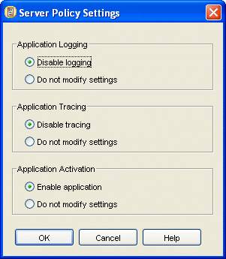

Figure 18: Server Policy Settings Dialog

2 The default setting for Application Logging is Disable logging. This setting disables logging for all applications after they are installed. To use the current logging settings for each application, select Do not modify settings.

3 The default setting for Application Tracing is Disable tracing. This disables tracing for all applications after they are installed. To use the current tracing settings for each application, select Do not modify settings.

4 The default setting for Application Activation is Enable application. This activates all applications after they are installed. To use the current activation settings for each application, select Do not modify settings.

5 Click [OK].

The Multi-Server Manager saves the Server Policy Settings.

C H A P T E R 5

About Mapping Elements and Datasources and Identifying ID Types

To install certain parts of CM System with the Multi-Server Manager, you must enter some information manually.

Rhythmyx Elements

Your source server includes various elements that you may be installing, such as Content Types, Editions, Keywords and Contexts. Each of these has a numeric identifier. The same elements may or may not exist on the target server. If they do exist on the target server, they may have different numeric identifiers. For example, a Content Type named Home may be Content Type Definition 312 on the source server and Content Type Definition 314 on the target server. You must indicate this manually to the Multi-Server Manager. As another example, the Keyword Adhoc_Type may be Keyword Definition 125 on the source server and may not exist on the target server. The Multi-Server Manager must add it during installation. You must also indicate this manually to the Multi-Server Manager.

Datasources

If a source server has any applications that reference a database other than the repository database, you must map the application's non-repository datasource used on the source server to the application's non- repository datasource used on the target server. When you install applications onto the target server, the source server datasource is automatically changed in applications to the target server datasource. But the Multi-Server Manager does not know how to change a non repository datasource in an application. You must indicate this manually to the Multi-Server Manager.

Identifier Types

Server objects on your source server, such as Content Type definitions and Template definitions, may contain identifiers for CM System elements that are hard-coded. For example, a Template binding may be mapped to a value of 1. The Multi-Server Manager cannot know if the application is referring to Context Definition 1, Search Definition 1 or another element with ID 1. You must manually indicate the element type of the identifier so that the Multi-Server Manager knows which element is represented by “1”. If the Multi-Server Manager knows that “1” represents Context Definition 1, it can give you the option of installing Context 1. It can also make appropriate changes to the Template definition if this element is mapped to another element on the target server (for example, if source Context Definition 1 = target Context Definition 3, the Multi-Server Manager knows to change the value mapped to the binding from 1 to 3 in Template definition).

Mapping source and target Rhythmyx elements (on page 40)

Mapping source and target datasources referenced in applications (see "Mapping Source and Target
Datasources" on page 41)

Identifying hard-coded identifiers types in server objects (see "Identifying Types of Elements" on page
42)

When to Map Elements and Datasources and

Identify ID Types

The Multi-Server Manager provides dialogs for entering CM System element mappings, datasource mappings and ID types from the Multi-Server Manager Window. In addition, it may display the dialog for entering ID types in the Create Archive/Descriptor Wizard, and it may display the dialog for entering element and datasource mappings in the Archive Installation Wizard. When you access the dialogs from
the Multi-Server Manager Window, you can enter ID types and mappings for all elements and applications on the server; when you access the dialogs from a Wizard, you can only add ID Types or mappings for elements and applications selected in the Wizard and edit ID Types and mappings for all elements and applications on the server. Regardless of where you enter the mappings or ID types, the Multi-Server Manager saves them on the server, so you do not have to reenter them unless you want to make changes. NOTE: To create mappings, you must also select a target server.

The dialogs that you can access from the Multi-Server Manager Window allow an implementer to set up all mappings and ID types for a server prior to creating and installing archives. By creating all your manual settings initially, you make installation easier because you only have to map and set ID types for newly added elements when you create and install archives using the wizards. In addition, you allow users without knowledge of CM System elements and applications to install using the wizards with the settings that you have already created.

Users always have the option of changing existing ID types and mappings in the wizards.

Mapping Source and Target Rhythmyx

Elements

If you are installing elements such as Content Types and Templates for the first time, you can copy the source elements (the target server gives them a new identifier (ID number)) to the target server; however, if you are installing source server elements to a target server that already contains some Rhythmyx
elements, the names and identifiers of elements may not match. You may have the same elements on both servers, but they may have different identifiers and possibly, different names.

Examples:

Source Server  Sample Element |  | Target Server Sample  Element | User Action
Brief content type, Content Type ID= 301 | is the same as | Brief content type, Content Type ID =303 | Map Content Type ID 301 on the source server to Content Type ID 303 on the target server.
List Slot,  Slot ID= 509 | is the same as | List Slot,  Slot ID= 509 | Map Slot ID 509 on the source server to Slot ID 509 on that target server.
Quick Publish Workflow, Workflow ID = 6 | Does not exist on target server. |  | Add Quick Publish Workflow, Workflow ID 6 to the target server. Target server will add it and give it a new Workflow ID.
For each element type, you must either manually map the source and target identifiers so the Multi-Server
Manager knows which target element represents each source element or specify that it should be added as a new element. The Multi-Server Manager provides the Element Maps tab of the Define Transforms dialog (see "Define Transforms for <Server:Port> Element Maps Tab" on page 50) for you to add, edit, or delete Rhythmyx element mappings.

Mapping Source and Target Datasources

CM System applications may reference datasources other than the default datasource used by the source server. You must map the non-default datasources in the applications to the datasources they should reference on the target server. The Multi-Server Manager provides the Datasource Maps tab of the Define Transforms dialog (see "Define Transforms for <Server:Port> Datasource Map Tab" on page 48) for you to add, edit, or delete datasource mappings.

Identifying Types of Elements

CM System objects (such as Content Types and Templates) may contain hard-coded identifiers that reference other CM System elements, such as Contexts and Sites. For example, the following Template identifies a Context as 0.

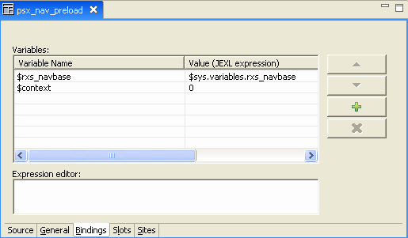

Figure 19: Example of Element with ID

The Multi-Server Manager needs you to specify what type of CM System element the 0 represents for two reasons:

- To see if the 0 is mapped to a different value in your source/target element mappings (see "Mapping Source and Target Rhythmyx Elements" on page 40). The Multi-Server Manager does not know if 0 represents a Content Type ID, Context ID, Site ID, or any other ID type. You must specify its ID type (in this case Context Definition) so that it can check the element mappings. If you have mapped Context 0 on the source server to Context 6 on the target server, the Multi-Server Manager locates the mapping and changes the value in the application before installation.
- To give you the option of including Context 0 as a dependency. This Template must have access to Context 0 to run correctly. If you identify 0 as a Context Definition, the Multi- Server Manager later gives you the option of including Context 0 in the Package.
The Multi-Server Manager provides the Identify ID Types dialog (on page 43) for you to identify ID types of hard-coded identifiers.

Identify ID Types Dialog

The Multi-Server Manager provides the Identify ID Types dialog for specifying ID types of hard-coded identifiers in applications and other installable server objects. The Multi-Server Manager locates and displays all hard-coded identifiers in each installable server object of the selected CMS or Package, and prompts you to specify each identifier’s ID type, such as Content List Definition, Content Type Definition, or Not an id.

The Identify ID Types dialog is accessible from the Multi-Server Manager Window and the Create Archive/Descriptor Wizard. If the objects that you are installing do not contain hard-coded identifiers, the Identify ID Types dialog does not appear in the Create Archive/Descriptor Wizard.

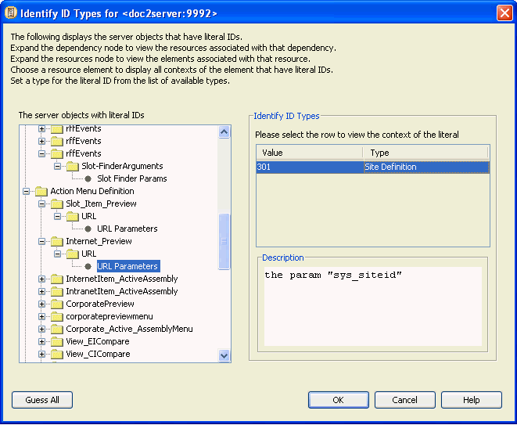

Figure 20: Identify ID Types dialog

The Identify ID Types dialog displays a tree of all elements in installable server objects on the selected server or package that have literal (hard-coded) identifiers. Each server object expands to display its resources. Each resource expands to display elements that may contain literal identifiers. Click on an element to view its hard-coded identifiers in the Value column of the Identify ID Types table.

For example, in the graphic, the Action Menu Definition is an installable server object that expands to display the Internet Preview (action) which, when fully expanded displays the URL Parameters element. The URL Parameters node is selected and the Identify ID Types table displays its literal identifier, 301, in the Value column. If you click on an ID in the Value column a description of the identifier’s location in the element displays in the Description box as a hint of its ID type. See Reading Descriptions in the Identifying ID Types Dialog (see "Reading Descriptions in the Identify ID Types Dialog" on page 44) for help interpreting the information in this box. In the Multi-Server Manager, click in the Type row to access a drop list of all possible ID Types and select an ID Type.

Click the [Guess All] button to have the Multi-Server Manager guess as many of the ID Types as possible. Multi-Server Manager guesses ID Types based on exact or partial names of elements. In addition, if an element has the value of 0, Multi-Server Manager guesses Not an ID. Otherwise, Multi-Server Manager does not guess, and you must manually enter the ID Type.

Reading Descriptions in the Identify ID Types Dialog

The Identify ID Types dialog (on page 43) provides a Description box that describes the context of an ID Value (identifier) selected in the Identify ID Types table. The information in the box describes where the value appears to help you determine its ID Type. The following table shows some descriptions that you may see and explains how to interpret them.

Element in tree | Description in dialog | Interpretation
URL Parameters node embedded in an Action Menu Definition folder | the param "sys_siteid" | The parameter name (sys_siteid)  indicates that it is a Site Definition.
Slot Finder Params embedded in a Slot Definition folder | the param "max_results" | You must identify the ID Type of the param "max_results". “max results” indicates that you are specifying a number of items, not an ID, so the type is Not an id.

Element in tree | Description in dialog | Interpretation
Post Exits node in the XML resource folder within an application folder | the param #0 with name "filenameContext" and value "301" in the extension call #0 "Java/global/percussion/fastforward/sfp/rx s_SiteFolderContentListBulkBuilder" | You must identify the ID type of filenameContext. The rest of the description tells you the URL of the extension in which the parameter named filenameContext is located.  The name filenameContext indicates that the parameter represents a Context ID. You can specify the ID Type as a Context Definition.  If you want to confirm your selection, in the Workbench, open the application in XML Server view, find the XML resource, and open the exits until you find the one named in the description, rxs_SiteFolderContentListBuilder. In  the Exit Properties dialog, click the filename to view the parameters; then click the filenameContext parameter. The text in the Exit Properties description box confirms that filenameContext represents a Context ID.

Specifying ID Types

To identify ID Types:

1 Either:

- Right-click the Server Repository Node and select Identify ID Types.

OR

- Select the Server Repository Node and select Edit > Identify ID Types in the Menu Bar.

The Multi-Server Manager displays the Identify ID Types dialog (on page 43). The dialog displays a tree of all Rhythmyx elements in installable server objects that have literal (hard- coded) identifiers.

NOTE: You can access a similar mode of this dialog in the Create Archive/Descriptor Wizard
(see "Identify ID Types Dialog" on page 43).

2 Follow the steps in Using the Identify ID Types dialog.

3 Click [OK].

CM System stores all of the ID Types and will send them to the target server when you install the archive.

Using the Identify ID Types Dialog

To have Multi-Server Manager guess ID types of literal (hard-coded) identifiers in server objects:

1 In the Identify ID Types dialog (on page 43), click [Guess All].

Multi-Server Manager guesses ID Types based on exact or partial names of elements. In addition, if an element has the value of 0, Multi-Server Manager guesses "Not an ID". Otherwise, Multi-Server Manager does not guess, and you must manually specify the ID Type.
To manually specify the ID types of literal (hard-coded) identifiers in server objects:

1 In the Identify ID Types dialog (on page 43), expand the Server Objects Tree.

When fully expanded, the tree displays all CM System elements in the objects that have literal identifiers.

2 Select an element.

The Multi-Server Manager displays its literal identifiers in the Value column of the table under Identify ID Types. If you specified its ID Type previously, it displays the ID Type in the Type column.

3 Click an identifier in the Value column.

The Multi-Server Manager displays a description of its context within the selected element in the Description box.

4 Double-click in the Type column to access a drop list of all possible types and select a type. If the literal value does not represent an ID, select Not an id.

Repeat these procedures until you have specified the types for all of the identifiers in the server objects listed.

Define Transforms for <Server:Port>

The Multi-Server Manager provides the Define Transforms dialog for creating maps of CM System elements and of non-default datasources specified in applications. This dialog is available from the Multi-Server Manager Window and the Install Archive Wizard. It has two tabs: the Datasource Maps tab and the Element Maps tab.

The Multi-Server Manager saves the maps on the target server and uses them during installation.

Define Transforms for <server:port> Datasources Map Tab (see "Define Transforms for <Server:Port> Datasource Map Tab" on page 48)

Define Transforms for <server:port> Element Maps Tab (on page 50)

Define Transforms for <Server:Port> Datasource Map Tab

The Multi-Server Manager provides the Datasource Maps tab of the Define Transforms dialog for you to add, edit, or delete mappings of non-default datasources specified in applications on the source server. This Multi-Server Manager only displays this dialog if you have at least two servers registered.

If you access the dialog from the Install Archive Wizard, the Wizard searches through the applications that you have selected for installation, and lists their references to non-default datasources. You can modify these listings. If you access the Define Transforms dialog through the Install Archive Wizard and are not installing applications that access non-default datasources, the Datasource Map tab does not appear. The dialog in the Wizard also includes an Advanced option that lets you change source/target server mappings that the archive does not use; this allows you to make datasources available for mappings that the archive uses.

When you access this dialog from the Server Groups Tree, the Multi-Server Manager does not guess or search for non-default datasource references in source applications as it does in the Install Archive Wizard. You must add all of them.

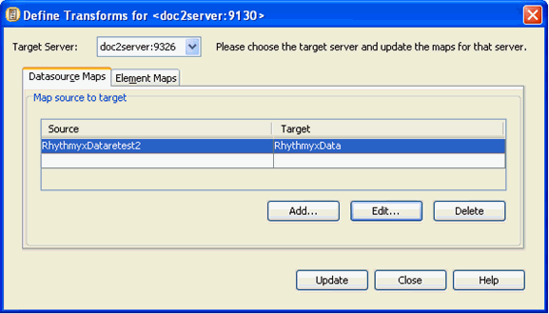

Figure 21: Datasource mapping

In the Datasource Maps tab, you select a target datasource from the list of registered servers in the Target Server drop list at the top of the dialog.Then you click [Add] to add an existing source server datasource and map it with an existing target server datasource.

Define Transforms dialog, Datasource Maps tab fields

Under Map source to target Source - source datasource Target - target datasource

Edit/Add Datasource

In the Datasource Maps tab of the Define Transforms dialog (see "Define Transforms for <Server:Port> Datasource Map Tab" on page 48), when you click [Add] or click a row in the source to target mappings and click [Edit], the Multi-Server Manager displays the Edit/Add Datasource Map dialog. This dialog lets you insert or change a datasource mapping.

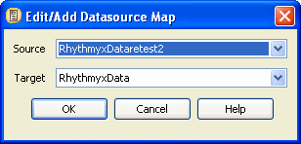

Edit/Add Datasource Map fields

Figure 22: Edit/Add Datasource Dialog

Source - drop list containing all registered datasources on the source server

Target - drop list containing all registered datasources on the target server

Define Transforms for <Server:Port> Element Maps Tab

The Multi-Server Manager provides the Element Maps tab of the Define Transforms dialog for you to add, edit, or delete CM System element mappings. The Element Maps tab lists elements that CM System knows by ID numbers, such as content types and slots. It lists the element names for your reference; you are actually mapping the identifiers.

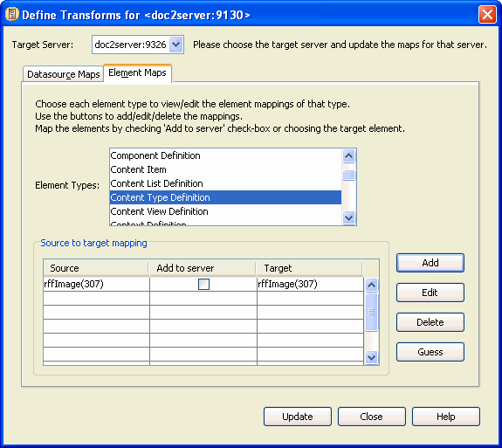

Figure 23: Element mapping

Select a target server from the list of registered servers in the Target Server drop list at the top of the dialog. Then select a type in the Element Types list, and add or edit its mappings in the Source to target mapping table.

Because you must map parent elements before mapping child elements, the Multi-Server Manager lists parent elements before child elements in the Element Types list. For example, Workflows are parent elements of States and are listed before them. To avoid getting error messages, map element types in the order they appear in the list.

If you access this dialog through the Install Archive Wizard, when you select an Element Type, the Multi- Server Manager lists all elements of that type in the selected element in the Source: Name(id) column. If you select an element in this column and click [Guess], the Multi-Server Manager either finds a match for it on the target server and lists the element in the Target: Name(id) column or does not find a match and checks the Add to server check box to indicate that the source element will be added to the target server. You can change the guesses if they are incorrect. When accessed through the Wizard, the dialog also includes a [Guess All] button that causes the Multi-Server Manager to guess mappings for all elements for all Element Types.

If you access the Define Transforms dialog through the Install Archive Wizard and no CM System elements require mapping, the Element Maps tab does not appear.

If you access this dialog through the Multi-Server Manager Window, when you select an Element Type, the Multi-Server Manager lists all elements of that type on the source server in the Source column. If you click [Guess] , the Multi-Server Manager finds matches or checks the Add to server check box for all of the listed elements. The dialog accessed through the Multi-Server Manager Window also provides [Add] and [Edit] buttons for accessing the Edit/Add Mapping dialog and the [Delete] button for deleting mappings.

The dialog in the Wizard also includes an Advanced option that lets you change source/target server mappings that the archive does not use; this allows you to make elements available for mappings that the archive uses.

Define Transforms dialog, Element Maps tab fields

Target Server - drop list of target servers;

Element Types (non-editable) - all source CM System elements that require mappings;

Source (non-editable) - source value of element;

Add to server - check to copy element from source to target; automatically checked if you select blank in the Target column;

Target - target value for element.

Edit/Add Mapping

In the Element Maps tab of the Define Transforms dialog (see "Define Transforms for <Server:Port> Element Maps Tab" on page 50), when you click [Add] or click a row in the Map source to target table and click [Edit], the Multi-Server Manager displays the Edit/Add Mapping dialog. This dialog lets you add and edit mappings.

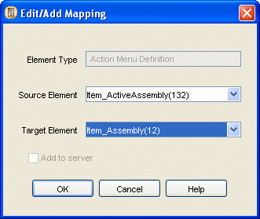

Edit/Add Mapping fields

Figure 24: Edit/Add Mapping Dialog

Element Type (non-editable) - element type selected in Element Types list;

Source Element - source element name and identifier;

Target Element - target element name and identifier;

Add to server - check to add new name and identifier to the target server.

If you are adding, all elements for the Element Type on the source and target server appear in the Source Element and Target Element drop lists. When you select a Source Element, if a Target Element with the same name exists, the dialog displays it in the Target Element field; otherwise it checks the Add to server check box.You can change the automatic selections.The Target Element drop list includes a blank field; if you choose this field, the Multi-Server Manager automatically checks the Add to server check box.

If you are editing, the selected source and target elements display in the fields, but you can only change the Target Element.

States are listed with parent workflows. You must map the parent workflow before mapping the state or the Multi-Server Manager displays an Error dialog.

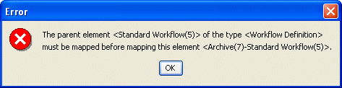

Figure 25: Error Dialog

Source to Target Transform Procedures

The Define Transforms dialogs let you map datasources and element names, and add, edit, and delete datasources and element name mappings.

Mapping Datasources

To map datasources:

1 In the Server Groups Tree of the Multi-Server Manager

- right-click a server repository node and select Define Transforms

OR

- click a server repository node and select Edit > Define Transforms in the Menu Bar.

The Multi-Server Manager displays the Datasource Maps tab of the Define Transforms dialog (see "Define Transforms for <Server:Port> Datasource Map Tab" on page 48). The dialog does not include information in the Map source to target table the first time it opens.

NOTE: You can access a similar mode of this dialog through the Install Archive Wizard
(see "Transforms" on page 89).

2 Select a target server in the Target Server drop list.

3 Click [Add] to add a datasource mapping. (see "Adding Datasource Mappings" on page 54)

4 Repeat step 3 until you have mapped all non-default datasources.

5 To edit a row that you added to the Map source to target table, select the row and click
[Edit]. (see "Editing a Datasource Mapping" on page 55)

6 To delete a row that you added to the Map source to target table, select the row and click
[Delete] (see "Deleting a Datasource Mapping" on page 55).

7 Click [Update].

The Multi-Server Manager saves your datasource mappings and sends them to the target server during installation.

Adding Datasource Mappings

To add datasource mappings:

1 Follow step 1 and step 2 of Mapping Datasources (on page 54).

2 Click [Add].

The Multi-Server Manager displays the Edit/Add Datasource Map dialog (see "Edit/Add
Datasource" on page 49).

3 Select source and target datasources.

4 Click [OK].

The Multi-Server Manager displays the new mapping in the Map source to target table.

Editing a Datasource Mapping

To edit datasource mappings:

1 Follow step 1 and step 2 of Mapping Datasources (on page 54).

2 Select a mapping in the Map source to target table and click [Edit].

The Multi-Server Manager displays the Edit/Add Datasource Map dialog (see "Edit/Add
Datasource" on page 49).

3 Change the source and/or target datasource.

4 Click [OK].

The Multi-Server Manager displays the changed mapping in the Map source to target table.

Deleting a Datasource Mapping

To delete a datasource mapping:

1 Follow step 1 and step 2 of Mapping Datasources (on page 54).

2 Select a datasource mapping in the Map source to target table and click [Delete].

The Multi-Server Manager removes the row from the Map source to target table.

Mapping Elements

To map elements:

1 In the Server Groups Tree of the Multi-Server Manager:

- right-click a server repository node and select Define Transforms

OR

- click a server repository node and select Edit > Define Transforms in the Menu Bar.

The Multi-Server Manager displays the Define Transforms dialog (see "Define Transforms for <Server:Port>" on page 47).

2 Click the Elements Maps tab.

The Multi-Server Manager displays the Elements Maps tab (see "Define Transforms for
<Server:Port> Element Maps Tab" on page 50). NOTE: You can access a similar mode of this dialog through the Install Archive Wizard (see "Transforms" on page 89).

3 Click an Element Type.

NOTE: Element Types are listed in the order in which you should map them, so begin with the first Element Type in the list.

If you have already mapped elements of this type, the mappings display in the Source to target mapping table.

4 Click [Guess].

The Multi-Server Manager lists all elements of this type on the source server in the Source column. If it can find a target server element with a matching name, it lists it in the Target column. If it cannot find a matching target element, it checks the Add to server check box. You can edit the Multi-Server Manager's guesses.

5 To add a mapping, click [Add]. (see "Adding an Element Name Mapping" on page 56)

6 If a source element is mapped to a target element in the table, but you want to add it to the target server instead, check the Add to server check box.

The Multi-Server Manager automatically changes the Target field to blank.

7 To edit a mapping, select its row in the table and click [Edit]. (see "Editing an Element
Name Mapping" on page 56)

8 To delete a mapping, select its row in the table and click [Delete].

9 Complete steps 3 through 9 for the next Element Type in the list. Continue until you have mapped all Element Types.

10 Click [Update].

Adding an Element Name Mapping

To add an element name mapping:

1 Follow steps 1 through 3 of Mapping Elements (on page 55).

2 Click [Add].

The Multi-Server Manager displays the Edit/Add Mapping dialog. Element Type displays the element type selected in the Element Maps tab. Source Element and Target Element display drop lists of all elements of that type on each server.

3 Select a Source Element.

The Multi-Server Manager guesses the matching Target Element and displays it in the Target
Element drop list or checks the Add to server check box.

4 Optionally, change the Target Element or select blank to add the source element to the target server.

If you select blank, the Multi-Server Manager automatically selects the Add to server check box.

5 Click [OK].

The Multi-Server Manager displays the new mapping in the Source to target mapping table.

Editing an Element Name Mapping

To edit an element name mapping:

1 Follow steps 1 through 3 of Mapping Elements (on page 55).

2 Select a row in the Source to Target Mapping table and click [Edit].

The Multi-Server Manager displays the Edit/Add Mapping dialog with the values from the selected mapping entered in the fields.

3 Select a new Target Element or select blank.

If you select blank, the Multi-Server Manager automatically checks the Add to server
checkbox to add the Source Element to the target server.

4 Click [OK].

The Multi-Server Manager displays the edited mapping in the Source to target mapping table.

Deleting an Element Name Mapping

1 Follow steps 1 through 3 of Mapping Elements (on page 55).

2 Select a row in the Source to target mapping table and click [Delete].

The Multi-Server Manager removes the selected mapping from the Source to target mapping
table.

C H A P T E R 6

Creating and Editing Archives and Generating Deployment Descriptors

An archive is a file on which a installation Package or set of installation packages are stored from a source server and installed on a target server. A descriptor is a file that lists the Packages to be included in the archive and their settings.

The Multi-Server Manager provides the Create Archive/Descriptor Wizard to guide you through the process of defining a descriptor and/or creating an archive. The Wizard always guides you through the process of creating a descriptor, but it gives you the option of saving the descriptor, creating an archive from it, or both. If you save the descriptor, you can modify it or reuse it to create an archive.

Warning: Do not allow users to modify design elements on your server while you are running this Wizard; the server’s contents must remain static for the Wizard to function correctly.

Create Archive/Descriptor Wizard steps:

Step | Create Archive/Descriptor Wizard dialog
1. Choose a server and, optionally choose a descriptor. | Choose a Server and/or Descriptor dialog (see  "Choose a Server and/or Descriptor" on page 61)
2. Choose whether or not to modify types already specified for CM System elements. | Choose Create Mode dialog (see "Choose Create  Mode" on page 62)
3. Select CM System elements to install. | Add Elements to the Archive dialog (see "Add  Elements to the Archive" on page 63)
4. Modify or add types specified for CM System elements | Identify ID Types dialog (on page 43)
5. Choose which dependencies of elements to install. | Include Element Dependencies or Ancestors dialog (see "Include Element Dependencies or Ancestors" on page 69)
6. Create an archive and/or a descriptor. | Create Archive or Descriptor dialog (see "Create  Archive or Descriptor" on page 77)

Open the Create Archive/Descriptor Wizard in one of the following ways:

 In the Menu Bar of the Multi-server Manager Window, choose Action > Create Archive. Use this method to create a new descriptor or archive.
 In the Descriptors View, right-click a row for a descriptor and select Create Archive. The Wizard skips the first dialog. Use this method to use an existing descriptor but get the most recent versions of the elements that you plan to install from the source server.
 In Archives View, right-click on the row of a descriptor or archive and choose, Create Archive.
The Wizard skips the first dialog. Use this method to repackage elements previously installed from the selected archive without having to redefine the archive contents.
The first screen of the Wizard describes the functions of each dialog:

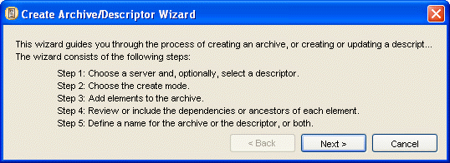

Figure 26: Create Archive/Descriptor Wizard, first screen

Click [Next] to proceed to the Choose a Server and/or Descriptor dialog (see "Choose a Server and/or
Descriptor" on page 61).

Choose a Server and/or Descriptor

The Choose a Server and/or Descriptor dialog of the Create Archive/Descriptor Wizard prompts you to specify your source server and optionally, an existing descriptor name. If you enter the Wizard through Descriptors View, the Multi-Server manager uses the selected descriptor’s name and server and skips this dialog.

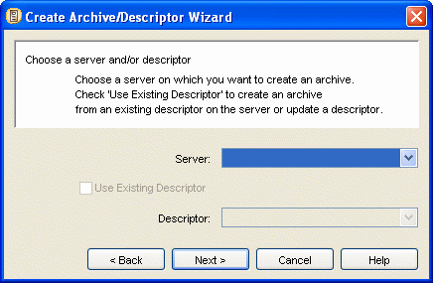

Figure 27: Create Archive/Descriptor Wizard, Choose a Server and/or Descriptor Dialog

To complete the Choose a Server and/or Descriptor dialog:

1 Select a server in the Server drop list. Unconnected servers appear disabled (gray). If you select an unconnected server, a message instructs you to connect the server when you click [Next].

2 If you want to use an existing descriptor, check the Use Existing Descriptor check box.

The Descriptor drop list becomes enabled and displays existing descriptors on the server selected in Server.

In the Descriptor drop list, select a descriptor name.

3 Click [Next>>] to proceed to the Choose Create Mode dialog (see "Choose Create Mode" on page 62).

Choose Create Mode

The Choose Create Mode dialog prompts you to specify whether you want to proceed through the Create/Archive Wizard in Typical or Custom mode. Typical mode only takes you to the Identify ID Types dialog (on page 43) if hard-coded identifiers in server objects that you are installing are unidentified. Custom mode takes you to the Identify ID Types dialog to review and modify your ID types whenever you are installing server objects with hard-coded identifiers

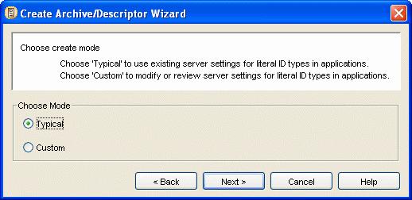

Figure 28: Create Archive/Descriptor Wizard, Choose Create Mode

To complete the Choose Create Mode dialog:

1 Choose Typical to proceed in the typical mode.

OR

Choose Custom to proceed in the custom mode.

2 Click [Next>>] to proceed to the Add Elements to the Archive dialog (see "Add Elements to the Archive" on page 63) of the Wizard.

Add Elements to the Archive

The Add Elements to the Archive dialog lets you select the CM System elements to include in your descriptor. If you specified an existing descriptor in the Choose a Server and/or Descriptor dialog (see "Choose a Server and/or Descriptor" on page 61), the Add Elements to the Archive dialog lists its content in the Elements to Package list and lets you edit the list. If you did not specify a descriptor in the Choose a Server and/or Descriptor dialog, the Add Elements to the Archive dialog helps you create a descriptor.

If you specified an existing descriptor that has elements that are no longer present on the server, the
Wizard does not list the elements in the Elements to Package list and displays a notification. It also notifies you if dependencies of the elements that you are installing are no longer present on the server.

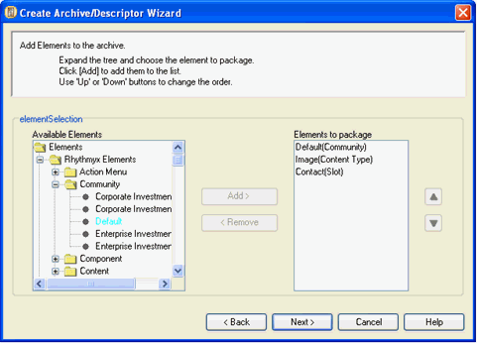

Figure 29: Add Elements to the Archive

The Available Elements tree lists all CM System Elements and Custom Elements on the server, including pre- CM System 6.0 legacy elements for upgrade users. When expanded, CM System Elements displays all the Package Types present on the server. When you expand each Package Type, it displays the names of all of the CM System elements of that Type (for example, if the Content Types on your system were Article, Image, and Web Page, it would display Article, Image and Web Page under the Package Type Content Type). You can include any of these CM System elements in your descriptor. See Package Types (see "Package Types and their Dependencies" on page 12) for a description of the required elements included with each of these.

When expanded, Custom Elements displays Applications, Extensions, Shared Groups, System Definitions, System Definition Overrides, Table Schemas, Table Data, and User Dependencies. When you expand any of these element nodes except User Dependencies, the tree displays all names of existing installable elements of these types on the server. You can package these elements individually from the Custom Elements list.

The User Dependencies node allows you to create a package for including installable elements that are not listed in the Available Elements tree. Use it to include any files on the server. When you expand the User Dependencies node, it displays another node that you can click to add a User Dependencies element in the Elements to Package list. You cannot add the specific user dependencies in this dialog, use the Include Element Dependencies or Ancestors dialog (see "Include Element Dependencies or Ancestors" on page
69) to add them.

You may select elements in the Available Elements tree individually or multi-select them.

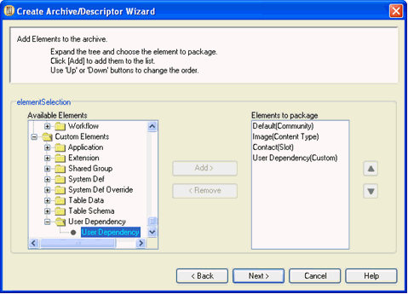

Figure 30: User Dependency Element

Only add Custom Elements if you are an experienced user.

The order in which you list elements (Packages) under Elements to Package is the order in which the
Multi-Server Manager will install them on the target server. If an element and one of its dependencies are in separate Packages, always install the dependency’s Package before the Package of the element that requires it. For example, if a Content Type is associated with a Workflow, install the Workflow Package before the Content Type Package, so that when you install the Content Type, it can locate the Workflow.

In the typical deployment scenario, Packages should be organized according to the following list. (Note that this list does not cover all deployment scenarios. Each implementation may have some unique characteristics that call for a different order than the one recommended below. We strongly recommend that you test any combination of packages in a test environment before deploying it to your production environment.)

1 Workflows

2 Community Definitions

Technically, Communities could be deployed at any point in the order because they are only referenced by name in the ACLs of other objects. Deploying Communities early makes testing of later package installations more effective. Remember that Role Membership must be updated manually on the target server if Roles are added or if Membership is different in the source and target environments.

3 Slots

4 Templates, Content Types

These implementation elements should deployed in one Archive, and in the order specified
(all Templates followed by all Content Types.) Include any Keywords used by Content Types as dependencies. Also see the posting: http://forum.percussion.com/showthread.php?t=563 on adding and removing Content Type fields.

5 Content Assemblers (if any)

6 Slots (again)

Slots must be deployed twice due to the circular references between Slots and Templates. The first deployment adds the Slots to the server; the second deployment updates the Template references within the Slots.

7 Contexts, Item Filters, Content Lists (include Location Schemes)

8 Sites (include Editions and Publishers)

9 Display Formats

10 Content Views & Searches

11 Action Menus

12 Relationship Definitions

13 Locales

14 Keywords

One or more archives containing Keywords not used in Content Types.

15 Components

16 Folder Trees

Automatically includes all folders, but does not include navigation content.

17 Folders

Deploy to include navigation content where applicable.

When you package an Entire Community, the Multi-Server Manager does not order the packages in the recommended order.

To complete the Add Elements to the Archive dialog:

1 Expand the CM System Elements tree and Custom Elements tree.

2 For each element that you want to include in your Package, click the element name and click
[Add>].

If the element is listed under Communities, the Wizard prompts you to choose Community Definition or Entire Community. If you select multiple Communities, your choice applies to all Communities selected. See the table entries for Community Definition and Entire Community in Package Types (see "Package Types and their Dependencies" on page 12) for descriptions of these choices.

The Wizard moves the element name to the Elements to Package list.

3 If you want to add one or more user-defined dependencies, click User Dependency in the Custom Elements tree. It expands to display a User Dependency sub-node. Click the sub-node and click [Add]. User Dependency appears in the Elements to Package list. You can add the user defined dependencies in the Include Element Dependencies or Ancestors dialog (see "Include Element Dependencies or Ancestors" on page 69).

4 If you want to change the order in which you will install an element, select it in the Elements to Package list and click [Up] or [Down].

5 If you want to remove an element from the Elements to Package list, click it, and select
[<Remove].

6 Click [Next>>] to proceed.

If you selected Custom in the Choose Create Mode dialog (see "Choose Create Mode" on page 62) or some of your literal identifier types are unspecified, the Identify ID Types dialog (on page 43) is next; otherwise, the Include Element Dependencies or Ancestors dialog (see "Include Element Dependencies or Ancestors" on page 69) is next.

Identify ID Types

The Identify ID Types dialog in the Create Archive/Descriptor Wizard functions identically to the Identify ID Types dialog (on page 43) that you access from the Server Groups Tree, except it displays the server objects with identifiers from the descriptor.

- If you selected Typical in the Choose Create Mode dialog, this dialog initially displays only Packages without ID Types specified, so that you can add them. Packages without ID Types specified have a red exclamation point beside them. As you specify the ID types, the exclamation points disappear, but the Packages remain in the list.
- If you selected Custom in the Choose Create Mode dialog, this dialog displays both Packages without ID Types specified and Packages with ID Types specified so that you can both add and change ID Types. The Packages without ID Types specified have red exclamation points beside them until you specify the ID Types.
When you select a Package, the Server objects with literal ids tree displays its objects.

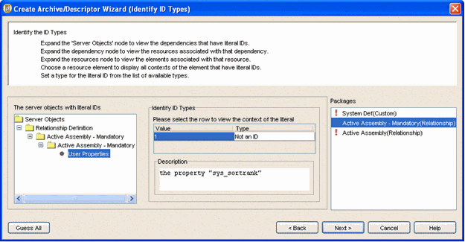

Figure 31: Create Archive/Descriptor Wizard, Identify ID Types Dialog

To understand the function of ID Type specification, see Identifying Types of Elements (on page 42). To have Multi-Server Manager guess ID types:
1 In the Identify ID Types dialog (on page 43), click [Guess All].

Multi-Server Manager guesses ID Types based on exact or partial names of elements. If an element has the value of 0, Multi-Server Manager guesses Not an ID. Otherwise, Multi- Server Manager does not guess, and you must manually specify the ID Type.

To manually specify ID types:

1 Click an element under Packages.

Server Objects with literal (hard-coded) identifiers for the element display in the Server objects with literal ids tree.

2 Follow the steps in Using the Identify ID Types dialog.

3 Repeat steps 1 and 2 for all elements under Packages.

4 Click [Next] to proceed to the Include Element Dependencies or Ancestors dialog (see
"Include Element Dependencies or Ancestors" on page 69).

Include Element Dependencies or Ancestors

The Include Dependencies or Ancestors dialog lets you specify the dependencies or ancestors that you want to include in your descriptor with the CM System elements that you have chosen, and lets you specify user defined dependencies. If you are performing a Custom archive creation, you can also edit the ID
Types in server objects associated with dependencies.

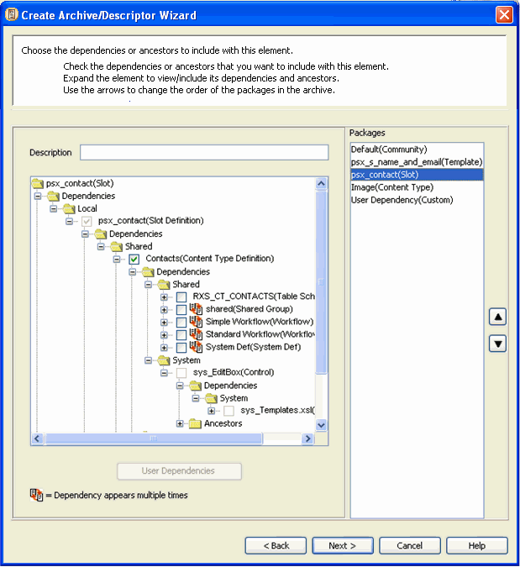

Figure 32: Create Archive/Descriptor Wizard

The Include Dependencies or Ancestors dialog displays each element that you have included in the descriptor under Packages. When you select an element under Packages, the dialog displays a tree of the dependencies for the element. A main node is included for each of the Dependency types (local, shared, server, system, user defined) present in the element list. Expand these nodes to see the dependency elements and their dependencies and ancestors. Each dependency may have any of the other dependency types, which are listed below it. Check boxes next to dependency and ancestor names indicate your options for including them in Packages:

- a checked, disabled check box indicates that you are including a dependency by default.
- an unchecked, disabled check box indicates that you cannot include a dependency, but it is required on the target server
- a checked or unchecked, enabled check box indicates that you may choose whether or not to include a dependency. If you do not include it, it should be present on the target server.
Each dependency type and ancestors are treated differently in the tree:

Dependency  Type | Description | Appearance in Dependency  Tree | Example
Local | Dependencies that make up the Package for an element and must be installed with it. | Checked, disabled check boxes. | For a Slot Package, the Slot definition is a local dependency .
Shared | Installable dependencies that are installed with CM System, must be present for an  element to function properly, but are  not a required part of its Package. They are “shared”  because they may  be dependencies of other Packages. | Unchecked, enabled check boxes (allow you to optionally include them in package). | A Content Type definition is a shared dependency of a Slot that uses it not because it is a part of the Slot’s Package, but  because the Slot requires it for proper functioning.
System | Elements that are installed with CM System and must be present on the target server  for a Package to function correctly, but cannot be installed by the Multi-Server Manager. System dependencies usually begin with the prefix sys_. | Unchecked, disabled check boxes. | The sys_EditBox control is a system dependency of  the Contacts Content Type application. It is a non-  installable element  installed with CM System that the application requires to function.

Dependency  Type | Description | Appearance in Dependency  Tree | Example
Server | Elements that are not installed with CM System but  must be present on the target server  for a Package to function correctly. They cannot be  installed by the  Multi-Server  Manager. | Unchecked, disabled check boxes. | A handler that you added to your CM System system and is required to process a CM System extension and a role are server dependencies.
User Defined | Files used by elements in a Package that the Multi-Server Manager does not discover, but the user specifies. | You can add User Defined dependencies to a Package or as an independent Package under User Dependencies. A User Dependency is only available if you added a custom User Dependency element in the Add Elements to the Archive dialog. | An implementer can include the extension PSImageInfoExtractor.java as a user dependency for the sys_File control since the extension is often used with the control but the Multi-Server Manager  does not automatically add it as a dependency.  If you include table data, the Multi-Server Manager installs all rows from the source table:   If the table does not have a primary key, the Multi-Server Manager inserts all source table rows into the target table.   If the table has a primary key, the Multi-Server Manager updates target table rows with matching source table rows, and inserts non- matching source table rows into the target table.

Dependency  Type | Description | Appearance in Dependency  Tree | Example
Ancestors | Elements outside a dependency’s Package that use the dependency.  The Multi-Server Manager cannot locate as ancestors server objects which have undefined ID Types. To locate all possible ancestors, you must specify ID Types for all elements on the server with literal identifiers | Enabled check boxes (allow you to optionally include them in package). | In a dependency tree for the Image Content Type definition, the Slots that allow the Image Content Type to appear in them are listed as Ancestors.

The Multi-Server Manager cross checks for dependencies within and between an archive’s packages. In the Include Dependencies or Ancestors dialog, dependencies that appear multiple times are preceded by the icon .

Checking or unchecking its check box in one location affects it in all locations. For example, in the following graphic, the RXS_CT_SHARED Table Schema appears as a checked shared dependency under both the Shared Group and the rxs_Support_ce application nodes. If you uncheck RXS_CT_SHARED below Shared Group, the node below rxs_Support_ce automatically becomes unchecked. (This is also true across packages; a dependency checked in one package is automatically checked in other packages.) During installation, the Multi-Server Manager verifies if it has already installed a dependency,and does
not install the dependency each time it finds it.

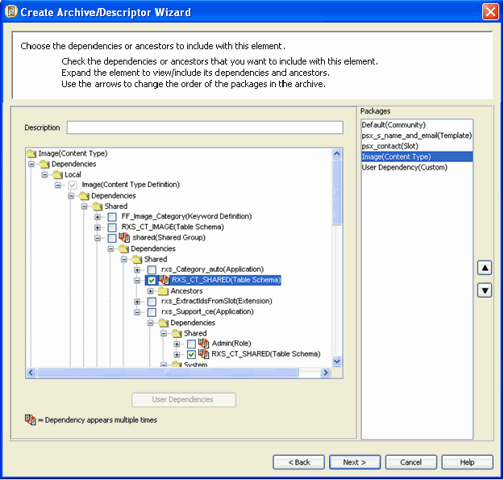

Figure 33: Dependency appearing multiple times

To complete the Include Element Dependencies or Ancestors dialog:

1 Click an element under Packages.

2 In Description, optionally enter a comment about the package that will display under the
Description heading in Packages View after the package is installed.

3 Fully expand the Dependency tree.
NOTE: Expanding ancestors may be slow due to the length of the search required.

4 Check the check boxes of any Shared Dependencies or Ancestors that you want to include in your descriptor.

5 If you check a shared Dependency that can stand alone as a Package Type, such as a workflow, a confirmation dialog pops up.
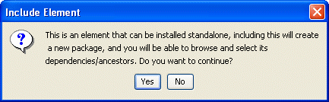
If you confirm adding the Dependency, Packages displays the new element name. When you click the new element under Packages, it displays a dependency tree for the element, and you can check optional dependencies. Dependencies do not appear under the element name in the original view. NOTE: The Multi-Server Manager orders the new dependency package before the "parent" package so that the parent can access the dependency after it installs. Do not move the new package after the "parent" package.

If you uncheck a shared Dependency that is a Package Type, the Wizard prompts you to confirm its removal, and removes it from the Packages list.

6 If you expand or check a Dependency that does not have ID Types defined, the Wizard displays an Identify ID Type dialog (see "Identify ID Types Dialog" on page 43). Specify the ID Types for the Dependency.

7 If you are in Custom archive creation mode and if user-defined Dependencies are supported by any of the dependencies in the tree, when you select the dependency, the [User
Dependencies] button becomes enabled. If you want to add user-defined Dependencies, click [User Dependencies]. The Wizard displays a file browser that lets you select files from the server root. After you select a file, the Wizard includes the user-defined dependency below the selected element wherever it appears in the Dependency tree.

8 Repeat steps 2 through 7 for all of the elements listed under Packages.

9 If you added a User Dependencies custom element in the Add Elements to the Archive dialog (see "Add Elements to the Archive" on page 63), Packages lists User Dependency (Custom). To add an independently installable user defined dependency (one that is not included in another Package), click User Dependency (Custom) under Packages.

Select the User Dependency (Custom) folder node and click the [User Dependencies] button to select a user-defined dependency from a file browser that displays the contents of the CM System root directory. After you select the file, it displays in the tree.
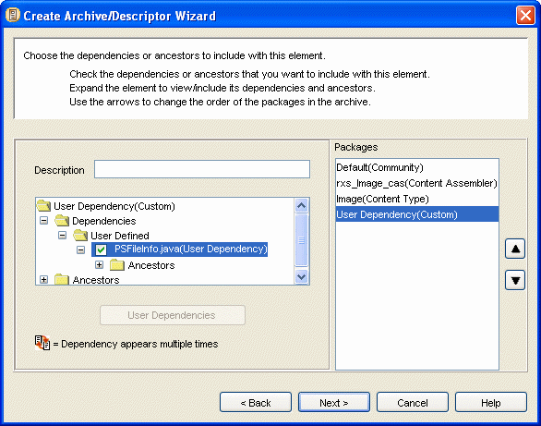

Figure 34: Adding a User Dependency

10 Click the arrows to the right of Packages to change the installation order of the elements in the descriptor. See Add elements to the archive (on page 63) for information about Package order.

11 Click [Next>>] to proceed to the Create Archive or Descriptor dialog (see "Create Archive or
Descriptor" on page 77).

Choosing User Dependencies

After you click the [User Dependencies] button in the Include Element Dependencies or Ancestors dialog, a User Dependencies dialog opens:

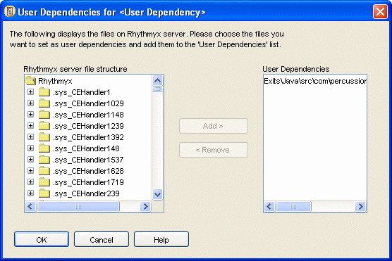

To add user dependencies:

Figure 35: User Dependencies dialog

1 In the file tree under CM System server file structure, navigate to a file that you want to add as user dependency.

2 Select the file.

The [Add] button becomes enabled.

3 Click [Add].

4 The User Dependencies box displays the file name.

5 Repeat steps 1 through 4 for each file that you want to add as a user dependency.

6 Click [OK].

The dialog closes and the Dependency Tree in the Include Element Dependencies or
Ancestors dialog displays the user dependencies that you have added.

Create Archive or Descriptor

The Create Archive or Descriptor dialog lets you create an archive, save the descriptor that you have created, or both. If you selected an existing descriptor in the Choose a Server and/or Descriptor dialog (see "Choose a Server and/or Descriptor" on page 61), the descriptor name appears in the Descriptor Name field.

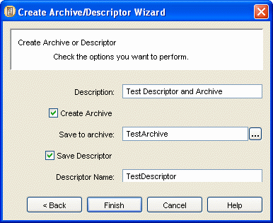

Figure 36: Create Archive/Descriptor Wizard, final dialog

To complete the Create Archive/Descriptor dialog:

1 In the Description field, optionally enter a description that will display under the Description heading in Descriptors View (on page 21) after you create the descriptor.

2 To create an archive, check the Create Archive check box.

The Wizard enables the Save to Archive field.

- Enter a name in the Save to Archive field.

3 To save the descriptor that you have created, check the Save Descriptor check box.

The Wizard enables the Descriptor Name field.

- Enter a name in the Descriptor Name field or leave the default name.

4 Click [Finish].

- If you have selected an existing descriptor name, the Wizard prompts you to confirm overwriting it.

- If you have selected an existing archive name, the Wizard prompts you to confirm overwriting it.

- If you have checked Save Descriptor, the Wizard saves the descriptor file on the source server and adds a Descriptor node to the Server Groups Tree in the Multi- Server Manager Window.

- If you have checked Create Archive, the Wizard displays the Archive Status dialog.
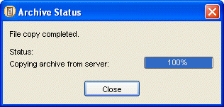

Figure 37: Archive Status dialog

The Multi-Server Manager creates the archive on the source server and then copies and saves it on the client (Multi-Server Manager machine). A progress bar tracks the creation of the archive on the source server and the copying of the archive onto the client. While the progress bars are active, you can click [Cancel].

After the archive is created, the Wizard changes the [Cancel] button to [Close]. Click
[Close] to close the Create Archive/Descriptor Wizard.

C H A P T E R 7

Installing an Archive

Installing an archive involves preparing a target server for installation, and then using the Install Archive Wizard to choose the packages on the archive that you want to install and sending them to the target server.

Preparing a Target Server for Deployment

Prior to running the Install Archive Wizard, confirm that your target server is ready for installation. Check that you have met all of the conditions in the following list before installing:

- the version and build of CM System used to create the archive are installed on the target server;
- dependencies that are required on the target server but are not being installed with the archive are present on the target server;
- users have been notified not to work off the target server during the time that you plan to install;
- you have backed up your target server and repository in case archive installation causes system errors or instability.

Publishing Lock During Installation

CM System does not let you perform a publishing run and install an archive at the same time:

- When CM System begins installing an archive, it locks the server so that you cannot begin a publishing run until archive installation is complete. If CM System cannot lock the server, it suspends archive installation and performs the publishing run, then lets you resume archive installation from the point where you left off in the Wizard.
- When CM System begins a publishing run, it locks the server so that you cannot begin installing an archive until the publishing run is complete. If CM System runs multiple publishing runs, it waits until the final one is complete to remove the lock from the server.
Use the following console commands to view and manage locks:

- dump resources - The results include a <ServerLocks> element which displays active locks as follows:
<ServerLocks>
<Lock id="0" locker="EnterpriseMgr:admin1" created="20030210
08:46:20">
<Resources>
<Resource>Publisher</Resource>
</Resources>
</Lock>
</ServerLocks>
- When there is no locked resource, the element is empty. Note that a single lock may be holding more than one resource, but currently the Publisher is the only server resource that may be locked.

- clear server lock <lockid> - Releases a lock. <lockid> is the Lock id listed in the dump resources command, above. Only use this command if a process terminates abnormally and does not release a lock.

Using the Install Archive Wizard

The Install Archive Wizard helps you install an archive on a target server. Before beginning the Wizard, register the target server with the Multi-Server Manager.

WARNING: Do not allow users to access your target server while you are running this Wizard; the server’s contents must remain static for the Wizard to function correctly.

Install Archive Wizard steps:

Step | Create Archive/Descriptor Wizard dialog
1. Choose archive and target server. | Select an Archive and Server dialog (on page 84)
2. Choose whether or not to modify mappings already specified for CM System elements and datasources. | Choose Installation Mode dialog (see "Select an  Archive and Server Dialog" on page 84)
3. Select packages from the archive to install. | Add Packages to Install dialog (see "Add Packages to Install" on page 86)
4. Modify or add element and datasource mappings | Transforms dialog (see "Transforms" on page 89).
5. Specify whether or not to install packages and dependencies that cause warnings. | Specify an Action for Warning dialog (see  "Specify Actions for Warnings" on page 95)
6. Review your installation selections and install them. | Summary dialog (see "Summary" on page 98)

Open the Wizard in one of the following ways:

- In the Multi-Server Manager Window, select Action > Install Archive in the Menu Bar.
- In the Descriptors View (on page 21), right-click a Descriptor row and select Install in the menu that appears. The Wizard displays the name of the last archive created using the Descriptor but you may change it.
- In the Archives View (on page 22), right-click an Archive row and select Re-install in the menu that appears. The Wizard requires you to install this archive on the same server as you installed it previously (it skips the first two dialogs).
Before opening the Install Archive Wizard, the Multi-Server Manager displays a dialog reminding you to back up your target server and repository.

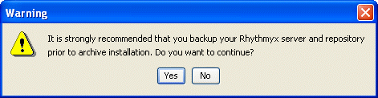

Figure 38: Backup warning

If you click [Yes], the Multi-Server Manager opens the first dialog of the Install Archive Wizard, which displays installation steps. (If you are installing from Archives View, the first dialog that opens is Choose Installation Mode (see "Select an Archive and Server Dialog" on page 84).)

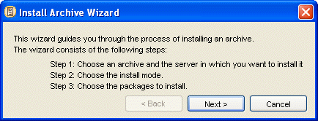

Figure 39: Install Archive Wizard, first dialog

Click [Next>>] to proceed to the Select an Archive and Server dialog (on page 84).

Select an Archive and Server Dialog

The Select an Archive and Server dialog lets you select an archive on the source server and the name of the target server. When it opens, it displays all registered servers as available target servers. Unconnected target servers are gray (disabled). If you select one of these servers, the Wizard prompts you to connect it.

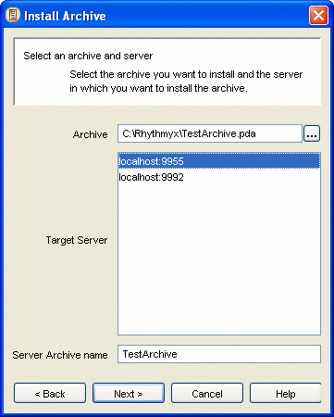

Figure 40: Install Archive Wizard, Select an Archive and Server Dialog

To complete the Select an Archive and Server dialog:

1 In Archive, enter the name of the archive on the client (Multi-Server Manager) that you want to install.

2 In Target Server, select a target server.

3 In Server Archive Name, enter a name for the archive on the target server. If you enter the name of an existing archive, the new archive overwrites the existing one.

4 Click [Next>>] to proceed to the Choose Installation Mode dialog (see "Select an Archive and Server Dialog" on page 84).

Choose Installation Mode Dialog

The Choose Installation Mode dialog prompts you to specify whether you want to proceed through the Wizard in Typical or Custom mode. Typical mode only takes you to the Transforms dialog (see "Transforms" on page 89) if mappings are not complete. Custom mode always takes you to the Transforms dialog to review and modify your mappings.

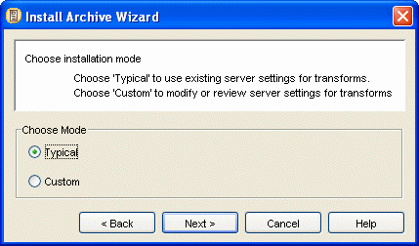

Figure 41: Install Archive Wizard, Choose Installation Mode Dialog

To complete the Choose Installation Mode dialog:

1 Choose Typical to proceed in the typical mode.

OR

Choose Custom to proceed in the custom mode.

2 Click [Next>>] to proceed to the Add Packages to Install dialog (see "Add Packages to
Install" on page 86) of the Wizard.

Add Packages to Install

The Select Packages to Install dialog lets you select the packages in the archive that you want to install on the target server. When the dialog opens, it displays all the archive’s packages under Available Packages, and the Packages to install list is empty. When you move packages from the Available Packages list to the Packages to install list, the packages remain in their original order (the order in which they are listed in the archive). Packages are installed on the target server in the order that they appear in the Packages to install list.

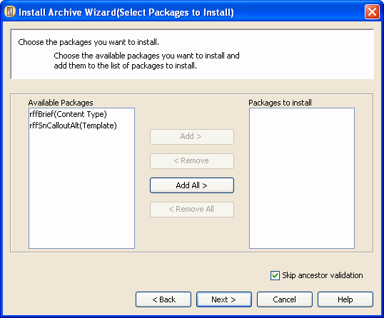

Figure 42: Select packages dialog

In Custom Mode, up and down arrows beside the Packages to Install list let users change the installation order of packages:

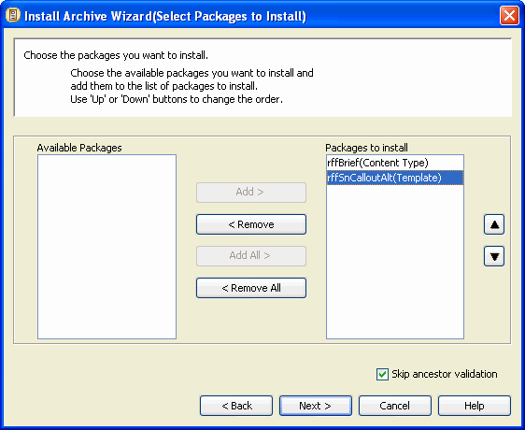

Figure 43: Custom Dialog, Add Packages to Install

To complete the Select Packages to Install dialog:

1 Move packages from the Available Packages list to the Packages to install list:

- To select a Package for installation, click the Package under Available Packages and click [Add >].

The package name moves from the Available Packages list to the Packages to install list.

- To select all Packages for installation, click [Add All >].

All package names move from the Available Packages list to the Packages to install list.

- To remove a Package from the Packages to install list, click the Package in the Packages to install list and click [< Remove].

The package name moves from the Packages to install list to the Available Packages list.

- To remove all Packages from the Packages to install list, click [< Remove All].

All package names move from the Packages to install list to the Available Packages list.

2 By default Skip ancestor validation is checked to increase the speed of installation. To indicate that the Wizard should perform ancestor validation prior to opening the Specify Actions for Warnings dialog (see "Specify Actions for Warnings" on page 95), uncheck Skip ancestor validation at the bottom of the Select Packages to Install dialog.

3 If you are in Custom Mode, you can change the order of the packages in the Packages to
install list if the existing order has caused installation to fail in the past or if you see a potential error in the installation order.

4 Click [Next >>] to move to the next dialog. If some of your elements are not mapped or you chose Custom installation mode, the Transforms dialog (see "Transforms" on page 89) is next. Otherwise, the Specify Actions for Warnings dialog (see "Specify Actions for Warnings" on page 95) is next.

Transforms

If you have not mapped all of your elements or you selected Custom installation mode, you must complete the Transforms dialog. The dialog that appears functions similarly to the Define Transforms dialog that you access from the Multi-Server Manager Window (see "Define Transforms for <Server:Port>" on page
47), but it displays a Packages section listing each Package and does not have buttons for adding, editing, and deleting mappings.

- If you selected Typical installation mode, this dialog initially displays only Packages that are missing datasource or element mappings, so that you can add them. Packages that are missing mappings have a red exclamation point beside them. As you create the mappings, the exclamation points disappear, but the Packages remain in the list.
- If you selected Custom installation mode, this dialog displays both Packages that are missing datasource or element mappings and Packages that have required datasource or element mappings so that you can both add and change them. Packages that are missing mappings have red exclamation points beside them until you create the mappings.
NOTE: If the objects in a package are not missing datasource or element mappings, the Datasource Maps tab or Elements Maps tab does not appear for the package. If none of the packages have elements or datasources to map, even if you choose Custom installation mode, the dialog does not appear.

For more about mapping (transforms) see Mapping Source and Target Datasources (on page 41) and
Mapping Source and Target CM System Elements (on page 40).

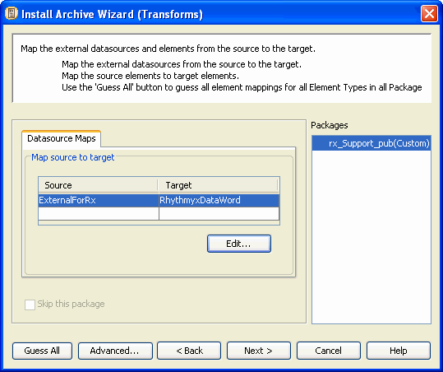

Figure 44: Install Archive Wizard (Transforms)

To complete the Datasource Maps tab of the Transforms dialog:

1 Click a Package under Packages.

The Multi-Server Manager lists all existing datasource mappings for the Package in the Map source to target table.

2 Each non-repository datasource used by an application in the package is listed in the Source
column, and the user may specify a Target datasource or check Skip this package (if available).

3 Check the Skip this Package check box to skip installation of this Package. This option is only available if the ID mappings on a package are incomplete. You may use this option if you do not know how to map the source and target datasources; if you do not check it, the Wizard requires you to map all of the datasources. If the ID Mappings on the package are complete, you cannot skip it. When you complete the ID mappings for a package, this option is disabled.

4 Click [Advanced] to go to the Advanced Transforms dialog (see "Advanced Transforms" on page 93). In this dialog, remove mappings that the archive does not use and add the datasources to mappings that the archive uses.

5 Click the Element Maps tab to create or edit element mappings.
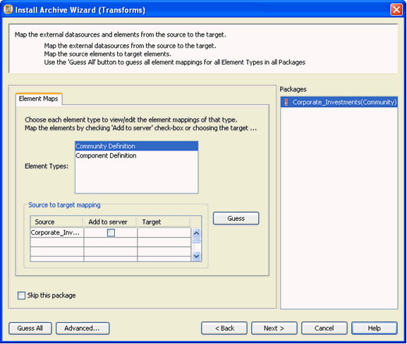

Figure 45: Element Mapping

To complete the Element Maps tab of the Transforms dialog by having the Multi-Server Manager create mappings for you:

1 Click [Guess All].

The Multi-Server Manager creates mappings for all elements within all element types. You only have to click [Guess All] once.

The Multi-Server Manager searches for matches for unmapped source elements on the target server by searching on name. If it finds multiple matches by name, it searches for a matching ID. If it finds a matching ID, then it selects the element with the matching name and matching ID. If it does not find a matching ID, it selects the first element with a matching name that it found. The Multi-Server Manager lists the matching target element in the Target field. If it does not find a target element match, it checks the Add to server check box.
To complete the Element Maps tab of the Transforms dialog by manually creating mappings and/or having the Multi-Server Manager create mappings for all elements within Element Types:

1 Click a Package under Packages.

2 Click an Element Type.

The Multi-Server Manager displays elements of that type in the Source column. For elements that you have already mapped, it displays the complete mapping in the table. For elements that you have not yet mapped, it displays the Add to server check box as unchecked and the Target fields as empty.

3 Click [Guess] for the Multi-Server Manager to search for matches for unmapped source elements on the target server by searching on name. If it finds multiple matches by name, it searches for a matching ID. If it finds a matching ID, then it selects the element with the matching name and matching ID. If it does not find a matching ID, it selects the first element with a matching name that it found. The Multi-Server Manager lists the matching target element in the Target field. If it does not find a target element match, it checks the Add to server check box.

4 To manually map source and target elements:

- Click the Target field to access a drop list. If an appropriate target element exists in the Target drop list for the source element, select the target element in the drop list.

NOTE: You are mapping the identifiers (ID numbers), not the names. The names are included for reference.

OR

- Check the Add to server check box to add the source element to the target (and automatically map the source identifier to the target identifier).

5 If you are using Typical installation mode, select all the entries under Packages, and check all of them for unmapped elements.

6 If you cannot determine how to map an element, you may check the Skip this Package check box to not install the package; if you do not check it, the Wizard requires you to map the elements.

7 Click [Advanced] to go to the Advanced Transforms dialog (see "Advanced Transforms" on page 93). In this dialog, remove elements from mappings that the archive does not use and add them to mappings that the archive uses.

8 Click [Next] to proceed to the Specify Action for Warnings (Dependency Validation) dialog
(see "Specify Actions for Warnings" on page 95).

Advanced Transforms

The Advanced Transforms dialog shows you incomplete mappings required by the archive and additional complete mappings between the source server and target server. This lets you change element and datasource mappings between the source and target server other than those used in the archive. This is useful if you need to access a target element or datasource that is already being used by another mapping.

For example, the following graphic shows an archive that is installing the rffCategory and rffCalendar Content Types from the source server to the target server. The dialog also displays the rffBrief to Press Release mapping that has been created between the source and target servers although the archive does not use the mapping. If the user wants to map the rffCategory Content Type to the Press Release Content Type, in this dialog, the user can Delete the rffBrief to Press Release mapping, and then map the rffCategory Content Type on the source server to the Press Release Content Type on the target server.

If datasource mappings are defined for the archive, a Datasource Maps tab appears as well.

To map a previously mapped target element to one of an archive's source elements:
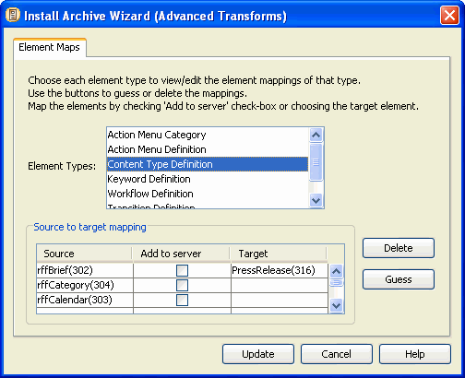

1 In the Install Archive Wizard's Transforms dialog, click [Advanced] The Advanced Transforms dialog opens.
2 Select the Element Type that includes a mapping that you want to change.

Note that the previously mapped target server element is not available in the list of target elements to map to the source element.
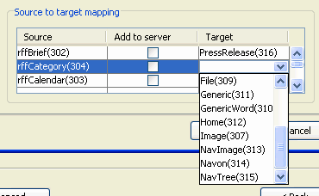

Figure 46: List of available elements

3 Select the mapping that is not used by the archive (rffBrief to Press Release in the example).
Delete the mapping or change the target element.

Now the target element is available to be mapped to the source element.
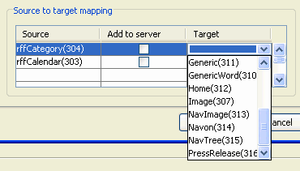

Figure 47: Drop list with element available

4 Map the target element to the source element.

5 Click [Update].

Multi-Server Manager updates the mapping and returns to the Transforms dialog.

Specify Actions for Warnings

Before the Wizard opens the Specify Actions for Warnings dialog, it validates dependencies by checking for the presence of required and optional dependencies in the Packages and on the target server. The Wizard displays a progress bar for validation.

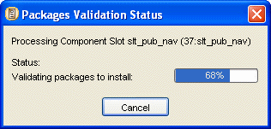

Figure 48: Package Validation Status Bar

When validation is complete, the dialog closes, and the Specify Actions for Warnings dialog opens. For each finding, it displays a warning message if the finding is not fatal and an error message if the finding is fatal. If a package validation does not result in a warning or error, it is not listed under Packages.

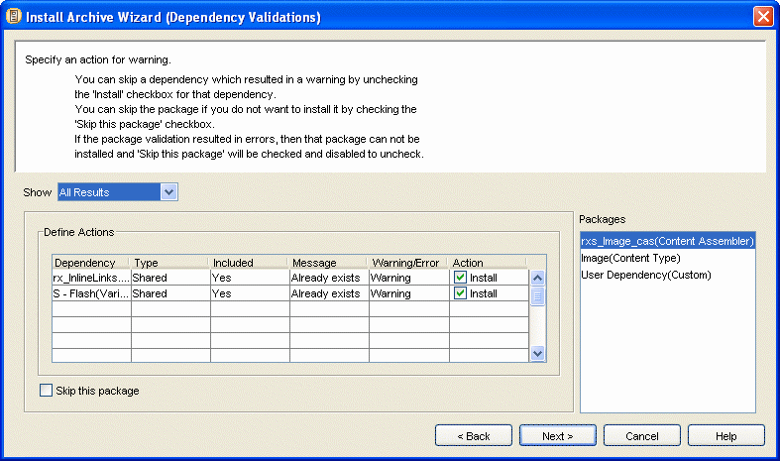

Figure 49: Install Archive Wizard, Dependency Validations Dialog

The Specify Actions for Warnings dialog includes a Show drop list that lets you choose the types of warnings and errors that you want to display.

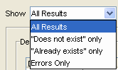

The Show options are:

Figure 50: Show drop list

- All Results - shows all warnings and errors;
- "Does not exist" only - shows only warnings and errors that indicate missing dependencies;
- "Already exists" only - shows only warnings that indicate that a dependency will be overwritten;
- Errors only - shows errors, but not warnings.
The Packages list only displays packages that have warnings or errors included in the Show option. If changing the Show option results in no Packages with errors or warnings, the dialog displays There are no messages to display.

Select each package to see the warnings or errors for it in the Define Actions table. The table displays the following:

Dependency - Dependency name;

Type - Dependency Type;

Included - Whether or not the dependency is included in the Package;

Message - Error or warning message;

Warning/Error - Whether the result is a warning or an error;

Action - Whether or not to install the Dependency (Included reflects this choice).

If validation results in any errors, you cannot install the Package. If validation results in warnings but not errors, you can choose whether or not to install the Package. If validation results in warnings or errors and includes optional dependencies, you can choose whether or not to install each optional dependency.

To complete the Specify an Action for Warning dialog:

1 Choose a Show option.

2 Under Packages, select a Package.

3 If the Skip this Package check box is enabled (because the Package has validation warnings but does not have validation errors, or because the ID mappings for the package are incomplete) check Skip this Package if you do not want to install the Package. If you want to install it, leave Skip this Package unchecked.

4 If any optional dependencies have an Install check box in the Action column (because the package has validation errors or warnings) check Install to install the dependency. Uncheck Install to skip installation of the dependency.

5 Complete steps 2 through 4 for all Packages.

6 Click [Back] to attempt to rectify the cause of warnings, errors, or validation results.

7 Choose another Show option, or click [Next>>] to continue to the Summary dialog (see
"Summary" on page 98).

If you have chosen to install packages or dependencies with warnings, the Wizard prompts you to confirm continuing.
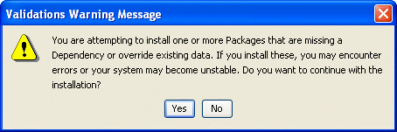

Figure 51: Validations Warning Message

8 Click [Yes] to continue to the Summary dialog (see "Summary" on page 98). Click [No] to continuing editing in the Specify Actions for Warnings dialog.

Summary

The Summary dialog displays your installation selections and lets you complete your archive installation. The Packages to Install list displays the Packages you have selected for installation. The Warnings and Actions table displays the actions you have selected for dependencies with warnings. The Ancestors that will be affected by Installation list displays ancestors that you have not selected for installation, but are affected by your dependencies.

The Summary dialog includes a Show drop list that lets you choose the types of errors and warnings that you want to display in the Warnings and Actions table.

The Show options are:

Figure 52: Show drop list

- All Results - shows all warnings and errors;
- "Does not exist" only - shows only warnings and errors that indicate missing dependencies;
- "Already exists" only - shows only warnings that indicate that a dependency will be overwritten;
- Errors only - shows errors, but not warnings.
Unlike the Packages list in the Specify Actions for Warnings dialog, the Packages to install list in the
Summary dialog displays all Packages whether or not they meet the criteria of the Show option.

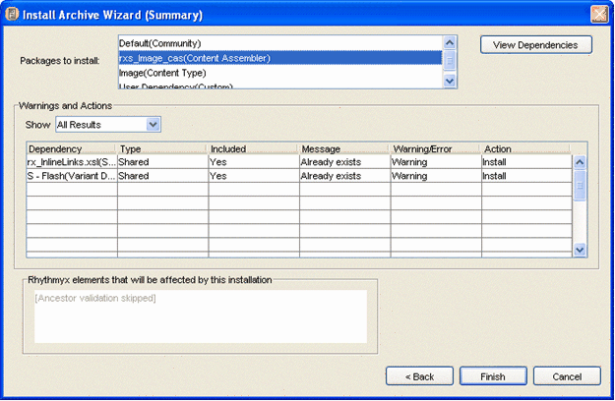

Figure 53: Install Archive Wizard, Summary Dialog

To complete the Summary dialog:

1 Choose a Show option.

2 Review the Packages to Install, Warnings and Actions, and Ancestors sections to make sure that you have made the correct selections. If you checked Skip ancestor validation in the Add Packages to Install dialog (see "Add Packages to Install" on page 86) the Ancestors section (CM System elements that will be affected by this installation) displays Ancestor validation skipped. Normally if a dependency being installed already exists on the target server, any ancestors not also being installed are listed here as being affected by the installation

3 Select a package in the Packages to Install list and click the [View Dependencies] button to view its dependency tree.

4 Click [Finish] to install the archive

OR

Click [Back] to attempt to rectify the cause of warnings or errors

OR

Click [Cancel] to cancel installation and exit the Wizard.

If you click [Finish], the Wizard displays an installation confirmation dialog.
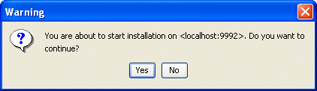

Figure 54: Installation Confirmation Dialog

5 Click [Yes] to install. The Wizard begins to install the archive on the target server and displays the Install Status dialog.
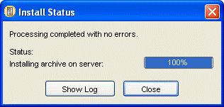

Figure 55: A completed installation

The dialog lists the current installation action. The Status bar displays the progress of archive installation.

You can click [Cancel] at any time during installation to cancel. Warning: Canceling an installation in progress may leave your server in an unstable state.

6 When the installation is complete, the Wizard enables the [Show Log] button. Click the
[Show Log] button to view the archive installation log (see "Reviewing Archives" on page
101).

When the Multi-Server Manager finishes installing the archive’s contents on the target server, it adds Archive and Package nodes to the Server Groups Tree in the Multi-Server Manager Window.

Installation is now complete. After you restart the target server and open CM System you should be able to view the changes to your content editors, Templates, Workbench applications and other CM System elements.

Reviewing Archives

After installing an archive, you should review its Archive Summary to make sure that your Packages installed successfully. Determine if the dependencies and mappings of Packages installed correctly by checking their package logs.

To access the Archive Summary dialog:

- In the Multi-Server Manager, select the Archives node of the target server in the Server Groups Tree to display the Archives View (on page 22) in the Details Pane. Locate the archive that you want to review and double-click it.
OR
- From the Install Status dialog (see "Summary" on page 98) (the dialog that the Archive Installation Wizard displays during installation), click [View Log].
The Multi-Server Manager displays the Archive Summary dialog with the Package Logs tab selected.
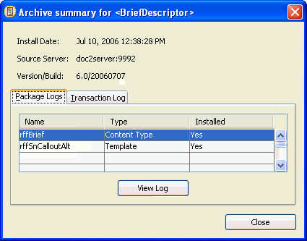

Figure 56: Archive Summary dialog

In addition to the archive name, the installation date, the source server, and the CM System version and build, the Archive Summary displays the name and Package Type of each Package in the archive and lists its installation status. Successfully installed packages are listed in installation order. The possible values for Installed are:

- Yes - Multi-Server Manager successfully installed package.
- No - Multi-Server Manager did not attempt to install package. Either it skipped the package or did not install it because failure of an earlier package caused installation to stop.
- Failed - Multi-Server Manager attempted to install package, but failed.
Select a package and click the [View Log] button to display the package log. (Packages with an Installed value of No do not have package logs.)

Click the Transaction Log tab to view the installation actions for all of the packages in the archive. For each element installed for each package, the Transaction Log tab displays the element’s package, the element's dependency, the element name, the element type, and the installation action.

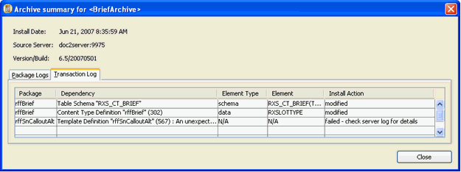

The possible Actions are:

Figure 57: Transaction Log

- created - the Multi-Server Manager inserted a file or a table, or inserted new data into a table;
- modified - the Multi-Server Manager updated a file or rows in a table;
- deleted - the Multi-Server Manager deleted content in the database before inserting new content. The element is listed again in the table with a created action;
- skipped - installed in previous package. This dependency was listed in multiple packages. It was installed in a previous package, but is listed here because it also was included in this package.
- failed - the Multi-Server Manager did not install the package because the installation attempt resulted in an error.

Reviewing Installed Packages

Review the installation details of each installed Package by viewing its package log. The package log shows the dependencies installed, transforms (datasource and element mappings), dependency validation warnings, and the installation actions on each element in a package.

You can access the package log through the Archive Summary dialog (see "Reviewing Archives" on page
101) or the Packages View (on page 24) of the Multi-Server Manager Window Details Pane.

- To access the package log through the Archive Summary dialog, select a Package and click [View Log].
- To access the package log through the Packages view, double-click a package row.
You can export or save a package log from Packages View or the Package Log dialog.

- To export a package log from Packages View, click the package, and select Export. The Multi-Server Manager displays a File Browser window for saving the package log to file.
- To export a package log from the Package Log dialog, click the [Export] button. The dialog displays a File Browser window for saving the package log to file.
The Package Log dialog has four tabs:

Main (see "Package Log Main Tab" on page 104)

Transforms (see "Package Log Transforms Tab" on page 105)

Informed Warnings (see "Package Log Informed Warnings Tab" on page 106)

Transaction Log (see "Package Log Transaction Log Tab" on page 107)

Package Log Main Tab

The Main tab of the Package Log displays the Package Type, archive name, installation date, source server, CM System version and build, and a read-only dependencies tree. Click the [Export] button to save the log to a file.

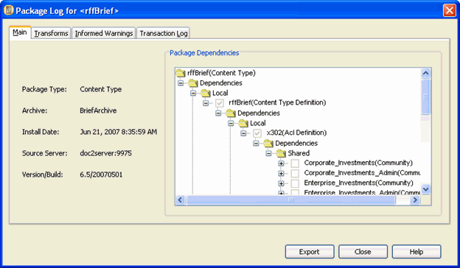

Figure 58: Package Log, Main Tab

Package Log Transforms Tab

The Transforms tab displays the transform maps (element and non-default datasource mappings) as they appeared at the time this package was installed. Click the [Export] button to save the log to a file.

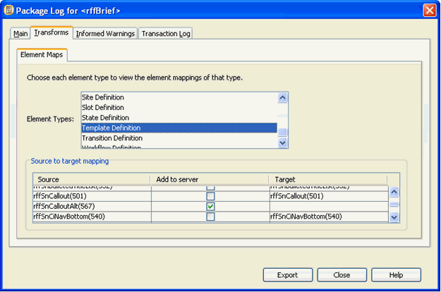

Figure 59: Package Log, Transforms Tab

This tab does not appear if the package has no mappings.

Package Log Informed Warnings Tab

The Informed Warnings tab displays the validations, warnings, and the corresponding actions taken for the dependencies of this package. Click the [Export] button to save the log to a file.

This tab does not appear if the package has no warnings.

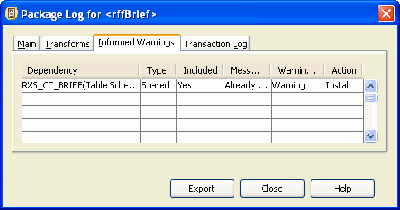

Package Log Transaction Log Tab

For each element installed for each dependency in the package, the Transaction Log tab displays the element’s dependency, the element name, the element type, and the installation action.

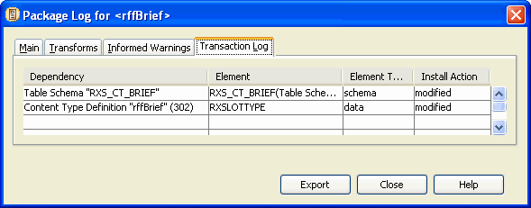

The possible Actions are:

Figure 60: Package Log, Transaction Tab

- created - the Multi-Server Manager inserted a file or a table, or inserted new data into a table;
- modified - the Multi-Server Manager updated a file or rows in a table;
- deleted - the Multi-Server Manager deleted content in the database before inserting new content. The element is listed again in the table with a created action;
- skipped - installed in previous package. This dependency was listed in multiple packages. It was installed in a previous package, but is listed here because it also was included in this package
- failed - the Multi-Server Manager did not install the package because the installation attempt resulted in an error..
Click the [Export] button to save the log to a file.

You can also view a single log of all archive transactions (see "Reviewing Archives" on page 101).

Archiving an Entire CM System System

The following procedure breaks down the steps required for installing everything on a test server to a production server. Follow this procedure to initially install CM System from a test server to a production server.

1 Alert CM System developers and administrators not to make changes on the source server, including the Workbench, Server Administrator and browser interface during the time that you plan to create your archive.

2 Use the Identify ID Types dialog to identify all ID Types on the source server.

3 Use the Define Transforms dialog to define transforms (mappings) between the source and target servers.

4 To simplify the process, create separate archives for each Package Type in the following list:

a) Custom elements, if they exist.

b) Table schemas or data. For tables that are managed by content editors, package the table schemas. For tables that hold manually entered data, package the table data. In the Add Elements to the Archive dialog (see "Add Elements to the Archive" on page 63), table schemas and data are listed under Custom Elements. NOTE: You may also package the table schemas as dependencies of Content Types and Content Assemblers.

c) All Workflows and custom Workflow actions that appear as dependencies. The Multi- Server Manager cannot detect if properties files in your CM System directory are dependencies of Workflow actions. Include any properties files that are dependencies as User Dependencies.

d) All Content Types, all of their local dependencies, and optionally, all of their shared dependencies including table schemas.

e) All Slots and only their Template Definition dependencies.

f) All Content Assemblers, all of their local dependencies except Content Types, Slots, and
Table Schemas, and optionally, all of their shared dependencies. g) Site or Content List elements.
h) Components that have been modified or are new than the target server, all of their local dependencies, and optionally, all of their shared dependencies. If you are installing more than 20 components, install them using multiple archives.

i) All communities. When you include each community in the Add Elements to the Archive dialog (see "Add Elements to the Archive" on page 63), choose Community Definition.
Do not package the Entire Community. Do not package any dependencies of the community.

j) Content Views k) Action Menus
l) Relationship Definitions m) Display Formats

n) Locales o) Folders
p) Item Filters q) Folder Trees r) Searches
s) Templates and Variants

t) Keywords (as stand alone Packages)

u) Contexts (as stand alone Packages)

v) Any content that is required to be installed on the target server. If you are installing to a production server, content should be limited to a few items, if any, and may include items necessary for building site navigation. Only include related content if necessary.

5 Prepare the target server for archive installation.

a) Configure source server security components on the target server. These components include security providers, roles, role subjects, and the server ACL.

b) Map target and server datasources if your applications reference non-CM System repository datasources.

c) Add any source server custom JAR files to the CLASSPATH of the target server. d) Add any source server custom Request Handlers to the target server.
e) Add any source repository custom database objects other than table schemas to the target repository. NOTE: This step may require custom table schemas to be present on the target server. In this case, complete this step after installing the table schema archive.

f) If you are installing to a production server, alert content contributors that the production server will be unavailable during the time you have scheduled for archive installation and post-installation testing.

g) Alert CM System developers and administrators not to make changes on the target server, including the Workbench, Server Administrator and browser interface during the time that you plan to create your archive. (If the target server is a staging or production server, development work should only involve elements that the Multi-Server Manager does not handle.)

6 Install the archive.

a) Start the Multi-Server Manager. b) Register the target server.
c) Install the archives in the order you created them in Step 2 and install any views (step iii, below).

i) Custom Elements

ii) Table Schema and Table Data

iii) Any views used by the element types that follow. You cannot install views with the
Multi-Server Manager, but must use a SQL script.

iv) Workflows

v) Content Types vi) Slots
vii) Content Assemblers viii) Sites or Content Lists ix) Components
x) Communities xi) Content Views xii) Action Menus
xiii) Relationship Definitions xiv) Locales
xv) Folders xvi) Content
xvii) Keywords (as stand alone Packages)

xviii) Contexts (as stand alone Packages)

7 Flush the server cache or restart the target server.

8 Modify transition notifications for custom cc lists to notify the correct target server users.

9 Set up or modify Publisher information to reflect the target server’s Publisher.

10 Perform QA testing on the target server.

C H A P T E R 8

Multi-Server Manager

Best Practices

1 Always back up your target CM System repository and file tree before installing with the Multi-Server Manager. Use standard RDBMS and file tree back up procedures in conjunction with source control. Multi-Server Manager installation is not a replacement for backup or source control.

2 Before attempting to install an archive, verify that all required security providers, and
database credentials are present and properly configured on the target server. Installation does not proceed if any of these elements are missing and may result in errors if they are not properly configured.

3 Remove source test data that you do not need to install (for example, content and workflow transition notification cc lists) before creating archives. Removing excess data helps prevent packaging of unnecessary elements and lengthy processing.

4 Acquire some CM System development experience and understand each CM System element and its relationship to its dependencies.

5 Create some test archives (see "Simple Example: Adding a New Field to a Content Editor" on page 115) and install them on test or development servers.

6 If you develop the CM System applications that the Multi-Server Manager moves from a target to source server either create the archives or thoroughly document names and functions of the applications and their dependencies, so that administrators can easily create archives.

7 Use naming conventions for descriptors and archives so that CM System developers or administrators who did not create them may easily reuse them.

8 Order the Packages in an archive so that dependencies install before the elements that require them. For example, if a Content Type uses a certain workflow, install the workflow first. The Multi-Server Manager attempts to order packages in this manner, but review the order in the Create Archive/Descriptor Wizard and make any necessary changes.

9 You can reduce processing time by including shared dependencies once per archive; however, if you choose to do this confirm that you have packaged the most current version of the shared dependency at least once.

10 The Multi-Server Manager does not lock the server against updates during installation. Alert content contributors and CM System administrators not to update the repository and perform registry changes while you are installing, and if possible, schedule installation at a time when these activities are minimal.

11 Modify staging and production servers with the Multi-Server Manager. Only modify elements manually if the Multi-Server Manager does not install the elements requiring modification.
See the limitations described in How Multi-Server Manager Installation Works (on page 10)
for elements that the Multi-Server Manager does not install.

12 Use the ID Types dialog against the entire source server to save time during archive creation.
The Create Archive/Descriptor Wizard locates CM System elements added to the source server after identifying types or not identified initially and prompts you for ID Type identification if necessary.

13 Use the Define Transforms dialog to create source/target mappings to save time during archive installation. The Install Archive Wizard locates CM System elements added to the source server after defining transforms and prompts you to create mappings if necessary.

The Development Environment

To ensure that your target server remains stable when you install elements from an archive, implement the recommended backup procedures, multi-tiered development environment, and security mechanisms.

System backup allows you to retrieve a recent working edition of your CM System system if archive installation causes target server instability.

- Regularly perform backup of your CM System filesystem and RDBMS.
- Depending on the size and required availability of your system, implement other disaster recovery mechanisms.
A multi-tiered development environment helps prevent archive installation from causing target server performance problems.

- Test servers let you test the effects of the installation process and the installed elements so that you can eliminate problems before installing to a production server.
- Hot standby servers provide instant backup to target servers if installation does cause failures.
- Firewalls prevent Multi-Server Manager users from accidentally installing to an insecure location.
To further avoid installation-related target server instability, only assign Administrator roles to users with an understanding of your development environment and your CM System system. Only users in Administrator roles can access the Multi-Server Manager.

Selecting an Archive Structure

Before you begin creating an archive with the Multi-Server Manager, plan the scope of the archive using the following guidelines. If elements that you want to install do not fit into the structure of the archive you have chosen, you should probably include them in a separate archive. For example, rather than packaging the elements for a community and the elements for a CM System enhancement into one archive, package them into two separate archives.

Archive Structure | Description
Entire CM System System | Archive everything possible in the CM System System. This is recommended for initial installations to a production server. See Archiving an Entire CM System System (on page 108).
Minor Changes | Archive test server elements necessary for applying a bug fix or adding an enhancement, or archive production server elements to perform debugging or development. The Simple Example (see "Simple Example: Adding a New Field to a Content Editor" on page 115) is structured as a minor change.
Site | Archive all elements required for a site to function, but no additional elements. Use this if your development environment is site-centric (if you develop for individual sites) or if you have different production servers for different sites.
Community | Archive all elements required for a community to function, but no additional elements. Use if your development environment is community-centric (if you develop for individual communities).

C H A P T E R 9

Simple Example: Adding a New

Field to a Content Editor

In this example, an implementer has CM System installed on a development server and a test server. The implementer adds a new field to the Brief Content Editor on the development server and creates a new Template that displays the field. Then the implementer installs the changed Brief Content Type and the new Template on the test server.

The Brief Content Editor in this example is included in the FastForward sample implementation. Initially, the Brief Content Editor on the source development server appears as:
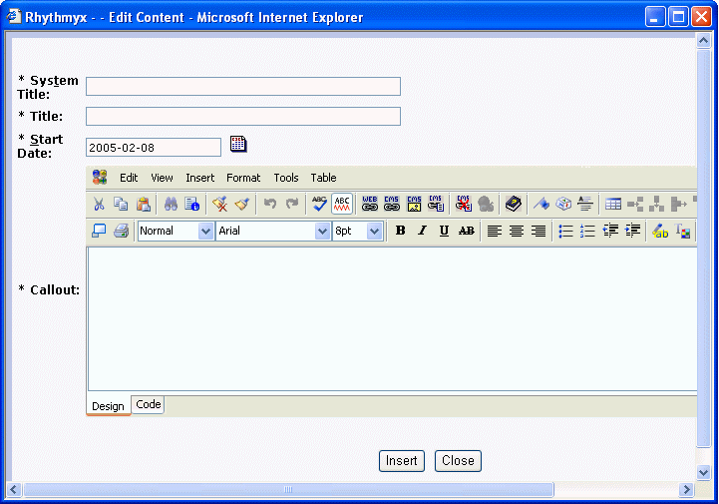

Figure 61: Original Brief Content Editor on source server

The Brief Content Editor is exactly the same on the target test server:

Figure 62: Original Brief Content Editor on source server

The implementer adds the Topic field to the Brief Content Type on the development (source) server, so that now the Brief Content Editor appears as:

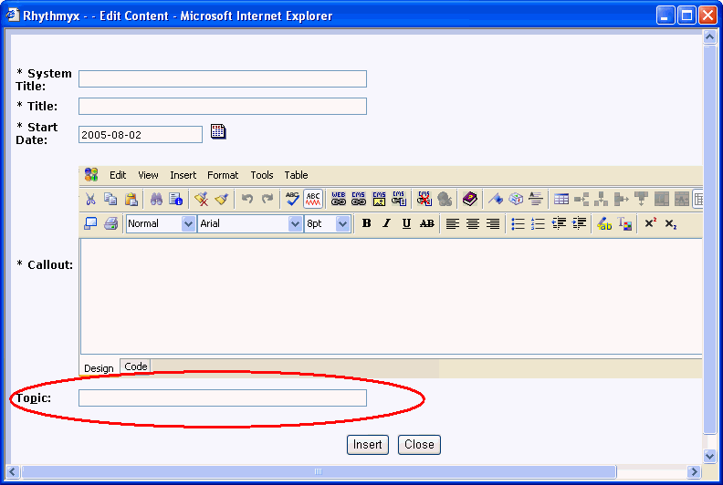

Figure 63: Brief Content Editor with Topic field added on Source Server

In the Workbench, the implementer creates a new Template that is local to the Brief Content type, named rffSnCalloutAlt, and with the display label S - CalloutAlt, to display the new Topic field.

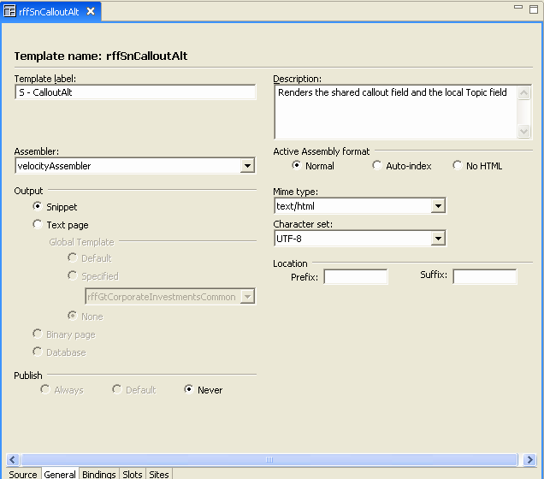

Figure 64: S - CalloutAlt Template

The S - CalloutAlt Template now appears in Preview choices for Brief Content Items in Content Explorer.

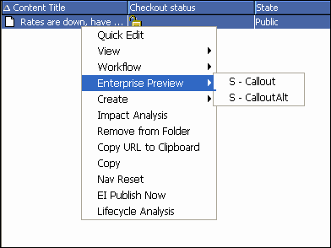

Figure 65: Option for S - CalloutAlt Template

Simple Example: Setting Up the Source and

Target Servers

You install this new version of the Brief Content Type on the test (target) server using the following steps:

1 Start the CM System source (development) server and the Multi-Server Manager. Start the Multi-Server Manager using the <Rhythmyx Root>/RhythmyxMultiServerManager.exe file.

In this example, the source (development) server is already registered but the target (test)
server is not.
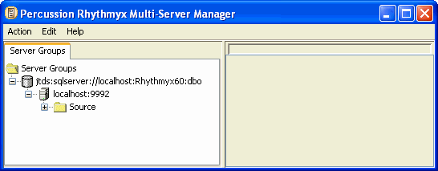

Figure 66: Source Server

2 To register the target (test) server, select Action > Register Server.

The Multi-Server Manager displays the Edit/New Rhythmyx Server Registration dialog.
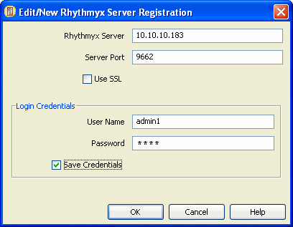

Figure 67: Registration of target host

3 In the Edit/New Rhythmyx Server Registration dialog, enter the target (test) server name and port in Rhythmyx Server and Server Port, and enter the login in name and password in User Name and Password. Leave Use SSL unchecked since you are not using a secure connection. Check Save Credentials so that you do not have to reenter them each time you connect to the server. Click [OK].

The Multi-Server Manager displays the Enter Repository Alias dialog.

Figure 68: Enter Repository Alias Dialog

4 Leave the default repository Alias Name or enter a new one and click [OK].
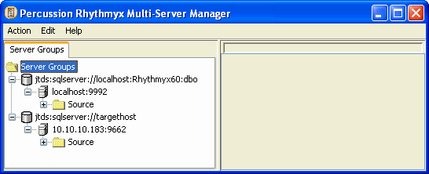

Figure 69: Server Group Tree after target server is added

5 In this example, the implementer has previously identified ID Types on the source (development) server. (To identify ID Types select the Target Server node and choose Edit > Identify ID Types. This action opens the Identify ID Types dialog (on page 43).) When you enter the Create Archive/Descriptor Wizard, you can identify new ID Types (such as the new Template S - CalloutAlt) that have been added to the source (development) server since the implementer identified them.

6 In this example, datasource mappings and CM System element mappings between the source and target server have not been previously added. To map datasources and CM System elements on the source and target servers, select the source server and choose Edit > Define Transforms.

The Multi-Server Manager displays the Define Transforms dialog.
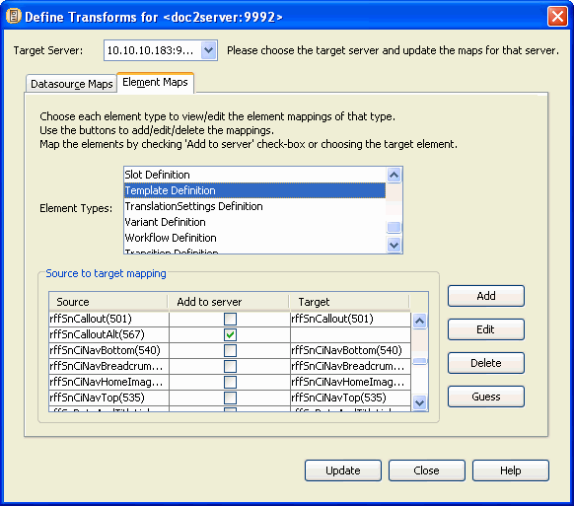

Figure 70: Defining Transforms

7 Select the target (test) server in the Target Server drop list. None of the applications on your source server have a non-default datasource specified (none of your applications access tables in repositories other than your CM System repository). In most cases, your CM System applications will not have non-default datasources specified. Click the Element Maps tab.

In the Element Maps tab, select each Element Type to display all elements of that type under Source and click [Guess]. The Multi-Server Manager looks for matches on the target server and displays them under Target. If it does not find a match, it checks the Add to server check box to indicate that the Multi-Server Manager should copy the source element to the target server.

In the example graphic above, the Add to server check box for the rffSnCalloutAlt Template is checked because no match for the element exists on the target server. The other Templates have matches because they exist on both the source and target servers.

Click [Update] to save the mappings and [Close] to close the Define Transforms dialog.

You have now set up the source and target servers and are ready to create an archive.

Simple Example: Creating an Archive

To create the archive for installing the new Brief Content Editor and S - CalloutAlt Template to the target test server:

1 Notify users not to work on the source (development) server while you are creating the archive

2 Choose Action > Create Archive.

The Multi-Server Manager opens the Create Archive/Descriptor Wizard.

3 Click [Next].

Figure 71: Create Archive/Descriptor Wizard

The Multi-Server Manager displays the Choose a Server and/or Descriptor dialog of the
Wizard.
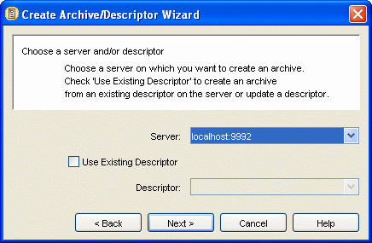

Figure 72: Server on which to create archive

4 In the Server drop list, choose the source (development) server. Do not check the Use Existing
Descriptor check box; you will create a new descriptor. Click [Next].

The Multi-Server Manager displays the Choose Create Mode dialog of the Wizard.

Figure 73: Create Archive/Descriptor Wizard, Choose Create Mode

If you choose Typical mode, the Wizard only displays unspecified source server ID Types for you to identify. If you choose Custom, the Wizard displays all source server ID Types for you to modify and review. In this example, you want to specify ID Types for new elements but
not modify or review existing ID Type settings. Choose Typical and click [Next].

The Multi-Server Manager displays the Add Elements to the Archive dialog of the Wizard.
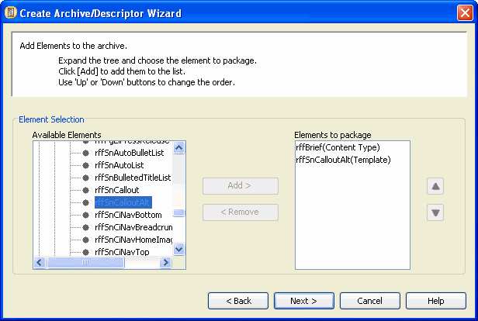

Figure 74: Add Elements to the Archive dialog

5 The elements that you want to install on the target server are the modified Brief Content Type and the new S - CalloutAlt Template for the Brief content type. Move these elements from Available Elements to Elements to Package.

Expand the Content Type folder in the Available Elements tree, choose Brief, and click [Add].
Brief(Content Type) appears in the Elements to package list. Expand the Template folder in the Available Elements tree, choose rffSnCalloutAlt, and click [Add]. rffSnCalloutAlt appears in the Elements to package list.

Click [Next].

The Multi-Server Manager displays the Choose the Dependencies or Ancestors dialog of the
Wizard.
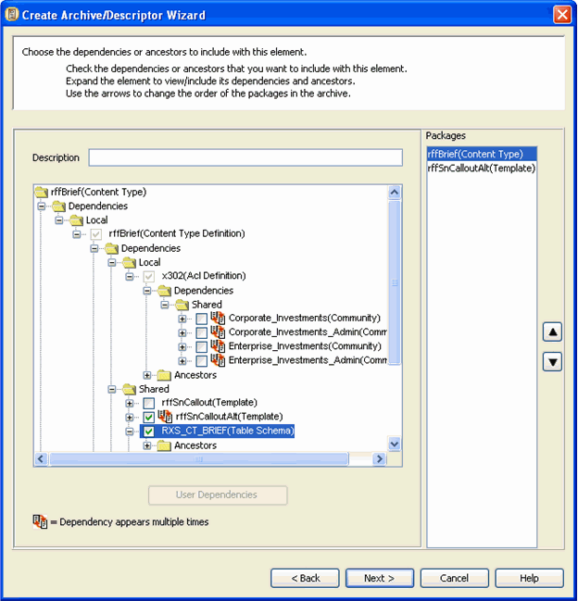

Figure 75: Choose the dependencies or ancestors dialog

6 The Brief Content Editor has a new field; therefore, the RXS_CT_BRIEF table schema has changed (it has a new column). You must include the RXS_CT_BRIEF table schema as a dependency to install on the target server because the Content Type Package Type does not automatically include table schemas. Select rffBrief(Content Type) under Packages and expand the tree until you can see the contents of the Shared node. Check the RXS_CT_BRIEF(Table Schema) check box to include the RXS_CT_BRIEF table schema as a dependency of the Brief Content Type.

You may enter a Description for each package. It will appear in Packages View (on page 24)
after you install the package on the target server. Click [Next].
The Multi-Server Manager displays the Create Archive or Descriptor dialog of the Wizard.
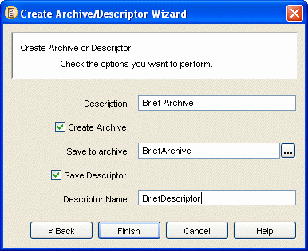

Figure 76: Archive and descriptor name choices

7 In this example, you will create both an archive and a descriptor.

In Description, enter the description of the descriptor that you want to appear in Descriptors View (on page 21). Check Create Archive and enter a name for the archive. Check Save Descriptor and enter a name for the descriptor.

Click [Finish].

The Multi-Server Manager saves the descriptor on the source server and saves the archive on the Multi-Server Manager client. In this example, the Multi-Server Manager client is located in the source server.

The Wizard displays the Archive Status dialog while it saves the archive.
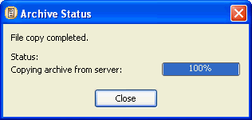
When the Multi-Server Manager has completed installing the archive, click [Close].

8 Return to the Multi-Server Manager window and expand the Source Server Node. Click the Descriptors node to view the descriptor that you created listed in the Descriptors View. Descriptors View displays the Descriptor Name and Description that you entered in the Create Archive or Descriptor dialog and today's date.
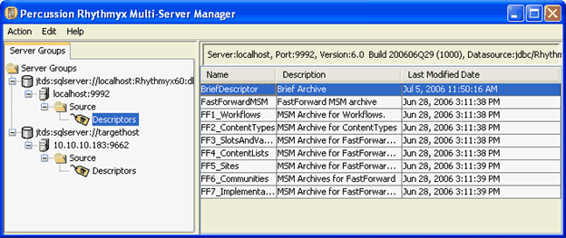

Figure 77: Descriptors View

Simple Example: Installing the Archive

To install the contents of the archive that you created on the target server:

1 Notify users not to work on the target (test) server while you are installing the archive.

2 Back up your CM System tree on your target (test) server in case an installation error incorrectly modifies the contents of the CM System tree, and you want to re-install the original.

3 If you are not connected to the target server, connect to it (see "Connect to Server" on page
31). In this example, you will install the archive by accessing it from Descriptors View on the source server, so you must also connect to the source server; however, in general it is not necessary to connect to the source server to install an archive created on it.

4 In the Server Groups Tree, expand the source (development) server and select the Descriptor Node so that Descriptors View displays in the Details Pane. Right-click the descriptor and select Install in the drop menu.
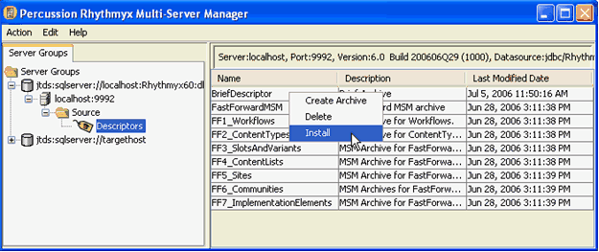

Figure 78: Install from Descriptors View

The Multi-Server Manager displays a dialog reminding you to back up your target server. Click [Yes] to continue.

The Multi-Server Manager opens the Install Archive Wizard.

5 Click [Next].

Figure 79: Install Archive Wizard, first dialog

The Multi-Server Manager displays the Select an Archive and Server dialog.
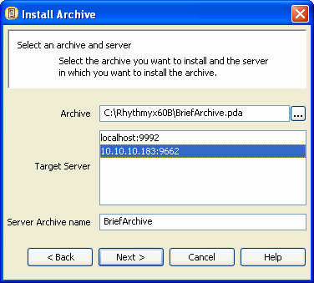

Figure 80: Select Archive and Server

By default, Archive displays the archive created with the descriptor and Server Archive Name displays the name of the archive on client. Server Archive Name is the name the archive will have on the target server. Leave these default values.

Target Server displays all registered servers. Choose the target server. Click [Next].

The Multi-Server Manager displays the Choose Installation Mode dialog.
6 In this example, you do not have to review mappings and you have already mapped your new
Brief Template. Choose Typical to use your existing mappings and click [Next].

The Multi-Server Manager displays the Select Packages to Install dialog.

Figure 81: Select packages dialog

7 Click [Add All >] to move both packages to Packages to Install. Click [Next].

The Multi-Server Manager displays a dialog showing the progress of package validation. When package validation is complete, the dialog closes and the Multi-Server Manager displays the Specify Actions for Warnings dialog.
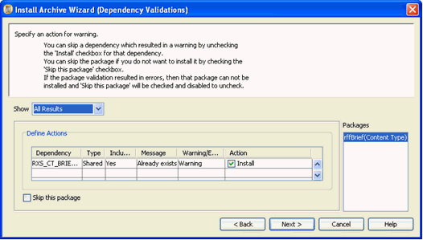

Figure 82: Specify Actions for Warnings

The Brief (Content Type) package validations both result in warnings that the RXS_CT_BRIEF table schema already exists. You want to overwrite the existing table, so leave Install checked.

8 Click [Next].

The Multi-Server Manager displays a dialog telling you that you are installing packages with warnings. Click [Yes] to continue.

The Multi-Server Manager displays the Summary dialog of the Wizard.
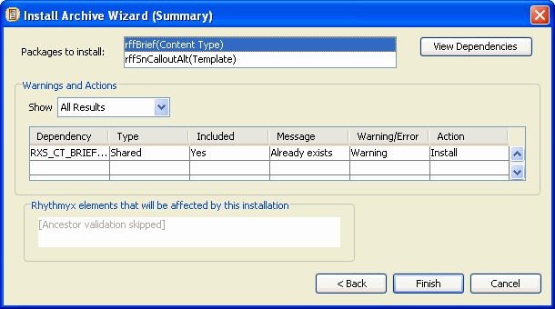

9 Click [Finish].

Figure 83: Installation Summary dialog

The Multi-Server Manager displays a dialog prompting you to confirm installation. Click
[Yes] to install.

The Multi-Server Manager displays the Install Status dialog. When installation is complete, it enables the [Show Log] button.

Figure 84: A completed installation

Simple Example: Reviewing the Installation

Review your archive installation by examining the archive and package logs, by looking at Archives View and Packages View on the target server in the Multi-Server Manager window, and by checking your changes on the target server.

To review your archive installation:

1 After you complete the Archive Installation Wizard, when the Install Status dialog indicates that installation is finished, click [Show Log].

Figure 85: A completed installation

The Multi-Server Manager displays the Archive Summary log.

Figure 86: Archive Summary dialog

Click each package in the Packages List and click [View Log] to view its package log.

Figure 87: Package Log, Main Tab

2 In the Server Groups Tree of the Multi-Server Manager window, expand the Target Server node.

Click the Archives node. Archives View displays a listing for the archive that you installed on the target server in the Details Pane. The Name of the archive is BriefArchive, the name that you entered in the Select an Archive and Server dialog of the Install Archive Wizard. Double- click on the archive to view the same archive summary that you viewed from the Install Status dialog.
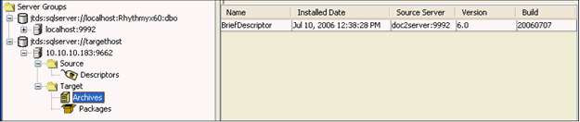

Figure 88: Archives View

Then click the Packages node. Packages View displays in the Details Pane. Packages View lists the Brief Content Type and rxs_Shared_cas Content Assembler packages that you installed on the target server. Double-click on a package to view the same package log that you viewed from the Archive Summary.
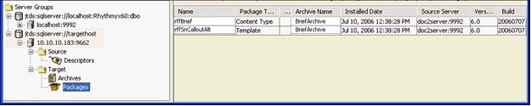

Figure 89: Packages View

3 Log in to CM System on the target (test) server as a user in a Community that you have given access to your new Template.

4 Click the Content tab and Open a new Brief content item.

Figure 90: Brief Content Editor with Topic field added on Source Server

The new Topic field appears. Fill in the Content Editor and save the Content Item.

5 Right-click your new Brief Content Item in Content Explorer and choose the Preview option in the drop menu. The new S - CalloutAlt Template should be one of the preview options.

Figure 91: Option for S - CalloutAlt Template

C H A P T E R 1 0

Troubleshooting

1 If an archive fails to install:

a) Attempt to re-install the archive using Custom rather than Typical mode and review your element mappings.

b) Attempt to re-install the archive one package at a time to avoid an error due to incorrect package order.

c) Recreate the archive using Custom rather than Typical mode. Be sure to include all Table
Schema dependencies and verify that the packages are in the correct order.

2 If an archive containing a Workflow fails to install and you receive an error message similar to:
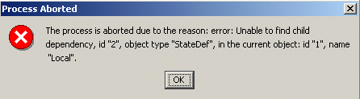

Figure 92: Process Aborted Error Message

You are probably using an older version of CM System with a bug that causes transitions to be orphaned if the "to state" is deleted from the workflow. To correct this error, complete the following steps:

a) Run the following SQL script against the source repository:
delete from TRANSITIONS where not ( TRANSITIONS.WORKFLOWAPPID in
(select WORKFLOWAPPID from WORKFLOWAPPS)
and
TRANSITIONFROMSTATEID in
(select STATEID from STATES
where WORKFLOWAPPID = TRANSITIONS.WORKFLOWAPPID

)
and

TRANSITIONTOSTATEID in

(select STATEID from STATES
where WORKFLOWAPPID = TRANSITIONS.WORKFLOWAPPID
)
)
b) Recreate the archive containing the workflow. c) Install the new archive on the target server.

3 If your installation modifies a target server workflow to have fewer states, target server content items in the states that you remove are orphaned. A content item's state and workflow are stored in the CONTENTSTATUS table in the columns CONTENTSTATEID and WORKFLOWAPPID. You can change the state of orphaned content items to a state that currently exists in the workflow with the SQL statement:
update CONTENTSTATUS set CONTENTSTATEID=[x] where CONTENTSTATEID=[y] and
WORKFLOWAPPID=[z]
x = the new state ID for the orphaned content item (a state that exists in the installed workflow)

y = the deleted state ID

z = the workflow ID

