Image Editor Architecture and Design
An Overview of the architecture of the server side components of the Image Editor.
Image Editor Architecture and Design 1
1. Overview 1
1.1. Dispatcher Servlet Controllers 2
1.1.1. Image Editor Wizard Controller 2
1.1.2. Image Controller 3
1.1.3. Progress Bar Controller 3
1.1.4. Image Persistence Manager 3
1.1.5. Image Resize Manager 3
1.2. Server Components 3
1.2.1. Image Size Definition Manager 3
1.2.2. Image Cache 4
1.3. Rhythmyx Components 4
1.3.1. JEXL Functions 4
1.3.2. Image Size Template Expander 4
2. Data Structures 4
2.1. Image Size Definition 4
2.2. Image Meta Data 5
3. Rhythmyx Design Components 5
3.1. Image Content Type 5
3.2. Templates 6

Overview

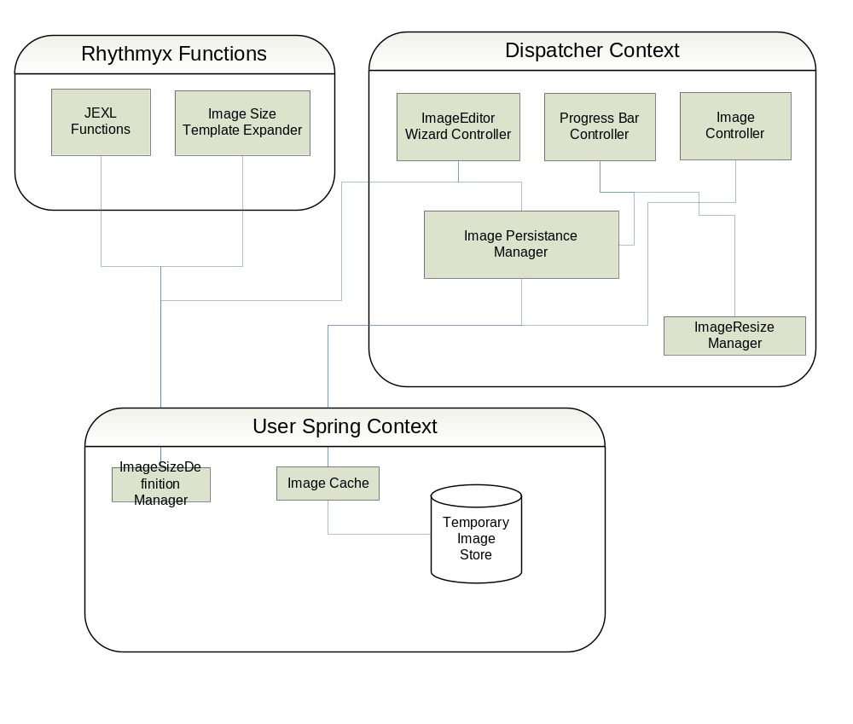

Dispatcher Servlet Controllers
The Dispatcher Servlet Controllers interact with the user's browser to control the user experience of the Image editor.

Image Editor Wizard Controller
The Image Editor Wizard controller handles the main user interface. It is a subclass of the Spring AbstractWizardController.
The number of pages in the wizard is determined dynamically based on the number of child images defined for this image. In addition to a wizard page for each selected image size, there are 2 additional pages: a main entry page and a confirmation page.
The Image Editor Wizard controller is a session scoped Spring bean. There is a separate copy of this controller for each user session, and it maintains state directly in the controller. (This does mean that each user can have only 1 Image Editor open on his browser, even if he has separate windows).

Image Controller
The Image controller is responsible for serving the binary images to the user browser. Information regarding image id and size will be encoded in the request, meaning that this controller can be stateless.
The Image Controller is a singleton Spring bean.

Progress Bar Controller
The progress bar controller returns status information about the progress of update operation. This information is provided by the Image Persistence Manager during the save operation.
It is the responsibility of the JavaScript routines running on the front end to make repeated requests for Progress Information.
The Progress bar controller is a singleton Spring bean.

Image Persistence Manager
The Image Persistence Manager reads and writes the Content Item that represents the Image. This includes managing the child image rows.
The Persistence Manager is passed data from the Wizard controller that identifies the meta-data and properties of the images, but not the actual binaries. All of the binary images are obtained from the Image Rendition Manager.
During the save operation, the Persistence Manager maintains status information, including a count of total child images and the number of child images completed. This information will provided to the Progress Bar controller on request.
The Persistence Manager is NOT asynchronous: it reads and updates items using the user's credentials and thread.

Image Resize Manager
The Image Resize Manager is responsible for creating and storing the different image sizes required by the Image Editor. This includes scaling and cropping of the images.

Server Components
The server components interact with the server backend. They are defined in the User context. All of these objects are singleton beans, and can be found via locators that extend PSBaseServiceLocator.

Image Size Definition Manager
The Image Size Definition Manager manages a Set of Image Size Definitions, which are defined in the XML configuration document.
Each Image Size Definition contains a unique ID, along with data about the allowable height and width of the image, and the templates used to render that image size.
The Item Size Definition Manager has methods to return the entire set, and to search for a specific definition by id or size.

Image Cache
The Image Cache stores the images in a temporary storage location. The cache will be backed with an ehcache (in memory) instance as well as a table with an appropriate BLOB column in it.
It might be possible to implement only the "in-memory" component initially, but as usage of the Image Editor grows, so too will the requirements for system memory. Without some way to control memory usage, we run the risk of server memory errors and crashes. It is better to plan this into the architecture now, rather than having to make a major modification later when we discover that a persistent cache is required.
Configuring the cache to use disk storage is very easy, and the impact is totally contained within the Spring beans files. No code changes are necessary.

Rhythmyx Components

JEXL Functions
The JEXL functions provide access to the Image Size Definition Manager from within Templates. They also contain convenience methods for locating the desired image size within a content node.

Image Size Template Expander
The Image Size Template Expander is used when publishing binary image templates. It uses information from the content node and the image size definition manager to determine which binary templates are published for a given content item.

Data Structures

Image Size Definition
The Image Size definition contains the following fields:
Code – the image size code that uniquely identifies the image size.
Label – the descriptive label for the image size.
Height – the height of the image in pixels
Width – the width of the image in pixels.
Snippet Template – the name of the template used to render a link to the image size.
Binary Template – the name of the template that produces the binary image of the desired size.
The Height and Width are numbers. If either the height or the width is zero, then that dimension is variable for this image size. The front end will allow the user to image areas that vary in shape for these image sizes.

Image Meta Data
Image Meta Data represents the actual image.

Rhythmyx Design Components

Image Content Type
Main Field Set fields:
Field | DataType | Description
sys_title | Text | System Title
displaytitle | Text | Display title – also used for tooltip or title attribute.
description | Text | General Description (Long)
alt | Text | Short Description for alt tag
img | Binary | Master Image
img_type | Text | MIME Content Type for master image.
img_filename | Text | Original Filename for master image
img_ext | Text | File extension for master image
img_size | Number | File size in bytes for master image
img_height | Number | Master image height in pixels
img_width | Number | Master image width in pixels

Child Table Fields:
Field | DataType | Description
size_code | Text | Image size code.
sized_img | Binary | Sized Image
sized_img_type | Text | MIME Content Type for sized image.
sized_img_filename | Text | Original Filename for sized image
sized_img_ext | Text | File extension for sized image
sized_img_size | Number | File size in bytes for sized image
sized_img_height | Number | Actual image height in pixels
sized_img_width | Number | Actual image width in pixels

Note that some image size definitions allow variable sized images (e.g. one that specifies a width but not a height). In all cases, the actual size of the image will be stored in the sized image.

Templates
Each sized image will have a distinct pair of templates: a Binary template and a Snippet template.
The Snippet template renders a simple <img> tag and a link to the binary template. The tooltip, alt and description tags should be filled in.
The Binary template renders the actual binary for the image size.
The master image and all defined image sizes each have a pair of templates.
The snippet templates are all dispatch templates. They set the binding $imedSizeCode to the image size code for the snippet and dispatch to the "Common" template.

