Configuring the Percussion CM1 Workbench within Eclipse on Linux
This document assumes that eclipse version 3.3.2 with JDK 1.6 or higher and the Percussion CM1 SDK is installed on your machine. By configuring the Percussion CM1 Workbench, you will have access to the CM1 content design tab for building and managing new content types.

Plugins
You will find the required workbench plugins in the “plugins” folder. This folder is located in the root install directory of the Percussion CM1 SDK. e.g. PercussionSDK/plugins
- Copy the workbench plugins into the plugins folder within eclipse. e.g. eclipse/plugins
- Start eclipse and select File -> Connect to Percussion CM1 server… to connect.
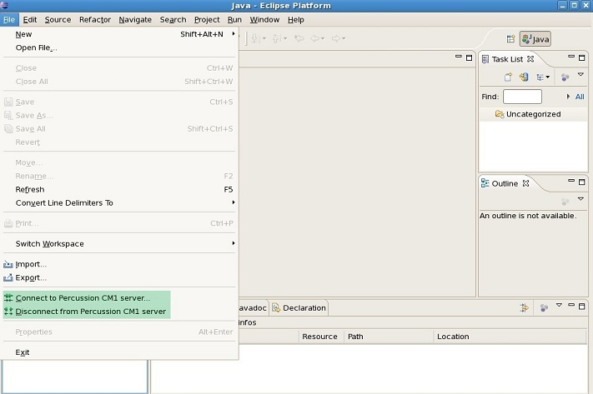

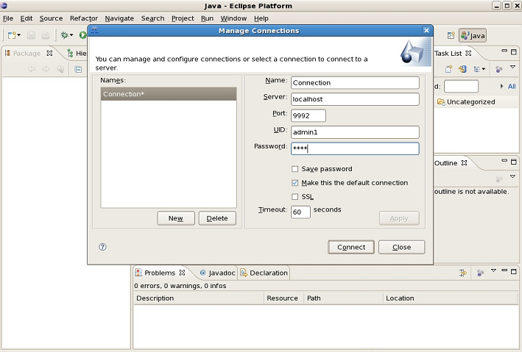
- Once connected, to see the CM1 workbench views, select Window -> Show View -> Percussion CM1
