Widget Development Quick Start

Requirements
The SDK is only useable for Windows OS

Install CM1 and CM1 SDK
Install CM1 and start it.
Unzip the CM1 SDK to a base drive like C: or D: making sure to check the “use folder names” option in Winzip (or other unzipping software). After unzipping a directory named “cm1_sdk” will exist.

Create the Initial Widget Skeleton
Open a windows command line and move into the “cm1_sdk” directory.
Run the “createWidgetSkeleton” batch file

Usage:
createWidget.bat install_directory_path widget_name [widget display name]

After skeleton creation the following file structure will exist:
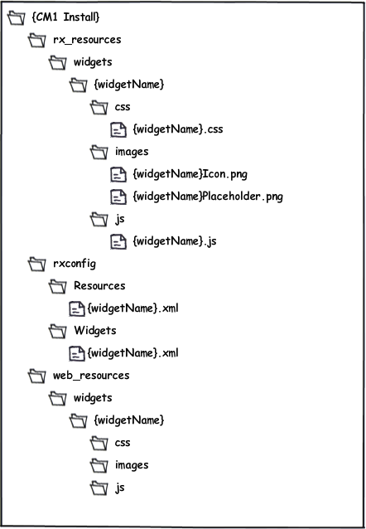

The new widget will be available right away in CM1 and can be placed on a page for testing.

Create Asset Content Type
If an asset is needed to store content for the widget you will need to create it by using the workbench. After the content type is created you will need to add a reference to it using the contenttype_name attribute in the widget xml file.

Modify the Widget XML
Modify the widget xml to implement your desired functionality.
See: WidgetDevelopersGuide_r3.doc for more details on widget development.

Packaging the Widget
Widgets are distributed via packages. The CM1 SDK includes the package builder and installer. The package builder contains help files in the tool itself, so to read the help simply start the tool and click the help menu option.

