Q2

|  |  |  |
| --- | --- | --- |
| **Portfolio** | **Value—weighted portfolio** | **Equally—weighted portfolio** |
| Annualized average return | 0.0678 | 0.1145 |
| Annualized volatility | 0.2261 | 0.4661 |
| Minimum return | -0.4543 | -0.6013 |
| Maximum return | 0.5026 | 0.7621 |
| Sharpe Ratio | 0.0787 | 0.1384 |

*Figure 2: Portfolio characteristics.*

|  |  |  |
| --- | --- | --- |
| **Portfolio** | **Value—weighted portfolio** | **Equally—weighted portfolio** |
| Annualized average return | 0.0678 | 0.1145 |
| Annualized volatility | 0.2261 | 0.4661 |
| Minimum return | -0.4543 | -0.6013 |
| Maximum return | 0.5026 | 0.7621 |
| Sharpe Ratio | 0.0787 | 0.1384 |

*Figure 2: Portfolio characteristics*

The value-weighted portfolio has an annualized average return of 6.78% and an annualized volatility of 22.61%. In comparison, the equally-weighted portfolio has an annualized average return of 11.45% and an annualized volatility of 46.61%. The Sharpe ratio, which measures the excess return per unit of risk, is ~0.08 for the value-weighted portfolio and ~0.14 for the equally-weighted portfolio. The higher average return of the equally-weighted portfolio can be explained by the fact that it includes smaller companies with potentially higher returns than larger, more established firms. This is consistent with the size premium, where smaller stocks tend to outperform larger stocks over the long-term. Additionally, the equally-weighted portfolio may be more exposed to certain factors that have historically generated higher returns, such as value or momentum.

Moreover, the higher volatility of the equally-weighted portfolio can be explained by its lack of diversification compared to the value-weighted portfolio. The value-weighted portfolio assigns more weight to larger, more established companies, as previously stated, which tend to be less volatile than smaller, less established firms. Following this logic, the equally-weighted portfolio may be more sensitive to market movements, as small changes in the prices of individual stocks can have a more significant impact on the overall portfolio. In contrast, the value-weighted portfolio may be more resilient to such movements due to its constituents of larger, more stable stocks. This is consistent with the efficient market hypothesis, which states that in a well-functioning market, investors will demand higher returns to compensate for higher risk. The Sharpe ratio, which measures the excess return per unit of risk, is higher for the equally-weighted portfolio. This suggests that the equally-weighted portfolio provided a higher return per unit of risk compared to the value-weighted portfolio.

Regarding the dip in annual returns for both portfolios in 2007-2009, it is due to a combination of macroeconomic factors, such as the global financial crisis, which led to a significant decline in energy prices and demand, punishing energy firms. This is consistent with the concept of systematic risk. Additionally, changes in regulations and political uncertainty may have contributed to the decline in returns for energy firms during this period.

Check how many firms are in each group. The weight of the big-size companies can result in an imbalance due to they are less likely to default and have fewer NaN’s compared to the smaller firms.

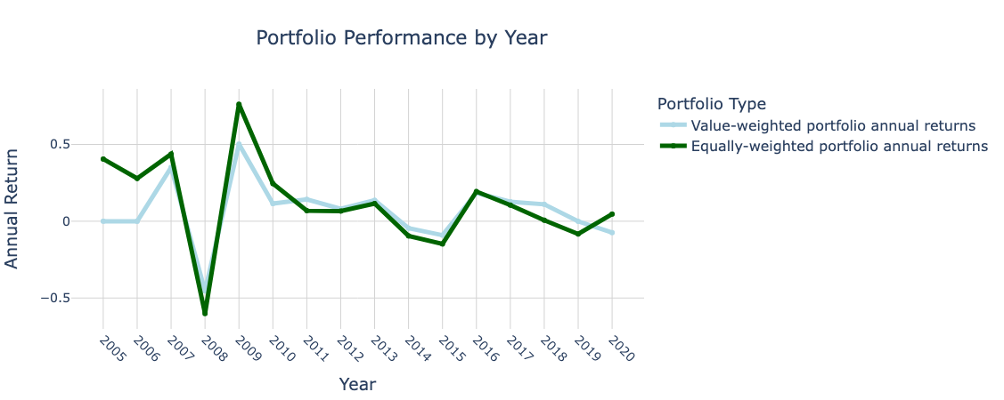

*Figure 3: Portfolio Performance with Annual Returns 2005-2020.*

Q3

|  |  |
| --- | --- |
| **AAR:** | 4.735% |
| **Max yearly return:** | 7.906% |
| **Min yearly return:** | 1.861% |
| **Sharpe ratio:** | 4.072% |
| **Annualized volatility:** | 6.517% |

*Figure 4*

|  |  |
| --- | --- |
| **AAR:** | 4.735% |
| **Max yearly return:** | 7.906% |
| **Min yearly return:** | 1.861% |
| **Sharpe ratio:** | 4.072% |
| **Annualized volatility:** | 6.517% |

Q4

|  |  |  |  |
| --- | --- | --- | --- |
| **Portfolio** | **Value—weighted portfolio** | **Equally—weighted portfolio** | **Minimum variance portfolio** |
| Annualized average return | 0.0265 | 0. 1145 | 0.0473 |
| Annualized volatility | 0.1301 | 0.4732 | 0.0652 |
| Minimum return | -0.0429 | -0. 1189 | 0.0186 |
| Maximum return | 0.0985 | 0. 1621 | 0.0791 |
| Sharpe Ratio | -0.1807 | 0.1363 | -0.0407 |

|  |  |  |  |
| --- | --- | --- | --- |
| **Portfolio** | **Value—weighted portfolio** | **Equally—weighted portfolio** | **Minimum variance portfolio** |
| Annualized average return | 0.0265 | 0. 1145 | 0.0473 |
| Annualized volatility | 0.1301 | 0.4732 | 0.0652 |
| Minimum return | -0.0429 | -0. 1189 | 0.0186 |
| Maximum return | 0.0985 | 0. 1621 | 0.0791 |
| Sharpe Ratio | -0.1807 | 0.1363 | -0.0407 |

*Volatility:*

|  |  |  |
| --- | --- | --- |
| **Correlation Matrix** | **AAR** | **Volatility** |
| **AAR** | 1 | 0,106 |
| **Volatility** | 0,106 | 1 |

|  |  |  |
| --- | --- | --- |
| **Portfolio return** | **Portfolio volatility** | **Portfolio Sharpe ratio** |
| 22% | 13% | 1,51 |
| 24% | 15% | 1,51 |
| 20% | 12% | 1,49 |
| 26% | 16% | 1,49 |
| 28% | 18% | 1,46 |