Floated before Fired: Canals, Coal and the Two Clocks of Britain’s Energy Transition, 1700–1870

Abstract
Britain’s energy transition is usually dated by the steam engine, which supplied under a quarter of installed power before 1800 and overtook water and wind only in 1833. This article asks what ran the eighteenth-century acceleration instead. Using annual sectoral output for 1700–1870, a corrected year-by-year series of canal openings checked against 152 parliamentary Acts, Kanefsky’s power benchmarks and the Google Books British corpus, it finds two clocks: an aggregate break in 1775–92, as the canals were dug, absorbed by population, and a per-capita break in 1818 that belongs to steam. Coal, the good canals were built to carry, rose with the canal network; income per head did not. Randomisation inference shows that national series cannot tie this to the canals’ exact timing, so the sequence rests on break dates, power benchmarks and print. Britain’s fossil economy was floated before it was fired.
Keywords: energy transition, Industrial Revolution, canals, coal, water power, steam power, organic economy, growth regimes, text as data

Introduction
The fossil economy has two birthdays. One is the steam engine, dated by its readers to Watt’s rotative engine of the 1780s and by its historians to the 1830s, when steam overtook water and wind as the source of Britain’s stationary power. The other is coal as heat, which Wrigley dates to the sixteenth century, when London began to burn it in place of wood. Between the two lies a long eighteenth century in which Britain burned more and more mineral fuel while its machines still turned on organic power. The standard chronologies have little to say about how that coal reached the hearths, forges, kilns and boilers that burned it, and when.
The question matters because a transition is a sequence, and sequences can be misread. If the fossil economy began with the steam engine, then the acceleration of British output from the 1770s, before steam was a significant source of power, needs another explanation, and one candidate has been proposed by Terje Tvedt: that Britain’s distinctive endowment was water that could be engineered, rivers with the gradient to drive mills and the flow to float barges, and that the canal network built on them was the precondition of the coal economy. On this reading the fossil economy was floated before it was fired. The claim is about order, and order is something annual data can speak to.
This article sets the two clocks side by side on British annual series for 1700–1870 and asks three questions. When did the economy accelerate, and in which variables? What supplied the power while it did? And did coal, the good the canals were dug to carry, move with the canal network before steam could burn it in quantity? The answers are clear on the first two and deliberately bounded on the third.
First, Britain had two growth regimes, not one. In the sectoral output series of Broadberry and co-authors, total output, industry, coal, iron and population break upwards between 1775 and 1792; income per head breaks in 1818; agriculture never breaks. The first regime was absorbed by population: the economy grew faster and fed more people at the same income for half a century. Second, it did not run on steam. On Kanefsky’s benchmarks steam supplied 6% of installed stationary power in 1760 and 21% in 1800, and coal output per unit of installed steam horsepower fell by almost two-thirds between those years: coal grew far faster than the engines that could burn it. Third, coal and population rose with the canal network and income per head did not, and in the British printed record the vocabulary of coal on the water reaches a quarter of its mid-century frequency a generation before the vocabulary of steam.
The third answer comes with a qualification that we treat as a finding. The canal network was built over sixty years in two waves, and its cumulative mileage is almost indistinguishable from a smooth trend. Conventional tests on such a stock report a strong association with coal. Randomisation inference, which asks whether the canals’ actual timing matters, does not: stocks with the same waves moved to other decades fit coal as well about a third of the time. The national series therefore show where the acceleration fell, not that the canals’ timing caused it. The sequence rests on evidence that does not need a dose-response regression: the break dates, the power benchmarks and the print record.
The contribution is to energy history more than to the econometrics of the canal. It is a quantitative chronology of the British transition that separates mineral heat from mineral power and places water transport between them; a reconciliation of the aggregate chronology of canal historians with the per-capita chronology of growth accountants; and a demonstration, with numbers, of how far a national accumulating stock can carry a claim about sequence.

Two clocks and a precondition
The energy literature starts from Wrigley’s organic economy, bounded by the annual product of the land, and its escape through a mineral-based energy economy in which coal replaced wood as heat and, much later, muscle, water and wind as power. Wrigley is careful that the first substitution was under way long before 1760 and that the eighteenth-century economy was an advanced organic one, burning mineral heat while its power remained organic; Warde’s energy accounts, and Kander, Malanima and Warde’s European comparison, confirm the chronology. The steam clock belongs to Wrigley’s readers more than to Wrigley. Allen makes cheap British coal and dear British labour the reason the steam engine was worth inventing in Britain; Pomeranz gives coal a leading role in the Great Divergence; Malm accepts coal’s centrality but argues that steam displaced water in the 1830s and 1840s because it freed capital from the riverbank, not because water was exhausted. What these accounts share is a clock calibrated to combustion in engines.
The transport literature runs on a different clock. The Bridgewater Canal of 1761 halved the price of coal in Manchester, and between then and the Liverpool and Manchester Railway of 1830 the inland waterway network of England and Wales grew from about 1,400 miles of improved river to some 4,000 miles of river and canal. Priestley’s survey of 1831 records that the Duke of Bridgewater’s ‘primary object’ was ‘to open his valuable collieries at Worsley, and to supply the town of Manchester with coal, at a much cheaper rate’. Turnbull showed that canals were built where coal was, carried coal above all else, and served counties where coal and population grew faster; Alvarez-Palau, Bogart, Satchell and Shaw-Taylor estimate that transport costs relative to producer prices fell by nearly three-quarters between 1680 and 1830 and that inland towns would otherwise have been a fifth to a quarter smaller in 1841. The coal trade itself was older: the coastal trade from the Tyne to London was Europe’s largest bulk-freight flow before 1700. What canals changed was inland access.
Tvedt joined the two clocks. His argument is that Britain’s advantage was not coal as such, which China had in abundance, but a hydrology of gentle gradients and steady flow that could be engineered cheaply into canals and mill-races, where the monsoonal rivers of Asia could not. On this reading water was the precondition of the coal economy, not its rival: it made coal cheap far from the pit and supplied the water-powered factory on which steam later built. A precondition makes predictions a rival cause does not. The sectors canals served should accelerate before steam was a significant source of power; coal should rise with the canal network; income per head, which canals could not directly raise in an organic economy, should not; and steam should raise it only once steam was the majority power source.
The macroeconomic record appears to stand in the way. Crafts and Harley cut the growth rates of 1780–1830, and Broadberry and co-authors confirm that income per head grew at around 0.3% a year until the 1820s. Crafts’s growth accounting finds steam’s contribution to productivity trivial before 1830. Gradualism in income per head has been read as a verdict against an eighteenth-century take-off. It is a verdict about one variable. The same series show total output and population doubling between 1760 and 1830, and an infrastructure shock in an organic economy should produce exactly that: more mouths fed, not richer ones.

Sources and methods

Output, population and power
Annual real output for Great Britain by sector, 1700–1870, is from Broadberry, Campbell, Klein, Overton and van Leeuwen, as published in the Bank of England’s Millennium of Macroeconomic Data, version 3.1. We use total output, agriculture, industry and services, the physical output indices for coal, iron and textiles, and population, based on Wrigley and Schofield’s reconstitution to 1801. Income per head is total output divided by population. Coal, iron and industry are built from physical output and are independent of population; some service sub-series are not, which is why we do not rest the argument on services.
Installed stationary power is Kanefsky’s, as tabulated by Crafts, at 1760, 1800, 1830 and 1870 (Table 2). Interpolated series between four benchmarks are smooth by construction, so we use them to date crossovers and ratios, not for year-to-year inference.

The canal network
A single treatment date cannot represent a network built over sixty years in two waves, so we construct a continuous series of cumulative canal miles in operation. It starts from the completion year and length of the canals and post-1700 river navigations in a published reference table of English waterways. That table cannot be used as it stands. For several of the largest canals it records the first opening or the year of the Act rather than completion, it dates the Kennet and Avon to the river navigation of 1727 rather than the canal of 1810, it counts the 1927 amalgamation of the Grand Union as construction, and it omits the South Wales coal canals. We correct twenty-four entries against Hadfield’s canal histories, dating every staged canal to the completion of its through route, which biases the series late by a few years, and add seven Welsh canals; each change is listed with its reason in the replication package. The corrected series has 143 waterways opened in 1700–1830, with 2,437 miles open by 1830. The Cambridge Group’s dynamic GIS of navigable waterways puts the England and Wales network at about 1,400 miles in 1760 and 4,000 in 1835; our 2,276 miles added over 1760–1830 are close to seven-eighths of that increase, the remainder being later completions, branches and river improvements we omit. All results are reported on the corrected series; on the uncorrected table they are the same in sign and similar in size. The timing is corroborated by an independent primary source. From the digitised text of Priestley’s 1831 survey we recover the year of first authorisation for 152 navigations, including 70 canals authorised in 1760–1829; the authorisation series leads the completion series by roughly a decade and shows the same two waves.

Print
Word and phrase frequencies are from the Google Books Ngram corpus, British English 2019 edition, 1700–1900. We index eight bigrams naming coal’s mode of use to their own 1850 frequency: ‘coal barge’, ‘coal wharf’, ‘coal boat’ and ‘canal boat’ for coal moved by water, and ‘steam engine’ and ‘steam power’ for coal burned in engines, with ‘coal field’ and ‘fire engine’, the older name for an atmospheric engine, as checks. For each term and group we record the first year its five-year mean reaches 10, 25 and 50% of the reference level. The corpus over-represents technical publishing, which for this vocabulary is an advantage, and is thin before 1770, which is why we read crossings as decades.

Methods
For each series we fit a log-linear trend and test for one break in level and slope at an unknown date with the Andrews sup-F statistic, and for two breaks by grid search with a minimum segment of twenty years. We relate each output series to the canal stock in levels, with a linear or a quadratic trend and a war dummy (1756–63, 1775–83, 1793–1815), in first differences with ten lags of new mileage, and in local projections at horizons of five to twenty years, with Newey–West errors throughout.
Two properties of the design govern what these regressions can show. First, the canal stock is 97.7% explained by a quadratic trend. A Monte Carlo calibrated to the British series shows that Newey–West tests on 131 annual observations then reject a true null 18% of the time at a nominal 5%; the size-corrected threshold is about p < 0.003. Second, conventional inference asks whether the stock fits better than a trend, not whether the canals’ timing matters. We ask the second question directly, in two ways. A timing placebo shifts the stock backwards and forwards by up to thirty years: a precondition predicts that canals already open fit coal better than canals not yet open. Randomisation inference circularly shifts the annual series of new mileage within 1700–1830, which preserves its two waves and its lumpiness but moves them in time, rebuilds the stock, and re-estimates; the share of 130 re-timed stocks that fit as well as the real one is a randomisation p-value for the hypothesis that the canals’ timing is irrelevant. All code and data are in the replication package.

Results

Two growth regimes
Figure 1 plots the British series on a logarithmic scale with the two canal waves shaded. Total output and population steepen together after 1760 while income per head keeps its previous slope until the 1820s. Agriculture never steepens.
[Figure 1 about here]
Table 1 formalises the picture. Between 1700–60 and 1790–1815 the trend growth of total output nearly tripled, from 0.55 to 1.58% a year; coal’s more than tripled; population’s quadrupled. Income per head grew at 0.25% a year in the first period, 0.08% in 1760–90 and 0.40% in 1790–1815. The best single break falls between 1777 (population) and 1792 (total output) for every series canals could serve, with sup-F statistics far above the Andrews critical value, and in 1818 for income per head. Agriculture has no significant break. Allowing two breaks places the first in 1774–75 for total output, industry and services and the second in 1818–23. Coal’s first break falls earlier, in 1741, and its second in 1798: the coal trade did not begin with the canals, but its inland expansion is dated by them.
[Table 1 about here]
The arithmetic of the first regime is simple. Between 1760 and 1815 the growth of total output and of population each rose by about a percentage point a year, and coal output per head doubled. The economy fed half again as many people at the same income, for two generations, without the Malthusian check that had ended earlier expansions. Coal output per head, indexed to 100 in 1700, stood at 202 in 1790 and 246 in 1800. Agriculture’s share fell throughout, and in the sceptical specifications below its response to the canal network is, if anything, negative: labour and capital moved towards the sectors that were growing. The 1818 per-capita break survives a war dummy, which moves it to 1816, and the per-capita trend of 1816–30, at 0.7% a year, is well below the 1.2% of 1830–70.

What powered the first regime
Table 2 gives the power benchmarks. In 1760 steam supplied about 6% of installed stationary power; in 1800, when the first regime was a generation old, 21%; in 1830, 47%. On log-linear interpolation, steam overtook water and wind combined in 1833, fifteen years after the per-capita break. Coal output per unit of installed steam horsepower fell from 100 to 37 between 1760 and 1800. Most of the extra coal went not to engines but to hearths, forges, kilns and salt pans. The first regime ran on mineral heat and organic power: water wheels, windmills, horses and men turned the machines, and coal supplied the heat.
[Table 2 about here]
Steam’s contribution to income per head belongs to the second regime. In local projections, installed steam horsepower has no association with subsequent income per head on the 1760–1830 sample; on 1830–70 alone the response is positive at every horizon with p-values below 0.001, and an interaction of horsepower with a post-1830 indicator is positive and significant. Because horsepower is interpolated between benchmarks, we read the sign and timing, not the magnitude. Steam’s per-capita dividend is a post-1830 phenomenon, which is Crafts’s result seen from the other side.

Canals and coal: where the acceleration fell, and what the dose cannot show
Figure 2 sets the canal series beside coal. Miles opened per decade were 55 in the 1760s, 349 in the 1770s, 83 in the 1780s, then 609, 467 and 527 in the three decades of the canal mania and its completions; the cumulative stock rose from 161 miles in 1760 to 759 in 1790, 1,277 in 1800 and 2,437 in 1830. The two waves correspond to the two steepenings of coal output per head.
[Figure 2 about here]
Table 3 reports the association. With a linear trend, a thousand miles of canal is associated with 41% more coal, 36% more industrial output, 21% more population and no change in income per head or agriculture. With a quadratic trend and war dummy, coal retains a coefficient of 30% (p = 0.003, on the size-corrected threshold) and population one of 7% (p < 0.001); industry and total output are indistinguishable from trend; income per head and agriculture remain at zero. In first differences only population has a cumulative response clearly distinguishable from zero, and coal’s is 32% (p = 0.05). In local projections the canal stock predicts coal by 27% at five years, 36% at ten and 44% at fifteen. The pattern of incidence is what a precondition predicts: coal and population, not income per head.
[Table 3 about here]
The timing is another matter, and Figure 3 shows why. Panel (a) shifts the stock. Under a quadratic trend, the stock five years ahead, canals not yet open, fits coal better than the current stock (t = 3.7 against 3.0), the stock ten years ahead as well (t = 3.0), and the fit declines steadily with lags. Some of this is our dating, since staged canals enter at completion, and some is anticipation: past coal growth predicts new parliamentary authorisations with a joint p-value below 0.001, so canals were promoted where demand was already growing. But a dose whose leads fit as well as its lags does not establish order. Panel (b) re-times the stock. Of 130 stocks with the same waves moved to other decades, 34% fit coal at least as well as the real one under a quadratic trend (31% excluding re-timings within ten years of the actual one), and 41% do in the ten-year local projection. Under the quadratic trend no outcome rejects; in the local projections two of six cross the 5% line, industry (p = 0.03) and, negatively, income per head (p = 0.04), which is the direction the population-absorption reading predicts but does not survive allowance for six tests. Any stock that accumulates while coal accelerates fits coal; the canal network fits it well, but not uniquely.
[Figure 3 about here]
Predetermined versions of the dose do not change this. Canals were authorised by Act of Parliament roughly a decade before they were completed, and an Act cannot respond to output after it is passed. With the completion stock lagged ten or fifteen years, coal’s coefficient is 44–46% per thousand miles and income per head’s is zero; with the number of canals authorised, lagged ten years, each ten Acts are followed by 12% more coal, and by 11% after controlling for coal’s own growth over the preceding decade. But the authorisation stock is even more trend-like than the completion stock (a quadratic trend explains 98.2% of its variance, against 97.7%), and under a quadratic trend its coal coefficient falls to 4%, significant only at the 7% level. Predetermined doses remove contemporaneous feedback; they do not remove anticipation, and they inherit the trend.
The canal regressions therefore show where the first regime’s acceleration fell, in coal and population and not income per head, and not that the canals’ timing produced it. We draw the sequence from evidence that does not depend on them.

The order in print
If coal moved by water before it burned in engines, the printed record should say so, and it does. Table 4 records when each term first reached a quarter of its 1850 frequency. ‘Canal’ does so in 1763, the year after the Bridgewater opening; ‘coal barge’ in 1781; ‘coal wharf’ in 1800; ‘steam engine’ in 1808; ‘steam power’ in 1826. The coal-by-water group crosses in 1800, the coal-by-steam group in 1819, and ‘steam engine’ overtakes ‘fire engine’ in 1800 (Figure 4). The ordering holds across three-, five- and nine-year windows and with 1830 as well as 1850 as the reference year: the coal-by-water group crosses between 1785 and 1801 and the coal-by-steam group between 1814 and 1819 in every combination.
[Table 4 about here]
[Figure 4 about here]
The corpus also shows what such vocabulary measures. The frequency of ‘canal’ correlates at 0.91 with the cumulative mileage in existence over 1740–1850 and at −0.04 with the mileage opened in the surrounding decade. Print records the level of the built environment, which is written about every year it exists, not the rate of building. The bigram sequence asks about order, not magnitude, and on that it is unambiguous: coal travels by water in print a generation before it is burned in engines.

Discussion

Floated before fired
The results describe an economy that changed gear twice. The first change, in the 1770s and 1780s, was in the quantity of things: coal dug, iron smelted, goods made, people fed. The second, after 1818, was in the quantity per person. The first coincided with the building of the canal network and ran on water wheels, horses and mineral heat; the second coincided with steam becoming the majority power source. Coal is the hinge. Its output per head doubled in the first regime, when steam supplied between a twentieth and a fifth of installed power, and most of it was burned outside engines.
This is Tvedt’s sequence, and it is visible in the British record without a causal estimate of the canals’ effect. Steam could not have carried the first regime, because it was too small; the regime ran on coal, because coal output per head doubled; the coal had to reach users away from the coast and the pit, and before railways the only cheap way to move a bulk good inland was on water; and the language of the period registered coal on the water before coal in the engine. What the national series cannot establish is that the canals’ own timing, rather than the general acceleration they were part of, moved coal. Canals were built where demand was growing, and a sixty-year stock is too close to a trend to separate the two. The regional evidence of Turnbull and the market-access estimates of Alvarez-Palau and co-authors supply the cross-sectional variation that could; a county panel of coal prices and output, with terrain as the source of variation in canal access, is the natural next step.

The advanced organic economy at full stretch
The first regime was not a rise in living standards. It was a rise in carrying capacity: the same income for half again as many people. We do not claim that canals caused the growth of population, which the demographic literature attributes above all to earlier and more universal marriage; we claim that the economy fed it at constant income, and that cheap inland coal and freight were part of how. In Wrigley’s terms this was not the escape from the organic economy but the advanced organic economy working at full stretch, with mineral heat, organic power and engineered water. The escape from the ceiling in aggregate came before the escape per head, and it came before steam.
This adds a stage to the accounts of Allen and Malm without contradicting either. Allen’s induced-innovation argument needs coal to be cheap where engines were built; the canals are a large part of why it was cheap inland. Malm’s argument that steam displaced water in the 1830s and 1840s because it freed capital from the riverbank presupposes a factory system organised around water wheels, a fuel supply organised around water transport, and, in the canal company, a legal template for raising capital by Act of Parliament. Before steam could be chosen over water for its portability, water had built the markets that made a portable prime mover worth having. Steam had to improve on a prime mover that was, in 1800, three times its size.

A check for infrastructure preconditions
The British case carries a lesson beyond Britain. Energy history is full of claims that some slowly accumulated infrastructure was the precondition of a transition: canals for coal, railways for the coalfields of the Ruhr and Pennsylvania, transmission grids for electrification, pipelines for natural gas. When such claims are tested quantitatively, they are usually tested as here, by relating a national stock to national output. The exercise in Figure 3 shows how far that can go, and it can be repeated in a few lines for any stock. First, regress the stock on a quadratic trend: when the trend explains more than about 95% of its variance, as it does for both British canal series, conventional Newey–West tests on a century of annual data reject a true null several times too often, and a threshold nearer 0.003 than 0.05 is needed. Second, shift the stock forwards and backwards: if canals, lines or pipes not yet built fit the outcome as well as those already in use, the stock is standing in for the trend. Third, re-time the stock by circularly shifting its annual increments and ask how often a re-timed stock fits as well. Where the stock was built in sharp, dated episodes, these checks leave room for a result; where, like the British canal network, it grew for sixty years in overlapping waves, they will usually say that national series can locate the acceleration but not attribute it. That is still worth knowing, and it points the analysis towards the regional variation where attribution is possible.

The comparative question, briefly
Tvedt’s thesis is comparative, and the British result gives it a form other cases can be checked against: if engineered water was the precondition of a coal economy, economies with one and not the other should not have left the organic regime. At the Maddison benchmarks the cases are consistent with that rule, and no more. The Netherlands had Europe’s densest engineered waterways, ran on peat and imported coal, and lacked the gradient to drive mills; its total output grew 9% between 1700 and 1820. Belgium had coal in Hainaut and Liège and acquired the canals to move it in 1818 and 1832; its income per head grew 8% between 1700 and 1820 and 82% between 1820 and 1870, more than Britain’s. China’s coal lay in Shanxi and Shaanxi, a thousand kilometres from the Jiangnan core, and its population rose by 176% between 1700 and 1820 while its income per head fell. Three benchmark readings cannot test a rule; they can fail to contradict it, and they do. They cannot be pushed further with annual cross-country regressions, because over 1790–1815 the per-capita series of the continental controls record the Revolutionary and Napoleonic wars (Dutch income per head fell 44% from its peak, Britain’s 1.4%), not their rivers.

Limitations
The canal series is provisional. It rests on a corrected reference table checked against the Cambridge Group’s network totals and corroborated by Priestley’s authorisations, only 152 of which could be recovered from the digitised text; it excludes Scottish canals and dates staged openings late. A definitive series would come from the Cambridge Group’s sectional opening dates. The power series exists at four benchmarks, so the ordering of steam relative to coal is established across benchmarks, not year by year, and water horsepower is collinear with the canal stock, so the transport and power halves of Tvedt’s thesis cannot be separated with these data. The design has limited power: at the size-corrected threshold it would detect a direct effect of canals on income per head of about 40% by 1830 with 80% probability, so the null on income per head rules out a large rival effect, not a modest one. The print record over-represents technical publishing and is thin before 1770. Each of these is a reason to read the magnitudes cautiously. The chronology rests on several independent sources — break dates in independently constructed output series, the power benchmarks and the printed record — and none of these limitations affects all of them at once.

Conclusion
Britain’s energy transition ran on two clocks. The first, set in the 1770s, measured how much the economy produced and how many people it fed; the second, set around 1818, measured how much each of them had. The first ran on mineral heat, water power and water transport: coal output per head doubled while steam supplied a twentieth and then a fifth of installed power, and the coal went inland to hearths, forges and kilns along a canal network built in the same decades. The second ran on steam, and it was steam that finally raised income per head, after it overtook water and wind in 1833.
The national series show that coal and population, not income per head, rose with the canal network, and they show honestly where their evidence stops: an accumulating national stock cannot, on its own, show that its timing mattered. That boundary is itself useful. Claims that some slowly built infrastructure was the precondition of a transition — canals, railways, grids — are common in energy history, and are usually tested, when they are tested at all, on trending national series. The test here says how much such series can bear and how to check it.
The sequence does not depend on that test. It rests on when the economy accelerated, what powered it when it did, and what its printed record talked about. On all three the answer is the same. The fossil economy was floated before it was fired.

Data availability statement
All code and data required to reproduce the analyses are publicly available at [REPOSITORY URL REDACTED FOR REVIEW] and in the supplementary replication package. British sectoral output and population are from the Bank of England’s A Millennium of Macroeconomic Data for the UK, which reproduces Broadberry et al. (2015); cross-country benchmarks are from the Maddison Project Database 2023; horsepower benchmarks are from Kanefsky (1979) as reported in Crafts (2004); canal completion years and lengths, and parliamentary authorisation years parsed from Priestley (1831), are included with their construction scripts; word frequencies are from the Google Books Ngram Corpus, British English 2019 edition.

Tables
Table 1: Trend growth and break dates of British series
Series | 1700–60 | 1760–90 | 1790–1815 | 1815–30 | 1830–70 | Best single break (sup-F) | Best two breaks
Total output | 0.55 | 0.82 | 1.58 | 1.98 | 2.35 | 1792 (778) | 1775, 1818
Industry | 0.47 | 1.16 | 1.81 | 3.64 | 2.85 | 1789 (909) | 1774, 1823
Coal | 0.87 | 2.05 | 2.85 | 2.84 | 3.57 | 1784 (667) | 1741, 1798
Services | 0.50 | 0.83 | 2.02 | 1.62 | 2.62 | 1786 (927) | 1775, 1844
Population | 0.29 | 0.74 | 1.18 | 1.49 | 1.16 | 1777 (3,052) | 1730, 1783
Income per head | 0.25 | 0.08 | 0.40 | 0.50 | 1.19 | 1818 (270) | 1720, 1818
Agriculture | 0.75 | 0.60 | 0.81 | 0.63 | 0.78 | none (4.2) | 1720, 1757
Growth: slopes of log-linear trends within each window, per cent per year. Breaks: 1700–1870, Andrews sup-F with 15% trimming (5% critical value about 11.8); two-break grid search with a minimum segment of 20 years. Source: own calculations from the Bank of England millennium dataset, after Broadberry et al.
Table 2: Installed stationary power in Britain, thousands of horsepower
Year | Steam | Water | Wind | Steam share | Coal output per steam hp (1760 = 100)
1760 | 5 | 70 | 10 | 6% | 100
1800 | 35 | 120 | 15 | 21% | 37
1830 | 160 | 160 | 20 | 47% | 19
1870 | 2,060 | 230 | 10 | 90% | 6
Source: Kanefsky’s estimates as tabulated in Crafts; coal output from the Bank of England millennium dataset.
Table 3: Canal stock and British output, 1700–1830 (per cent per 1,000 canal miles)
Outcome (log) | Linear trend | Quadratic trend + war | First differences, 10-year sum | Randomisation p, quadratic
Coal | +40.9 (<0.001) | +29.8 (0.003) | +32.4 (0.05) | 0.34
Industry | +35.9 (<0.001) | +1.3 (0.84) | +24.0 (0.09) | 0.90
Population | +21.4 (<0.001) | +6.7 (<0.001) | +19.7 (<0.001) | 0.65
Total output | +21.7 (<0.001) | +3.7 (0.32) | +10.9 (0.20) | 0.73
Income per head | +0.3 (0.85) | −3.0 (0.44) | −8.8 (0.30) | 0.46
Agriculture | −1.1 (0.77) | −6.4 (0.51) | −17.3 (0.32) | 0.76
Newey–West p-values (10 lags) in parentheses; the size-corrected 5% threshold is about 0.003. First differences: sum of coefficients on lags 0–10 of new mileage. Randomisation p: share of 130 circularly re-timed canal stocks whose quadratic-trend t-statistic is at least as large in absolute value.
Table 4: First year in which print frequency reaches a share of its 1850 level
Term or group | 10% | 25% | 50%
‘canal’ | 1743 | 1763 | 1809
‘coal barge’ | 1753 | 1781 | 1783
‘coal wharf’ | 1774 | 1800 | 1815
Coal-by-water group | 1780 | 1800 | 1817
‘steam engine’ | 1800 | 1808 | 1821
‘steam power’ | 1821 | 1826 | 1831
Coal-by-steam group | 1804 | 1819 | 1825
‘coal field’ | 1788 | 1820 | 1831
Source: Google Books Ngram corpus, British English 2019 edition, five-year centred mean. Groups are equal-weighted averages of member terms each indexed to 1850; the coal-by-water group also contains ‘coal boat’ and ‘canal boat’.

Figures
Figure 1: Britain’s two growth regimes. Annual indices, 1700 = 100, log scale. (a) Total output, population and income per head; (b) coal, industry and agriculture. Shaded: the first canal wave (1760–80) and the canal-mania completions (1790–1816). Vertical lines at 1761 and 1818. Source: Bank of England millennium dataset.
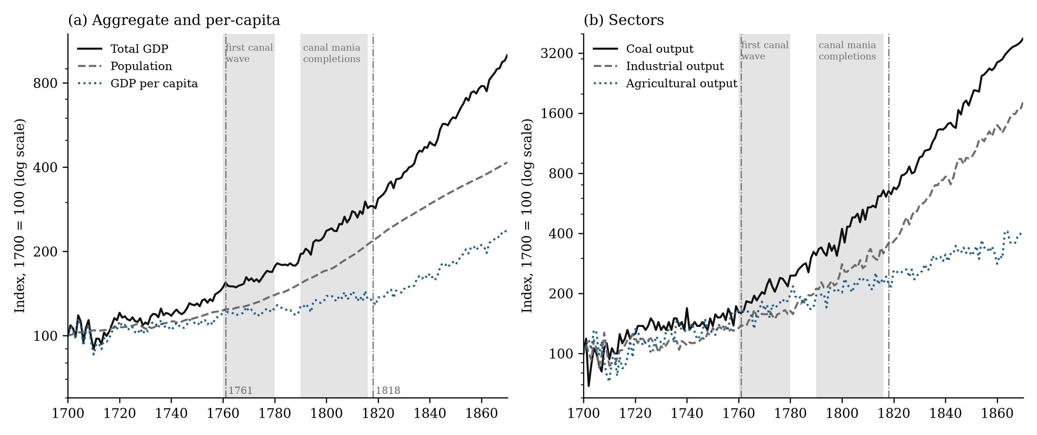
Figure 2: The canal network and coal. (a) Canal miles opened per decade, corrected series, by completion year. (b) Cumulative canal miles. (c) Coal output per head, 1700 = 100, with the year steam overtook water and wind. Sources: canal series described in the text; Bank of England millennium dataset; Kanefsky as tabulated in Crafts.
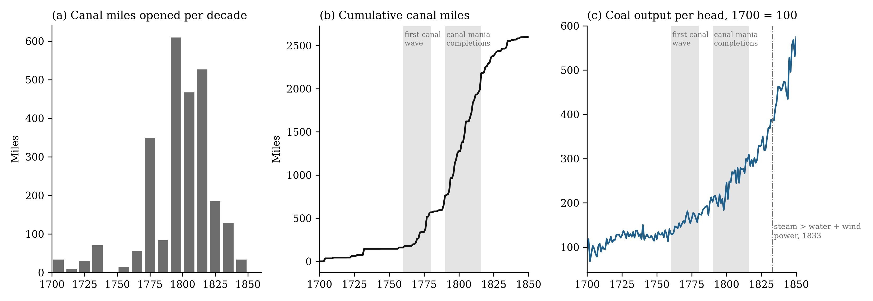
Figure 3: What the canal stock can and cannot identify. (a) t-statistic on the canal stock in the coal and income-per-head equations (quadratic trend and war dummy, 1700–1830, Newey–West errors) when the stock is shifted by up to thirty years; negative shifts use canals not yet open. (b) Distribution of the same statistic for 130 canal stocks rebuilt from the annual series of new mileage, circularly re-timed within 1700–1830; the vertical line marks the actual stock. Dashed lines: size-corrected 5% threshold.
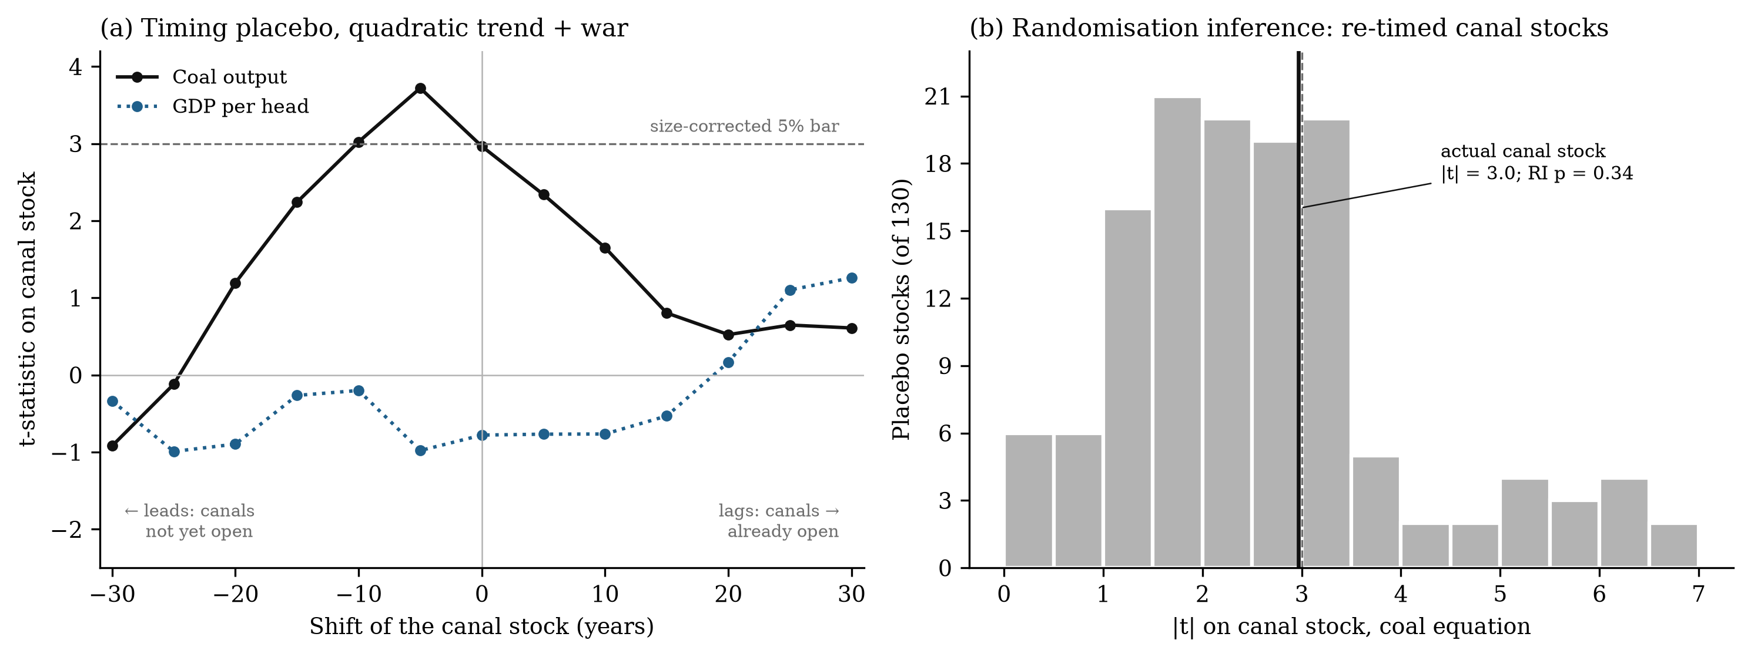
Figure 4: In print, coal travels by water before it is burned in engines. Five-year moving averages indexed to 1850 = 100. Coal-by-water: ‘coal barge’, ‘coal wharf’, ‘coal boat’, ‘canal boat’. Coal-by-steam: ‘steam engine’, ‘steam power’. Source: Google Books Ngram corpus, British English 2019 edition.
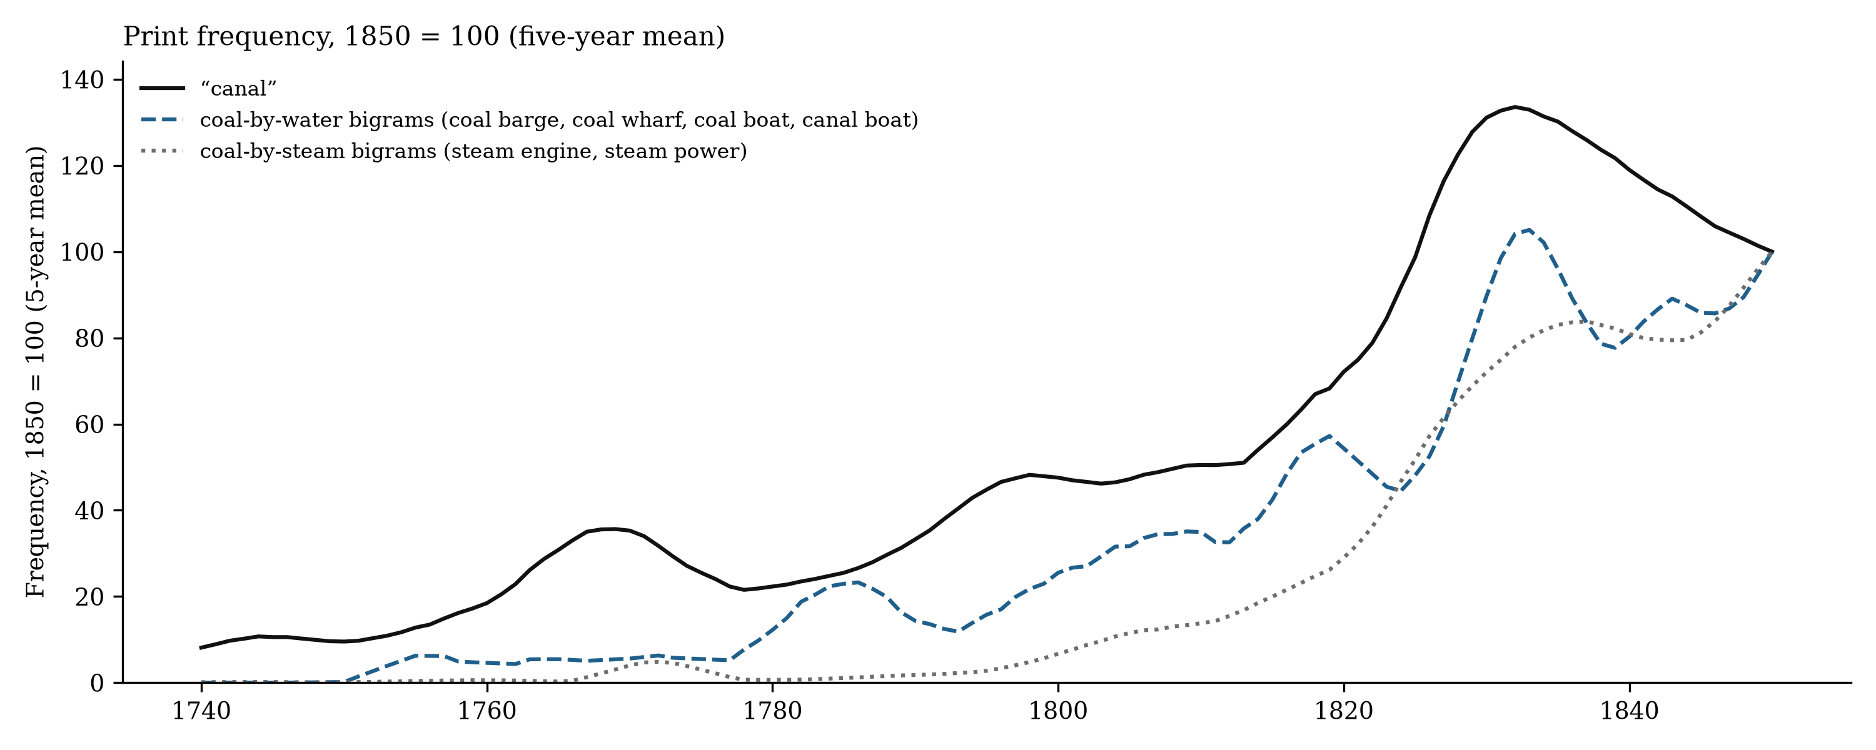

John W. Kanefsky, ‘The Diffusion of Power Technology in British Industry, 1760–1870’ (PhD diss., University of Exeter, 1979); Nicholas F. R. Crafts, ‘Steam as a General Purpose Technology: A Growth Accounting Perspective’, Economic Journal 114, no. 495 (2004): 338–51.
E. A. Wrigley, Energy and the English Industrial Revolution (Cambridge University Press, 2010).
Terje Tvedt, ‘Why England and Not China and India? Water Systems and the History of the Industrial Revolution’, Journal of Global History 5, no. 1 (2010): 29–50.
Stephen Broadberry, Bruce M. S. Campbell, Alexander Klein, Mark Overton and Bas van Leeuwen, British Economic Growth, 1270–1870 (Cambridge University Press, 2015).
E. A. Wrigley, Continuity, Chance and Change: The Character of the Industrial Revolution in England (Cambridge University Press, 1988); Wrigley, Energy and the English Industrial Revolution.
Paul Warde, Energy Consumption in England and Wales, 1560–2000 (CNR-ISSM, 2007); Astrid Kander, Paolo Malanima and Paul Warde, Power to the People: Energy in Europe over the Last Five Centuries (Princeton University Press, 2013).
Robert C. Allen, The British Industrial Revolution in Global Perspective (Cambridge University Press, 2009); Kenneth Pomeranz, The Great Divergence: China, Europe, and the Making of the Modern World Economy (Princeton University Press, 2000); Andreas Malm, Fossil Capital: The Rise of Steam Power and the Roots of Global Warming (Verso, 2016).
Dan Bogart, ‘The Transport Revolution in Industrialising Britain: A Survey’, in The Cambridge Economic History of Modern Britain, Volume 1: 1700–1870, ed. Roderick Floud, Jane Humphries and Paul Johnson (Cambridge University Press, 2014), 368–91; Charles Hadfield, British Canals: An Illustrated History, 7th ed. (David and Charles, 1984).
Joseph Priestley, Historical Account of the Navigable Rivers, Canals, and Railways, throughout Great Britain (Longman, Rees, Orme, Brown and Green, 1831).
Gerard Turnbull, ‘Canals, Coal and Regional Growth during the Industrial Revolution’, Economic History Review 40, no. 4 (1987): 537–60; Eduard J. Alvarez-Palau, Dan Bogart, Max Satchell and Leigh Shaw-Taylor, ‘Transport and Urban Growth in the First Industrial Revolution’, Economic Journal 135, no. 668 (2025): 1191–228.
John Hatcher, The History of the British Coal Industry, Volume 1: Before 1700 (Clarendon Press, 1993); Michael W. Flinn, The History of the British Coal Industry, Volume 2: 1700–1830 (Clarendon Press, 1984).
Tvedt, ‘Why England’.
Nicholas F. R. Crafts, British Economic Growth during the Industrial Revolution (Clarendon Press, 1985); Nicholas F. R. Crafts and C. Knick Harley, ‘Output Growth and the British Industrial Revolution: A Restatement of the Crafts–Harley View’, Economic History Review 45, no. 4 (1992): 703–30; Broadberry et al., British Economic Growth.
Crafts, ‘Steam as a General Purpose Technology’.
Broadberry et al., British Economic Growth; Ryland Thomas and Nicholas Dimsdale, A Millennium of UK Data, Bank of England OBRA dataset (2017).
Kanefsky, ‘Diffusion of Power Technology’; Crafts, ‘Steam as a General Purpose Technology’.
‘List of canals in the United Kingdom’, Wikipedia, retrieved 3 September 2026; every entry with a stated length and opening year is included. Corrections follow Charles Hadfield’s regional series The Canals of the British Isles (David and Charles, 1966–72) and Hadfield, British Canals; the list of corrections and the construction script are in the replication package.
Max Satchell, ‘Navigable Waterways and the Economy of England and Wales, 1600–1835’, Cambridge Group for the History of Population and Social Structure, Online Historical Atlas of Transport (2017).
Jean-Baptiste Michel et al., ‘Quantitative Analysis of Culture Using Millions of Digitized Books’, Science 331, no. 6014 (2011): 176–82.
Eitan Adam Pechenick, Christopher M. Danforth and Peter Sheridan Dodds, ‘Characterizing the Google Books Corpus: Strong Limits to Inferences of Socio-Cultural and Linguistic Evolution’, PLOS ONE 10, no. 10 (2015): e0137041.
Donald W. K. Andrews, ‘Tests for Parameter Instability and Structural Change with Unknown Change Point’, Econometrica 61, no. 4 (1993): 821–56; Jushan Bai and Pierre Perron, ‘Estimating and Testing Linear Models with Multiple Structural Changes’, Econometrica 66, no. 1 (1998): 47–78.
Whitney K. Newey and Kenneth D. West, ‘A Simple, Positive Semi-Definite, Heteroskedasticity and Autocorrelation Consistent Covariance Matrix’, Econometrica 55, no. 3 (1987): 703–8; Òscar Jordà, ‘Estimation and Inference of Impulse Responses by Local Projections’, American Economic Review 95, no. 1 (2005): 161–82.
Crafts, ‘Steam as a General Purpose Technology’.
Turnbull, ‘Canals, Coal and Regional Growth’; Alvarez-Palau et al., ‘Transport and Urban Growth’.
E. A. Wrigley and R. S. Schofield, The Population History of England, 1541–1871: A Reconstruction (Edward Arnold, 1981); Wrigley, Continuity, Chance and Change.
Allen, British Industrial Revolution.
Malm, Fossil Capital; J. R. Ward, The Finance of Canal Building in Eighteenth-Century England (Oxford University Press, 1974).
Jutta Bolt and Jan Luiten van Zanden, ‘Maddison-Style Estimates of the Evolution of the World Economy: A New 2023 Update’, Journal of Economic Surveys 39, no. 2 (2025): 631–71.
Jan de Vries, Barges and Capitalism: Passenger Transportation in the Dutch Economy, 1632–1839 (HES Publishers, 1978); J. W. de Zeeuw, ‘Peat and the Dutch Golden Age: The Historical Meaning of Energy-Attainability’, A.A.G. Bijdragen 21 (1978): 3–31; Jan de Vries and Ad van der Woude, The First Modern Economy (Cambridge University Press, 1997).
Joel Mokyr, Industrialization in the Low Countries, 1795–1850 (Yale University Press, 1976).
Pomeranz, Great Divergence; Mark Elvin, The Pattern of the Chinese Past (Stanford University Press, 1973); Stephen Broadberry, Hanhui Guan and David Daokui Li, ‘China, Europe, and the Great Divergence: A Study in Historical National Accounting, 980–1850’, Journal of Economic History 78, no. 4 (2018): 955–1000.
François Crouzet, ‘Wars, Blockade, and Economic Change in Europe, 1792–1815’, Journal of Economic History 24, no. 4 (1964): 567–88; own calculations from Bolt and van Zanden, ‘Maddison-Style Estimates’.

