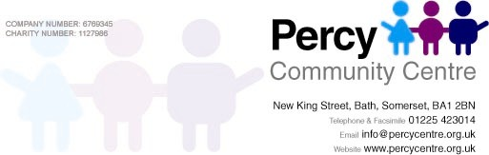

PRACTICAL ARRANGEMENTS FORM

Organisation or Group Leader :

TYPE OF EVENT : DATE OF HIRE :

ROOM REQUIRED : NUMBER ATTENDING :

TIME REQUIRED : ACCESS REQUIRED FROM :

ROOM LAY-OUT
If you have any specific room lay-out requirements
please provide us with a simple diagram in the box
provided on the right and we will do our best to
accommodate your wishes

Number of Chairs

Number of Tables

Equipment hired out at £5.00 per item

TV / DATA CD FLIPCHART
DVD PROJECTOR PLAYER PADS

Flip chart stands are hired out at no extra charge

REFRESHMENTS : How many Tea-breaks are required

Please note that we reserve the right to provide all forms of refreshments. Our tea and coffee are supplied solely by “Fair Trade” companies. Please tick amounts as required.

TEA COFFEE MINERAL WATER ORANGE OR

& BISCUITS (2Ltr Bottle£1.50) APPLE JUICE
(per cup 50p) (per Ltr £1.50)

WE ALSO HAVE A FULL RANGE OF CATERING FOR PARTIES AND CONFERENCES. PLEASE ASK FOR A MENU

