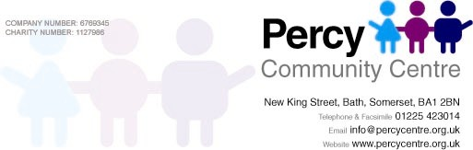

BOOKING FORM

Please note that Percy Community Centre reserves the right to provide all refreshments for your booking
(See Practical Arrangements form)

Organisation / Group / Individual:

Address:

Invoice name & address:

Purchase order no. if applicable

Telephone: Email:

I am authorised to make a booking either on behalf of the above organisation or myself, and shall make known and comply with the conditions of hire, which I have been provided with. (Please also see website.)

T YPE OF EVENT: DATE OF HIRE:

ROOM REQUIRED: NUMBER ATTENDING:

TIME REQUIRED: Access required from:

HIRE CHARGE: £ (Per hour) TOTAL CHARGE: £

A DEPOSIT AMOUNTING TO 50% OF THE TOTAL ROOM HIRE CHARGE IS REQUIRED TO SECURE YOUR BOOKING. Please note: This deposit will be forfeit upon cancellation of a booking is cancelled or any damage to the facilities are caused during your visit to the centre. Payment can be made by cheque (payable to Percy Community Centre) or by BACs: Sort code 40-52-40, a/c 00028934.

Your booking is not confirmed until this form has been received and processed by Percy CC

ALCOHOL LICENCE REQUIREMENTS

I will be serving alcoholic beverages : Signed :

I will supply Percy CC no less than seven days prior to the event with a copy of any and all the necessary legal documentation that may be required to do this.

I will not be serving alcoholic beverages. Signed :

Print Name : Signed :

The person named on this form will be held responsible for their group during its time at the Centre.

