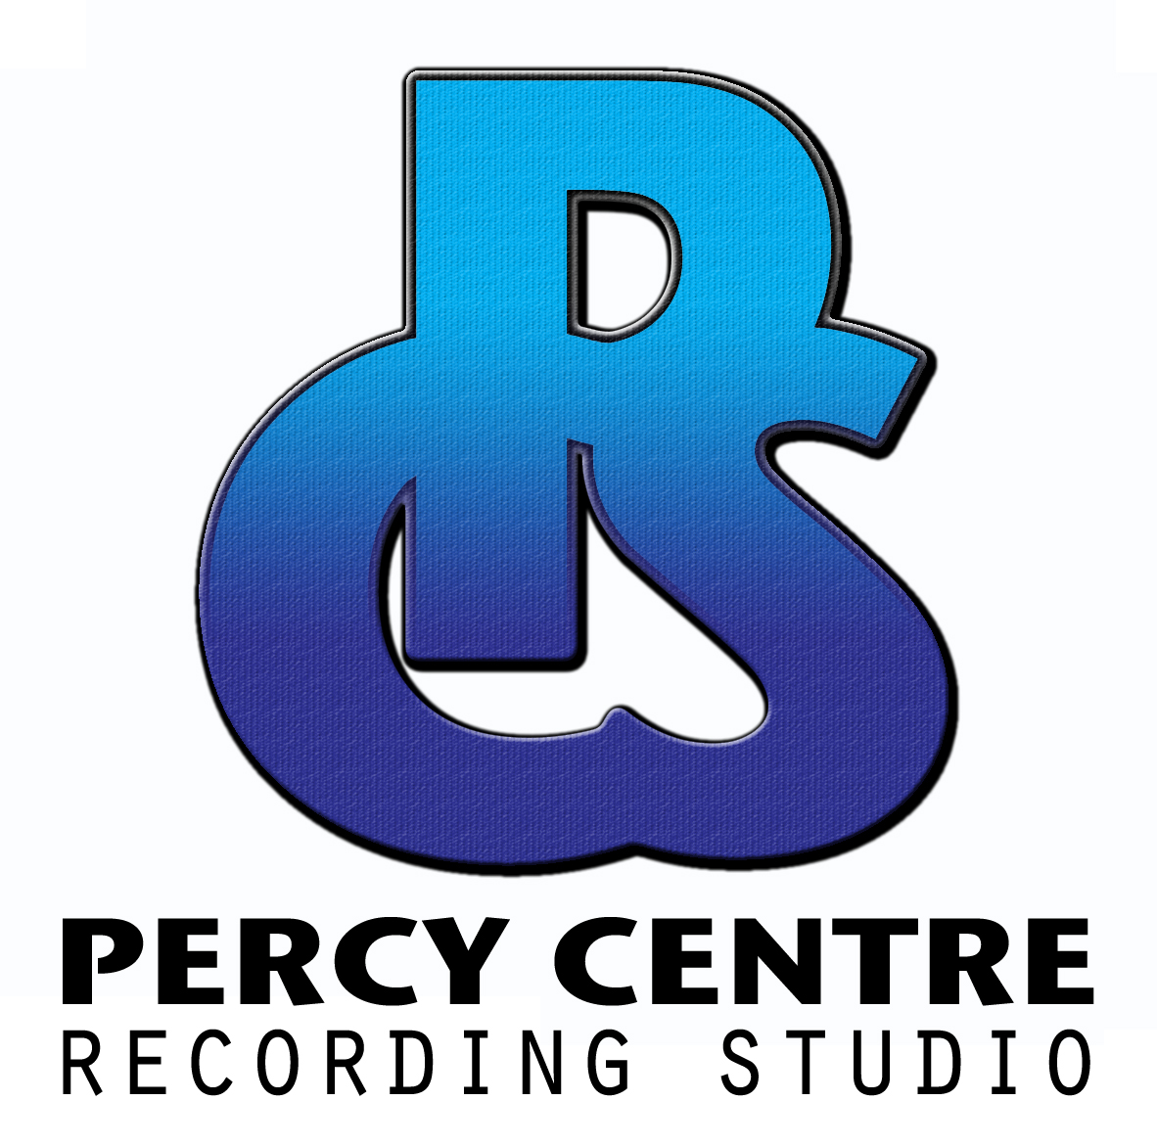

PERCY CENTRE STUDIO, NEW KING STREET, BATH, BA1 2BN
TEL: 01225 423014 EMAIL: INFO@PERCYCENTRE.ORG.UK WWW.PERCYCENTRE.ORG.UK

TO HIRE EQUIPMENT PLEASE FILL OUT THIS FORM BEFORE BOOKING OR ON ARRIVAL

Top of Form
Full Name
Email Address
Telephone Number
Date of Booking
Start Time Finish Time
Equipment Required:

Microphones 1 2 3 4 5 +5 Qty
<INPUT TYPE=\ <INPUT TYPE=\ <INPUT TYPE=\ <INPUT TYPE=\ <INPUT TYPE=\ <INPUT TYPE=\

Mic Stands 1 2 3 4 5 +5
<INPUT TYPE=\ <INPUT TYPE=\ <INPUT TYPE=\ <INPUT TYPE=\ <INPUT TYPE=\ <INPUT TYPE=\

Headphones 1 2 3 4 5 +5
<INPUT TYPE=\ <INPUT TYPE=\ <INPUT TYPE=\ <INPUT TYPE=\ <INPUT TYPE=\ <INPUT TYPE=\

XLR Cables 1 2 3 4 5 +5
<INPUT TYPE=\ <INPUT TYPE=\ <INPUT TYPE=\ <INPUT TYPE=\ <INPUT TYPE=\ <INPUT TYPE=\

Jack Cables 1 2 3 4 5 +5
<INPUT TYPE=\ <INPUT TYPE=\ <INPUT TYPE=\ <INPUT TYPE=\ <INPUT TYPE=\ <INPUT TYPE=\

XLR-Jack 1 2 3 4 5 +5
<INPUT TYPE=\ <INPUT TYPE=\ <INPUT TYPE=\ <INPUT TYPE=\ <INPUT TYPE=\ <INPUT TYPE=\

PA System Yes No Guitar Amp Yes No
<INPUT TYPE=\ <INPUT TYPE=\ <INPUT TYPE=\ <INPUT TYPE=\

Midi Drums Yes No Bass Amp Yes No
<INPUT TYPE=\ <INPUT TYPE=\ <INPUT TYPE=\ <INPUT TYPE=\

Signed
Bottom of Form

Terms and Conditions
All bookings are provisional until we have received a completed booking form. The person hiring is responsible for any damage to equipment or the venue by themselves and their guests. We are not responsible for lost, stolen, or damage to personal items.

To reserve the rehearsal room a deposit of £15.00 is required. The deposit can be paid in cash at our reception office, or via banks transfer and will be returned within 72 hours following the session date providing the equipment is in full working order and the room has been returned to the condition it was supplied in. Including switching off, unplugging and returning any equipment.

By hiring the studio you agree to all terms and conditions contained herein.

