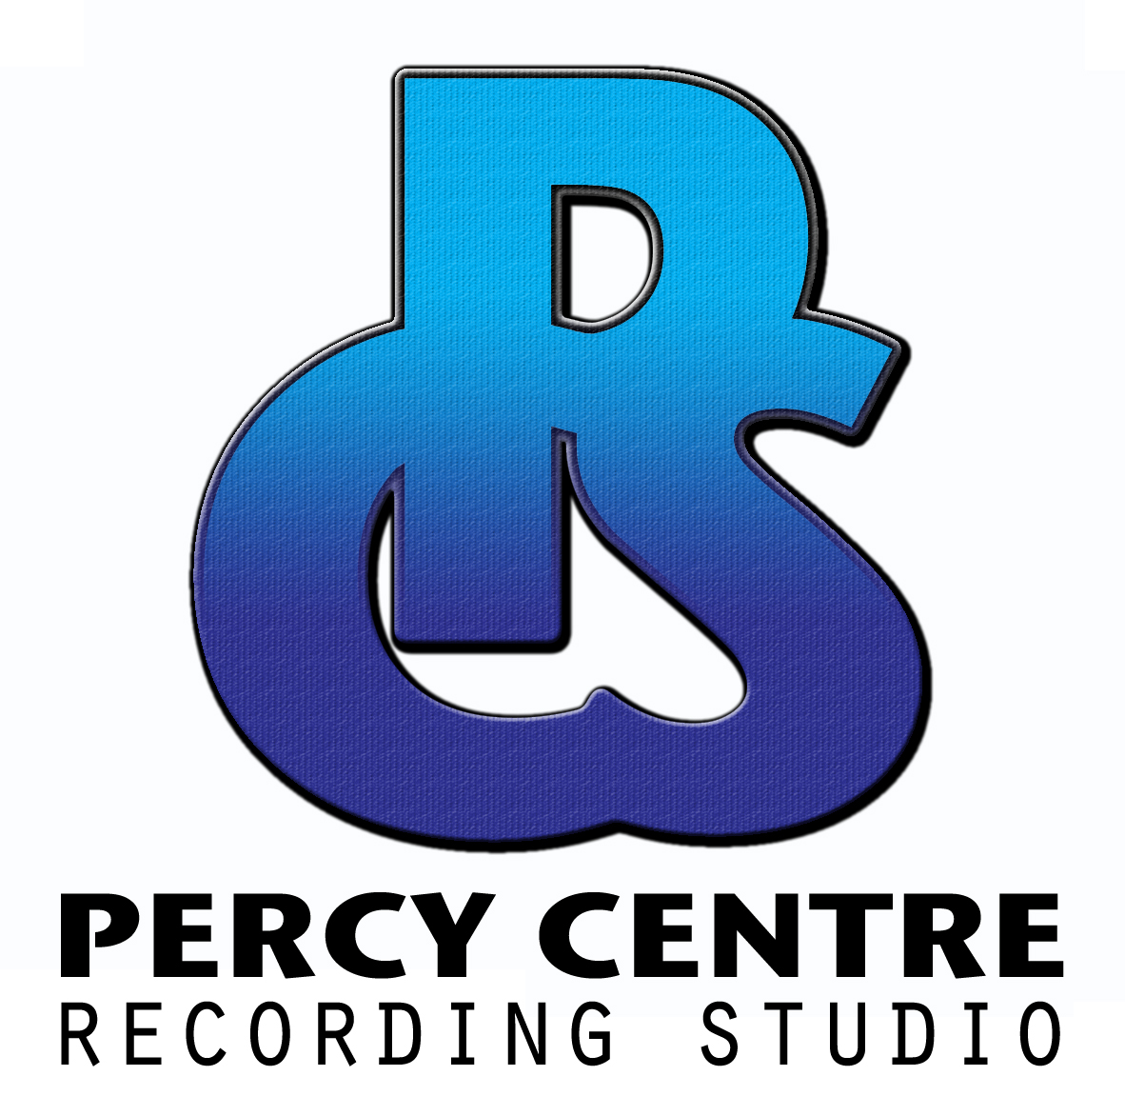
STUDIO BOOKING FORM

To hire the studio please email a completed booking request form and submit via email to: studio@percycentre.org.uk Once we have received your request we will try our very best to arrange a session for your preferred time and date. For more information on our studio rates and services visit our website at: www.percycentre.org.uk/studio

Full name

Address

Postcode

Email
Phone

STUDIO SERVICES Please tick all relevant studio services requested.

Vocal recording Band recording Audio/Vocal mixing Audio mastering Private tuition

Top of Form
<INPUT TYPE=\
Top of Form
<INPUT TYPE=\
Top of Form
<INPUT TYPE=\
Top of Form
<INPUT TYPE=\
Top of Form
<INPUT TYPE=\
Bottom of Form

BOOKING REQUEST

Requested date

Start time
End time

(Minimum booking 2 hours)

BOOKING DETAILS Briefly describe style of music, number of songs and desired outcome

TERMS AND CONDITIONS
To book and reserve a session a deposit of 50% of your total booking fee is required. The deposit can be paid in cash at our reception office, or via banks transfer and will be applied to the session fee or refunded if a cancellation request is received no later than 48 hours prior to booking.

All remaining studio fees are expected to be paid in cash upon your arrival prior to your studio session. Failure to attend or cancel within the allotted time will result in the deposit being taken to cover administration costs and loss of business.

PERCY CENTRE STUDIO, NEW KING STREET, BATH, BA1 2BN
TEL: 01225 423014 EMAIL: STUDIO@PERCYCENTRE.ORG.UK

