Client-Side Web Development: Site Document

Alex Bruno 3147371

Percy Focazio-Moran 3147979

Manoel de Mattos Leal 3147945

Griffith College Cork

Client-Side Web Development: Site Document

Through this document, we will go through the description of the site design, delve into some of the research taken before the creation of the site, share the site map design and the wireframes, review the site as a whole, and finally share the resources and references of the site and the research pages.

Description of site design

The P1P0 website design was decided to be friendly and interactive.  The colour scheme is based on the ping-pong pallet (red, blue, white). Besides that, personal image content was produced to make the website design unique. We have some animations and also a fun ping pong game!

*Home Page*

The home page includes an animated header with the logo and small balls (with the logo image) bouncing and the logo spinning. A picture of developers playing is the main component on this page. Additionally, there are headings with a black shadow design on every page. Finally, on every page we have a footer designed as a ping pong table along with rackets on the top left and bottom-right, simulating a ping pong match. The home page provides a resting place for the user, a jumping off place that has the navigation available and shows the user where they can go to find more information about the club.

*Contact Us Page*

The first part of this page lists some helpful emails to the user, including the emails of the three developers. The contact us page also includes a form to fill out that requests the user’s name, email, subject, and message. The form does not currently actively email anyone, as this requires another language such as PHP. Additionally, the page has CSS to match the theme of the remainder of the website, including a white background for the text areas.

*About Us Page*

The About Us page goes into greater detail about the club, the main players of the club, and what you can expect as a student at Griffith. In the future, we will likely make this more applicable to how to join and what we are currently doing as a club.

*Developers Page*

The Developers page has an interactive set of photos of the three developers: Manoel, Percy, and Alex. When you hover over the image, the image grows slightly and becomes brighter in colour using a grey scale effect in HTML/CSS. Additionally, when you click the image of the developer, the information about what each developer did for the project pops out below their image.

*Ping Pong? Page*

The ping pong page goes into further detail about ping pong itself. Initially, it differentiates between ping pong and table tennis. Then, the page goes into detail about the history of ping pong as a sport. To match the theme of the rest of the site, we utilised CSS.

*Game Page*

A small description of the rules content is shown along with a clickable text to start the game. By clicking on any key the game starts. After the user wins the rounds the theme colours of the game change to show movement to the next round.

*Locations Page*

We used a CSS grid to present the information. Every grid has a paragraph, an image and the address tag below the images. This page provides the locations across Ireland to play ping pong and join teams and games.

*Rules of Ping Pong Page*

Similarly, we used a CSS grid to present the information with a brief description followed by personal images used to illustrate the rules of the game. This page provides the rules of the game, including the governing body that officiated the rules, and what the rules look like using imagery.

Research

This site was inspired from a variety of sources, including the game of ping pong itself. In this section, we will go into more detail about some of the research that inspired us to create the P1P0 site in the way that we did.

*Sticky Header*

While we found many websites with “sticky” headers, the UCC ping pong site was a decent example of what we were looking for. Also, it was important for us to check out our competition’s website. The header is clear, easy to read, and has links to each of the different sections that you can click at any point.

*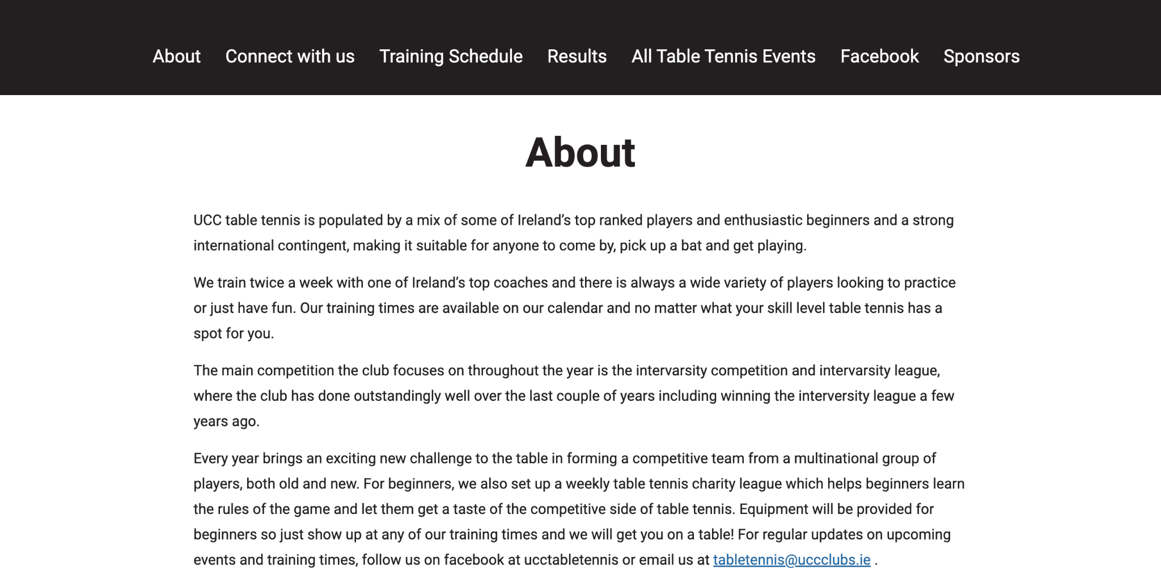*

*Footer*

Our footer was majorly inspired by the game of ping pong itself. We based the bottom off a ping pong table, as pictured below, in both its blue colour and its distinctive lines. Additionally, we utilised imagery of ping pong rackets to perfect the image.

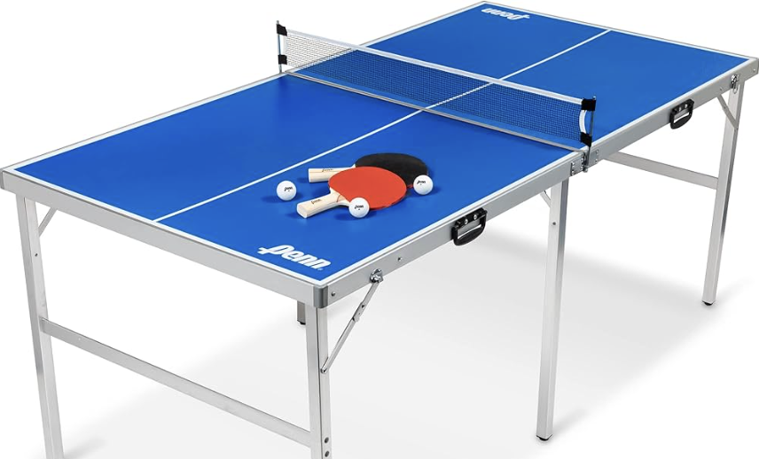

Image sourced from <https://www.amazon.com.au/Folding-Table-Tennis-Tables-HyperPong/dp/B09KNC9JKZ>

*JavaScript Animation*

The following example site for Eastside Paddle Club was a large inspiration for some of the JavaScript effects and animation that we implemented in our site. One of the main animations we enjoyed was the spinning text around the pickleball ball.



*Contact Us Form*

The following contact form, while simple, was also an inspiration for our contact us page. It was clear, easy to read, within a colour scheme, and gave notification when you sent a message.

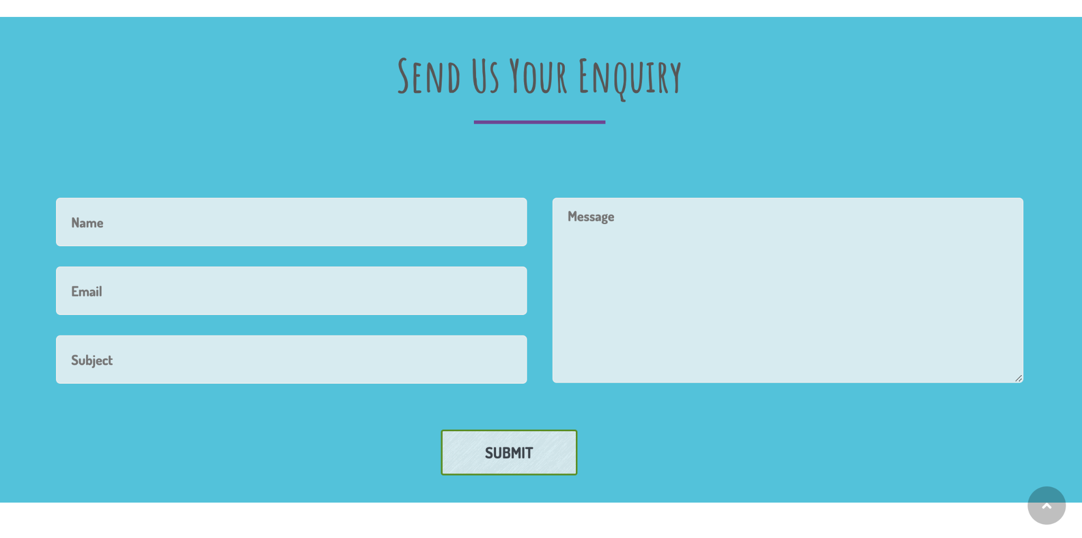

Site-Map Diagram

Site-Map Diagrams are vital for organising and planning sites. They give the developers an idea of where each page should link to and what should be available to the users. In this case, the first document we created was the site-map diagram. Since its creation, we have kept the linking the same but changed the names of the site pages to better suit what a user may expect a page to be labelled.

*Site Map Diagram, next page.*

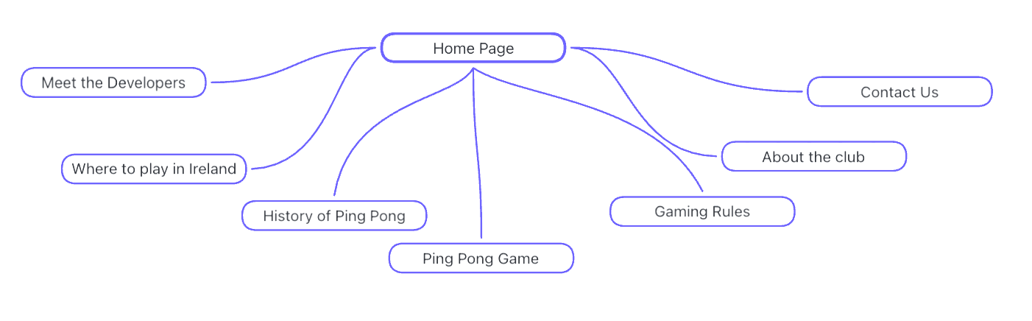

Wire Frames

This section provides the wire framing for the home page of our ping pong website.

*Desktop*

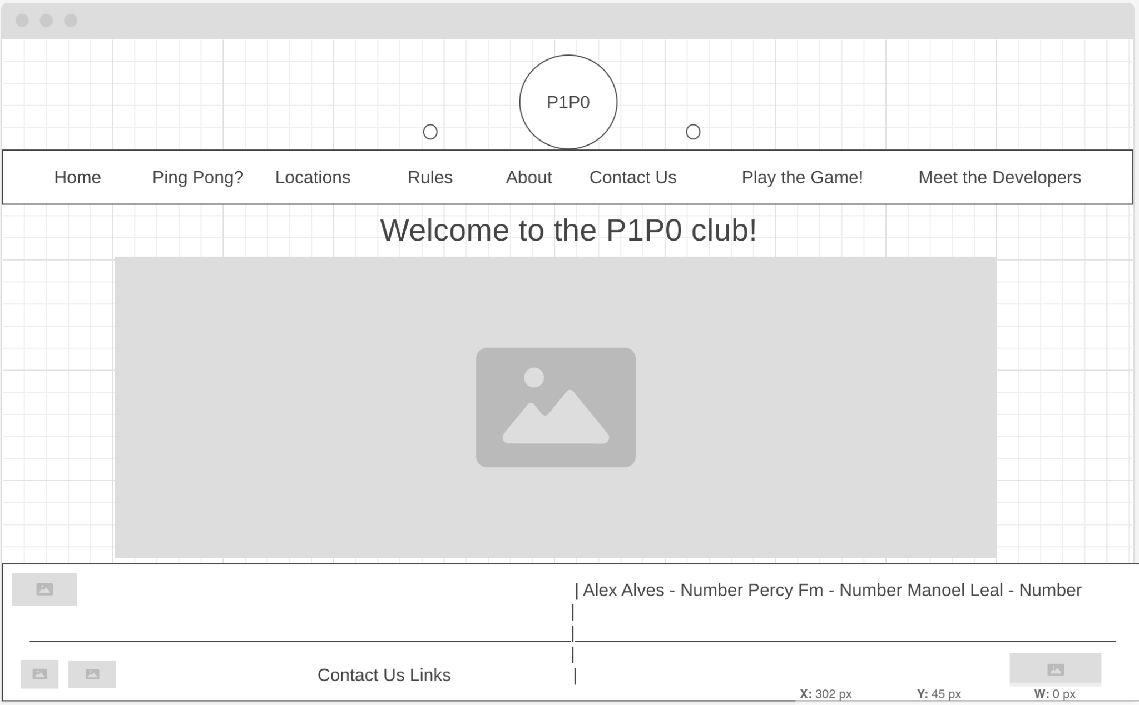

*Mobile*

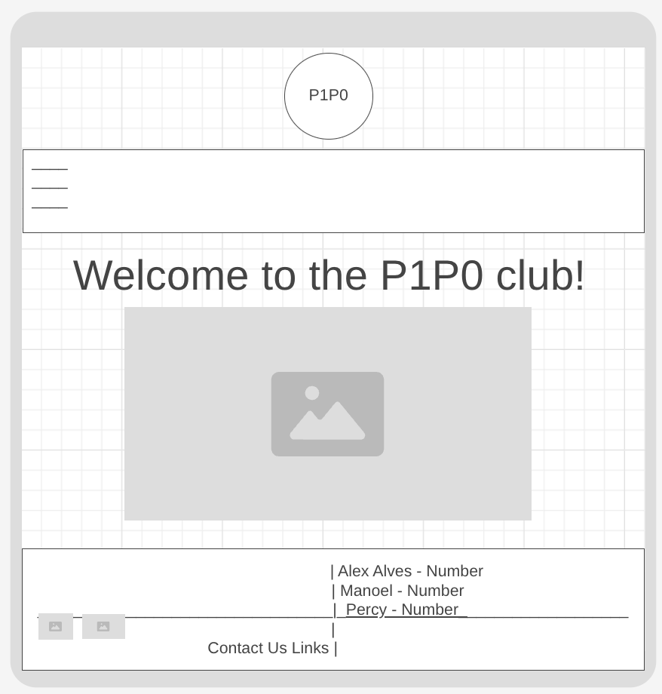

Review

In this section, we will go into more information about our site, both what we enjoy and feel like we could improve on. Additionally, we will discuss some notes that we feel needed to share but had no other place to.

*Images*

All images used in the site were created for us and used personally by us (Manoel de Mattos Leal, Alex Bruno Alves, and Percy Focazio-Moran), or are referenced both in the code and below in this document in APA format.

*Where We Excelled*

This project really brought out each of our strengths, as working in a team for the first time in web development allowed us each to bring a variety of strengths. Manoel has a history of working with JavaScript, and was able to teach Alex and Percy various methods of using JavaScript in ways we were not familiar with previously. Percy was able to create the HTML and CSS bones quickly and created structure and framework for each of us to work on. Alex is hardworking and very capable with CSS, giving the site a distinctive look and feel.

*Room For Improvement*

Throughout this project, each of our team members had difficulties that we persevered through. With every project, we learn where we can improve and what more we could learn. In the case of this project, there are a couple areas that could be room for improvement. First off, the game, while impressive, does not work on mobile or tablet. It is only responsive in desktop formats. Secondly, we could work on the responsive design for longer, and give more features and functionality no matter the size of the desktop or mobile device in general.

*Reflection*

Overall, our team is proud of our accomplishments and excited to continue to update this site and eventually host it online as a legitimate site for Griffith’s ping pong club.

References

*Athlone Table Tennis Club*. (n.d.-c). https://www.facebook.com/ATTC59/photos

Barna, V. (2024, July 24). *Table tennis | History, Rules, Equipment, Champions, & Facts*. Encyclopedia Britannica. https://www.britannica.com/sports/table-tennis/Equipment-rules-and-play-of-the-game

*Beechhill Table Tennis Club*. (n.d.). https://www.facebook.com/BeechhillTableTennisClub/photos

*CBC Table Tennis Galway*. (n.d.). https://www.facebook.com/CBCTTG/

Coach EmRatThich. (2024, May 12). *Why Table Tennis Struggles to Gain Popularity in the US*. PingSunday. Retrieved July 25, 2024, from https://pingsunday.com/why-table-tennis-struggles-to-gain-popularity-in-the-us/

*Contact – Apres School Club.* (n.d.).

https://www.apresschoolclub.com/contact/

*Eastside Paddle Club - Webflow*. (n.d.). Eastside Paddle Club. https://webflow.com/made-in-webflow/website/eastside-paddle-club

Loop Table Tennis. (2024, February 8). *Home - Loop table tennis*. https://looptabletennis.com/

*Ping Pong free icon*. (n.d.). https://www.flaticon.com/free-icons/ping-pong

Social Media Flaticon. (n.d.). https://www.flaticon.com/free-icons/social-media?word=social%20media&color=white

*Table Tennis | University College Cork*. (n.d.). University College Cork. https://www.ucc.ie/en/sport/clubs/tabletennis/

*Table Tennis Stars Waterford*. (n.d.-b). https://www.facebook.com/profile.php?id=61560397763756&sk=photos

User, S. (n.d.). *What is the difference between ping pong and table tennis? | FAQ | Rules of Sport*. https://www.rulesofsport.com/faq/what-is-the-difference-between-ping-pong-and-table-tennis.html