市立新北高工105學年度第1學期補考試題 |  |  |  |  |  |  |  | 班級 |  | 座號 |  | 成  績
科 目 | 英文閱讀 | 使用答案卡及答案卷 |  | 年級 | 1 | 科別 | 機鑄電模汽圖資訊 | 姓名 |  |  |  | 成  績

請將以下選擇題答案劃記於答案卡上(否則不予計分);並劃上座號, 未劃座號者酌扣總分15分
When you learn a new language, it is important to learn some of its slang. For example, American friends may say “What’s up?” to each other when they meet. “What’s up” is slang. It doesn’t mean “What is up there?” Instead, it means “How are you?” or “How are you doing?” Another example is the slang phrase “big gun.” When people say “Tom brought two big guns to the meeting,” it doesn’t mean Tom brought two real guns to work. Instead, it means Tom brought two powerful and important people to the meeting.
It is also important to learn idioms when you study a new language. For example, when people say “Let’s play it by ear,” it doesn’t mean they want to play with their ears. It means they want to do something without a plan. Another example of an idiom is “to jump down someone’s throat.” When people say “If I don’t get home on time, my parents will jump down my throat,” it means their parents will scold* them. Therefore, the next time your parents scold you for something you didn’t do, you can say to them, “Don’t jump down my throat. I didn’t do it!”
1. According to the article, which is true?
(A) When you speak a new language, try not to use too many slang words.
(B) When people learn a language, they should also learn its slang and idioms.
(C) “Let’s play it by ear” means playing with ears is fun.
(D) “To jump down someone’s throat” means to hit someone.
2. What does “What’s up?” mean?
(A) “What is up there?” (B) “What’s your plan?”
(C) “How is everything?” (D) “How is the weather today?”
3. What could you answer when your friends ask you, “What should we do
tonight?”
(A) “Don’t jump down my throat.” (B) “What’s up there?”
(C) “Let’s play it by ear.” (D) “How are you doing?”


King’s Bakery Grand* Opening!
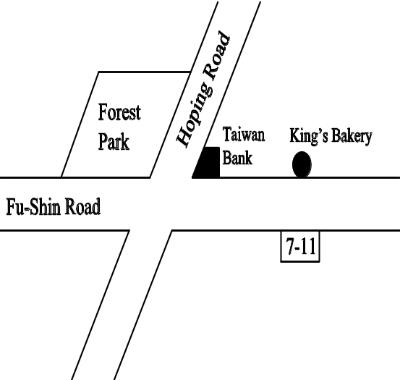
We open our doors to welcome you on December 29th (Sunday)
Don’t miss the wonderful taste and smell of our delicious bread!
- Opening Day Special Sale (One day only!)
Bagel* (NT$35)  Buy 2 get 1 free
Donut* (NT$20)  Buy 1 get 1 free
- New Year’s Special Sale (Until January 12th)
All cakes → 50% off!
TEL: 07-533-3345

4. Where is King’s Bakery?
(A) Next to the bank.
(B) Across from a convenience store.
(C) At the corner of Hoping Road and Fu-Shin Road.
(D) Next to the park.
5. If you go to King’s Bakery on December 29th and get 3 bagels and 4 donuts, how much will you pay?
(A) NT$70.
(B) NT$40.
(C) NT$110.
(D) NT$185.
6. How long will the New Year’s Special Sale last?
(A) For two weeks.
(B) For three weeks.
(C) For the whole month of January.
(D) For the whole month of December.
As the saying goes, “He that travels far knows much.” If I have a chance to travel abroad, I will go to Japan. There are several reasons for my choice.
First, Japan is close to Taiwan. The flight takes less than 4 hours and the local time in Japan is only one hour ahead of Taiwan time. I won’t have jet lag* or feel too tired.
Second, I’ve been learning Japanese for years. I hope I can get a chance to improve my Japanese and better understand the country’s history, art, and culture. Since I was little, I’ve learned a lot from history classes about this country. I also realize that Taiwan and Japan are very similar in many ways. The trip will allow me to directly experience what I’ve read and heard about.
Third, Japanese people are believed to be polite and friendly. I am sure I won’t feel lonely and will be treated nicely during my stay in Japan.
In addition, paying a visit to Disneyland in Tokyo has been my dream since I was a child. As an elementary school student, I was jealous of* my classmates who had been there. Now I have been working for three years and have saved some money. I think I will carry out my dream very soon.
7. What does the writer want to express here?
(A) Traveling is fun but costs lots of money.
(B) Japan is a country worth visiting for various reasons.
(C) Taiwan and Japan are much alike in many ways.
(D) Learning Japanese is necessary.
8. Why is Japan the writer’s first choice?
(A) The standard of living is higher than that in Taiwan.
(B) Tickets to Japan are cheaper than those to other countries.
(C) The writer has a relative living there.
(D) The writer wants to learn more about Japanese culture.
9. How does the writer know about Japan?
(A) His parents have told him about the country.
(B) He has a Japanese friend.
(C) He has learned about Japan in school.
(D) He has been to Japan several times.
10. The saying “He that travels far knows much” means .
(A) traveling is more important than taking exams
(B) traveling is expensive but interesting
(C) traveling helps people experience many things
(D) people who love traveling are easy-going
11. Which statement is NOT true?
(A) The writer loves Japan.
(B) The writer is now out of work.
(C) Flying to Japan won’t take too long.
(D) The writer can speak some Japanese.
Body language plays an important role in people’s everyday lives. Some studies show that more than 90 percent of our communication is done through body language, and even a kid knows more than one hundred gestures. We may think some kinds of body language are the same all around the world, but this is not the case.
For example, when people want to show that they agree, in many countries they nod their heads. However, nodding the head does not always have this meaning. Take the countries of Bhutan* and Nepal* for example. People in these countries nod their heads to show disagreement and shake their heads to express agreement. The same is true of the Inuits*, whose ways of sending messages with their bodies are completely different from those of most of the world.
In Japan people bow when they say goodbye to a friend, but in France it’s common to give the other person a hug and kiss. In Taiwan, waving goodbye is common.
As the saying goes, “When in Rome, do as the Romans do.” We have to be very careful about the meanings of gestures in certain countries or regions if we don’t want to be considered impolite or rude.
12. What’s the main idea of the passage?
(A) Body language may replace human speech in the future.
(B) People can express their thoughts and feelings through gestures.
(C) The Japanese are polite while the French are very romantic.
(D) Understanding local customs and body language is very important.
13. How are Bhutan and Nepal different from many other countries?
(A) People in these two countries are easy-going and healthy.
(B) Nodding means disagreement and shaking one’s head means yes.
(C) People in these two countries believe in Buddhism.
n. [U] 佛教
(D) The laws in these two countries don’t allow people to make gestures.
14. According to the passage, what does the word “most” refer to?
(A) Most gestures. (B) Most messages.
(C) Most countries. (D) Most Inuit people.
15. Which statement is NOT true?
(A) Over 90 percent of all communication is done through body language.
(B) Even a kid can understand gestures.
(C) The French usually give a hug and kiss when parting from their friends.
(D) In Japan, bowing is a rare gesture.
16. When an Inuit nods his or her head, it means he or she .
(A) likes something
(B) is afraid of something
(C) disagrees with someone
(D) wants to make friends with someone
Without a doubt, Jeremy Lin is one of the most popular players in the NBA. The American-born Chinese realized his dream of becoming an NBA player in 2010. His story has encouraged tens of thousands of teens. A well-known word, “Linsanity,” was even created because of him.
Lin was raised in a Christian* family in Los Angeles. His parents went to the United States from Taiwan in the mid-1970s. The couple had three sons, Jeremy being the second. His father taught his sons to play basketball at the local YMCA. His mother also encouraged him to develop his basketball skills, even though her friends disagreed with her idea. Luckily, she allowed her son to do what he enjoyed.
Jeremy Lin’s success is not a miracle. The support of his family and his own efforts have both helped with his amazing achievements.
17. What’s the main idea of the passage?
(A) Jeremy Lin’s parents are from Taiwan and have achieved much.
(B) Lin’s parents like him to play basketball very much.
(C) The word “Linsanity” was created because of Lin.
(D) Lin’s achievements resulted from his family’s support and his own efforts.
18. How many brothers does Jeremy Lin have?
(A) One. (B) Two. (C) Three. (D) None.
19. The Lin family believes in .
(A) Christianity
(B) Catholicism
(C) Buddhism
(D) Islam
20. Which statement is NOT true?
(A) Lin used to practice playing basketball with his father and brothers at the
YMCA.
(B) Lin’s parents are both from Taiwan.
(C) Lin’s mother’s friends agreed with the way she treated Lin.
(D) Lin grew up in the U.S.

