市立新北高工105學年度第1學期第1次段考試題 |  |  |  |  |  |  |  | 班級 |  | 座號 |  | 成  績
科 目 | 英文 | 使用答案卡及答案卷 |  | 年級 | 1 | 科別 | 機鑄電模汽圖資訊 | 姓名 |  |  |  | 成  績

請將以下選擇題答案劃記於答案卡上(否則不予計分);並劃上座號, 未劃座號者酌扣總分15分
- Listening Comprehension (10%)
a. Pictures 看圖辨義 -2%
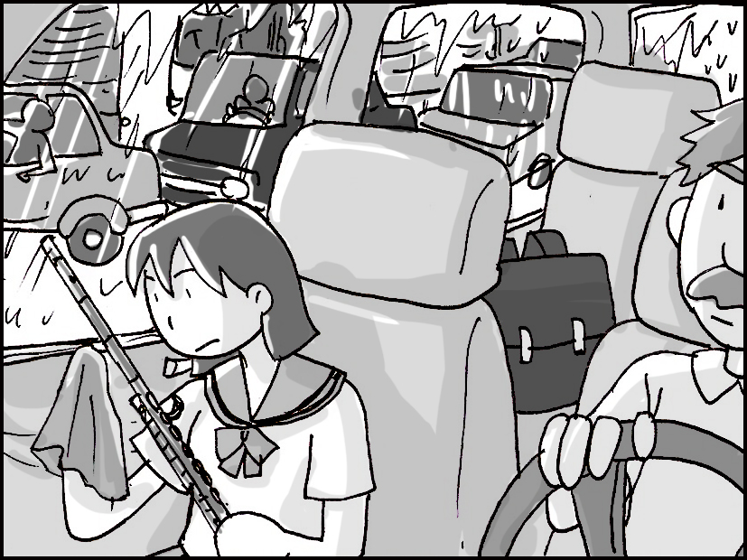
Listen to the questions. Then choose the best answer according to each picture.
A.

- ______

- ______

b. Best Response 最佳回應句 -3%
Choose the best response to each question or statement.

- A. I forgot to add sugar.
B. Your customers will love it.
C. I’d like another piece, please.
D. I don’t like scary movies, either.

- A. Well, I can buy some new earrings.
B. It’s always in my purse.
C. Sure, I can pay for lunch.
D. Near the bank in the mall.

- A. I want to buy a card made of thick paper.
B. You need to get a card for your brother.
C. Here’s is a pen to write a note.
D. Use this glue to do it.

c. Short Conversations 簡短會話 -3%
Listen to the conversations. Then answer the questions.

- A. To buy a gift.
B. To eat a meal.
C. To play a sport.
D. To paint a picture.

- A. He is a customer.
B. He is a server.
C. He is a baker.
D. He is a writer.

- A. They will shine.
B. They will sing.
C. They will cook.
D. They will swim.
d. Short Talk 短文 -2%
Listen to the talk. Then choose the best answer to each question.

- A. She is checking his schedule.
B. She is sharing a funny story.
C. She is telling him some news.
D. She is asking him for help.

- A. Saturday morning.
B. Saturday at noon.
C. Saturday afternoon.
D. Saturday evening.
II. Grammar (20%)
11. If you feel uncomfortable, why not _____ a day off and rest?
(A) take (B) taking (C) to take (D) taken
12. Ray believes _____ there are ghosts.
(A) which (B) that (C) who (D) what
13. We always look forward to Christmas Eve because then we open the gift boxes under the Christmas tree. Every gift box can be _____.
(A) seem surprising (B) a surprise (C) surprised (D) to surprise
14. .The shampoo smells _____ chocolate.
(A)× (B) like (C) alike (D) likely
15. If you ______the train, you can take the bus.
(A) missing (B) will miss (C) miss (D) missed
16. The tree in my garden has grown so _____.
(A) be tall (B) tally (C) at tall (D) tall
17. It doesn’t really matter _____ did the work. What matters is that the work gets done.
(A) where (B) who (C) when (D) which
18. Debbie didn’t want to tell her dad that she skipped class last week because she knew he would be angry. _____, her dad was already having a bad day.
(A) Then (B) Therefore (C) Besides (D) However
19. The milk _____ bad easily if you don’t store it in the refrigerator.
(A) go (B) goes (C) going (D) went
20. David’s cold is _____ worse. He had better see a doctor.
(A) get (B) gets (C) got (D) getting
III. Cloze (20%)
“I can’t give you anything but my love….” Does this song 21_____ familiar to you? Its 22_____ lyrics were used by Gatsby in its hair wax* TV commercial, and they 23_____ stuck in people’s heads. “I can’t give you anything but my love…” was changed into “I can’t give you anything but Gatsby.” Through the lyrics, Gatsby tried to tell the viewers 24_____ it wanted to give them the most special hair wax they could ever wish for. 25_____ this song, the commercial became more exciting and catchy.
21(A) taste (B) sound (C) become (D) look
22(A) catchy (B) sudden (C) involved (D) real
23(A) get (B) gets (C) got (D) is got
24(A) which (B) who (C) where (D) that
25(A) By (B) Into (C) With (D) Toward
“Ding-dong!” “May I help you?” Why do you feel like buying a cup of coffee every time you 26_____ a convenience store? Just 27_____ many others, you may long to experience the happy feeling in the TV commercial for the coffee brand. This happy feeling is associated 28_____ the actors’ smiles in the commercial. When you drink the coffee, you may be in a happy 29_____. That’s how the convenience stores succeed in selling their 30_____. There is a story behind every cup of coffee sold!
26(A) walk by (B) get stuck (C) take away (D) play a role
27(A) in (B) like (C) toward (D) with
28(A) at (B) in (C) of (D) with
29(A) product (B) beginning (C) mood (D) creativity
30(A) classic (B) music (C) products (D) commercials
IV. Synonyms (10%) 近義字選擇-選出最接近劃線單字意義的字
31. .Our original plan didn’t work, so we had to change it.
(A) best (B) latest (C) long (D) earliest
32. The prisoner escaped through a hidden tunnel.
(A) yummy (B) secret (C) popular (D) closed
33. Shelly answered the teacher’s question in a(n) surprising way: she sang the answer like it was a song.
(A) unexpected (B) useful (C) peaceful (D) colorful
34.“Nobody” is one of the most popular dance tunes from a Korean (韓國的) pop group.
(A) lyrics (B) melodies (C) circles (D) dolls
35. It is an interesting idea to include the students’ parents in classroom activities. In this way, maybe the parents can learn something, too.
(A) appear (B) involve (C) produce (D) long
V. Reading Comprehension (10%)
Annie is in the supermarket now. She has to buy some ingredients* to make tiramisu. She is going to have a potluck party tonight. She has asked her friends to bring salad, pasta, pizza, and fried chicken. Annie has decided to prepare tiramisu. She has already picked up flour, sugar, chocolate, cheese*, and eggs. She does not know what else she should also buy. She is thinking that maybe she should buy a cookbook to see how to prepare tiramisu. But then she comes up with a better idea. She remembers that her grandma knows how to prepare delicious desserts. She is talking with her grandma on the phone now. “Yes. I need to prepare tiramisu. What? Pudding is a better idea? OK, pudding is fine, too. What should I do then? Keep the eggs, flour, and sugar. OK. Are five eggs enough? There will be just five friends and I. OK, five eggs. I don’t need the rest? OK. Can you come and help me? Thanks, Grandma! See you later!”
36.What WON’T Annie’s friends bring to the potluck party?
(A) Pasta. (B) Fried chicken. (C) Pudding. (D) Salad.
37.What ingredients does Annie need in the end?
(A) Eggs, sugar, and chocolate.
(B) Flour, sugar, and cheese.
(C) Cheese, eggs, and flour.
(D) Flour, eggs, and sugar.
38.What is Annie going to prepare for the potluck party?
(A) Pudding. (B) Tiramisu. (C) Pasta. (D) Salad.
39.How will Annie prepare her dessert?
(A) She will follow a cookbook.
(B) Her grandma will help her.
(C) Her friends will help her.
(D) She will create a new dish.
40.How many people will there be at the potluck party?
(A) Three. (B) Four. (C) Five. (D) Six.
*ingredient n. [C] （烹調的）原料 *cheese n. [U] 乳酪
VI. Vocabulary and Phrases (30%)
41. Chinese New Year is a j_____l time when families get together.
42. The Olympic Games drew an a_____e of more than 15 million people.
43. Tracy is f_____r with Taichung because she spent her childhood there.
44. The old lady wants to do something meaningful for the r_____t of her life.
45. Nancy’s parents gave her a computer as a birthday gift because they knew that she l_____d to have a new computer.
46. This company’s p_____ts are very popular among young people.
47. Many people feel a_____d when they speak a foreign language for the first time.
48. Ann’s father is very g_____e when he reads the bedtime story. His soft sound lets her fall asleep very quickly.
49. I don’t remember much about the accident because it happened so s_____y.
50. Teenagers, both boys and girls, care a lot about their a_____e.
51. Because Anthony lost an important game, he was in a bad m_____d.
52. Would you like to go to the flower f_____r with me tomorrow? There will be lots of florists (花商) selling various flowers.
53. The history of this old castle d_____b_____ to the 8th century. It has been standing there for a long time.
54. I was afraid that I would get lost in the big city. But i_____ f______, the subway is very easy to understand, so I had no trouble at all.
55. Lily plans to i_____ some friends o_____ for her birthday party.

*英文要好，沒有瞬間的奇蹟，只有每天的累積!!
*提升英文能力的不二法門—勤勞!
平日主動積極參與英文學習—多聽，多讀，多說，多寫，多譯!
As you sow, so shall you reap!! 一分耕耘，一分收穫

