新北高工 一0五學年度第 一學期 段考 |  |  |  |  |  |  |  | 班級 |  | 座號 |  | 成
科目 | English | 年級 | 二 | 科別 | 機鑄汽模圖資電訊 |  |  | 姓名 |  |  |  | 績
- 10% (請選出最適合的答案)  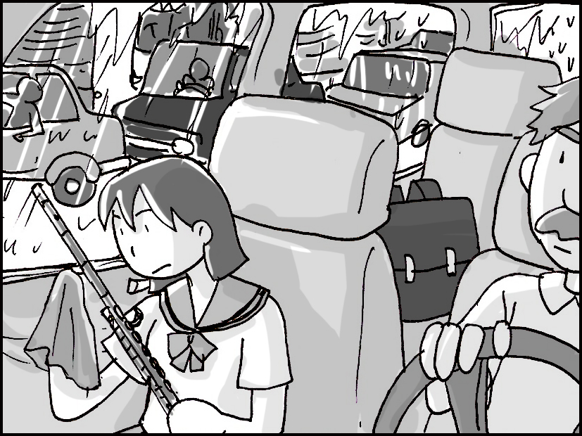  - Pictures 看圖辨義 Listen to the questions. Then choose the best answer according to each picture.  - ______  - ______  II. Best Response 最佳回應句 Choose the best response to each question or statement.  - A. Is it a good elementary school?  B. Do you like junior high?  C. Are you in the high school band?  D. What grade do you teach?  - A. I forgot to add sugar.  B. Your customers will love it.  C. I’d like another piece, please.  D. I don’t like scary movies, either.  - A. We can’t see very far.  B. Look! I’m good at bowling!  C. OK, pick a day.  D. Yes, I’m sure.  - A. Well, I can buy some new earrings.  B. It’s always in my purse.  C. Sure, I can pay for lunch.  D. Near the bank in the mall.  - A. I want to buy a card made of thick paper.  B. You need to get a card for your brother.  C. Here’s is a pen to write a note.  D. Use this glue to do it.  III. Short Conversations 簡短會話Listen to the conversations. Then answer the questions. Each question will be read twice.  - A. Open a box.  B. Open a book.  C. Open a purse.  D. Open a closet.  - A. The man’s job.  B. The man’s health.  C. The man’s family.  D. The man’s clothes.  - A. He is a customer.  B. He is a server.  C. He is a baker.  D. He is a writer.  27. (A) who (B) who named (C) named (D) naming  28. (A) In the beginning (B) As a result (C) For instance (D) After all  29. (A) so that (B) as to (C) in addition to (D) in order to  30. (A) board (B) position (C) crew (D) reception  D. Reading Comprehension 20% (請選出最適合的答案)  Nike, New Balance, and Adidas are world-famous sportswear brands. But do you know their histories?  Nike was founded in 1964 by an athlete and his coach. “Nike” was the name of the Greek goddess of  victory. At first, the company only sold Japanese shoes. The interesting thing was that Nike didn’t have a  store but used a car to do business when there were sports meets. Who would have thought that someday it  would become the world’s most valuable sports brand? Air Jordan is one of the company’s best –selling  products due to Michael Jordan’s endorsement. Nike’s impressive slogan is “Just Do It!” and it has greatly  helped to increase its global sales.  New Balance, like Nike, is an American brand, and it was founded near Boston in 1906. This company  has continued to make shoes in the United States and in the United Kingdom. That is why some New Balance  shoes are more expensive than the shoes of companies which make their shoes in less developed countries  using cheaper labor.  Unlike New Balance and Nike, Adidas is a European company. It was set up in 1948 in southern  Germany. It is the largest sportswear manufacturer in Europe. Its founder were two brothers, but the  older one left to establish Puma and then these two brands faced bitter competition. Unfortunately,  the two brothers’ relationship never improved before they died.  31. According to the passage, which sportswear brand is from Europe?  (A) Nike. (B) New Balance. (C) Adidas. (D) All of the above.  32. Among the international brands mentioned above, which one is the oldest?  (A) Nike. (B) Adidas. (C) New Balance. (D) Puma.  33. Why are some New Balance shoes more expensive?  (A) They are handmade. (B) They are produced in the USA and the UK.  (C) Many sportsmen wear them. (D) They are sold at fancy department stores.  34. Where did the name “Nike” come from?  (A) It was named after Michael Jordan. (B) It was created by a Japanese. (C) It was named after a  type of labor in America. (D) It was the name of the Greek goddess of victory.  35. According to the passage, which statement is not true?  (A) Nike was founded by two brothers. (B) The slogan “Just Do It!” has been helpful in increasing  Nike’s market share. (C) Adidas is the largest sportswear manufacturer in Europe. (D) “Air Jordan”  is a popular shoe product due to Michael Jordan’s support.  Cathy’s trip to New York was a total disaster. To begin with, she reserved a room at the wrong  hotel. She didn’t reserve a room at the Park Hotel; she reserved one at the Parked Hotel, which is not  only far from the city’s top attractions but also more expensive than the Park Hotel. Second, she  forgot to download a New York City map onto her smartphone, so she got lost many times and  arrived late at many places. Worst of all, she lost her ticket to a Broadway show. She had booked  and paid for the ticket online before going to New York and got the ticket on the first day she  arrived there. However, on the day of the show, Cathy could not find the ticket. On her way back  home, Cathy looked back on this four-day trip and knew that she had made several mistakes. First  of all, she was too careless when booking the hotel. Then she did not plan well in advance and  prepare everything she needed before her departure. Also, she did not look after her belongings  carefully. Although she did not really enjoy her trip because of these mistakes, she learned a lot  from the experience. Next time, she will be better prepared before going on a trip!  36. What is the best title for this passage?  (A) New York City’s Top Five Attractions (B) How to Book a Broadway Show  (C) A Trip with Many Problems (D) How to Choose a Hotel  37. Which of the following statements about the Park Hotel is true? |  |  |  |  |  | B. 綜合選擇 20% (請選出最適合的答案)  11. Nancy did nothing yesterday but _______ online shopping.  (A) went (B) go (C) goes (D) going  12. The stray dog was _______ pitiable that she had no choice but to take it home.  (A) such (B) so (C) too (D) even  13. _______ lovely the new born baby is!  (A) Which (B) What (C) How (D) Why  14. What _______! The magician is totally amazing!  (A) great (B) greatly (C) a great show (D) great a show  15. Lucas went cycling as soon as the rain _______.  (A) will stop (B) stops (C) stopped (D) stopping  16. Cathy has decided to go to Korea for working holidays next month. She thinks it is worth ____.  (A) to do (B) to be done (C) do (D) doing  17. Taipei 101 is the _______ building in Taiwan.  (A) as tall as (B) tall (C) taller (D) tallest  18. _______ place is as sweet as home; that is, home is the sweetest place.  (A) Any other (B) All the other (C) No other (D) Other  19. No other country in the world is _______ my country.  (A) as beautiful (B) more beautiful than (C) the most beautiful (D) the more beautiful  20. We arrived at the movie theater early _______ we could get the best seats.  (A) in order to (B) so that (C) because (D) so as to  - Cloze 20% (請選出最適合的答案)  The FIFA World Cup is a well-known football competition, which offers you a chance to get involved in one of the most exciting international sports events. It ___21____ every four years in countries that FIFA members decide on. Teams from every country have to compete against each other in the first stages, which last ___22____ three years. And in the fourth year, or the FIFA year, only 32 teams are allowed to join in the final match of the World Cup. This is when people all over the world get most ___23____. Lots of people will watch the live ___24____ of the match and may jump up and down while they shout out the names of their favorite players or teams to cheer for them. The winners not only get a large amount of money but also give their countries something to be proud of. It is not ___25____ that so many people are crazy about following the World Cup!  21. (A) takes on (B) takes off (C) takes place (D) takes action  22.(A) in (B) with (C) on (D) for  23. (A) excited (B) excite (C) excites (D) exciting  24. (A) ability (B) broadcast (C) confidence (D) creativity  25. (A) surprises (B) surprise (C) surprising (D) surprised  One hundred and fifty years ago, there was no bridge across the East River between  Manhattan and Brooklyn. Every day, ___26____ of people crossed the river by boat. An engineer  ___27____ John Roebling wanted to build a bridge so that people could cross more easily. ___28____, things were going well. However, John soon got seriously injured and passed away. His son, Washington, had to take over. But soon, Washington got hurt, too. He could neither speak nor walk. Despite these disabilities, he did not give up. He created a code with his wife ___29____ tap her on the arm to tell her what to do. She would then tell the___30____. At last, they finished building the bridge.  26. (A) thousand (B) two thousand (C) many thousand (D) thousands  (A) Its staff can help you book a ticket to a Broadway show. (B) It is more expensive than the Parked  Hotel. (C) Cathy did not reserve a room in it in advance. (D) It is far from the city’s top attractions.  38. Which of the following is one of the bad things that happened to Cathy when she was in New York?  (A) She was hit by a car. (B) She got lost many times. (C) She met her old friends. (D) She caught a cold.  39. According to the passage, which of the following statements is not true?  (A) Cathy’s smartphone was stolen. (B) Cathy booked a Broadway show ticket online.  (C) Cathy stayed in New York for four days. (D) Cathy reserved a room at the Parked Hotel.  40. According to the passage, which is not one of the mistakes that Cathy made?  (A) She could not find the ticket to a Broadway show. (B) She reserved a room at a more expensive  hotel. (C) She was not well-prepared in advance. (D) She was late for her Broadway show.  E. 填充30%  41. All of the fans r_______ed their cameras in the crowded hall to take pictures of the superstar.  42. The school will spend a huge s_______m of money building a large modern gym.  43, Lucy was e_______r to get a job after she graduated from college.  44. I am fond of pets, e_______y dogs and cats.  45. Ang Lee is busy shooting the new movie _______ a_______ (n)_______.  46. To build an island-side railway, the government has to ask a number of e_______ts for their  suggestions  47. The Leaning Tower of Pisa is a l_______k in Italy; it attracts a lot of tourists every year.  48. Before you start to use this new washing machine, you should read the i_______ns carefully.  49. I believe that you can complete this difficult task. I have f_______h in you.  50. I_______ _______ o_______ being short, Ken was still chosen to be a member of the school  basketball team. (despite)  .
新北高工 一0五 學年度第 一 學期 段 考 |  |  |  |  |  |  |  | 班級 |  | 座號 |  | 成
科目 | English | 年級 | 二 | 科別 | 機鑄汽模圖資電訊 |  |  | 姓名 |  |  |  | 績
國立海山高工 九十六 學年度第 一 學期 段 考 |  |  |  |  |  |  |  | 班級 |  | 座號 |  | 成
科目 | English | 年級 | 二 | 科別 | 機鑄汽模圖電資 |  |  | 姓名 |  |  |  | 績
國立海山高工 九十一 學年度第 一 學期 複 習 考 |  |  |  |  |  |  |  | 班級 |  | 座號 |  | 成
科目 | English | 年級 | 三 | 科別 | 機鑄汽模圖電資 |  |  | 姓名 |  |  |  | 績

