新北市立新北高工 一O五 學年度第 一 學期 第二次段考 |  |  |  |  |  |  |  | 班級 |  | 座號 |  | 成
科目 | English | 年級 | 二 | 科別 | 機鑄汽模訊圖電資 |  |  | 姓名 |  |  |  | 績
- 聽力（10%，每題1分）  I. Pictures 看圖辨義  Listen to the questions. Then choose the best answer according to each picture.  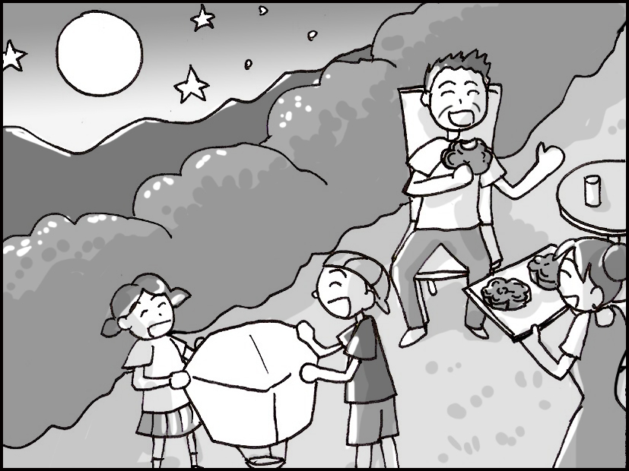  - ______  - ______  II. Best Response 最佳回應句  Choose the best response to each question or statement.  - A. I agree, it’s messy.  B. It’s just around the corner.  C. It’s so clean and neat.  D. I really like this book.  - A. I agree. I don’t like people that are cruel.  B. Sure, bullies don’t bother people.  C. Yeah, the math problem took 30 seconds.  D. I really like school, don’t you?  III. Short Conversations 簡短會話  Listen to the conversations. Then answer the questions. Each question will be read twice.  - A. A warm blanket.  B. A leather shoe.  C. A soft pillow.  D. A cold drink.  - A. He is a king.  B. He is a writer.  C. He is a salesman.  D. He is a mechanic.  IV. Short Talk 短文  Listen to the talk. Then choose the best answer to each question.  - A. At a children’s hospital.  B. At a junior high school.  C. At a shopping center.  D. At a train station.  - A. Use their ID.  B. Get a new job.  C. Find a code online.  D. Become a member. |  |  |  |  |  | - A. A special Christmas story.  B. A special Thanksgiving story.  C. A special Mid-Autumn Festival story.  D. A special Dragon Boat Festival story.  - A. He would never die.  B. He would grow very old.  C. He would become a dragon.  D. He would have super strength.  二.綜合文法  11. The salesman brought all the necessary documents, _____ to convince his customers of his professional knowledge.  (A) hopes (B) hoping (C) hope (D) hoped  12. You looked tired. Why not _____ a rest for a while?  (A) took (B) taking (C) takes (D) take  13. The manager asked his secretary to remind him _____ the schedule for the upcoming release of the  new product.  (A) of (B) in (C) over (D) without  14. The man _____ next door is a great gardener. He plants many beautiful flowers and pot plants in his  backyard.  (A) live (B) lives (C) living (D) lived  15. No matter _____ poor you are, you should not ask for pity from others.  (A) what (B) where (C) who (D) how  16. Excuse me. We are heading to Hotel California. Do you know _____ from here?  (A) how it is far (B) how far it is (C) it is how far (D) how is it far  17. We had better stay inside because the wind is _____ to blow a house’s roof off.  (A) enough strong (B) too strong (C) strong enough (D) so strong  18. It is time that we ______ our educational system.  (A) improved (B) improving (C) improve (D) to improve  19. The schools are teaching students to _____ the danger of taking drugs.  (A) take action (B) be aware of (C) as well (D) be close to  20. The candles _____ a pleasant smell of lavender as they burn.  (A) dies out (B) gives off (C) makes sure (D) for a while  三.對話  21. Frank: Don’t you think this trip will cost too much money?  Ben: Maybe. But it’s a once-in-a-lifetime experience! Come on!  Frank: All right. _____  (A) It was fun. (B) Take your time. (C) Count me in. (D) I don’t believe you.
新北市立新北高工一O五 學年度第 一 學期 第二次段考 |  |  |  |  |  |  |  | 班級 |  | 座號 |  | 成
科目 | English | 年級 | 二 | 科別 | 機鑄汽模訊圖電資 |  |  | 姓名 |  |  |  | 績
22. Athena: Have you been to the film festival yet?  Rocky: No, but I intend to go. Any recommended movies?  Athena: _____  (A) You cannot miss the one about a bank robbery.  (B) I like the novel which is related to the issue of family conflicts.  (C) Do not be that demanding. Nobody is perfect.  (D) I will suggest that you attend the festival as soon as possible.  23. Annie: How was the party?  Andy: It was awesome! There was free food, drinks, and even a live band playing great music!  Annie: I bet you had a good time there. _____  (A) When will you go? (B) I don’t know if I have time.  (C) It’s not my fault. (D) I should have gone with you.  24. Brian: I want to hold a barbecue party, but I need a hand. Are you available this weekend?  Ted: Let me check my schedule first.... Yes, I am. I can come and help out.  Brian: _____ Thank you so much!  Ted: It’s no big deal.  (A) That sounds terrible. (B) That’s fantastic.  (C) I have no idea. (D) That’s a problem.  25. Andy: Hi, Miranda, I’d like to know if Mr. Wang called yesterday.  Miranda: Sorry, I took a day off yesterday, but I know someone left a message for you.  Andy: _____  (A) No problem. Just give me your phone. (B) It is so nice of him to give me a hand.  (C) It seems a good sign. (D) Thank you. I’ll check with my secretary.  四.克漏字  Nowadays, it is very common to see young people doing cosplay. They like to dress up like their favorite comic book heroes. They also act and speak like them, __26___ to bring their heroes to life. They really enjoy what they do. However, some parents are worried that their children may spend too much time __27___ cosplay. While this may be true, it is also true that cosplay gives young people a sense of __28___. If cosplay makes them __29___ happy, parents should not stop them from doing it. Instead, parents can try to understand why ___30__ it so much. After all, doing cosplay is not a bad thing. Maybe next time parents can join their children and do cosplay together!  26. (A) try (B) tried (C) trying (D) and to try  27. (A) do (B) did (C) doing (D) to do  28. (A) achievement (B) ability (C) effort (D) responsibility  29. (A) feel (B) felt (C) feeling (D) to feel  30. (A) do they like (B) they like do (C) like they (D) they like |  |  |  |  |  |  | One scientist says that half of the animal species living in the world today will __31___ within a hundred years, and the main cause will be human activities. Some animals, like minks, __32___ for their fur in order to make expensive clothes. __33___ animals, like bears, may also be hunted for their body parts, because they can be used in traditional Chinese medicine. Many other animals are close to __34___ as well, because humans have destroyed the forests where they live.  What’s worse, __35___ our own lives better, we are also slowly killing the planet, even though we might not be aware of it.  31. (A) pass on (B) take action (C) give off (D) die out  32. (A) are killed (B) are killing (C) kill (D) killed  33. (A) Another (B) The other (C) Others (D) Other  34. (A) survival (B) pollution (C) extinction (D) profit  35. (A) make (B) to make (C) having made (D) making  五.閱讀測驗  In a 2005 documentary*, Discovery recorded the severe battles between humans and the largest animals on land. The film started with a group of researchers trying to help out the decreasing population of elephants in a remote area in India.  The researchers found that in order to feed more people, the villagers cut down forests and grew rice on the land. As a result, the elephants lost their living space and were forced to find food in humans’ territory. The elephants tramped* on the fields and ate up all the crops. Sometimes the elephants attacked people who tried to stop them from “stealing” people’s rice. Unfortunately, many villagers and more elephants died in the conflicts. In addition to a lack of food, a great number of elephants died from gunshots. That’s the main reason why those elephants were dying out.  When the researchers proposed to protect the elephants, the villagers disagreed. One villager said, “Last year, because the elephants destroyed our fields, we didn’t have enough rice to eat and sell. Many people starved.” It seemed that there was still a long way to go before the elephants and the villagers could finally live in peace.  *documentary n. [C] 記錄片 *tramp vi. 踐踏  36. The article is mainly about _____.  (A) country lives in India (B) an elephant’s life cycle  (C) a new discovery about elephants (D) conflicts between elephants and people  37. Which of the following does NOT describe the elephants in the article?  (A) They were hungry. (B) They were killed by guns.  (C) They attacked people for no reasons. (D)They lost their natural environment.
新北市立新北高工一O五 學年度第 一 學期 第二次段考 |  |  |  |  |  |  |  | 班級 |  | 座號 |  | 成
科目 | English | 年級 | 二 | 科別 | 機鑄汽模訊圖電資 |  |  | 姓名 |  |  |  | 績
38. Which of the following is true?  (A) The film was presented by Discovery.  (B) The elephants were well cherished in the village.  (C) The villagers cut down forests in order to hunt elephants.  (D) The researchers helped the villagers protect their rice fields.  39. Which of the following is true?  (A) The villagers used elephants to help grow rice.  (B) The elephants lived with the villagers in the forests.  (C) The villagers depended on the rice fields very much.  (D) The elephants were in danger of dying out because most of them were starved to death.  40. What’s the author’s attitude toward the possibility that the villagers and the elephants can get along  with each other?  (A) Positive. (B) Negative. (C) Doubtful. (D) Surprised.  六.字彙填空（30%，每題2分）  41. Every summer, my cousin takes me to music f____ls held for rock fans.  42. You should take the medicine when you feel uncomfortable because it can r_____e your pain.  43. The c_____rs in the play were so interesting that I could not help bursting out laughing several times  in the theater.  44. We all burst into laughter when Jeff i_____es the voice and behavior of our boss.  45. My younger brother loves to read science f_____n. He believes that everything he reads in his books is  possible.  46. Mary thinks that office work is d_____l. She can’t stand sitting at a desk for eight hours.  47. Failing the math exam didn’t d_____y Adam’s confidence. He believes that he can improve his  grades next time with more practice.  48. Scientists are all excited that a new s_____es of birds has been found in Taiwan.  49. This company is run for p_____t. In other words, its aim is to make money.  50. After William s_____ved the car accident, he learned to be more careful when driving.  51. Elephants are highly intelligent c_____es. They are among the smartest animals on Earth.  52. Bad weather was r_____e for the flight delay. The plane couldn’t take off until it stopped thundering.  53. The airplane crash had c_____sed the death of two pilots and one hundred passengers.  54. In order to reduce water p_____n, the factory built a processing plant to process its wastewater.  55. All the students will c_____h the memory of their trip to Kenting. |  |  |  |  |  |  | 請寫上姓名座號，將答案卷交回
  41. | 42. | 43.
  44. | 45. | 46.
  47. | 48. | 49.
  50. | 51. | 52.
  53. | 54. | 55.

