- 填充題

- 90 × 0.2=________________

- 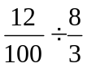=________________

- 90 ÷ 0.2 =________________

- 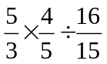=_________________

- 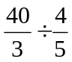=________________

- 0.52 × 0.2=________________

- 0.48 ÷ 12 ＝________________

- 0.52 ÷ 0.4=________________

- 小數點換分數 , 分數換小數點
(1) 0.98 ＝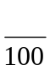 , (2) 0.07 ＝ , (3) 0.006 ＝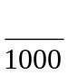 ,(4)7.45＝

(5) 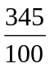＝ , (6) 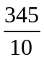＝ , (7) 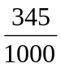＝

三、是非題
_____ 1. 0.52 + 0.1 = 0.53

_____ 2. 0.52 + 0.1 = 0.63

_____ 3.  + = 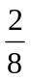

_____ 4. × = 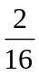

_____ 5.  + =

