市立新北高工105學年度第2學期第一次段考試題 |  |  |  |  |  |  | 班級 |  | 座號 |  | 成  績
科目 | 英文 | 年級 | 一 | 科別 | 機鑄汽模圖資電訊 |  | 姓名 |  |  |  | 成  績
I.聽力測驗 (10%)  A. Pictures 看圖辨義(2%)  Listen to the questions. Then choose the best answer according to each picture.  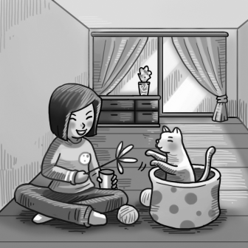  1.__________    2.__________  - Best Response 最佳回應句(3%)  Choose the best response to each question or statement.  _______3.(A) 10% is enough.  (B) On the table is fine.  (C) After you eat, of course.  _______ 4.(A) You can’t have a puppy.  (B) Of course you can!  (C) Take good care of his or her pet.  _______ 5.(A) That’s good. Me, too!  (B) Not much. And you?  (C) School will start soon!  - Short Conversations 簡短會話(3%)  Listen to the conversations. Then answer the questions.  II.文法選擇(20%)  11. I think it is more convenient _____ to the stadium by bus than on foot.  (A) for we to go (B) for us to go (C) to go for us (D) for us go  12. Don’t drive after drinking, _____ you will be fined heavily.  (A) and (B) or (C) however (D) when  13. There are a lot of people in the park now. _____ are jogging, _____ are sitting  on benches, _____ are having a picnic.  (A) Some; others; others (B) Some; some; still others  (C) Others; still others; and some (D) Some; others; and still others  14. Stella is _____ that she can answer many difficult math questions.  (A) such smart (B) so a smart student (C) so a student smart  (D) such a smart student  15. The fighter jet pilot was _____ person that he landed his damaged plane safely.  (A) such calmness (B) such a calm (C) so calm (D) so a calm  16. All of a sudden, Garfield felt someone _____ his face.  (A) touched (B) to touch (C) touching (D) will touch  17. That chicken soup smells as _____ as this shrimp soup. I like both of them.  (A) delicious (B) tastily (C) well (D) badly  18. The new babysitter can help you _____ your baby.  (A) will look after (B) look after (C) looking after (D) looks after  19. Which of the following sentences is correct? (選出正確的選項)  (A) Keep your desk clean, or you will be more efficient.  (B) Never to lie to your parents, or they won’t trust you anymore.  (C) Respect others, and you will be respected.  (D) Avoiding staying up late, and you won’t feel tired all the time.  20. Which of the following sentences is correct? (選出正確的選項)  (A) The guard won’t let you to pass the gate without your ID card.  (B) Please let me to know what you think about the article.  (C) Who let the bird out of the cage?  (D) Dad won’t let me watching TV unless I finish my homework first.  IV.綜合測驗題(20%)  The world is full of interesting eating customs. Indians, __26__, eat with their right hands instead of their left hands. That’s because the left hand __27__ the unclean hand. __28__ Indians, Arabs also eat with their hands. They often sit close together and share the food from a common bowl. Like Arabs, the Chinese also share their food. But unlike Indians and Arabs, the Chinese eat with chopsticks. For Chinese people, eating all the food in one’s bowl is a way of __29__ thanks for the meal. It is inconsiderate(不體貼的) __30__ the food in the bowl. If you do so, it means that you don’t like the food and don’t appreciate it.  ( )26. (A) for instance (B) such as (C) in detail (D) over time  ( )27. (A) is good at (B) is regarded as (C) is born into (D) is kicked out of  ( )28. (A) Because of (B) Despite (C) Besides (D) Except for  ( )29. (A) say (B) said (C) saying (D) to say  ( )30. (A) to leave (B) leaves (C) being left (D) left  One day, my dad handed me a plane ticket to Australia. He told me that he had planned a very special summer vacation for me. After I arrived in Australia, I was not taken to a luxurious(豪華的) hotel; __31__, I was taken to Mr. Smith’s house. Mr. Smith had a big farm. My dad did not pay him, so I had to help __32__ his sheep during my stay. I worked as __33__ as I could, and I often hoped I could leave soon and go home. However, when I was finally told that I could go home, I felt a little sad. Mr. Smith had always told me what to do __34__ a friendly manner, so working with him was very enjoyable. Also, my English language abilities improved a lot after the stay. I was thankful for this __35__, and I promised Mr. Smith that I would visit him again.  ( )37. Which of the following is NOT true about Dublin?  (A) Many people go on a working holiday in Dublin.  (B) People in Ireland do not speak English.  (C) Buying a good Dublin map is useful.  (D) Many employers in Ireland do not pay their employees in cash.  ( )38. Why do people want to find cheap places to live when they go on a working  holiday?  (A) Dublin City University has many empty rooms in summer.  (B) There is information about cheap living places at www.daft.ie.  (C) People may get lost in Dublin because it is a big city.  (D) People want to save money for traveling later.  ( )39. According to the article, why would you need to buy a city map?  (A) To get an opportunity to go on a working holiday.  (B) To get a cheap place to live.  (C) To travel around the city.  (D) To find the most suitable job.  ( )40. Which of the following statements is NOT true?  (A) You may find a room at Dublin City University in August.  (B) You need to go to a bank and set up an account.  (C) Dublin is on the eastern coast of Ireland.  (D) It is safe to have a lot of cash with you in Dublin.  VI.單字(20%)  41. Mark plans to s_____h his job this year. He wants to find a new job.  42. The coach p_____ed his players for their great performance in the competition.  43. William r_____ed a table for ten to celebrate his father’s birthday. |  |  |  |  |  | _______6. (A) She totally forgot.  (B) She didn’t really like the food.  (C) She thought it was already on the bill.  _______7. (A) At home.  (B) At an animal shelter.  (C) Walking a black and white dog on the street.  _______8. (A) Teaching Chinese.  (B) Taking care of kids.  (C) Planting trees.  D. Short Talk 短文(2%)  Listen to the talk. Then choose the best answer to each question.  9. ________  (A) (B) (C)  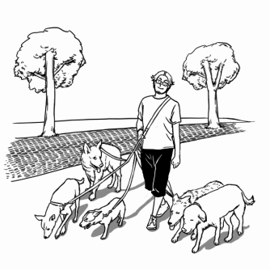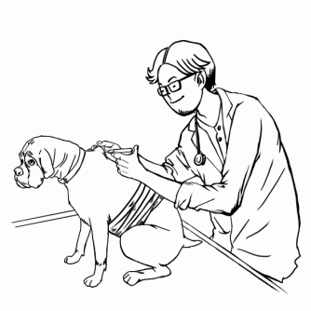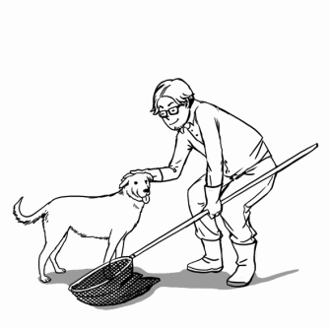  10. ________  (A) (B) (C)  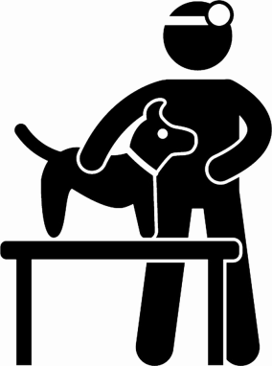  III.對話題(10%)  21.Mary: I’ve got great news. _____  Judy: Well, what is it?  Mary: I have a week’s vacation next month, and I’m so excited!  Judy: Do you? That’s wonderful.  (A) This isn’t fair at all. (B) You won’t believe it.  (C) The store is having a big sale. (D) John is having a party Friday night.  22. Ann: Anping is worth a visit. I love eating shrimp rolls and bean curd jelly.  Tony: And those foods are not expensive.  Ann: _____  (A) You can say that again. (B) You go too far.  (C) It’s not my fault. (D) I won’t buy your story.  23. John: Hi, Jack. Any plans for this afternoon?  Jack: Yes, I will play basketball with some friends.  John: Can I join you?  Jack: _____ Let’s meet at 2 p.m. in the gym.  (A) Why? (B) Of course not. (C) I don’t think so. (D) Why not?  24. (In a taxi in San Francisco)  Patrick: Don’t forget to tip the taxi driver!  Lucy: Oh, I nearly forget.  Patrick: Americans always give a tip for the service.  Lucy: _____ Taxi drivers usually don’t expect a tip.  (A) I told you taking a taxi is expensive.  (B) That’s really different from what we do in Taiwan.  (C) Tipping is not unique to America.  (D) That was the best service I’ve ever had.  25. Teresa: Mom, can I go to the movies with Lidia tonight?  Mom: _____ Don’t forget you will have a math exam tomorrow.  Teresa: OK. I think you are right.  (A) No way! (B) All right. (C) Don’t mention it. (D) Go ahead.  ( )31. (A) therefore (B) however (C) instead (D) thus  ( )32. (A) take care of (B) taking care of (C) taking care (D) to take care  ( )33. (A) hardly (B) harder (C) hardest (D) hard  ( )34. (A) with (B) in (C) at (D) of  ( )35. (A) entertainment (B) experience (C) fulfillment (D) shelter  V.閱讀測驗(10%)  Dublin is one of the most popular cities to go to on a working holiday. It is a beautiful city located on the eastern coast of Ireland, and is the home of some famous writers. While you take a working holiday there, you can not only practice your English but also pick up a little Gaelic(蓋爾語), the Irish language. Here are some tips to keep in mind if you go there.  First, find a cheap place to live. Check www.daft.ie for this kind of information. If you arrive between June and September, try Dublin City University. Usually, there are plenty of rooms available while students are away on their summer vacation. Most importantly, these rooms are not expensive, so you can save money for traveling later. Second, buy a city map. A map is useful when you are traveling or going to job interviews. You don’t want to get lost in Dublin and miss an important job interview. Third, open a bank account. It is not safe to bring much cash with you. Also, most employers may prefer paying you through your bank account.  Going on a working holiday is so much fun. If you are fully prepared, it’s sure to be one of the most memorable experiences of your life.  ( )36. Which of the following is the best title for the passage?  (A) Tips for Taking a Working Holiday in Dublin  (B) The City of Beauty—Dublin  (C) The History of Working Holidays in Dublin  (D) Do’s and Don’ts in Ireland  44. There are a few things on this report that you could i_____e before you hand it  in to your teacher.  45. Harry became an o_____n after his parents died in a plane crash.  46. It was a long j_____y from Taipei to London. I was tired and jet-lagged (時差).  47. I think you should go out and do something m_____l instead of sitting in front  of the TV all day long.  48. It’s s_____l that some sportsmen take drugs in order to win competitions. They  are supposed to be our role models.  49. I closed my eyes for the s_____y parts of the horror movie.  50. After a big fire, our school is really in a m_____s now.  VII.引導式翻譯(10%)  51.我哥哥的工作相當累人，以致於他傾向在週末睡久一點。  My elder brother’s job is so tiring that he (t)__(1)__ __(2)__ sleep in on weekends.  52.Blake沒有為自己的錯誤道歉。更糟的是，他還怪罪同學。  Blake didn’t say sorry for his mistake. (w)__(3)__ __(4)__ __(5)__, he blamed it  on his classmates.  53.我姊姊熱愛音樂，她喜歡看MTV頻道。  My sister is (c)__(6)__ __(7)__ music; she loves watching the MTV channel.  54.Tony今天早上被困在車陣裡。因此，他上班遲到了。  Tony was caught in the traffic jam this morning. (A)__(8)__ __(9)__ __(10)__, he  was late for work.  No pain, no gain! ㄧ分耕耘，ㄧ分收獲:D

