新北市立 新 北 高工 105 學年度 第二學期 期末考 |  |  |  |  |  |  | 班級 |  | 座號 |  | 成
科目 | 英文 | 年級 | 一 | 科別 | 訊機鑄汽模圖電資 |  | 姓名 |  |  |  | 績
請在答案卡上劃卡作答 共 50 題, 每題兩分 請仔細核對題號!  I. 聽力測驗  A. 看圖辨義  試卷上該題有一張圖片，請聽一個和該題相關的問題，與(A)、(B)、(C)三個英語敘述後，選一個與所看到圖片最相符的答案。  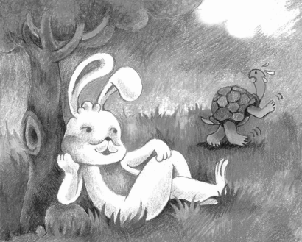  1. _________  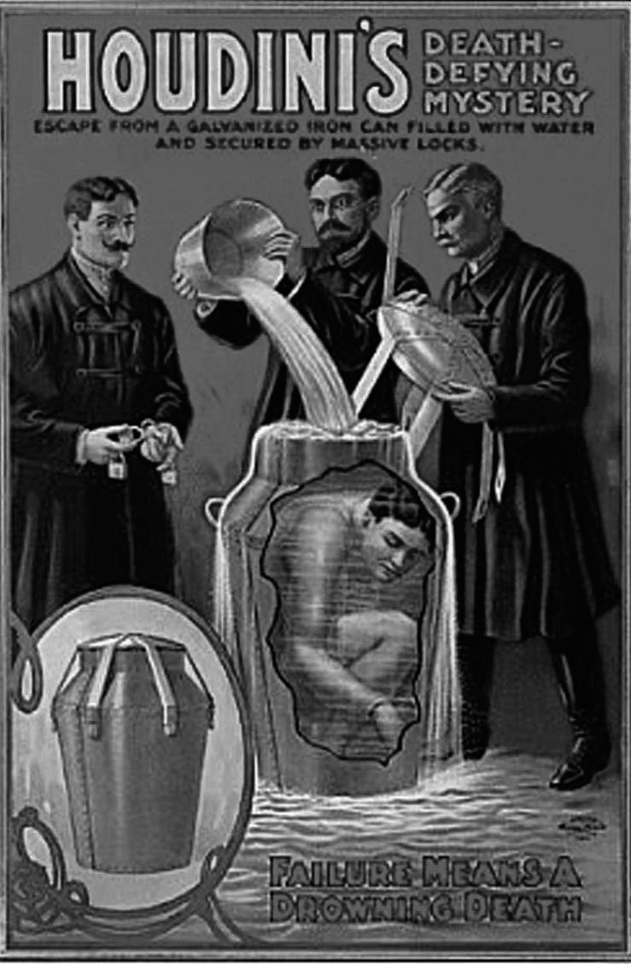  2. _________  B. 最佳回應句  每題會播出一個問句或直述句，聽後請由試卷上(A)、(B)、(C)三個選項中，選出一個最適合的回答或回應。  _______3. (A) Yes, it happened in 1982.  (B) Yes, it was a story about a ruler who built a cave.  (C) Yes, it means you should be careful of what you say.  _______4. (A) As the saying goes, “Time is money.”  (B) Great minds think alike.  (C) You know what they say, “Money doesn’t grow on trees!”  _______5. (A) I can pick the lock with this wire.  (B) Just use your keys to open it.  (C) Thanks for letting me inside.  II. 字彙測驗選擇題  （ ）11. Dr. Wu is a well-known expert in children’ s education. Many elementary school  teachers ask him for advice.  (A) famous (B) unknown (C) hard-working (D) little-known  （ ）12. Ms. Chen often told us stories about her travels.  (A) metals (B) tales (C) swept (D) scratches  （ ）13. If you don’t do bad things, you will never be sent to prison.  (A) cave (B) theater (C) jail (D) hospital  （ ）14. All the members of the audience kept quiet while they were watching the magic show.  (A) tight (B) sound (C) noisy (D) silent  （ ）15.Hank jumped out of the bed when he heard the alarm clock ringing.  (A) arose (B) leaped (C) recycled (D) swept  （ ）16. Let’s hope that Laura can recover from her illness before Friday and go on the picnic  with us this weekend.  (A) business (B) homework (C) profession (D) disease  （ ）17. Those high school students are tested on two different skills: writing and speaking.  (A) hobbies (B) habits (C) abilities (D) arts  （ ）18. As the proverb goes, "Time is money." Your time is precious as you can use it to earn  money, so you shouldn't waste your time.  (A) sightseeing (B) meaning (C) warning (D) saying  （ ）19.I didn’t understand the rules. Can you them to me again, please?  (A) discover (B) explain (C) drown (D) fall  （ ）20.The superstar said she was tired and wanted to retire and live an life.  (A) ancient (B) ordinary (C)cunning (D) clever  （ ）21. Thanks to modern , people can communicate easily even if they are far away  from each other.  (A) illness (B) source (C) prison (D) technology  （ ）22. The huge clothing store sells types of tops and pants for children of all  ages. (A) silent (B) cunning (C) wise (D) various  （ ）23. Linda is very interested in . You can always see her reading a novel or a  collection of poems.  (A) literature (B) illness (C) tanks (D) wisdom  （ ）24. The little boy is very . He can learn new words very quickly.  (A) ancient (B) clever (C) cunning (D) various  （ ）25. My came to Taiwan after the war and settled in Taipei. My dad and my  uncles were born in Taipei.  (A) silence (B) source (C) abilities (D) ancestors  IV. 對話測驗  （ ）36. Tim: We are getting old. If we want to travel around the world, we should start  planning now.  Anita: You are right. We should act before we are too old to do it.  (A) Bad news travels fast. (B) Walls have ears.  (C) Look before you leap. (D) Time and tide wait for no man.  （ ）37. Mark: Hurry up! We are late for the student meeting.  Laura: Why do we need to go so fast? We aren't really late.  Mark: You know what they say--  Laura: That's silly. It's just a meeting, not a job!  (A) Great minds think alike. (B) Practice makes perfect.  (C) Time is money. (D)The grass is always greener on the other side.  38. ( ) Bob: Tina, are you free this Saturday? I would like to invite you to a concert.  Tina:  Bob: Oh, that's OK. maybe next time!  Tina : Sorry!  (A) How long is the concert? (B) I am going to skiing this Saturday.  (C) Are you coming with us? (D) I suggest you go to another concert.  39. ( ) Ann: Linda, I need to tell you a secret! I...  Linda: Shhh...Not here!  Ann: You're right. Let's find a safer place then.  (A) I can't keep a secret. (B) I can't hear you.  (C) I am all ears. (D) Walls have ears.  40. ( ) David: David Copperfield is a great magician.  Zoe: _______ I am a big fan of his shows.  David: That makes two of us.  (A) It was unbelievable. (B) You can say it again.  (C) I can't believe you. (D) Who is he? |  |  |  |  |  | C. 簡短會話  每題會播出一段對話及一個相關的問題，聽後請由試卷上(A)、(B)、(C)三個選項中，選出一  最適合的回答。  _______6. (A) A person who is under the surface of some water.  (B) A person who is wrapped tightly in chains.  (C) A person who is upside down.  _______7. (A) The man thinks she’s not a human.  (B) The man knows where she put the rabbit.  (C) The man is really amazed by her magic.  _______8. (A) The man.  (B) The woman.  (C) The man’s grandfather.  D. 短文  每題有三個圖片選項。請聽題目，並選出一個最適當的圖片。  9._______  (A) (B) (C)  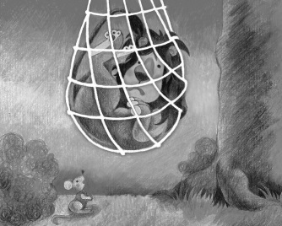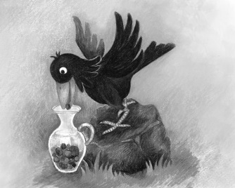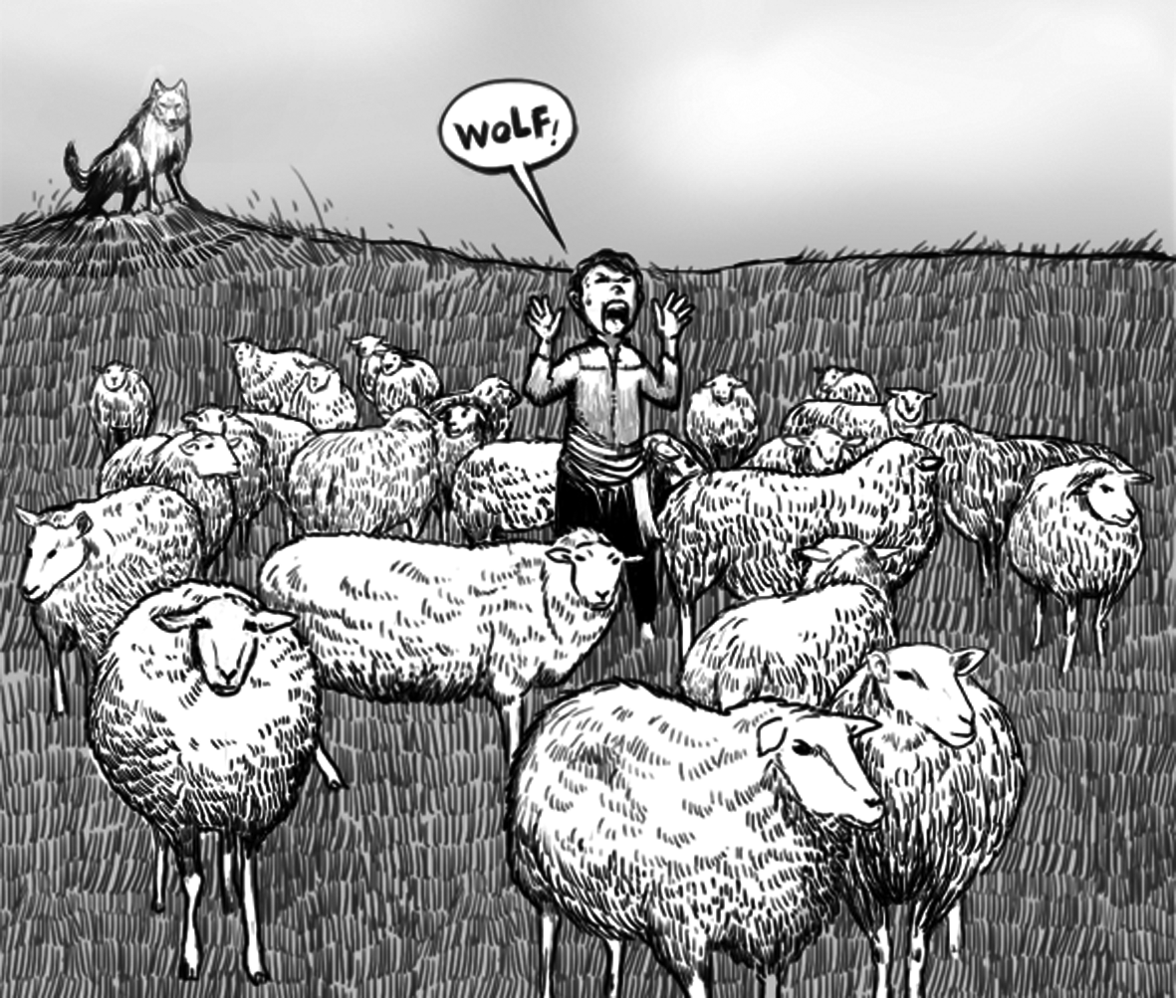  10._______  (A) (B) (C)  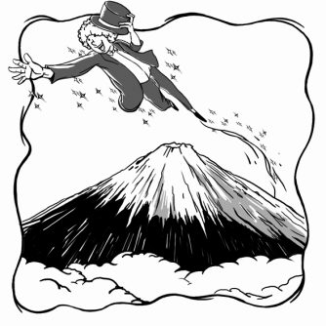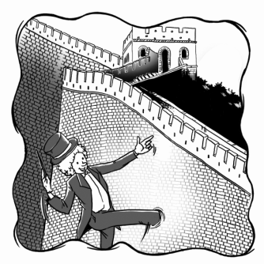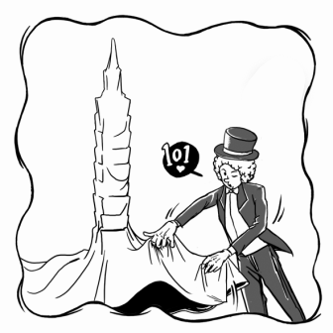  (請翻面，背面尚有試題)  P1  III. 文法選擇  （ ）26. Bryant had his car _____ before he took a long trip to Kenting.  (A) fix (B) to fixing (C) fixes (D) fixed  （ ）27. Last Friday, Jay got up at eight o’ clock, had his breakfast, and to the office  as usual.  (A) goes (B) gone (C) went (D) going  （ ）28. No one deserves(值得)my love more than my mother works hard to  give me everything.  (A) who (B) , who (C) that (D) , that  （ ）29. Ellen’s math teacher her hair cut every three months. Her short hair makes  her look very young.  (A) have (B) has (C) had (D)having  （ ）30. Peter is already the tallest boy in our class, but his brother is taller than he.  (A) very (B) more (C) even (D) most  （ ）31. On weekends, Gary enjoys doing outdoor activities, such as . (A) hike and swim (B) to hike and to swim  (C) hikes and swims (D) hiking and swimming  （ ）32. Katrina sings more than any of the other students in her class.  (A) beautify (B) beauty (C) beautiful (D) beautifully  （ ）33.“Love your neighbor as yourself”is a saying comes from the Bible.  (A) who (B) that (C) where (D) , that  （ ）34.Before you go on long trip, you should prepare everything you may need.  (A) that (B) what (C) whose (D) whom  （ ）35. John failed the test because he didn’t study, but also because he  wrote down the answers in the wrong order.  (A) not only (B) only (C) only not (D) not when  P2.  V. 克漏字測驗  At seventeen, Ehrich Weiss changed his name to Harry Houdini. He then began to perform dangerous shows to 41. more audience members. In one of his shows, he was wrapped tightly in heavy chains and then he had himself 42. upside down into a large tank that was filled with water. The audience could see him 43. a window of the tank. They waited 44. fear and silence. Everyone thought he would not escape; however, Houdini got rid of the chains, and 45. when he came out of the water. His shows amazed people every time; that’s why he is still considered the greatest escape artist ever.  41.( ) (A) consider (B) attract (C) succeed (D) breathe  42.( ) (A) lowered (B) lowering (C) to lower (D) lower  43.( ) (A) in (B) through (C) on (D) at  44.( ) (A) at (B) with (C) for (D) in  45.( ) (A) held his breath (B) gave up (C) took a deep breath (D) gave away  One day, a fox fell into a deep well. He tried to climb out but failed. After a long time, heard the sound of goat 46. was walking by. The fox knew he was 47. than the goat, so he  decided to trick him. “My friend,” he cried, “come taste the water! It is more delicious than any other water in the world!” The goat 48. was now feeling very thirsty, quickly jumped down into the well. The fox hopped onto his back and jumped out to safety. He looked down at the goat and said, “My friend, always 49. carefully before you jump into a well!” This tale tells us  50. we should always take the time to think about possible problems before we do something. It’s also what the proverb “Look before you leap” means.  46. ( ) (A) whose (B) that (C) whom (D) it  47. ( ) (A) very smart (B)more smart (C) smarter (D) smartest  48. ( ) (A) ,which (B) , that (C) who (D) when  49. ( ) (A) thinking (B) thought (C) to think (D) think  50. ( ) (A) that (B) when (C) what (D) if  P3.
新北市立 新 北 高工 102 學年度 第二學期 期末考 |  |  |  |  |  |  | 班級 |  | 座號 |  | 成 | P.2
科目 | 英文 | 年級 | 一 | 科別 | 機鑄汽模圖電資 |  | 姓名 |  |  |  | 績 | P.2

