市立新北高工105學年度第2學期第2次段考試題 |  |  |  |  |  |  |  | 班級 |  | 座號 |  | 成  績
科 目 | 英文 | 使用答案卡及答案卷 |  | 年級 | 1 | 科別 | 機鑄電模汽圖資訊 | 姓名 |  |  |  | 成  績

請將以下選擇題答案劃記於答案卡上(否則不予計分);並劃上座號, 未劃座號者酌扣總分15分
- Listening Comprehension (10%)
A. Pictures (2%)
Listen to the questions. Then choose the best answer according to each picture.
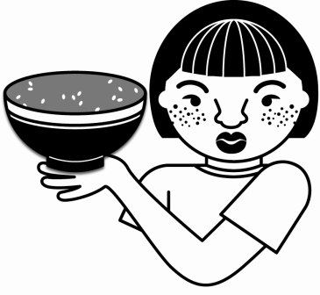
1. _________

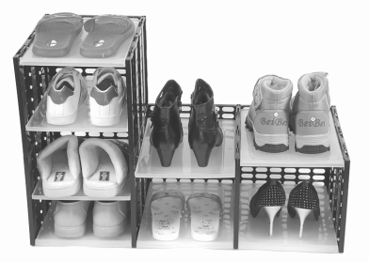
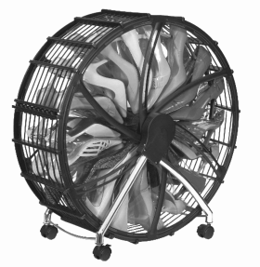

2. _________

B. Best Response.
Choose the best response to each question or statement.
_______ 3. (A) That’s because we consider the number four unlucky.
(B) That’s why we avoid certain floors.
(C) That’s where we go during ghost month.
_______ 4. (A) You should not give away a clock.
(B) You can ask people there about their beliefs.
(C) These taboos are only for certain periods.
_______ 5. (A) Here’s a tissue paper.
(B) Because we saw a sad movie.
(C) This will protect you.

C. Short Conversations (3%)
Listen to the conversations. Then answer the questions.
_______6. (A) It’s for a high quality computer.
(B) It’s colored and very stylish.
(C) It’s cheaper because they make many of them at one time.
_______7. (A) It’s screamingly great.
(B) It’s strange but funny.
(C) It’s nice and useful.
_______ 8. (A) A clock.
(B) A pair of shoes.
(C) He doesn’t know yet.
D. Short Talk (2%)
Listen to the talk. Then choose the best answer to each question.
9. _______
(A) (B) (C)
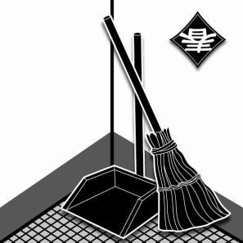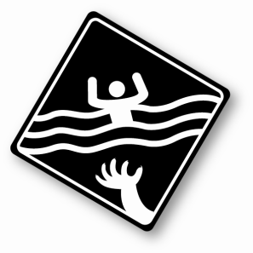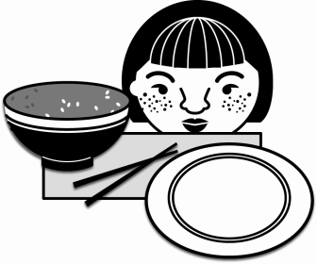
10.____________
(A) (B) (C)
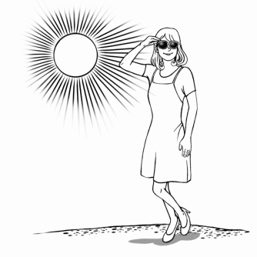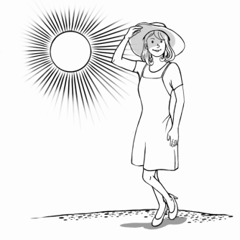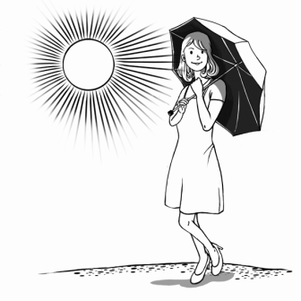
II. Grammar (20%)
11. Our teacher told us a story _____ inspired us a lot.
(A) who (B) which (C) whom (D) what
12. My husband wants to know _____ so expensive.
(A) why was my dress (B) why my dress was (C) why to be my dress (D) why my dress to be
13. Our teacher has taught us _____ to use “the” correctly.
(A) who (B) which (C) whether (D) how
14. Either the students or the teacher _____ wrong.
(A) is (B) am (C) are (D) be
15. Water is important to us. Don’t leave it _____.
(A) run (B) running (C) to run (D) for running
16. The police have not found the weapon _____ in the murder yet. They suspect that it might have been thrown into the river.
(A) use (B) used (C) using (D) was used
17. If you want to keep a pet, you should not only provide it with shelter but also keep it _____ and _____.
(A) safety; health (B) safety; healthy (C) safe; healthily (D) safe; healthy
18. They searched on the Internet, hoping netizens (網民) could suggest to them _____ to enjoy their honeymoon to the fullest.
(A) why to go (B) what to go (C) where to go (D) which to go
19. Paul likes neither seeing movies nor _____ shopping.
(A) going (B) goes (C) go (D) to go
20. The missing soldier was found _____ and being in a state of complete shock.
(A) starve (B) starved (C) to starve (D) starving
III. Cloze (20%)
a. Have you ever heard about the “Laba Rice Porridge Festival”? It is celebrated 21_____ the eighth day of the twelfth lunar month. Its history can be traced back over one thousand years in China. 22_____, it actually came from the tradition of India Buddhism, and it commemorates the Buddha’s sufferings under a banyan tree. In the old days, Laba rice porridge was cooked in the temple 23_____ rice, beans, and other grains. It would be first 24_____ the Buddha and then given away to the poor. If people have Laba rice porridge on this day, they can be blessed with good 25_____ and a long life.
21 (A) in (B) on (C) at (D) for
22 (A) However (B) Therefore (C) In contrast (D) Besides
23 (A) as (B) for (C) of (D) with
24 (A) serving with (B) served with (C) serving by (D) served to
25 (A) fortunate (B) fortunes (C) fortune (D) fortuned
b. When you look around at all the things you own, do you ever wonder when and why they were invented? You might find some of the answers very 26_____. For instance, the buttons on men’s jacket sleeves have a very surprising history. They were created 27_____ as a fashion accessory 27_____ as a way to hold sleeves in place. One day in the 1700’s, the king of Prussia found his soldiers 28_____ their jacket sleeves to clean their face. He was very angry, because his soldiers were supposed to keep their clothes 29_____. To stop them 30_____ doing this, he told his tailors to sew metal buttons onto the jackets. That way, if the soldiers tried to use their sleeves as a towel, they would hurt their face.
26 (A) interesting (B) interested (C) interests (D) interest
27 (A) either; or (B) both; and (C) as; possible (D) neither; nor
28 (A) uses (B) to use (C) using (D) usage
29 (A) cleaning (B) clean (C) cleans (D) to clean
30 (A) into (B) from (C) with (D) off
IV. Synonyms (10%) 近義字選擇-選出最接近劃線單字意義的字
31. A cleaning lady is brushing some dust off the balcony.
(A) sweeping (B) honoring (C) improving (D) rejecting
32. I won’t be able to go to class tomorrow because I am going to Hualien with my family.
(A) serve (B) attend (C) reserve (D) complete
33. It is so lucky that I have you as my friends who are always there when I need lots of support.
(A) forgiving (B) forever (C) fortunate (D) negative
34. John never had the idea of asking Marsha out on a date.
(A) century (B) accessory (C) judge (D) thought
35. That company uses different security techniques to guard its client information database.
(A) protect (B) produce (C) recycle (D) judge
V. Reading Comprehension (10%)
A necktie, a piece of long cloth tied around the neck, is worn for decorative and formal purposes. For example, men wear neckties to go to work or to attend a ceremony*. Moreover, some schools make neckties a part of their uniform. Furthermore*, recently more and more people are wearing neckties as a fashion accessory.
In the past, neckties were called “neckwear” and were worn by soldiers in ancient* China and the Roman Empire*. Neckwear was regarded as part of the military uniform or as a symbol of membership in a particular army. This sort of neckwear spread to Europe during the Thirty Year’s War (1618-1648), and was favored by the European kings and army. In the 17th century, the neckwear was made of leather which made soldiers keep their heads high so as to be more energetic. To some extent*, leather neckwear was also able to protect soldiers’ necks from possible attacks.
Around the 1850s, the word “tie” was first used for neckwear. Neckties were now worn not only by soldiers but even by ordinary people for various purposes. Today there are different necktie-wearing styles, and a range of necktie materials and patterns for people to choose from.
36. What would be the best title for the article?
(A) How neckties spread to the Western world (B) Different kinds of neckties
(C) The origin of neckties (D) The purpose of wearing necktie
37. Based on the article, what was the original purpose of wearing neckwear?
(A) Wearing neckwear was considered to be a symbol of membership, especially in the
school.
(B) Wearing neckwear was considered to be a symbol of membership, especially by
separating one’s nationality.
(C) Wearing neckwear was considered to be a symbol of membership, especially in the
army.
(D) Wearing neckwear was considered to be a symbol of membership, especially by
distinguishing one’s religion.
38. Based on the article, when and how did neckwear spread to Europe?
(A) Neckwear was brought to Europe by soldiers during the Thirty Year’s War.
(B) Neckwear was brought to Europe by soldiers during the First World War.
(C) Neckwear was spread to Europe by soldiers during the Second World War.
(D) Neckwear came originally from Europe, and it was spread to China during the Thirty
Year’s War.
39. Based on the article, which of the following statements is NOT true about neckwear in the
17th century?
(A) Neckwear was normally made of leather.
(B) Wearing neckwear enabled soldiers to look more energetic.
(C) Wearing neckwear protected soldiers’ necks from attacks.
(D) Neckwear was normally made of metal.
40. Based on the article, which of the following statements is true?
(A) The word “tie” meaning “neckwear” appeared in English around the middle of the
18th century, and not only soldiers but also ordinary people could wear ties for various
purposes.
(B) The word “tie” used to mean “neckwear” appeared in English around the middle of
the 19th century, and not only soldiers but also ordinary people began to wear ties for
various purposes.
(C) The word “tie” meaning “neckwear” appeared in English around the middle of the
18th century, and only soldiers could wear ties.
(D) The word “tie” as used to mean “neckwear” appeared in English around the middle
of the 19th century, and only soldiers could wear ties.
*ceremony n. [C] 儀式、典禮 *furthermore adv. 除此之外 *ancient adj. 古老的 *Roman Empire 羅馬帝國 *extent n. [U] 程度

VI. Vocabulary and Phrases (30%)
41. The novel gained its reputation(名譽) from the fact that the story’s historical background (歷史背景)was carefully and thoroughly(完全地) r_____hed.

42. Hundreds of people lost their homes because the flood(水災) s_____t the village away.
43. In India’s culture, killing and eating cows is a serious t_____o.
44. She o_____ded Jack by saying he was a coward and had no courage.
45. We should a_____d talking behind others’ backs, because this kind of behavior is very rude.
46. The way to explain the m_____g of the Bible(聖經) passages(段落) may depend on which time we are living in.
47. Due to the layoff(裁員) last month, Jack and Sherry are c_____ring moving back to Tainan to find a new job.
48. J.K. Rowling has gained a reputation w_____e because of her Harry Potter novel series.
49. As we are going to stay in Britain for a month, we can p_____y plan a four-day London tour. I have heard that Buckingham Palace and Big Ben are really worth visiting.
50. A lot of taboos began to disappear or be taken less seriously in the 20th c_____y.
51. It was hard for the court(法庭) to j_____e the case, because both sides presented strong statements(陳述) in support of their viewpoints(觀點).
52. The p_____e “to put yourself in somebody else’s shoes” means that we should think from others’ points of view.
53. Every year during the Christmas holidays, Sam is excited to d_____e the Christmas tree with shining balls and lights.
54. It is strange that neither of Pamela’s parents a_____ded her wedding.
55. These cans can be r_____ed and reused; don’t throw them away.

