新北高工 一0五學年度第 二學期 段考 |  |  |  |  |  |  | 班級 |  | 座號 |  | 成
科目 | English | 年級 | 二 | 科別 | 機鑄汽模圖資電訊 |  | 姓名 |  |  |  | 績
- 聽力測驗10% (請選出最適合的答案)  看圖辨義:試卷上該題有一張圖片，請聽一個和該題相關的問題，與(A)、(B)、(C)三個英語敘述後，選一個與所看到圖片最相符的答案。  問答:每題會播出一個問句或直述句，聽後請由試卷上(A)、(B)、(C)三個選項中，選出一個最適合的回答或回應。  3. (A) He violated some of the rules.  (B) He was fired by the manager.  (C) He knows how to use the equipment.  4. (A) He received several injections from a scientist.  (B) He had great physical strength.  (C) He protected his people from harm in World War II.  5. (A) I might travel around the world.  (B) I would turn into an ugly frog.  (C) I would be known for my unique voice.  簡短對話:每題會播出一段對話及一個相關的問題，聽後請由試卷上(A)、(B)、(C)三個選項中，選出一個最適合的回答。  6. (A) He’s a customer and wants to complain.  (B) He’s a manager and wants to be transferred.  (C) He’s an intern and wants to call in sick.  7. (A) To a park to play baseball.  (B) To a restaurant to have dinner.  (C) To her house to do some homework.  8. (A) A coffee club.  (B) A cosplay club.  (C) A music club.  C. Cloze 20% (請選出最適合的答案)  Three years ago, I had a part-time job. I was __21___ by a charity to dress up as Mickey Mouse  to entertain orphans. At first, I was not willing to do so because I thought it was silly to wear that  costume. However, __22___ I saw those kids smile, I felt a sense of accomplishment. After a  month, I started to love my job and I couldn’t wait to __23___ those lovely kids. Two years later, my  parents wanted me to move with them to a big city, so I was forced to quit my job. After finding out  that I was about to leave, those children all gave their phone numbers __24___ me and wanted me to  hug them. They all thanked me __25___ having a positive impact on their life. What I gained from  the job was much more than I had expected.  21. (A) employed (B) embarrassed (C) encouraged (D) enjoyed  22. (A) whatever (B) whenever (C) wherever (D) whoever  23. (A) saw (B) seeing (C) seen (D) see  24. (A) for (B) at (C) to (D) with  25. (A) for (B) in (C) with (D) on  Steven Rogers was a physically weak young man. He really wanted to get into the army.  However, he was never allowed __26___. All this changed when he underwent some medical tests __27___ by a scientist. Having had several injections, Steven turned into Captain America, a soldier with extraordinary physical strength. He was also known __28___ his unbreakable shield, which returned just like a boomerang after he threw it. With this amazing shield, he found it easy to defend himself __29___ any weapons that his enemies used. Captain America’s great courage and spirit do inspire us to do __30___ we can to fight evil. We may not have such unusual powers, but our will to do the right thing should be just as strong as his.  26. (A) join (B) joining (C) joined (D) to join  27. (A) designing (B) designed (C) was designing (D) was designed  28. (A) as (B) by (C) for (D) to  29. (A) against (B) through (C) under (D) without  30. (A) as (B) that (C) what (D) which  D. Reading Comprehension 20% (請選出最適合的答案)  When I was a little boy, my dream was to become a doctor. I wanted to become a doctor not  because I liked to help others and save patients’ lives, but because I could make lots of money by  being a doctor. After I grew up, I did become a doctor, but I was not happy at all. Every day, I had to  work almost ten hours. This job was physically and emotionally draining. I had lost my passion for  the job. Sometimes I even considered changing my job. However, one day, a beautiful lady gave me  a present to thank me for saving her father’s life. She kept saying “thank you” to me, with tears in  her eyes. She told me, “My father is the most important person in my life. Thank you for saving his  life.” At that moment, I felt a sense of accomplishment and happiness which was beyond description.  I felt that my passion for being a doctor had returned. But this time, I did it not for money, but for  happiness.  31. Why did I want to become a doctor at first?  (A) To help others. (B) To become famous. (C) To be happy. (D) To make lots of money.  32. Why didn’t I love my job?  (A) It was so boring. (B) It made me feel tired.  (C) It was not interesting at all. (D) It didn’t make me famous.  33. Why did the woman say “thank you” to me?  (A) I had helped her mother. (B) I was the most important person in her life.  (C) I had advised her to change her job. (D) I had saved her father’s life.  34. What aroused my passion for being a doctor again?  (A) Money. (B) A gift. (C) A sense of achievement. (D) My father. |  |  |  |  |  | 短文聽解:每題有三個圖片選項。請聽題目，並選出一個最適當的圖片。  9. (A) (B) (C)  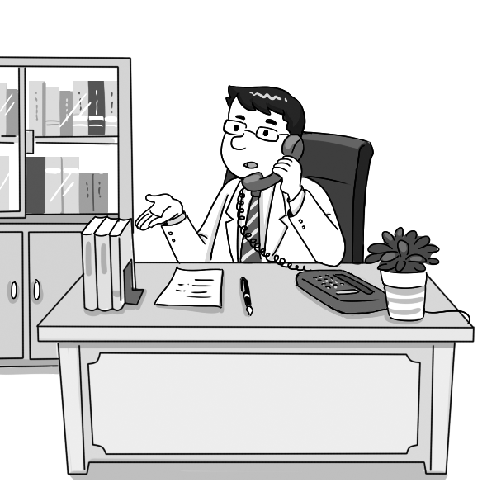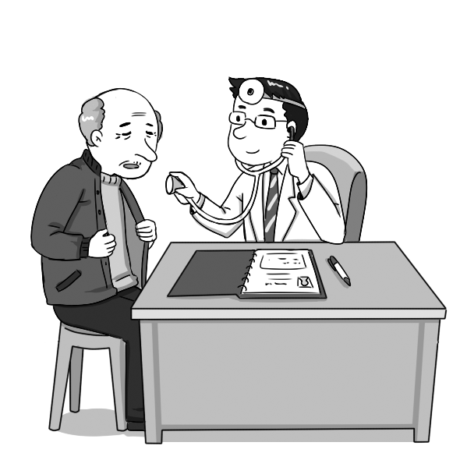  10. (A) (B) (C)  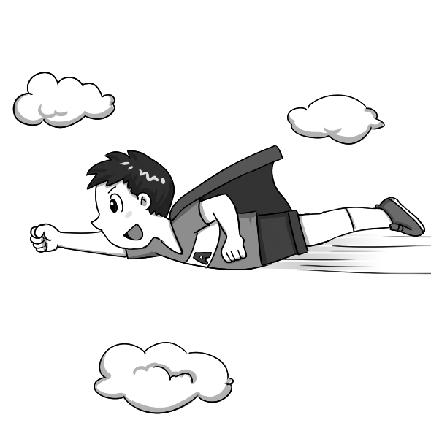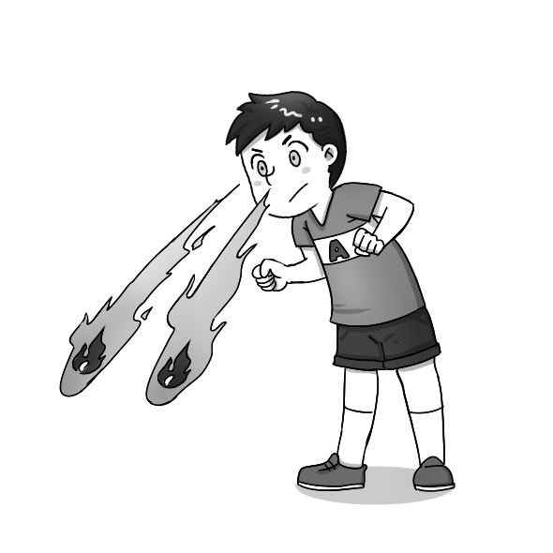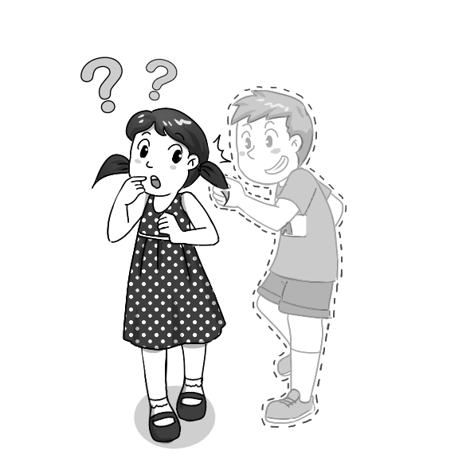  B. 綜合選擇 20% (請選出最適合的答案)  11. When I was taking a shower, I heard my sister _____ a song.  (A) have sung (B) singing (C) sang (D) sings  12. Patty found that the designer bag she _____ online was a fake.  (A) will buy (B) has bought (C) buys (D) had bought  13. Houdini was a great magician who was able to _____ magic tricks by _____ escapes underwater.  (A) does; perform (B) does; performing (C) do; perform (D) do; performing  14. John advised that the garden party _____ until the beautiful fountain is completed.  (A) put off (B) was put off (C) be put off (D) must be put off  15. On _____ off the bus, the old man saw his grandson waiting for him.  (A) gets (B) got (C) getting (D) get  16. Cynthia used to imagine _____ a prince and living happily ever after in a beautiful castle.  (A) marry (B) marrying (C) to marry (D) have married  17. If I _____ as intelligent as Edison, I would be able to invent many things.  (A) am (B) will be (C) were (D) was  18. In the singing contest, the female competitor _____ a deep, loud voice won the first prize.  (A) to (B) for (C) in (D) with  19. Do you think it necessary for a high school student _____ a second foreign language?  (A) to learn (B) learning (C) learn (D) learned  20. After not having seen her for years, I am surprised that my neighbor has changed _____ a shy girl  to a talkative, confident, and successful saleswoman.  (A) for (B) with (C) of (D) from  35. Which is true about the story?  (A) I had to work about ten hours a day. (B) I became a doctor because I liked to help others.  (C) The woman was one of my patients. (D) An old man was diagnosed with autism.  When it comes to heroes in movies or comic books, we may think first of Superman. The first  Superman comic books were published in 1938, and sales greatly increased within an amazingly short period of time. In 1942, this was even called “the best comic book in the world.” Superman was born on Krypton, a distant planet. His original name was Kal-El. When he was a baby, his parents put him in a spaceship before the planet exploded. Then the spaceship traveled a long distance and finally reached the Earth, where it landed on a farm in Kansas. Mr. and Mrs. Kent adopted the baby boy and gave him the name Clark Kent. After young Clark grew up, he worked as a reporter at The Daily Planet newspaper.  Clark Kent had superhuman abilities and a strong sense of justice. Whenever there were people in need of help, he would put on his costume right away and fly off to help them. You may wonder if he felt lonely sometimes. In fact, deep in his heart he also needed the love of others. He once fell in love with a co-worker named Lois Lane and even revealed his true identity to her. Although he was extremely strong, he had a soft soul and always hoped he could find someone to love.  36. What is the best title for the passage?  (A) A Brief Introduction to Superman. (B) The Reason Why Krypton Exploded.  (C) Spaceships and Planets. (D) How to Adopt a Baby.  37. Where was Superman born?  (A) On Mars. (B) On the Moon. (C) On Krypton. (D) On the Sun.  38. Where did Kal-El arrive on the Earth?  (A) In New York. (B) In California. (C) In Texas. (D) In Kansas.  39. What does the word “distant” mean?  (A) Strange. (B) Mysterious. (C) Faraway. (D) Popular.  40. According to the passage, which statement is NOT true?  (A) Superman was created in 1938.  (B) Superman’s original name was Kal-El, but Mr. and Mrs. Kent renamed him Clark Kent.  (C) Superman told a lady he loved about his true identity.  (D) Superman worked as a teacher after he came to the Earth.  E. 填充30%  41. Clement has entered m_____l school because he wants to become a doctor.  42. Lily s_____ed for 20 years and finally became a self-made millionaire.  43. Lilian’s parents r_____t that she get a master’s degree in medicine.  44. My family doctor s_____ted that I learn Yoga to keep fit.  45. If we work together, we can really m_______ _______ d_______.  46. Ang Lee is a l_____y film director who has won the Academy Award for Best Director twice.  47. Pao-chun Wu’s story tells us that even an a_____e person can be successful if he or she works  hard.  48. In the movie, Superman has enough s_____h to fight the bad guys and win a victory in the end.  49. Parents’ love for their children is i_____e but powerful.  50. We s_______ o_______ a_______ people telling stoeires about other people, but we end up being one  of those stories.  .
  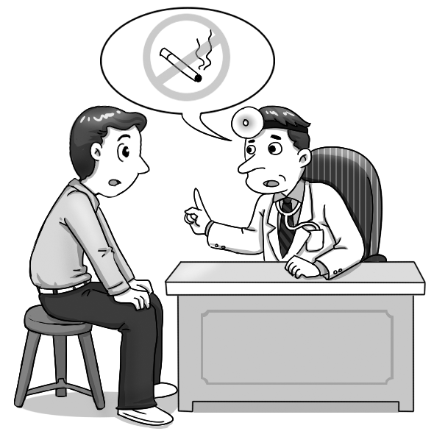  1. ______ | 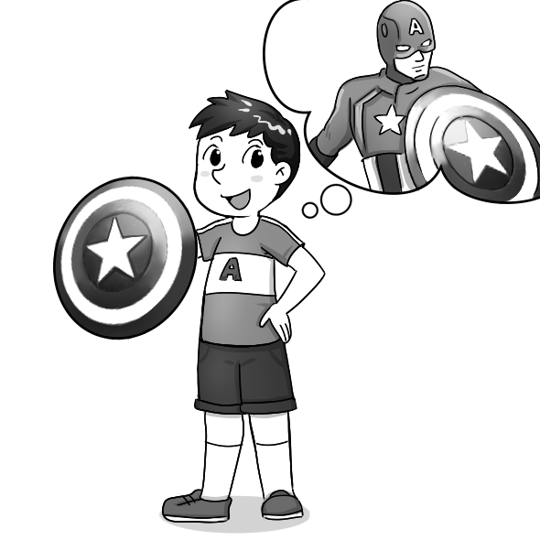  2. _____
新北高工 一0五 學年度第 學期 段 考 |  |  |  |  |  |  | 班級 |  | 座號 |  | 成
科目 | English | 年級 | 二 | 科別 | 機鑄汽模圖資電訊 |  | 姓名 |  |  |  | 績

