- 聽力 (10%)
第一部分：看圖辨義(2%)
試卷上該題有一張圖片，請聽一個和該題相關的問題，與(A)、(B)、(C)三個英語敘述後，選一個與所看到圖片最相符的答案。
 1. ( ) | 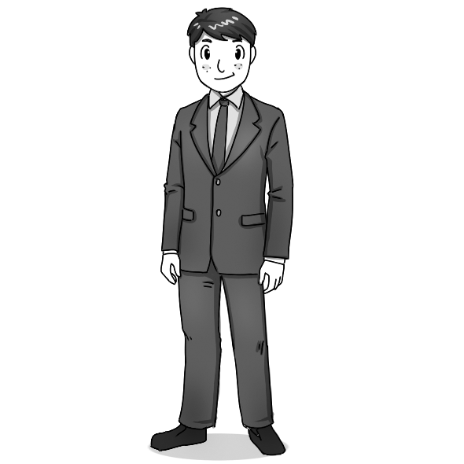 2. ( )
第二部分：問答(3%)
每題會播出一個問句或直述句，聽後請由試卷上(A)、(B)、(C)三個選項中，選出一個最適合的回答或回應。
3.( ) (A) It’s the trendiest tablet!
(B) I’m just sending a LINE message.
(C) It’s all Greek to me!
4.( ) (A) I think Google is the best.
(B) Jeremy Lin is the most influential player.
(C) I’m currently combining two words.
5.( ) (A) There’s a discount if you pay in cash.
(B) My imagination is running wild.
(C) They are too plain looking.

第三部分：簡短對話(3%)
每題會播出一段對話及一個相關的問題，聽後請由試卷上(A)、(B)、(C)三個選項中，選出一個最適合的回答。
6.( ) (A) The dictionary he used was too old.
(B) He copied words from an online dictionary.
(C) He made too many typing mistakes.
7.( ) (A) She will be a participant in a study.
(B) She is trying to get a new job.
(C) She is trying to encourage her students.
8.( ) (A) It’s finished.
(B) She quit the project.
(C) She needs to try doing it again.
第四部分：短文聽解(2%)
每題有三個圖片選項。請聽題目，並選出一個最適當的圖片。
9.( )
(A) (B) (C)
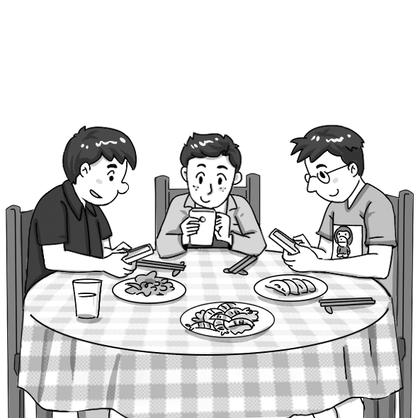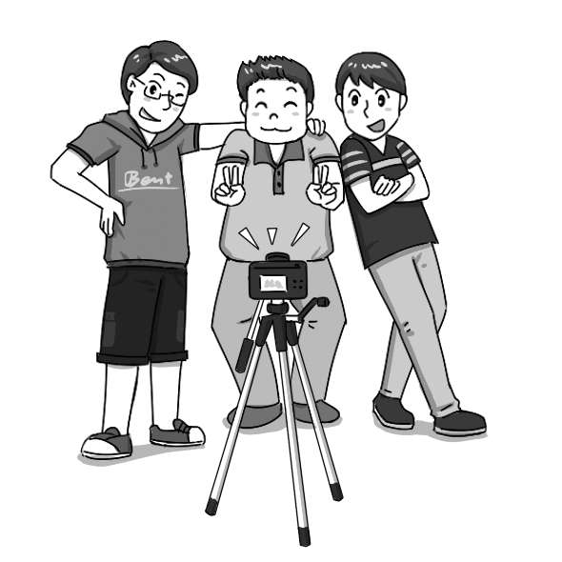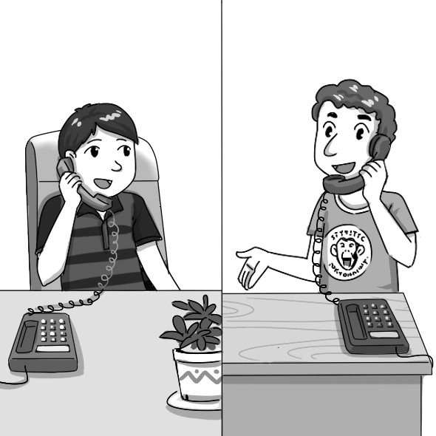

10.( )
(A) (B) (C)
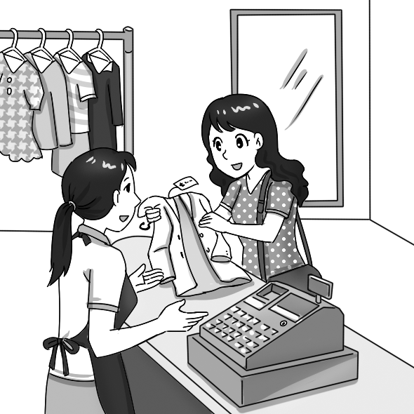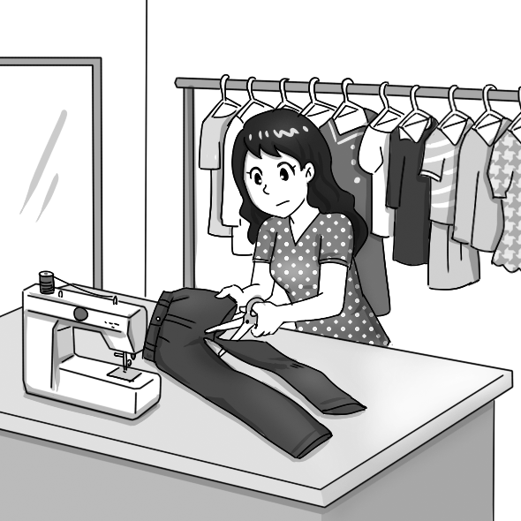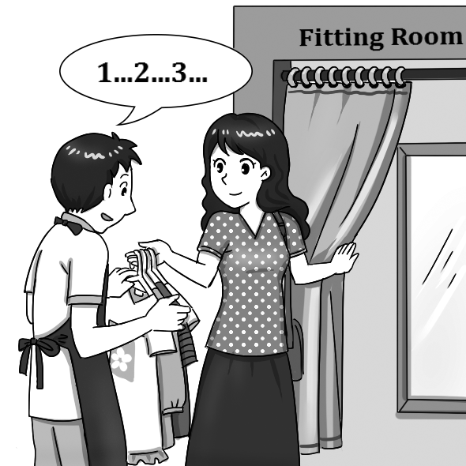

二、文法與慣用語 (24%)
( )11. There are so many words on this menu that I don’t know. I think I’ll have to _____ some of
the words before I order.
(A) hear up (B) hear out (C) look up (D) look out
( )12. I have two sisters. One of them is really tidy, but _____ is very messy.
(A) other (B) the others (C) another (D) the other
( )13. _____ seems to encourage people to behave more responsibly and to make their best
effort.
(A) Being dressed in (B) Dressing up (C) Dress up (D) Dressed in
( )14. We should show the utmost respect to firefighters, _____ jobs require bravery and
sacrifice.
(A) whose (B) whom (C) which (D) who
( )15. Doing volunteer work seems _____ the old man happier.
(A) making (B) to make (C) that makes (D) that it makes
( )16. Gary is 30 years old, but his parents still treat him as if he _____ a kid.
(A) is (B) were (C) are (D) been
( )17. Matt is _____ a successful writer that every publisher in the city wants him to work for
them
(A) so (B) such (C) too (D) even
( )18. The old man _____ downstairs is a German.
(A) lived (B) live (C) lives (D) living
( )19. Many students were seen _____ off in class.
(A) doze (B) dozed (C) to dozing (D) dozing
( )20. Listening to loud music makes it _____ to concentrate when driving.
(A) be difficult (B) to be difficult (C) difficult (D) being difficult
( )21.The technician was explaining the production process, but I felt that what he was
saying was _____.
(A) all Greek to me (B) all Greek to you (C) all Roman to me (D) all Roman to you
( ) 22. It was not hard to fix the leaking water pipe. All you had to do is _____ the plumber and
let him take care of the problem.
(A) calls (B) call (C) called (D) been called

三、文意字彙 (26%)

( )23. Social equality is a heatedly debated _____ in the US and many other parts of the world.
(A) society (B) culture (C) issue (D) symbol
( )24. I really enjoyed the play, especially the _____. The things the performers said were so
witty.
(A) dialogues (B) interests (C) websites (D) alternatives
( )25. Vocational high school students should have greater _____ in themselves in order to learn
English well.
(A) influence (B) dependence (C) confidence (D) performance
( )26. The school holds _____ meetings to hear the opinions of students, parents, and teachers.
(A) regular (B) recent (C) strong (D) competitive
( )27. There are no _____ differences between the way the two brothers look. That’s why they
are often considered to be twins.
(A) common (B) full (C) mature (D) significant
( )28. “Working from home” is no longer a new _____ in today’s society. Many companies have
adopted this idea.
(A) modification (B) frequency (C) concept (D) demand
( )29. We should not judge a person too quickly because first _____ are often misleading.
(A) impressions (B) restrictions (C) elements (D) experiments
( )30. Since my grandfather was hospitalized (住院), my father had to rush _____ from his office
to the hospital after he got off work.
(A) accurately (B) powerfully (C) frequently (D) wildly
( )31. The main street was blocked. Drivers were advised to take _____ routes.
(A) formal (B) mature (C) mobile (D) alternative
( )32. The competition for first prize _____ my relationship with my best friend.
(A) impressed (B) alerted (C) affected (D) performed
( )33. The athlete’s long-distance run through the Sahara Desert was a(n) _____ achievement.
(A) impressive (B) regular (C) accurate (D) foreign
( )34. The _____ estimated that the current bird population of this island has decreased to 300
due to pollution from chemical factories.
(A) challengers (B) publishers (C) participants (D) researchers
( )35. Even if you don’t agree with someone, sticking your tongue out is not what a(n) _____
person should do.
(A) mature (B) adventurous (C) certain (D) general

四、綜合選擇 (20%)

When people go into a clothing store, many things influence which clothing they buy. Some people choose clothes for the design, __36__ others choose them for the material or the color. __37__ people don’t care too much about where their clothes were made. In fact, the story behind these clothes may be more miserable than we thought. Clothing today is usually made in poor countries. Sweatshops* there hire poorly-paid workers __38__ working hours are very long. __39__ the long working hours, these workers work in very terrible conditions. Though attempts have been made to improve these people’s working conditions and salaries, little progress has been made so far. To make a difference, we consumers can buy clothes that are considered “fair trade” products __40__ those made in sweatshops. A little effort on our part may make a big difference.
*sweatshop n. [C] 血汗工廠
( )36. (A) while (B) because (C) unless (D) so that
( )37. (A) They seem to (B) They seem that (C) It seems that (D) It seems to
( )38. (A) whom (B) that (C) whose (D) which
( )39. (A) Owing to (B) Besides (C) As a result of (D) Thanks to
( )40. (A) instead of (B) in addition to (C) inclusive of (D) for the rest of

Just like e-words, symbols such as “♥” have also __41__ common elements in computer and __42__ phone text messages. It all started __43__ the “I ♥ NY” T-shirts printed in the 1980s to promote tourism. The design became so popular that almost everyone owned a T-shirt with an “I ♥…” logo on it. People can still be seen today __44__ shirts that say “I ♥ TW.” These days, the symbol “♥” can even be used as a word. If you look up the word “heart” in Oxford Dictionaries Online, you will find the symbol “♥” __45__ the same entry.
( )41. (A) became (B) becoming (C) becomed (D) become
( )42. (A) alert (B) alternative (C) mobile (D) frequent
( )43. (A) to (B) with (C) by (D) on
( )44. (A) are wearing (B) wearing (C) wear (D) worn
( )45. (A) under (B) in (C) from (D) by

五、對話 (10%)
( )46. Fanny: What are you doing, Adam? You shouldn’t use your phone in class.
Adam: _____ I have to read it now.
Fanny: Stop it, or the teacher will take your phone away.
(A) I’m sending a letter to my teacher. (B) I’m looking around for my date.
(C) My girlfriend sent me a LINE message. (D) I’m using the keyboard to type.
( )47. Jasmine: Do you have this T-shirt in any other colors? I don’t think it’s my style to wear
such a bright color.
Clerk: In fact, _____.
Jasmine: That would look better on me. I’ll take it.
(A) this one also comes in black (B) we also have it in a small size
(C) we can shorten it (D) it isn’t that tight
( )48. Derek: I’m going on a blind date tonight.
Finn: Here’s a tip: Interaction is very important. Pay close attention to what she says. So I
suggest that when you two meet tonight, you should _____.
Derek: Your advice is very helpful. Thanks a lot!
(A) google her before you head out for the date
(B) try talking to her instead of focusing on your phone
(C) be sure you’re going to find a husband there
(D) ask for her Facebook account and chat with her on Facebook

( )49. Clerk: Here you are. Size 6.
May: Thank you. _____
Clerk: Of course. The fitting room is right this way.
(A) Could you give me a hand? (B) May I try it on?
(C) Is that a good one? (D) May I buy it online?
( )50. Kate: I like this cute pair of shorts very much, but they are a little too tight.
Clerk: No problem. _____
Kate: That’s great. Can I try them on?
(A) They are out of stock. (B) They come in many colors.
(C) You can get a full refund. (D) We have them in larger sizes.

六、閱測 (10%)
If you glance at someone’s smartphone, you might see an app with a blue-sky background, some funny stickers*, and green text bubbles. You will know immediately what it is. It’s called LINE, a popular messaging app that allows you to send free text messages whenever and wherever you are. According to App Annie, an app market analysis firm, LINE ranked No. 1 in worldwide app sales in 2013. It’s estimated that LINE has been used by over 1 billion people all over the world so far.
Why are such a large number of people charmed by LINE? LINE has become such a popular app for several reasons. First, it allows users to text, to call, and to share photos, videos, and voice messages without any charge. Second, users can make their chats more fun with LINE stickers, which speak louder than words. Those who do not have smartphones can easily use LINE on their desktops or laptops. Moreover, playing games with their LINE friends is a wonderful pastime*. Users can choose to either compete for the highest scores or battle with one another in teams. Also, LINE has added a new function called Timeline*, with which users can share great moments with their close friends.
For all these reasons, it is not hard to see why LINE has earned such great popularity with people around the world. Have you used LINE today?
＊sticker n. [C] 貼圖 ＊pastime n. [C] 消遣 ＊Timeline n. 動態牆
( )51. What is the main idea of the passage?
(A) According to App Annie, LINE ranked No. 1 for worldwide app sales in 2013.
(B) With so many interesting features, LINE is popular with people worldwide.
(C) Although LINE is quickly growing in popularity, its origins are still unknown.
(D) The number of people who use LINE is on the increase just because it’s free.
( )52.What does the word “charmed” in the second paragraph most likely mean?
(A) Bored. (B) Annoyed. (C) Offended. (D) Attracted.
( )53.Based on the passage, which of the following statements about LINE features is true?
(A) You can share great moments with your friends on your Timeline.
(B) You can only stay in touch with your LINE friends on your smartphone.
(C) You can send text messages through LINE, but not voice messages.
(D) You can only compete with your LINE friends in a game, but not work together with
them in teams.
( )54.Why do people send stickers to their LINE friends?
(A) They don’t know how to type text messages.
(B) They send messages from their desktops.
(C) They want to make their messages seen.
(D) They want to make their chats more fun.
( )55.Which is probably the best slogan for LINE?
(A) Impossible is nothing!
(B) Let’s make things better!
(C) Quick, easy, and fun: free messaging for everyone!
(D) It’s everywhere you want to be!

