新北市立新北高工 一O五 學年度第 二 學期 第二次段考 |  |  |  |  |  |  |  | 班級 |  | 座號 |  | 成
科目 | English | 年級 | 二 | 科別 | 機鑄汽模訊圖電資 |  |  | 姓名 |  |  |  | 績
- 聽力（10%，每題1分）  第一部分：看圖辨義(2%)。試卷上該題有一張圖片，請聽一個和該題相關的問題，與(A)、(B)、(C)三個英語敘述後，選一個與所看到圖片最相符的答案。  第二部分：問答(3%)。每題會播出一個問句或直述句，聽後請由試卷上(A)、(B)、(C)三個選項中，選出一個最適合的回答或回應。  3. (A) No, my bag is at home.  (B) Yes, this bag belongs to me.  (C) Yes, I used it to carry some fruit.  4. (A) It assists me to get my shoes.  (B) It has a keen sense of smell.  (C) It likes to eat chemicals.  5. (A) You can exchange them for a key chain.  (B) Here are your free stickers!  (C) That comes to 120 dollars.  第三部分：簡短對話(3%)。每題會播出一段對話及一個相關的問題，聽後請由試卷上(A)、(B)、(C)三個選項中，選出一個最適合的回答。  6. (A) Order food in the restaurant.  (B) It waits for her outside.  (C) It guides her around. |  |  |  |  |  | 7. (A) He smelled something suspicious.  (B) He had a restricted item.  (C) He got a reward.  8. (A) No, because there’s no promotion on it.  (B) No, because they don’t need it.  (C) Yes, because it’s 40% off.  第四部分：短文聽解(2%)。每題有三個圖片選項。請聽題目，並選出一個最適當的圖片。  9.  (A) (B) (C)  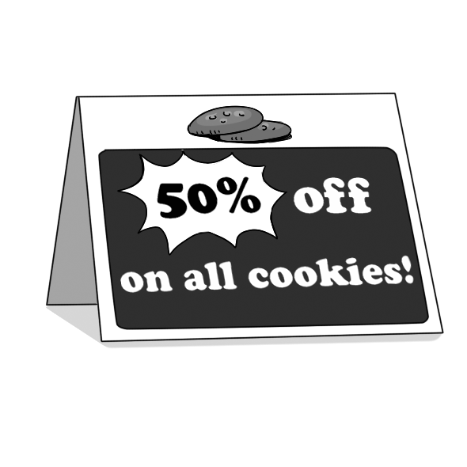  10.  (A) (B) (C)  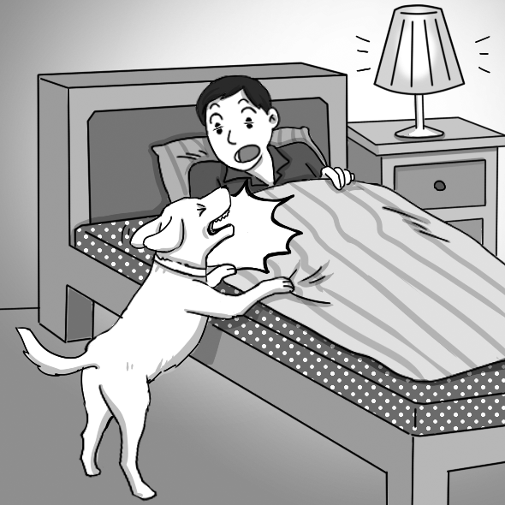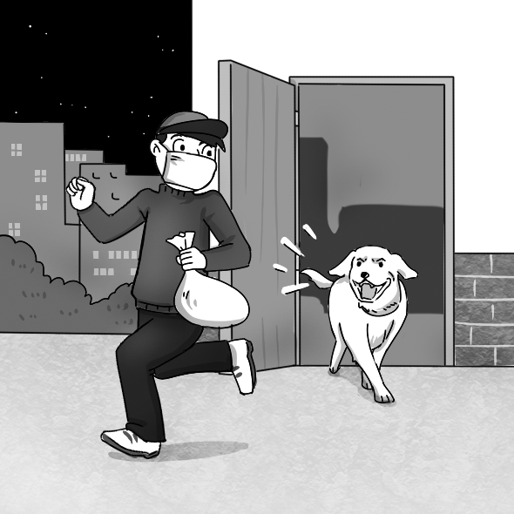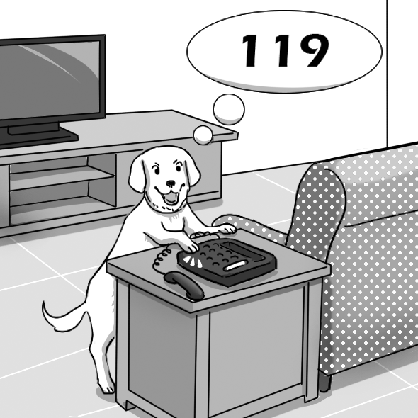  - 綜合文法 （每題2分，共30%）  11. The doctor suggests that children who are infected _____ the flu stay home and get more rest.  (A) with (B) for (C) on (D) by  12. When I woke up this morning, the light was on. I _____ turn it off.  (A) must forget to (B) must have forgotten to  (C) should have forgotten to (D) should forget to  13. I forgot to tell our coach that I had asked Bill _____ he would like to join our baseball team or  not.  (A) which (B) where (C) whether (D) whom  14. _____ it gets, _____ the ice will melt.  (A) The hot; the faster (B) The hotter; the fastest  (C) The hot; the fast (D) The hotter; the faster
  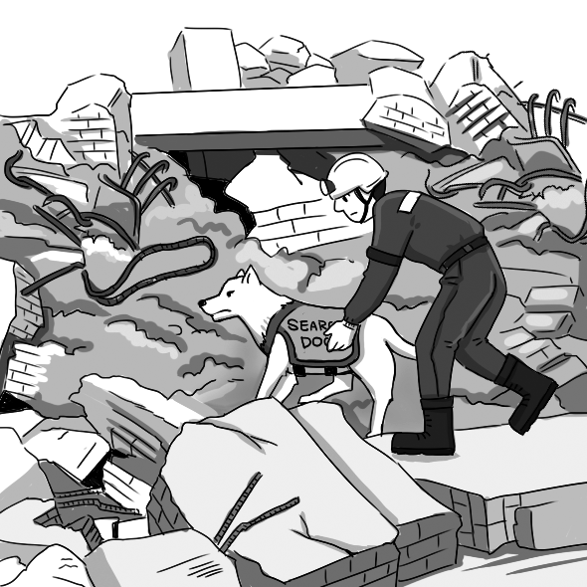  1. ______ | 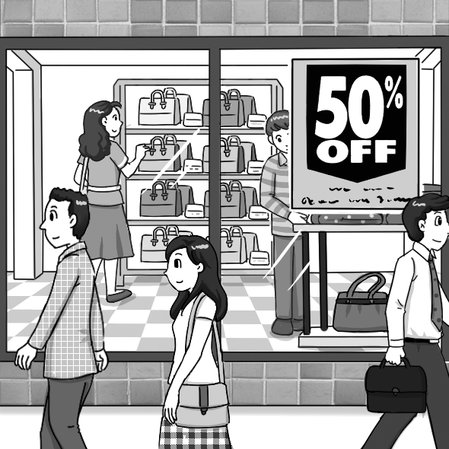  2. ______
新北市立新北高工一O五 學年度第 二 學期 第二次段考 |  |  |  |  |  |  |  | 班級 |  | 座號 |  | 成
科目 | English | 年級 | 二 | 科別 | 機鑄汽模訊圖電資 |  |  | 姓名 |  |  |  | 績
15. _____ by Helen’s smile, George decided to ask her out.  (A) Attracting (B) Attracted (C) Attract (D) To attract  16. Today the class will discuss _____.  (A) whether we should invite the teachers to the class party  (B) if decide the color of our class T-shirt  (C) whether will we have a class trip this summer  (D) if who will be the class officers for the spring semester  17. The weather forecast _____ to be completely wrong. Heavy rain ruined my trip.  (A) likely to (B) turned out (C) added up (D) come in  18. A: The dancers have stopped dancing!  B: There _____ something wrong with the music.  (A) will be (B) must be (C) were (D) must have  19. _____ a beautiful girl next to him, Billy was so nervous that he forgot to breathe.  (A) Noticing (B) Noticed (C) Had noticed (D) To notice  20. You can exchange these stickers _____ whatever item you like here.  (A) to (B) on (C) for (D) with  21. _____ what to do, the little boy sat crying at the side of the road.  (A) Not knowing (B) Knowing not (C) Not knew (D) Didn’t know  22. I don’t know _____ Helen will visit me tomorrow.  (A) what (B) if (C) then (D) who  23. Michael is now a professional mechanic because he _____ for three years.  (A) was being trained (B) is trained (C) had trained (D) has been trained  24. The risk of getting skin cancer is higher if you _____ your skin _____ the sun very often.  (A) are exposed; to (B) are exposed; under (C) expose; to (D) expose; under  25. Eating a balanced diet is _____ healthier than eating pizza and hamburgers.  (A) most (B) more (C) very (D) much  三.克漏字（每題2分，共10分）  Many people consider dogs to be our best friends. Dogs’ function need not be __26___ that of keeping their master company; in fact, they can also go on military missions. Cairo, the Belgian Malinois*, was a part of the Navy SEAL team, __27___ successfully killed Osama Bin Laden. With a sense of smell forty times stronger than __28___ of a person, this dog was trained to detect and identify explosives as well as enemies who are hiding. Cairo, equipped with video cameras, enters certain danger zones before humans do. His handler* can clearly see what’s ahead thanks to Cairo. Moreover, the dog can run twice as fast as a trained soldier, so it’s hard for his enemies to escape. __29___ Cairo’s natural intelligence, physical abilities, and a strong sense of loyalty, he has contributed greatly to* the success of military missions. It seems that the more we learn about dogs, __30___ we need their help, especially if they are brave warriors* like Cairo.  *the Belgian Malinois 比利時狼犬 *handler n. [C] 馴犬師 *contribute to 貢獻  26. (A) extended to (B) various in (C) limited to (D) rich in  27. (A) where (B) which (C) that (D) when  28. (A) this (B) that (C) one (D) it  29. (A) Due to (B) In order to (C) So as to (D) For the purpose of  30. (A) the much (B) the most (C) the more (D) the very much |  |  |  |  |  |  | 四. 對話（每題2分，共10％）  31. Officer: I’m sorry, sir. The quarantine detector dog _____, so I need to check your baggage.  Ted: No problem.  (A) smelled something suspicious (B) needs your contact number  (C) is too tired to smell (D) will confiscate your bag  32. Larina: David, I thought you’d been longing to have this bag for a long time. Why don’t you  buy it?  David: _____  - I can’t save it. (B) I can’t afford it. (C) I can’t make it. (D) I can’t take it.  33. Charles: Two flashlights and four batteries. _____  Dylan: Here is NT$2,000.  Charles: Here is your change and receipt. Have a nice day.  (A) What’s today’s special? (B) The total comes to NT$1,950.  (C) Would you give me a break? (D) That’s really a good bargain.  34. Officer: _____  Thor: To visit my aunt.  Office: I see. Where in the city does your aunt live?  (A) When are you leaving? (B) What’s the purpose of your visit?  (C) What do you have in your bag? (D) What’s your passport number?  35. Customs officer: Welcome to Thailand. Please show me your passport.  Derek: Here it is.  Customs officer: Are you carrying any restricted items? _____, they will be confiscated.  Derek: No. I never bring illegal things.  (A) If possible (B) If necessary (C) If so (D) If permitted  五.閱讀測驗（每題2分，共10％）  People may know the advantages of having a pet. However, it is important to choose one that matches your lifestyle.  If most of your time is spent at home, select a pet that would be happy to stay with you at home. You may enjoy playing with a cat, watching a fish in its aquarium, or singing along with a bird. On the other hand, if you’re more active and enjoy outdoor activities, especially walking or running, an energetic dog might be the right choice for you. How about a family with small children or elderly people? Puppies and kittens are usually delicate and need more care. Larger dogs could accidentally knock over or hurt a small child or an older person. Perhaps a hamster* or bird in a cage or a fish in an aquarium would be the best choice.  Finally and probably most importantly, bringing home a pet is like making a commitment* that will last for the pet’s lifetime－maybe 10, 15, or 20 years for a dog or cat; as many as ten years for a bird. Remember that you should not abandon your pet for any reason.  *hamster n. [C] 倉鼠 *commitment n. [C] 承諾  36. What is the main message of the passage?  (A) Find a pet that reduces your stress.  (B) Find a pet that matches your lifestyle.  (C) Find a pet that eases your depression.  (D) Find a pet that promotes your health.
新北市立新北高工一O五 學年度第 二 學期 第二次段考 |  |  |  |  |  |  |  | 班級 |  | 座號 |  | 成
科目 | English | 年級 | 二 | 科別 | 機鑄汽模訊圖電資 |  |  | 姓名 |  |  |  | 績
37. This passage is about _____.  (A) pets and the environment (B) pets and communication  (C) pets and lifestyles (D) pets and health  38. According to the passage, which of the following is true?  (A) Keeping a fish as a pet is a good idea for a little kid.  (B) Keeping a cat as a pet is the best choice for an active person.  (C) Larger dogs can help take care of children.  (D) A dog can encourage an older person to exercise.  39. The word “energetic” in the second paragraph is closest in meaning to _____.  (A) active (B) tired (C) elegant (D) quiet  40. After reading the last paragraph, you will know that _____.  (A) owning a pet is something to do just for fun  (B) having a pet is a serious matter  (C) keeping a pet will cost a lot of money  (D) raising a pet will be very inconvenient  六.文意字彙（每題2分，共30%）  41. The president’s o_____l visit improved the relationship between the two countries.  42. Having some black coffee every day is b_____l to your health. It can reduce the risk of heart  disease.  43. That shop is running a special p_____n. We can get drinks for half price.  44. Kenny worked all summer to save money so that he could p_____e an iPad for his parents.  45. The president of the company e_____red many difficulties when he started his business.  46. The young man offered a_____e when he saw a blind man crossing the street.  47. One of the important f_____ns of a cellphone is to allow people to send text messages.  48. For a goalkeeper(守門員), it’s a great a_______e to have big hands.  49. The government’s short-term s_____y to reduce the drunk driving rate is to increase fines.  50. This drink doesn’t c_____n any sugar. It’s suitable for people who want to lose weight.  51. The police officer asked Sam if he could i_____y the woman in the picture.  52. In fact, people have never been able to stop natural d_____rs from happening.  53. Helen: Do you have any double rooms a________e this weekend? Staff: Yes, we do.  54. Although Will didn’t want to do that difficult job in the first place, he was c_____ed by Jane and  decided to take up the challenge.  55. We will d_____y our latest line of smartphones at the exhibition. |  |  |  |  |  |  | 請在本張試卷上方寫上姓名座號，將答案卷交回
  41. | 42. | 43.
  44. | 45. | 46.
  47. | 48. | 49.
  50. | 51. | 52.
  53. | 54. | 55.

