- 請選填正確英文。注意:請將字母寫在正確位置，單字和單字之間需有間隔。20%
turtle | Nice to meet you | teacher | Let’s go
Good morning | Be careful | Sit down | See you
Indian | Stand up | May I help you | It’s ok
Good night | You are welcome | Good evening | I am sorry
Please | How are you? | Good afternoon | mud

- 不客氣
- 晚安
- 坐下
- 印地安
- 烏龜
- 請保重
- 老師
- 我們走
- 請
- 站起來
- 早安
- 你好嗎?
- 很高興見到你
- 泥巴
- 我很抱歉
- 沒問題
- 午安
- 請
- 晚安(睡前)
- 我可以幫你嗎?

- 請完成下列的句子。2*10=20
nine | two | five | three
ten | four | seventeen | nineteen
six | fifteen | eleven | eight
twelve | thirteen | seven | twenty
fourteen | sixteen | eighteen

1 | 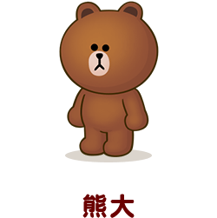 Brown 15歲 | A:How old is Brown?  B: Brown is years old.
2 | 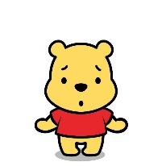Winnie 10歲 | A:How old is Winnie?  B: Winnie is years old.
3 |  Rilakkuma 14歲 | A:How old is Rilakkuma?  B: Rilakkuma is years old.
4 | Kumamon 19歲 | A:How old is kumamon?  B: kumamon is years old.
5 | Moon 11歲 | A:How old is Moon?  B:Moon is years old.
6 | cony 12歲 | A:How old is Cony?  B:Cony is years old.
7 | James 13歲 | A:How old is James?  B: James is years old.
8 |  Sally 7歲 | A:How old is Sally?  B: Sally is years old.
9 |  Boss 2歲 | A:How old is Boss?  B: Boss is years old.
10 | Leonard 20歲 | A:How old is Leonard?  B: Leonard is years old.
- 請寫出下列數字的英文:4*15=60
Twenty | Thirty | Forty | Fifty | Sixty
Seventy | Eighty | Ninety

數字 | 英文 | 數字 | 英文
28 |  | 79
35 |  | 81
47 |  | 94
56 |  | 23
62 |  | 39
42 |  | 54
66 |  | 79
83

