- 選擇題：請將答案畫記於答案卡。 同時請於卡上畫記班級、座號。
- 聽力測驗 10%
（一）看圖辨義：每題請聽錄音機所播出的題目和A、B、C三個選項後，選出與所看到的圖畫最相符的答案（每題播放一次）。
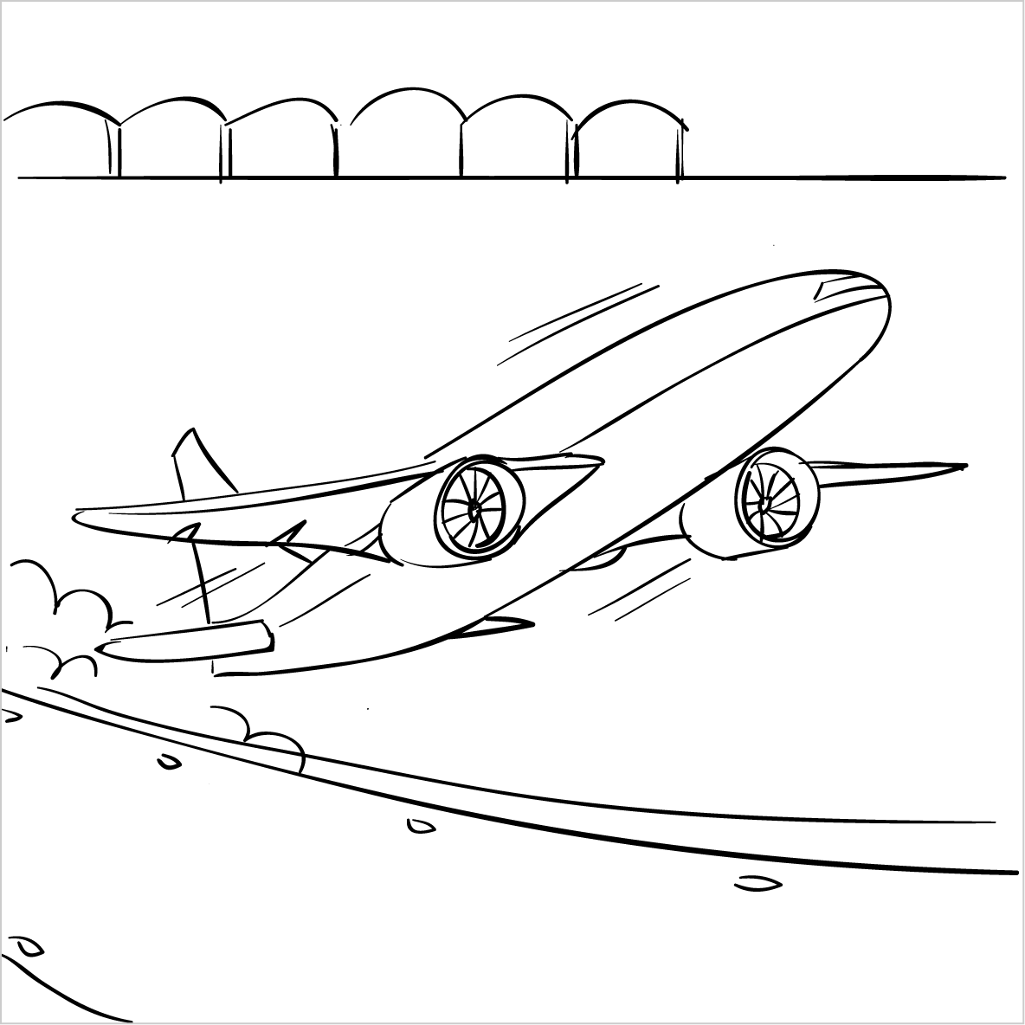
1. ______
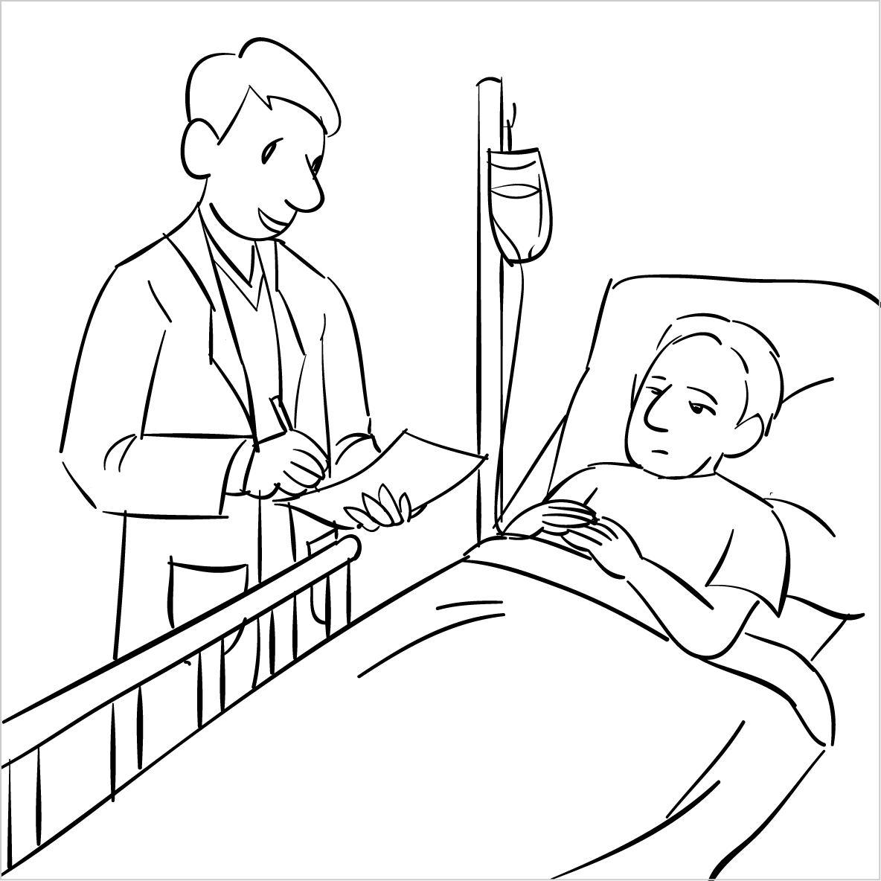
2. ______
（二）問答：每題請聽錄音機所播出的英語句子，再從試題上A、B、C三個選項中，選出一個最適合的回答或回應（每題播放一次）。
- (A) No, there’s no room for anything else. (B) No, it’s full.
(C) No, it’s empty.
- (A) They’re a symbol of my love for you. (B) You’ve made the right decision.
(C) You may miss the important things in life.
- (A) Thank you so much for helping me. (B) Right, you can do it by yourself.
(C) Sure, I’ll do it for you.
- (A) It’s because it is not good for your health. (B) It’s because throwing food away is a waste.
(C) It’s because I am hungry.
（三）簡短會話：每題請聽錄音機所播出的一段對話和相關問題，再從試題上A、B、C三個選項中，選出一個最適合的答案（每題播放兩次）。
- (A) Making the girl relaxed. (B) Telling the girl to be worried.
(C) Making the girl more nervous.
- (A) Taking the math test. (B) Complaining about their tests.
(C) Comparing their test scores.
- (A) She talks constantly during lessons. (B) She needs to speak more in class.
(C) She never volunteers to say anything.
- (A) Fix the machine. (B) Train the woman.
(C) Throw the machine away.

- 克漏字 10%
One day, our teacher brought a jar to class. Without _11_ a word, he filled the jar _12_ rocks, pebbles, and sand. When the jar was full, he asked us what these things stood for in our lives. He then explained that th rock were _13_ important things in life, _14_ family, friends, and health. The pebbles were smaller than the rocks, _15_ they were less important things like jobs, schoolwork, _16_. The sand was the smallest thing in _17_ to the rocks and pebbles. Then, the teacher said _18_ a more serious tone. If a person dropped pebbles and sand _19_ the jar before dropping rocks, he or she might lose the important things in life, The teacher taught us a life lesson and hoped we would _20_ a happy life.
 | (A) say | (B) to say | (C) saying | (D) said
 | (A) on | (B) in | (C) with | (D) for
 | (A) much | (B) more | (C) the most | (D) the more
 | (A) such like | (B) alike | (C) such | (D) such as
 | (A) so | (B) although | (C) or | (D) unless
 | (A) that is to say | (B) at first | (C) and so on | (D) once in a while
 | (A) environment | (B) concentration | (C) importance | (D) comparison
 | (A) in | (B) with | (C) on | (D) for
 | (A) from | (B) on | (C) into | (D) over
 | (A) let | (B) lead | (C) make | (D) take
- 文法選擇 34%
 | Bill tried to put on the shirt, ____it was too small for him
 | (A) or | (B) so | (C) but | (D) if
 | Sammy poured all the water our of the bottle to make it______
 | (A) emptily | (B) emptying | (C) emptied | (D) empty
 | Claire got good grades on her test ______studying hard.
 | (A) with | (B) by | (C) at | (D) in
 | Gina caught the bus, ___ she left her lunchbox at home.
 | (A) or | (B) before | (C) but | (D) so
 | Sandra ____ to do the dishes for her mother yesterday
 | (A) volunteers | (B) is volunteering | (C) volunteer | (D) volunteered
 | It is getting colder. Winter ______ soon.
 | (A) comes | (B) will come | (C) coming | (D) came
 | Jimmy and his family ______ to Japan next month.
 | (A) went | (B) goes | (C) will go | (D) going
 | Vicky’s magic show made the party _______
 | (A) interesting | (B) interested | (C) interest | (D) interestingly
 | The interview made me ______.
 | (A) nervously | (B) nervous | (C) to be nervous | (D) more nervously
 | It was difficult to carry the books ____ my own, so I askedmy sister for help.
 | (A) from | (B) to | (C) on | (D) for
31 | Marty cannot walk fast ________ his legs were hurt.
 | (A) so | (B) although | (C) because | (D) while
32 | Ivy always listens to music _____ she is doing the housework.
 | (A) while | (B) after | (C) and | (D) although
33 | Hard work and good luck _____ Danny a successful businessman,
 | (A) got | (B) let | (C) helped | (D) made
34 | Having fruit and vegetables every day makes us _____.
 | (A) health | (B) healthy | (C) healthily | (D) to be healthy
35 | Owen ate two sandwiches and one egg , ______ he still felt hungry.
 | (A) so | (B) X | (C) but | (D) although
36 | Michelle didn’t come to the party because she ______ a cold.
 | (A) caught | (B) was caught | (C) is catching | (D) catches
37 | Catherine ______ to church every Sunday.
 | (A) went | (B) is going | (C) goes | (D) will go
- 對話 10%
38 David: What can I do with these old books?
Benny: ______. Some people may like to read them.
(A) You are worried about the money | (B) More and more people are buying books.
(C) It is possible to throw them away. | (D) You don’t have to throw them away.
39 Susan: My desk lamp is out of order.
Joanna: ______. I can fix it for you.
(A) There is nothing wrong with your lamp. | (B) Just leave it with me.
(C) Let me buy you a new one. | (D) Maybe you should give it a try.
40 Annie: Making money isn’t my top priority. I should spend more time with my friends.
Kellly: I agree.
(A) You should hang out with your friends more often. (B) You can’t live without money.
(C) Your friends want you to make more money. (D) Your friends won’t like it.
41 Vincent: I’ve made up my mind to exercise more often.
Yvonne: _____. It does good to your body.
(A) You should study harder than before. | (B) You’ve made the right decision.
(C) It’s your turn to make the decision. | (D) You don’t have to do it.
42 Jenny: Oh, no. My cellphone isn’t working.
Oliver: _______.
Jenny: Sure. Here it is. Can you fix it?
Oliver: I’ll try my best.
(A) Try to do it again | (B) You don’t have to.
(C) Can I take a look at it? | (D) Why don’t you buy a new one?
- 閱讀測驗 6% (每題3分)
The School Bully
Sam was known as the school bully. He was tough. He had a lot of muscles. He was very tall, too. He looked really scary. He was mean. He teased people. He made fun of people's appearances. He spent 10 minutes teasing one of his classmates. The classmate cried. The classmate told the teacher. The teacher talked to the bully. The teacher called the bully's parents. The bully's parents arrived at the school. The bully, his parents, and the teachers all talked. The parents and the bully left the school. The teacher gave an announcement. The school kicked the bully out of school. He will never return.

muscles 肌肉 appearances 外表 tough 粗魯的
announcement 宣佈；通知 kick踢

43. What happened to the bully in the end?
(A) He and Sam became good friends.
(B) Some people in the school kicked him.
(C) Students in the school seldom saw him.
(D) The school wanted him to leave.

44.What may the word “tease” mean?
(A) to do interesting things in front of people
(B) to help people do something
(C) to laugh at people
(D) to tell jokes to people

請務必填寫考卷右上角的班級、姓名、座號，未寫扣5分。
- 非選擇題 (請作答於右半頁作答區)
- 文義字彙 12% (每題2分)
1. The doctor asked the p________t to take the medicine three times a day.
2. Kevin is trying to e_______n why he was late for school this morning.
3. Cathy and I have a long f_________p. We have known each other since we were kids.
4. My cellphone is b______n. Can you help me fix it?
5. By learning to play instrument(樂器), Lisa gets lots of s__________n(satisfy).
6. If we try to r_______e the waste,the world will be a better place.
- 填空式翻譯 18% (每題1分)
6. 我高中的時後，參加學校的搖滾樂社。
When I was in senior high school, I ________ _________ _________ the school rock music club.
7. 如果你想要減重，你應該減少糖分的攝取。
If you want tolose weight, you should _________ __________ __________ sugar.
8. 昨天我去買東西的時候，店員免費送我一張電影票。
Yesterday when I went shopping, the store clerk gave me a movie ticket ________ ________.
9. 在文章的最後，作者用幾句話來總結他的想法。
At the end of the article, the writer _________ _________ his thoughts in a few sentences.
10. 身為一個領袖，他必須把人民凝聚在一起。
As a leader, he has to ____________ the people ____________.
11. 無論我做什麼，我弟弟總是在妨礙我。
Whatever I do, my little brother always __________ ___________ my ___________.
12. 樹葉轉為一片黃。也就是說，秋天快到了。
The tree leaves are turning yellow. __________ ___________ to ___________, autumn is coming.

- 文義字彙 12%
1 | __________________ | 2 | __________________ | 3 | __________________
4 | __________________ | 5 | __________________ | 6 | ___________________

- 填空式翻譯 18% (每格只填一個字)
6
7
8
9
10
11
12

