市立新北高工106學年度第1學期第3次段考試題 |  |  |  |  |  |  |  | 班級 |  | 座號 |  | 成  績
科 目 | 英文 | 使用答案卡 |  | 年級 | 2 | 科別 | 機鑄電模汽圖資訊 | 姓名 |  |  |  | 成  績

請將以下選擇題答案劃記於答案卡上(否則不予計分);並劃上座號, 未劃座號者酌扣總分15分
- Listening Comprehension (10%)
- Pictures (2%)
Listen to the questions. Then choose the best answer according to each picture.
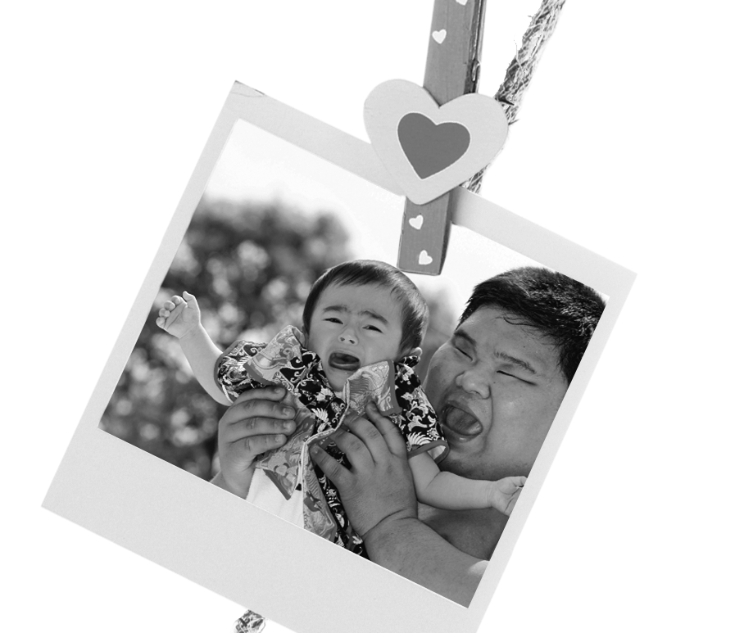 | 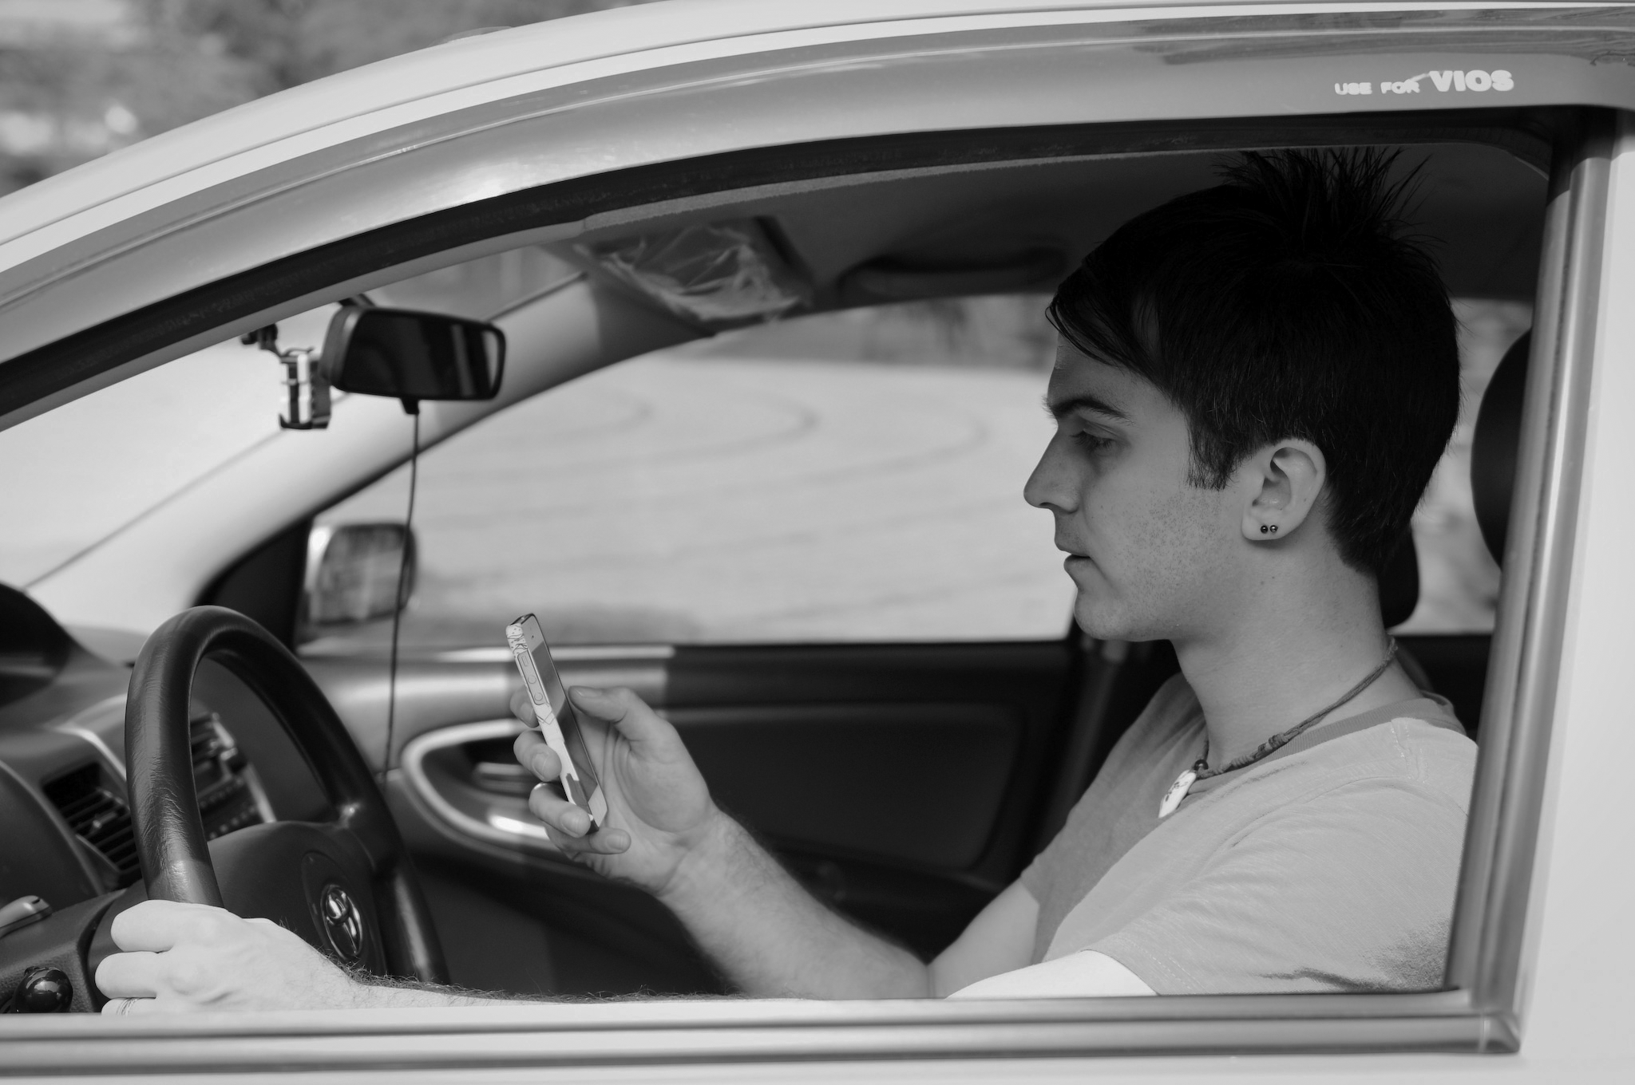
1. ______ | 2. ______
B.Best Response (3%)
Choose the best response to each question or statement.
_______ 3. (A) You can take the whole day to stroll around.
(B) You need to transfer at Ruifang Station.
(C) The one-way fare is 118 dollars.
_______ 4. (A) Because it doesn’t have an ancient civilization.
(B) Because it is packed with billions of people.
(C) Because religion is not very important here.
_______ 5. (A) I would recommend the smartphone shop downtown.
(B) I need to set up a new satellite navigation system.
(C) I’m not sure about my schedule yet. I’ll tell you later.

C. Short Conversations (3%)
Listen to the conversations. Then answer the questions.
_______ 6. (A) Comforting the woman.
(B) Breathing heavily because he is scared.
(C) Introducing dreams to the woman.
_______ 7. (A) From the ticket vending machine.
(B) From the ticket window.
(C) The woman will help him buy it.
_______ 8. (A) They always go to that Italian ice cream shop.
(B) Ice cream is highly recommended on hot days.
(C) The girl wanted ice cream and the shop was nearby.
D. Short Talk (2%)
Listen to the talk. Then choose the best answer to each question.
9. _______
(A) (B) (C)
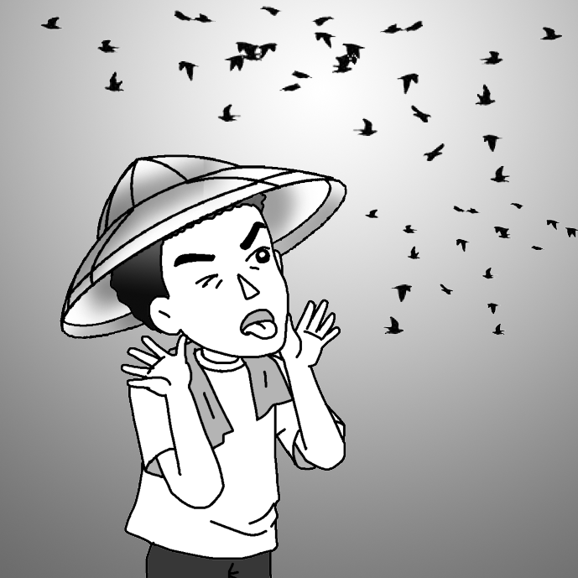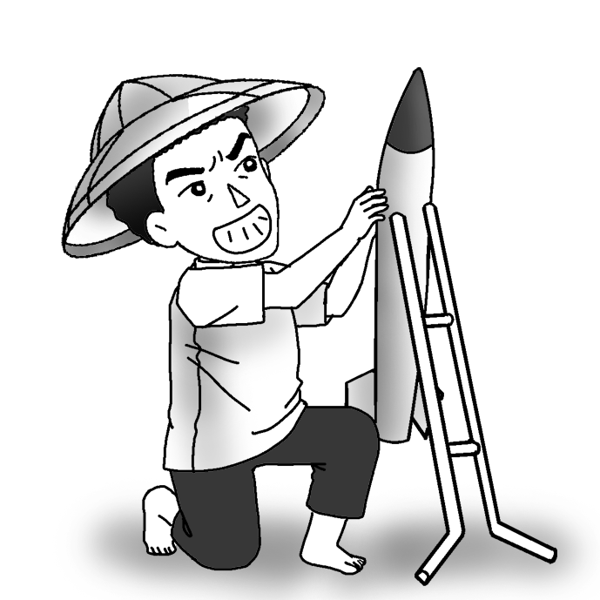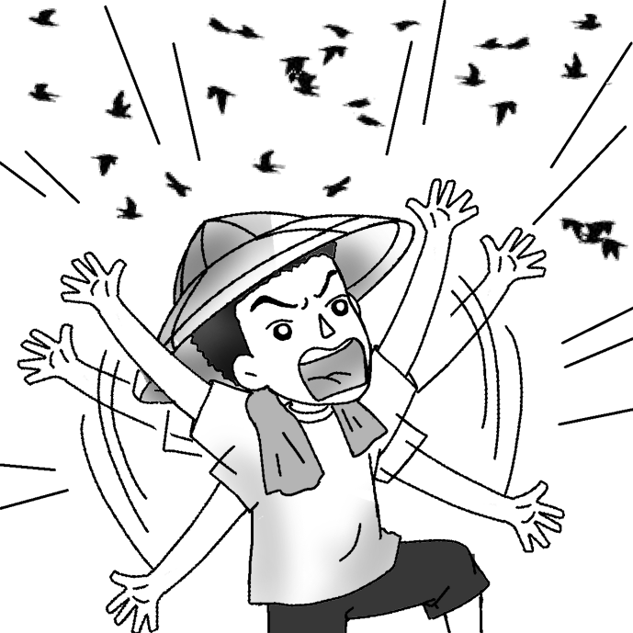
10. _______
(A) (B) (C)
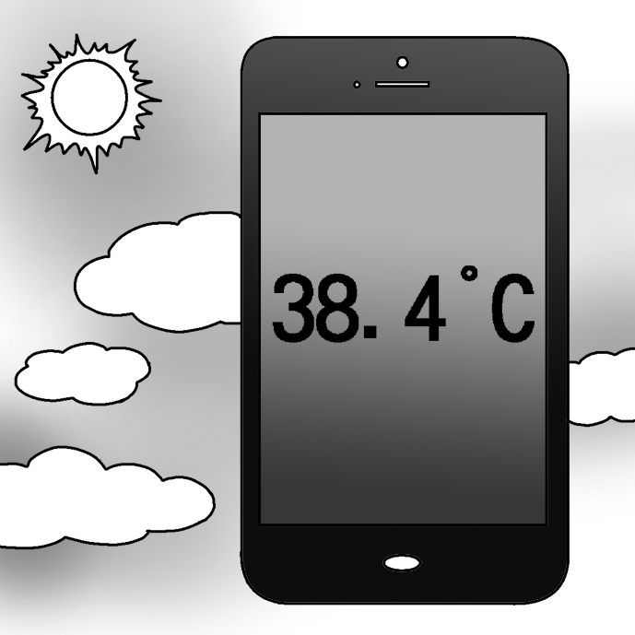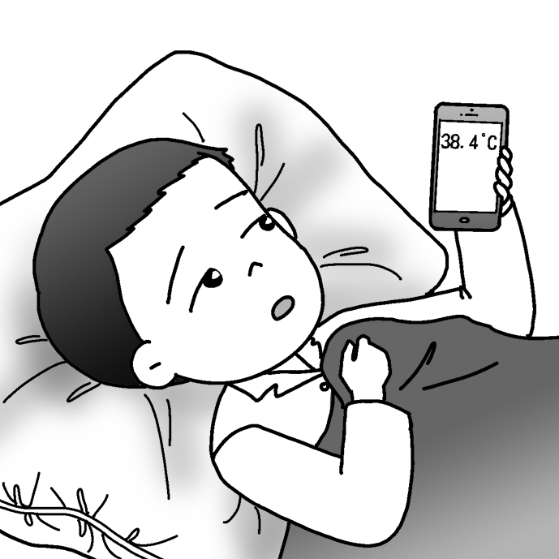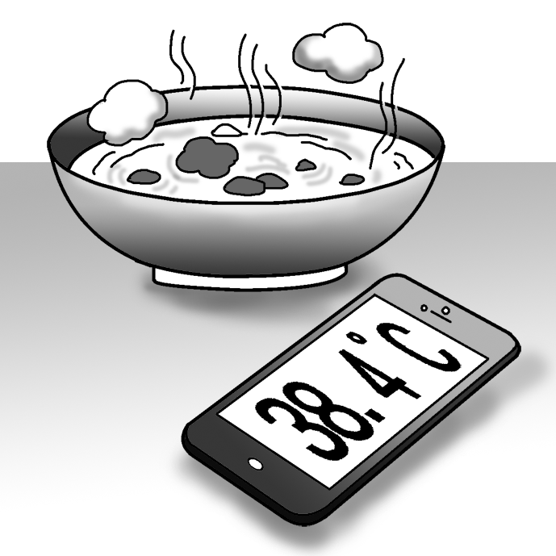

II. Vocabulary and Synonyms (30%)
11. Asia is the largest _____ in the world and many people live on it.
(A) civilization (B) climate (C) continent (D) celebration
12. The _____ is so exciting that I will join it again next year.
(A) parade (B) pollution (C) pose (D) position
13. The boss is _____, so you can’t change his mind easily. Don’t waste your time.
(A) facial (B) firm (C) false (D) fatty
14. Jack’s parents are very _____ because they pray every night and go to church every Sunday.
(A) religious (B) determined (C) effective (D) exact
15. The coach was proud because his basketball team won the championship. (選近義)
(A) absent (B) famous (C) pleased (D) worried
16. People will say “God _____ you” to people they are concerned about to show their kindness
(A) score (B) bless (C) settle (D) stress
17. Ken is a _____ and is famous for his generosity. He donates (捐贈) a lot of money to charities.
(A) civilization (B) cheer (C) character (D) billionaire
18. John’s father was so busy that he totally ignored his own health.(選近義)
(A) founded (B) persuaded (C) neglected (D) discouraged
19. The preachers (傳教士) tried to _____ the tribal people in the jungle.
(A) construct (B) design (C) civilize (D) pour
20. Taking regular vacations is necessary for those who _____ too much on work.
(A) complicate (B) concentrate (C) contain (D) consist
21. The restaurant has superb business because it serves delicious and healthy food.(選近義)
(A) works (B) provides (C) forwards (D) strikes
22. All of the people in the meeting _____ the chairman’s idea of selling the company.
(A) offered (B) raised (C) opposed (D) scored
23. Every year, many tourists who _____ art flock to the National Palace Museum in Taipei to admire
valuable ancient paintings and many other masterpieces.
(A) civilize (B) oppose (C) plant (D) appreciate
24. An idea _____ through Nick’s mind after he listened to the speech.
(A) thought (B) planned (C) flashed (D) offered
25. My sister is crying, but I don’t know how to _____ her.
(A) blame (B) comfort (C) bring (D) introduce
III.Grammar (20%)
26.I like to chat _____ Laney because she is very talkative.
(A) to (B) with (C) of (D) for
27.Marvin _____ a year preparing for the college entrance exam.
(A) cost (B) took (C) paid (D) spent
28. Amanda performed _____ well _____ all the audience stood up and clapped for her.
(A) such; that (B) so; that (C) too; to (D) as; as
29. None of the airplanes can take off _____ the strong typhoon is past.
(A) from (B) within (C) while (D) until
30. We all respect our class leader _____ is a responsible and hard-working model student.
(A) , who (B) who (C) , she (D) whom
31. It _____ that keeping early hours is good for health.
(A) is to say (B) saying (C) has been saying (D) is said
32.Lucky can’t go out until his owner, Linda, _____ home.
(A) comes (B) came (C) does not come (D) did not come
33.The party _____ the best one for the Halloween. Many people want to join it.
(A) considers (B) considered (C) is considered (D) is considered as
34.Linda has two brothers. One is Jimmy; _____ is Tony.
(A) the other (B) one (C) other (D) others
35._____ it gets, _____ your ice cream will melt.
(A) The hot; the faster (B) The hotter; the fastest (C) The hotter; the faster (D) The hot; the fast
IV. Cloze (20%)
One way to experience the various cultures of Asia is to visit its festivals.
One is the Rocket Festival (Bun Bang Fai) 36_____ takes place in Thailand in the middle of May. It is a 37_____ holiday that includes music and dance performances, parades with beautiful floats, and the firing of homemade rockets. Since each rocket 38_____ 25 kilograms of gunpowder, the Rocket Festival is considered one of Asia’s loudest celebrations. It is held just before farmers plant their 39_____ at the beginning of the rainy season. The rockets are fired into the sky 40_____ the rain god Vassakan. It is believed that Vassakan loves the loud sound of huge rockets. People hope that he will be pleased and send down rain to water the fields.
36(A) , where (B) , which (C) where (D) which
37(A) three day (B) three days (C) three-day-long (D) three-days-long
38(A) is aware of (B) is separated from (C) is packed with (D) is scared away by
39(A) crops (B) parades (C) continents (D) rockets
40(A) worship (B) worshiping (C) worshiped (D) to worship
Connie thinks that her smartphone, Ivy, is helpful to her. Ivy tells her 41_____ to do every morning. She tells her the 42_____ like the following*. “You should wake up 43_____ eight o’clock. After you eat breakfast, you have to 44_____ school by MRT to take classes. After school, you will have a date with your old friend, Kelly.” Her smartphone also tells her how the weather is every day, 45_____ she will know if she should bring sunscreen* or an umbrella. Connie needs her smartphone, Ivy, very much. She thinks she can’t live without Ivy.
*the following 下列事物 *sunscreen n. [C,U] 防曬乳
41(A) why (B) when (C) how (D) what
42(A) effort (B) support (C) schedule (D) comfort
43(A) at (B) on (C) in (D) to
44(A) set up (B) turn to (C) leave for (D) go for
45(A) but (B) so (C) then (D) yet
V.Dialogue (10%)
46. Louisa: How much is the flight to Tokyo?
Clerk: Well, it’s 6,000 dollars for a one-way ticket.
Louisa: _____
Clerk: I think you can try to use a low-cost airline.
(A) I’ll get one round-trip ticket. (B) How about the plane ticket to Osaka?
(C) Is there any cheaper way to get there? (D) It is cheaper than I thought.
47.Jim: When is your birthday?
Grace: August 18th.
Jim: _____ I was born on the same day!
Grace: No way!
(A) You are the boss. (B) Give me five more minutes.
(C) What a coincidence! (D) I don’t really care about that.
48. Jerry: How should I contact you?
Kate: ____.
(A) Here is my phone number. (B) My phone number are there. (C) It is my Facebook account and my e-mail address here. (D) There are my blogs.
49.Tina: A new Italian restaurant is open. Would you like to go there together?
Rita: Of course, _____
Tina: OK. I’ll google the number.
(A) but I want to ask my boyfriend to go together. (B) I can’t wait to eat there!
(C) but we had better make a reservation first. (D) could you tell me what your plan is?
50.Nancy: Aren’t you driving right now? You should not use Facebook at the same time.
Timmy: _____
Nancy: I still think that it’s dangerous.
(A) Yes, I am driving right now. (B) Relax! It just takes a few taps on the screen.
(C) Wait for a minute. (D) I can’t endure it anymore.
VI. Reading Comprehension (10%)
Songkran is a unique festival in Thailand that is celebrated with water. Similar traditions are seen
in other Southeast Asian countries such as Singapore, Myanmar, Laos, Cambodia, and even a part
of New Taipei City in Taiwan, where many Southeast Asian immigrants* live.
Songkran festival falls on the New Year days of the Thai calendar. People throw water at one
another, which symbolizes washing away all the bad things of the old year and welcoming the new.
Some people would put fragrant powder in the water to make it smell good.
There is a legend behind the Songkran festival. Ancient Siam (the former name of Thailand) was
plagued* by a powerful monster. The king and his seven daughters were planning to kill the monster.
The girls attacked the monster in the dark of the night and cut off its head, but the head began to burn
and roll all over the place, burning and destroying everything in its path. The girls used water to put
out the fire and saved the country. This is why water has become the center of the New Year
celebration in Thailand.
*immigrant n. [C] 移民 *plague vt. 使受災禍、折磨 *legendary adj. 傳說的
51. Which of the following is the best title for the article?
(A) A Special Festival in Thailand (B) Southeast Asian Customs
(C) A Special Street in New Taipei City (D) A Legendary* Monster in Thailand
52. Which of the following countries is NOT mentioned as having a water festival?
(A) Laos. (B) Singapore. (C) South Korea. (D) Thailand.
53. When is the Songkran water festival celebrated in Thailand?
(A) On Christmas. (B) On New Year days.
(C) On Valentine's Day. (D) On Thanksgiving.
54. Who celebrate water festival in Taiwan?
(A) Hakka people. (B) Tourists from the U.S.
(C) Japanese people. (D) Southeast Asian immigrants.
55. Which of the following statements is true?
(A) Nobody is allowed to put fragrant powder in the water.
(B) The king in the legend had more than five daughters.
(C) The monster in the legend escaped unharmed.
(D) People throw water at each other so they can remember the old year.

