市立新北高工106學年度第1學期第一次段考試題 |  |  |  |  |  |  | 班級 |  | 座號 |  | 備註 | 需附電腦卡:D
科目 | 英文 | 年級 | 二 | 科別 | 機鑄汽模圖資電訊 |  | 姓名 |  |  |  | 備註 | 需附電腦卡:D
I.聽力測驗 (10%)  A. Pictures 看圖辨義(2%)  Listen to the questions. Then choose the best answer according to each picture.  B. Best Response 最佳回應句(3%)  Choose the best response to each question or statement.  ______ 3. (A) I’m so tired that I could fall asleep standing up.  (B) It was such a long game that it didn’t finish until 4 a.m.  (C) The match was so special that I couldn’t miss it.  ______ 4. (A) Yes, some people call it the “Big Apple.”  (B) There are lots of things to see, such as the Statue of Liberty.  (C) The scenery there is beautiful and very impressive.  ______ 5. (A) The information is in the beginning of the book.  (B) You can pass it on to others.  (C) The book is a tribute to good design.  II.對話(10%)  ( )11. Simon: Would you like to go cycling with us this Wednesday?  Melody: Sorry. I’m very busy this week. _____  Simon: Sure. Please let me know when you will be free.  (A) Can I take a rain check? (B) Is everything ready?  (C) What will we do for today? (D) Please ask someone else.  ( )12. Sharon: We need to go visit Grandmother now.  Neo: _____ I want to finish this video game.  (A) It’s raining so hard. (B) Just wait another five minutes.  (C) Don’t be a couch potato. (D) What do you mean by that?  ( )13. Sunny: The exam is finally over! Now I have time to try my new Wii games and relax a little bit.  Phoebe: If you’d know where to… to… to find them.  Sunny: _____  Phoebe: I sold them online for A-mei’s concert tickets.  (A) What are friends for? (B) We have no time to waste.  (C) Let me explain. (D) What do you mean by that?  ( )14. Mom: Why is there a crack in the wall?  Max: _____  (A) Just wait another five minutes. (B) I am almost done with my homework.  (C) Let me explain…. (D) What are you doing?  ( )15. Doris: The Chinese Taipei team lost in the end.  Penny: _____ At least the players all did a great job in the game.  Doris: I know…. I should be proud of them. They’re the best!  (A) It’s been a long time. (B) Come on. Cheer up!  (C) They didn’t get ready. (D) That’s a good question.  III.文法選擇(20%)  ( )16. _____ difficult the assignment is!  (A) What (B) How (C) What a (D) How a  ( )17. This car costs over NT$10 million. _____ an expensive car!  (A) How (B) So (C) What (D) Who  ( )18. The train is delayed and I can do nothing but _____.  (A) wear (B) wearing (C) waiting (D) wait  V.克漏字(10%)  The FIFA World Cup is a well-known football competition, which offers you a chance to get involved in one of the most exciting international sports events. It __31___ every four years in countries that FIFA members decide on. Teams from every country have to compete against each other in the first stages, which last __32___ three years. And in the fourth year, or the FIFA year, only 32 teams are allowed to join in the final match of the World Cup. This is when people all over the world get most __33__. Lots of people will watch the live __34__ of the match and may jump up and down while they shout out the names of their favorite players or teams to cheer for them. The winners not only get a large amount of money but also give their countries something to be proud of. It is not __35__ that so many people are crazy about following the World Cup!  ( )31.(A) takes on (B) takes off (C) takes place (D) takes action  ( )32.(A) in (B) with (C) on (D) for  ( )33.(A) excited (B) excite (C) excites (D) exciting  ( )34.(A) ability (B) broadcast (C) confidence (D) creativity  ( )35.(A) surprises (B) surprise (C) surprising (D) surprised  VI.閱讀測驗(10%)  Jump Ashin! is a sports movie based on a true story about loss and courage. Ashin, played by Eddie Peng, is raised by a single mom in Yilan. Ashin has a talent for sports and joins the school’s gymnastics(體操) team. He has fun and does well on the team. But because his mom wants him to run the family fruit business, Ashin has to quit the team and stop practicing gymnastics.  ( )40. Why is Ashin’s story inspiring?  (A) It teaches people how to do business.  (B) It encourages people not to give up easily.  (C) It tells people to quit when things are difficult.  (D) It teaches people how to win first place in gymnastics.  VII.文意填充30%(單字2%*10；片語1%*10)  41. Since the bestselling novel Twilight《暮光之城》came out, there has been a s_____s of movies on the same topic.  42. Sherry has a k_____n interest in math. She is good with numbers.  43. Fans shouted w_____y when Jeremy Lin appeared at the Taoyuan International Airport.  44. Recently, the issue of food safety has r_____ed a lot of attention in  society.  45. Although a typhoon is approaching this weekend, Kevin i_____ed the warning  and insists on going mountain climbing with his friends.  46. When you go to a hospital, you should wear a mask to prevent i_____n.  47. I am d_____d to be an excellent dancer, and nothing will stop me.  48. In c_____n of his promotion, Tom invited his friends to come to his house for a  party.  49. Jack is an e_____t on money management and has many years of experience.  50. The Leaning Tower of Pisa is a l_____k in Italy; it attracts lots of tourists every year. |  |  |  |  |  | - Short Conversations 簡短會話(3%)  Listen to the conversations. Then answer the questions.  ______ 6. (A) The speakers’ team won.  (B) The speakers’ team will go to the next round.  (C) The speakers’ team lost.  ______ 7. (A) A high school student.  (B) A university student.  (C) A designer.  ______ 8. (A) Try to find a new place to live.  (B) Travel to Europe for summer vacation.  (C) See more sights around the city.  D. Short Talk 短文聽解(2%)  Listen to the talk. Then choose the best answer to each question.  9. __________  (A) (B) (C)  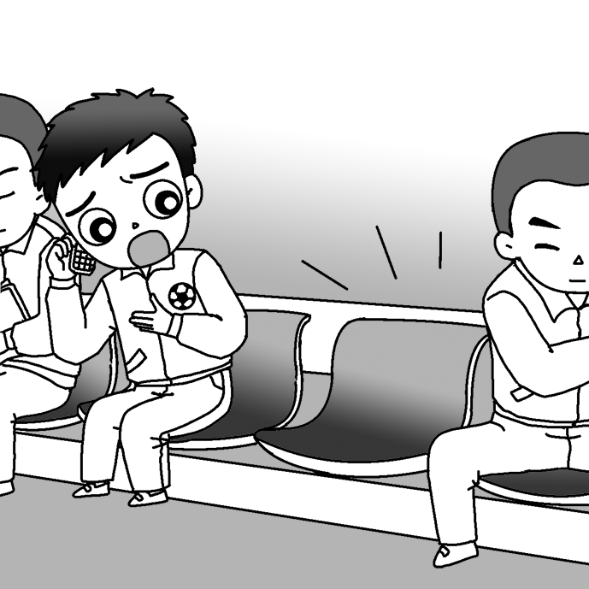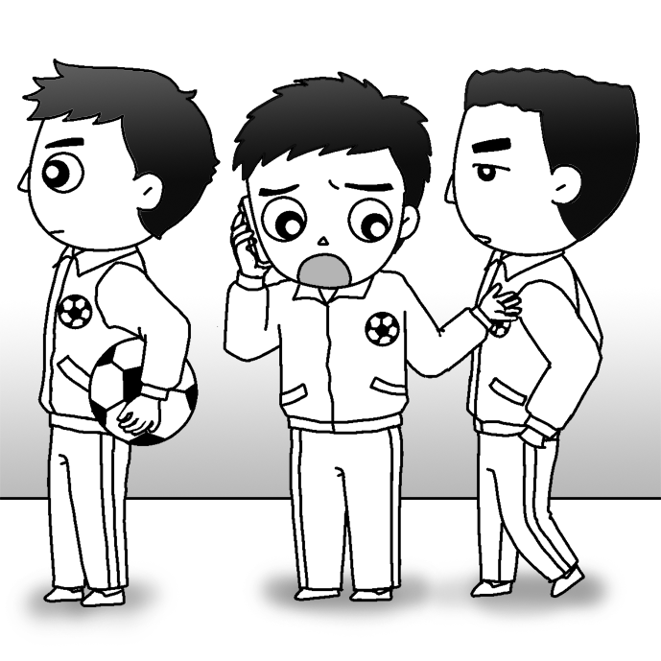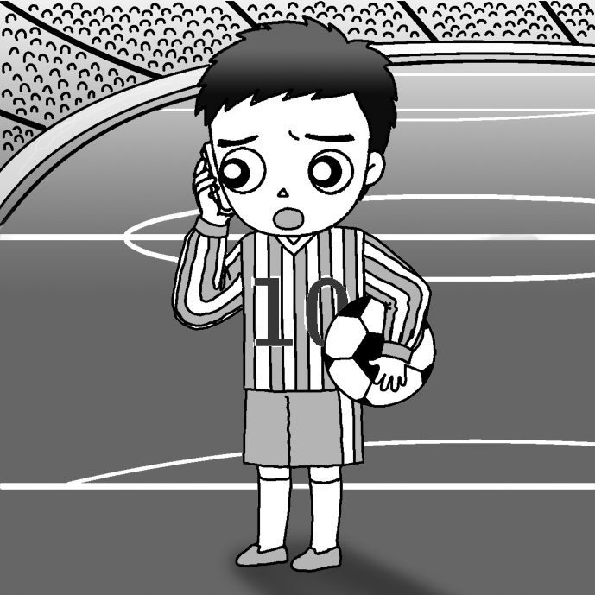  10. ________  (A) (B) (C)  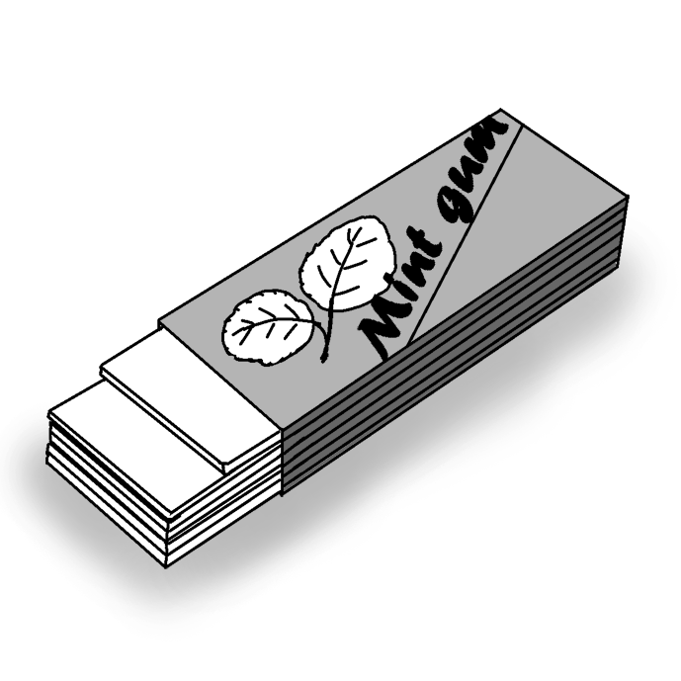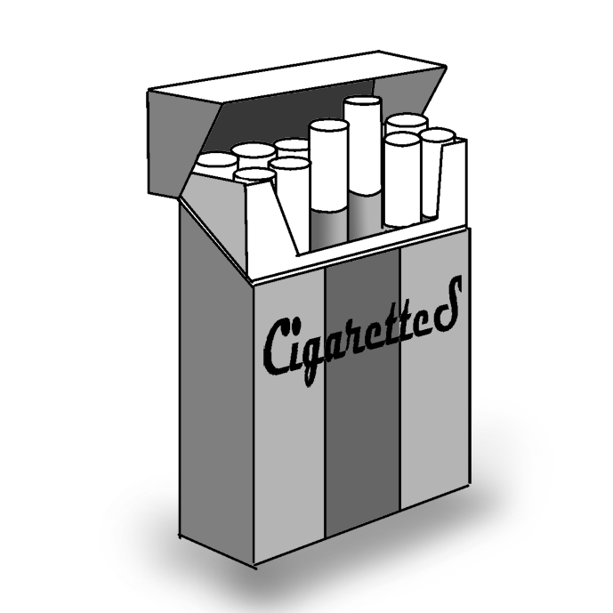  ( )19. As soon as _____, he will give me a call.  (A) Henry will get to the airport (B) Henry reached the train station  (C) Henry returned to his home (D) Henry arrives in Taipei  ( )20. No other city in Japan is _____ Tokyo.  (A) the crowdest (B) more crowded than  (C) as more crowded as (D) so crowded that  ( )21. We arrived at the movie theater early _____ we could get the best seats.  (A) in order to (B) so that (C) because (D) so as to  ( )22. No other student in our class is as smart _____ Jeremy.  (A) than (B) of (C) for (D) as  ( )23. As soon as Caroline _____ the top of the mountain, she spread her arms  open and shouted in excitement.  (A) reached (B) reaches (C) will reach (D) reaching  ( )24. Colin went to work _____ his severe headache.  (A) in spite (B) despite (C) although (D) even  ( )25. Which of the following sentences is correct?(選出正確的選項)  (A) The Golden Horse Film Festival takes place annually in Taiwan.  (B) I looked out of the window to see happened what.  (C) My mother promised to occur a party for me.  (D) The board meeting will hold tomorrow morning.  IV.同義字(10%)  ( )26. Kate is eager to become a musician. She practices playing the piano  every day.  (A) keen (B) awful (C) loose (D) round  ( )27. After years of searching, the boy finally found his parents.  (A) eventually (B) philosophically (C) inspirationally (D) gradually  ( )28. The university wanted to employ a professor with experience in  teaching French and Italian.  (A) raise (B) move (C) hire (D) infect  ( )29. Their boss asked that they have the idea for their plan ready by Monday.  (A) project (B) effect (C) expert (D) faith  ( )30. The school plans to build a new library for the students.  (A) connect (B) instruct (C) determine (D) construct  After leaving the team, Ashin feels lost and starts hanging out with gangster(幫派) friends and gets himself into fights and lots of trouble. He goes to Taipei with his friends for some time and gets into more trouble. Life in Taipei does not turn out well for Ashin and after fooling around for years, he finally decides to give himself another chance and go back to gymnastics. He works very hard to pick up every movement. Toward the end of the movie, he participates in a gymnastics competition and wins first place. The movie is inspiring in that it encourages people not to give up easily in times of difficulty.  ( )36. What is Ashin good at when he is little?  (A) He is good at selling fruit. (B) He is good at fooling around.  (C) He is good at hanging out his friends. (D) He is good at gymnastics.  ( )37. What happens to Ashin after he quits the gymnastics team?  (A) He does very well with the fruit business.  (B) He is having a good time and does not get into trouble.  (C) He moves to Taipei and has a family there.  (D) He is not sure about his future and gets into lots of trouble.  ( )38. Why does Ashin want to get into gymnastics again?  (A) He wants to run the family business.  (B) He loses money in the family business.  (C) He wants to give himself a second chance.  (D) He wants to make money to buy a house.  ( )39. How is Ashin doing after picking up gymnastics again?  (A) He is just fooling around.  (B) He works very hard.  (C) He is getting himself into trouble.  (D) He goes out with friends for fun all day long.  51. Look at that antique vase. Jane’s great grandmother (p)_____ it ______ ______  her parents.  52. These scientists are trying to find a more efficient way to (t)_________ sunshine  ________ electricity.  53. After working hard for many years, Mark eventually (r)______ ______ (d)_____  of running a large company of his own.  54. The exciting dance performances (k)_____ _________ the baseball game.  *請同學將手寫部分填寫於答案卷上，否則不予計分，謝謝!  
  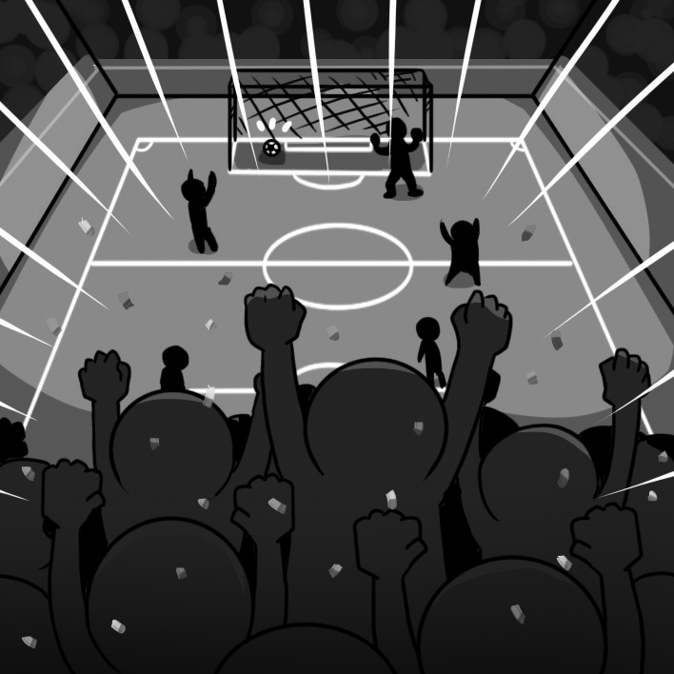 | 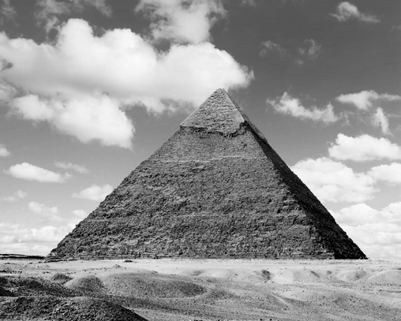
  1. ______ | 2. ______

