- 請選出正確的單字。45%
banana | strawberry | papaya | lychee | kiwi
Bell fruit | watermelon | Dragon eye fruit | orange | Dragon fruit
mango | pineapple | Star fruit | Cherry | Peach
tomato | lemon | apple

- what fruit do you like?
I like .(荔枝)
- what fruit do you like?
I like .(鳳梨)
- what fruit do you like?
I like .(龍眼)
- what fruit do you like?
I like .(楊桃)
- what fruit do you like?
I like .(蓮霧)
- what fruit do you like?
I like .(奇異果)
- what fruit do you like?
I like .(柳丁)
- what fruit do you like?
I like .(西瓜)
- what fruit do you like?
I like .(香蕉)
- what fruit do you like?
I like .(桃子)

- 口語測驗/聽力測驗。(將於課堂中測驗)29%
- What fruit are you like?
I like
- 圈出Mike喜歡的水果。
- 將Jayce討厭的水果畫X。
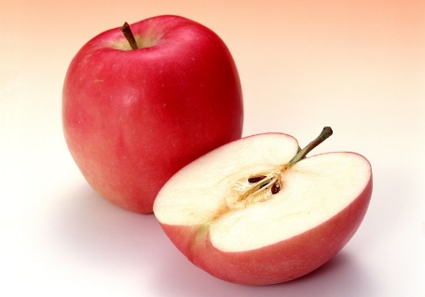 | 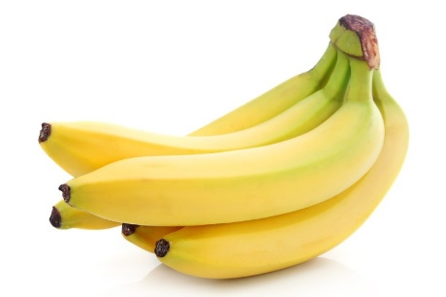j | 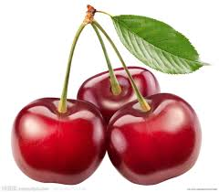
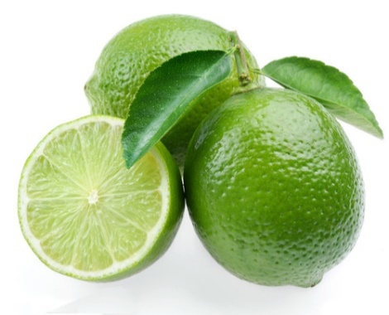 | 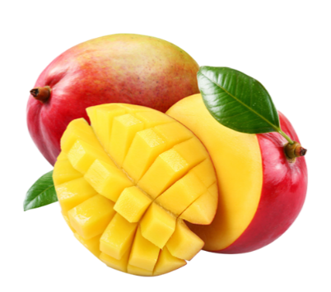 | 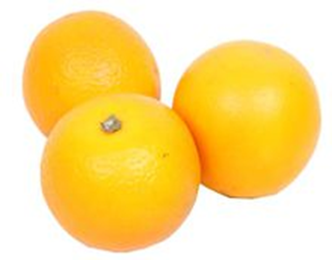
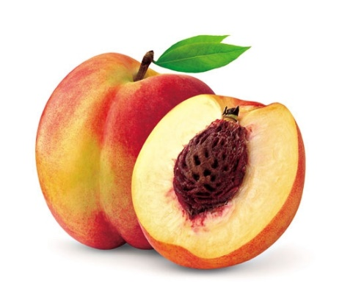 | 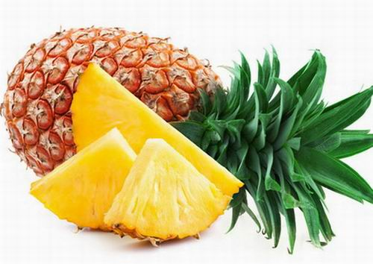 | 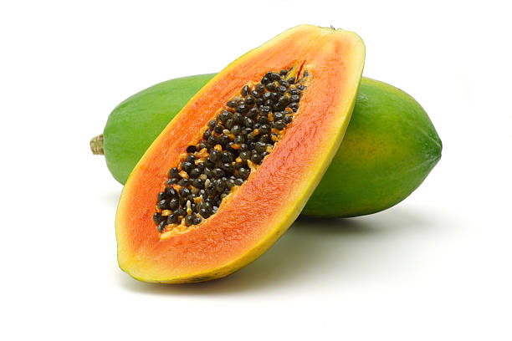
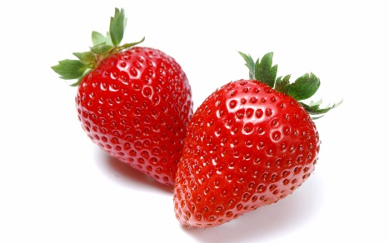 | 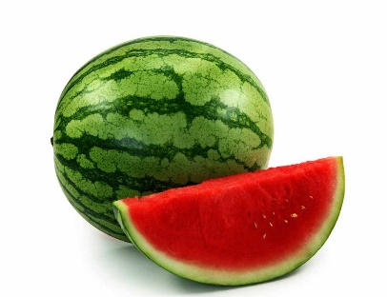 | 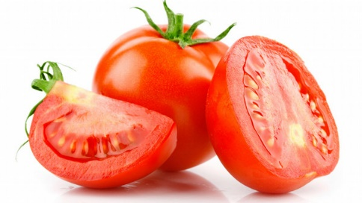
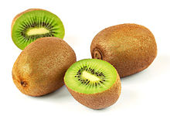 | 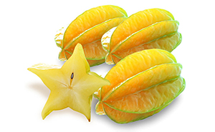 | 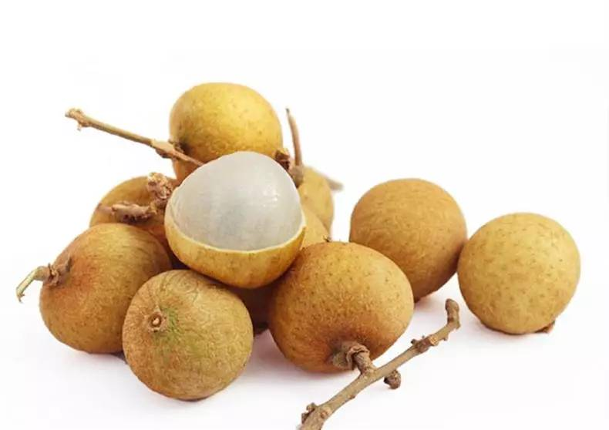
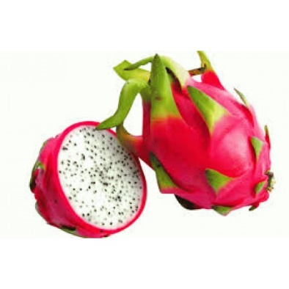 | 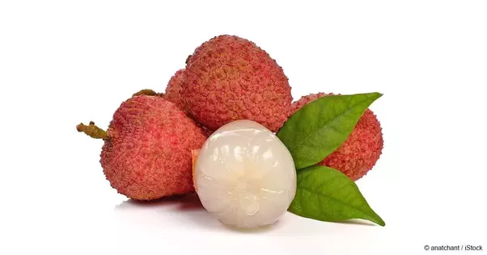 | 