新北市立 新 北 高工 106 學年度 第二學期 期 末 考 |  |  |  |  |  |  | 班級 |  | 座號 |  | 成 | P.1
科目 | 英文 | 年級 | 一 | 科別 | 機汽圖電資訊 |  | 姓名 |  |  |  | 績 | P.1
共55題，請在答案卡上劃卡作答，並劃妥座號，未劃座號者酌扣五分!  I. 聽力測驗10% 1. 看圖辨義：每題請聽錄音機所播出的題目和A、B、C三個選項後，選出與所看到的圖畫最相符的答案。  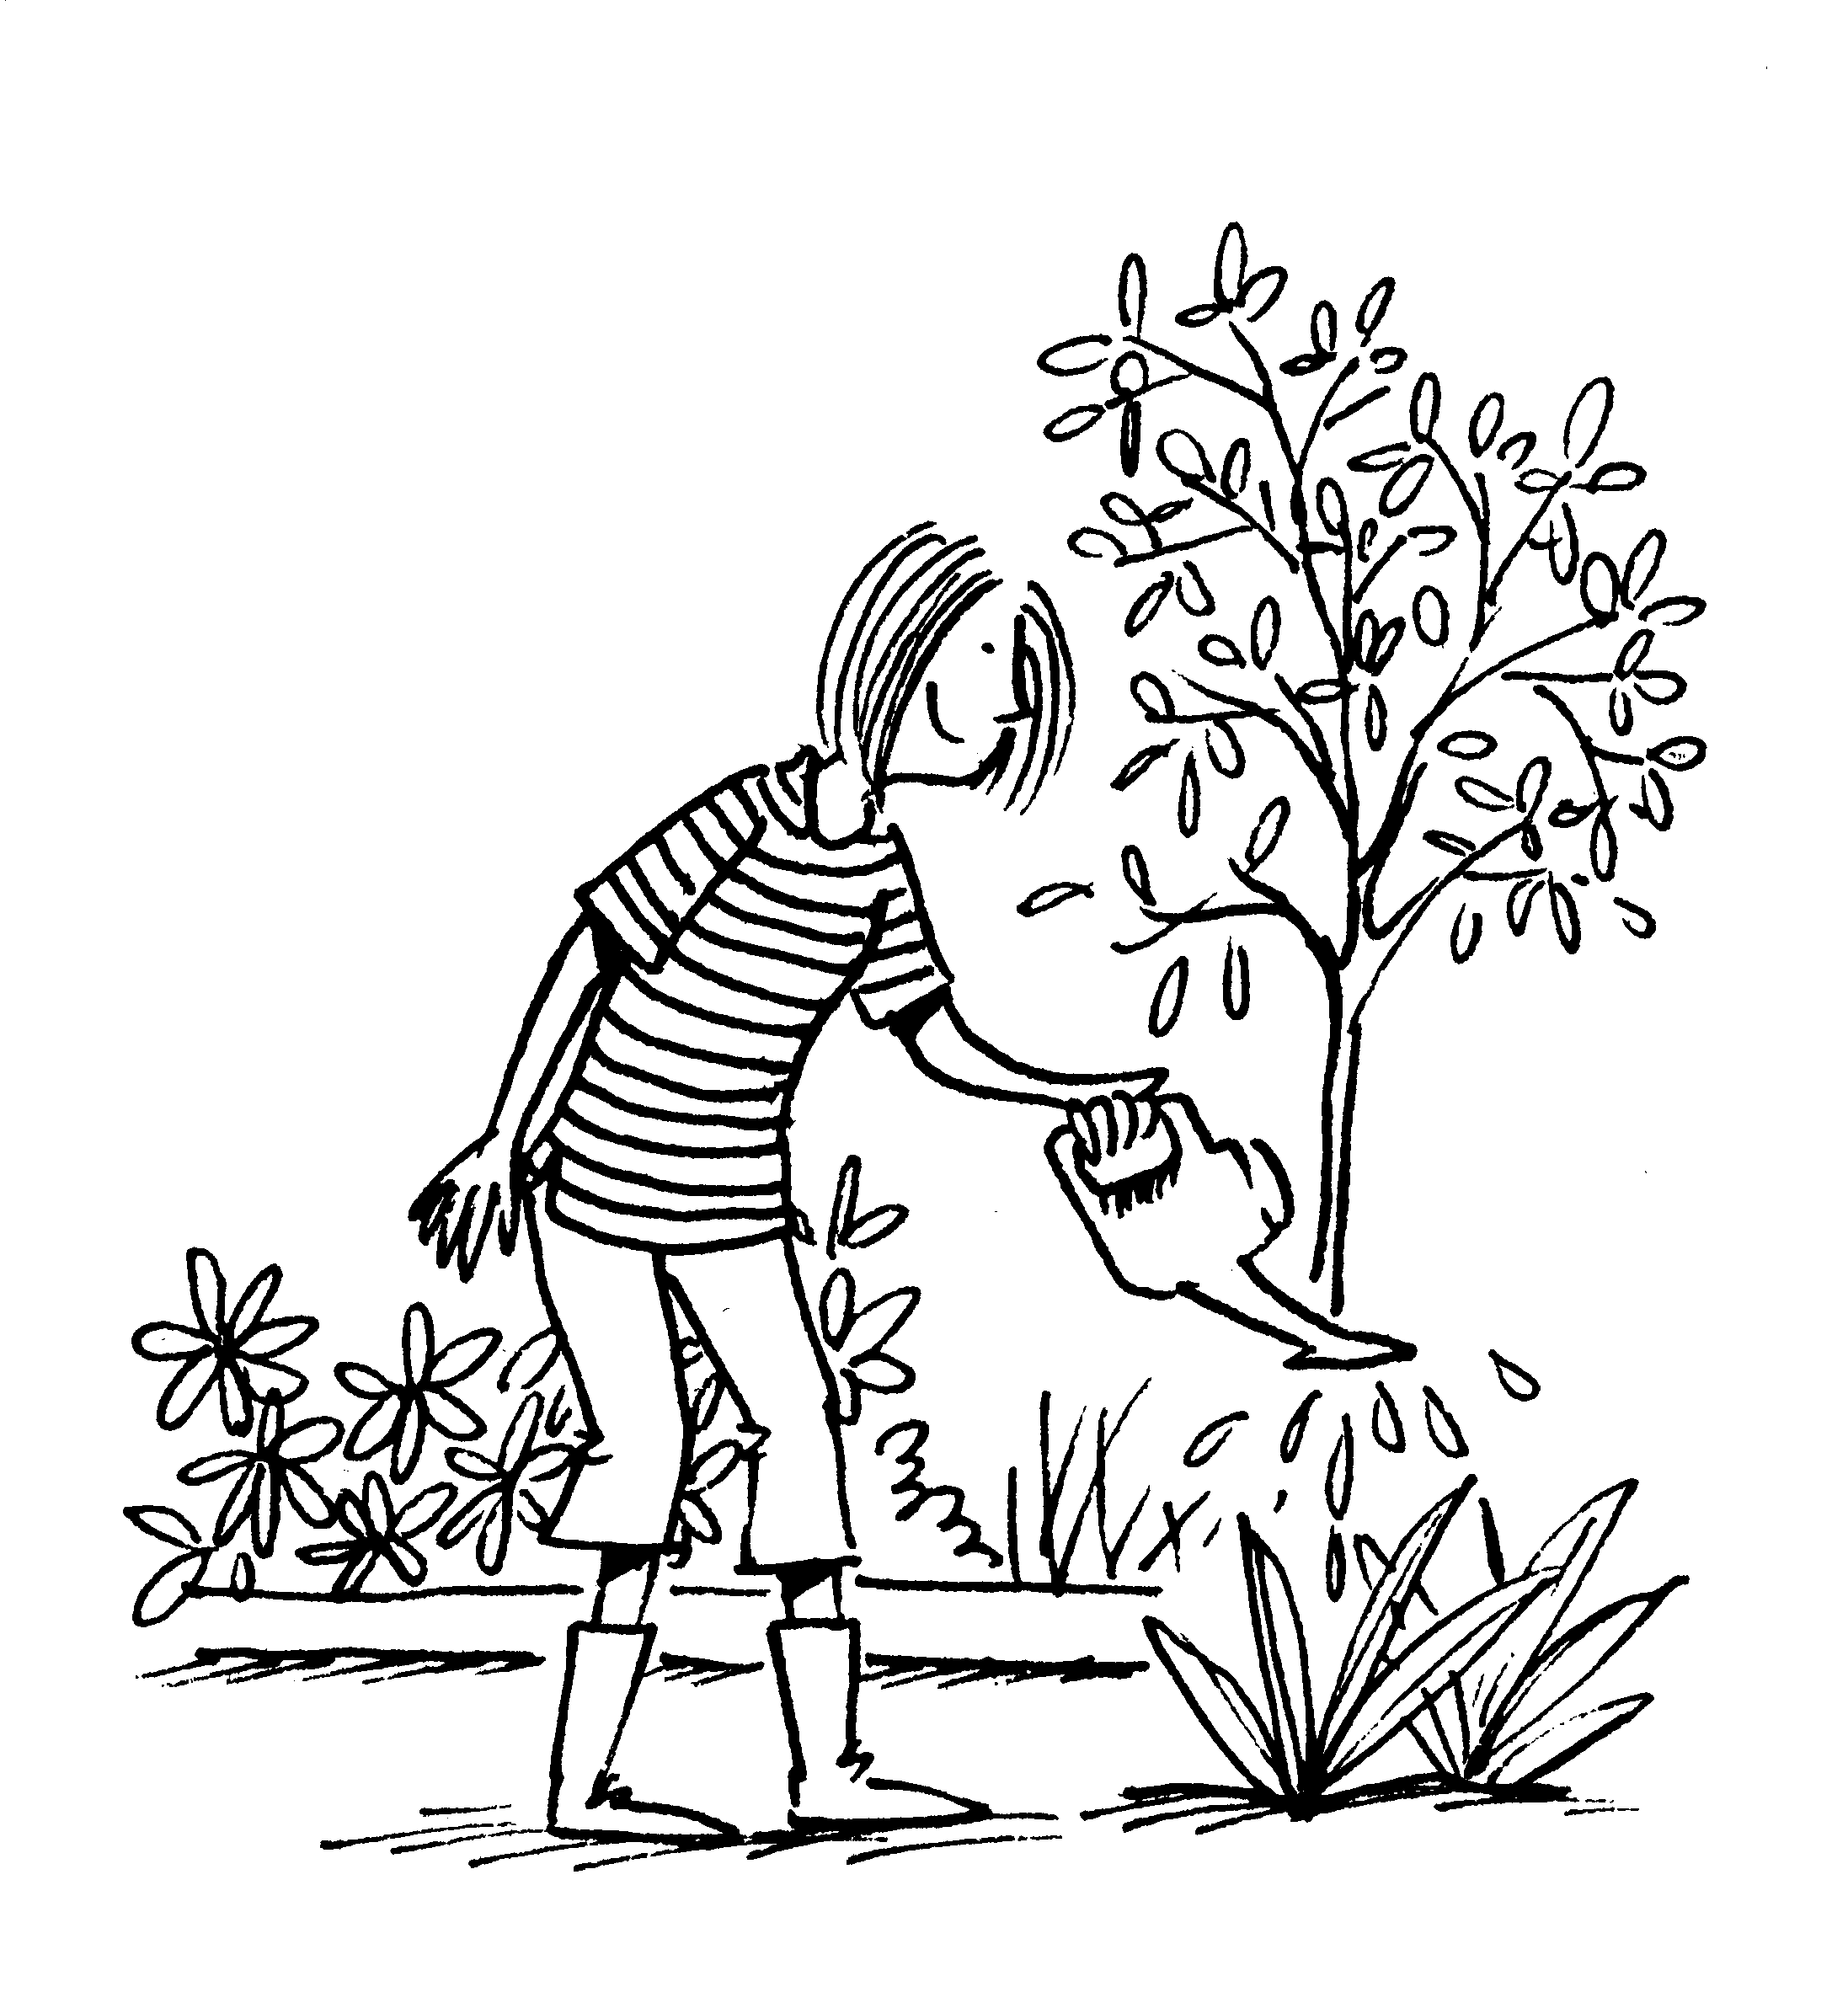  (左)1. ______  (右)2. ______  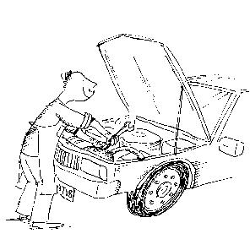  2. 問答：每題請聽錄音機所播出的英語句子，再從試題上A、B、C三個選項中，選出一個最適合的回答或回應。每題題目念兩次  ( ) 3. (A) No, it’s not expensive. (B) Right. It looks pretty dirty.  (C) Yeah. It’s made of cotton.  ( ) 4. (A) Wow! Your garden is so beautiful. (B) I see. I don’t like flowers, either.  (C) Actually, they’re not real. They’re plastic.  ( ) 5. (A) Well, I don’t like its design. (B) Taiwan exports many goods of high quality.  (C) I think you should ride a bike to school.  ( ) 6. (A) Yes, you have a cool cell phone. (B) Right, Taichung is my hometown.  (C) Actually, it’s made in Taiwan.  ( ) 7. (A) I’m going to the movies tonight. (B) I’ll take a trip overseas.  (C) I suggest that you visit Houli.  3. 簡短對話：每題請聽錄音機所播出的一段對話和相關問題，再從試題上A、B、C三個選項中，選出一個最適合的答案。  ( ) 8. (A) It is because they don’t have enough chemicals. (B) It is because of the water pollution.  (C) It is because too many people go fishing there.  ( ) 9. (A) The way of making umbrellas. (B) The foundation of the man’s company.  (C) The failure of the man’s umbrella business.  ( ) 10. (A) It is because the man gives her no attention.  (B) It is because she fails to influence the man.  (C) It is because of her failure to win the race.  II. 字彙片語選擇30%  ( )11. I’ll prepare the meal. , you can set the table.  (A)Meanwhile (B) Instead (C) However (D) As a result  ( )12. Kevin still felt _________ after midnight because of the coffee he just had.  (A)chemical (B)energetic (C)plastic (D)annual |  |  |  |  |  | ( )13. ________ things like cans and bottles can help reduce garbage.  (A)Replacing (B)Describing (C)Recycling (D)Polluting  ( )14. Instead of using ________, Julie used her handkerchief to wipe her wet hands.  (A)trends (B)chemicals (C)benefits (D)tissues  ( )15. My father has been working overseas for two years. (選出與句中劃底線的字詞意義最相近的答案)(A) abroad (B)forward (C) somewhere (D)outside  ( )16. Please pay ________ as the teacher explains the rules of the game.  (A) attention (B)failure (C) impression (D)foundation  ( )17. What the hungry man wants is ________ a good meal to eat.  (A)nothing more than (B)in the middle (C) )no longer (D)in addition to  ( )18. Before you accept the job offer, you should give it careful ________.  (A) consideration (B)detail (C) foundation (D)failure  ( )19. Eating too much fast food is bad for your health. Moreover, it can be addictive (使人上癮的). (選出字義與劃線的字最相似的選項)  (A)Rarely (B)Gradually (C)Furthermore (D)Meanwhile  ( )20. Dr. Hall’s study on the treatment for depression.  (A)described (B) polluted (C)focused (D)damaged  ( )21. The company manufactures cars and sells them worldwide. (選出字義與劃線的字最相似的選項) (A)recycles (B) produces (C)finds (D)uses  ( )22. In this dictionary, AE “American English.”  (A)looks like (B)is able to (C) acts on (D)stands for  ( )23. A smile always makes a good first .  (A)impression (B)failure (C)attention (D)foundation ( )24. Many studies shows that colors can people’s emotions(情緒).  (A)influence (B)be based in (C)cause failure to (D)found  ( )25. It is difficult to grow vegetables in this area because the soil here is of poor .  (A)detail (B)rest (C)brand (D)quality  III. 文法選擇24%  ( )26. Please check if all the lights are ________ before you leave.  (A)up (B)off (C)in (D)out  ( )27. The actress is famous ________ her great acting skills.  (A)as (B)with (C)for (D)by  ( )28. The waiter ________ at the front door is Leslie’s brother.  (A)standing (B)who standing (C)to stand (D)stood  (請翻面，背面尚有試題
新北市立 新 北 高工 106 學年度 第二學期 期 末 考 |  |  |  |  |  |  | 班級 |  | 座號 |  | 成 | P.2
科目 | 英文 | 年級 | 一 | 科別 | 機汽圖電資訊 |  | 姓名 |  |  |  | 績 | P.2
( )29. Exercising every day makes me ________.  (A)health (B)healthier (C)much health (D)much healthy  ( )30. Mr. Wang ________ is about seventy years old, goes jogging every morning.  (A)who (B), which (C)which (D), who  ( )31. Susan got wet ________ the heavy rain.  (A)ever since (B)since (C)because (D)because of  ( )32. Eric cut the meat ________ a sharp knife.  - for (B)of (C)as (D)with  ( )33. The earthquake ________ the area last night took many people’s lives.  (A)to hit (B)which hitting (C)hit (D)hitting  ( )34. Albert the leader of the school baseball team last year.  (A)was named (B)named as (C)naming as (D)been named  ( )35. Fred wrote me a letter, me for my help.  (A)and thanking (B)to thanked (C)thanking (D)thanked  ( )36. is believed that the super star lives in the mountains.  (A)It (B)The fans (C)There (D)He  ( )37. Dennis took out a map, to find out where he was.  (A) which (B) and he tried (C) and trying (D) that  IV. 克漏字26%  Many people want to be LOHAS followers, but they don’t know what to do. In fact, we can start with small changes 38. our habits. First of all, try to eat 39. food. Food which is grown in a natural way is good for our bodies. Also, it doesn’t 40. the environment. When 41. out, we can use our own chopsticks and spoons. This helps 42. waste. We can ride bicycles 43. driving cars as well. This not only saves energy 44. is good for our health. What we do in our lives can 45. the earth. So, let’s be LOHAS followers from now on.  38. ( ) (A)with (B)in (C)at (D)as  39. ( ) (A)private (B)curious (C)plastic (D)organic  40. ( ) (A)recycle (B)describe (C)pollute (D)protect  41. ( ) (A)to eating (B)eat (C)eating (D)eats  42. ( ) (A)to reduce (B)been reduced (C)to reducing (D)reduces  43. ( ) (A)even if (B)ever since (C)instead of (D)as soon as  44. ( ) (A)than (B)from (C)so that (D)but also  45. ( ) (A)stand for (B)make a difference to (C)make sure (D)make a living as |  |  |  |  |  | Zhang Lianchang learned Chinese painting when he was young. However, after he grew up, Zhang liked to perform music. One day, Zhang got a 46. saxophone and spent three months drawing every part of it. Then, after two and a half years, he was able 47. his own saxophone. This saxophone 48. be the first saxophone 49. was made in Taiwan. Zhang then shared his knowledge with other 50. in Houli. Though Zhang died in 1986, today his offspring (子孫) still make good saxophones in Houli and sell them to the whole world.  ( ) 46. (A) damage (B) to damage (C) damaging (D) damaged  ( ) 47. (A) to make (B) making (C) make (D) made  ( ) 48. (A) says to (B) is said to (C) is saying (D) said  ( ) 49. (A) , that (B) whom (C) that (D) what  ( ) 50. (A) rests (B) residents (C) brands (D) impacts  V. 對話10%  ( )51. A: How do you like the story?  B: Well, I think it is boring, and I don’t like the sad ending.  A: That’s an interesting point of view, but I think ________. I love it a lot.  (A)it doesn’t attract me at all. (B)it is boring as well.  (C)it was written by a friend of mine. (D)it is an interesting one.  ( )52. A: What’s your opinion about recycled goods? B: ________  A: I feel the same as you. We can save the earth by buying them.  (A)They are usually too expensive. (B)I think they are earth-friendly.  (C)In my view, they don’t do any good to the earth. (D)No wonder they look old.  ( )53. A: I’m thinking of buying a tablet.  B: I don’t like tablets because the screen is too small.  A: Right, but ________. I can play games anywhere with it.  (A)I feel the same (B)it is easy to carry around  (C)that’s a big weakness (D)it is not user-friendly  ( )54. A: You should buy a Gore-tex coat, because it can keep you warm in the cold weather.  B: I might need one, but ________. It is more than I can afford.  (A)I heard it is not cheap (B)it is not made of cotton  (C)you can borrow mine (D)I really like the coat  ( )55. A: ________  B: I think they are bad for the earth. I always carry my own bag when shopping.  (A)How about joining some LOHAS activities together?(B)Are you an eco-friendly person?  (C)What do you think of my new bag?(D)How do you feel about using plastic bags?  請仔細核對題號,並在答案卡劃上座號!! 未劃座號者酌扣五分!

